Ex1: Create a simple cloud software application for Flight Reservation System using any Cloud Service Provider to demonstrate SaaS include the necessary fields such as oneway, round trip, From, to, Departure, Departure, Travelers & Class, Fare Type, International and Domestic Flights etc.

PROCEDURE:

STEP 1: Go to zoho creator to create an application

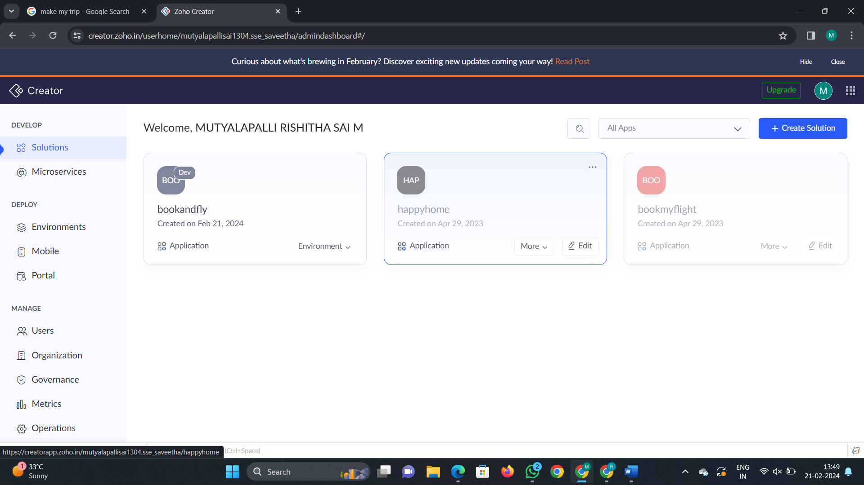

Step 2: Go to create solution and give the name for our application

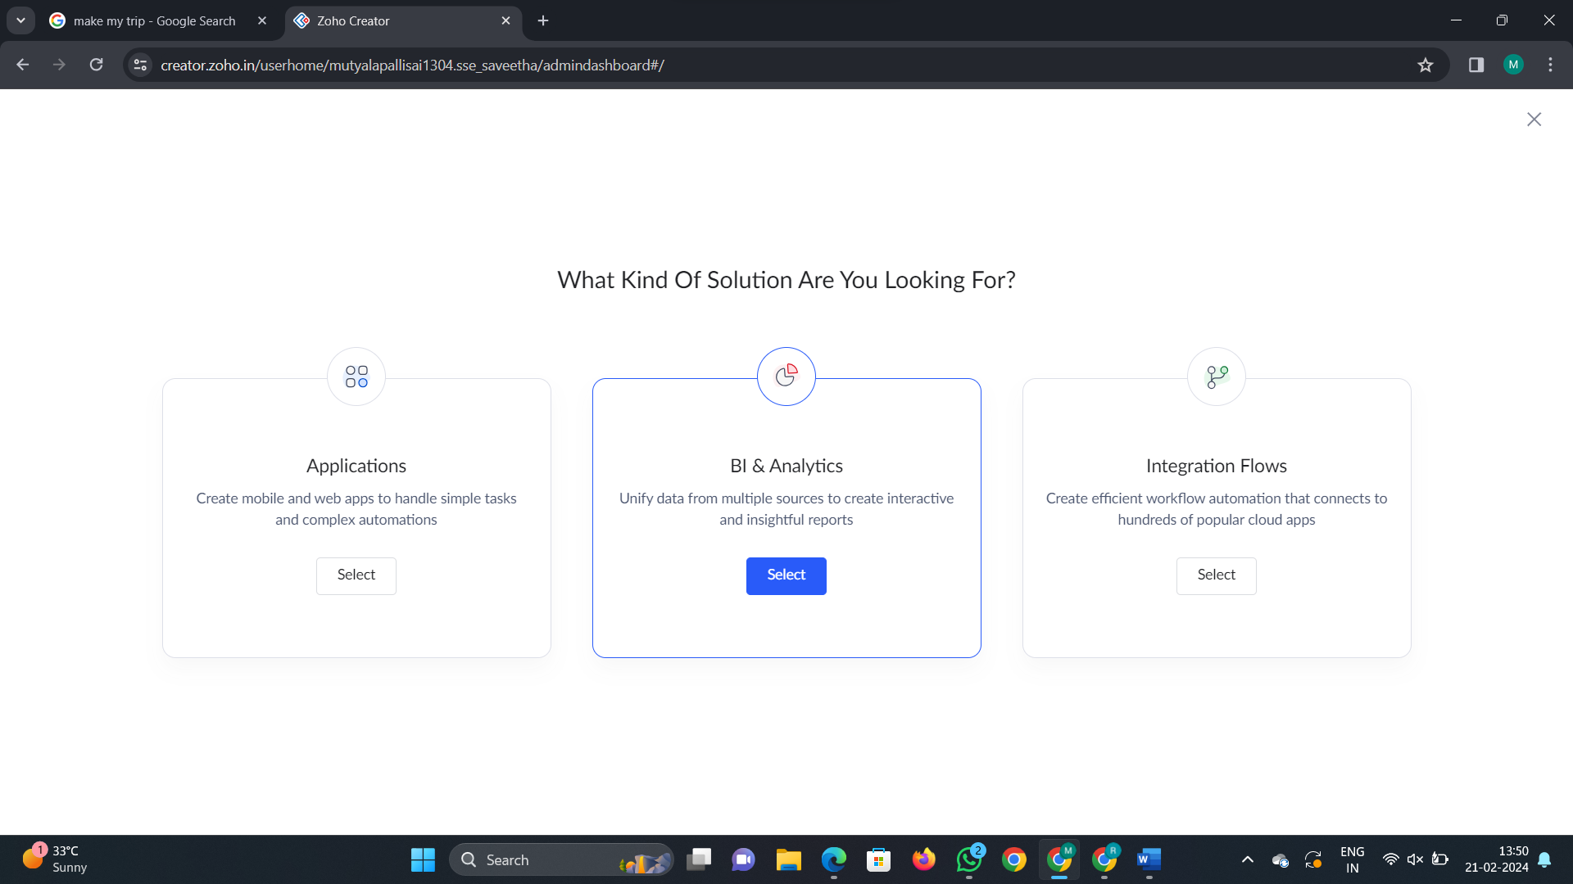

Step 2: Now select the type of form you need to create by using the given templates

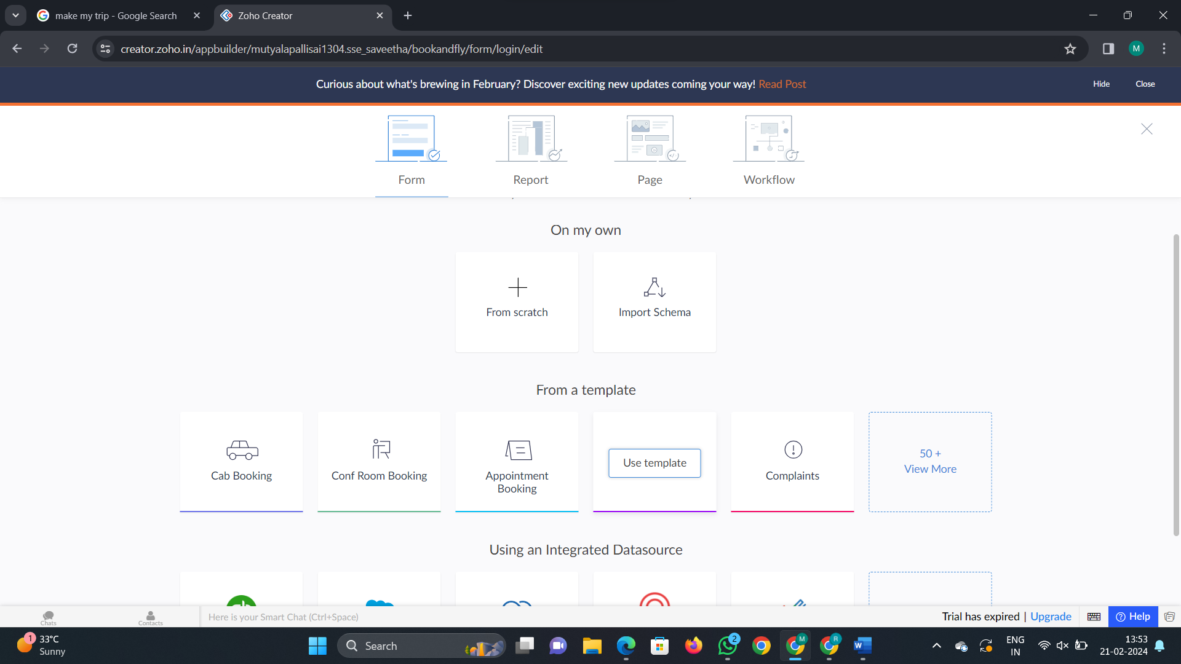

Step 3: Select the template and create a form required with necessary details

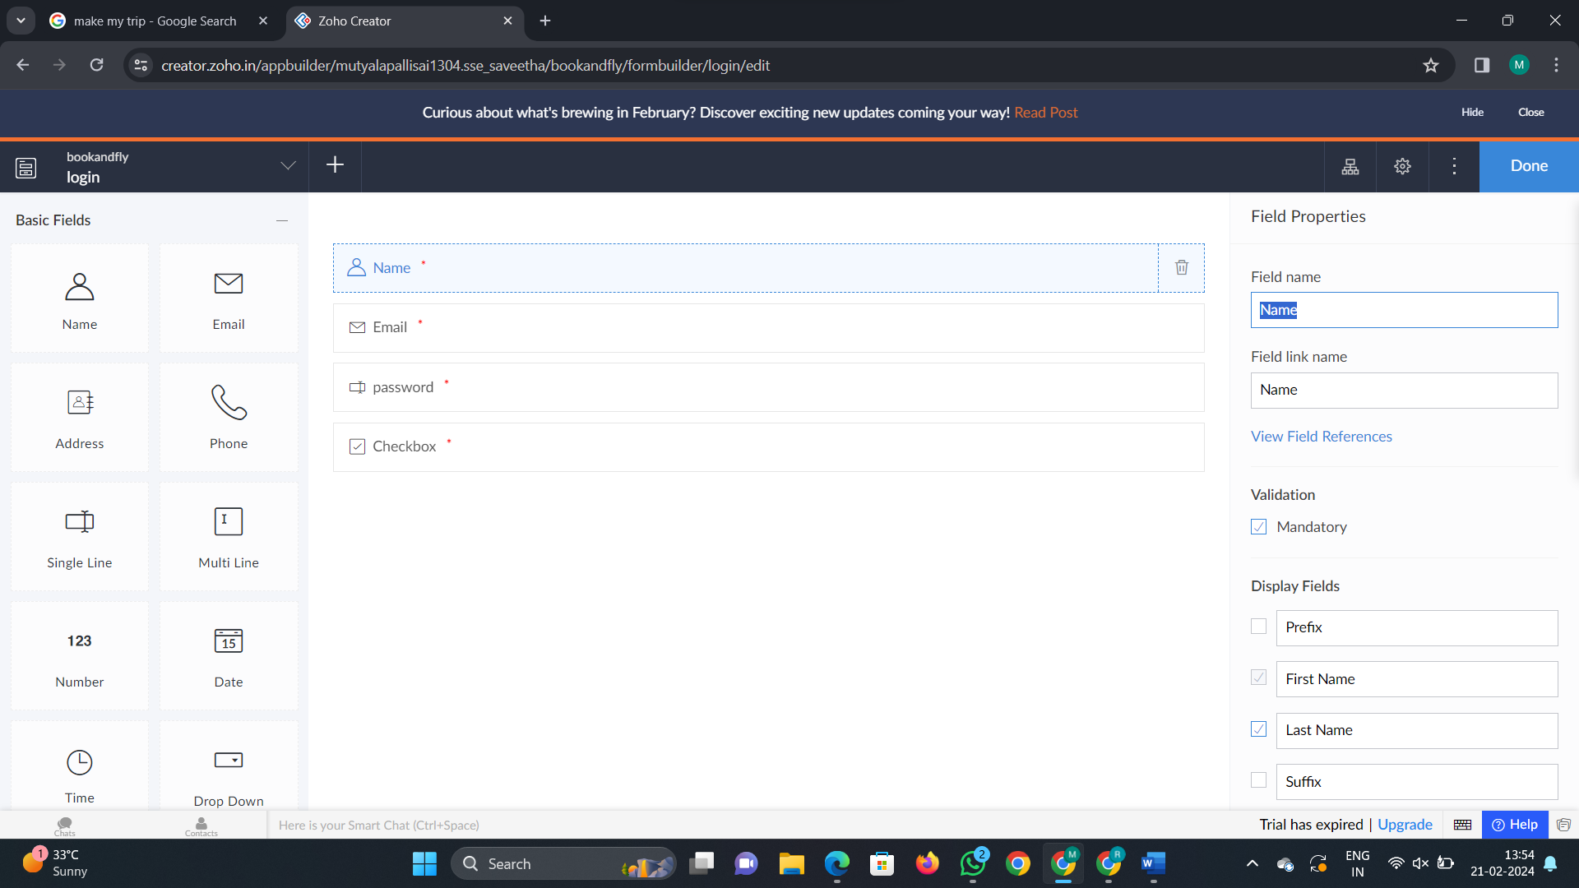

Step 4: create as many forms required according to the application and click on done

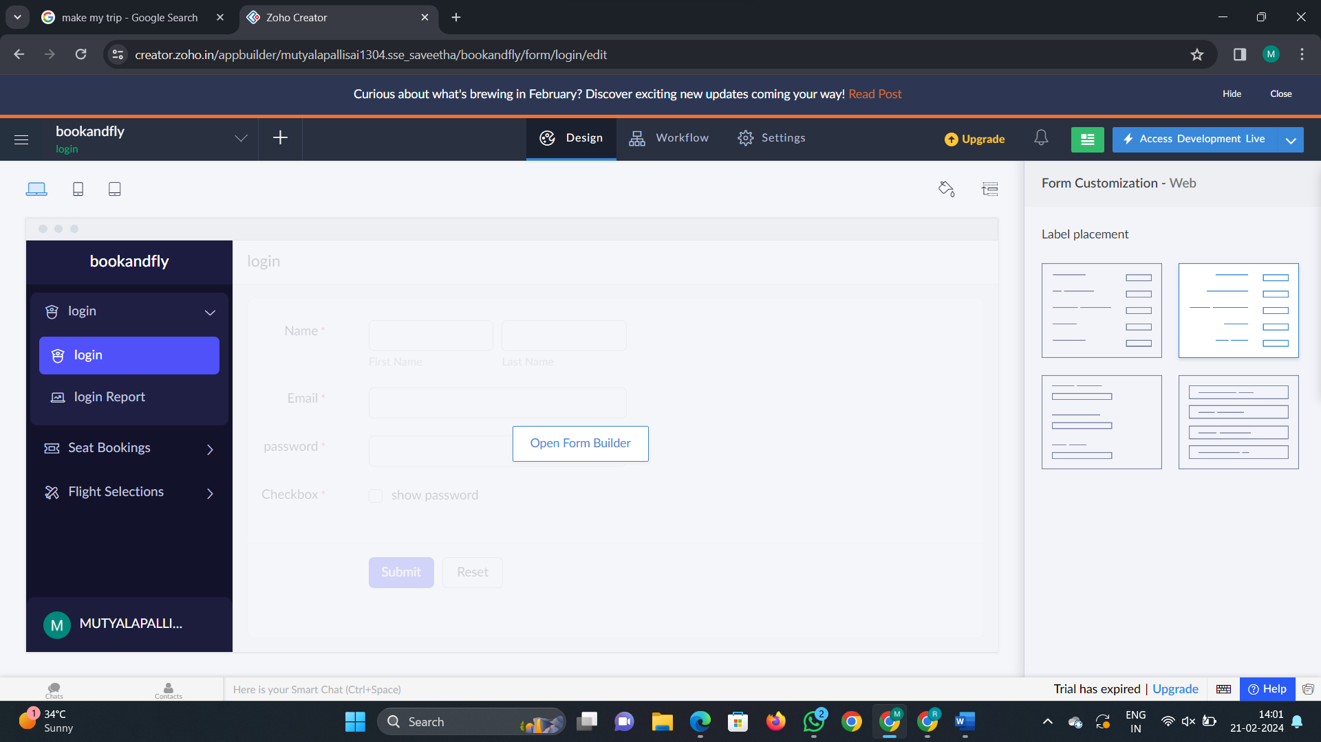

Step 5: Now click on access development live

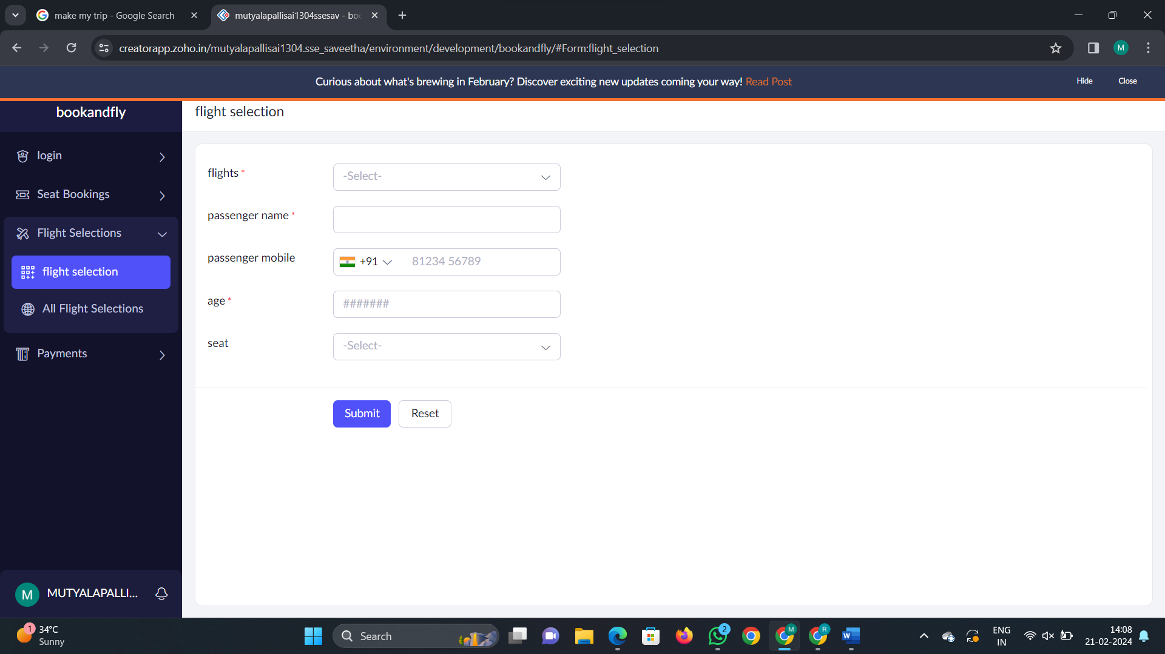

Step 6: now we can access the application and can find the report

