**How to Request Change of Major (student’s perspective)**

**Step 1**

Go to SF State’s home page at [www.sfsu.edu](http://www.sfsu.edu) and:

1. Select the Login link to log into SF State Gateway/MySFSU.
2. Log in with your SF State ID or E-mail and SF State Password.

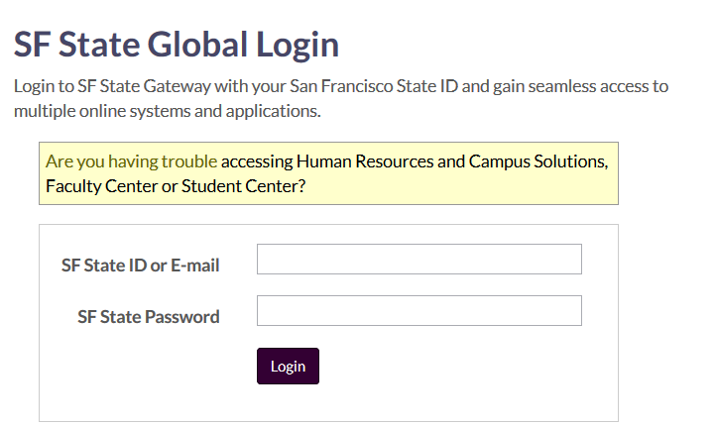

**Step 2**

Your **SF State Gateway** home page displays.

Click the **Schedule / Classes** link under the *Student* section and log into **Student Center**.

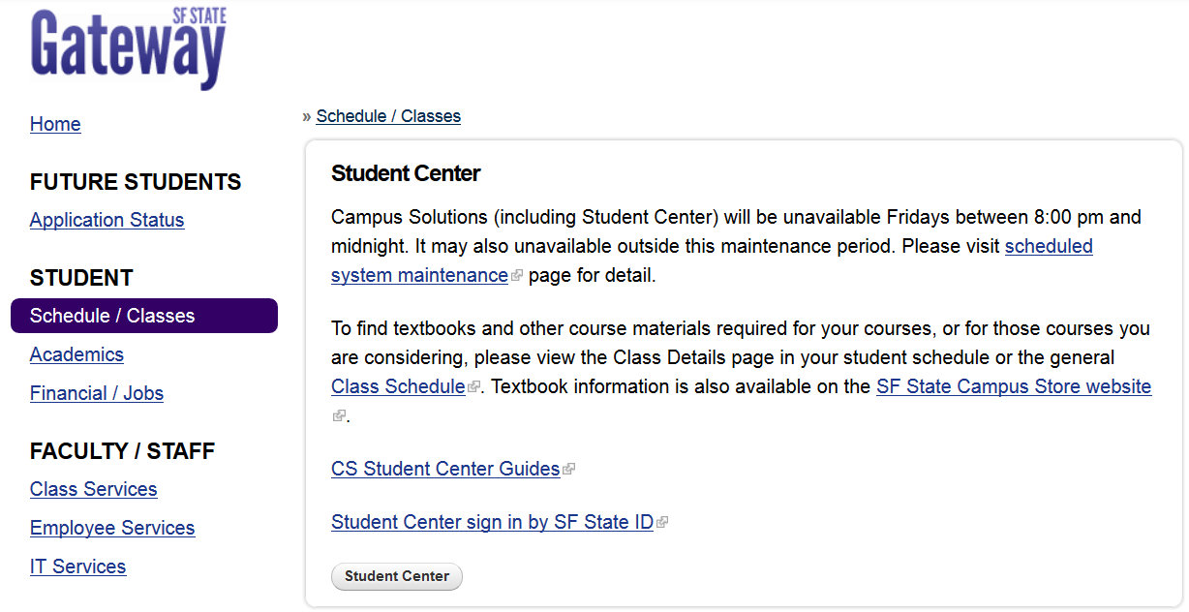

**Step 3**

The SF State Student Center displays.

1. Under the *Academics* section, select **Change Major** from the drop-down menu.
2. Click the **Go** button.

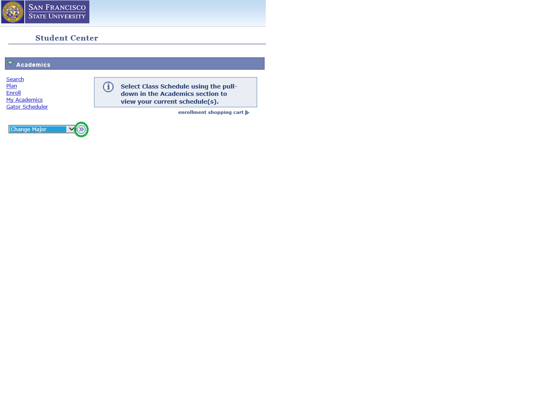

**Step 4**

The **Change of Major/Minor** page displays text to explain that:

* You can add, change or delete your major(s) and/or minor(s)
* Only selected majors and minors from the College of Business and the Pre-Kinesiology major in the College of Health and Social Sciences are currently up for consumption
* Your request will require an approval process
* You can check the SF State Student Center for a decision on the ‘Change Major Status’ page

To find the College of your major/minor, select the SF State Bulletin link. (You will need to know the College later in this process.)

To exit SF State Gateway, select Sign out. (upper right corner)

To return to the previous page, select Student Center from the drop-down menu and then click the ‘go’ icon.

To proceed, click the **Next** button.

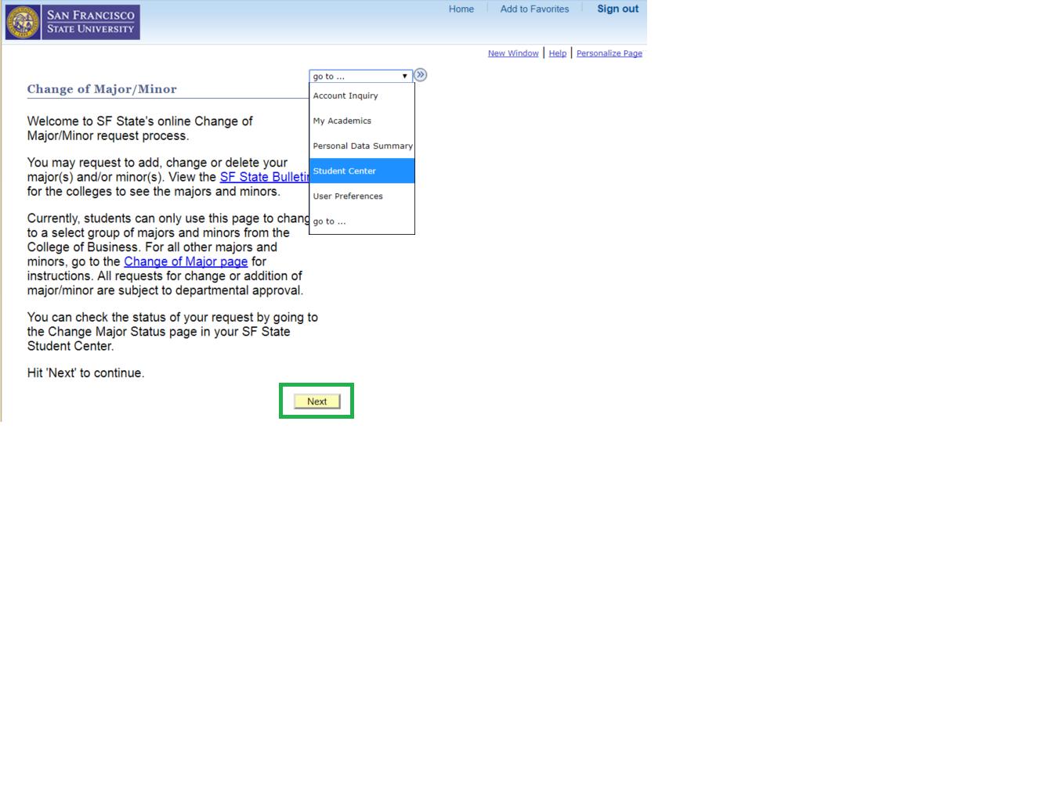

**Step 5**

The **Restrictions** page displays text to explain:

* A few limitations to changing your major/minor online, and
* Why some buttons might be greyed out.

Two boxes also display – one for each major and minor (if any).

Because the student in this example has only one major, the **Delete** button is greyed out. (He cannot delete his only major.)

This student can only **Change** his major. (If this student had multiple majors, the student can **Delete** one of the majors.) He can also add a **minor**.

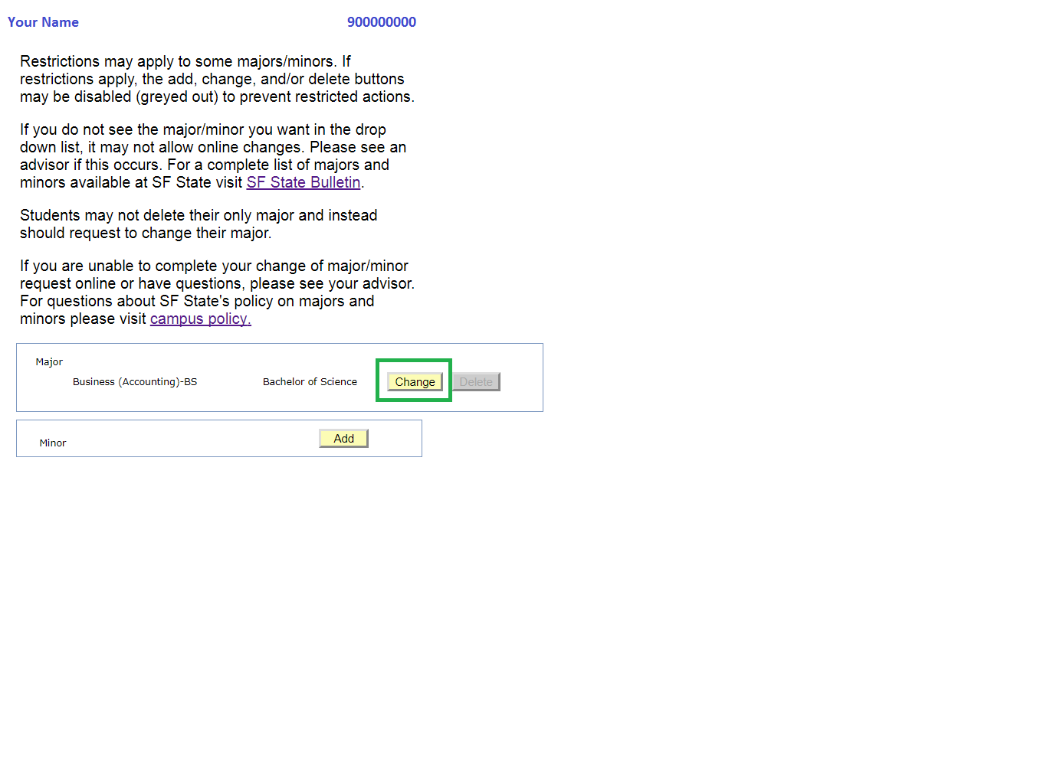

**Step 6**

A new page displays your intended action in the heading: ADD, CHANGE or DELETE a major/minor.

In this example, CHANGE Major/Minor, the page displays your ***current***major information:

* College name and code
* Major name and code
* Degree objective

To change your major, first look up the **Requested College.**

1. Click the magnifying glass icon.

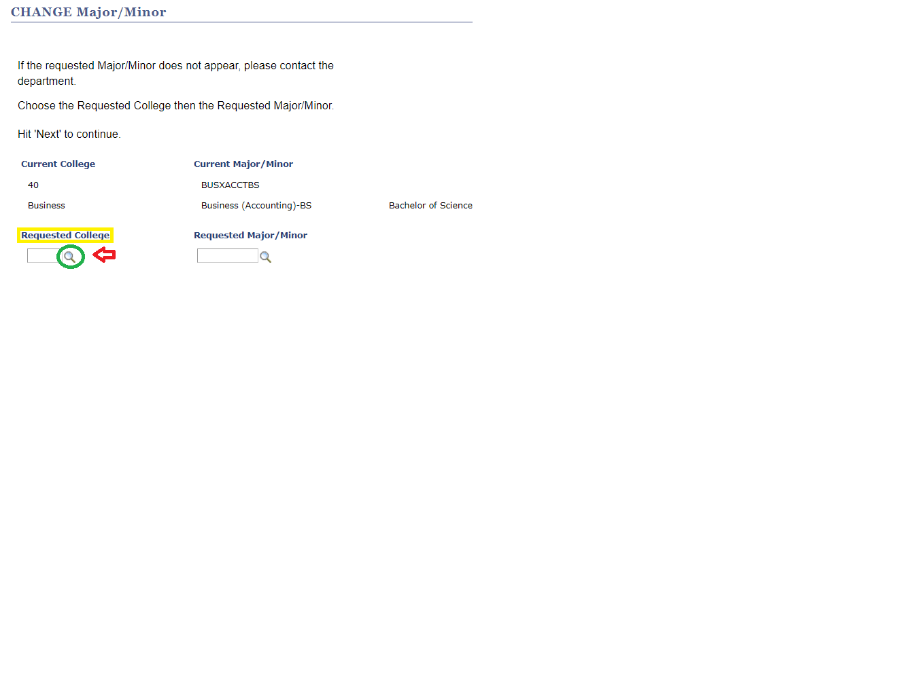

**Step 7**

The **Look Up Requested College** pop-up window displays a list of Colleges by ‘academic group code’ and ‘description.’

1. Select the **College** of your intended major/minor.

(This student has requested Business.)

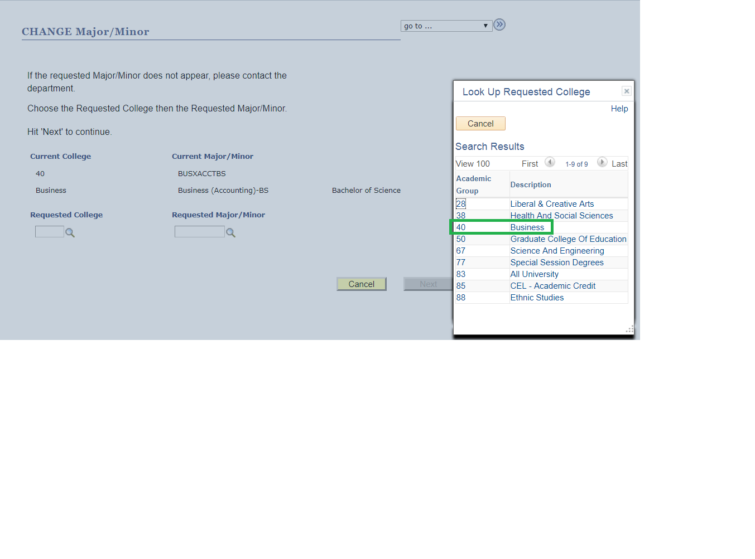

**Step 8**

Your **Requested College** name and code now display. Now…

1. Look up your **Requested Major/Minor**.
2. Click the magnifying glass to view the list of majors.

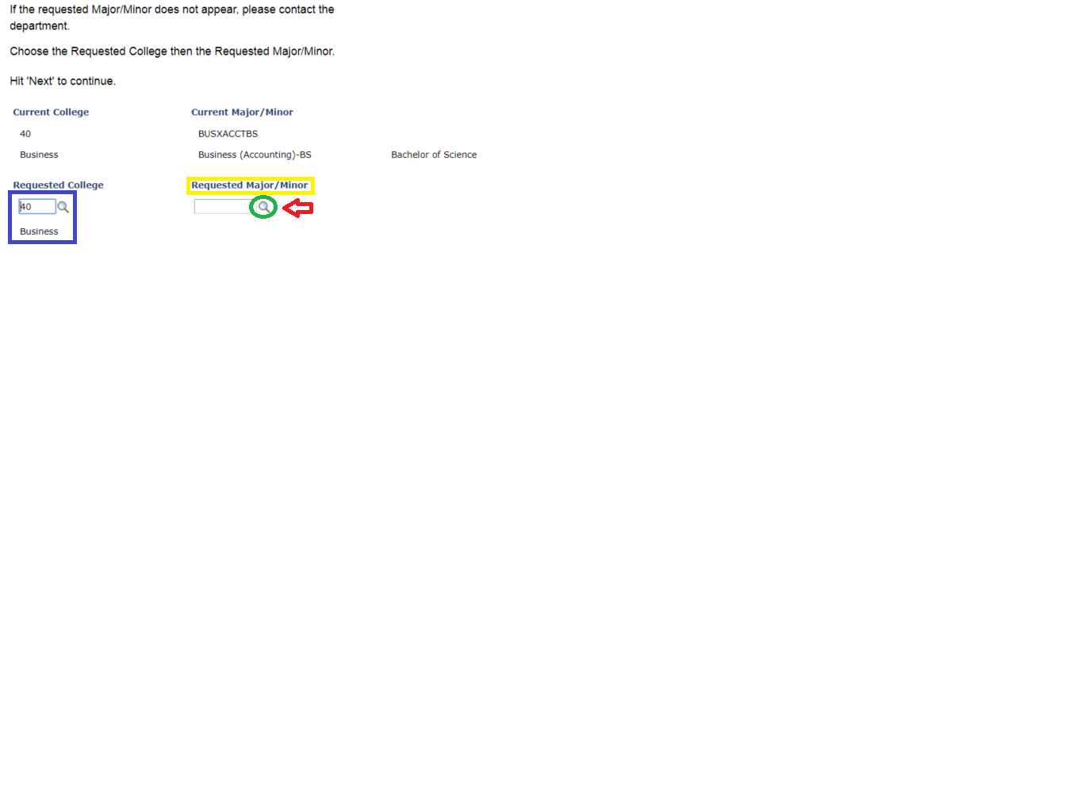

**Step 9**

The **Look Up Major/Minor** pop-up window lists all the academic program options (i.e. majors and minors) with their Academic Plan codes for the College you previously selected.

*Tip:* Click the ‘Description’ column heading to sort the program list alphabetically.

1. Scroll through the list if needed.
2. Select your intended major/minor by its **Academic Plan** code.

The student in this example has chosen Business (Management)-BS, Academic Plan code BUSXMGMTBS.

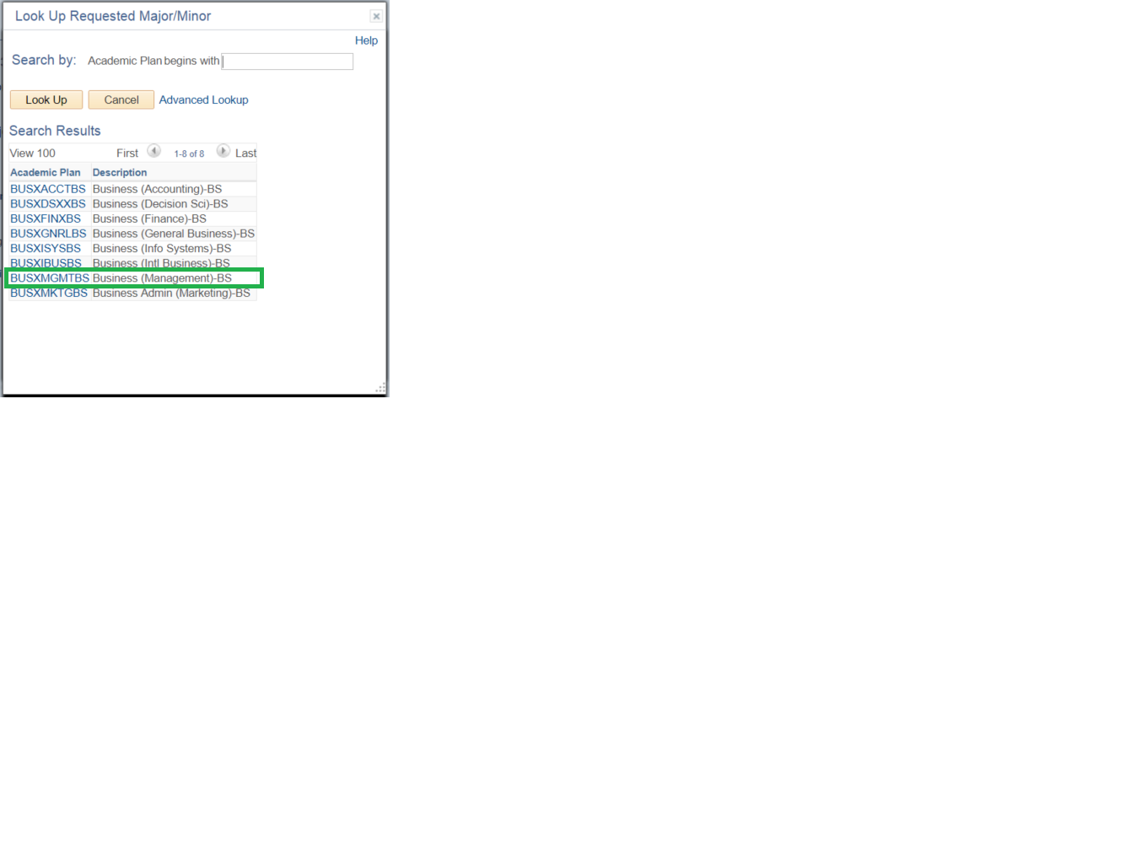

**Step 10**

Your **Requested Major/Minor** and new **degree objective** (Bachelor of Science) now display.

Proofread your selection.

* To go back and change your selection, click **Cancel.** (*Selecting* ***Cancel*** *will lead you back to the* ***Restrictions*** *page*.*)*
* If satisfied with your selection, click **Next.**

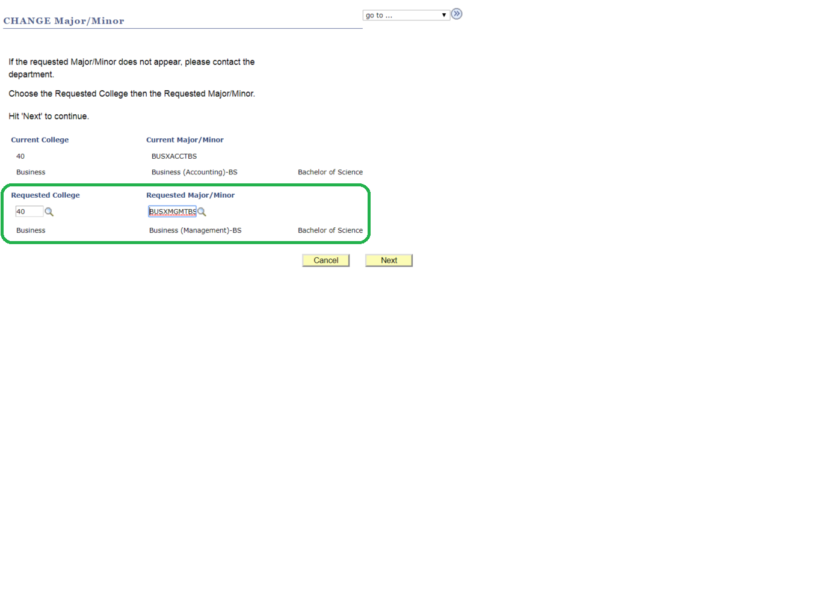

**Step 11**

The **CONFIRM Change Major/Minor** page displays.

Make sure you’ve selected the intended College and major/minor.

* To go back, click **Cancel**.
* To proceed with your request, click **Submit.**

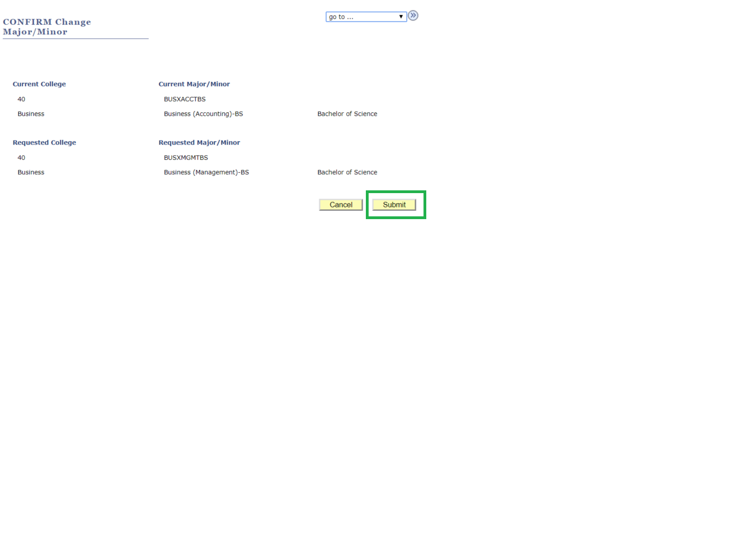

**Step 12**

The ‘approval required’ pop-up message displays to remind you that:

* Your request will be reviewed by the College advisor or administrator
* A decision notice will be sent to your SF State email account
* You can also ‘Check Major Status’ in the SF State Student Center

You can still cancel your request by click the **Cancel** button in the message window.

To proceed, click **OK.**

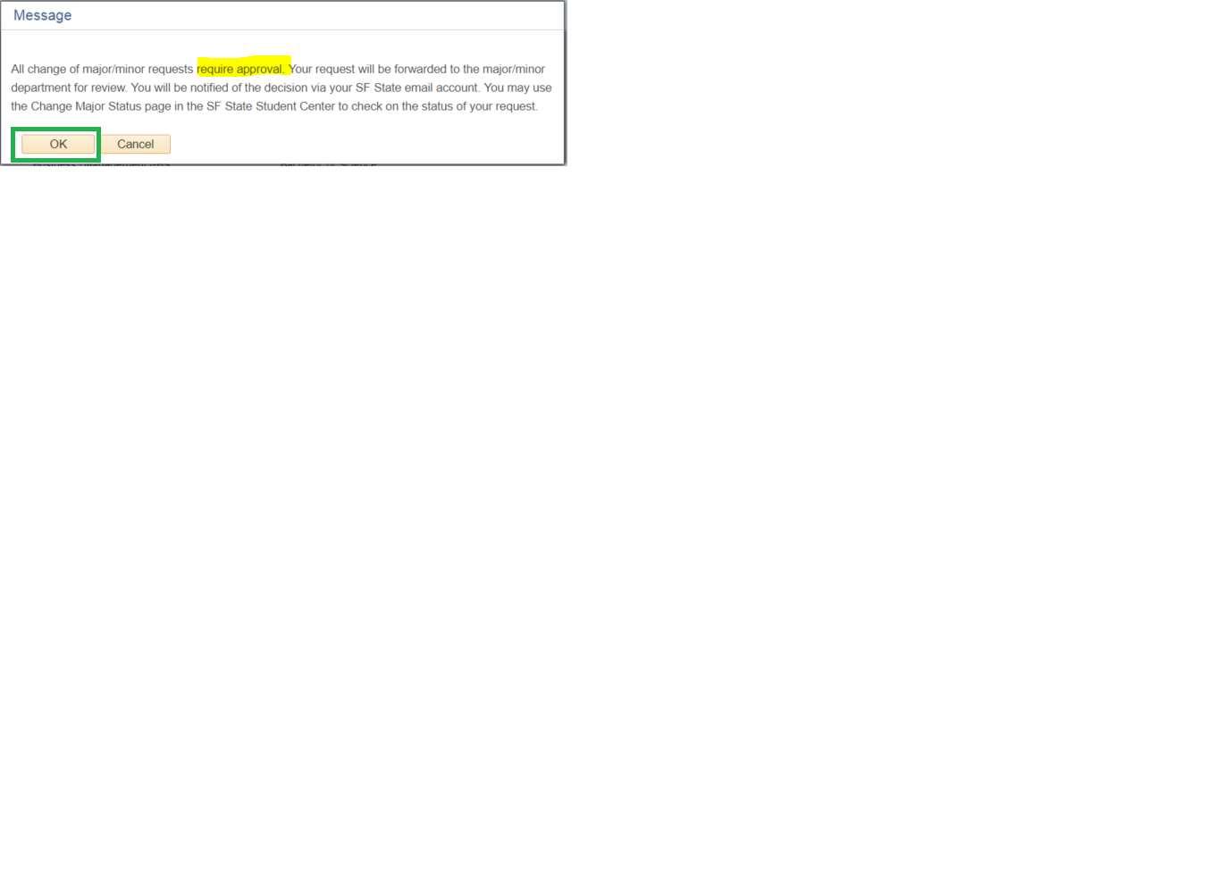

**Step 13**

The **Change of Major/Minor Request Completed** page confirms that your request has been submitted for review.

A confirmation of your request will be sent to your SF State email account.

1. Click the **View Change of Major Status** link.

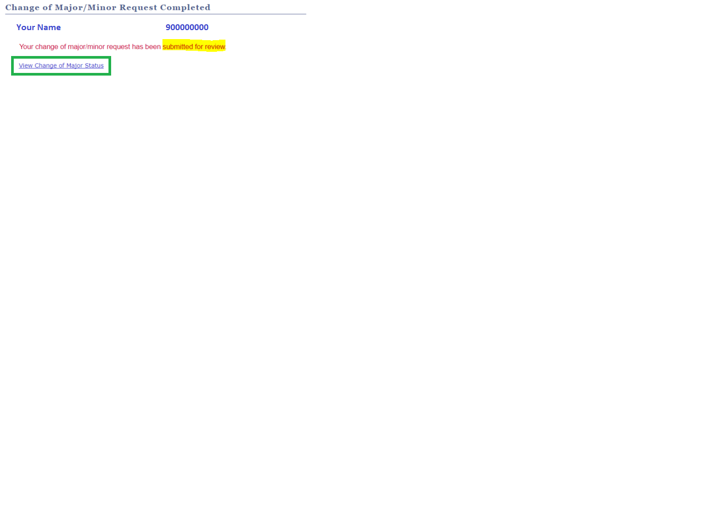

**Step 14**

The **Change of Major Status** page displays the record your request(s) including:

* Transaction details (date and time, action, type, major/minor code, description, degree)
* Status of request (applied, approved, denied, pending)
* Option to **Cancel** your request
* Comments, *if any*, made by the College advisor or administrator

If you change your mind, return to this page to cancel your Change of Major/Minor. The **Cancel** button will display until an advisor or administrator replies to your request.

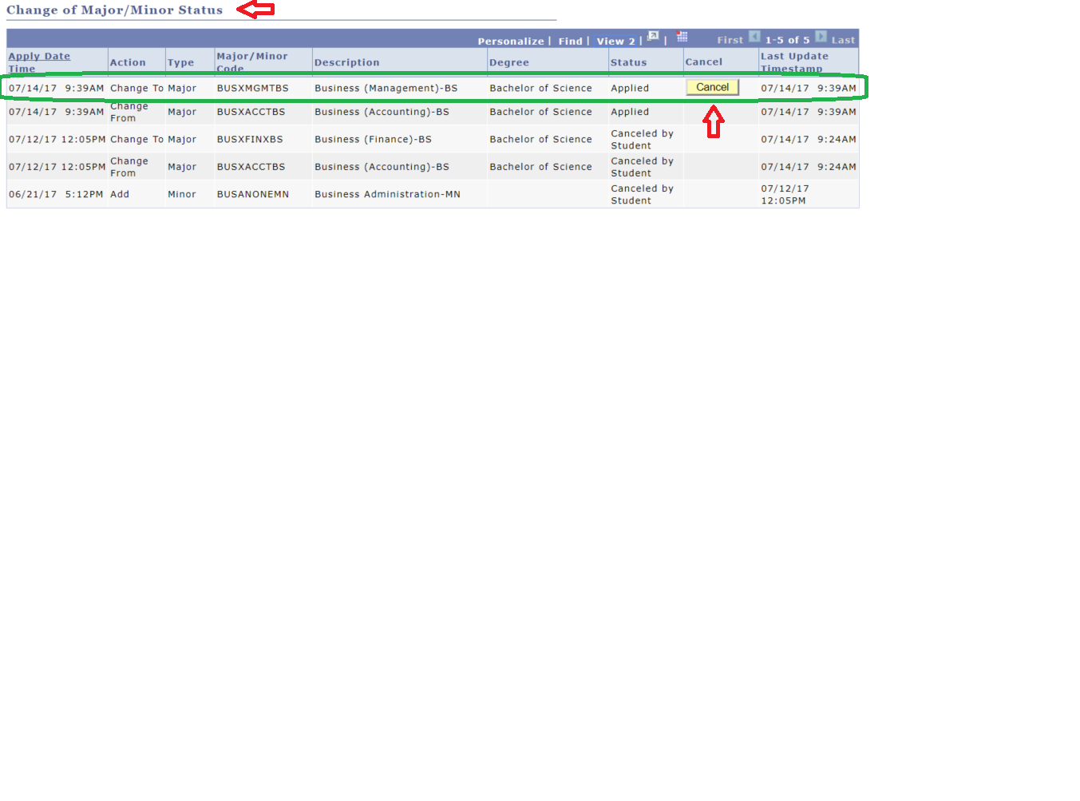

**Step 15**

If you had logged out of your SF State Student Center, you can return to the Student Center at a later time to view the status of your request.

1. Under the Academics section, select **Change Major** **Status** from the drop-down menu.
2. Click the **Go** button.

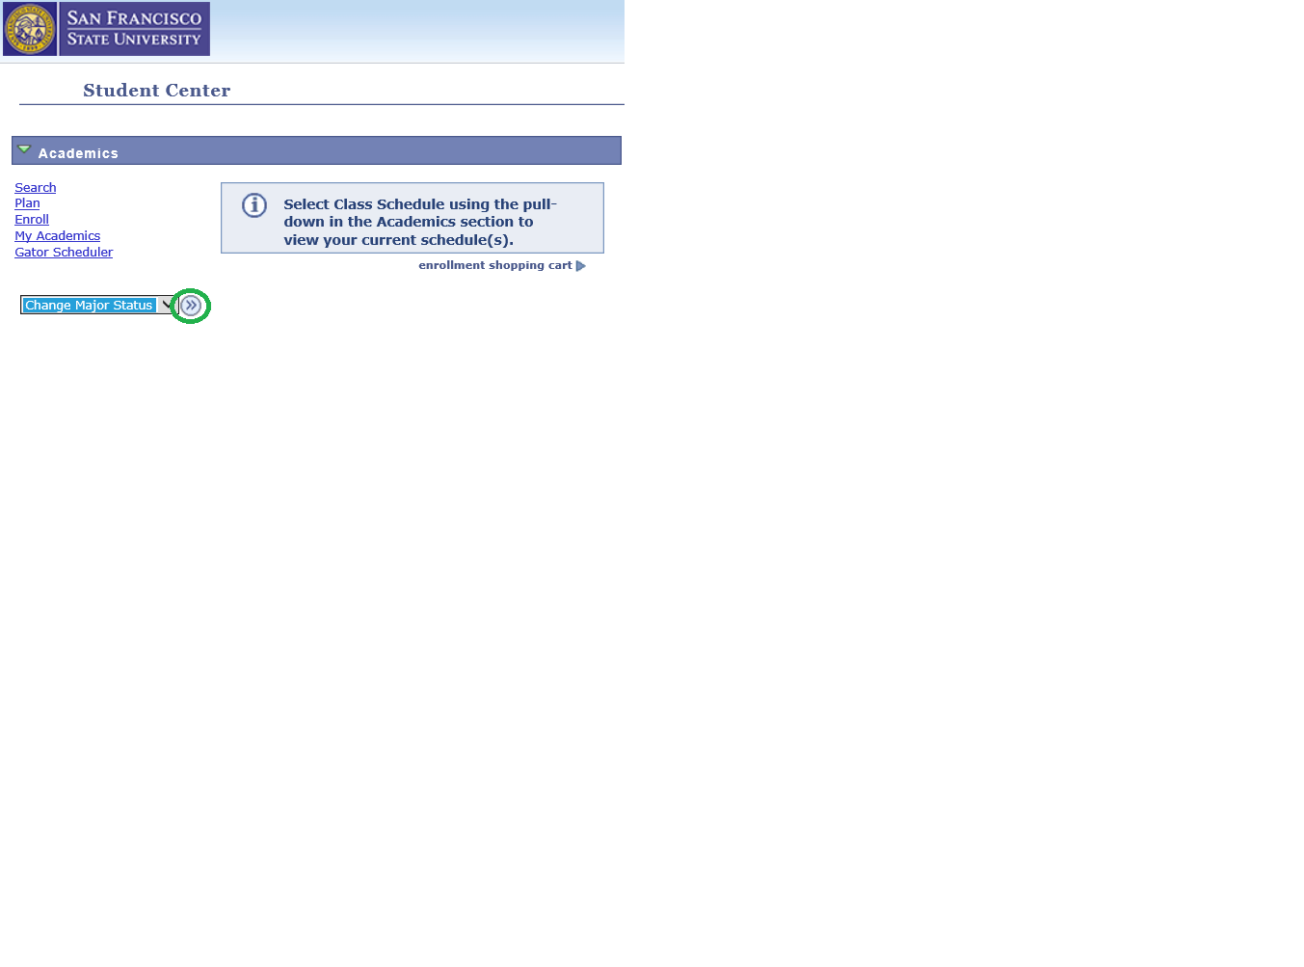

**Step 16**

The **Change of Major/Minor Status** page displays the decision, either approved, denied, or pending department review.

*Tip:* The option to **Cancel** the major/minor request is still allowed when status is pending.

A notice of the decision will also be sent to your SF State email account.

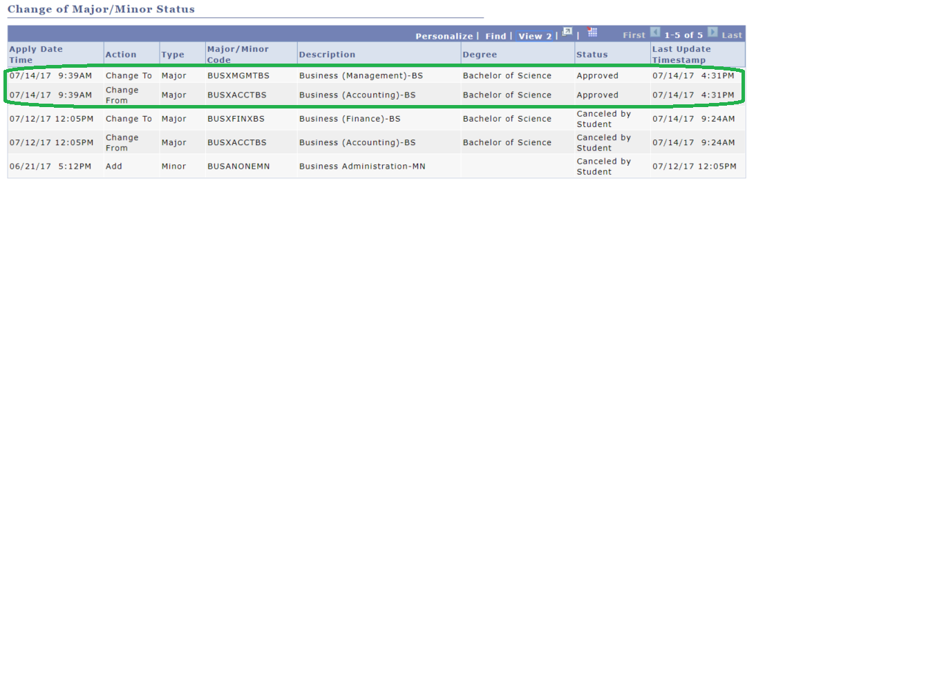

**Step 17**

Check your **SF State email** account for a message stating whether or not your Change of Major/Minor request has been approved.

For degree planning and answers to your questions about your new major/ minor, please contact your [academic advisor](http://advising.sfsu.edu/).

