

**FULL STACK DEVELOPMENT LAB**

**WEEK - 6**

**Name :M.MANISH Roll No : 22R21A3340 Date : 28/9/2024**

**PROBLEM STATEMENT 1:**

Write a HTML program to show the positions of elements in a web page

**PROGRAM:**

<!DOCTYPE html>

<html lang="en">

<head>

<meta charset="UTF-8">

<meta name="viewport" content="width=device-width, initial-scale=1.0">

<title>Document</title>

</head>

<body>

<div class="parent">

<div class="static">static</div>

<div class="realtive">relative</div>

<div class="absolute">absolute</div>

<div class="fixed">fixed</div>

<div class="sticky">sticky</div></div>

</body>

<style>

.parent{

background-color: lightblue; height: 8cm;

width: 40%;

}

.static{

backgroundcolor:red;position: static;

left: 20cm;

}

.realtive{

background-color: rgb(255, 253,255); position: relative;

left: 65px;

}

.absolute{

background-color: rgb(65, 244, 0); position: fixed;

top: 55px;

}

.fixed{

background-color: rgb(18, 18, 255); position: fixed;

top: 25px;

}

.sticky{

background-color: purple;

Position:sticky;

Top:0px;

</style>

</html>

**OUTPUT:**

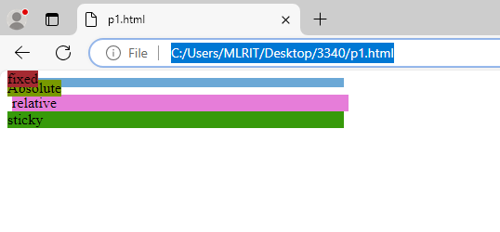

**PROBLEM STATEMENT 2:**

Use git commands to push 2 or more files into git repository using the terminal in VS code.

**PROCEDURE:**

1. Create a folder and open the folder in vs code, then open a new terminal in vs code for the selected folder.

2. Now type “git init” to create a local repo then create a .html file in your folder and type “git status” to check the status of the file.

3. Then, type “git add filename”, next use “git config” to change the username and email with your github user name and email.

4. Now use “git commit” command for the first commit of your file.

5. Then connect your github repository to the terminal by “git remote add orgin ‘url’ ”.

6. Lastly, “git push origin master” and when sign in window opens, sign in with either browser or personal access token.

**OUTPUT:**

