Name: Chundru Rishith Sai Chowdary

Section: K22BW

Reg no: 12212330

Roll no: 17

Case Study:

Rainfall refers to the amount of precipitation that falls to the ground in the form of rain. It's an important aspect of the Earth's climate system and plays a crucial role in replenishing water supplies, supporting agriculture, and influencing weather patterns.

Rainfall is typically measured in millimeters or inches and can vary widely depending on the region, season, and weather conditions. For instance, some areas experience frequent, heavy rainfall, like the tropics, while others, like deserts, receive very little.

1. What is the average annual rainfall of the regions from 1901-2015?

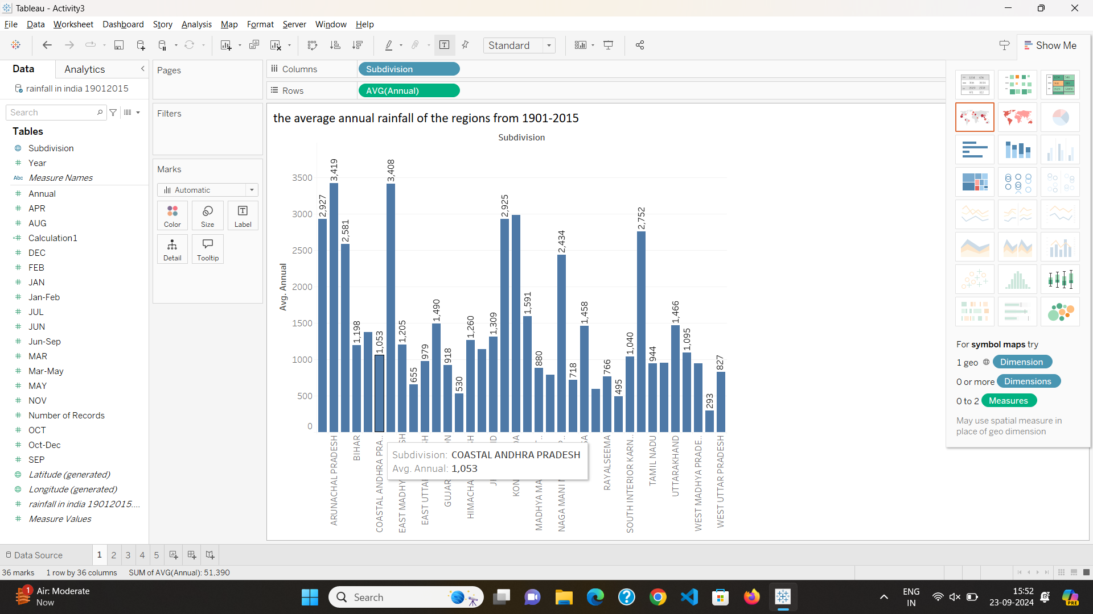

1. What is the Average rainfall of the regions from 2000-2015?

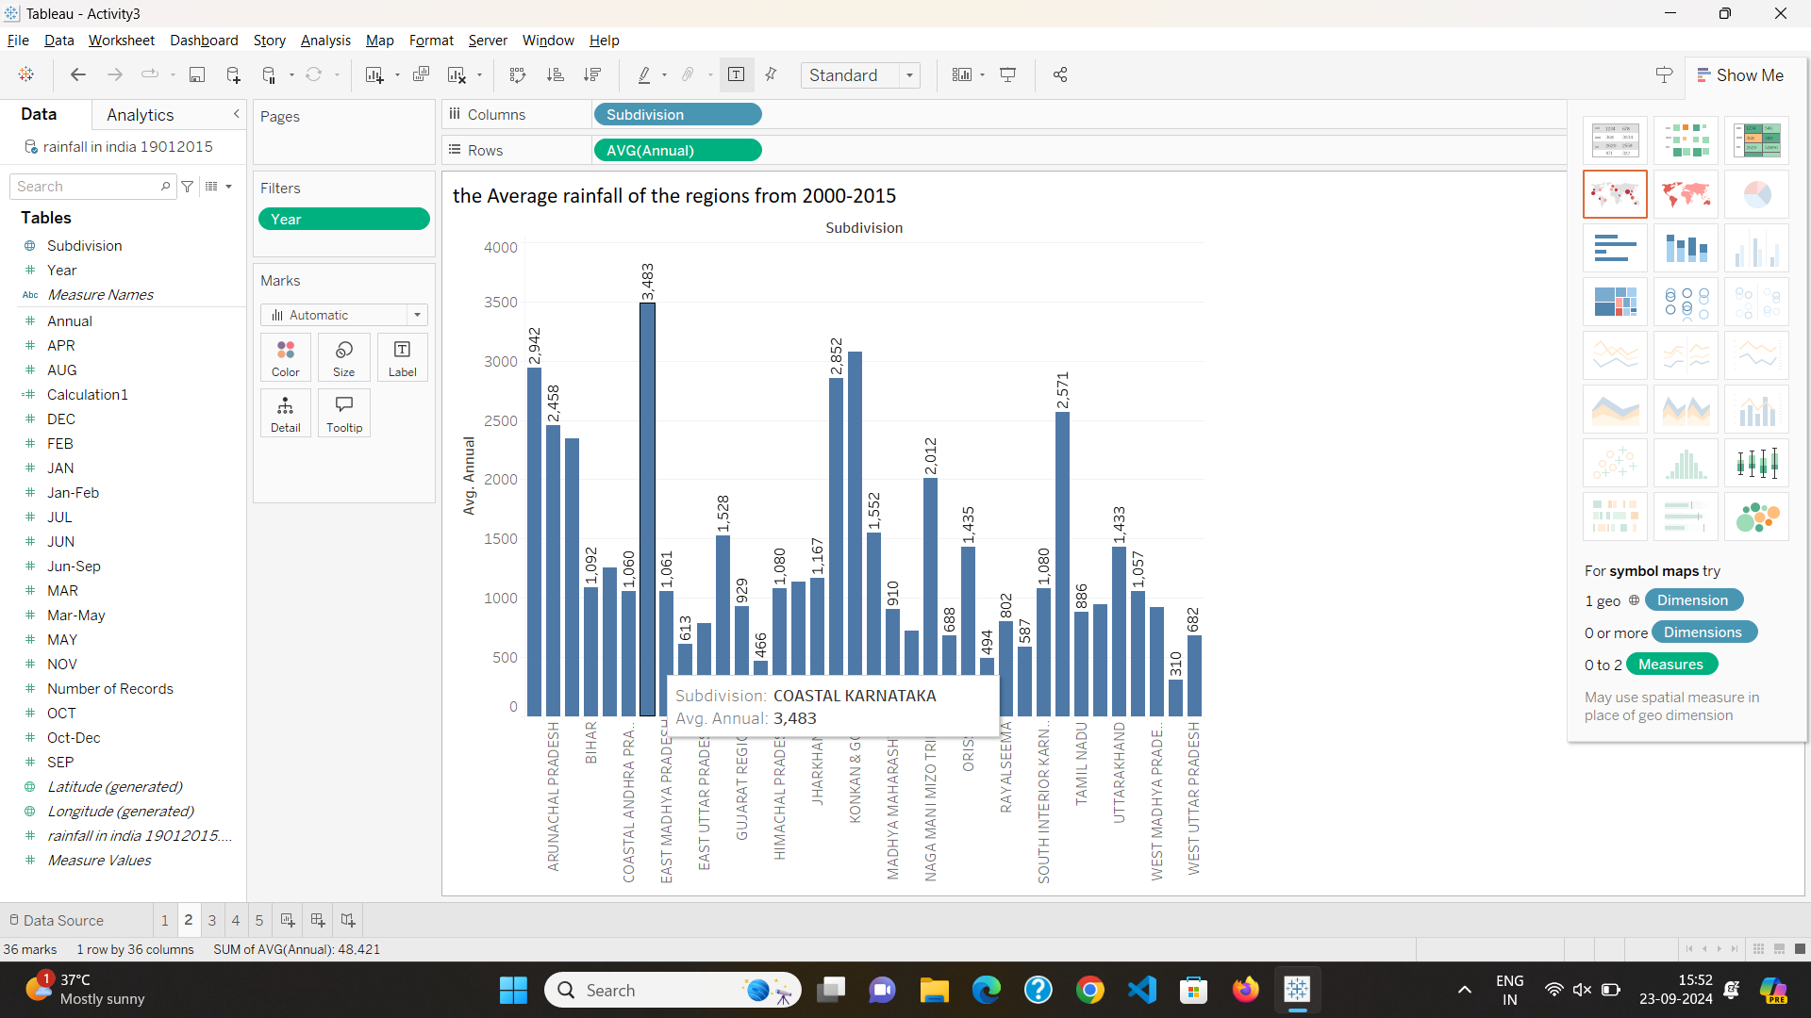

1. What is the average monthly rainfall?

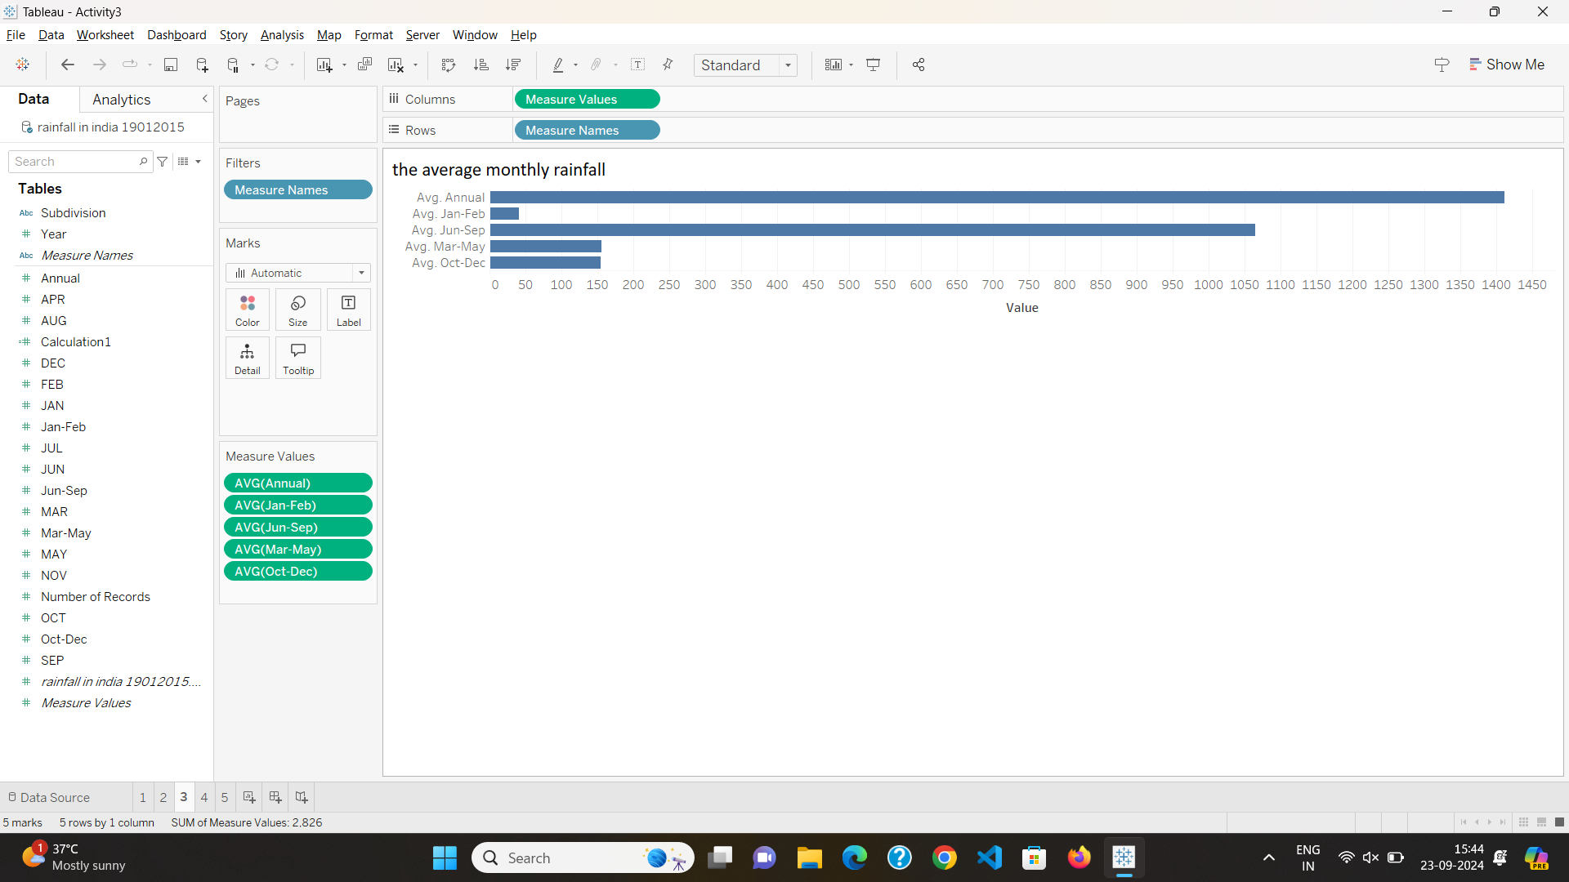

1. Top 10 places with highest rainfall.

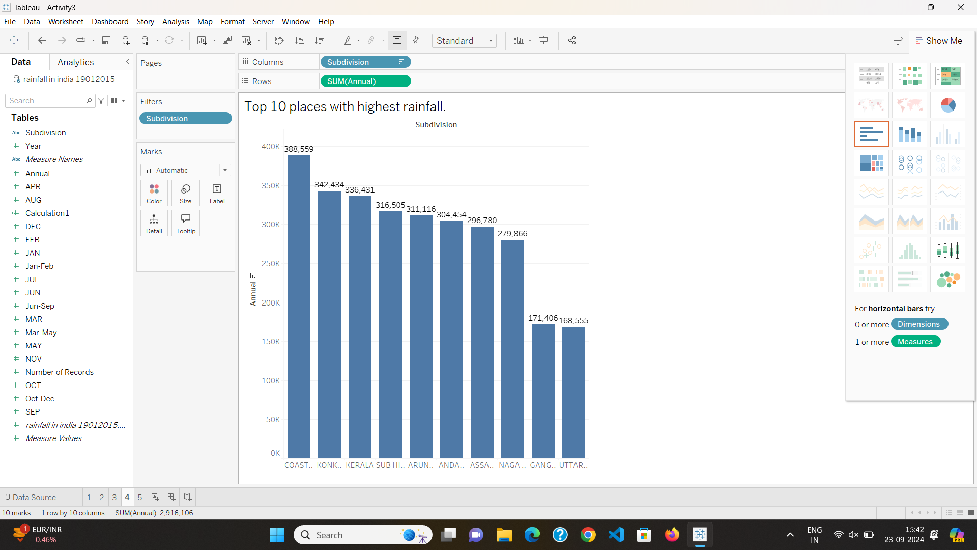

1. Show the data on a map.

