Experiment 4: Develop a Car Booking Reservation Application as SaaS
Aim
To develop a cloud-based Car Booking Reservation application using Zoho Creator.
Software Used
- Zoho Creator
- Deluge Workflow
- Web Browser
Algorithm
- Create Customer Registration form.
- Create Car Details form.
- Create Car Search form.
- Create Booking form.
- Create Payment form.
- Check vehicle availability.
- Confirm booking and update status.
- Generate booking reports.
Output:
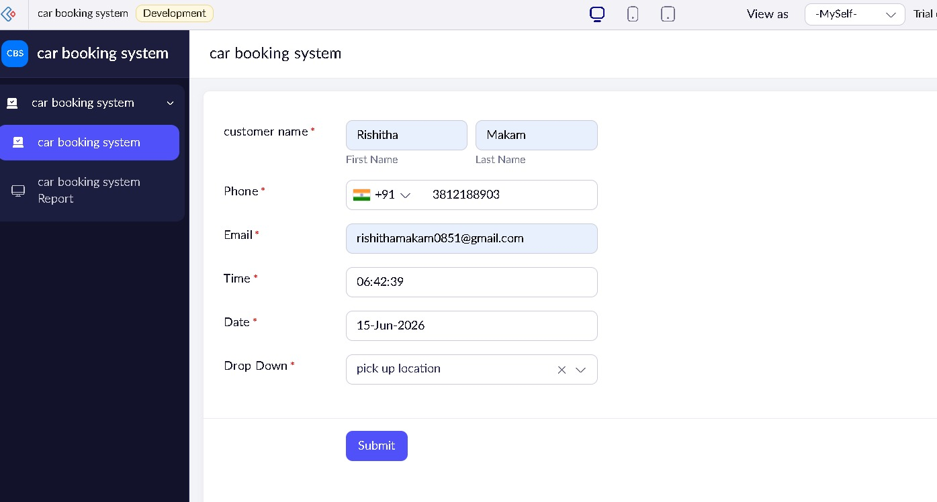

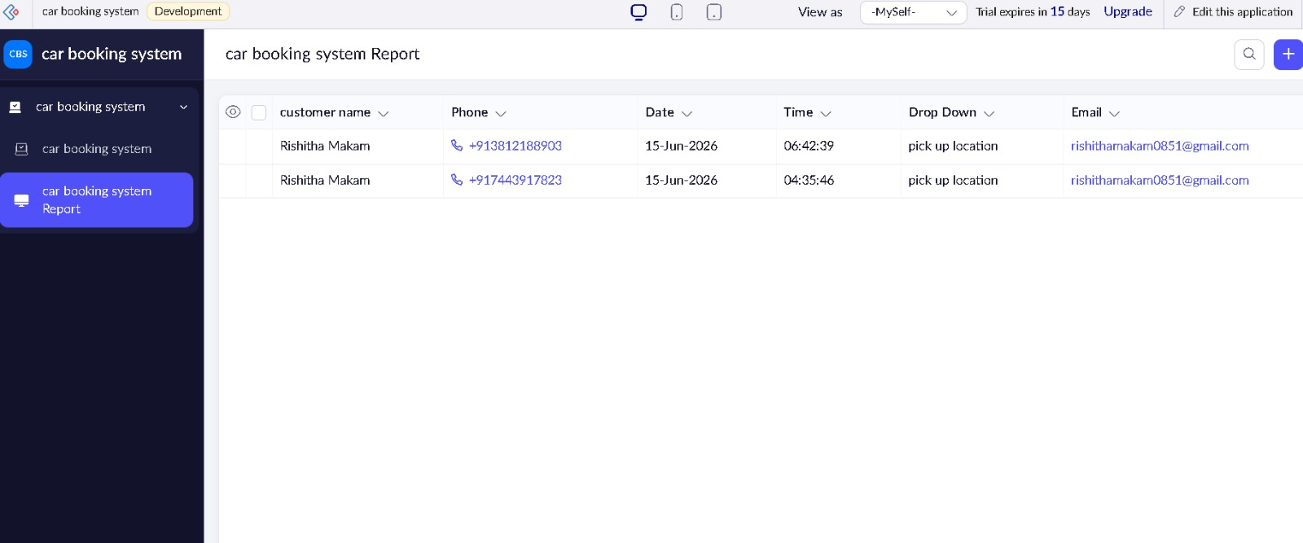
Result
A SaaS Car Booking Reservation application was successfully developed for managing vehicle reservations and payments online.

