

CONTENTS:

1.BUSINESS AND MARKET UNDERSTANDING

2.BRD

3.PRD

4.FLOWCHART

REPORT BY:

***ARAVA RISHITHA CHINMAYI***

INTRODUCTION:

CRED is an Indian fintech company founded in 2018 by Kunal Shah, who was motivated to create the [platform](https://fourweekmba.com/platform-business-models/)to solve the trust issues he believed were present in Indian finance. Shah wanted a create an ecosystem where credible individuals could connect and where lenders and other [financial](https://fourweekmba.com/financial-accounting/) institutions could lend money to trustworthy borrowers. The CRED app allows consumers to meet multiple credit card repayments on time and earn points to spend on exclusive offers in return. In April 2021, the company became one of the fastest startups to achieve unicorn status [with a valuation of $2.2 billion](https://www.livemint.com/companies/start-ups/cred-enters-unicorn-club-at-2-2-bn-valuation-11617702147518.html).

CRED now controls 22% of all credit card transactions in India, with various other features added in recent years such as P2P lending, eCommerce, and the ability to pay other recurring household [expenses](https://fourweekmba.com/cost-structure-business-model/) such as rent and utilities.

BUSINESS MODEL:

The three pillars of CRED’s business model are its customers, the CRED app, and the partnering businesses. Customers are crucial as they use the app to pay their credit card bills and earn rewards. As more people join and utilize CRED, the network effect strengthens, expanding the platform’s reach and influence.

The CRED app serves as a user-friendly interface where customers can access and explore various offers available for paying their credit card bills. Through regular bill payments, customers accumulate CRED coins, which can be redeemed for rewards provided by partnering businesses.

The partnerships with businesses are integral to CRED’s success. By collaborating with businesses of all sizes, CRED offers them visibility and exposure to a diverse range of customers. This benefits the businesses by expanding their customer base and increasing revenue while providing users with a wider selection of rewards and incentives.

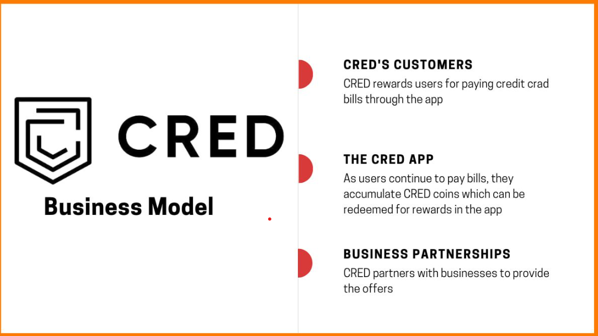

In order to access CRED programs,**a credit score of more than 750** must be obtained. This application also allows users to share certain data such as credit card numbers, access to emails to track users' expenses and due amounts, credit scores, and how they invest their money. CRED rewards its users with CRED coins for bill payments, which can later be redeemed with the offers available. In simple terms, CRED provides a basic incentive to make prompt bill payments. To make offers more attractive to the users, CRED partners with various businesses. In turn, businesses achieve exposure to buyers from all walks of life.

MARKET UNDERSTANDING:

In terms of revenue, CRED earns through listing fees paid by businesses to feature their products and offers on the app. Additionally, financial institutions gain access to user financial data, allowing them to tailor their offers accordingly. This data monetization is another source of revenue for CRED.

CRED offers a diverse range of products and services, including Rentpay, CRED Stash, Store, Credit Card Payments, and CRED Pay. Rent pay enables tenants to pay monthly rents using a credit card, providing an interest-free credit period and reward points. CRED Store offers member-exclusive products and experiences at special prices, which can be accessed using CRED coins. CRED Stash functions as a digital lending platform, providing users with a personal credit line.

CRED’s partnership with Razorpay and Visa resulted in CRED Pay, facilitating instant payments for brands through a D2C channel on their platforms.

Overall, CRED’s business model thrives on customer engagement, partnerships with businesses, and monetization of user financial data, allowing the platform to reward users, expand its offerings, and generate revenue.

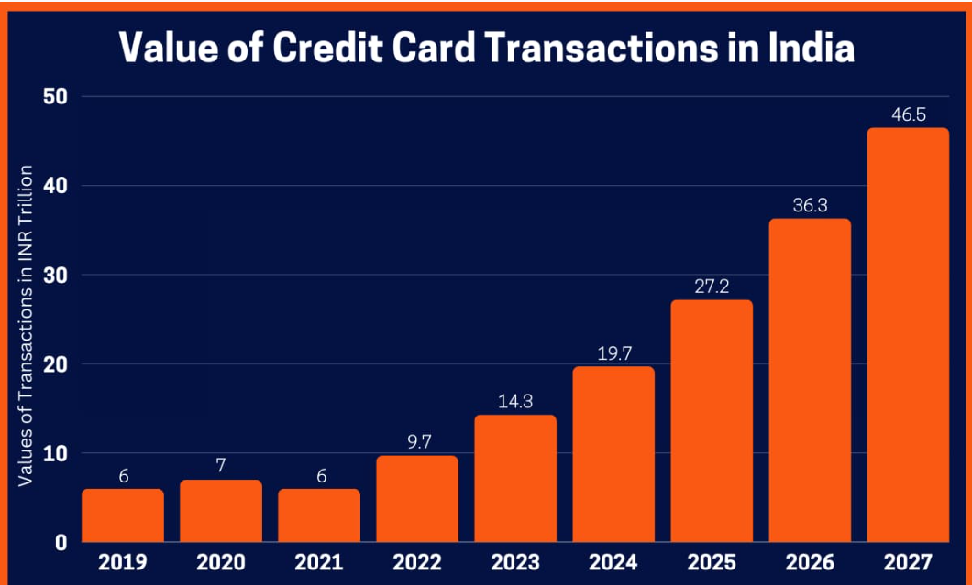

**BUSINESS REQUIREMENT DOCUMENT:**

ELEMENTS OF CRED:

* CRED provides you with one location to handle your entire credit card range.
* Whenever you pay your credit card bills, certain CRED coins are issued that you can use to earn discounts on different CRED partner products.
* It analyses the overall expenses and secret costs, records loan caps, and advises you of all this so that extra charges can be avoided.
* CRED security is the app's functionality that reads email statements with details on balance, due date, bank costs, and bifurcation of expenditures.
* The smart statement feature allows consumers to simplify costs by reviewing the CRED it card statements.

Dec, 17Dec, 18Dec, 19Dec, 20Dec, 21050.00M100.00M150.00M200.00M250.00MDec, 19● Total Current Assets: 243,140,000

Total Current Assets

* **LATEST**
* [**Previous**](https://in.investing.com/equities/cred-holding-balance-sheet?period_type=annually&periods=previous&period_type=annually)

| Name | Dec 31, 2021 | Dec 31, 2020 | Dec 31, 2019 | Dec 31, 2018 | Dec 31, 2017 |  |
| --- | --- | --- | --- | --- | --- | --- |
| Total Current Assets | **161.61** | **168.53** | **243.14** | **157.36** | **238.45** |  |
| Cash and Short Term Investments | 126.67 | 157.83 | 234.40 | 147.98 | 231.21 |  |
| Cash | 0.14 | 0.01 | 0.12 | 0.05 | 0.05 |  |
| Cash & Equivalents | 126.53 | 157.82 | 184.28 | 147.93 | 231.17 |  |
| Short Term Investments | 50 | - | - | - | - |  |
| Total Receivables, Net | 23.66 | 8.86 | 6.92 | 7.10 | 6.42 |  |
| Accounts Receivables - Trade, Net | 13.85 | - | - | - | - |  |
| Total Inventory | 0.69 | 0.69 | 0.69 | 0.69 | 0.69 |  |
| Prepaid Expenses | 10.59 | 1.14 | 1.13 | 1.59 | 0.13 |  |
| Other Current Assets, Total | 1.13 | 0.01 | - | - | - |  |
| Total Assets | **248.89** | **252.37** | **319.92** | **278.91** | **323.84** |  |
| Property/Plant/Equipment, Total - Net | 11.39 | 5.30 | 6.37 | 9.08 | 9.14 |  |
| Property/Plant/Equipment, Total - Gross | 26.02 | 14.90 | 15.70 | 15.53 | 13.22 |  |
| Accumulated Depreciation, Total | -14.63 | -9.60 | -9.33 | -6.45 | -4.08 |  |
| Goodwill, Net |  | - | - | - | - |  |
| Intangibles, Net | 0 | 0 | 0 | - | - |  |
| Long Term Investments | 75.88 | 78.54 | 50 | 112.47 | 76.26 |  |
| Note Receivable - Long Term |  | - | - | - | - |  |
| Other Long Term Assets, Total |  | - | - | - | - |  |
| Other Assets, Total | 44.90 | - | - | - | - |  |
| Total Current Liabilities | **32.57** | **21.26** | **37.97** | **25.46** | **28.36** |  |
| Accounts Payable | 3.96 | 3.57 | 3.57 | 3.57 | 4.58 |  |
| Payable/Accrued |  | - | - | - | - |  |
| Accrued Expenses | 6.60 | 5.58 | 4.84 | 4.95 | 6.62 |  |
| Notes Payable/Short Term Debt | 8.65 | 0 | 0 | 0 | 0 |  |
| Current Port. of LT Debt/Capital Leases | 0.97 | - | - | - | - |  |
| Other Current liabilities, Total | 12.39 | 12.11 | 29.56 | 16.95 | 17.15 |  |
| Total Liabilities | **35.96** | **22.83** | **39.54** | **27.03** | **29.92** |  |
| Total Long Term Debt | 1.83 | 0 | 0 | 0 | 0 |  |
| Long Term Debt | 0 | 0 | 0 | 0 | 0 |  |
| Capital Lease Obligations | 1.83 | - | - | - | - |  |
| Deferred Income Tax |  | - | - | - | - |  |
| Minority Interest | 1.56 | 1.56 | 1.56 | 1.56 | 1.56 |  |
| Other Liabilities, Total |  | - | - | - | - |  |
| Total Equity | **212.92** | **229.54** | **280.39** | **251.88** | **293.92** |  |
| Redeemable Preferred Stock, Total |  | - | - | - | - |  |
| Preferred Stock - Non Redeemable, Net |  | - | - | - | - |  |
| Common Stock, Total | 579.19 | 579.19 | 579.19 | 579.19 | 579.19 |  |
| Additional Paid-In Capital | 33.10 | 20.34 | 20.34 | 20.32 | 20.34 |  |
| Retained Earnings (Accumulated Deficit) | -399.37 | -369.99 | -319.15 | -347.63 | -305.61 |  |
| Treasury Stock - Common |  | - | - | - | - |  |
| ESOP Debt Guarantee |  | - | - | - | - |  |
| Unrealized Gain (Loss) |  | - | - | - | - |  |
| Other Equity, Total |  | - | - | - | - |  |
| Total Liabilities & Shareholders' Equity | 248.89 | 252.37 | 319.92 | 278.91 | 323.84 |  |
| Total Common Shares Outstanding | 579.19 | 579.19 | 579.19 | 579.19 | 579.19 |  |

MARKETING STRATEGY OF CRED:

Cred has several different marketing strategies. Some are viral marketing moves while others are as simple as releasing simple finance-related blogs and rewarding users with cashback and discounts.

But every strategy has two things in common, uniqueness and the ability to create brand awareness & brand recall.

Cred has partnered with the Indian Premier League (IPL) as an associate sponsor for 3 seasons and most of the marketing activities done by Cred are also during the time IPL kicks off. They organize social media contests, marketing campaigns and advertisements. This helps the brand gain more exposure and create trust among the general public.

### **Sending Cakes – A Customer Acquisition Strategy using Existing Users**

Imagine it’s a Tuesday and you’re working on your boring day shift job and suddenly out of nowhere, you receive a cake as a reward for paying bills. Delighted, isn’t it?

Yes, that’s what Cred did. In 2019, Cred attempted this customer acquisition move, targeted towards colleagues of existing users.

All it did was sending a cake to the user’s workplace, making every colleague eventually ask “who sent you this cake?” to which the user naturally replied, “Cred, it’s an app for paying bills” and thus generating guaranteed app downloads.

### **Cred Mega Jackpot Week Campaign**

Cred rolled out Mega Jackpot during IPL 2021. From winning iPhone’s for a decade to Bitcoin. This campaign had it all.

The concept behind this campaign was to offer its users a chance to participate and win jackpots. As the name suggests, Mega Jackpot Week, Cred gave away seven different rewards such as Gold, Harley Davidson Fat Boys, brand-new iPhones for a decade, free flights for five years, a TATA Safari car, a complete home makeover and a Bitcoin!

**Potential Backlogs:**

Limited bill pay options

Slow customer support

Limited / flaw reward options

Limited app features

Opaque user interface

**Suggestions for Customer**:

1. user experience

2. Introduce unified bill pay platform like paytm

3. Simplify reward system

4.Transparency and communication: on reward structures and some extra charges

5.Educational resources : offer some at least some resources so that users can learn and use

6. Focus on security and privacy

7. Exclusive features of credit is available for people who has credit score 750 or above - which limits it's market reach than its competitors

8.use simple language terms - everyone can understand

**PRODUCT REQUIREMENT DOCUMENT**:

1. Introduction

1.1 **Purpose**

CRED then proceeds to acquire your updated credit score through a CIBIL score soft inquiry. on CRED, you can access your credit score data anytime without any extra charges. as a member, this helps you keep regular checks on your credit score and re-evaluate your spending patterns to maintain a healthy credit status.

1.2 **Scope**

CRED is one of the best financial applications on the app market that offers rewards for paying your bills through the app. These rewards range from free products for CRED coins to cashback, and more. The app itself is very easy to use and provides a beautiful interface to work with.

2. **Objectives**

2.1 Primary Objectives

1. Credit Card Bill Payment: CRED aims to provide a platform where users can conveniently pay their credit card bills from multiple banks in one place. This simplifies the bill payment process, saving users time and effort.

2. Credit Score Monitoring: CRED helps users monitor their credit scores regularly. A good credit score is crucial for accessing various financial services such as loans and credit cards, and CRED assists users in keeping track of their credit health.

2.2 Secondary Objectives

1. Education and Awareness: CRED aims to educate users about financial literacy, including topics such as credit scores, credit card usage tips, responsible borrowing, and personal finance management. By providing educational content and insights, CRED empowers users to make informed financial decisions.

2. Transaction Tracking and Analysis: The app offers features for tracking and analyzing credit card transactions. Users can categorize their expenses, track spending patterns, set budgets, and receive personalized recommendations for optimizing their spending habits.

3. **Features**

1. Personalized Financial Insights: CRED offers personalized insights and recommendations to help users make informed decisions about their finances, such as optimizing credit card usage and improving creditworthiness.

2. Community Engagement: Users can interact with a community of financially responsible individuals, share tips and advice, and participate in discussions related to credit card management and personal finance.

3. Security and Privacy: CRED prioritizes the security and privacy of user data, implementing robust encryption and authentication measures to protect sensitive information.

4. Customer Support: The app provides access to customer support services to assist users with any inquiries, issues, or concerns they may have.

5. Refer and Earn: Users can refer friends to join CRED and earn rewards or cashback incentives for successful referrals.

**4. Functional Requirements**

1. User Registration and Profile Management: Allow users to register easily and manage their profiles within the app, including updating personal information, contact details, and preferences.

2. Credit Card Integration: Enable users to link their credit card accounts from various banks to the app securely.

5. **Non-Functional Requirements**

1. Performance: The app should respond to user interactions promptly, with minimal latency, even during peak usage periods. It should be able to handle a large number of concurrent users without significant degradation in performance.

2. Reliability: The app should be reliable and available 24/7, with minimal downtime for maintenance or updates. It should recover gracefully from failures and ensure that users' data is not lost or corrupted.

3. Security: The app should adhere to industry-standard security practices to protect users' personal and financial information. This includes encryption of data in transit and at rest, secure authentication mechanisms, and protection against common security threats such as SQL injection and cross-site scripting.

6. **User Stories**

1. **As a user, I want to be able to easily register for a CRED account using my email or phone number, so I can start managing my credit cards efficiently.

2. **As a user, I want to link my credit card accounts from different banks to the CRED app, so I can view all my credit card information in one place.

7. **Acceptance Criteria**

1. User Registration:

• The user should be able to successfully register for a CRED account using either their email address or phone number.

• Upon registration, the user should receive a verification code to confirm their identity.

• After verifying their identity, the user should be able to access the app's features and functionalities.

2. Credit Card Integration:

• The user should be able to link their credit card accounts from at least three major banks to the CRED app.

• The app should display accurate and up-to-date information about the user's linked credit card accounts, including current balance and available credit.

8. **Conclusion**

1. Efficient Credit Card Management: Users can easily link their credit card accounts from various banks, track transactions, view statements, and schedule payments, all within a single app.

2. Credit Score Monitoring: The app offers real-time updates on users' credit scores, empowering them to monitor their credit health and make informed financial decisions.

**USER JOURNEY AND WORKFLOW**:

