ASSIGNMENT-01
Name: Kunchala Rishitha
HT.No: 2303A51333
Batch: 20

Task 1: AI-Generated Logic Without Modularization (Fibonacci Sequence Without Functions)
Scenario
You are asked to write a quick numerical sequence generator for a learning platform prototype.
Prompt: #Fibonacci series upto n terms
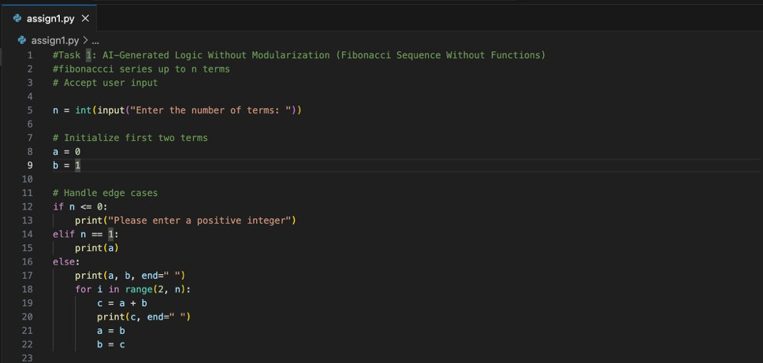

Result:
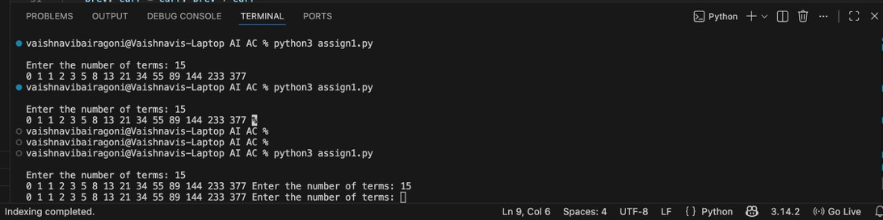
Observation: AI-Generated Logic Without Modularization
GitHub Copilot was able to generate a correct Fibonacci sequence using direct logic without user-defined functions. The code was simple and suitable for small, one-time scripts. However, the logic and input/output were tightly coupled, which reduced readability and reusability. This task demonstrated Copilot’s ability to quickly produce working code but also highlighted limitations in scalability.

Task 2: AI Code Optimization & Cleanup (Improving Efficiency)
Scenario
The prototype will be shared with other developers and needs optimization.
Prompt: Optimize this code
Code:
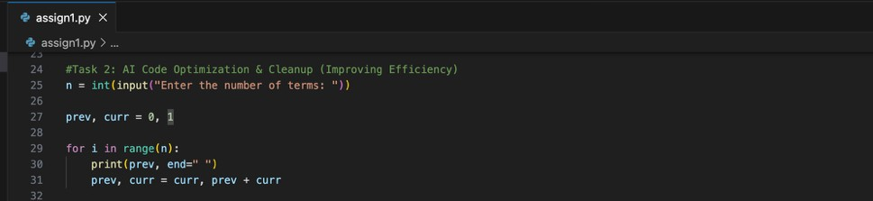
Result:
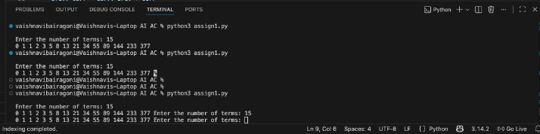

Observation: AI Code Optimization & Cleanup
When prompted for optimization, Copilot successfully simplified the original code by removing redundant variables and unnecessary conditional checks. The optimized version was shorter, more readable, and maintained the same time complexity. This task showed that Copilot can effectively improve existing code when given clear optimization-related prompts
Task 3: Modular Design Using AI Assistance (Fibonacci Using Functions)
Scenario
The Fibonacci logic is now required in multiple modules of an application.
Prompt: Optimize this code using functions
Code:
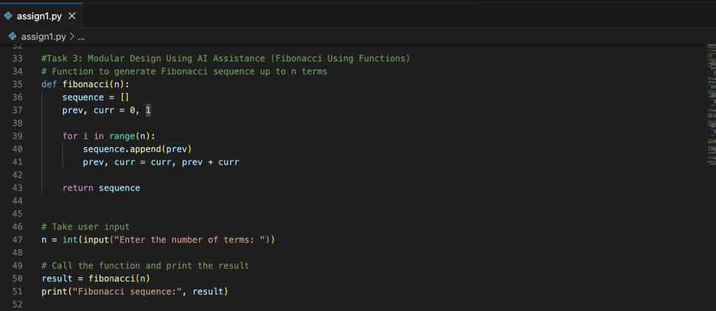
Result:

Observation: Function-Based Fibonacci Implementation
Copilot generated a modular, function-based Fibonacci implementation with meaningful comments. The use of a user-defined function improved code clarity, reusability, and ease of testing. This task demonstrated that Copilot understands modular programming principles and can produce code suitable for reuse across multiple modules

Task 4: Comparative Analysis – Procedural vs Modular Fibonacci Code
Scenario
You are participating in a code review session
Prompt: Description on comparision between with functions and without functions

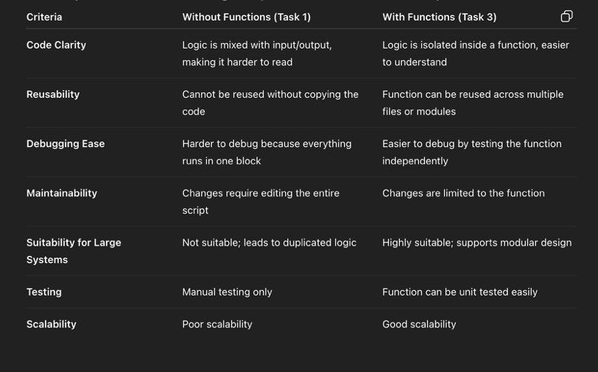

Observation: Code Review Comparison
The comparison between non-function and function-based implementations revealed that function-based code is more maintainable, easier to debug, and better suited for large systems. Copilot-supported modular code aligned more closely with software engineering best practices, emphasizing separation of concerns and reusability

Task 5: AI-Generated Iterative vs Recursive Fibonacci Approaches (Different Algorithmic Approaches for Fibonacci Series)
Scenario
Your mentor wants to assess AI’s understanding of different algorithmic paradigms.
Prompt: give me a code using iterative and recursive approch
Code:
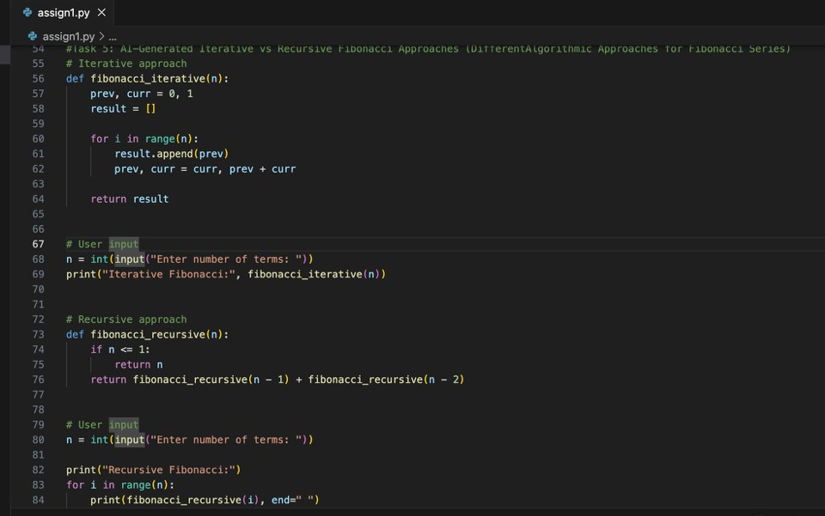
Result:
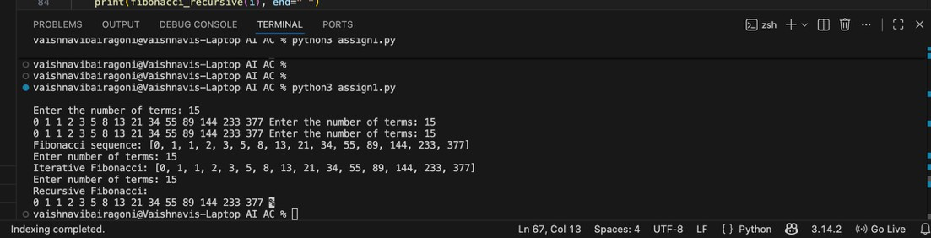
Observation: Iterative vs Recursive Fibonacci Approaches
Copilot successfully generated both iterative and recursive Fibonacci implementations. The iterative approach was efficient in terms of time and space complexity, while the recursive approach was simpler but computationally expensive for large inputs. This task demonstrated Copilot’s understanding of different algorithmic paradigms and their trade-offs.

