**MongoDB: Redefining Modern Data Storage**

**INTRODUCTION:**

WHAT IS MONGODB

* MongoDB is a NoSQL, document-based database.
* Stores data in **BSON** (Binary JSON) format.
* Uses **collections** and **documents** instead of tables and rows.
* Schema-less – flexible to store different data formats.
* Widely used in modern apps like social media, real-time systems, and IoT.
* Scalable and efficient for big data handling.
* It integrates well with modern programming languages like Python, Node.js, and Java.
* MongoDB supports powerful query features like indexing, aggregation, and text search.
* **Supports Rich Data Types** – You can store arrays, nested documents, and even geospatial data.
* **Schema-less Design** – MongoDB allows storing different types of documents in the same collection

**Key Features That Make MongoDB Stand Out**

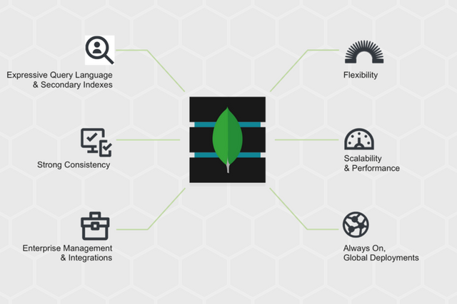

**Why NoSQL?**

* NoSQL can easily manage JSON, XML, images, videos, etc
* Suited for modern apps like social media, IoT, and analytics.
* Easily scales across multiple servers, unlike SQL which scales vertically.
* No fixed schema lets developers adapt data models as apps evolve.
* Schema-less design helps developers ship features quickly.
* Designed to run smoothly on cloud platforms like AWS, Azure, and GCP.
* NoSQL works well with agile teams and modular architectures.
* JSON-like data makes it easy to work with REST APIs and web apps.
* NoSQL databases offer built-in replication for uninterrupted access.
* Great for storing logs, sensors, and tracking events.

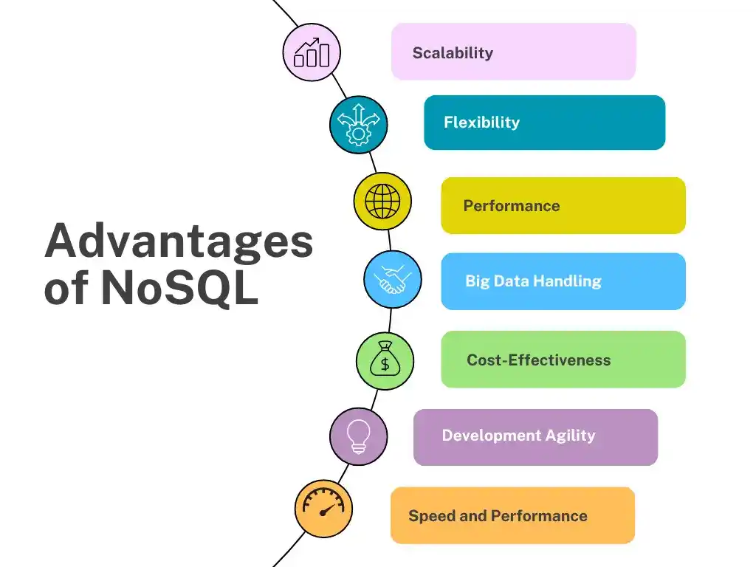

**SQL VS No SQL**

|  |  |
| --- | --- |
| **SQL (Relational)** | **NoSQL (Non-Relational)** |
| Structured schema | Dynamic schema |
| Uses tables with rows/cols | Uses JSON, documents, etc |
| Vertical scalability | Horizontal scalability |
| Strong consistency | High availability |
| Rigid relationships | Flexible, schema-less |
| Complex joins supported | Joins not commonly used |
| Slower with big data | Designed for big data |
| Examples: MySQL, PostgreSQL | Examples: MongoDB, Cassandra |

**DIFFERENCE BETWEEN SQL AND NO SQL**

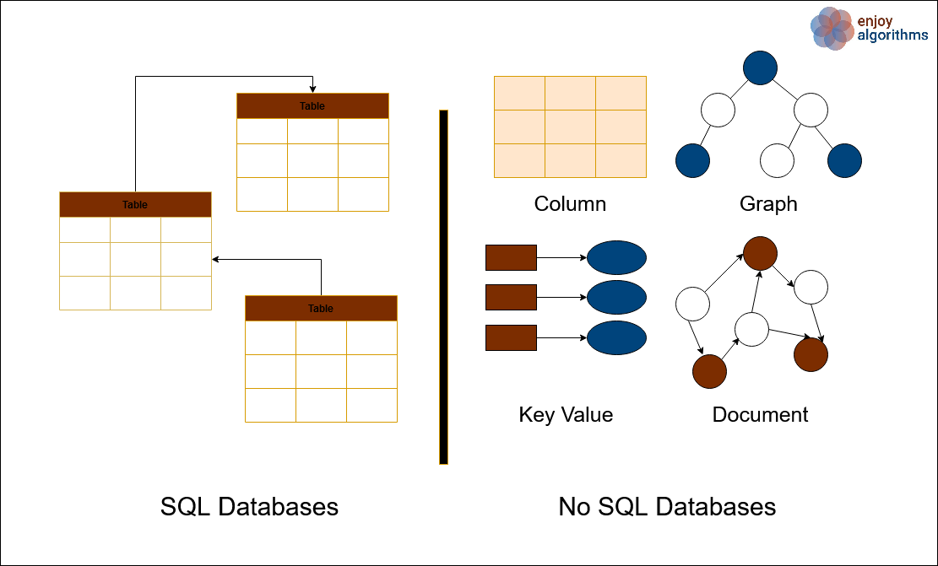

**Real-World Applications of MongoDB:**

* **Content Management Systems** – Handles dynamic content for blogs and news platforms.
* **IoT Applications** – Stores time-series sensor data efficiently.
* **E-Commerce Platforms** – Manages user data, orders, and product catalogues.
* **Mobile Applications** – Syncs flexible user data across devices.
* **Gaming** – Tracks game states, scores, and player interactions.

**Advantages of using MongoDB**:

* **Schema-less Structure** – Easily adapt to changing data requirements.
* **Horizontal Scalability** – Supports large data volumes with sharding.
* **High Performance** – Fast read/write operations using in-memory storage.
* **Developer Friendly** – JSON-style documents (BSON) are easy to use.
* **Cloud Integration** – MongoDB Atlas provides built-in cloud features.

