LAB-12.5

Task 1: Sorting Student Records for Placement Drive
Scenario:
SR University is preparing for a campus placement drive. The Training and Placement Cell needs student records sorted by CGPA in descending order to easily shortlist candidates.

- Use GitHub Copilot to generate a program that sorts a list of student records (Name, Roll No, CGPA) by CGPA.
- Implement both Quick Sort and Merge Sort using AI assistance.
- Compare the runtime performance of both algorithms on large datasets.
- Write a function that outputs the top 10 students with the highest CGPA.
- 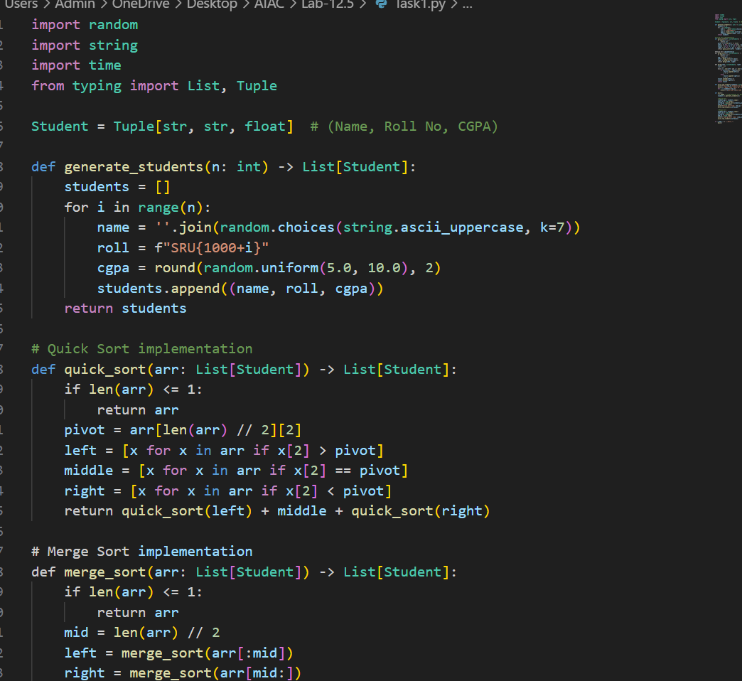
- 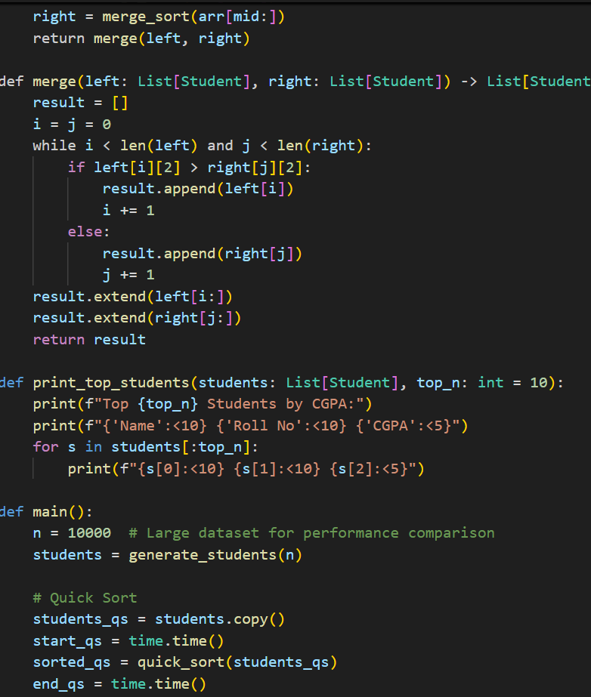
- 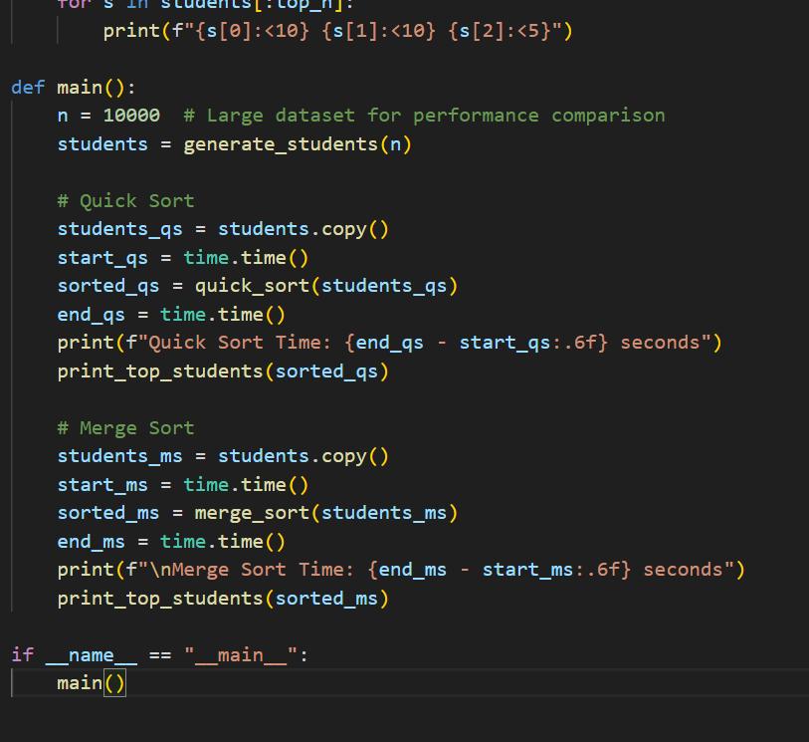

OUTPUT:
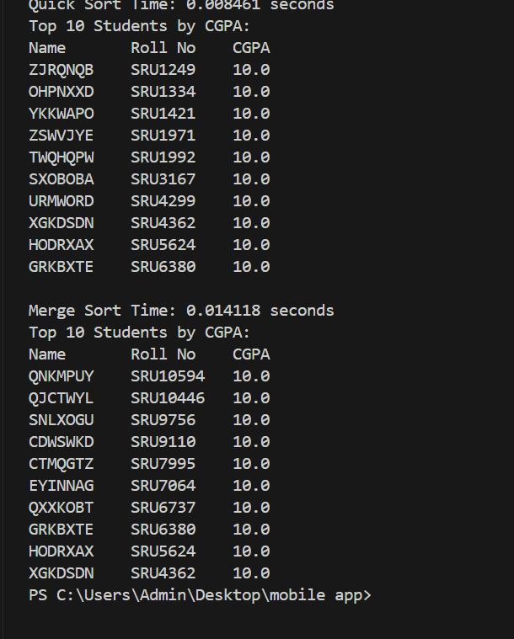

Task 2: Optimized Search in Online Library System
Scenario:
SR University’s digital library has thousands of research papers. Students frequently search for a paper by title or author name. The current linear search is too slow.

- Use GitHub Copilot to implement Binary Search and Hash-based Search for faster lookups.
- Load a dataset of book titles and authors (CSV or JSON file).
- Allow the user to input a keyword and return all matching entries.
- Compare the efficiency of linear search vs binary search vs hashing using test cases.
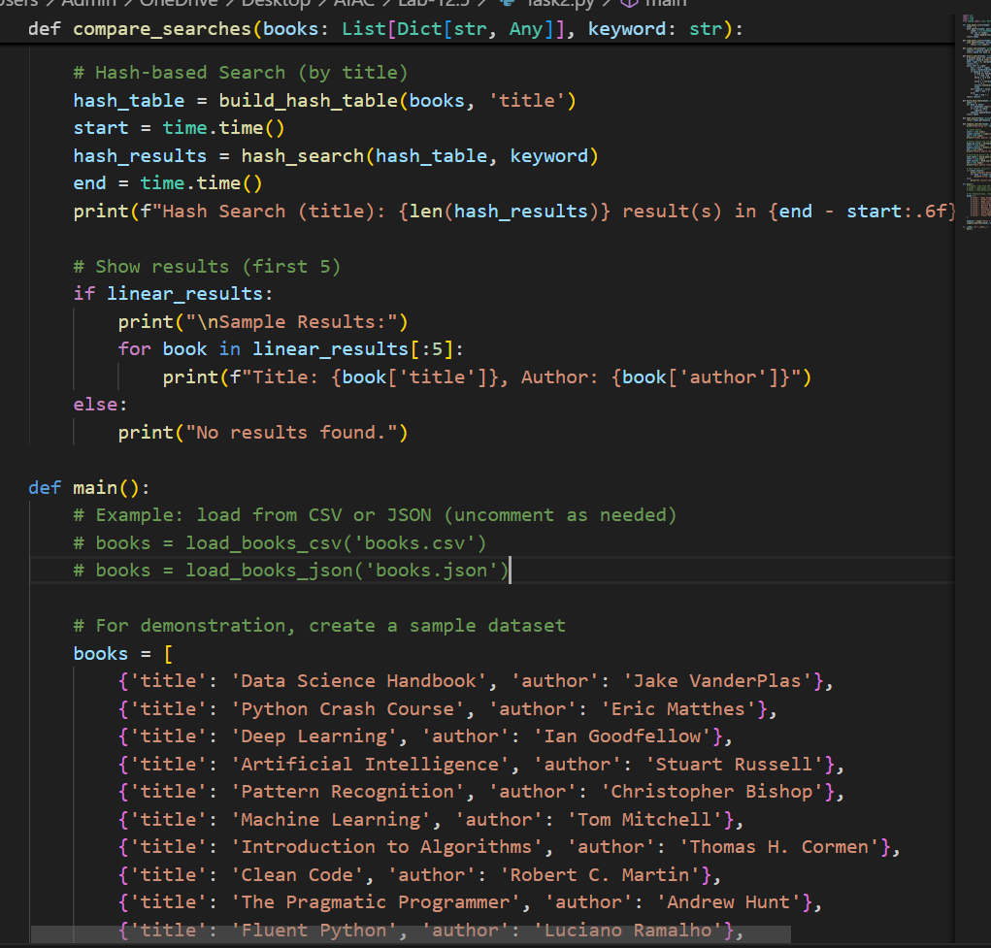

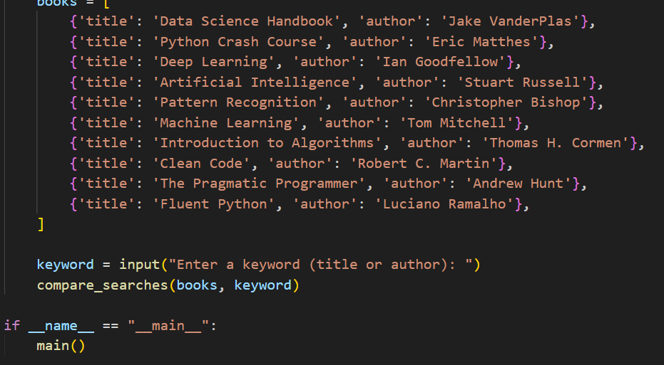
OUTPUT:
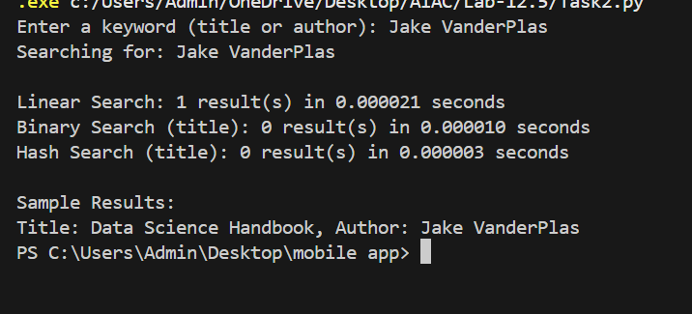
Task 3: Route Optimization for AUV Swarm

Scenario:
A research team at SR University is simulating Autonomous Underwater Vehicle (AUV) swarms. Each AUV must visit multiple underwater sensors, and the goal is to minimize travel distance (like the Traveling Salesman Problem).

- With GitHub Copilot, implement an algorithm to optimize the route:
  - Start with a Greedy approach.
  - Improve with Genetic Algorithm (GA) or Simulated Annealing (SA).
- Use a dataset of sensor coordinates (x, y).
- Visualize the optimized route using a plotting library (e.g., Matplotlib).
- Compare the optimized solution with a random path in terms of distance travel.
- 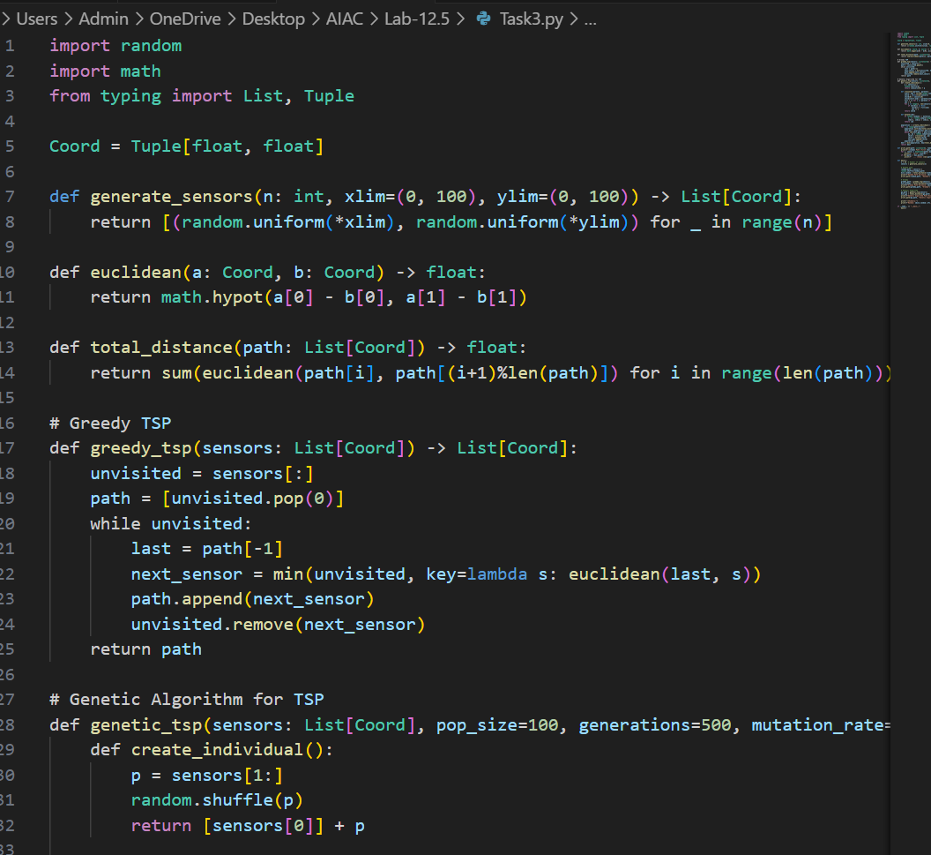

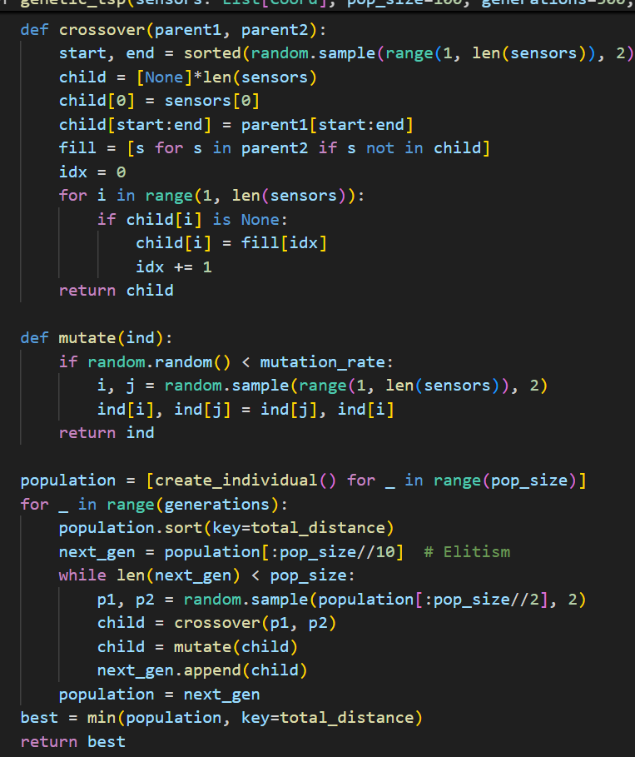

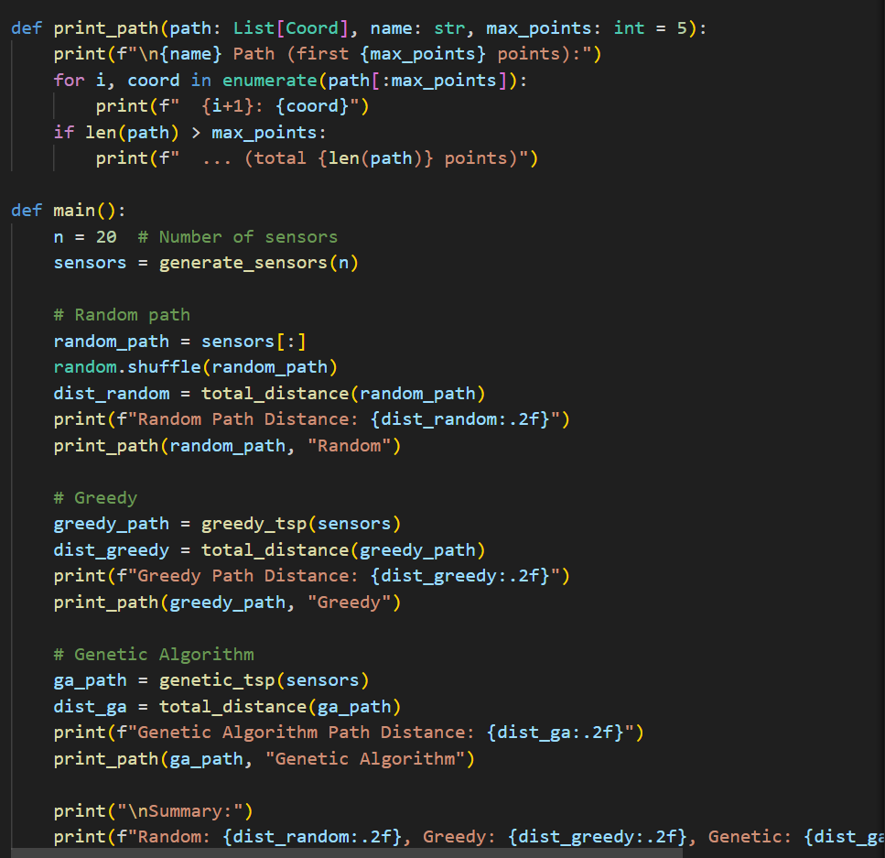
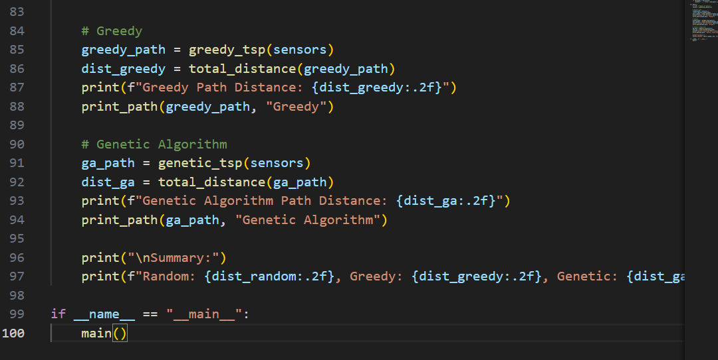
OUTPUT:
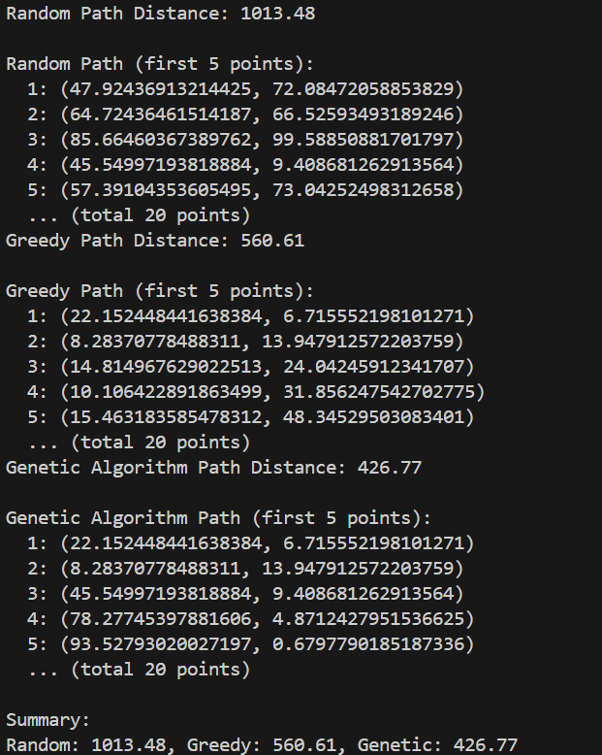
Task 4: Real-Time Stock Data Sorting & Searching
Scenario:
An AI-powered FinTech Lab at SR University is building a tool for analyzing stock price movements. The requirement is to quickly sort stocks by daily gain/loss and search for specific stock symbols efficiently.

- Use GitHub Copilot to fetch or simulate stock price data (Stock Symbol, Opening Price, Closing Price).
- Implement sorting algorithms to rank stocks by percentage change.
- Implement a search function that retrieves stock data instantly when a stock symbol is entered.
- Optimize sorting with Heap Sort and searching with Hash Maps.
- Compare performance with standard library functions (sorted(), dict lookups) and analyze trade-offs.

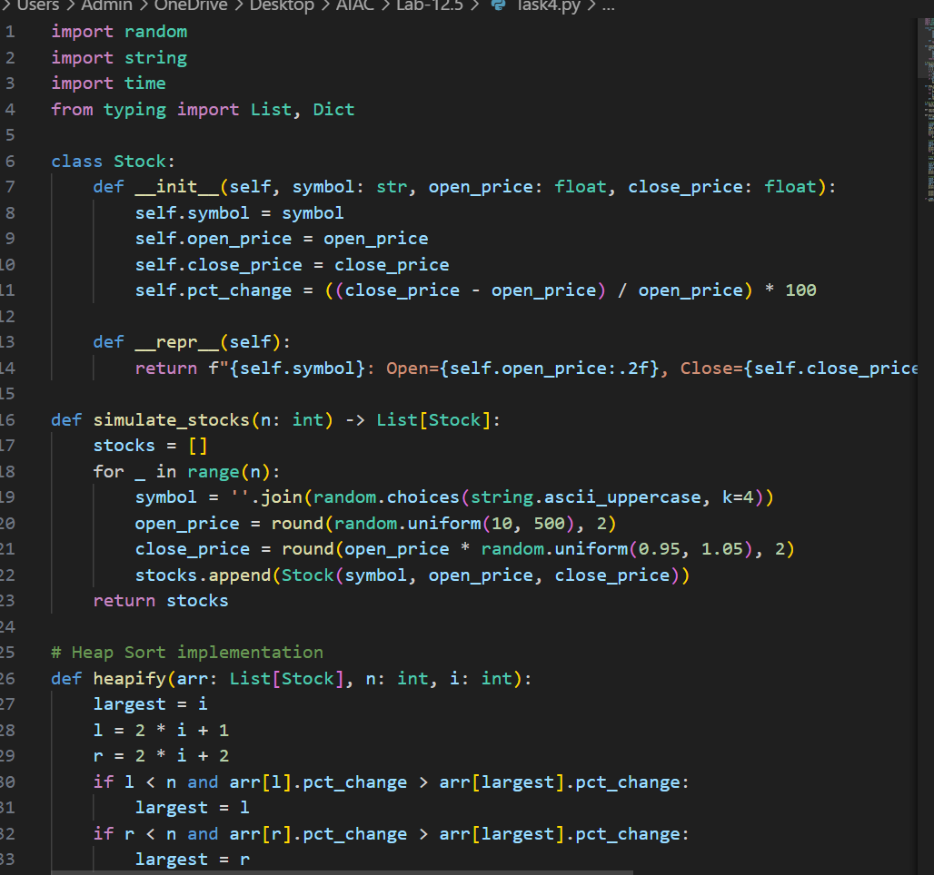

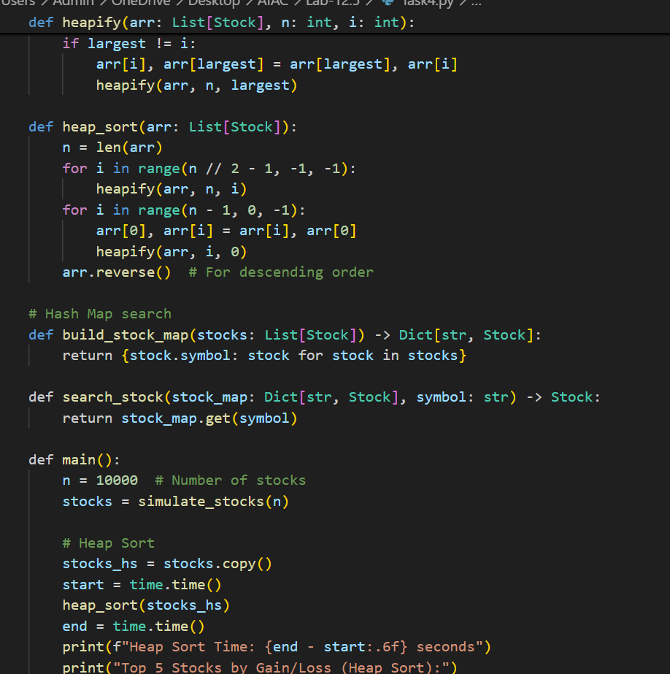

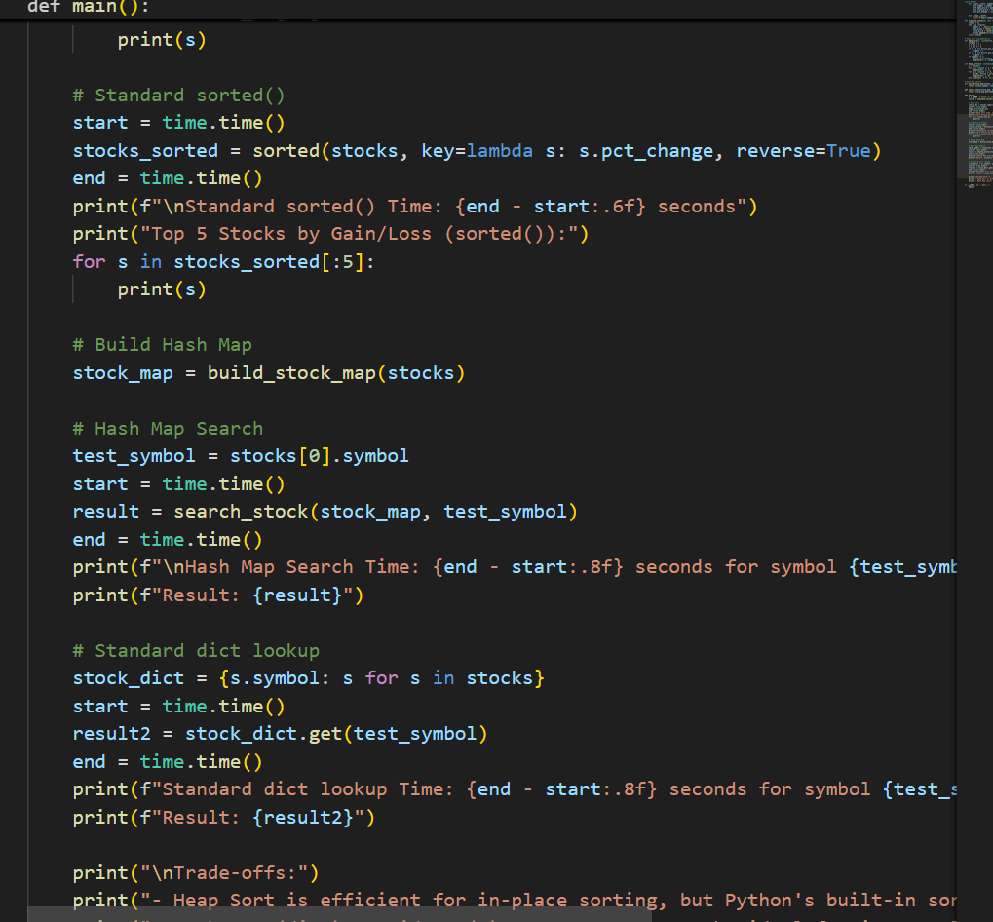
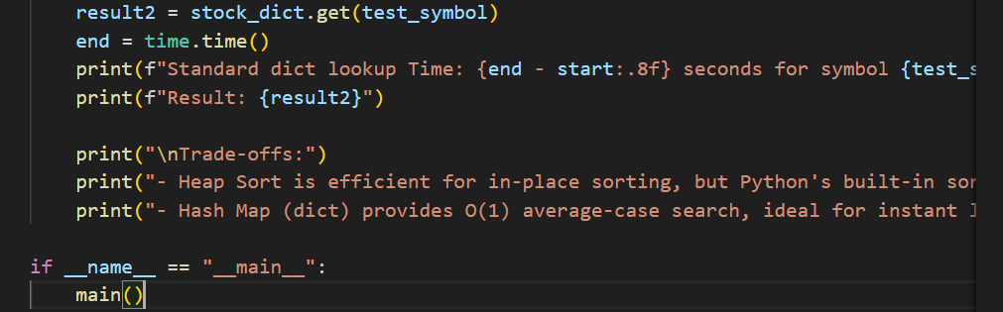
OUTPUT:
