LABTEST -4
Q1. Using AI tools, design a Hotel Reservation Database Schema.
- Create tables: Guests, Rooms, and Bookings.
- Insert Data in to these three tables
- Generate queries to find available rooms between given check-in and check-out dates.
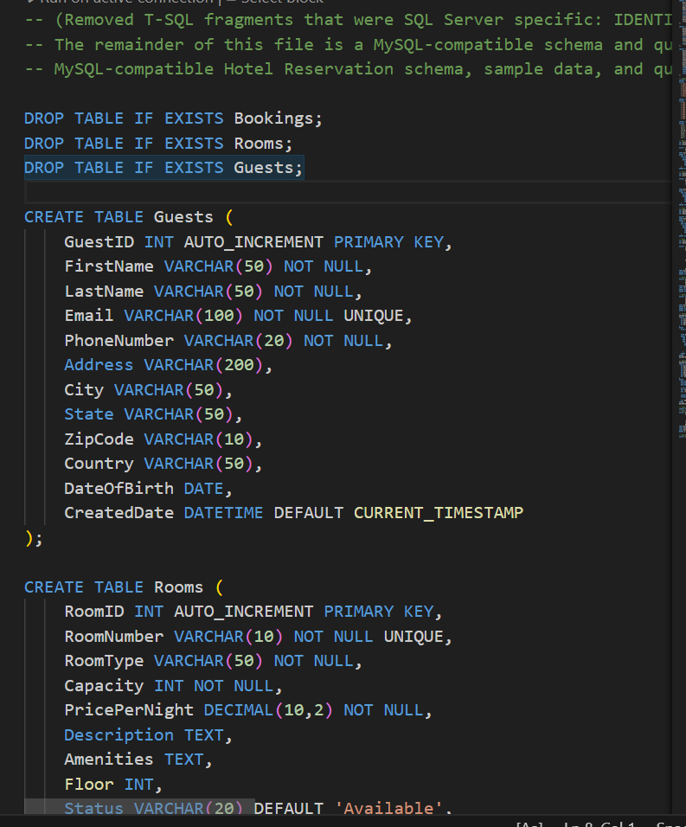
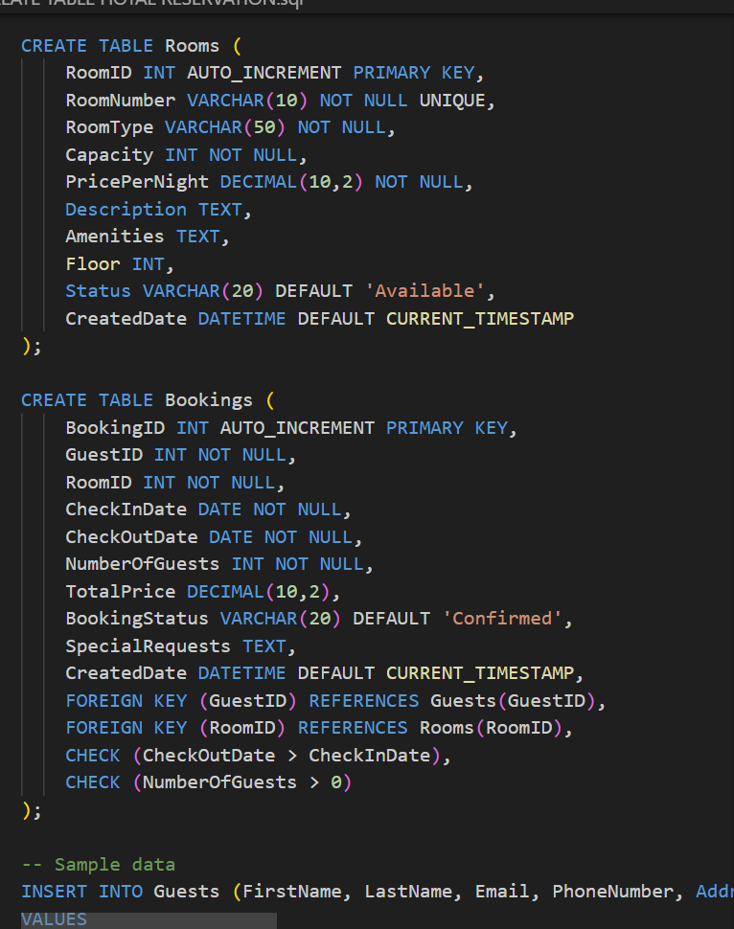

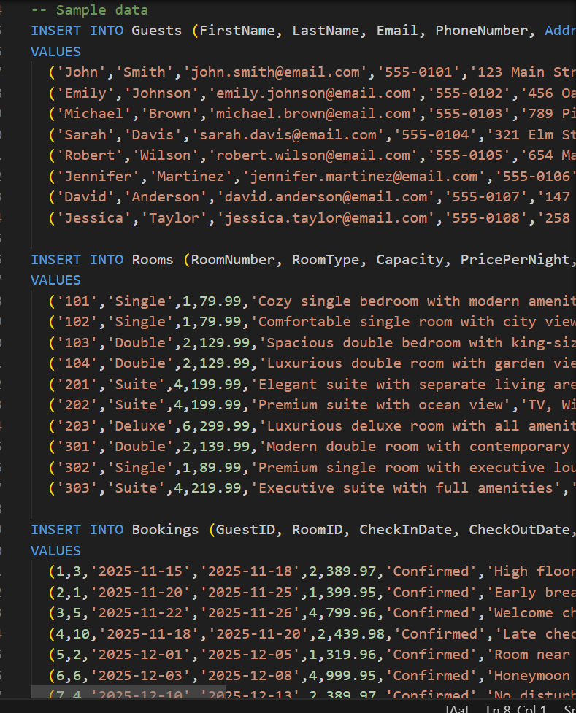

Q2. Use AI to generate a Python script that removes outliers in a numeric dataset using Z-score and saves the cleaned data to a new CSV file. (First randomly generate some data to complete this task)

