LAB-4.3
Task Description#1
- Zero-shot: Prompt AI to write a function that checks whether a given year is a leap year.
Expected Output#1
- AI-generated function with no examples provided
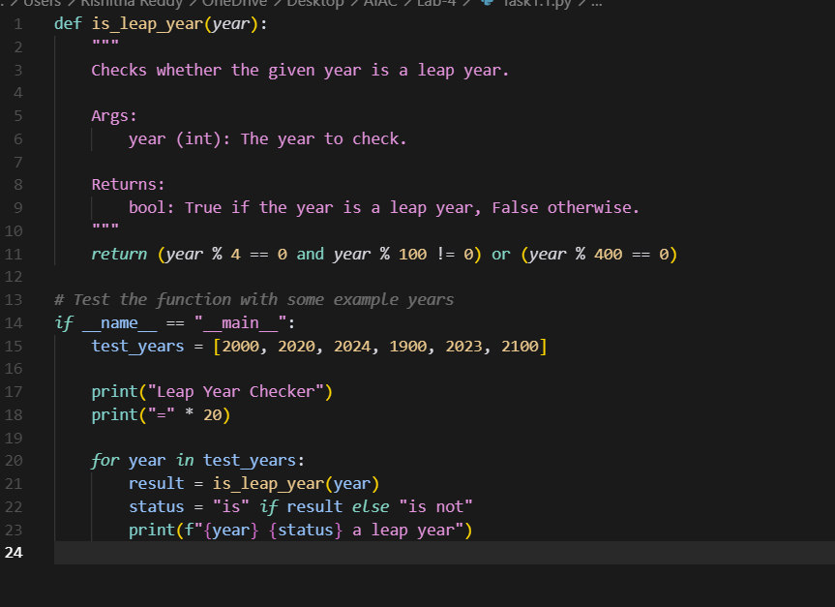
OUTPUT:
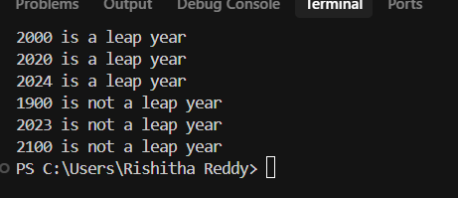

Task Description#2
- One-shot: Give one input-output example to guide AI in writing a function that converts centimeters to inches.
Expected Output#2
- Function with correct conversion logic
- 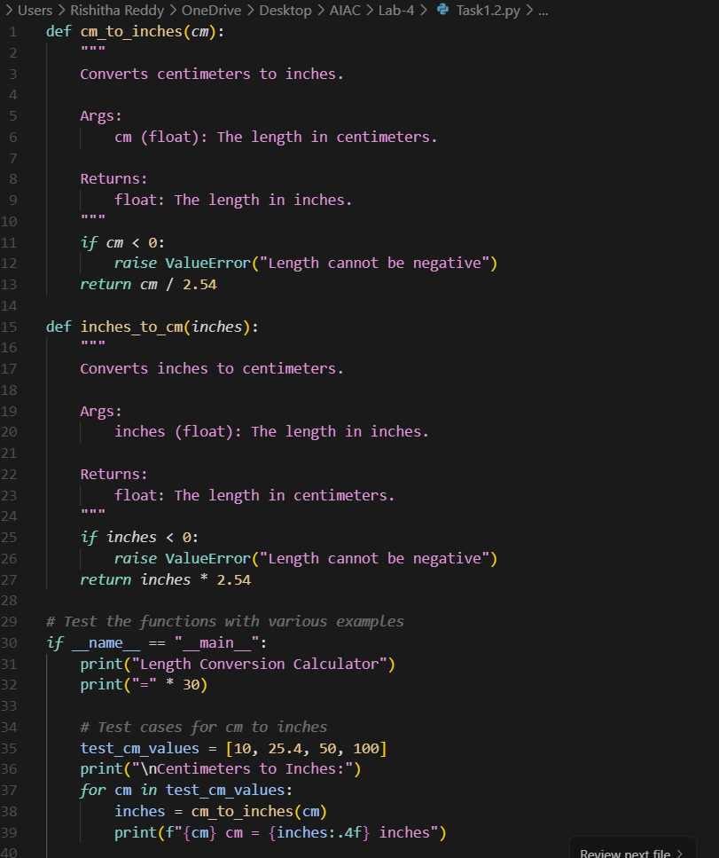

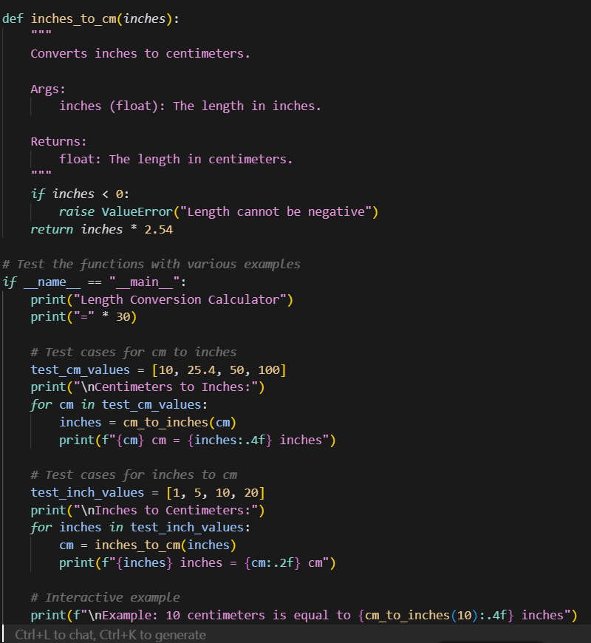

OUTPUT:
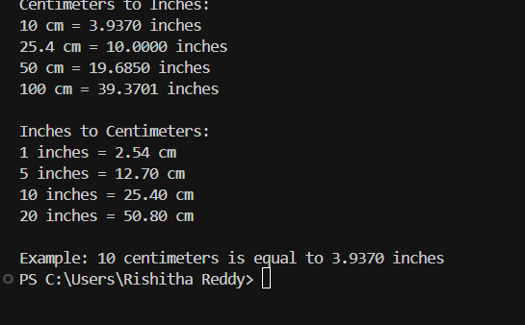

Task Description#3
- Few-shot: Provide 2–3 examples to generate a function that formats full names as “Last, First”.
Expected Output#3
Well-structured function respecting the examples
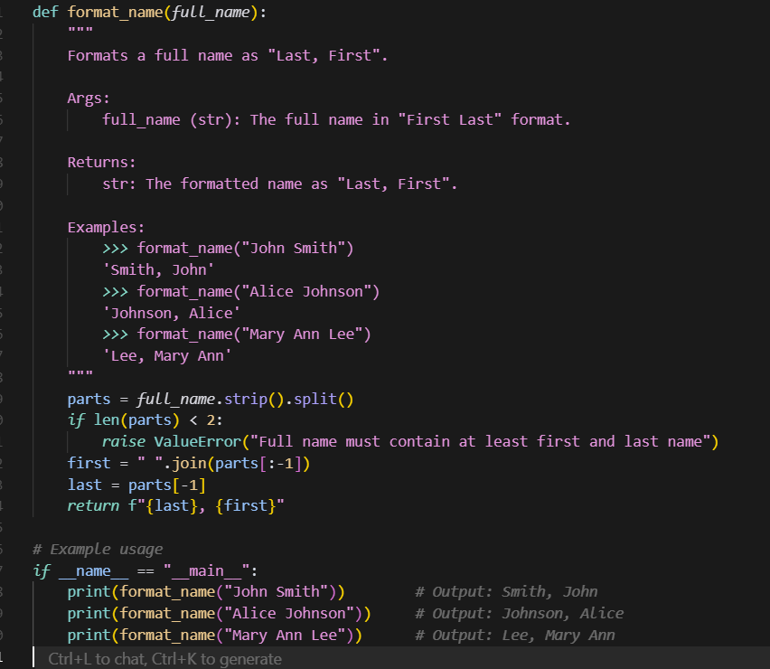
OUTPUT:
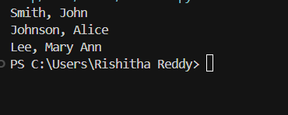

Task Description#4
- Compare zero-shot and few-shot prompts for writing a function that counts the number of vowels in a string.
Expected Output#4
- Functional output and comparative reflection
- 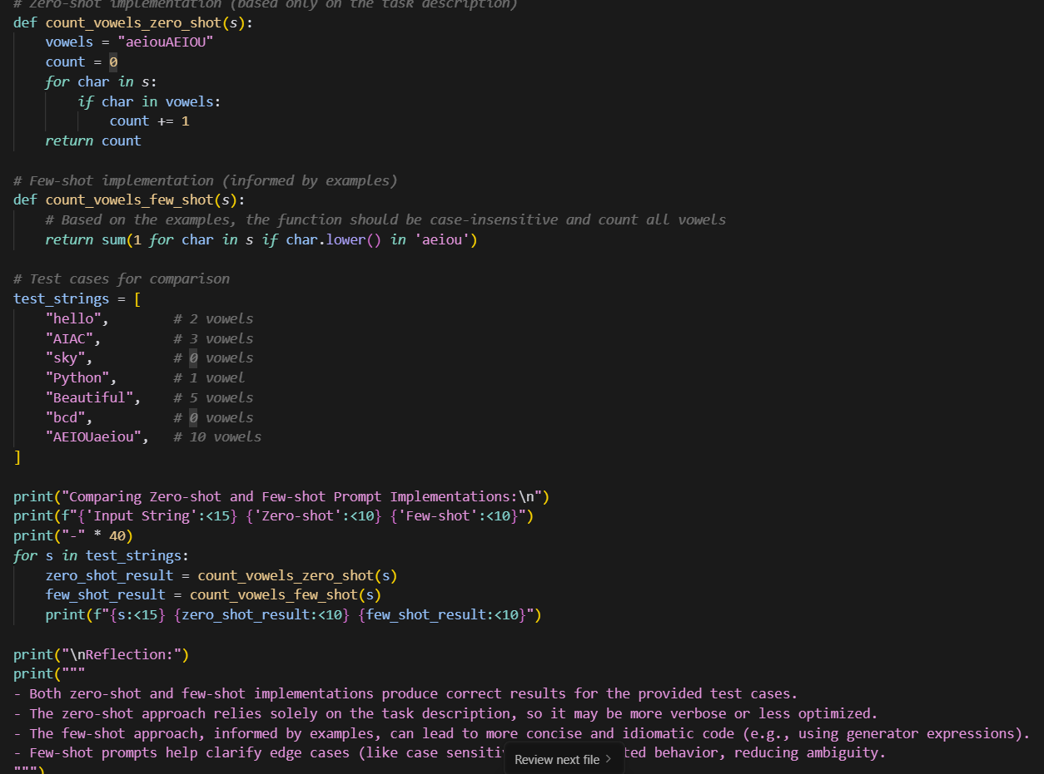
- OUTPUT:
- 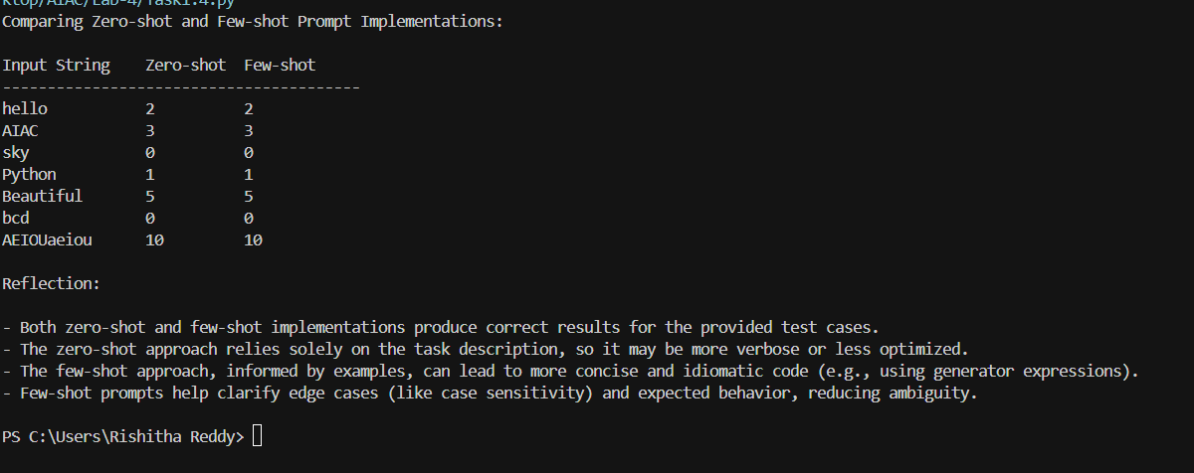
Task Description#5
- Use few-shot prompting to generate a function that reads a .txt file and returns the number of lines.
Expected Output#5
- Working file-processing function with AI-guided logic
- 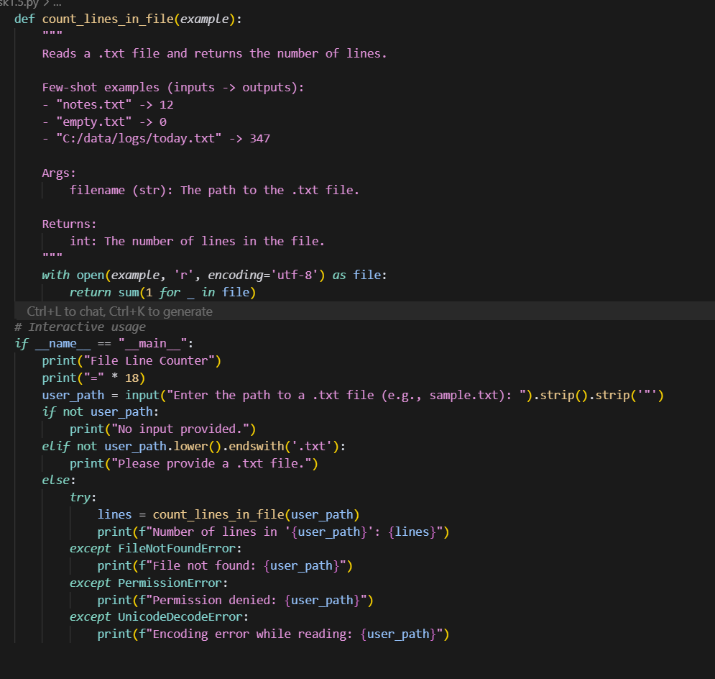

OUPTUP:
