LAB-11.4
Task 1: Implementing a Stack (LIFO)
- Task: Use AI to help implement a Stack class in Python with the following operations: push(), pop(), peek(), and is_empty().
- 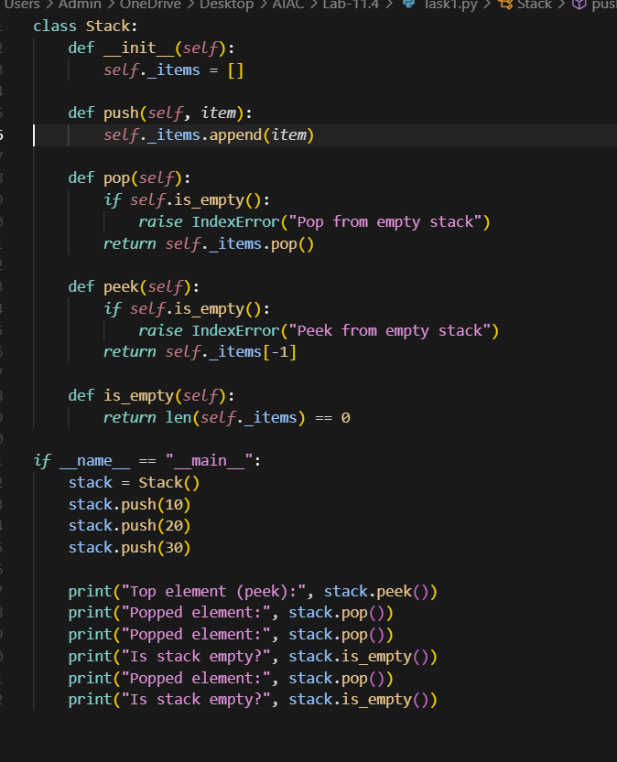
OUTPUT:
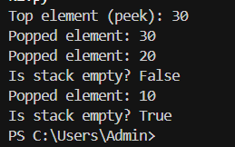

Queue Implementation with Performance Review
- Task2: Implement a Queue with enqueue(), dequeue(), and is_empty() methods.
- 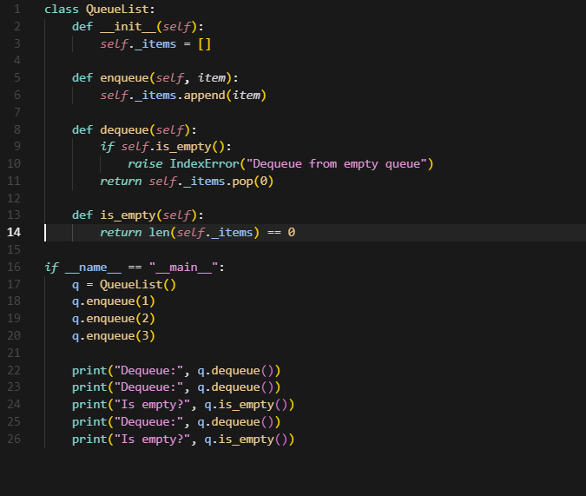
OUTPUT:
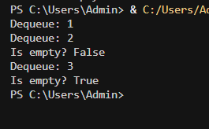

Task 3: Singly Linked List with Traversal
- Task: Implement a Singly Linked List with operations: insert_at_end(), delete_value(), and traverse().
- 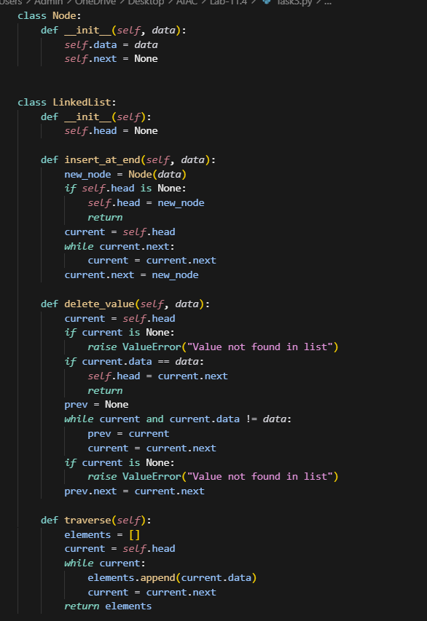

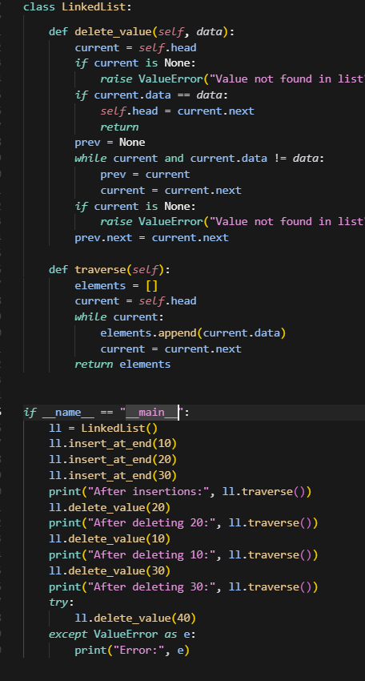

OUTPUT:
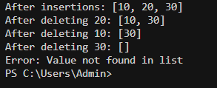

Task 4: Binary Search Tree (BST)
- Task: Implement a Binary Search Tree with methods for insert(), search(), and inorder_traversal().
- 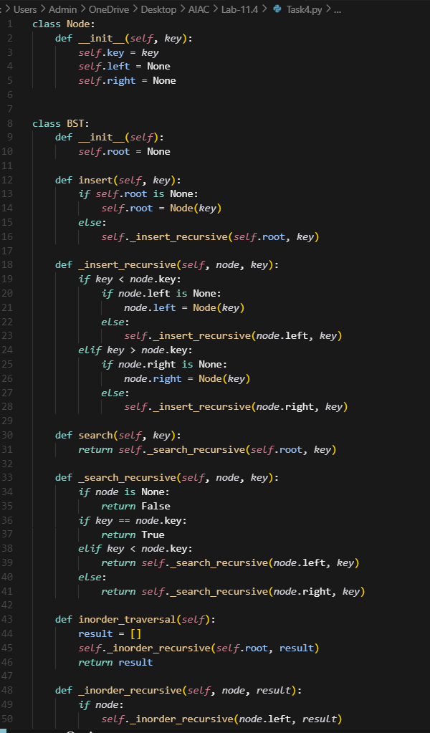
- 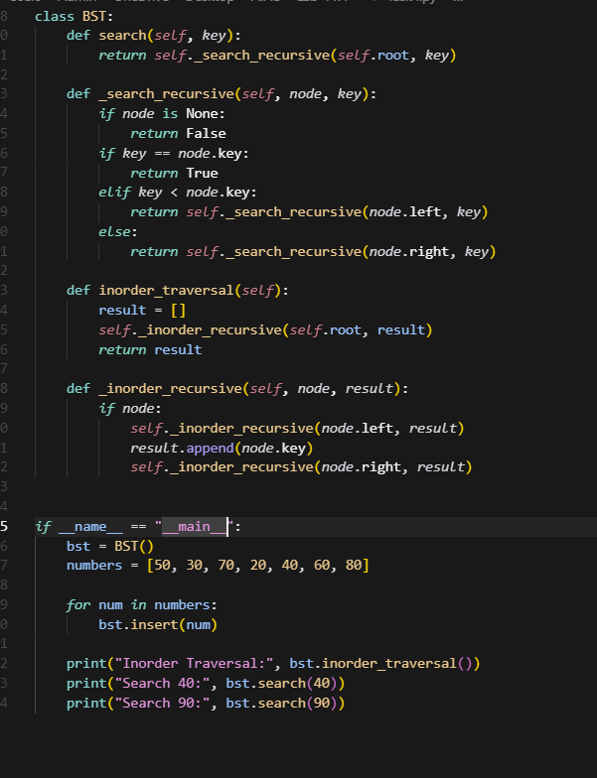
OUTPUT:
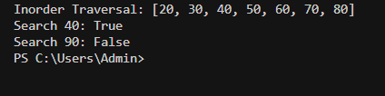

Task 5: Graph Representation and BFS/DFS Traversal
- Task: Implement a Graph using an adjacency list, with traversal methods BFS() and DFS().
- 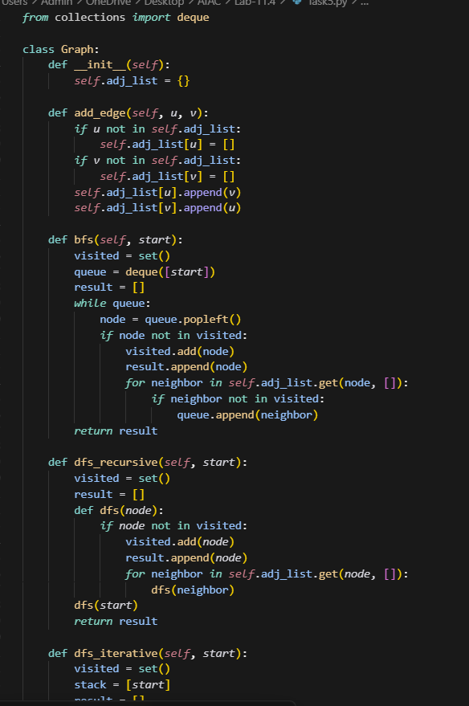

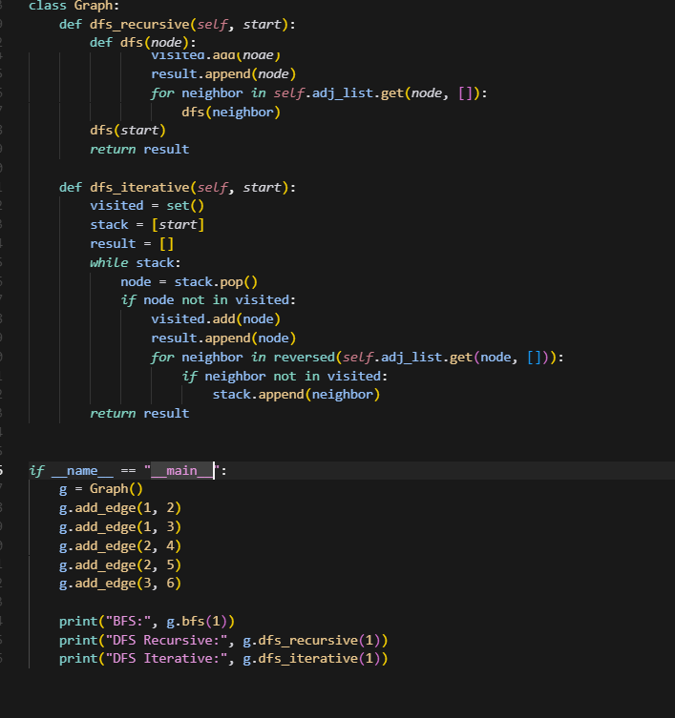
OUTPUT:
