Task Description#1

* Try 3 different prompts to generate a factorial function.

Expected Output#1

* Comparison of AI-generated code styles

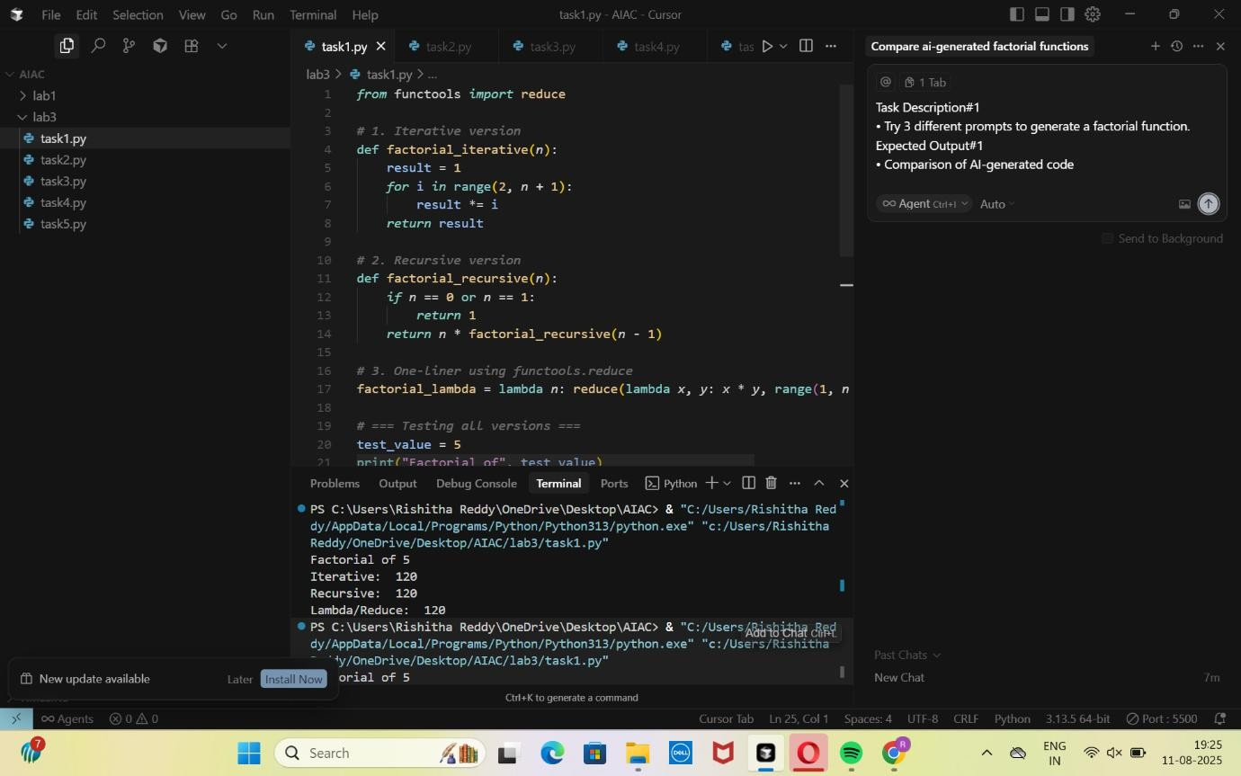

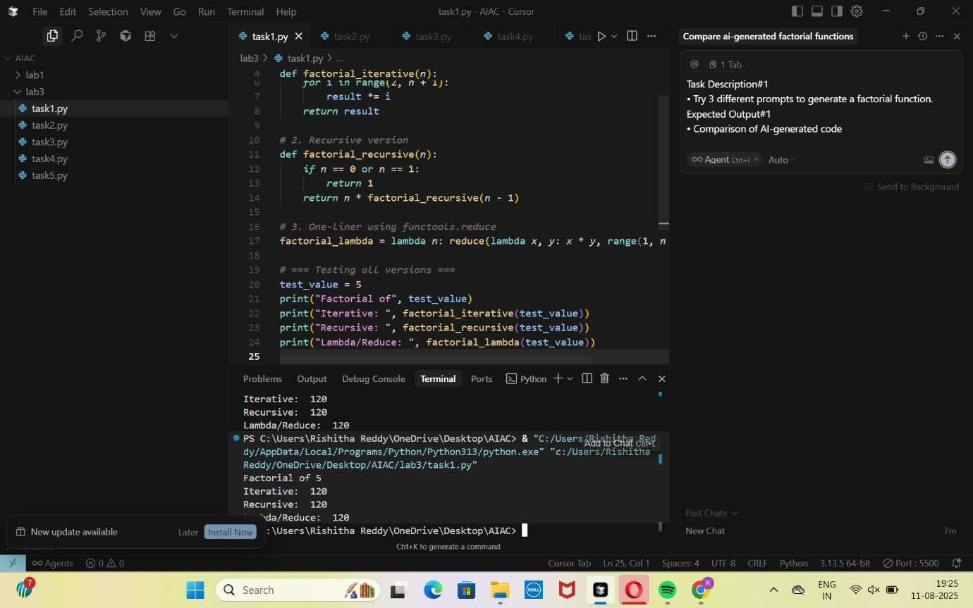

Task Description#2

* Provide a clear example input-output prompt to generate a sorting function.

Expected Output#2

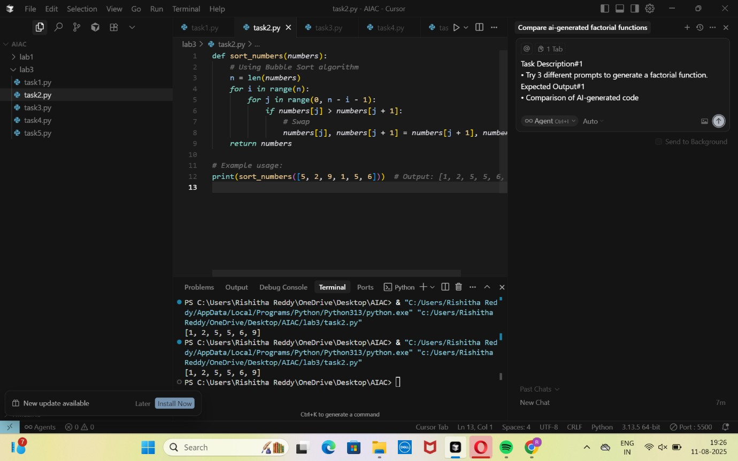

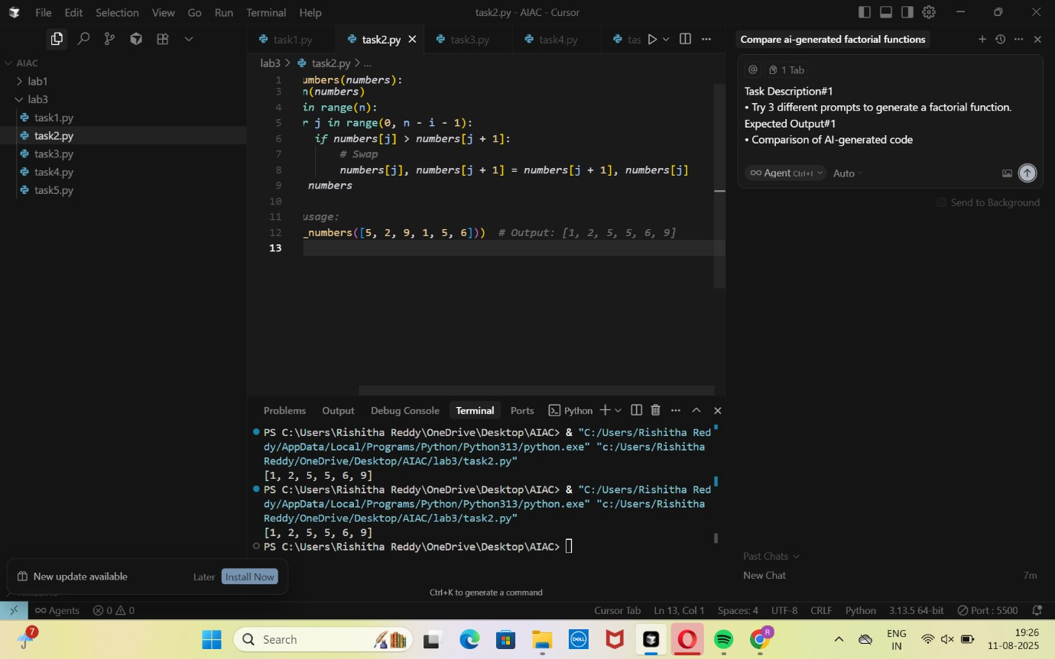

Task Description#3

* Start with the vague prompt “Generate python code to calculate power bill” and improve it step-by-step

Expected Output#3

* Enhanced AI output with clearer prompts

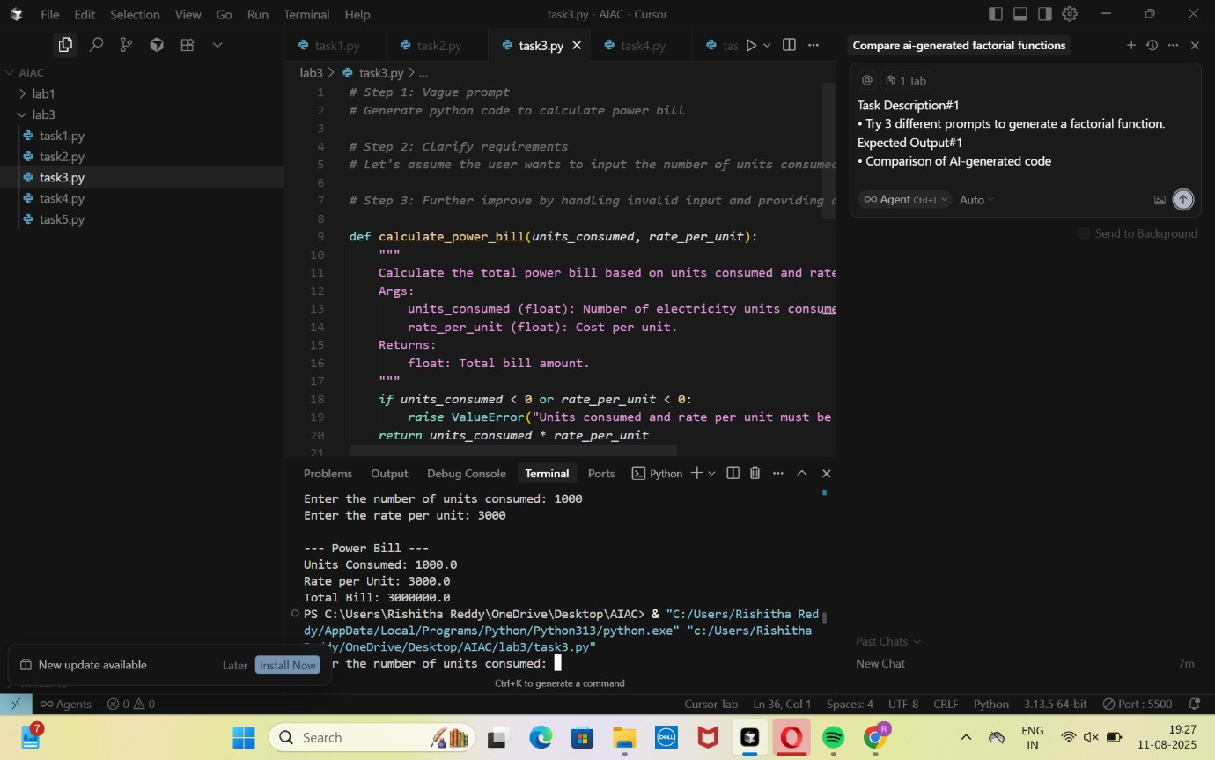

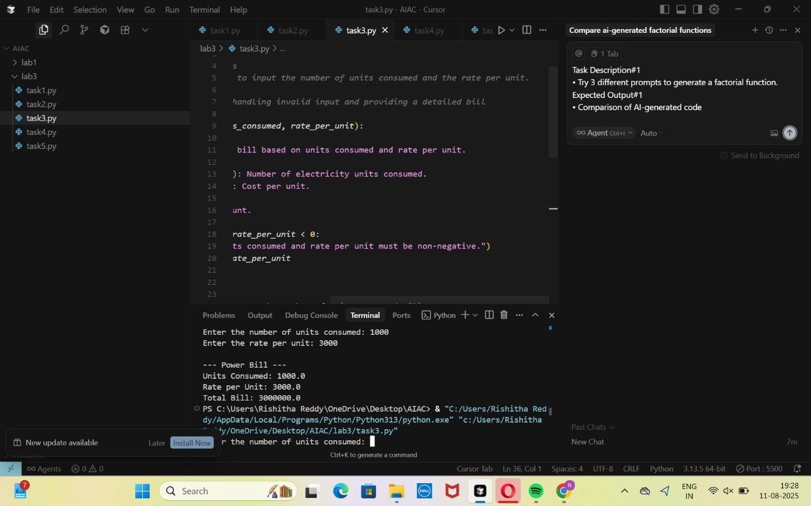

Task Description#4

* Write structured comments to help AI generate two linked functions (e.g., login_user() and register_user()).

Expected Output#4

* Consistent functions with shared logic

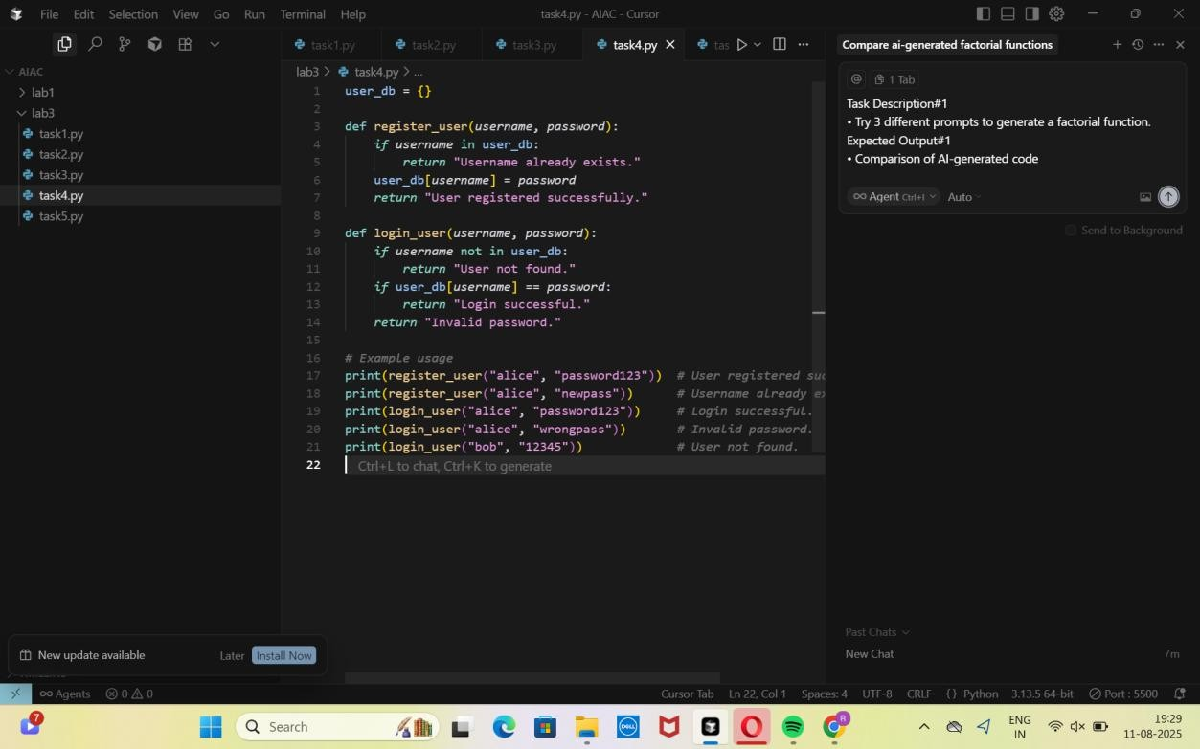

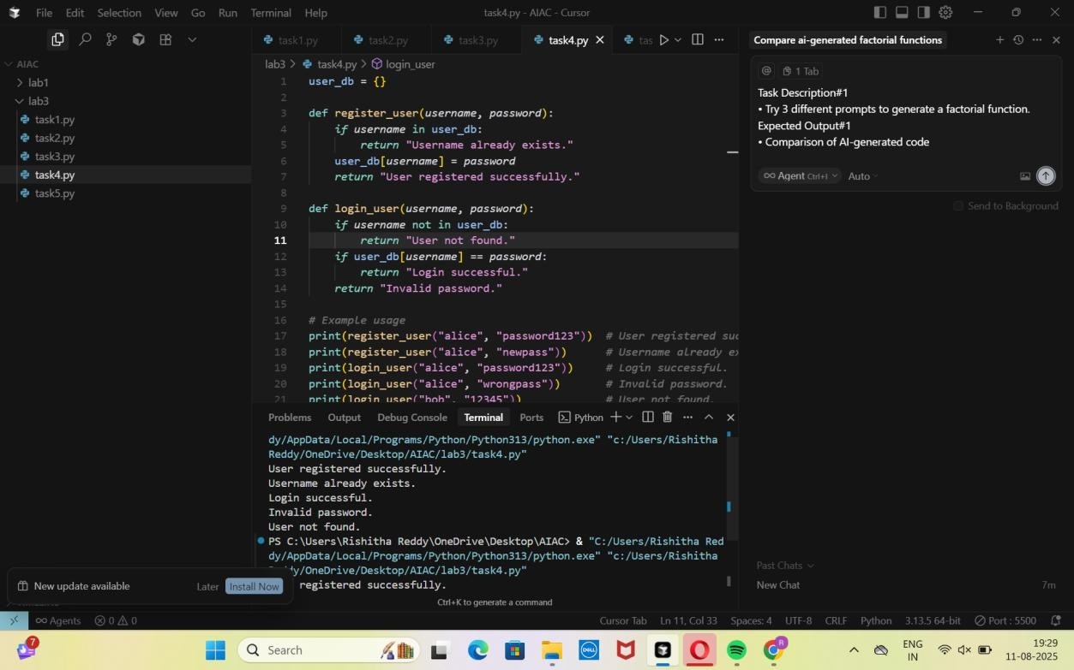

Task Description#5

* Analyzing Prompt Specificity: Improving Temperature Conversion Function with

Clear Instructions

Expected Output#5

