AML Automation — Agent Workflow Flowcharts
Generated: 2026-07-30T06:47:46.248Z
High-resolution flowcharts (3x scale, 3600px canvas). Regenerate: node pipeline/scripts/write-agent-workflows-docx.cjs

Figure 1 — High-level agent map
Standard AML pipeline with numbered navigation (①–⑨). **Blue boxes = Cursor agents** (orchestrators and Playwright workers). Amber = outputs/artifacts; gray = inputs. Path A: FSD + Figma required; Excel optional on input. Path B: defects → Google → regression.
Source: 4191×7296px PNG
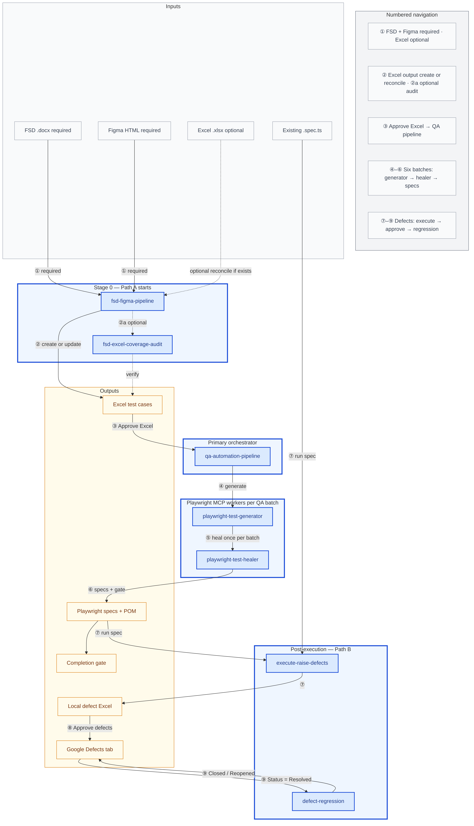

Figure 2 — Primary workflow — Excel to automation
Stage 0 reconciles or creates Excel; after human approval the QA pipeline validates, normalizes, and processes six batches with live UI generation.
Source: 9342×2310px PNG
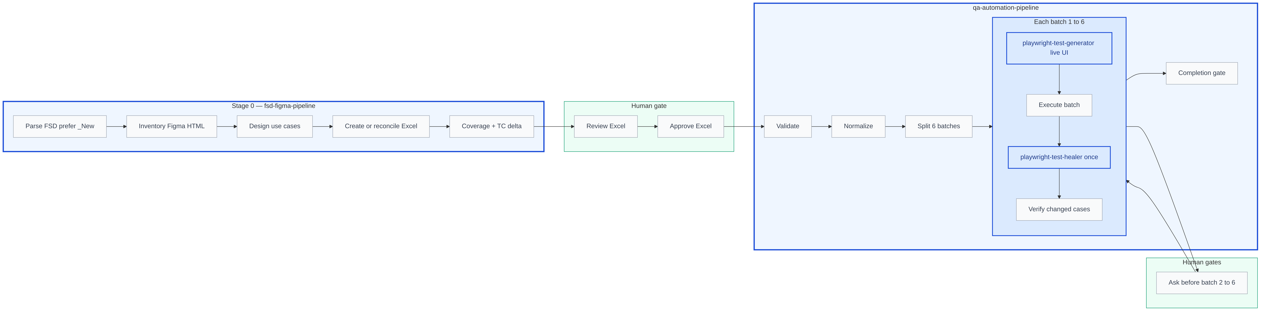

Figure 3 — Defects and regression
Execute specs to raise local defects; sync to Google after approval. Regression retests Resolved rows.
Source: 1545×2850px PNG
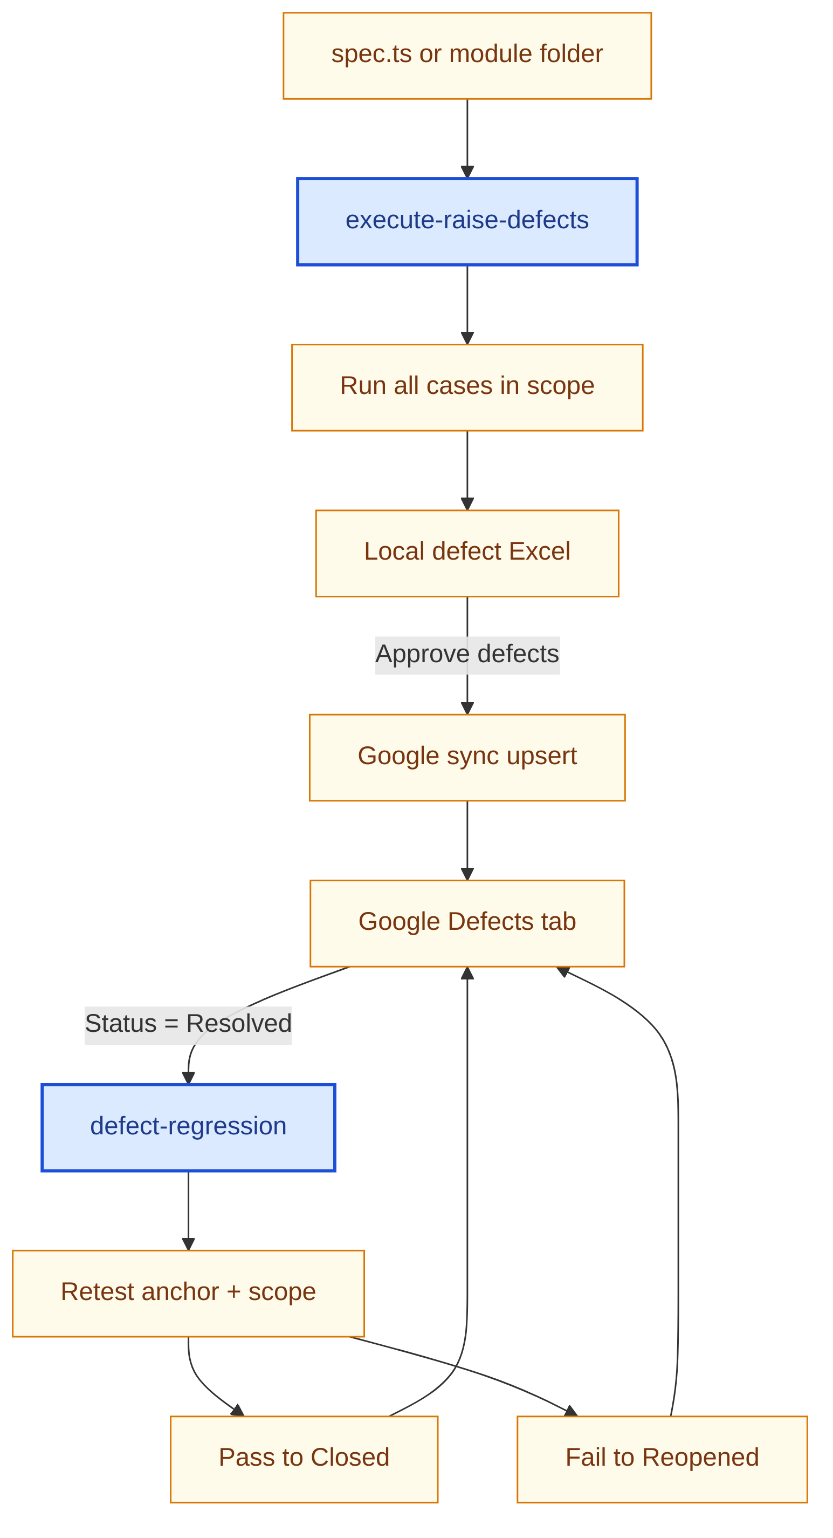

Figure 4 — Human approval gates and handoffs
Mandatory subagent invocation at each gate. Parent orchestrates only — must invoke named agents; if a subagent fails, parent continues orchestration per pipeline rules.
Source: 7959×876px PNG
