Q1.

Code:

|  |
| --- |
| 1. Math.sqrt(B*B + 4*A*C); 2. Math.sqrt(X + 4*Math.pow(Y,3)); 3. Math.cbrt(X * Y); 4. double area = Math.PI * Math.pow(radius,2); |

Q2.

Code:

|  |
| --- |
| **package Q__2;  import java.text.DecimalFormat; import java.util.Scanner;  public class Q_02 {  public static void main(String[] args) {  Scanner scanner = new Scanner(System.*in*);  DecimalFormat dff = new DecimalFormat("#.##");   double length;  System.*out*.println("Enter length or height in centimeters: ");  length = scanner.nextDouble() ;   double feet = length / 30;  System.*out*.println(dff.format(feet) + " feet"); //feet value   double inch = length / 2.54;  System.*out*.println(dff.format(inch) + " inch"); //inch value  } }** |

Output:

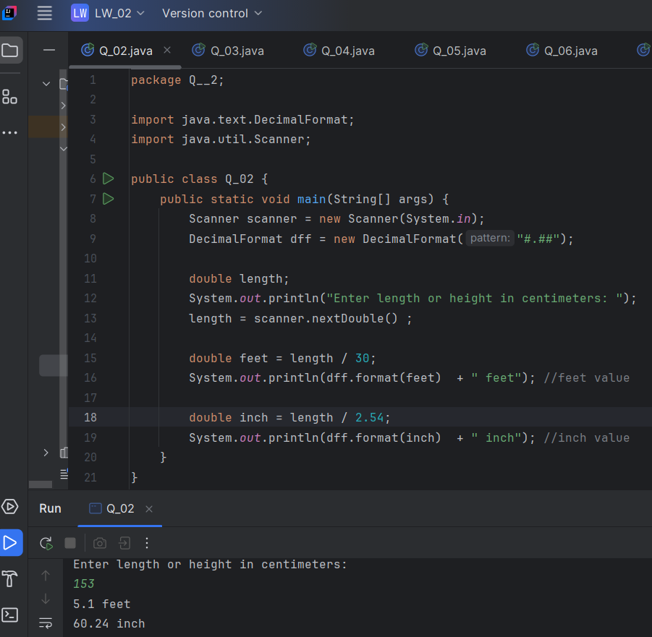

Q3.

Code:

|  |
| --- |
| **package Q__3;  import java.text.DecimalFormat; import java.util.Scanner;  public class Q_03 {  public static void main(String[] args) {  Scanner scanner = new Scanner(System.*in*);  DecimalFormat dff = new DecimalFormat("#.##");   double temp;  System.*out*.println("Enter temperature in Celsius: ");  temp = scanner.nextDouble();   double fahrenheit = (1.8*temp)+32;   System.*out*.println(dff.format(fahrenheit) + "\u00B0F"); // Temperature in Fahrenheit  } }** |

Output:

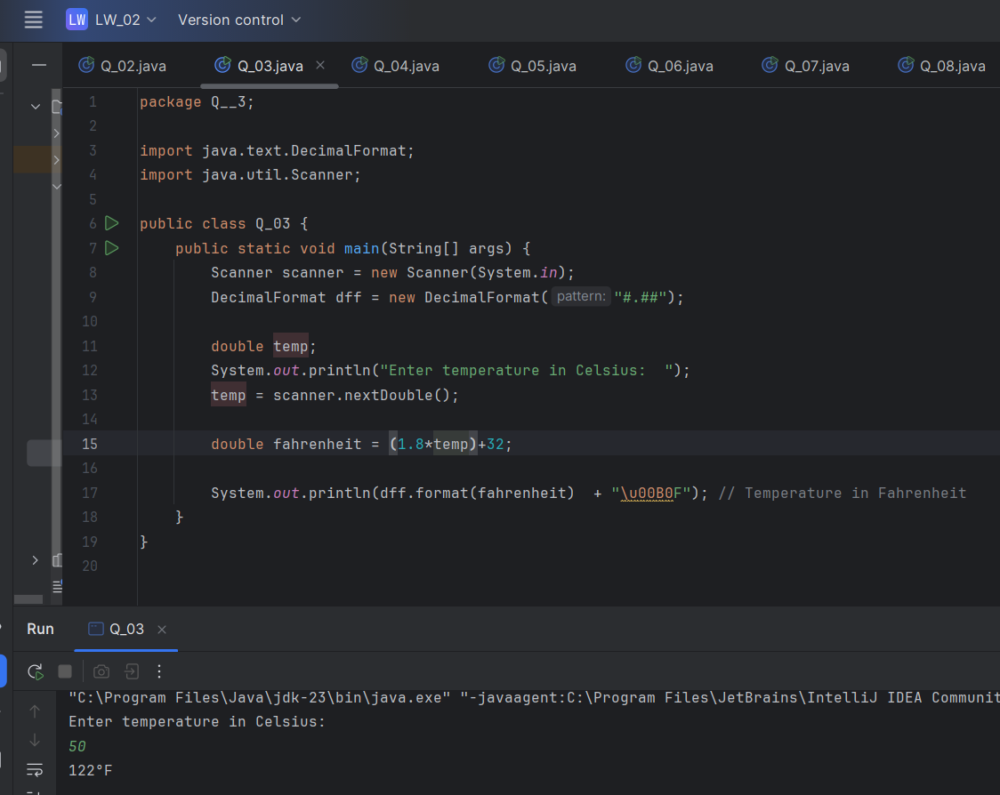

Q4.

Code:

|  |
| --- |
| **package Q__4;  import java.text.DecimalFormat; import java.util.Scanner;  public class Q_04 {  public static void main(String[] args) {  Scanner scanner = new Scanner(System.*in*);  DecimalFormat dff = new DecimalFormat("#.##");   double weight;  System.*out*.println("Enter weight in Pounds: ");  weight = scanner.nextDouble();   double calories = weight * 19;   System.*out*.println("Number of Calories per one day :"+ dff.format(calories) +" cal" ); // Required number of calories  } }** |

Output:

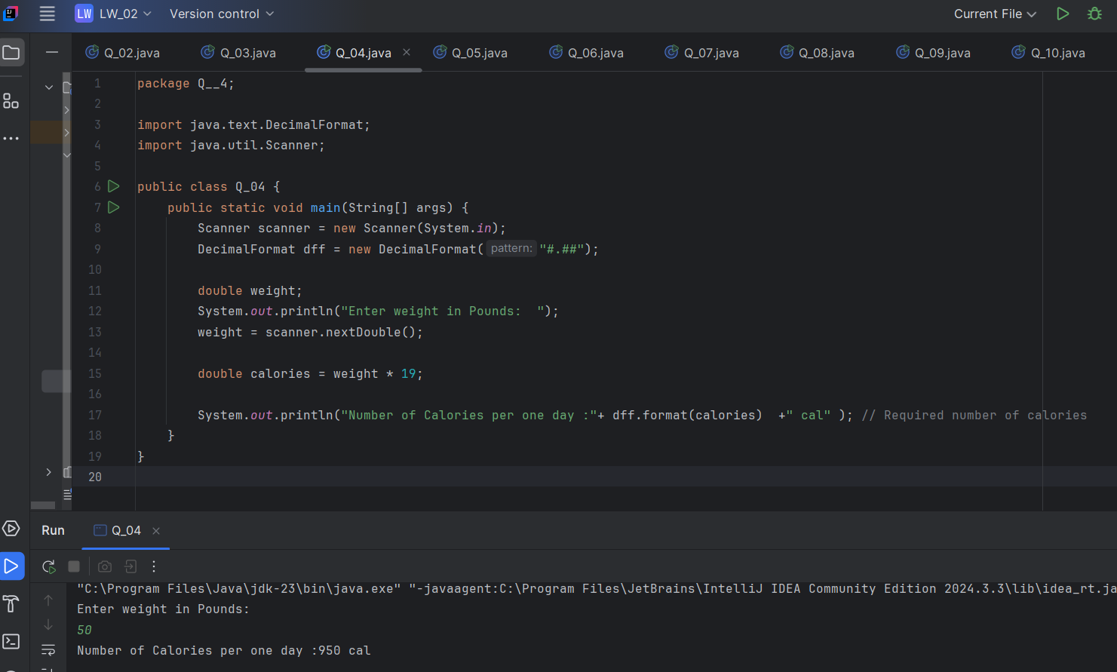

Q5.

Code:

|  |
| --- |
| **package Q__5;  import java.text.DecimalFormat; import java.util.Scanner;  public class Q_05 {  public static void main(String[] args) {  Scanner scanner = new Scanner(System.*in*);  DecimalFormat dff = new DecimalFormat("#.##");   double temper; //Temperature in Fahrenheit  System.*out*.println("Enter Temperature in Fahrenheit (\u00B0F): ");  temper = scanner.nextDouble();   double Celsius = (5.0 / 9.0)*(temper - 32);   System.*out*.println(dff.format(Celsius) + "\u00B0C");  } }** |

Output:

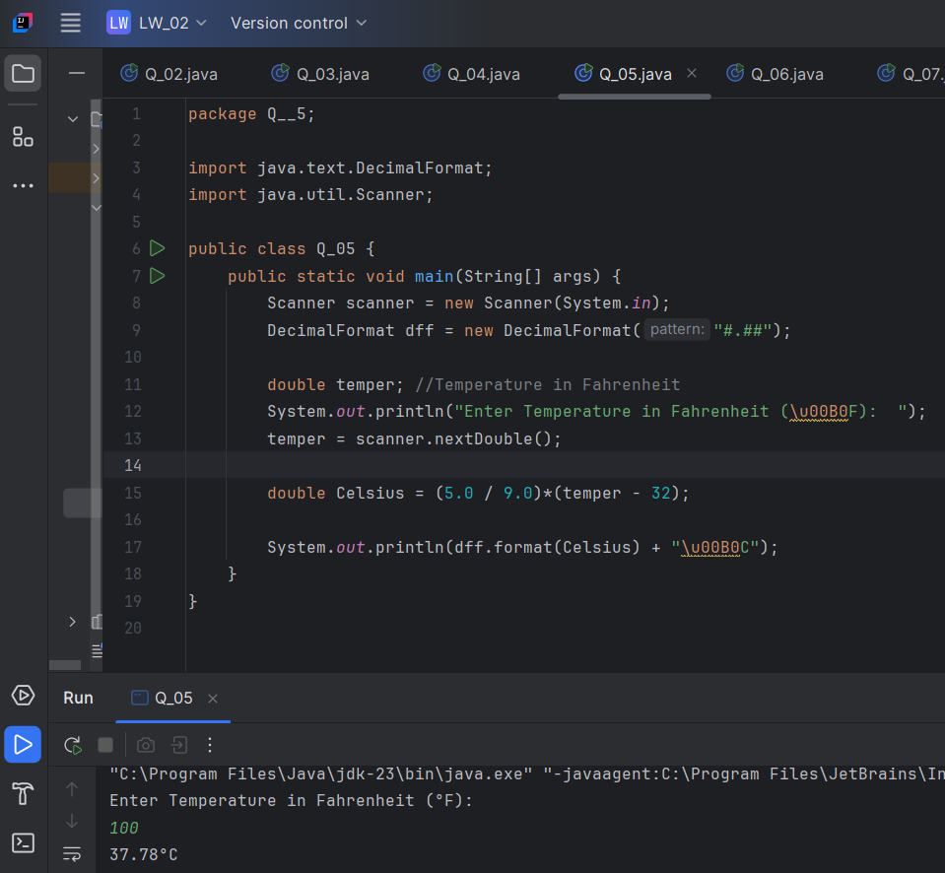

Q6.

Code:

|  |
| --- |
| **package Q__6;  import java.text.SimpleDateFormat; import java.time.Year; import java.util.Date; import java.util.GregorianCalendar; import java.util.Scanner;  public class Q_06 {  public static void main(String[] args) {   GregorianCalendar calendar = new GregorianCalendar();  int current_year = calendar.get(calendar.*YEAR*);   Scanner scanner = new Scanner(System.*in*);  int year;  System.*out*.println("Enter the year you are born : ");  year = scanner.nextInt();   int age = current_year - year;   System.*out*.println("You were born in "+ year+" and will be (are) "+age+" this year.");    } }** |

Output:

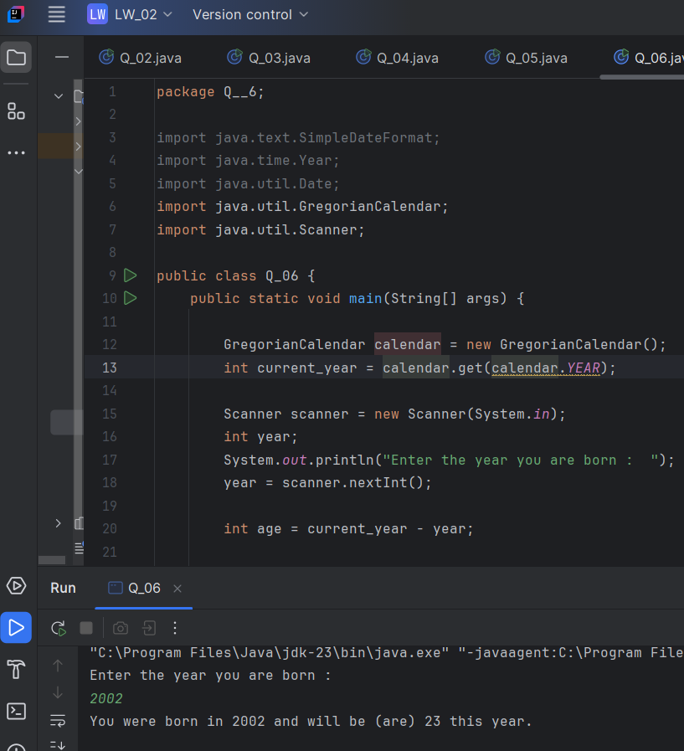

Q7.

Code:

|  |
| --- |
| **package Q__7;  import java.text.DecimalFormat; import java.util.Scanner;  public class Q_07 {  public static void main(String[] args) {  Scanner scanner = new Scanner(System.*in*);  DecimalFormat dff = new DecimalFormat("#.##");   double w; //weight  System.*out*.println("Enter weight in kilograms: ");  w = scanner.nextDouble();   double h; //height  System.*out*.println("Enter height in centimeters: ");  h = scanner.nextDouble();   double BMI = w / Math.*pow*((h / 100.0), 2);  System.*out*.println("Your BMI value is :"+dff.format(BMI)); //BMI value   if (20 <= BMI & BMI<=25){  System.*out*.println("BMI of about 20 to 25 is considered \"normal\"");  }  else {  System.*out*.println("not normal");  }  } }** |

Output:

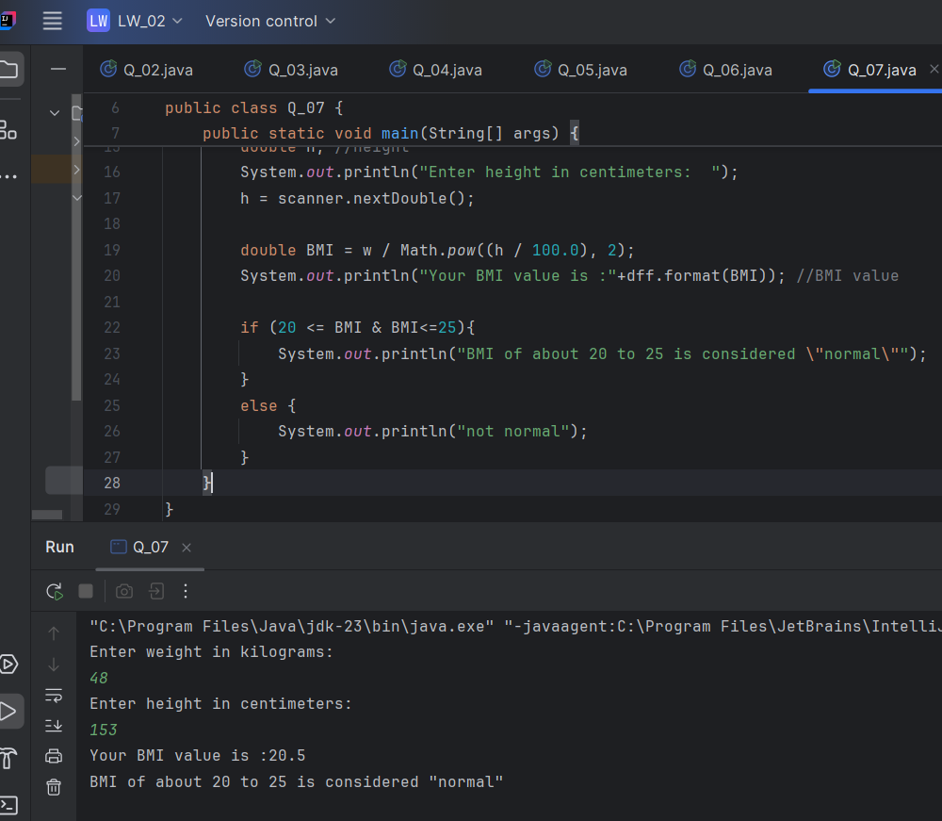

Q8.

Code:

|  |
| --- |
| **package Q__8;  import java.text.DecimalFormat; import java.util.Scanner;  public class Q_08 {  public static void main(String[] args) {  Scanner scanner = new Scanner(System.*in*);  DecimalFormat dff = new DecimalFormat("#.##");   double r; //radius  System.*out*.println("Enter radius in meters: ");  r = scanner.nextDouble();   double pi = Math.*PI*;   double v = ((4.0/3.0)*(pi * Math.*pow*(r,3))); // volume   System.*out*.println("Volume is "+ dff.format(v)+"m\u00B3");  } }** |

Output:

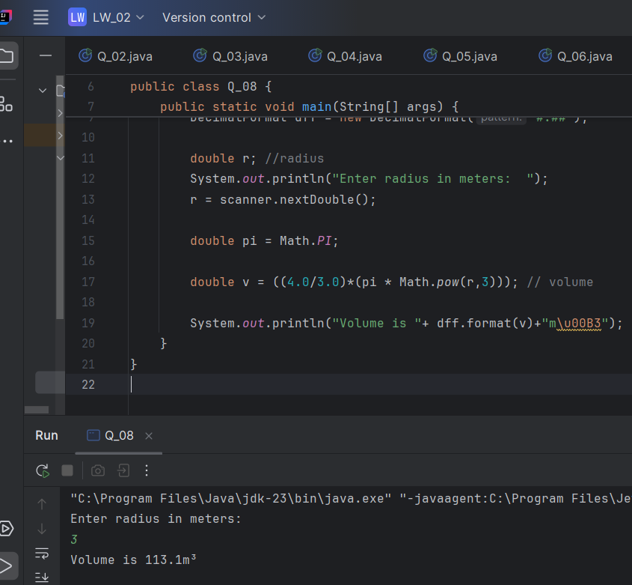

Q9.

Code:

|  |
| --- |
| **package Q__9;  import java.text.DecimalFormat; import java.util.Scanner;  public class Q_09 {  public static void main(String[] args) {  Scanner scanner = new Scanner(System.*in*);  DecimalFormat dff = new DecimalFormat("#.##");  double P ; // Principal amount  double R ; // Interest rate  double N; // Number of years   System.*out*.println("Enter Principal amount: Rs ");  P = scanner.nextDouble();   System.*out*.println("Enter thr interest rate(%): ");  R = scanner.nextDouble();   System.*out*.println("Enter the number of years: ");  N = scanner.nextDouble();   double rate= R/100.0; // rate in decimal form   double F = P*(Math.*pow*((1+rate),N));   double earn = F - P; // Amount of money earned   System.*out*.println("Amount of money earned:Rs "+ dff.format(earn));  } }** |

Output:

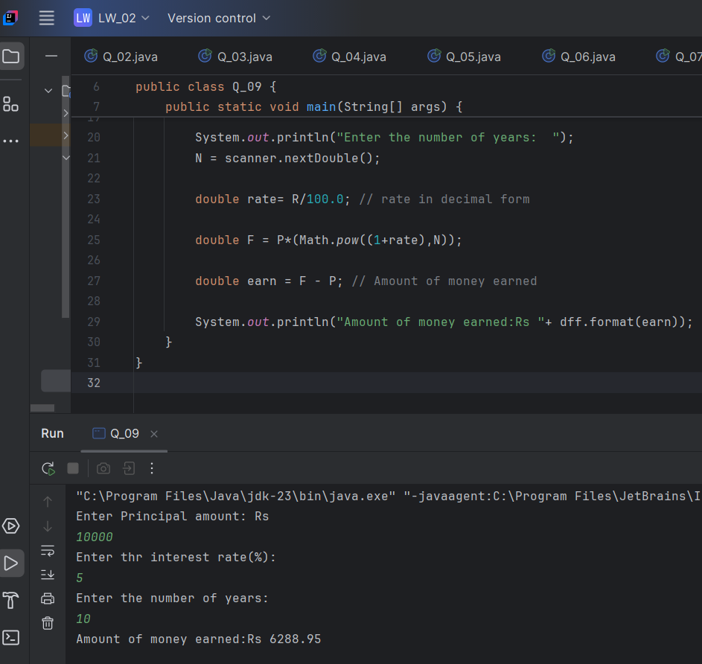

Q10.

Code:

|  |
| --- |
| **package Q__10;  import java.text.DecimalFormat; import java.util.Scanner;  public class Q_10 {  public static void main(String[] args) {  Scanner scanner = new Scanner(System.*in*);  DecimalFormat dff = new DecimalFormat("#.##");   double L ; // Loan amount  double P; // annual interest rate  double T; // time period   System.*out*.println("Enter the loan amount: Rs ");  L = scanner.nextDouble();   System.*out*.println("Enter the annual interest rate (%): ");  P = scanner.nextDouble();   System.*out*.println("Enter the loan period in years: ");  T = scanner.nextDouble();   double monthlyInterestRate = P / 100.0 / 12;  double numberofPayments = T * 12;  double monthlyPayment = (L * monthlyInterestRate) / (1 - Math.*pow*(1 / (1 + monthlyInterestRate),numberofPayments));  double totalPayment = monthlyPayment * numberofPayments;    System.*out*.println("Monthly Payment: Rs " + dff.format(monthlyPayment) ); // Monthly payment  System.*out*.println("Total Payment: Rs "+dff.format(totalPayment) ); // Total payment  } }** |

Output:

