Q1.

Code:

|  |
| --- |
| **package Q_01;**  **import javax.swing.*;**  **public class Q1 {**  **public static void main(String[] args) {**  **JFrame frame = new JFrame();**  **frame.setSize(800,600);**  **frame.setTitle("Welcome to Java");**  **frame.setVisible(true);**  **}**  **}** |

Output:

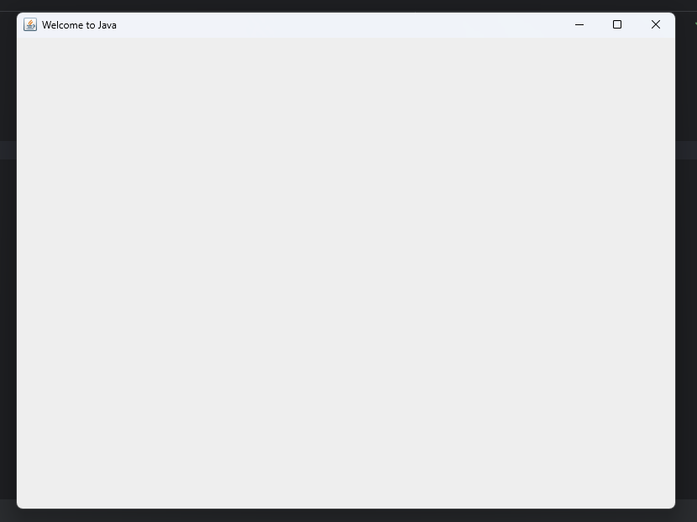

Q2.

Code:

|  |
| --- |
| **package Q_02;**  **import javax.swing.*;**  **import java.util.*;**  **public class Q2 {**  **public static void main(String[] args) {**  **Scanner scanner = new Scanner(System.in);**  **System.out.println("Enter first name: ");**  **String firtsname = scanner.next();**  **System.out.println("Enter last name: ");**  **String lastname = scanner.next();**  **System.out.println(firtsname + " "+ lastname);**  **JFrame frame = new JFrame();**  **frame.setSize(300,150);**  **frame.setTitle(firtsname + " " + lastname);**  **frame.setVisible(true);**  **}**  **}** |

Output:

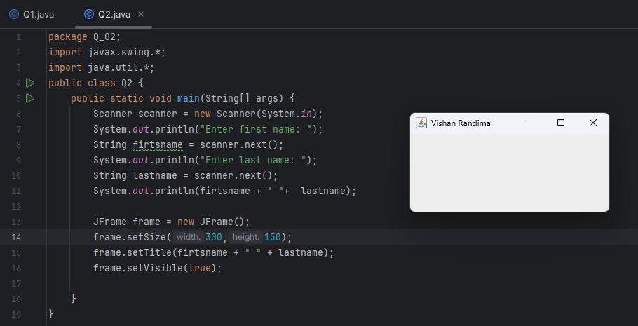

Q3.

Code:

|  |
| --- |
| **package Q_03;**  **import java.util.Scanner;**  **public class Q3 {**  **public static void main(String[] args) {**  **Scanner scanner = new Scanner(System.in);**  **System.out.println("Enter first name: ");**  **String firstname = scanner.next();**  **System.out.println("Enter middle name: ");**  **String middlename = scanner.next();**  **System.out.println("Enter last name: ");**  **String lastname = scanner.next();**  **String initial = middlename.substring(0,1);**  **System.out.println(firstname +" "+ initial + ". " + lastname );**  **}**  **}** |

Output:

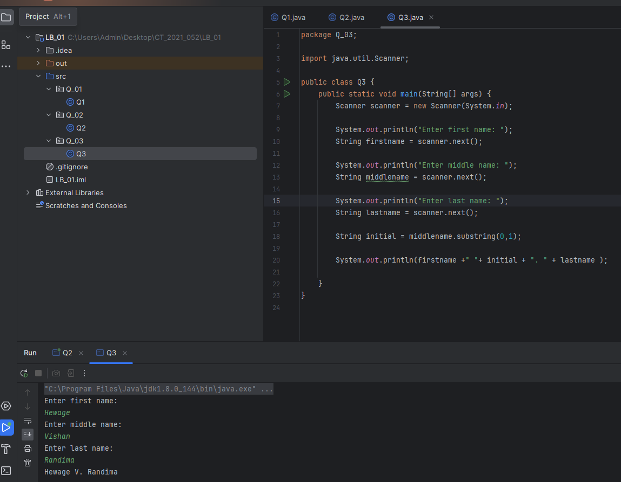

Q4.

Code:

|  |
| --- |
| **package Q_04;**  **import java.text.SimpleDateFormat;**  **import java.util.*;**  **public class Q4 {**  **public static void main(String[] args) {**  **Date today;**  **today = new Date();**  **SimpleDateFormat sdf = new SimpleDateFormat("dd MMM yyyy");**  **System.out.println(sdf.format(today));**  **}**  **}** |

Output:

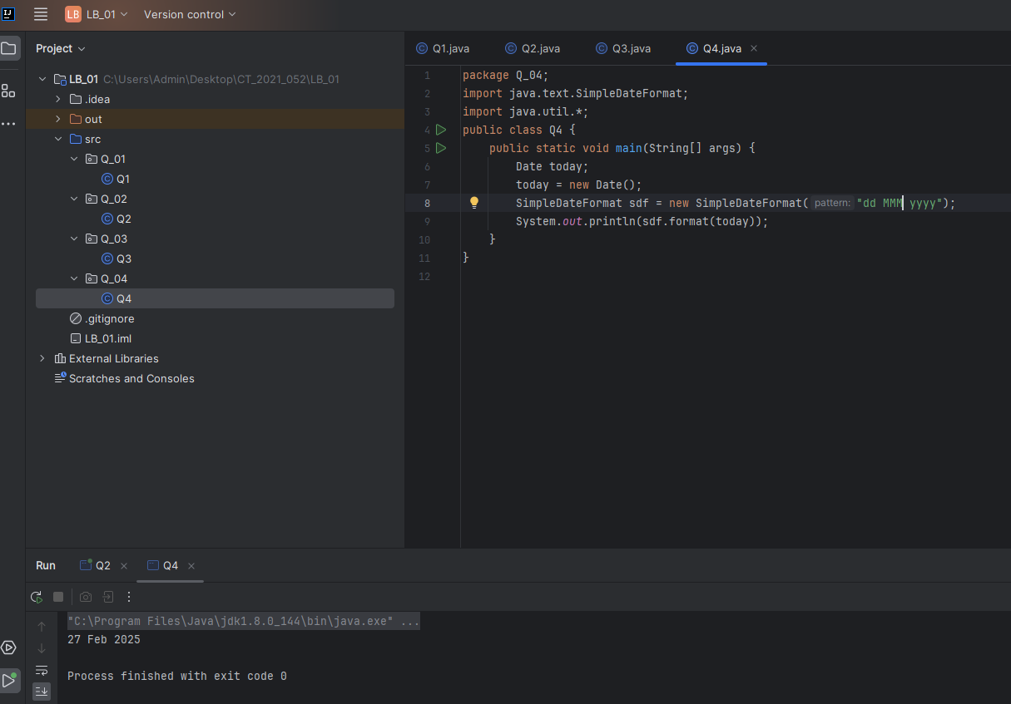

Q5.

Code:

|  |
| --- |
| **package Q_04;**  **import java.text.SimpleDateFormat;**  **import java.util.*;**  **public class Q4 {**  **public static void main(String[] args) {**  **Date today;**  **today = new Date();**  **SimpleDateFormat sdf = new SimpleDateFormat("EEEE, MMM dd, yyyy");**  **System.out.println(sdf.format(today));**  **}**  **}** |

Output:

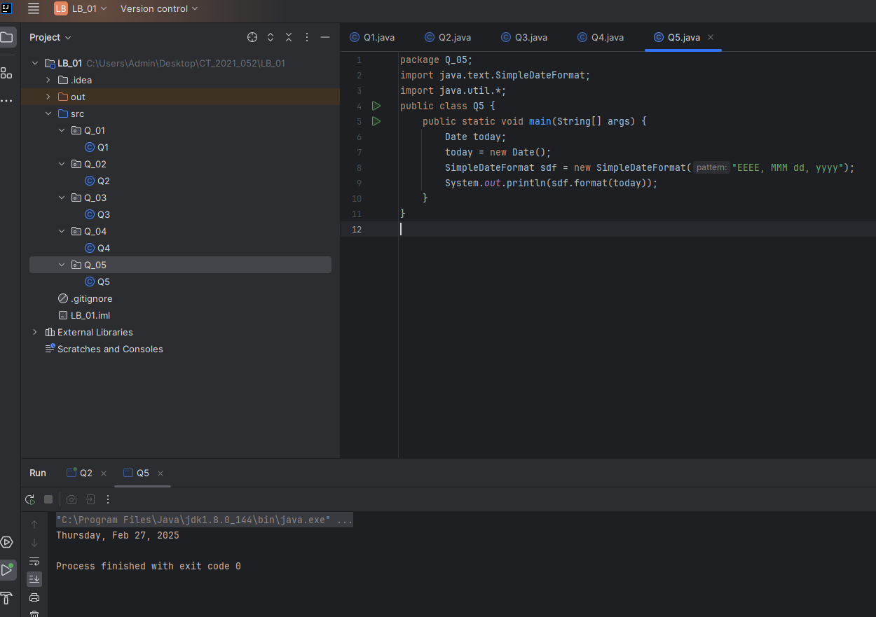

Q6.

Code:

|  |
| --- |
| **package Q_06;**  **import javax.swing.*;**  **import java.util.Scanner;**  **public class Q6 {**  **public static void main(String[] args) {**  **Scanner scanner = new Scanner(System.in);**  **System.out.println("Enter the Title: ");**  **String title = scanner.next();**  **System.out.println("Enter the value for Width: ");**  **int W = scanner.nextInt();**  **System.out.println("Enter the value for Height: ");**  **int H = scanner.nextInt();**  **JFrame frame = new JFrame();**  **frame.setSize(W,H);**  **frame.setTitle(title);**  **frame.setVisible(true);**  **}**  **}** |

Output:

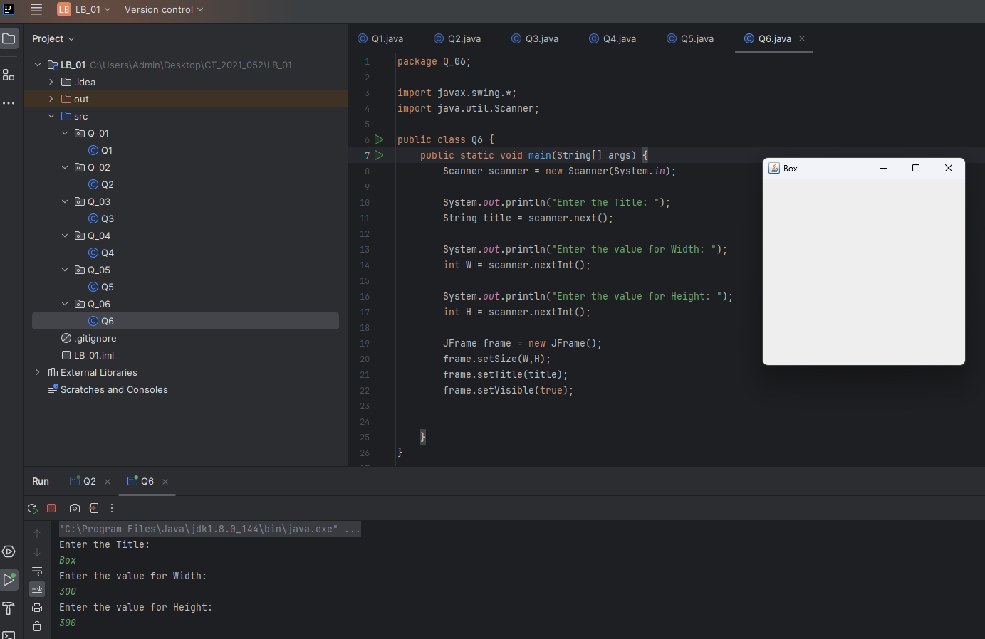

Q7.

Code:

|  |
| --- |
| **package Q_07;**  **import javax.swing.*;**  **import java.text.SimpleDateFormat;**  **import java.util.Date;**  **import java.util.Scanner;**  **public class Q7 {**  **public static void main(String[] args) {**  **Date today = new Date();**  **SimpleDateFormat sdf1 = new SimpleDateFormat("HH:mm:ss a");**  **Scanner scanner = new Scanner(System.in);**  **System.out.println("Enter the value for Width: ");**  **int W = scanner.nextInt();**  **System.out.println("Enter the value for Height: ");**  **int H = scanner.nextInt();**  **JFrame frame = new JFrame();**  **frame.setSize(W,H);**  **frame.setTitle(sdf1.format(today));**  **frame.setVisible(true);**  **}**  **}** |

Output:

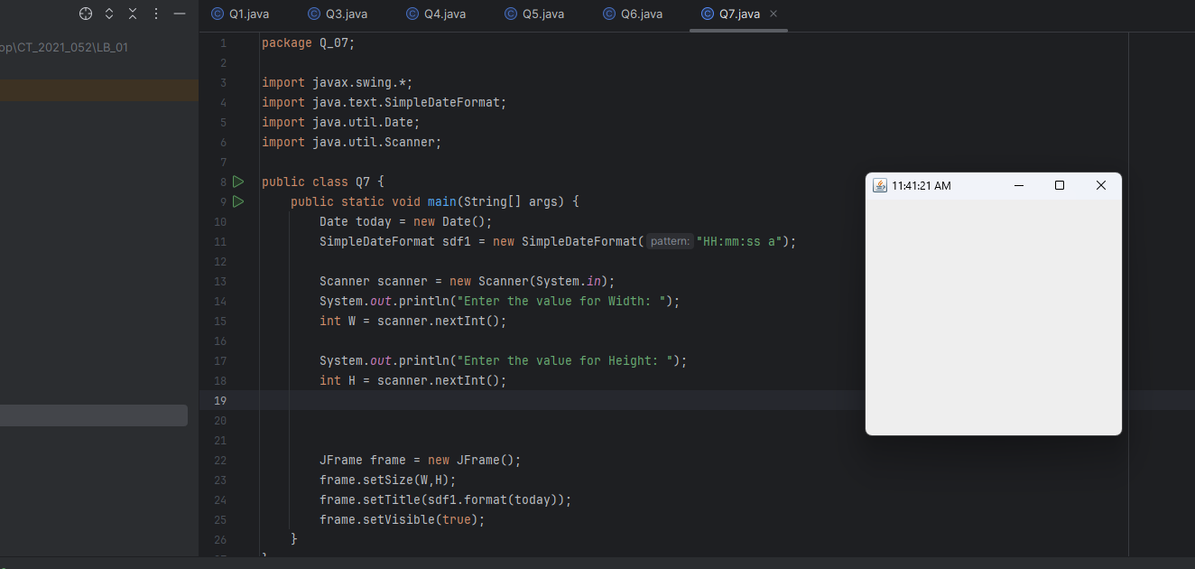

Q8.

Code:

|  |
| --- |
| **package Q_8;**  **import java.util.Scanner;**  **public class Q8 {**  **public static void main(String[] args) {**  **Scanner scanner = new Scanner(System.in);**  **System.out.println("Enter text: ");**  **String text = scanner.nextLine();**  **int exclamation = text.indexOf("!");**  **System.out.println(text.substring(0,exclamation));**  **System.out.println(text.substring(exclamation + 1));**  **}**  **}** |

Output:

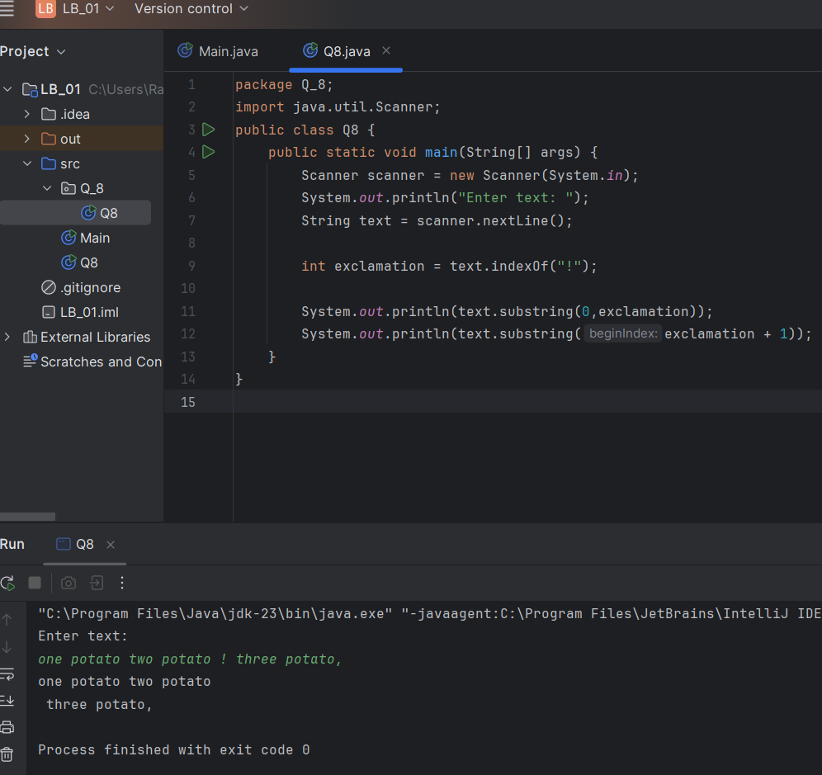

Q9.

Code:

|  |
| --- |
| **package Q_09;**  **import java.util.Scanner;**  **public class Q9 {**  **public static void main(String[] args) {**  **Scanner scanner = new Scanner(System.in);**  **System.out.println("Enter text: ");**  **String text = scanner.nextLine();**  **int length = text.length();**  **String first_letter = text.substring(0,1);**  **String last_letter = text.substring(length-1);**  **System.out.println(length);**  **System.out.println(first_letter);**  **System.out.println(last_letter);** |

Output:

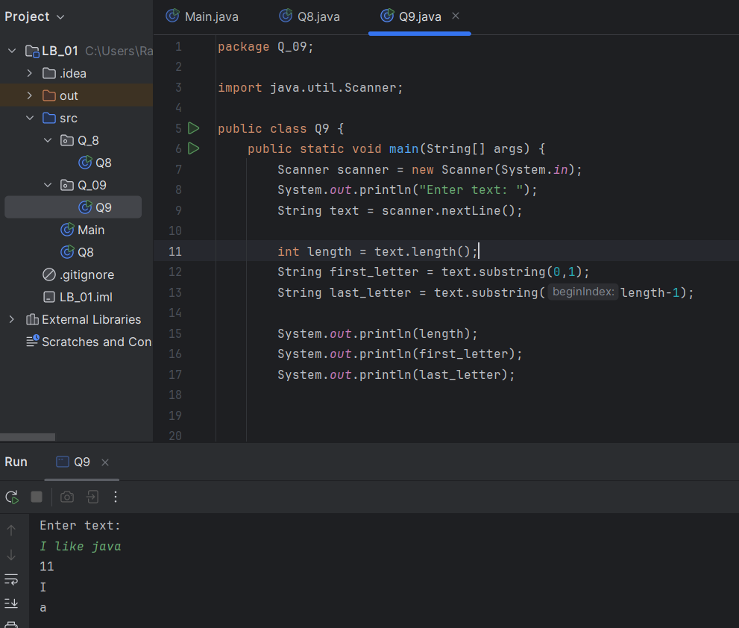

Q10.

Code:

|  |
| --- |
| **package Q_10;**  **import java.util.Scanner;**  **public class Q10 {**  **public static void main(String[] args) {**  **Scanner scanner = new Scanner(System.in);**  **System.out.println("Enter text: ");**  **String text = scanner.nextLine();**  **int length = text.length();**  **int middle = (length/2);**  **System.out.println(text.substring (middle,middle+1));**  **}**  **}** |

Output:

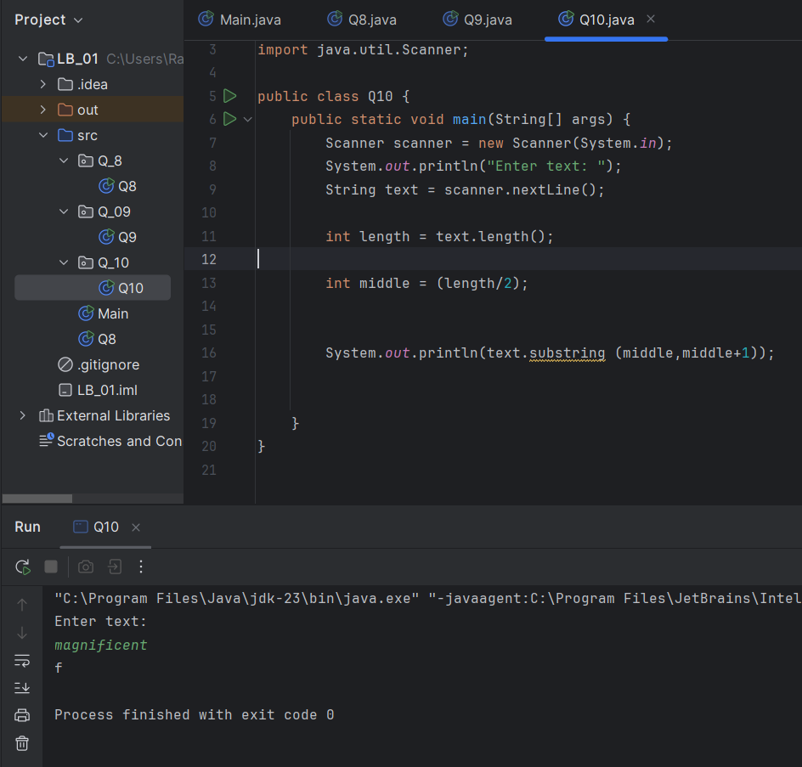

Q11.

Code:

|  |
| --- |
| **package Q_11;**  **import java.util.Scanner;**  **public class Q11 {**  **public static void main(String[] args) {**  **Scanner scanner = new Scanner(System.in);**  **System.out.println("Firts name: ");**  **String firstname = scanner.nextLine();**  **System.out.println("Middle name: ");**  **String middlename = scanner.nextLine();**  **System.out.println("Lasts name: ");**  **String lastname = scanner.nextLine();**  **String initial = middlename.substring(0,1);**  **System.out.println(lastname +", "+ firstname +" "+ initial + ".");**  **}**  **}** |

Output:

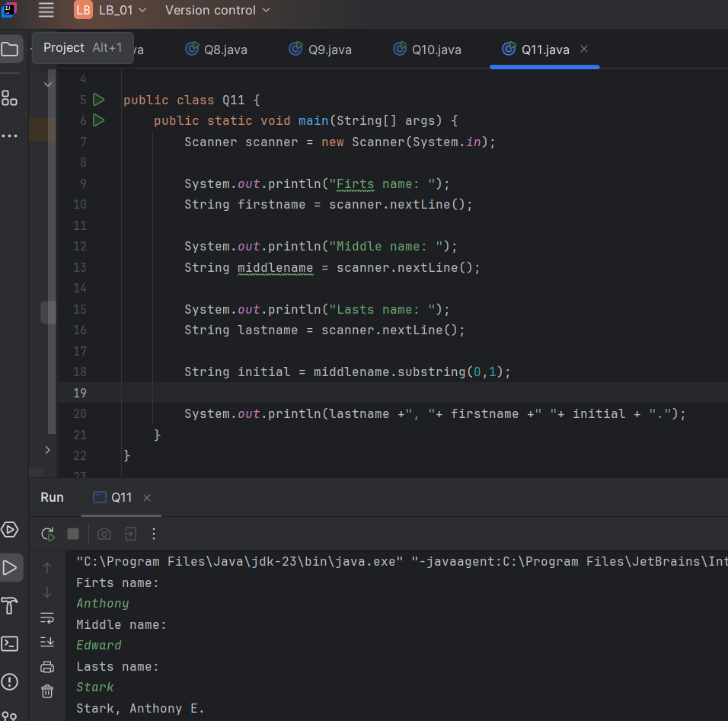

Q12.

Code:

|  |
| --- |
| **package Q_12;**  **import javax.swing.*;**  **public class Q12 {**  **public static void main(String[] args) {**  **JFrame frame = new JFrame();**  **frame.setSize(300, 200);**  **frame.setTitle("My First Frame");**  **frame.setVisible(true);**  **frame.setLocation(50, 100);**  **}**  **}** |

Output:

