

Agile Development Process And
Devops

Theory Project
Reg.No:23MIS0614
Name: Pothiprajan K
Course Code: ISWE406P
Faculty Name: Balaganesh N
Due Date: 08/04/2026

20. Trading Simulation System
Problem Statement:
Ensure correct trade execution and calculations.
Tasks:
- Develop trading logic
- Write JUnit tests for trades
- CI/CD pipeline for automated deployment
- Deploy on Kubernetes
Real-world relevance: Stock market apps

Problem Statement:
In modern financial markets, accurate trade execution and profit/loss calculation are critical to any stock market application. Errors in trade logic can lead to significant financial losses and loss of user trust.
This project ensures correct trade execution and calculation validation by simulating buy/sell trades, computing portfolio values, and automating testing and deployment using CI/CD and Kubernetes.

Objective:
Build a system that:
- Simulates buy and sell trades
- Calculates profit/loss and portfolio value
- Validates incorrect or invalid trade inputs
- Uses JUnit testing to verify trading logic
- Uses Jenkins CI/CD pipeline for automation
- Deploys application on Kubernetes
- Reflects real-world stock market application requirements

Real-World Relevance:
This project is highly useful in:
- Stock market trading platforms
- Algorithmic trading systems
- Fintech application development
- Portfolio management tools
- Investment simulation and back-testing tools

Example Use Cases:
- Simulating buy/sell orders and verifying profit margins
- Preventing incorrect trade deployments
- Monitoring trade execution accuracy in real time
- Validating investment strategies before going live

Functional Requirements:
The system should:
- Accept stock name, quantity, and price per share
- Simulate buy and sell transactions
- Calculate total trade value and profit/loss
- Handle invalid inputs (negative quantity, zero price, etc.)
- Provide full JUnit test coverage for all trade scenarios
- Automatically build, test, and deploy via Jenkins pipeline

Project Modules:
The project contains:
- Trade Execution Module
- Validation Module
- JUnit Testing Module
- CI/CD Pipeline Module
- Docker Containerization
- Kubernetes Deployment

Suggested Project Structure:
trading-simulation-system/
├── src/
│ ├── main/java/com/example/trading/
│ │ ├── TradeSimulator.java
│ │ └── App.java
│ └── test/java/com/example/trading/
│ └── AppTest.java
├── pom.xml
├── Dockerfile
├── deployment.yaml
└── README.md

CI/CD Workflow Explanation:
The CI/CD workflow begins when the developer writes or updates the application code and pushes it to the GitHub repository. Once the code is available, Jenkins starts the pipeline process.
Jenkins first clones the latest source code from GitHub. After fetching the code, Maven is used to compile the Java application and verify the build.
Next, JUnit test cases are executed to verify trade execution accuracy and invalid input handling. If all tests pass, Maven then packages the application into a JAR file.
After packaging, Docker builds a container image. The image is then deployed to Kubernetes, where deployment files create the Deployment, Pod, and Service. The application then becomes available inside the Kubernetes cluster through the exposed service.
This workflow ensures continuous integration, continuous testing, and continuous deployment of the Trading Simulation System.

Testing Strategy

JUnit Tests Covered

a) Trade Execution Accuracy
Checks whether trade calculation gives correct profit/loss values.

b) Invalid Input Values
Checks:
- quantity = 0 or quantity < 0
- price = 0 or price < 0
- sell price < buy price (loss scenario)
This ensures the system is safe and reliable.

Non-Functional Requirements
The system should be:
- Accurate
- Reliable
- Scalable
- Maintainable
- Testable
- Deployable automatically

Advantages of This Project
- Simple and practical
- Easy to test
- Industry-relevant
- Useful for DevOps demonstration
- Good for academic project and viva
- Shows knowledge of: Java, Maven, JUnit, Jenkins, Docker, and Kubernetes

Limitations
Current version may not include:
- Real-time market data integration
- User authentication and account management
- Trade history and persistent database storage
- Advanced charting and analytics dashboard
- Multi-user support

Output
Step 1: Install Docker Desktop, enable Kubernetes, enable three plugins (Docker, Docker Pipeline, Kubernetes CLI) and install them:

Docker:

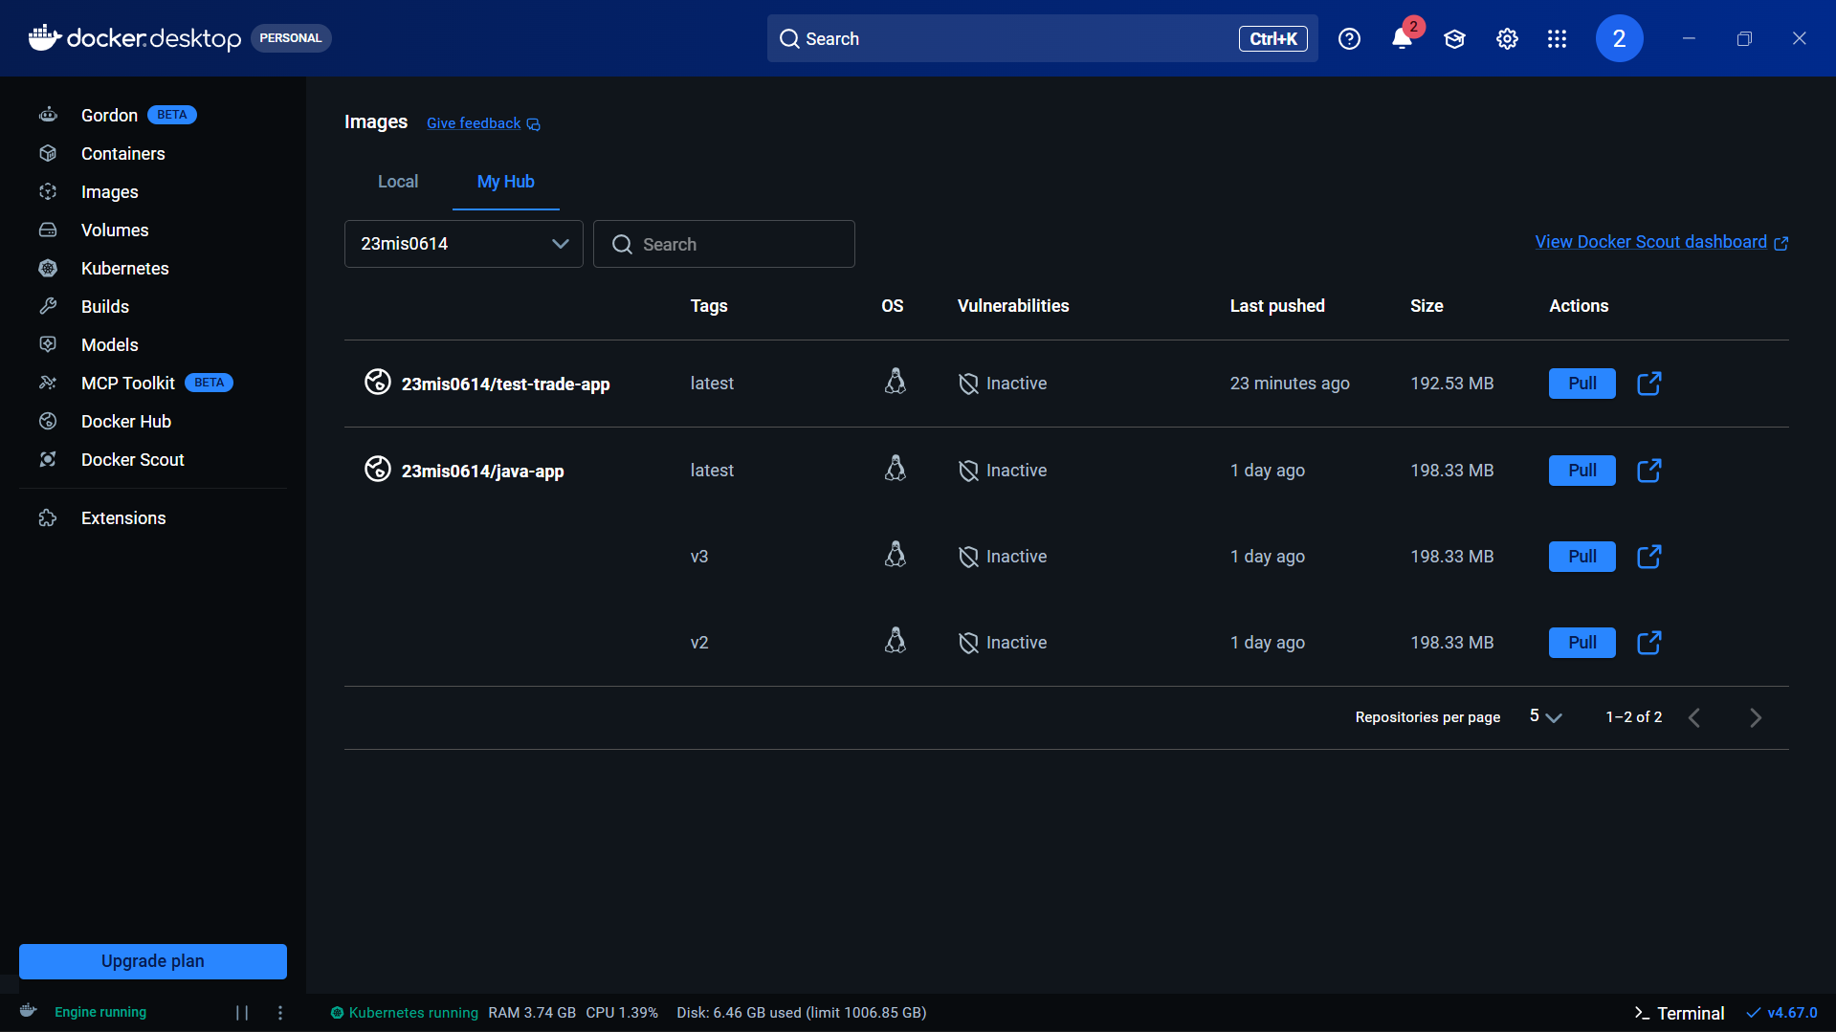

Kubernetes:
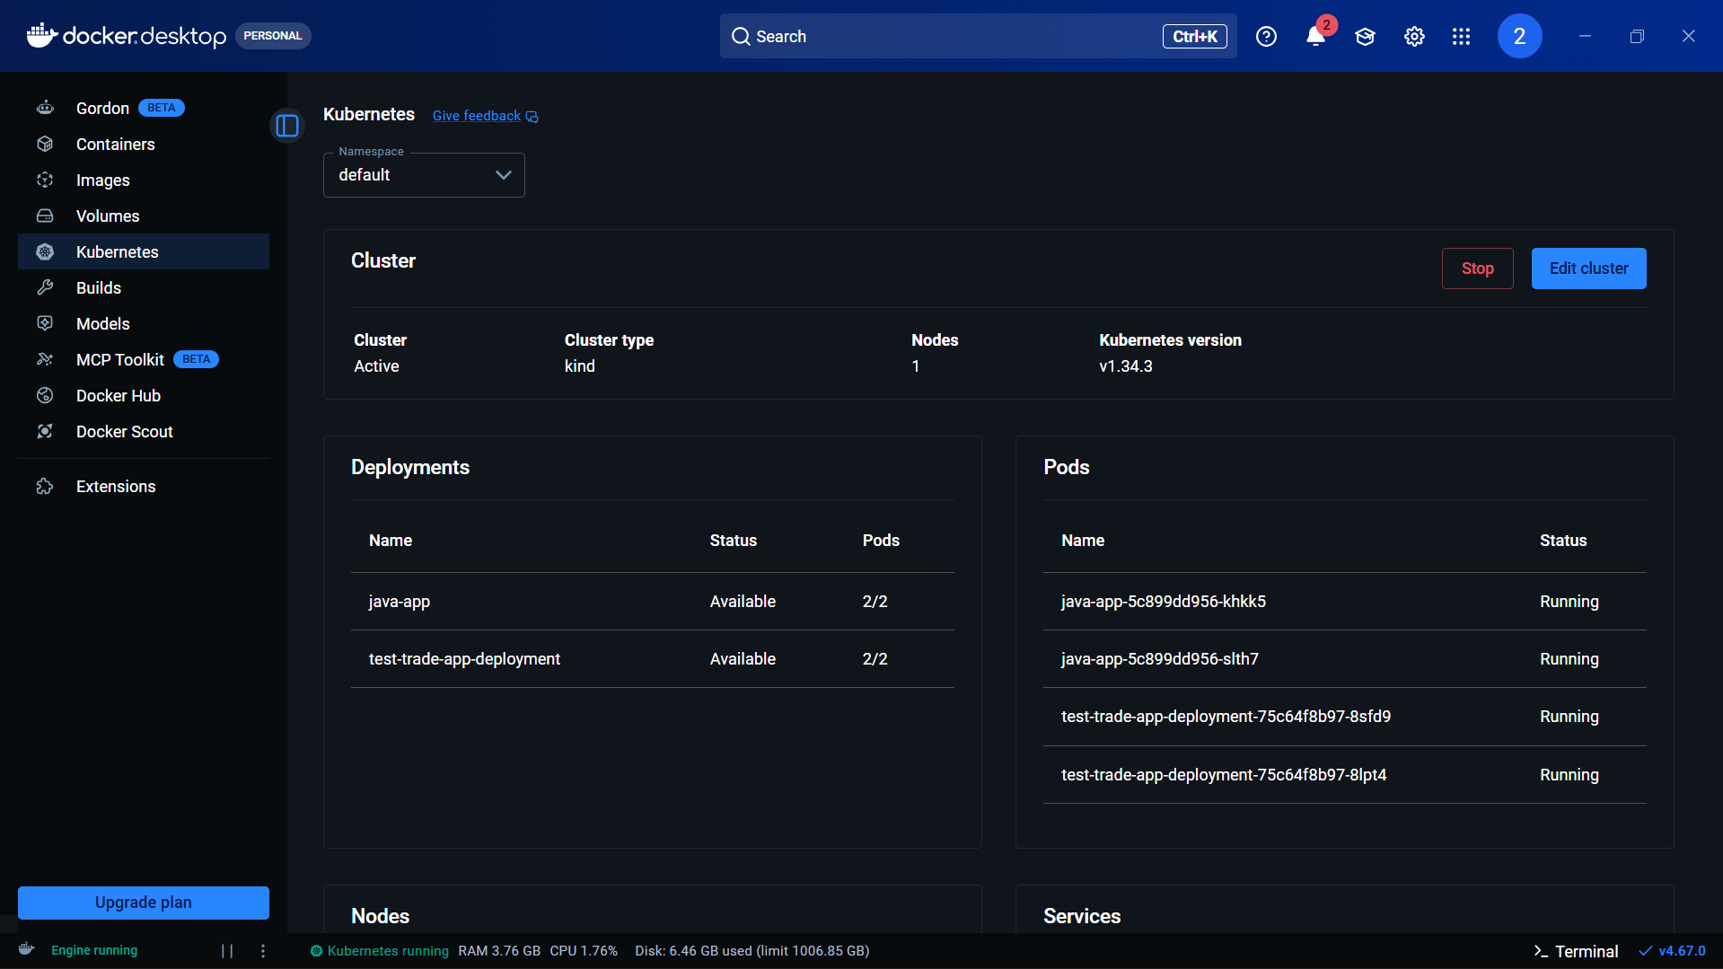

Plugin Installation:
Docker:
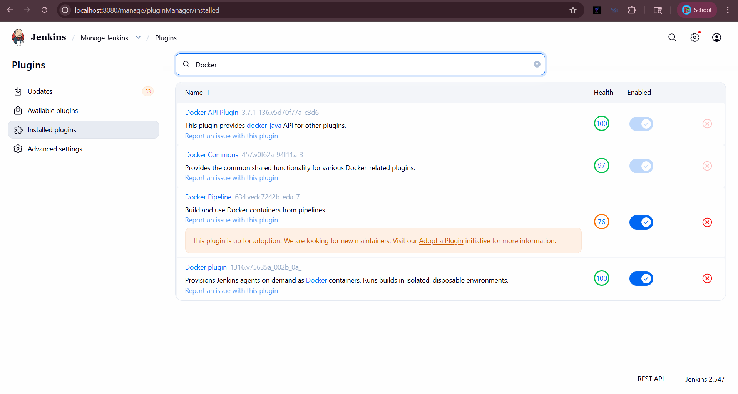

Kubernetes:
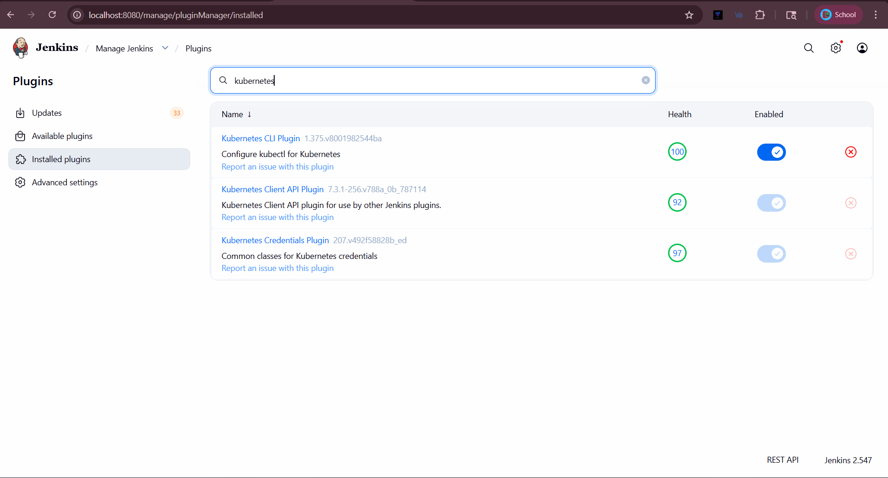

Step 2 - Create Simple Java Application (in local machine)

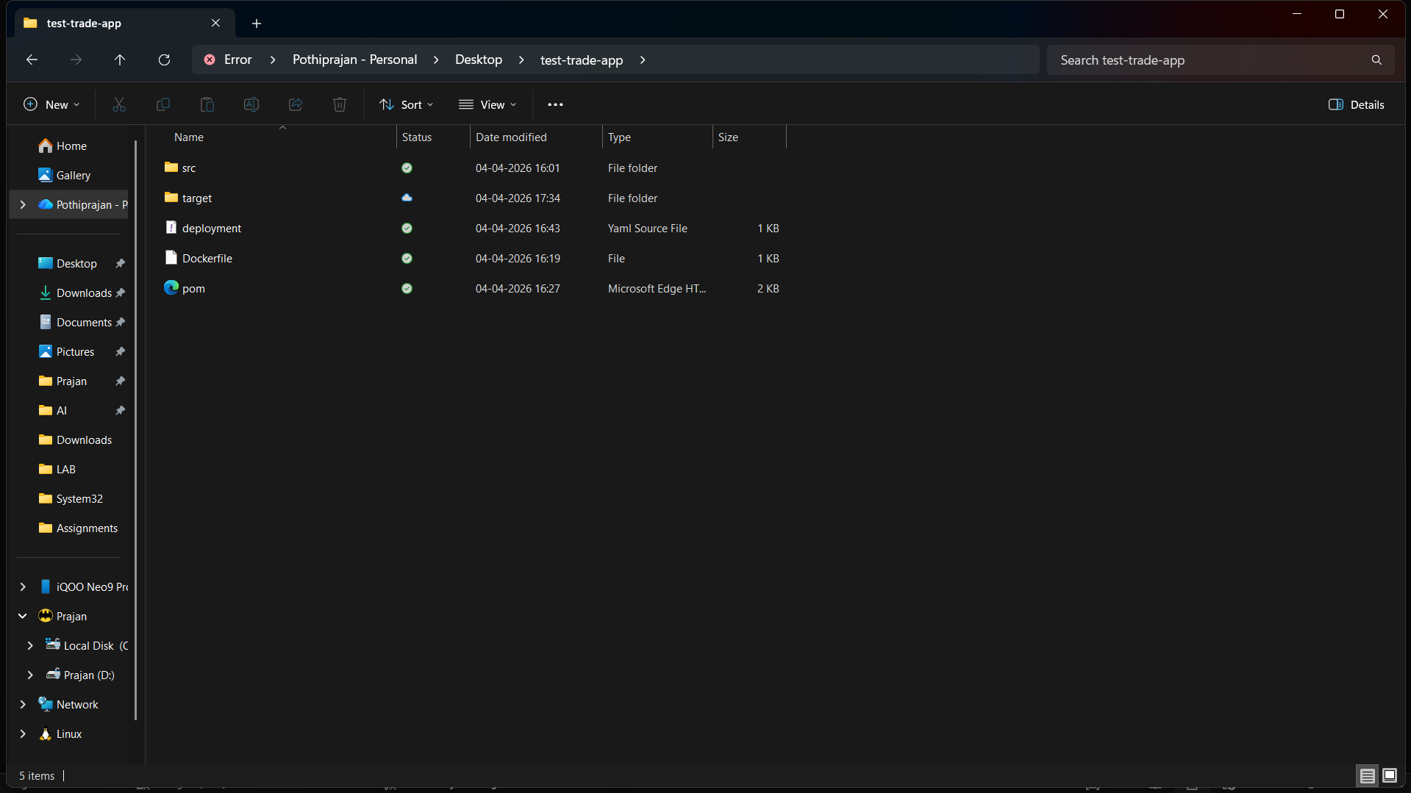
App.java:
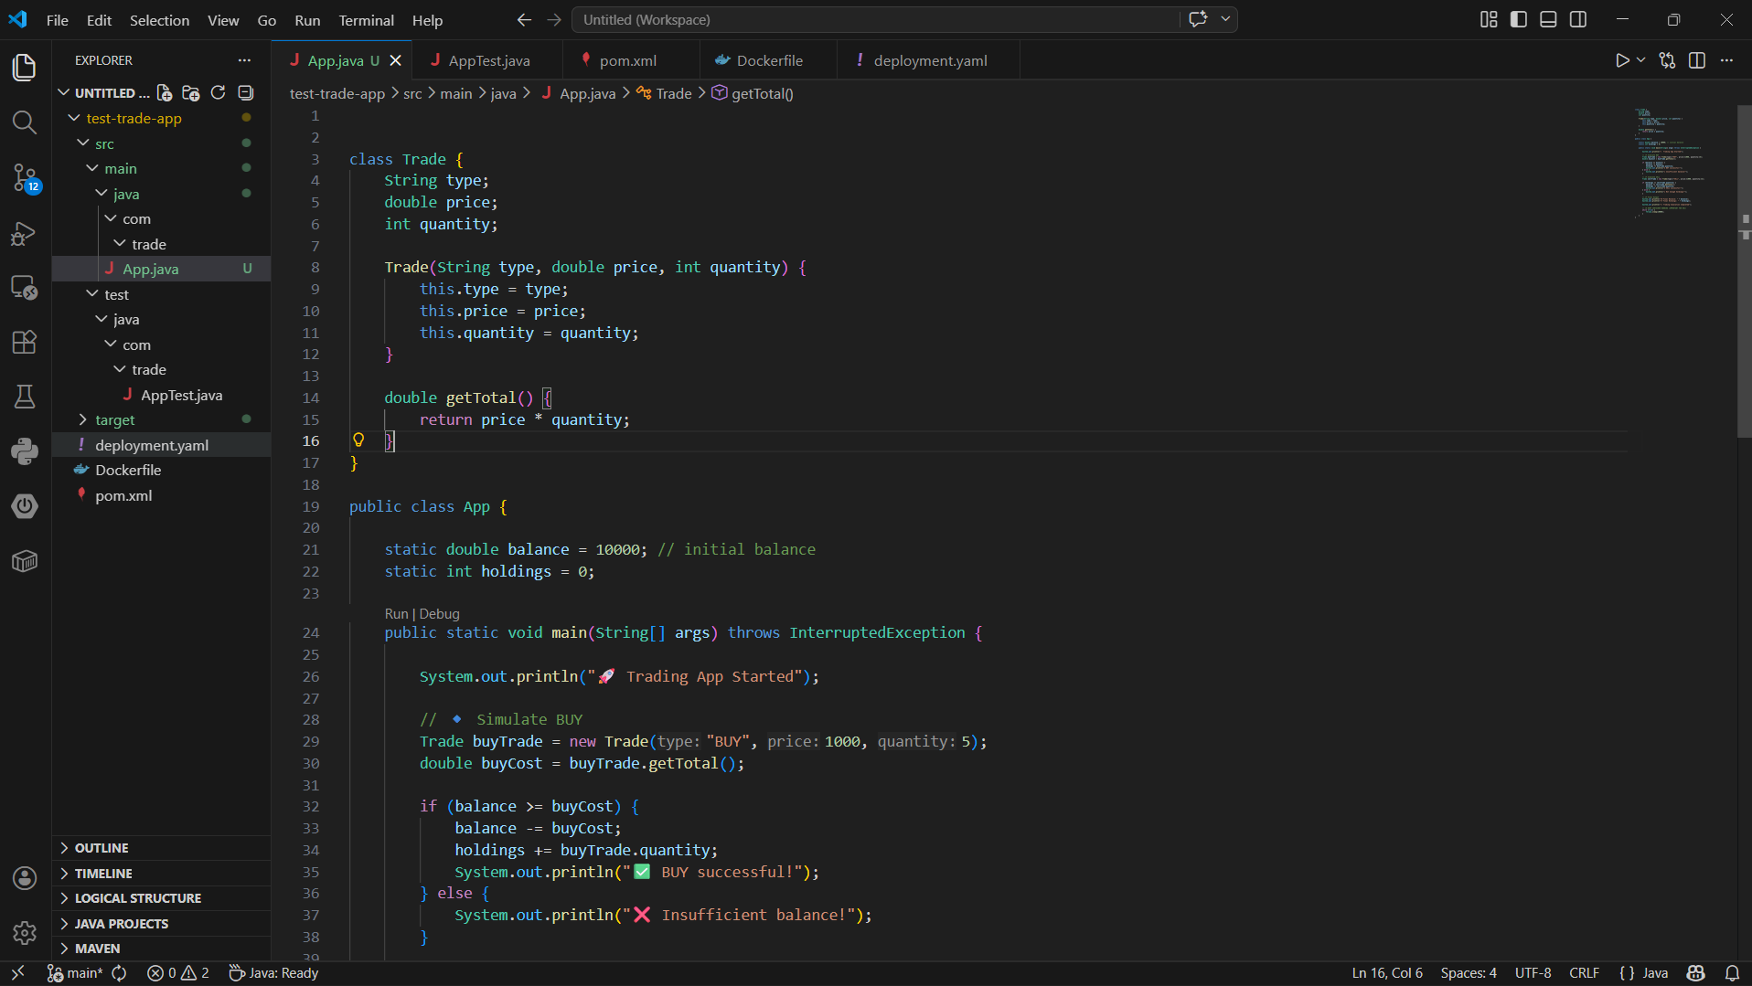

AppTest.java:
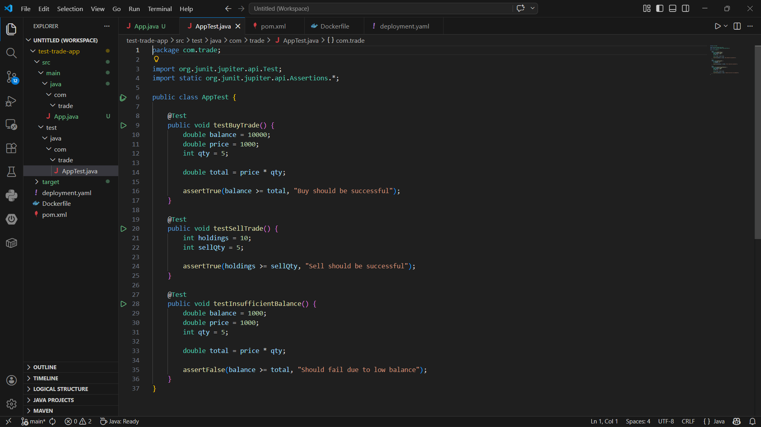

Creating Maven File(pom.xml):
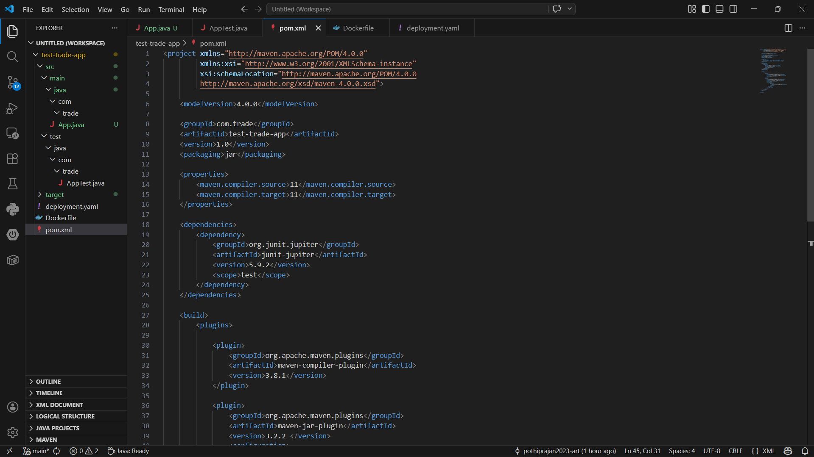

Step 3 - Build Locally using Maven (Test):
Running
- mvn clean test
- mvn clean package

mvn clean test: 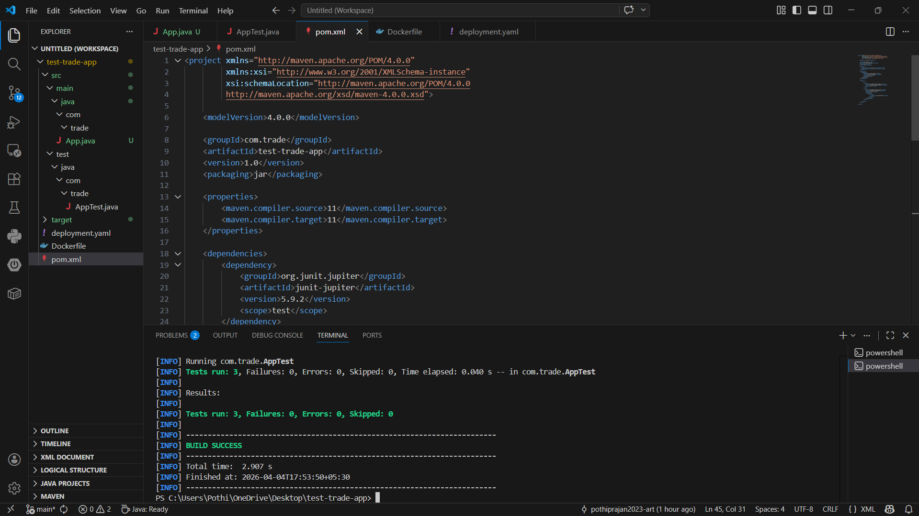

mvn clean package:
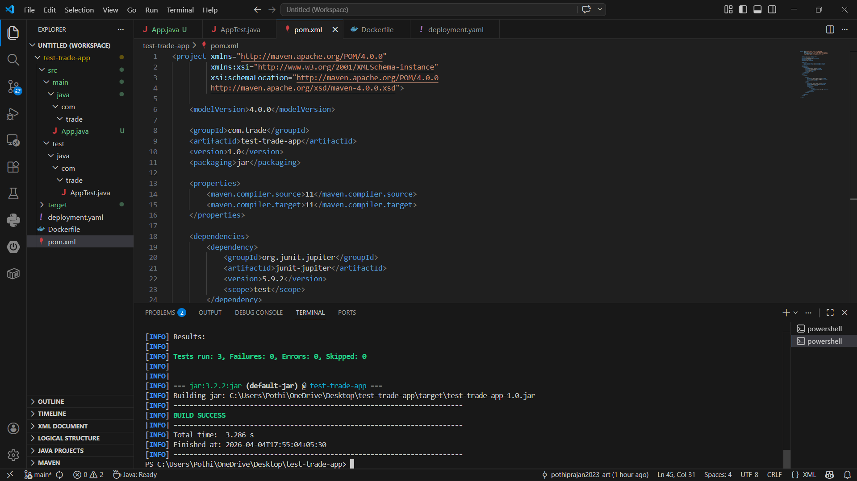

Generating Target File:

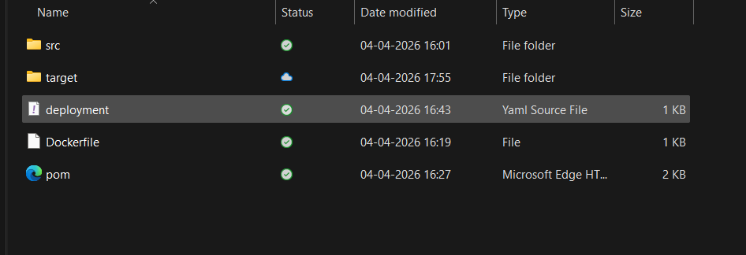

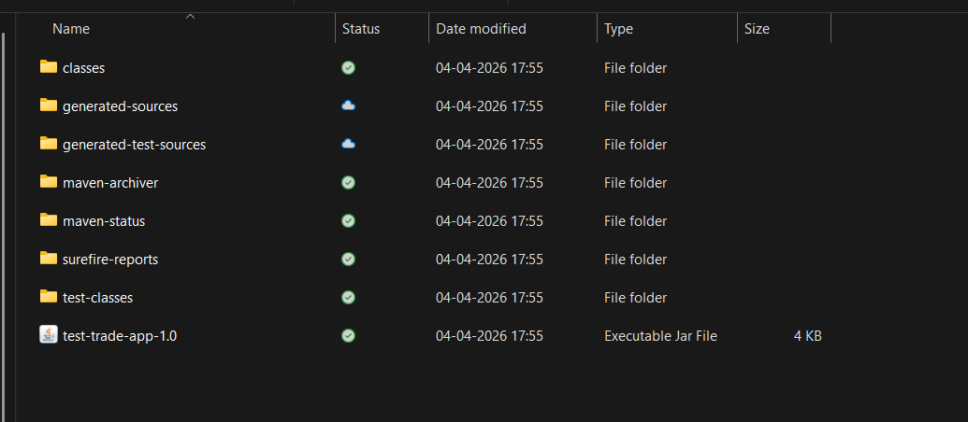

Step 4 - Create Dockerfile:
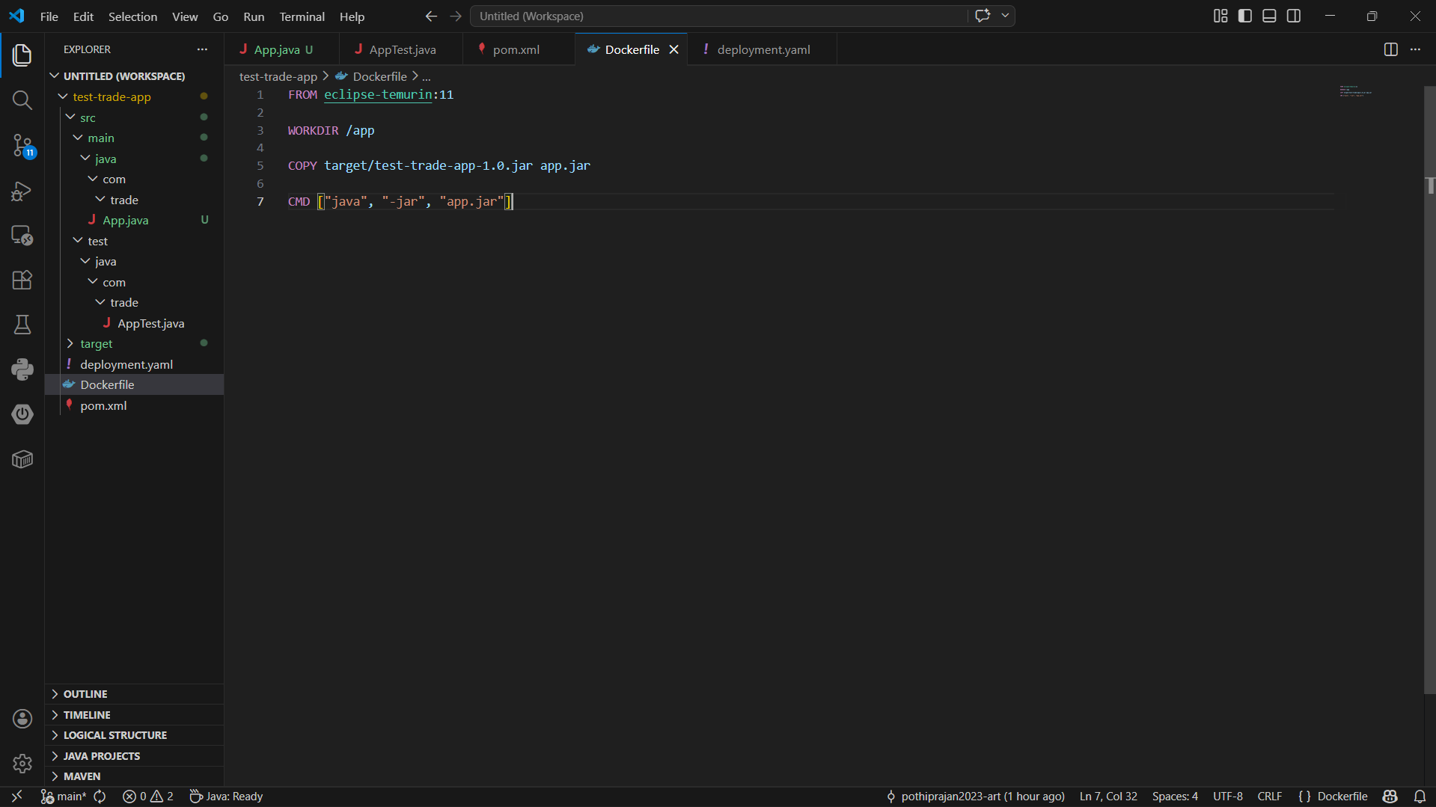

Step 5 - Create Kubernetes Deployment File:
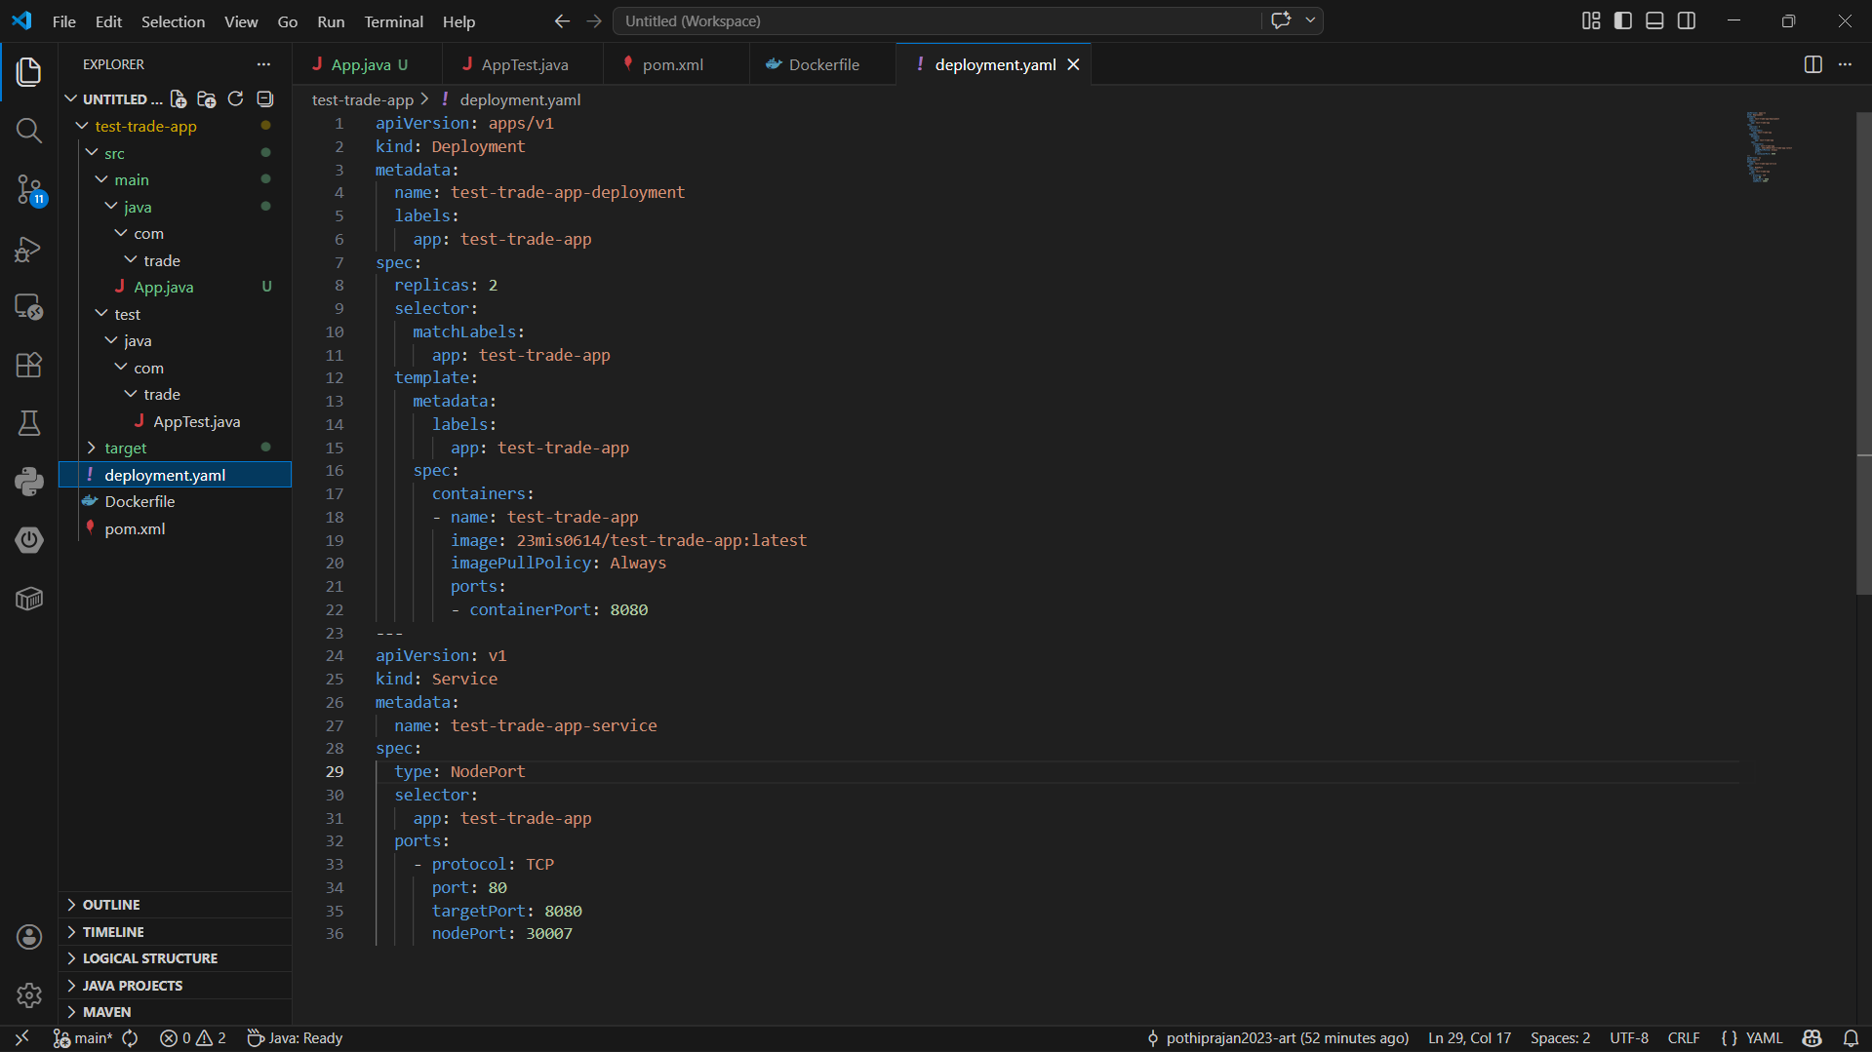

Step 6 - Push Code to GitHub:
After pushing the code to Git:
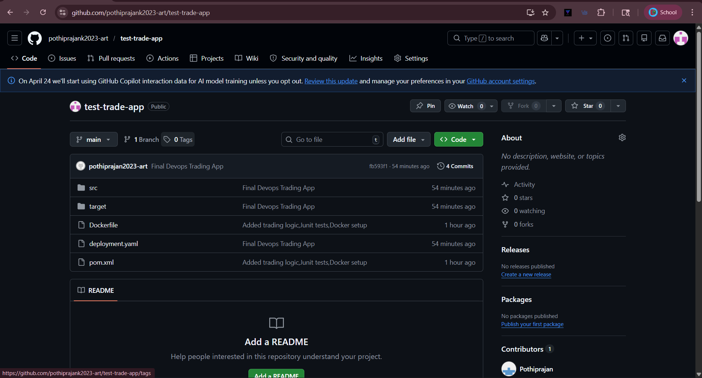

Step 7 - Create Jenkins Pipeline Job:
Creation of pipeline with script:
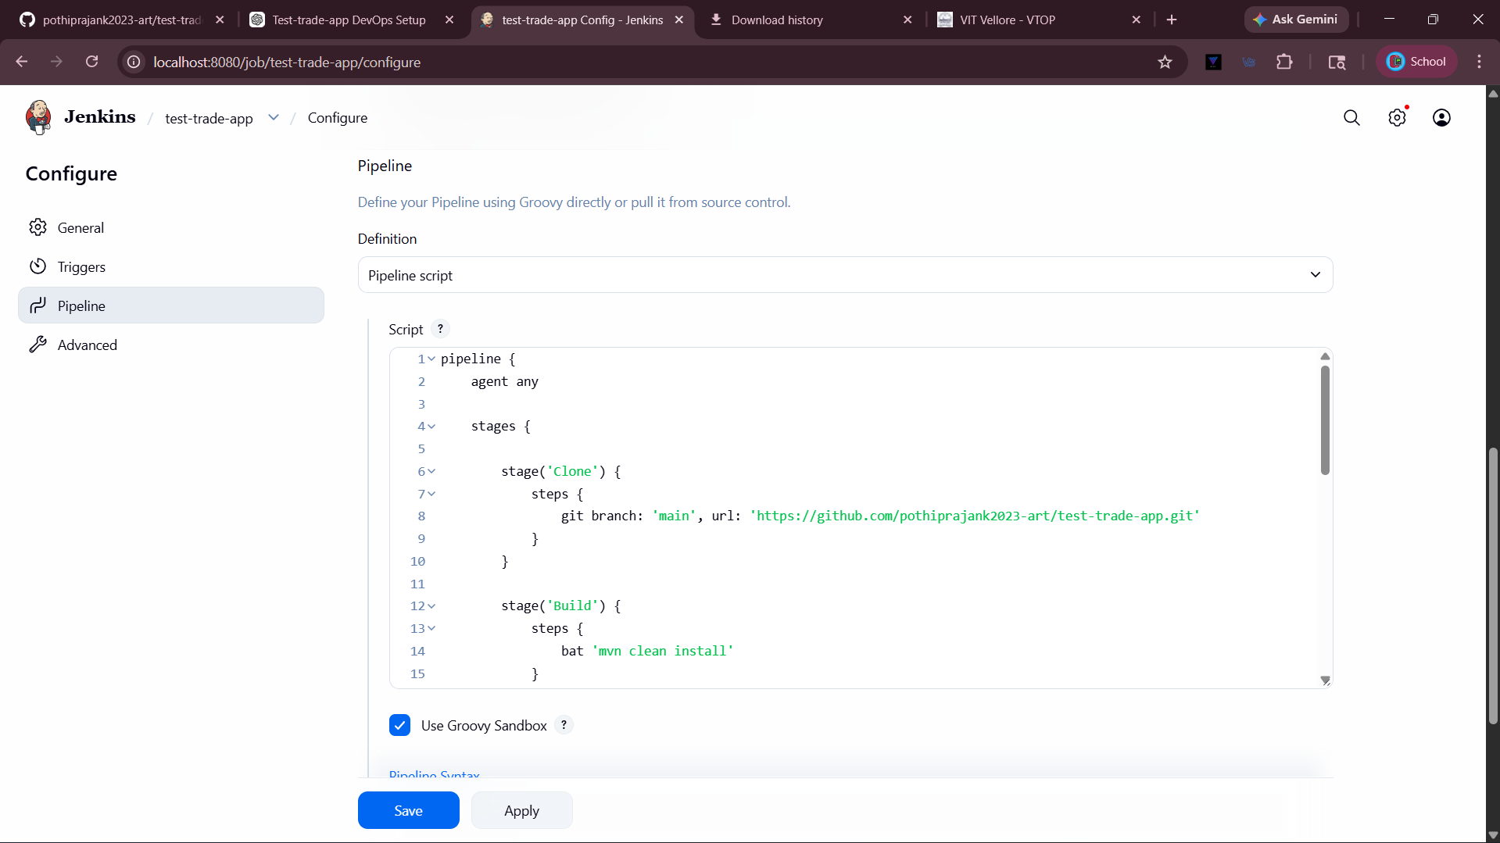
Console Output:
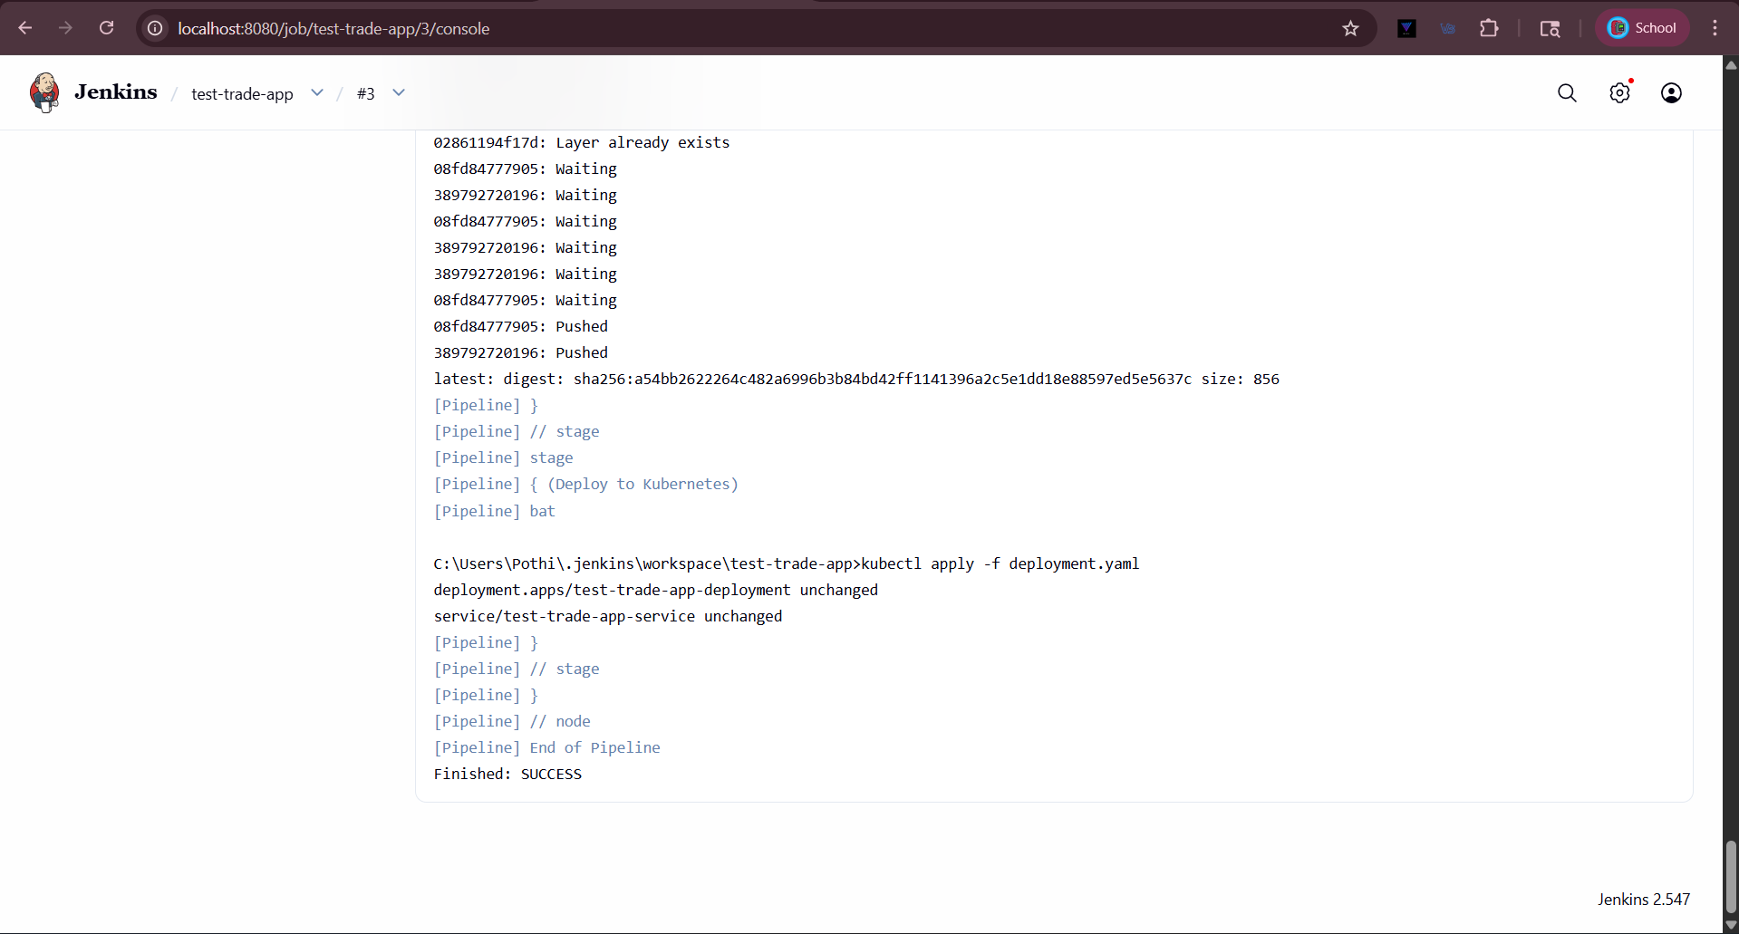

Step 8- Verify Docker and Kubernetes Deployment:
Docker:
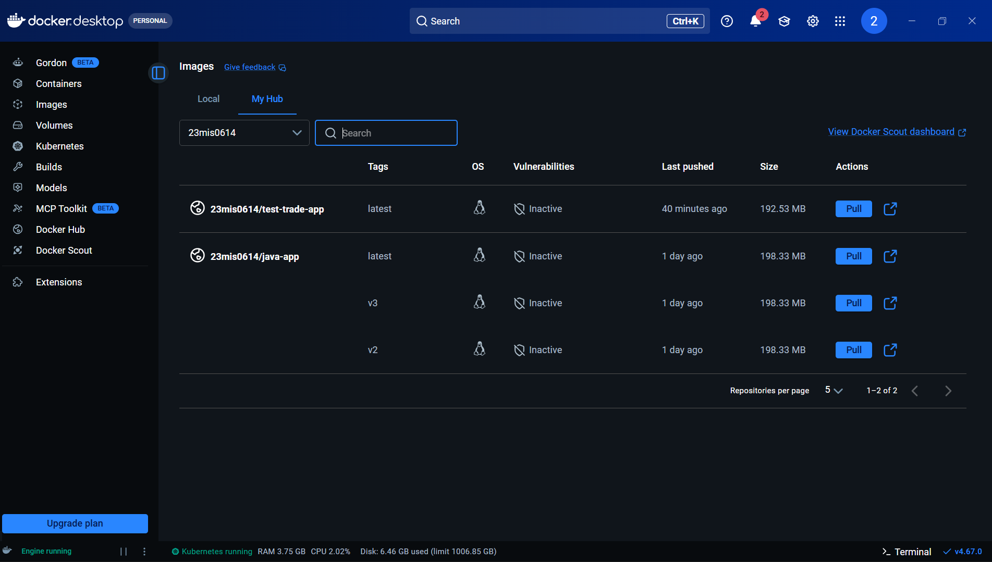
Kubernetes:
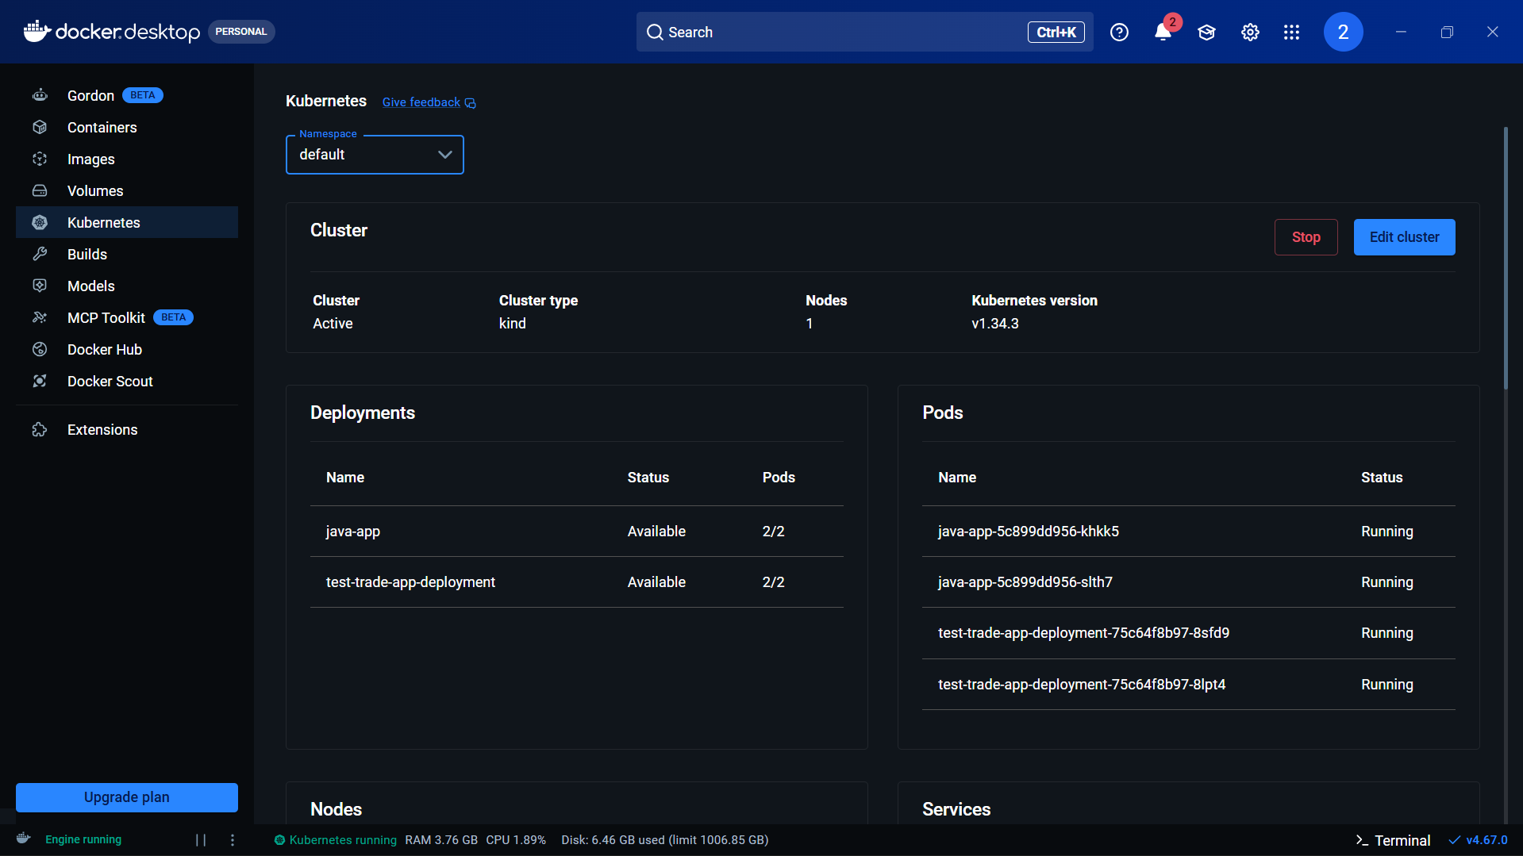

Output verification (Junit Tests):
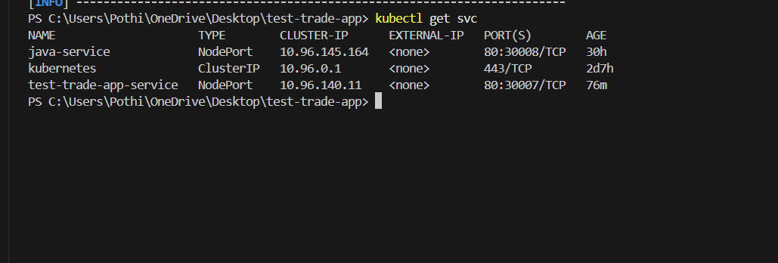

Java output: 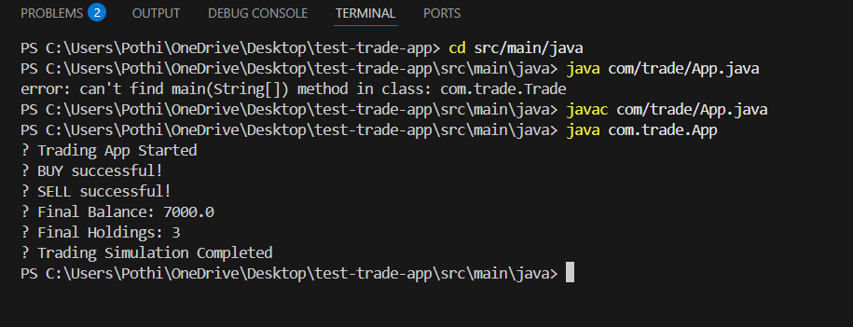

Conclusion:
The Trading Simulation System ensures accurate trade execution and profit/loss calculation before deployment. JUnit testing helps validate both correct and invalid scenarios, improving system reliability. With Jenkins CI/CD, the build, test, and deployment processes are automated, reducing manual effort. Docker and Kubernetes enable scalable and consistent deployment. Overall, the project demonstrates real-world trading system concepts along with modern DevOps practices.

