2400030416
S-56
T.Rishyendra
Skill-11
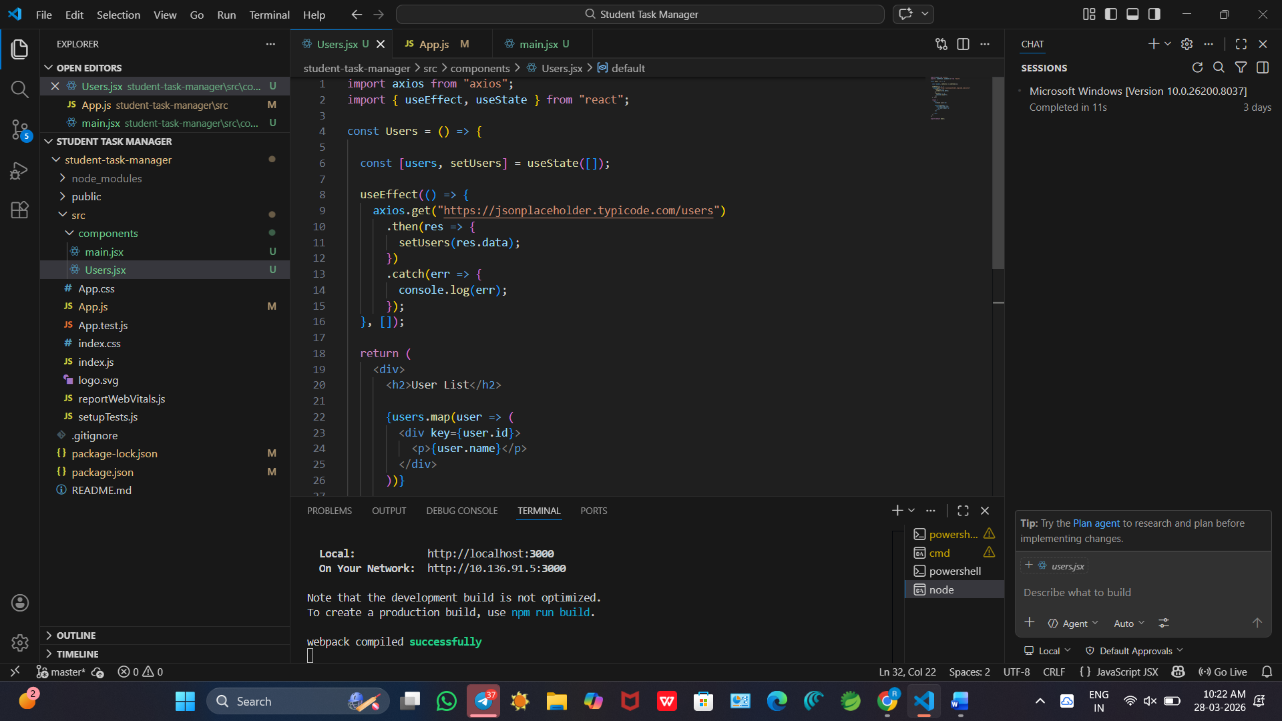
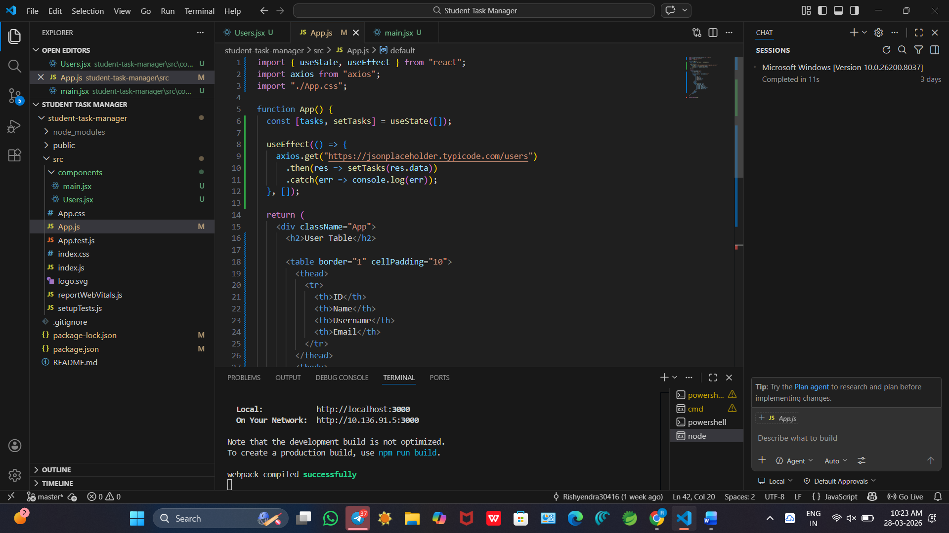
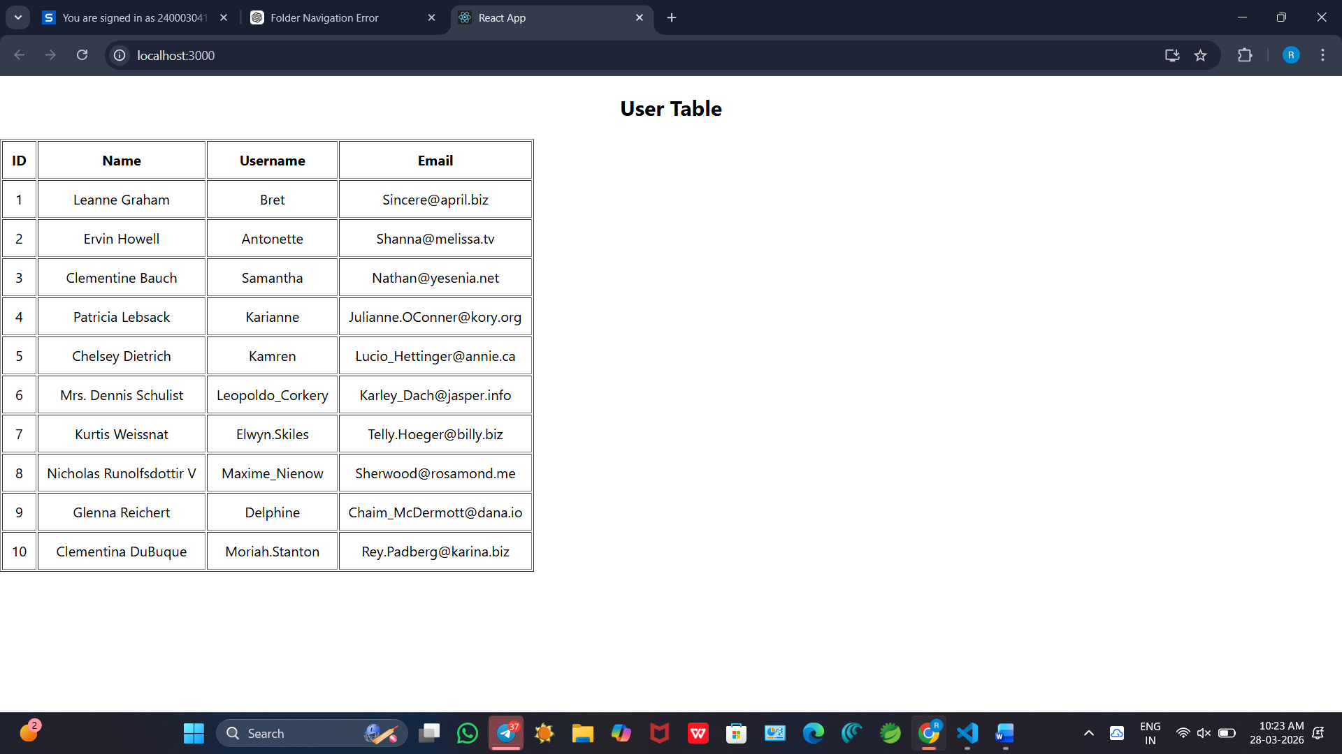
Git hub:- https://github.com/Rishyendra30416/FSD_skill1.git

