2400030416
T.Rishyendra
S56
Skill-6
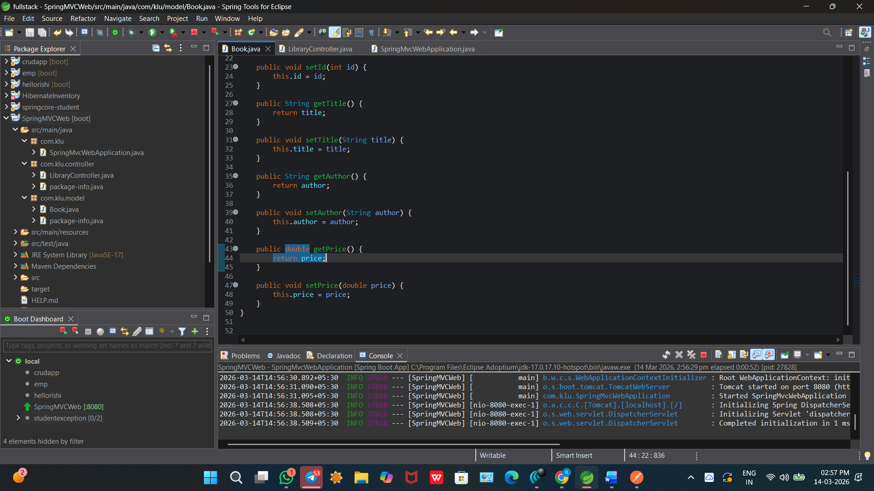
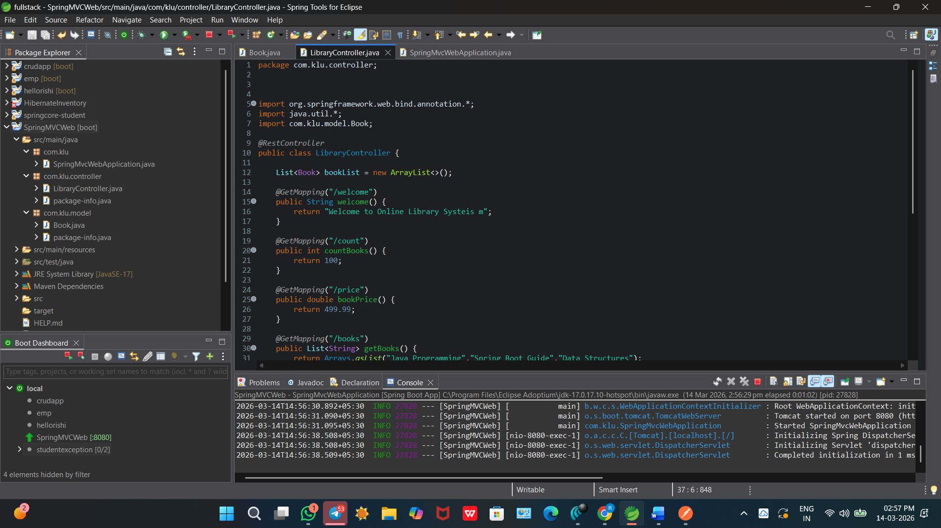

G

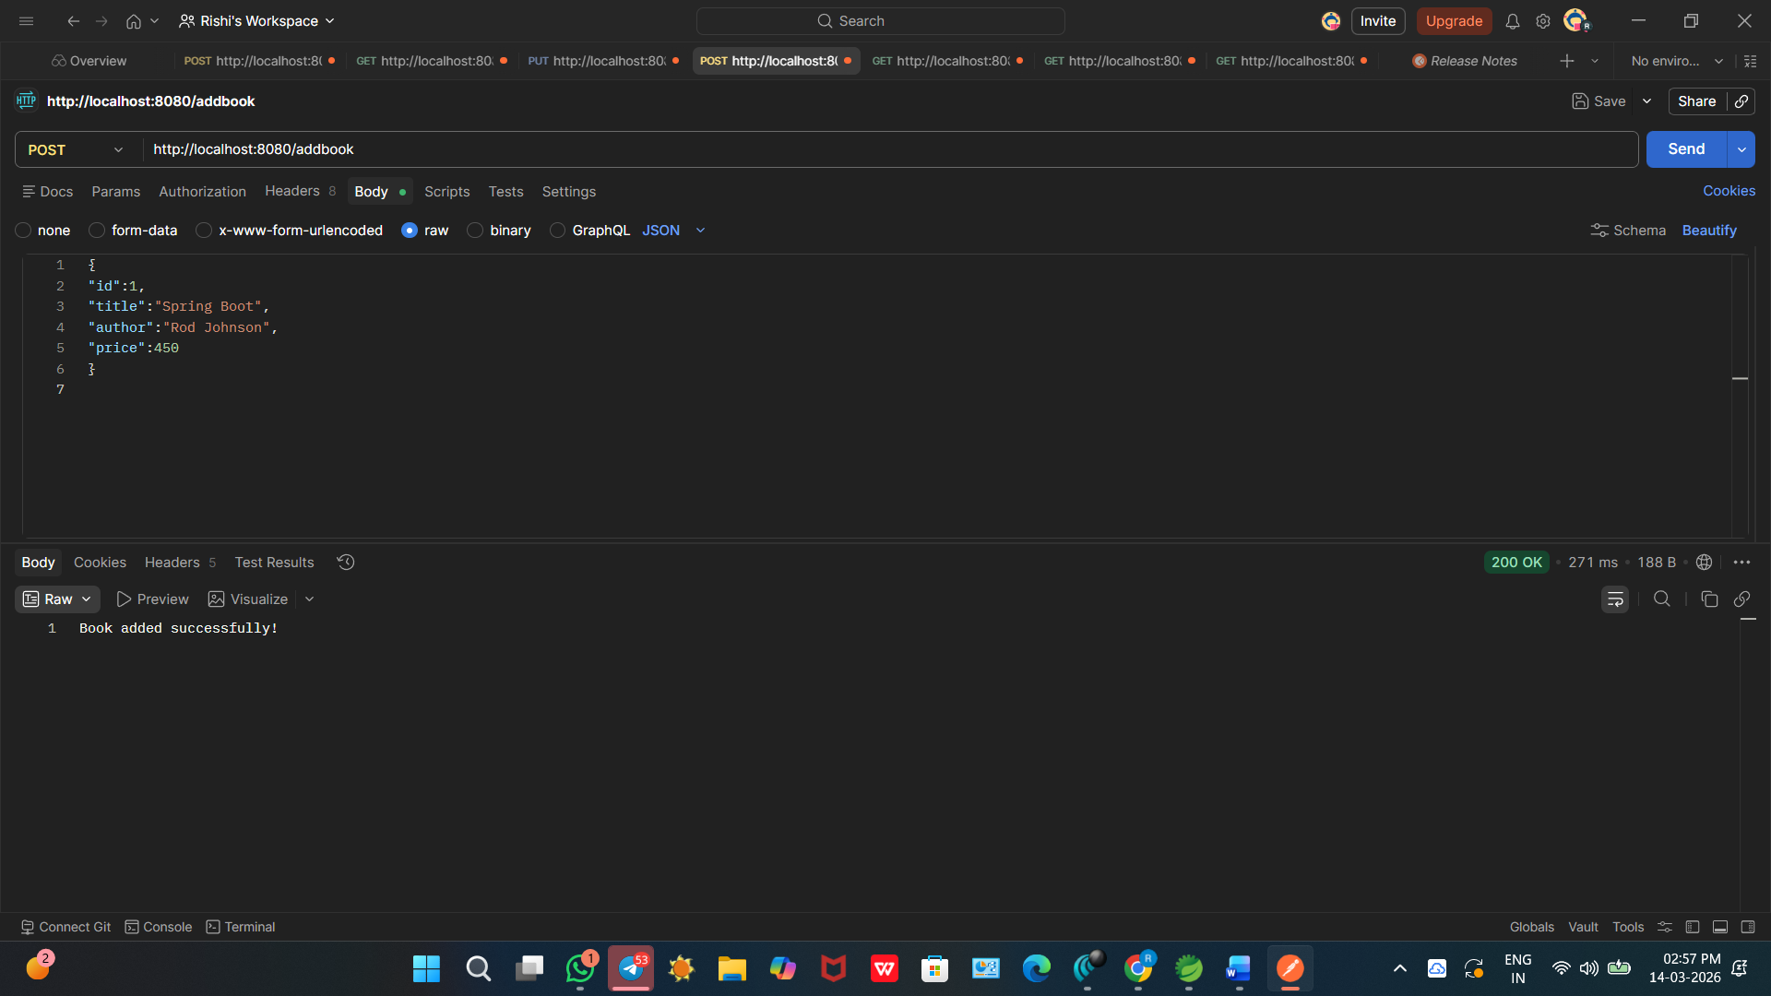
Github repo:- https://github.com/Rishyendra30416/FSD_skill1.git

