

Individual Assignment 02

Level: 06 CB012710 COMP60022
COMP60010: Enterprise Cloud and Distributed Web Applications

Batch Code/s: HF2561COM

Hand Out Date: As specified in the SAIS Hand In Date: As specified in the SAIS Weightage:50%

INSTRUCTION TO CANDIDATES:

- Students are advised to underpin their answers with the use of references (cited using the Harvard Name System of Referencing).
- Late submission will be awarded zero (0) unless Exceptional Circumstances (EC) are upheld.
- We draw your attention to the Academic Conduct Procedure to encourage good academic practice.
- Assignment presentation and modeling work should be submitted as a softcopy

Contents
1. Introduction 6
1.1 Current Architecture Analysis 6
2. Cloud Design Strategy 7
2.1 General cloud implementation 7
2.2 Architecture breakdown 8
2.2.1 Global Network Routing and Edge Security 8
2.2.2 API Management and Application 9
2.2.3 Compute Layer and Microservices 9
2.2.4 Data Persistence 10
2.2.5 Event Backbone 11
2.2.6 Centralized Observing 11
3. Security Compliance 11
3.1 Network Isolation 12
3.3.1 Encryption in transit 14
3.2 Access Control and Traffic filtering 15
3.3 Data Encryption and Compliance 16
3.4 Role Based Access Control and Oauth 2.0 17
3.5 Disaster Recovery and Data Protection 17
3.6 Distributed Data Consistency with Saga and CQRS 18
4. Implementation Overview 19
4.1 Infrastructure as Code Automation 19
4.2 Compute layer 20
4.3 Databases and Persistence Layer 25
4.4 Event Driven Architecture 28
4.5 Front End and Global Edge Routing 30
4.6 Service Integration 33
5. Testing and Performance 38
5.1 API Documentation and Functional Test 38
5.2 Unit Testing 40
5.3 Resilience and fault tolerance testing 40
5.4 Performance, Stress Testing and Autoscaling 42
5.5 Load testing Quantitative Results 44
5.6 Integration Testing 45
5.7 Security Testing 46
5.8 Observability 47
6.Challenges and Future Work for Aerolink 49
6.1 Technical Challenges 49
6.2 Future Work and Improvements 49
References 51
Appendix 53
Front End Screenshots 53

Table of Figures
Figure 1 - Architecture Diagram 8
Figure 2 - Virtual Private Cloud 12
Figure 3 - Subnets 13
Figure 4 - NAT gateway 13
Figure 5 - Internet gateway 14
Figure 6 - Route Table 14
Figure 7 - VPC Security Groups 15
Figure 8 - Amazon Cognito User Pools 16
Figure 9 - AWS Key Management System (KMS) 16
Figure 10 - OAuth 2.0 / RBAC Cognito Groups 17
Figure 11 - Disaster Recovery Strategy (PITR Enabled) 18
Figure 12 - CloudFormation Stacks showing execution 19
Figure 13 - CloudFormation Stack showing Resources 20
Figure 14 - Amazon ECR repository overview 21
Figure 15 - Docker image upload for the Booking microservice 21
Figure 16 - Docker image upload for the Baggage microservice 22
Figure 17 - Docker image upload for the Check-in microservice 22
Figure 18 - Docker image upload for the Flight Ops microservice 22
Figure 19 - Amazon ECS Cluster configuration with WS Fargate actively running container tasks 23
Figure 20 - Detailed view of active ECS tasks 23
Figure 21 - Integration of node-postgres (pg) driver in the Booking Service 24
Figure 22 -Installation of AWS SDK v3 in the Baggage Service 24
Figure 23 - Environment-based configuration logic implemented in index.js 25
Figure 24 - Amazon Aurora RDS instance running PostgreSQL 25
Figure 25 - Amazon DynamoDB table configuration 26
Figure 26 - DynamoDB Multi-region Global Table deployment 27
Figure 27 - DynamoDB schema and active item storage 27
Figure 28 - Amazon EventBridge bus and rule configuration 28
Figure 29 - Amazon SQS 29
Figure 30 - Amazon SNS 29
Figure 31 - AWS Lambda serverless function executing background tasks 30
Figure 32 - Application Load Balancer and Target Groups 30
Figure 33 - API routing configurations mapping paths to target groups 31
Figure 34 - Backend API endpoints successfully accepting traffic 32
Figure 35 - Amazon S3 and CloudFront CDN hosting the frontend 32
Figure 36 - Live production site accessed via CloudFront UR 33
Figure 37 - Seat inventory correctly decrementing after a booking is processed 34
Figure 38 - FlightOps service successfully communicating with the ALB and Booking Service 35
Figure 39 - Successful Check-in flow proving communication between Check-in and Booking microservices 36
Figure 40 - Baggage dashboard successfully reading and writing real-time status updates to DynamoDB Part 1 36
Figure 41 - Baggage dashboard successfully reading and writing real-time status updates to DynamoDB Part 2 37
Figure 42 - Payment frontend 37
Figure 43 - Payment DynamoDB 38
Figure 44 - Swagger API documentation 39
Figure 45 - Postman Testing 39
Figure 46 - Unit Testing For Microservices 40
Figure 47 - Circuit Breaker Code 41
Figure 48 - Retry Code 41
Figure 49 - aerolink-prod-worker-dlq in the AWS SQS Console 42
Figure 50 - Performance and Scalability Stress test 42
Figure 51 - CPU Target Tracking Policy (>70%) 44
Figure 52 - Load Test Console Log 44
Figure 53 - Swagger Integration Testing 46
Figure 54 - Security testing 46
Figure 55 - Monitoring and Observability Log Groups 47
Figure 56 - Prod-Auth Log Group 47
Figure 57 - Prod-Booking Log Group 48
Figure 58 - Trace Map 48
Figure 59 - Trace List 49
Figure 60 - Login Page 53
Figure 61 - Flight Booking Pag 53
Figure 62 - booking information 54
Figure 63 - Payment Approved Pop up 54
Figure 64 - Booking Complete 54
Figure 65 - Check-in Page 55
Figure 66 - Baggage Tracking Page 55
Figure 67 - Update Bag 55
Figure 68 - Flight Ops Page 56
Figure 69 - Flight Ops updated 56

Table of Tables
Table 1 - Stress Test Table 44
Table 2 - Load Test 45
Table 3 - Integration Testing 46

1. Introduction

Aerospace is a globally interconnected domain that expands rapidly. It scales dynamically as more passengers and aircrafts take on the world of flying. Due to these reasons the current systems in place to manage airline services struggle to keep up, often lagging behind with its reliance on legacy software architectures. The benefit of a flexible system such as cloud computing is a perfect fit to this industry to help with issues of logistics, communication and overall elasticity. It is important to not have down time and system breakdowns in such domains as time sensitivity is crucial. In the case of Aerolink, it is responsible for checking airlines and airport matters across a variety of regions. Aerolink is directly in charge of ensuring many vital services such as passenger ticketing, checking in, baggage tracking as well as the overall flight operations management. All these systems need to run with continuous integration in different areas further highlighting the need to switch to a cloud platform.

1.1 Current Architecture Analysis

The current system used by Aerolink is severely outdated to efficiently carry out all the required functions on time. The legacy architecture is stuck in a single deployable unit that will hinder operations when faults occur. These core issues, as shown in this section, can be addressed by the proper implementation of AWS cloud.

The first problem in the current system is the lack of high availability. This means that if there is a minor error or memory leak the entire system may malfunction. In the case of an airline service any downtime such as this will result in catastrophic delays for flight bookings and check ins disrupting the flight experience. The next issue to be considered is that of scalability. Holiday seasons are extremely busy for flights and will often have more passengers generating a lot of traffic. Scaling a legacy system is incredibly costly and inefficient, whereas AWS cloud will let Aerolink scale up and down depending on the system's current load requirement.

Data synchronization is a must when it comes to the world of airplanes. All ticket data and passenger details must be instantly recorded and updated in the system. Delays must be minimal at worst, and the information needs to be updated across international services. AWS cloud can help facilitate this much smoother in comparison to the current system. Furthermore, the tightly coupled architecture means that it is harder to pinpoint where an issue may arise from and the backlog that's created as a result may crash Aerolink's platform, highlighting the need to switch to AWS even more.

2. Cloud Design Strategy

2.1 General cloud implementation
Aerolink’s implemented architecture will be based on the cloud's native microservices strategies that can help to fulfill the daunting demands of running a global network. The idea that is followed in this implementation is one of decoupling the monolithic system into separate microservices that can run independently (Newman, 2019). These include booking in, checking in, baggage services and overall flight operation.

The switch from dealing with the high operational burden in the old infrastructure to now having to manage cloud services allows Aerolink to focus on business operations smoothly. This system now adheres to the principle of ‘high availability’ by having a multi-region active deployment model. This aims to avoid the single point of failure problem at both the compute and data layers. Real time data synchronization is also achieved in this model by assisting the event driven backbone of the system for flight scheduling and bagging. Overall Aerolink becomes scalable, elastic and a stronger platform with these proposed steps.

The system is in two AWS regions with US-East-1 as the main region and EU-West-1 as the backup. The DynamoDB Global Tables are active in both regions and is able to instantly copy data from USA to Europe. The compute layer of ECS Fargate and ALB runs in the US and has Eu as a standby to save costs for this implementation. Amazon Route 53 will do the health checks and detect failures so that DNS traffic will go to a backup ECS cluster in Europe with minimal downtime.

2.2 Architecture breakdown

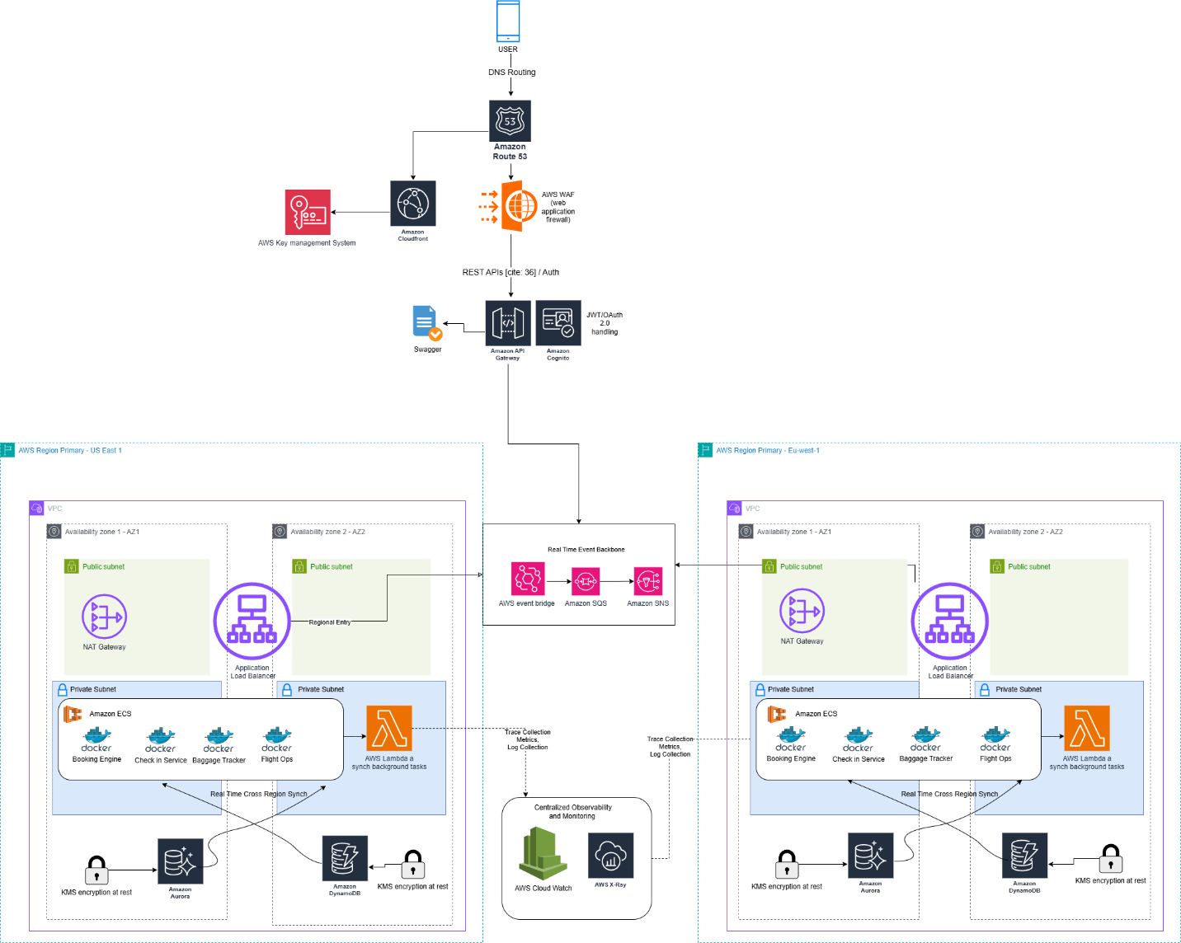
Figure 1 - Architecture Diagram

2.2.1 Global Network Routing and Edge Security

The system's entry point for any user of the system is strictly managed using a global edge. When a user requests to access the platform, it is first resolved by using Amazon Route 53 which uses highly available DNS (Domain Name System) web service to help find the most optimal traffic route for the best geographical location based on overall latency.

No traffic is allowed to enter the system without first passing through the strict security area. Amazon CloudFront is present in the system as a CDN (Content Delivery Network) which assists in securely caching and ensuring proper static delivery of the front end systems and its assets with little latency. In this routing layer, AWS WAF (Web Application Firewall) is also present. WAF is responsible for monitoring the inbound traffic and blocking any suspicious malware such as SQL injections or cross line scripting (Amazon Web Services, 2024a). AWS WAF overall ensures the system is secure from any external threats.

2.2.2 API Management and Application

The Amazon API Gateway in this architecture acts as the front door for the distributed network after traffic makes its way through the edge security layer. This API layer is responsible for the routing of all requests by RESTful APIs to the required backend micro service. The swagger documentation which contains the API definitions are also present within this layer. Amazon Cognito is also integrated with the API gateway directly and helps to manage user identities as well the handling of generating and validating OAuth 2.0 and JSON Web Tokens (JWT) (Hardt, 2026). In the case that an incoming request does not possess a signed JWT the API gateway can directly shut down that request so that unauthenticated traffic does not reach the internal private networks.

2.2.3 Compute Layer and Microservices

Aerolinks business logic to run the platform is present within this layer of the architecture. Virtual Private Clouds (VPCs) operate this section in a highly secure manner. It is split into two high availability zones with US east 1 and EU west 1, ensuring that there is proper fault tolerance as well.

Traffic that tries to enter into this section is firstly directed at the Application Load Balancer (ALB) which is part of the public subnets and sends the approved traffic into the private subnets that contain the actual micro services. The overall general internet then has no access to these services as a result of this architecture. Amazon ECS (Elastic Container Service) is used here to store the microservices that have been properly containerized using Docker (Turnbull, 2019). These microservices in this section are booking engine, check in service, baggage tracker and flight operations. This system ensures that each microservice can scale up or down as required without interfering with the other services. In order to allow these private containers to download the required updates for the system a NAT gateway is used in the public subnet.

2.2.4 Data Persistence

The implemented new cloud architecture for Aerolink handles the cloud managed database in a few unique ways so that all required data types are accounted for in the system.

- ACID or Atomicity, Consistency, Isolation Durability compliance is mandatory for storing transactional data of ticketing, reserving and more in flights (Kleppmann, 2017). Amazon Aurora and its relational database can be utilized to store these data types. Seats can be managed correctly with no overlapping bookings happening with Aurora intact.
- Baggage tracking and real time updates often fall under schema less and high velocity data and require the use of Amazon DynamoDB. In order to ensure multi region requirements, Aerolink can use DynamoDBs global tables configured to provide active-active synchronization across all global deployments.
- GDPR and PCI-DSS compliances can also be met in this infrastructure by integrating AWS KMS (Key Management System) to make sure that all sensitive data at rest is encrypted.

2.2.5 Event Backbone

A real time event backbone must be in place in the architecture to guarantee that there is no delay present in any real time updates such as updating baggage statuses, for this a Real Time Event backbone is implemented.

If any microservice needs to communicate a state change an event can be sent to the Amazon EventBridge and it can act as the central router and send these events to the Amazon SQS and Amazon SNS systems. SNS (Simple Notification Service) can immediately send out broadcasting while the SQS (Simple Queue System) can queue the message as required. These systems are primarily in place to build up more fault tolerance so that even in the event a service is offline it can store this message offline temporarily. Moreover, AWS Lambda functions can be used here for serverless computing in order to process necessary light weight background tasks.

2.2.6 Centralized Observing

Telemetry data of the system must go to a centralized observability system to constantly monitor the health and performance of the system. Two different Amazon services are used for this purpose in Aerolink. Amazon CloudWatch is first used to get logs on the performance of the entire architecture, followed by AWS X-Ray that allows for distributed tracing to track a single user request as it goes around the API Gateway, the ECS containers and the databases to quickly identify any potential bottlenecks and faults.

3. Security Compliance

As passenger and flight data often contain extremely sensitive information it is vital that proper security mechanisms are followed by Aerolink. Granite security policies were too hard to implement in the old monolithic architecture that existed previously as it had centralized vulnerabilities. The AWS architecture that has been implemented will have zero trust principles and have a working multi layered security system that will look into isolating networks, data encryption and identity management (Rose et al., 2020).

3.1 Network Isolation

First and foremost, a Virtual Private Network (VPC) has to be established to protect the system from the general internet and any DDoS attacks. This was done using AWS CloudFormation code as IaC (Infrastructure as Code) so that there was a lesser chance for manual errors and the overall network topologies can be consistent (Morris, 2020). The VPC is split into multiple availability zones and necessary private and public subnets for the ideal quality.

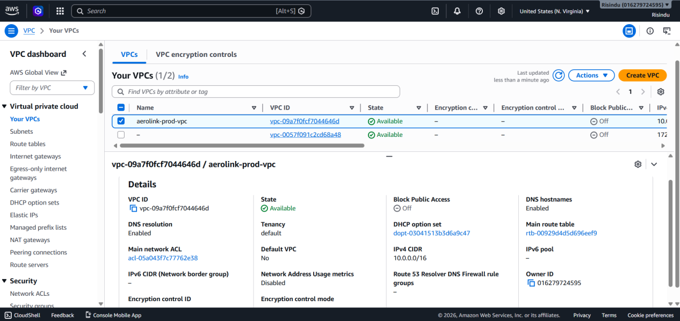
Figure 2 - Virtual Private Cloud

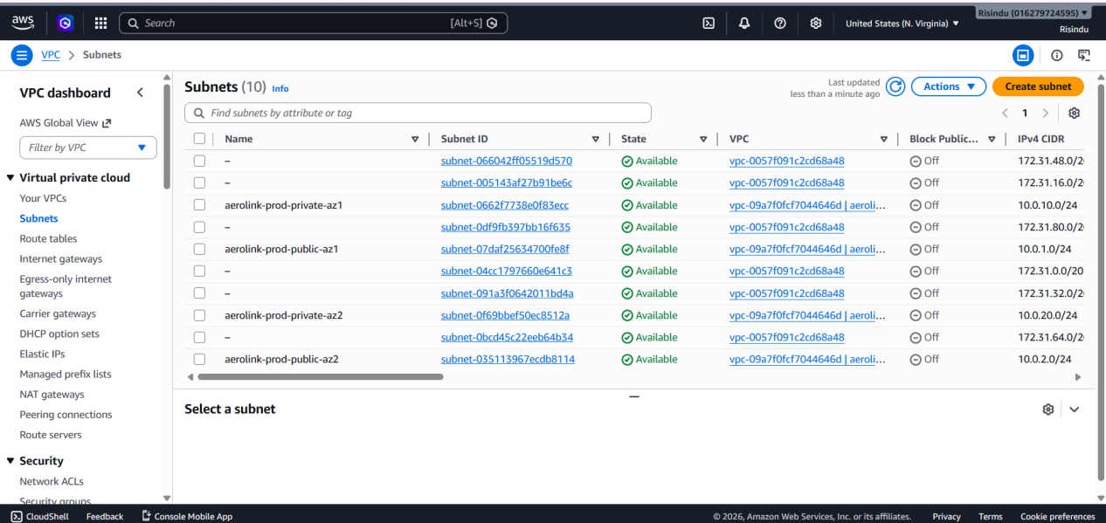
Figure 3 - Subnets

In the public subnets of the system only the internet facing components such as the Application Load Balancer (ALB) and NAT gateways are present. Incoming requests from any clients will go to the Application Load Balancer. Opposing this the private subnets will hold all the actual compute resources such as the CS Fargate tasks running the Booking, Baggage, and Check in microservices and the managed databases.

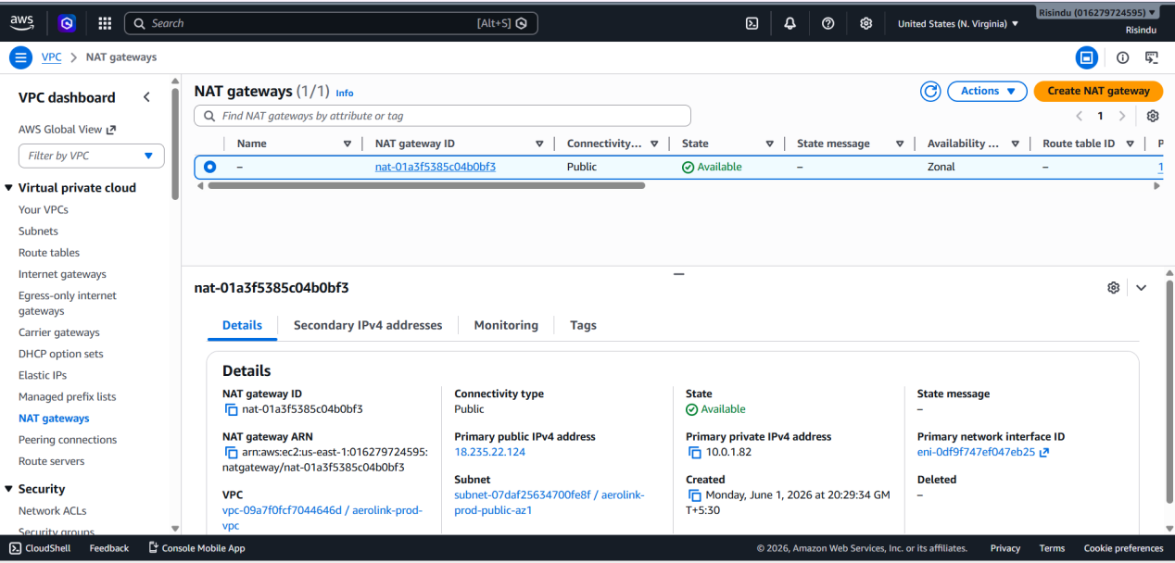
Figure 4 - NAT gateway

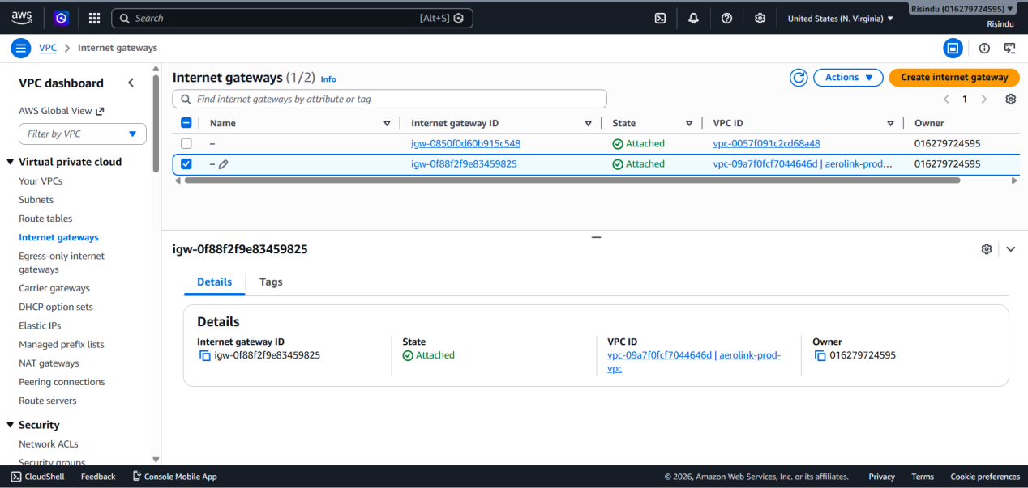
Figure 5 - Internet gateway

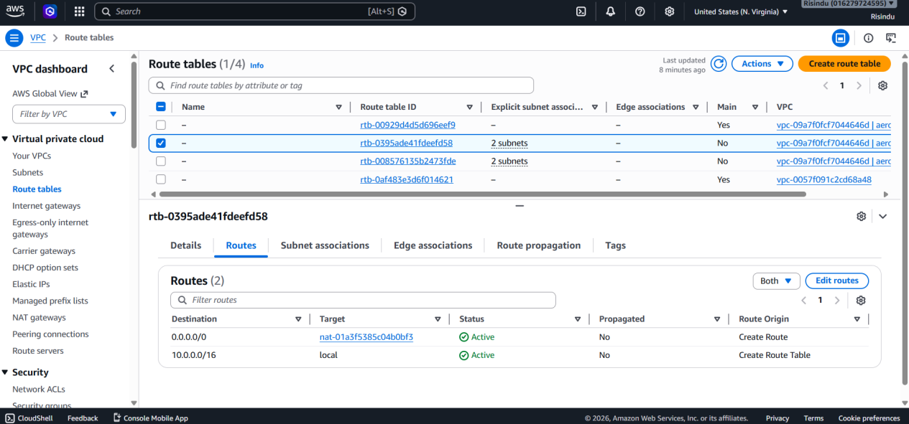
Figure 6 - Route Table

Overall, these work together to make sure that the microservices are isolated from the internet and still be able to call for required software updates or external dependency by using the NAT gateway present while still ensuing that bad actors can not gain unwanted access to the system.

3.3.1 Encryption in transit

For all data privacy and prevention of man in the middle attack (MITM) an encryption in transit is imposed using industry standard cryptography here. Firslty all the external traffic that comes from the client devices is enforced with HTTPS. In this. CloudFront distributions and API Gateway endpoints are configured with SSL/TLS certificates managed by AWS Certificate Manager (ACM). Furthermore, TLS 1.2 / TLS 1.3 enforcement is present with outdated tls versions being blocked at CloudFront edge. CloudFront edge caches are also fully encrypted in transit with the ALB. The ACM certificate is then used by the ALB to stop the TLS connection before going into the private subnets.

3.2 Access Control and Traffic filtering

The principle of least privilege is ensured more in the system by the utilization of VPC security groups. The current ECS instance will only accept any inbound traffic if its origin is the Application Load Balancer. This means that no one can bypass the API layer present.
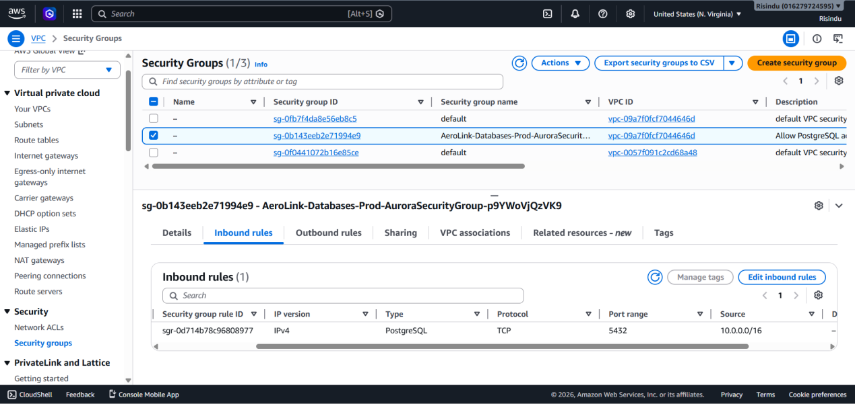
Figure 7 - VPC Security Groups

Amazon Cognito is further implemented in this system to ensure that proper identity management and authentication is present within the security aspects of the system. User Pools present in Amazon Cognito are used to handle registering a user, authentication as well as the issuing of any JSON Web Tokens (JWT). This is backed by the API layer acting as a checkpoint that can reject any signals that do not have the required JWT and not allow it to reach the private layer of architecture.

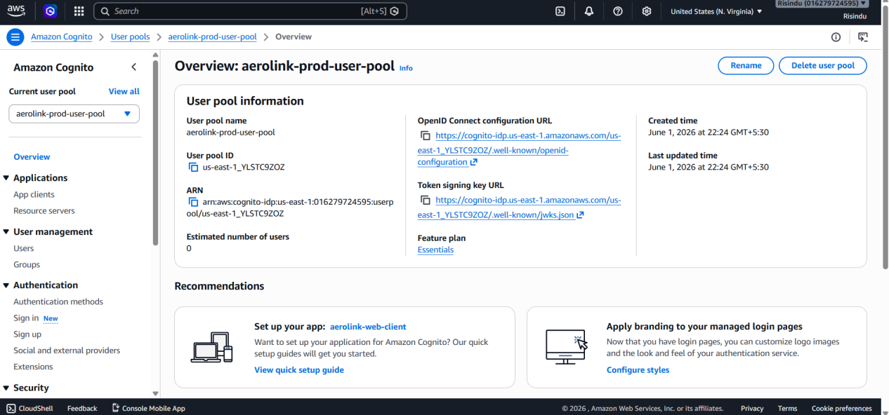
Figure 8 - Amazon Cognito User Pools

3.3 Data Encryption and Compliance

Encryption is extremely important in the security layer of Aerolink’s architecture. Standards such as the GDPR and PCI-DSS are met by the use of encryption. In this system it is achieved by using AWS Key Management System (KMS). It generates and manages the encryption keys in AWS to ensure proper encryption and compliance.

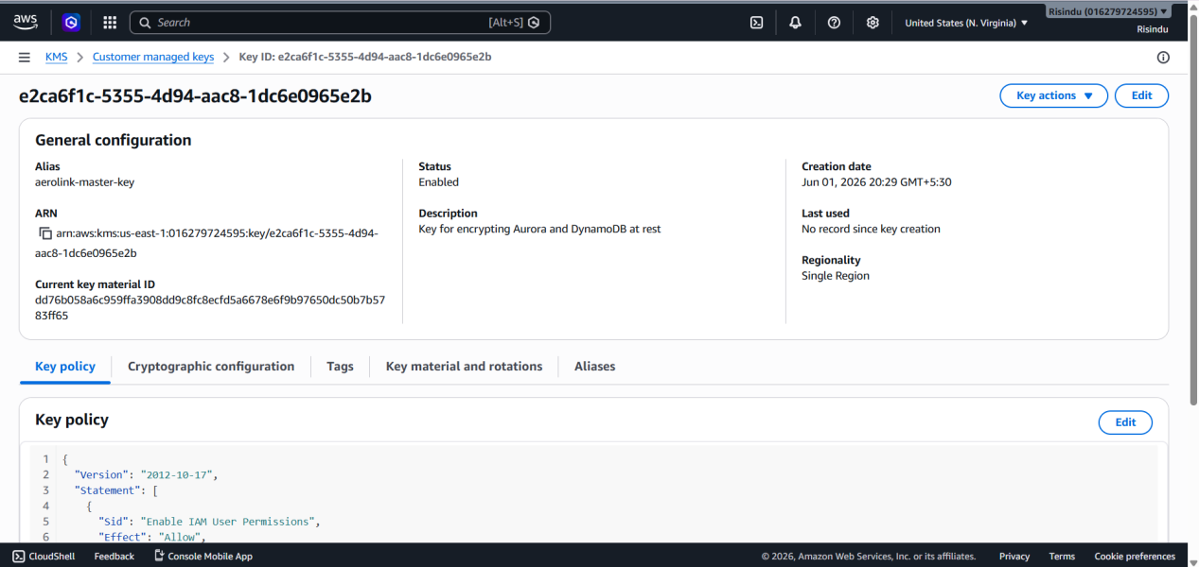
Figure 9 - AWS Key Management System (KMS)

Aerolink is fully in compliance with global data privacy regulations that are required for records of flight transactions and baggage tracking as these data stored in Amazon Aurora and Amazon DynamoDB are integrated with AWS KMS to remain encrypted properly on disk.

3.4 Role Based Access Control and Oauth 2.0

The importance of security for Aerolink’s system is already highlighted with the use of Amazon Cognito in the above section. To add more strict security, Role Based Access Control (RBAC) was implemented in Amazon Cognito User Pools by creating dedicated user groups of admins and staff who can access authorized and sensitive areas of Aerolink that have information that is critical to being protected.

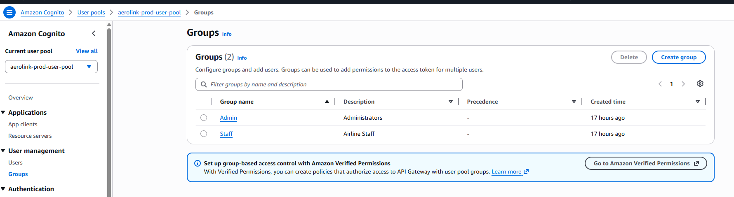
Figure 10 - OAuth 2.0 / RBAC Cognito Groups

3.5 Disaster Recovery and Data Protection

In the persistence layer of this system architecture a Data Recovery strategy with strict data retention policies is implemented. Point In Time Recovery (PITR) in Amazon DynamoDB is implemented here for the most important tables of AeroLink-Baggage. A continuous Recovery Point Objective (RPO) is present here with this automated backing up process so that the database can be properly restored to any second in a 35 day window.

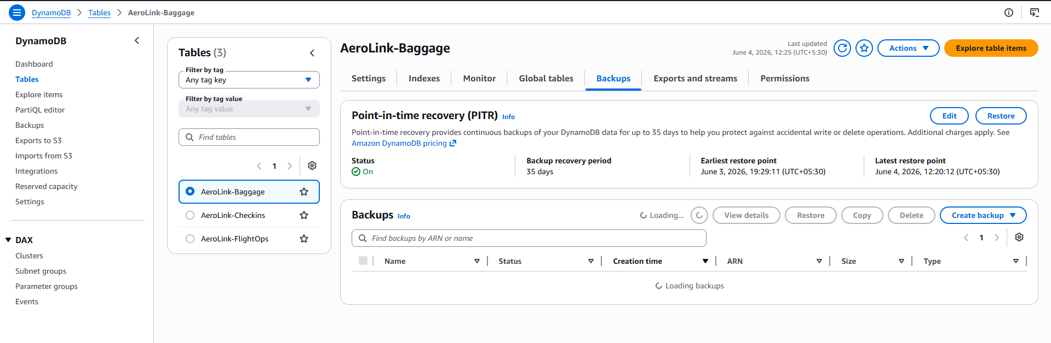
Figure 11 - Disaster Recovery Strategy (PITR Enabled)

3.6 Distributed Data Consistency with Saga and CQRS

Consistency must be upheld across all the microservices that are present with little latency and proper locking overhead of 2PC protocols. To achieve this the system of Aerolink implements a Choreography based Saga pattern that is combined with CQRS (Command Query Responsibility Segregation). For multi steps workflows such as booking and paying for a flight, a domain event of BookingCreated will be sent to the Amazon EventBridge. This will make the payment services trigger, or it will have a transaction of CancelBooking published so the system will have proper consistency. For the best and read and write isolation in this system write operations are segregated in DynamoDB tables and complex queries will be routed usually to Aurora PostgreSQL.

4. Implementation Overview

Aerolink’s old monolithic architecture was fully moved to the cloud including its five microservices that are now decoupled and independent. In order to maintain minimal cost and maximum scalability as well as removing any single points of failure, a multitude of AWS resources were utilized as follows.

4.1 Infrastructure as Code Automation

Manually implementing the services required for AWS is extremely time consuming and often leads the way for human error. To overcome this problem the system was migrated using AWS CloudFormation code. As isolation of different sections was important to avoid errors, the CloudFormation code was split into five distinct categories for each layer of the AWS architecture that was being implemented. These were network, database, compute, routing and frontend layers. This means that a mistake in one area does not destroy the system’s functionalities.

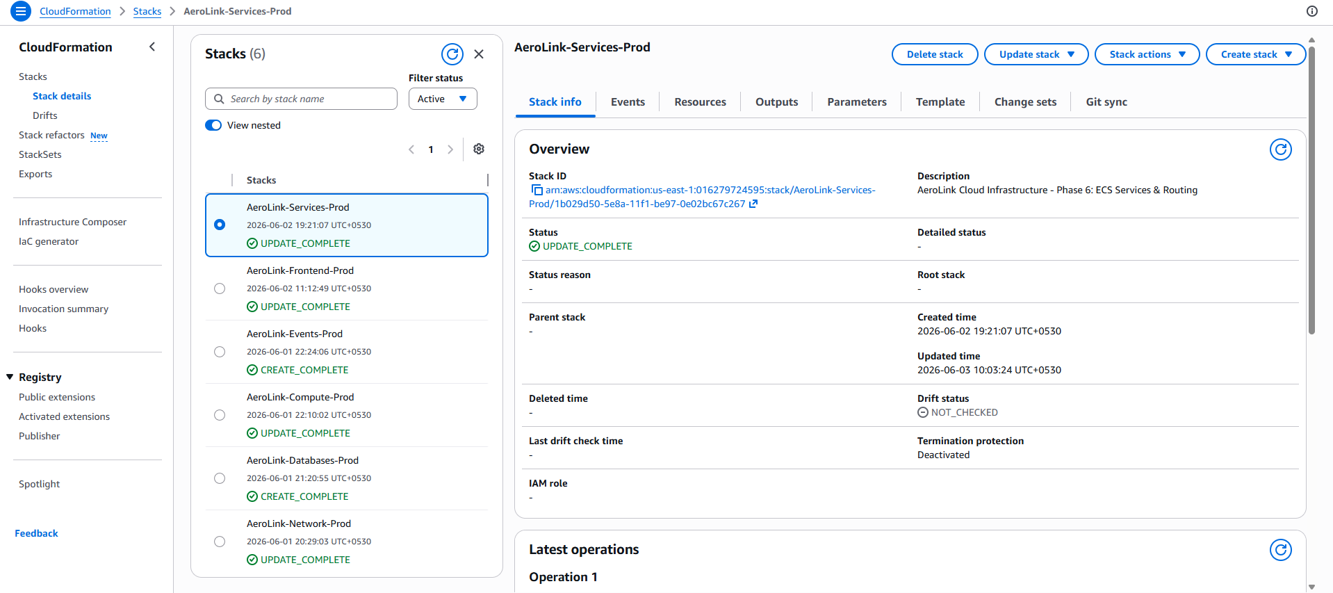
Figure 12 - CloudFormation Stacks showing execution
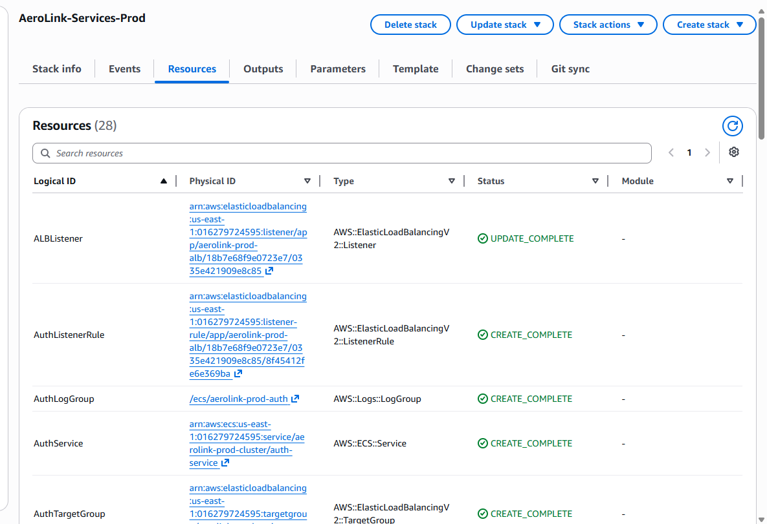
Figure 13 - CloudFormation Stack showing Resources

Dependency management was imposed strictly as a result of the phased approach of the CloudFormation stack. VPCs and the larger network layer were implemented first and was followed by the second phase where the databases were deployed into secure private subnets. Next the ECS cluster and the IAM security roles were implemented and then it was followed by phase four that looked into the ALB and API routing rules. Finally phase five looked into the s3 buckets and CloudFront areas required to host a decoupled front-end system.

4.2 Compute layer

The old legacy architecture that was being used by Aerolink was one single unit and had to be split into the five microservices when moving to the cloud. Each one of these services had to be containerized using docker to isolate the dependencies, libraries and runtime environment. These docker images must be placed and stored in the cloud securely using repositories in Amazon Elastic Registry (ECR). Amazon ECR is a highly available platform that Aerolink can use for hosting application codes as it a fully managed container registry.

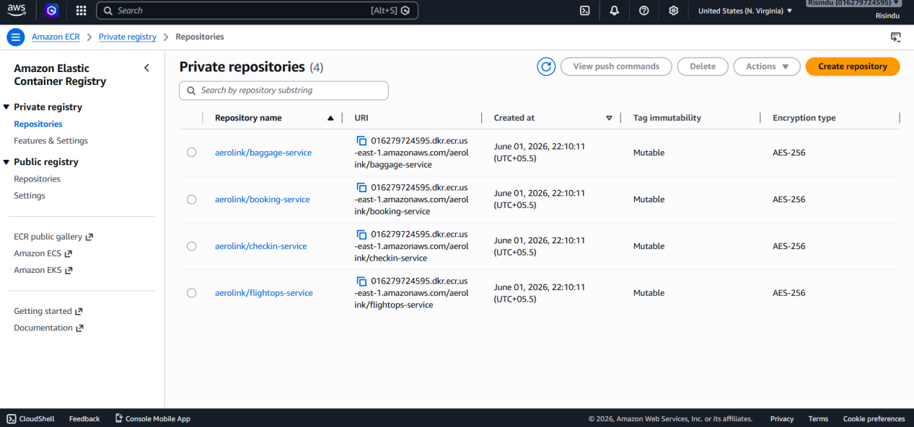
Figure 14 - Amazon ECR repository overview

After creating the ECR repositories all the microservices were individually packaged into docker images on a local computer and tagged and securely pushed into their relevant ECR repositories. This will ensure that the correct code tested locally will run in the cloud.

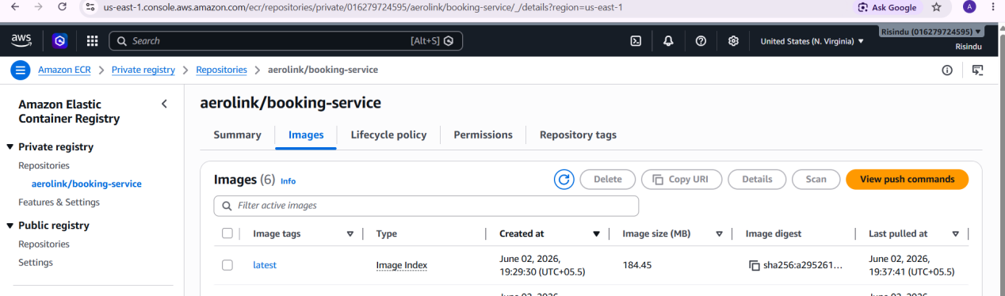
Figure 15 - Docker image upload for the Booking microservice

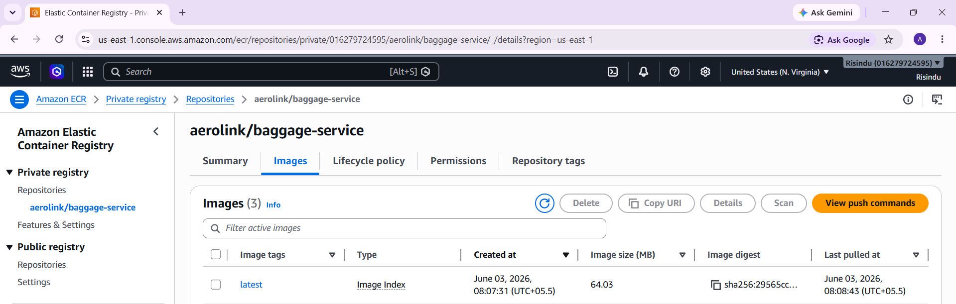
Figure 16 - Docker image upload for the Baggage microservice
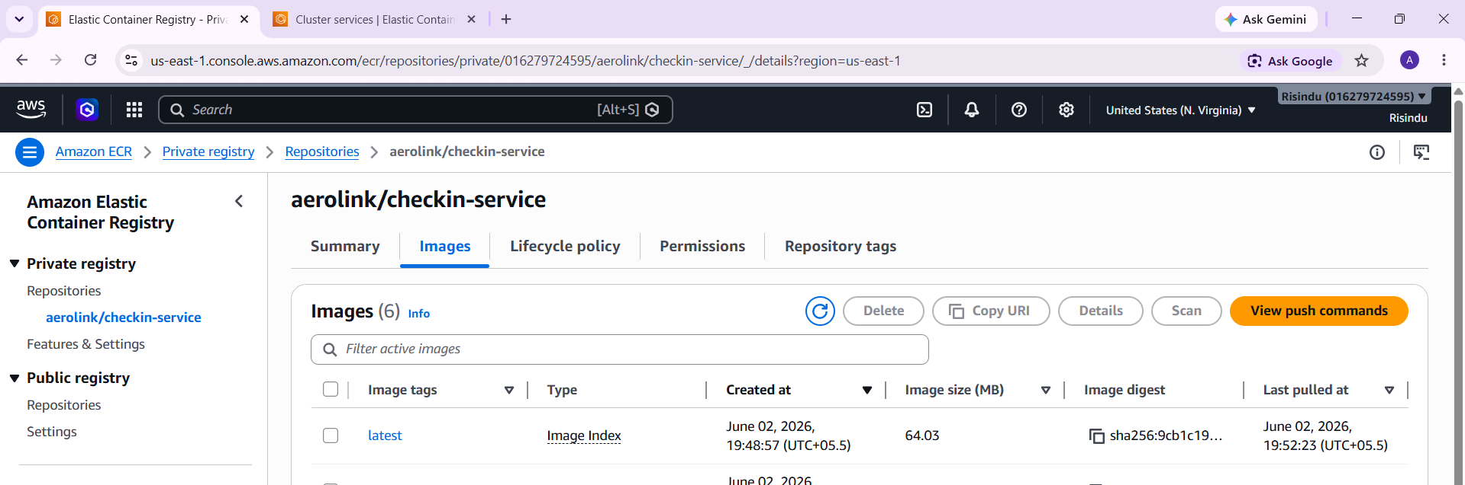
Figure 17 - Docker image upload for the Check-in microservice

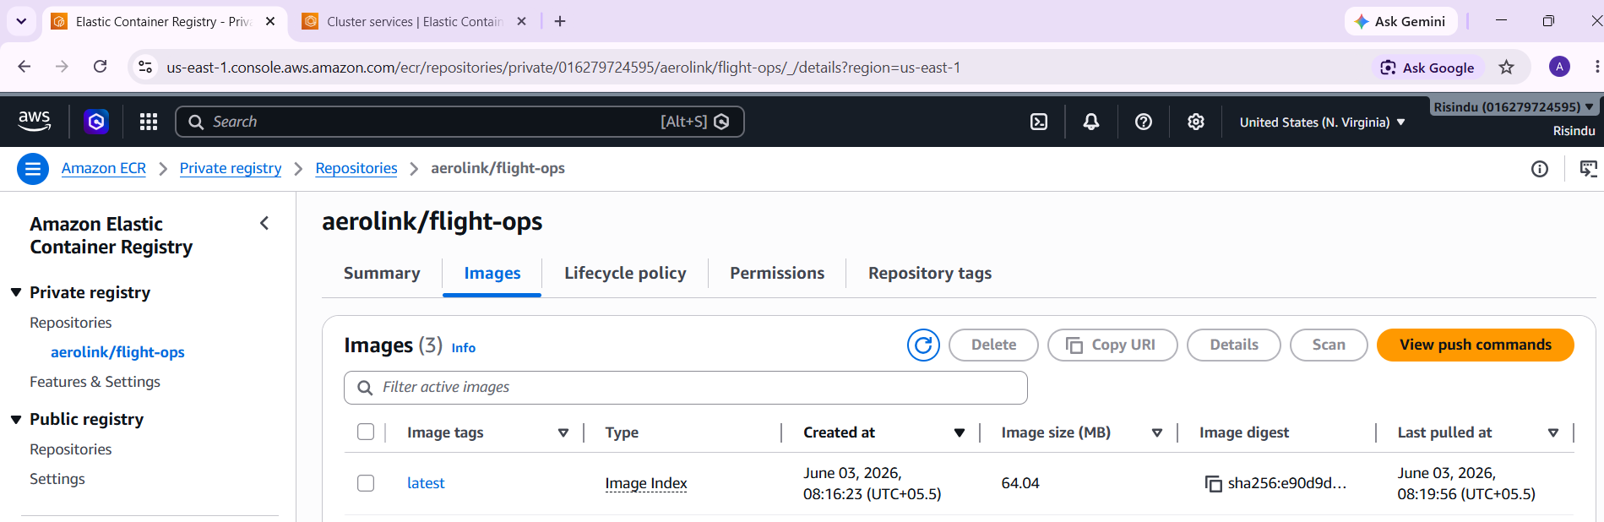
Figure 18 - Docker image upload for the Flight Ops microservice

The containers were run using Amazon Elastic Container Service (ECS) Cluster. These clusters were responsible for logically grouping the microservices compute tasks. ECS needs AWS Fargate to help organize the containers by acting as a serverless compute engine for these containers and removing the need to configure and scale EC2 virtual machines manually. Overall, the use of Fargate ensures that isolated containers are made up instantly with the correct CPU and memory requirements directly into the private subnets.

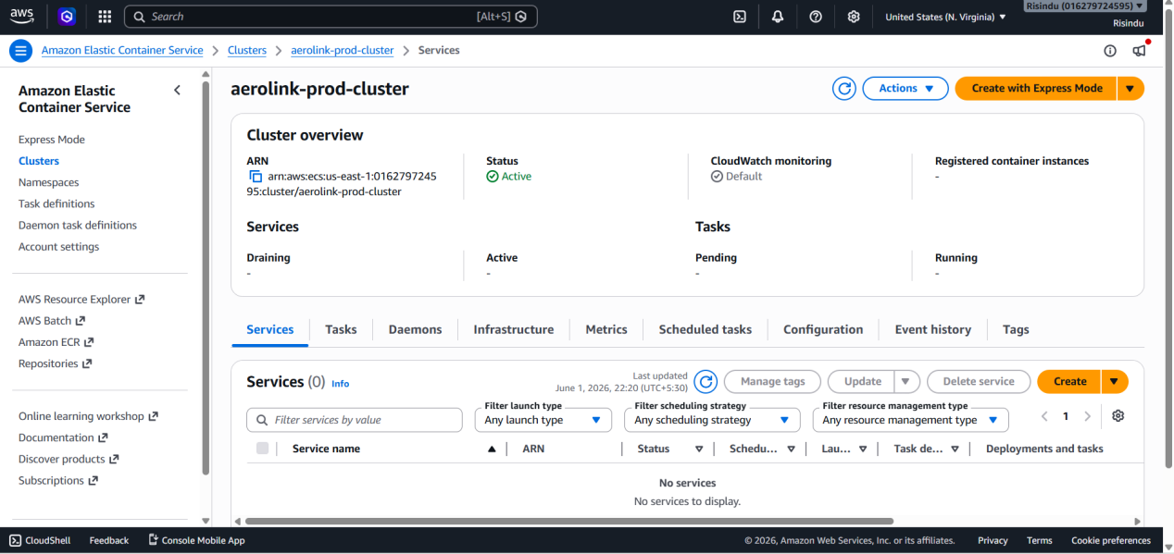
Figure 19 - Amazon ECS Cluster configuration with WS Fargate actively running container tasks

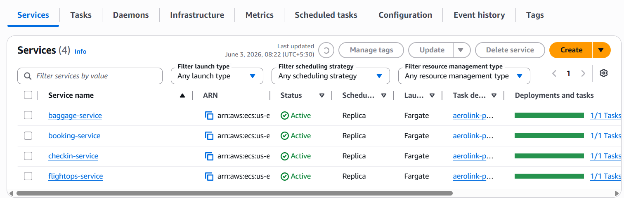
Figure 20 - Detailed view of active ECS tasks

These microservices need to be able to communicate with AWS’s infrastructure without any issues present. For this purpose, the codebase itself has to be changed to allow for the node-postgres (pg) driver to be installed in the booking service so it can communicate effectively with Amazon Aurora.

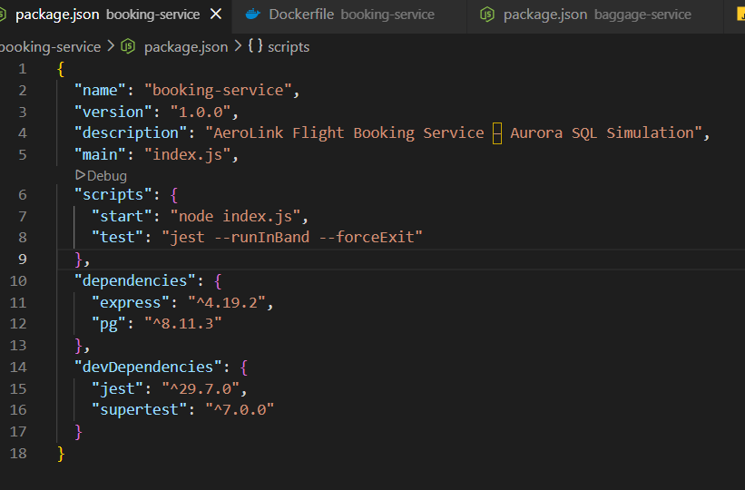
Figure 21 - Integration of node-postgres (pg) driver in the Booking Service
Moreover, the AWS SCK v3 must also be installed into the baggage service so that it can allow it to read and write directly to the cloud services by using the IAM role credentials present.

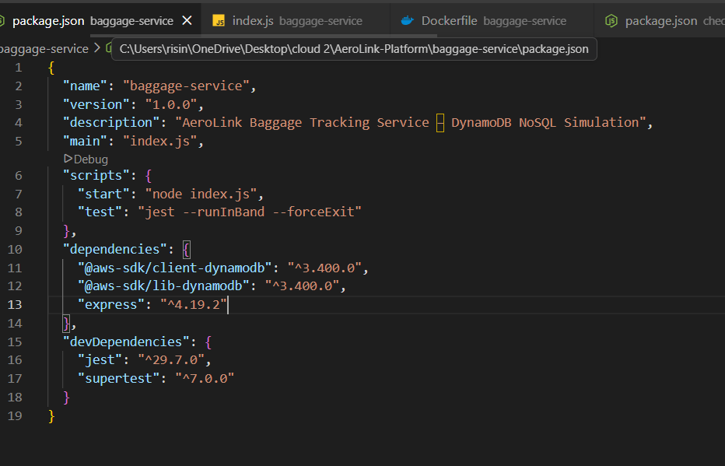
Figure 22 -Installation of AWS SDK v3 in the Baggage Service

Lastly in this section Aerolink’s application code also must be updated so it can use environment based configuration variables (Wiggins, 2011). This common practice is used to make sure microservices can still run locally for testing and fallback while dynamically connecting to the respective AWS cloud database when deployed using ECS.

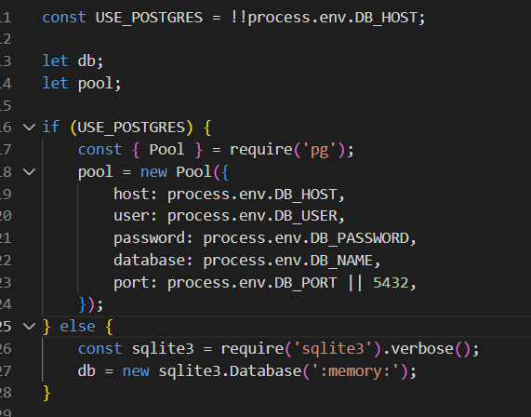
Figure 23 - Environment-based configuration logic implemented in index.js

4.3 Databases and Persistence Layer

Data persistence is properly managed in this new architecture with the move away from local SQL based files to cloud managed databases. The booking and check in services in Aerolink are responsible for handling critical data which requires proper ACID compliance so issues such as double booking are prevented. This is the reason that Amazon Aurora PostgreSQL is used as it can provide the required commercial level performance while still being cost effective. It ensures that data is replicated across multiple availably zones so that the best fault tolerance is present in the system.

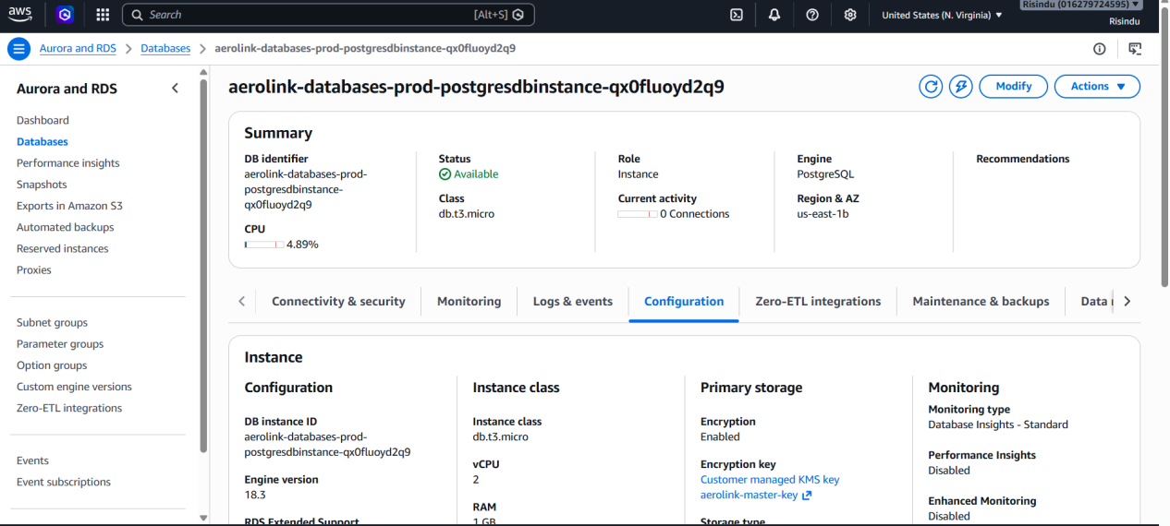
Figure 24 - Amazon Aurora RDS instance running PostgreSQL
Unstructured data is present in this system at the baggage tracking service with high velocity and schema less data being present. Amazon DynamoDB is used in this instance to manage unstructured data.

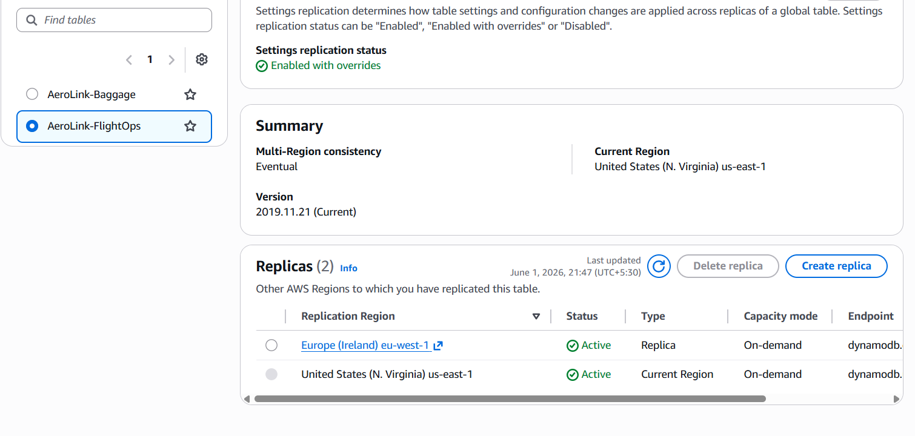
Figure 25 - Amazon DynamoDB table configuration

DynamoDB global tables are also used in this system so that a multi-region structure is established with active to active synchronization amongst global deployments of Aerolink (Amazon Web Services, 2024b). An example of this is when a bag scanned in one region such as us-east-1 is synced in a replica table in a completely different global region so that read latency is minimal for any airport staff using the system.

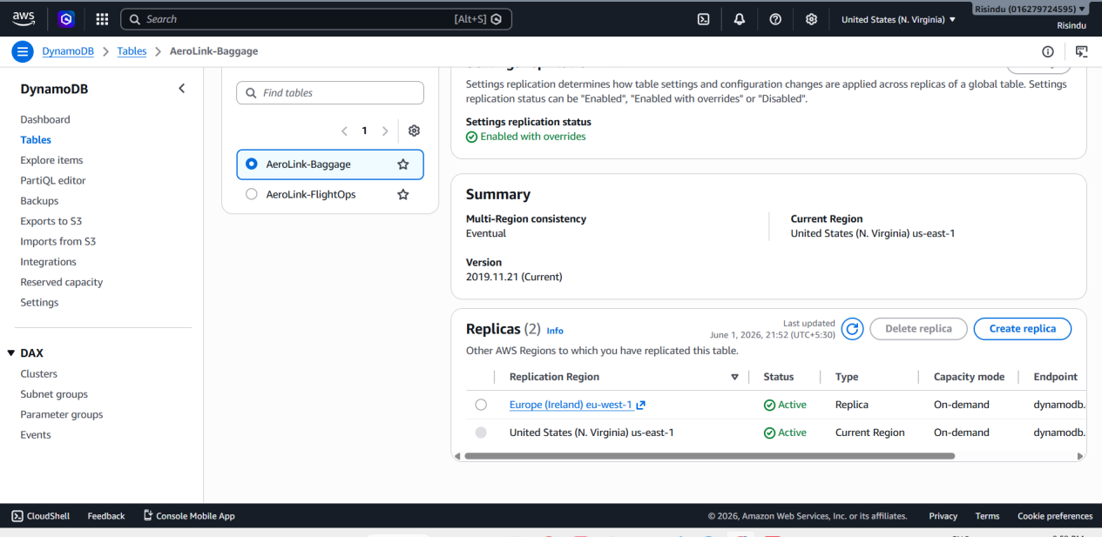
Figure 26 - DynamoDB Multi-region Global Table deployment

Finally, after connecting to the baggage service the DynamoDB tables will properly store live operational data in real time.

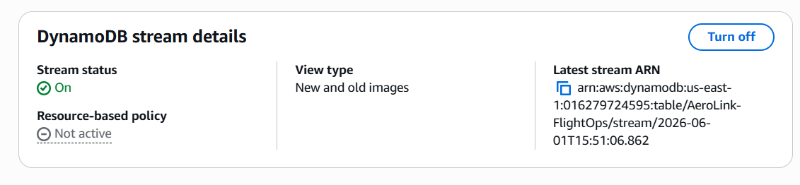
Figure 27 - DynamoDB schema and active item storage

4.4 Event Driven Architecture

The old architecture that Aerolink used was made so that in the event one service goes offline, all the others will have to wait for a response. The new AWS system aims to prevent this by implementing an asynchronous event focused structure (Richards and Ford, 2020). The central event bus in this case will be the Amazon EventBridge. This looks into publishing the state changes and routing these events from EventBridge to the appropriate users in the stream.

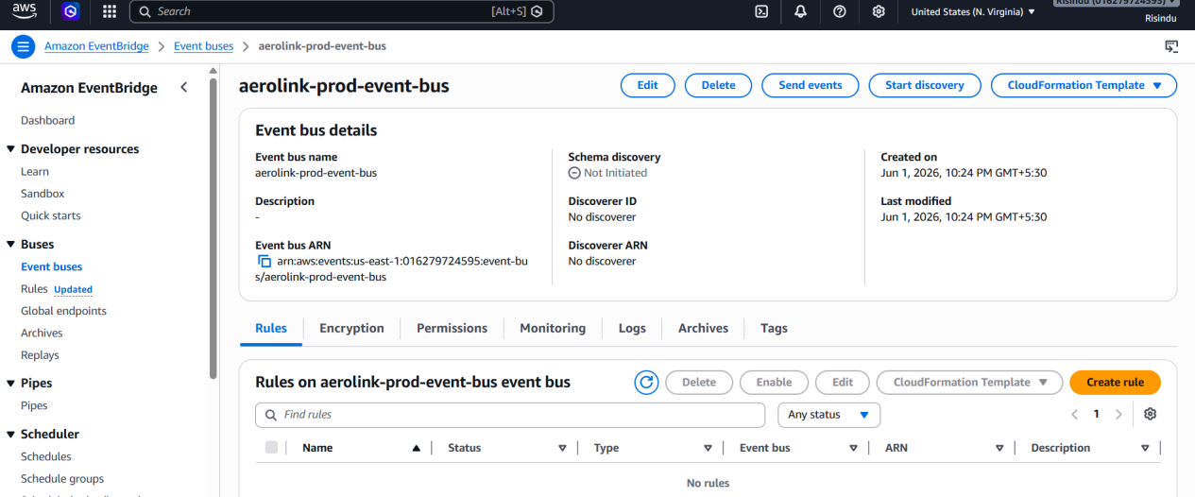
Figure 28 - Amazon EventBridge bus and rule configuration

Background queuing of messages is vital in a system with critical information such as Aerolink. EventBridge can route these vital messages to Amazon Simple Query Service (SQS) for background queueing. If the service is down SQS can help retain the message so that there is no data lost in the system.
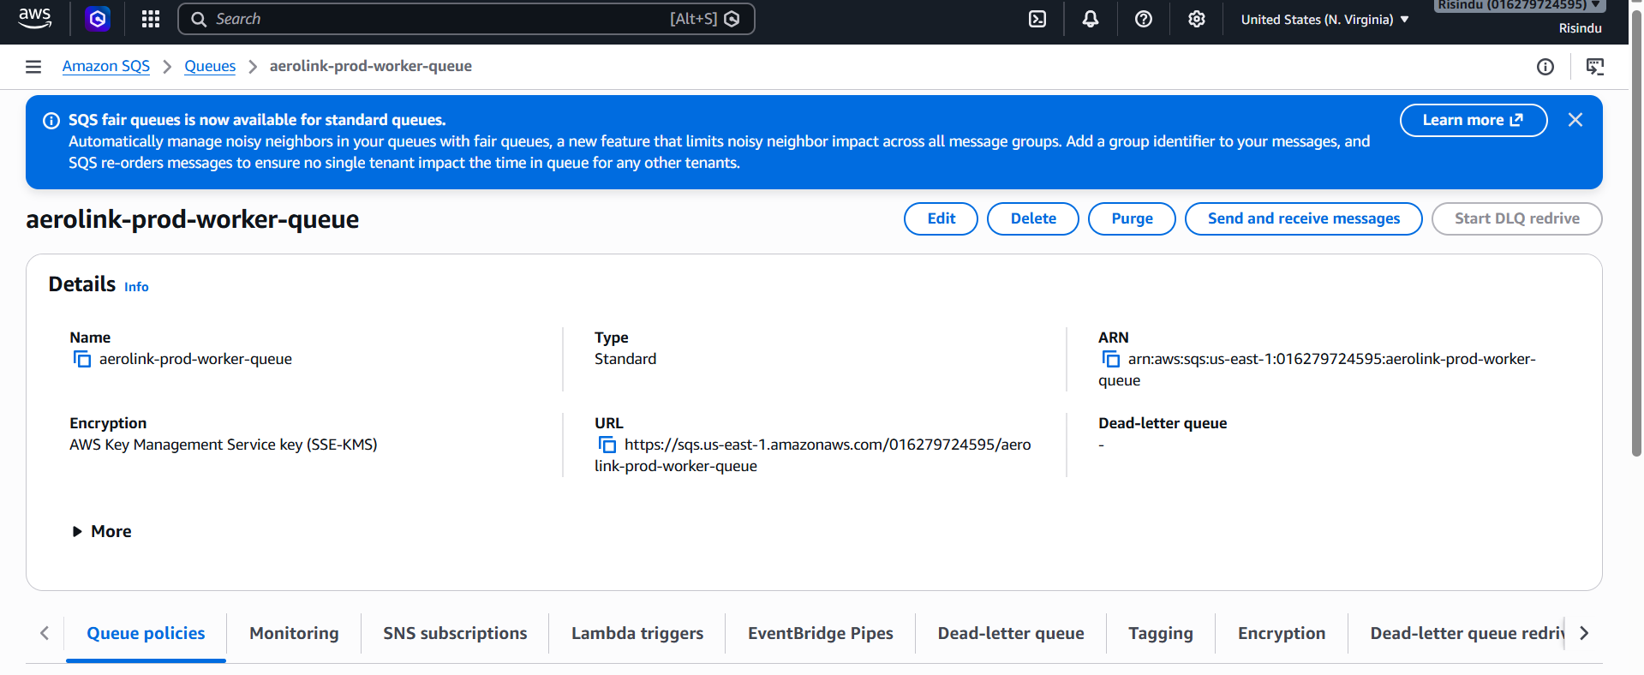
Figure 29 - Amazon SQS

EventBridge is also responsible for sending messages to the Amazon Simple notification System (SNS). SNS is responsible for making sure that notifications are pushed in real time based on the system events.

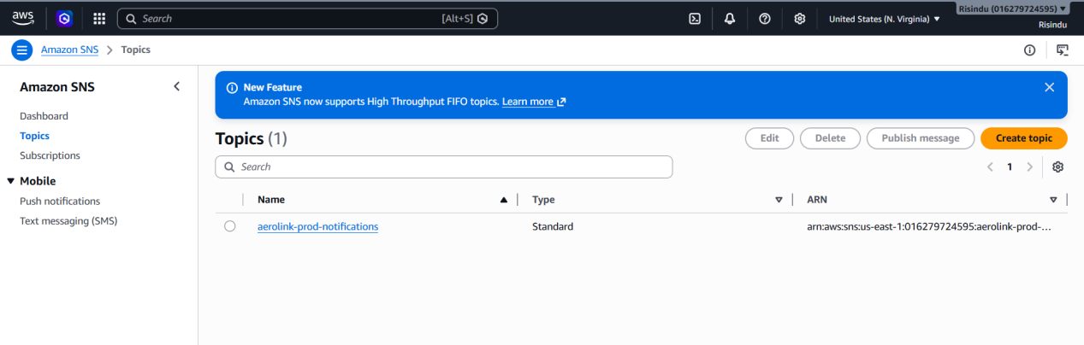
Figure 30 - Amazon SNS

The Aerolink further must maintain certain background tasks running without any manual ECS compute resources. For this purpose, AWS Lambda functions are deployed in the system. Lambda can then provide Aerolink with serverless computing capabilities that can make code in response to any SQS events and scale based on the volume of incoming messages.

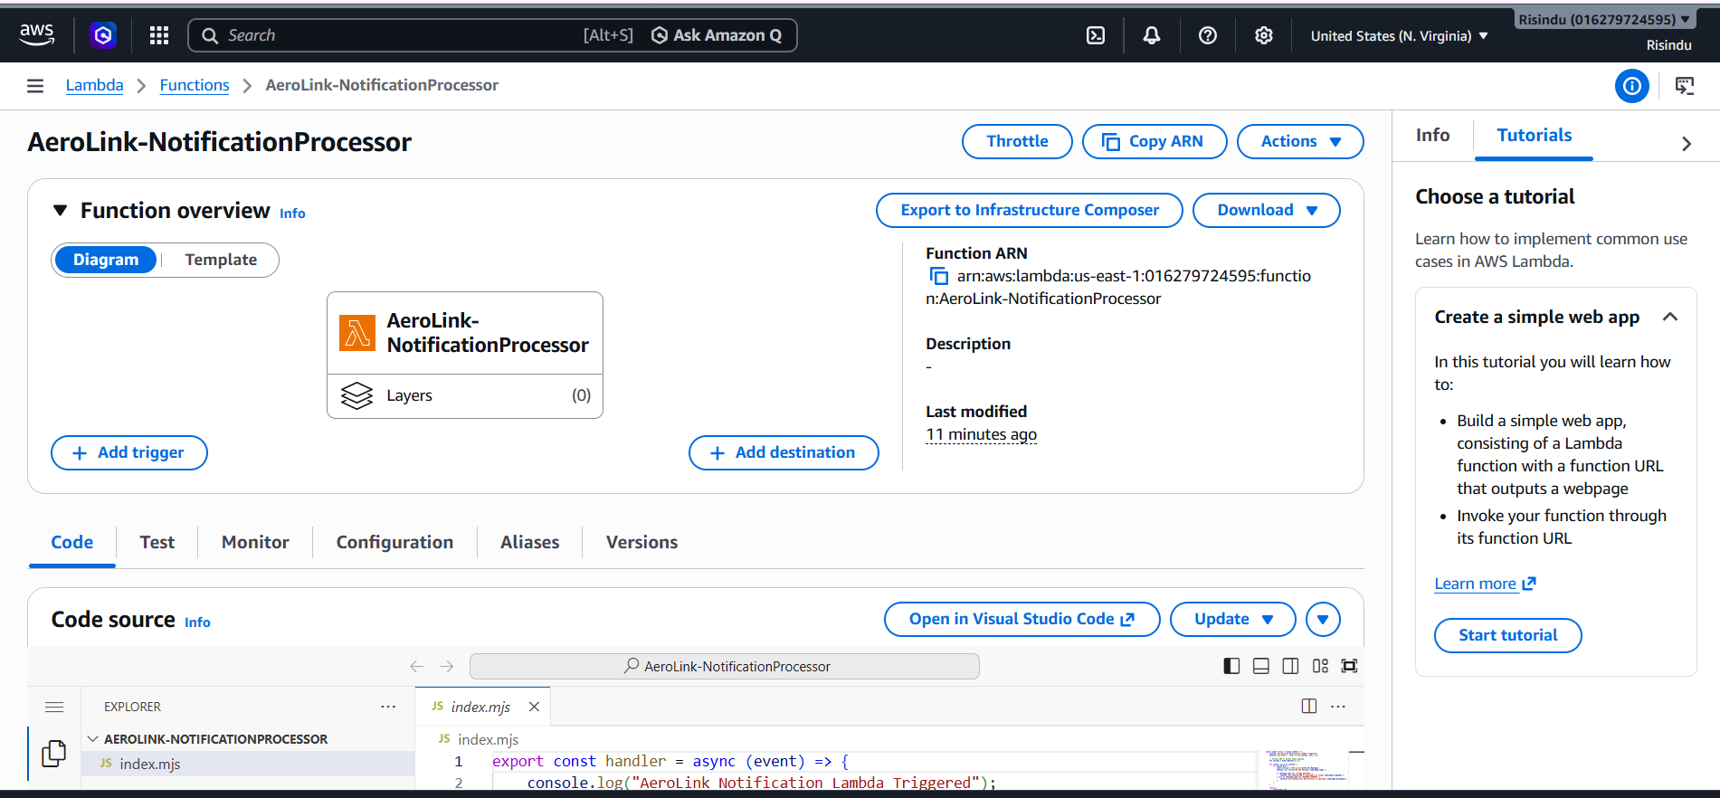
Figure 31 - AWS Lambda serverless function executing background tasks

4.5 Front End and Global Edge Routing

The local systems API was outdated and had to be replaced with the AWS Application Load Balancer (ALB) so it can more securely route user traffic into Aerolink’s system. The ALB in this instance is responsible for checking all incoming HTTP and HTTPS traffic into the system.

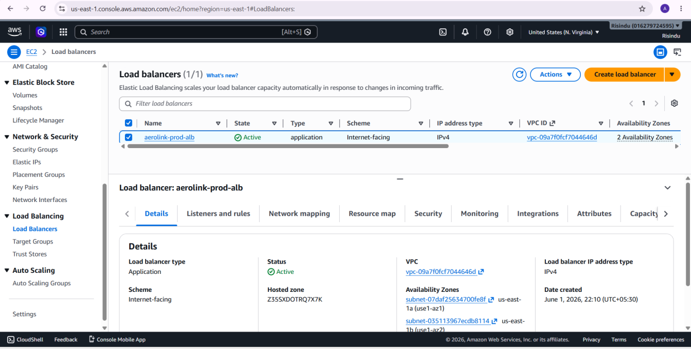
Figure 32 - Application Load Balancer and Target Groups

The application load balancer needs to be able to map the RESTful API paths correctly with the ECS target groups by utilizing the correct listener rules. If there is any traffic that hits API/bookings for example it will be directly routed to the bookings ECS task and baggage traffic to baggage and so on.

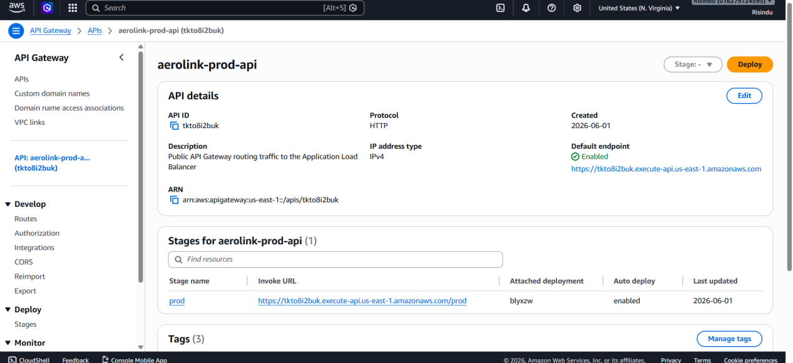
Figure 33 - API routing configurations mapping paths to target groups

The private IP addresses of containers should not be exposed to the public internet. The proper routing setup in the system can help maintain it so that the backend API can accept distributed traffic from the public internet and not expose the private areas.

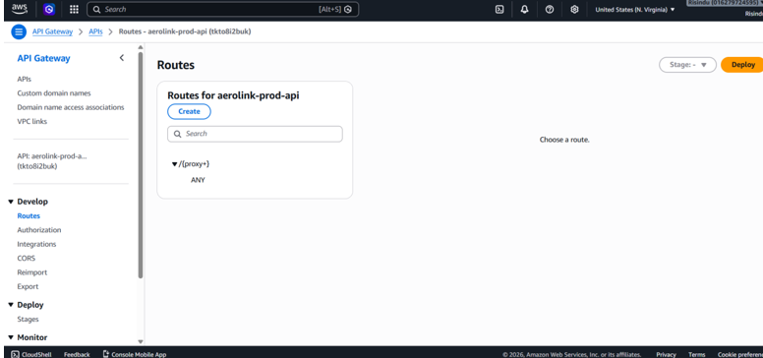
Figure 34 - Backend API endpoints successfully accepting traffic
The front end system that the users can access is also decoupled from the backend services in AWS. These static files are uploaded to the Amazon S3 bucket and will make sure that customers around the world can seamlessly load the user-facing system at any time. For this purpose, the CloudFront system was placed in the S3 bucket to be the global CDN (Content Delivery Network) and cache the frontend assets to the edge locations globally.

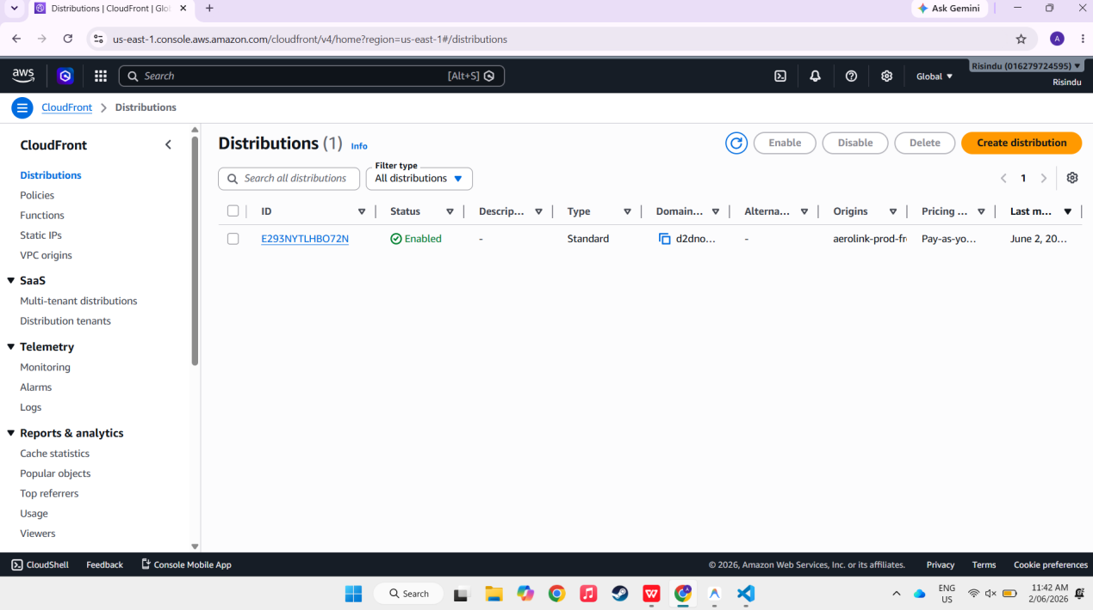
Figure 35 - Amazon S3 and CloudFront CDN hosting the frontend

Finally, the end users can interact with Aerolink’s website using CloudFront domain name which is both secure and low in latency.

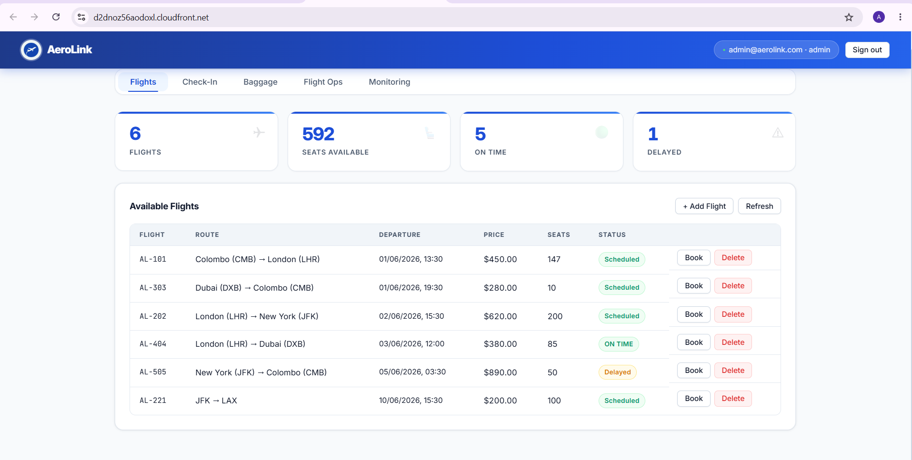
Figure 36 - Live production site accessed via CloudFront UR

4.6 Service Integration

For the cloud migration of Aerolink to be successful to the highest amount, the now decoupled microservices must be able to interact over AWS without any issues. The multi-step data process in the cloud has to be validated in the cloud production environment to prove this functionality.

In the front-end system when a user requests a ticket the booking service has to be able to talk to Amazon Aurora and decrease the seat inventory that is present within the database. ACID compliances are upheld as a result of this Aurora function.

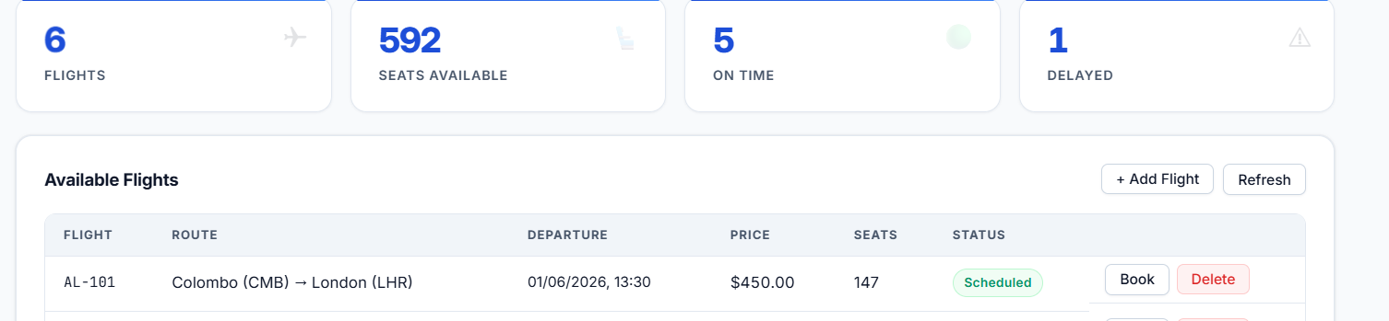
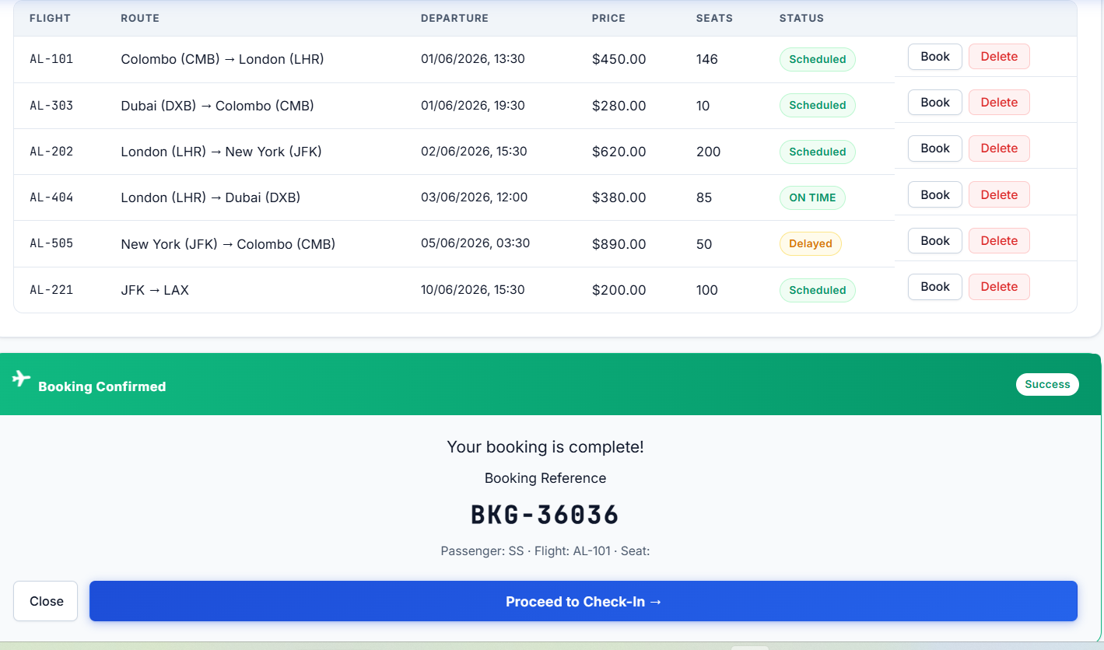
Figure 37 - Seat inventory correctly decrementing after a booking is processed

Multi hop communication is supported in the new AWS system for Aerolink. When the status of a flight is updated the FlightOps service can communicate the update using the ALB to the booking service ensuring that internal routing is taking place with no issues.

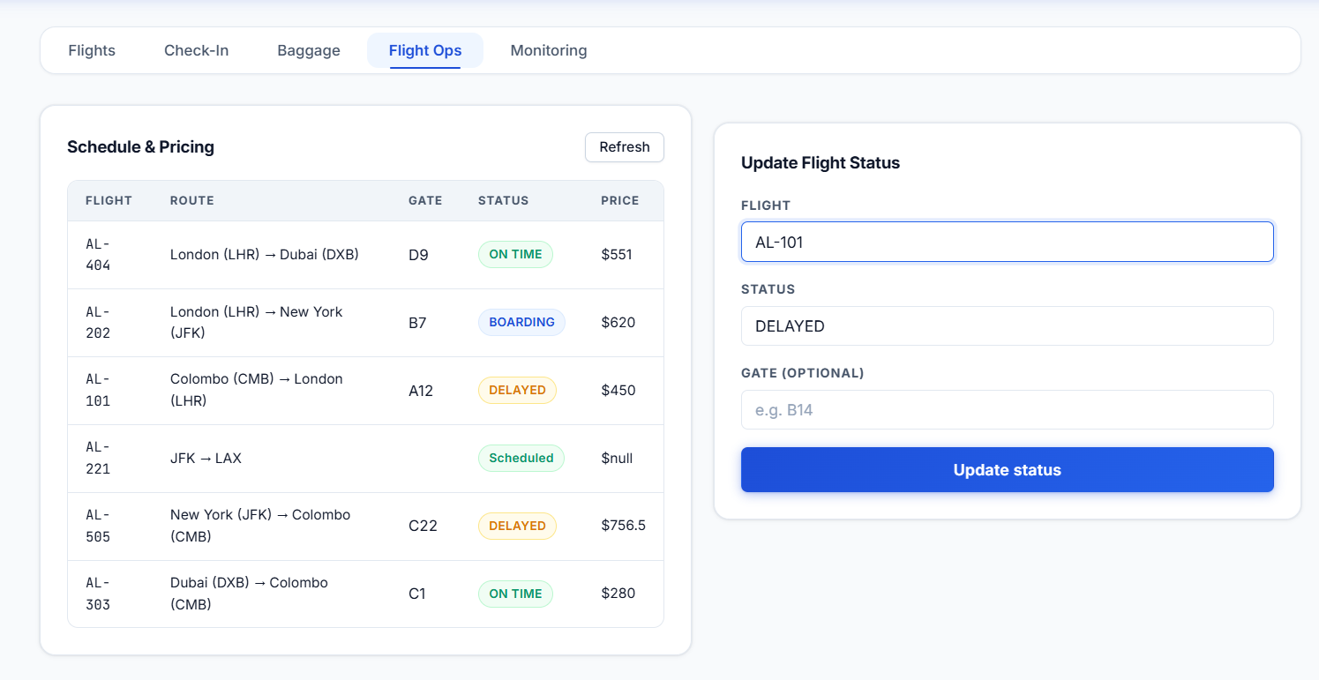
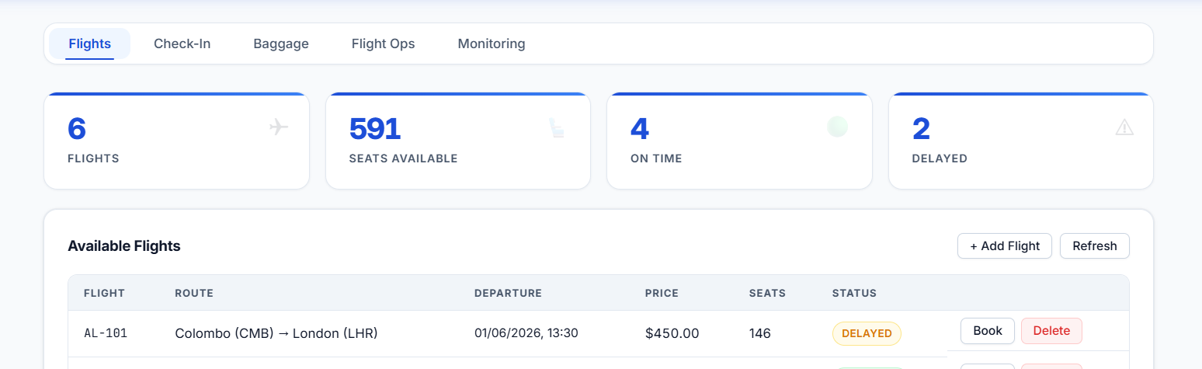
Figure 38 - FlightOps service successfully communicating with the ALB and Booking Service

The check in microservice too requires a cross validation procedure. Befrore a passenger can get their boarding pass it needs to be validated that the passenger has made a reservation. This can prove that synchronous REST communication can happen between individual ECS microservices.

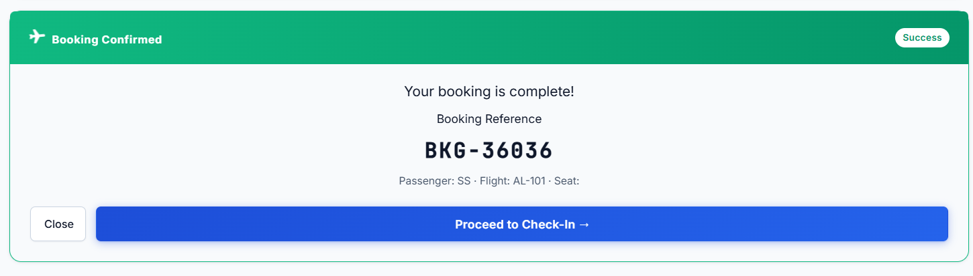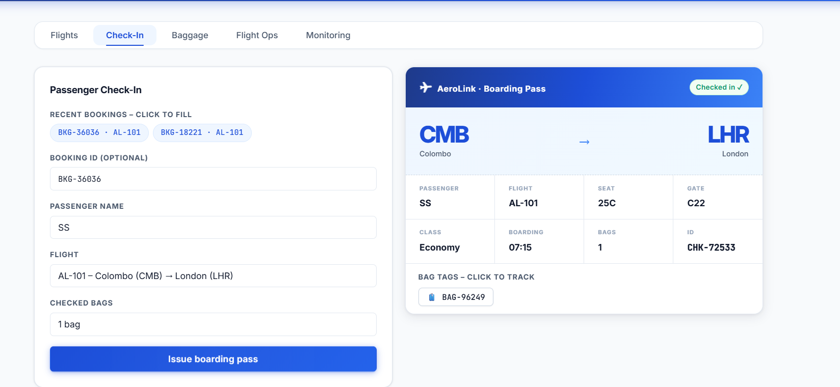
Figure 39 - Successful Check-in flow proving communication between Check-in and Booking microservices

Furthermore, the baggage section too needs to dynamically change with backend communication. Liva baggage data needs to be displayed to show that it’s authenticating via AWS SDK as well as executing real time read and write queries with the Amazon DynamoDB global tables.

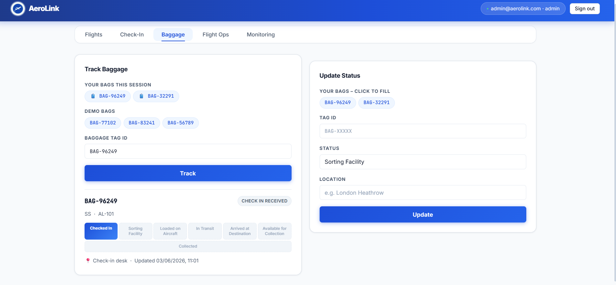
Figure 40 - Baggage dashboard successfully reading and writing real-time status updates to DynamoDB Part 1

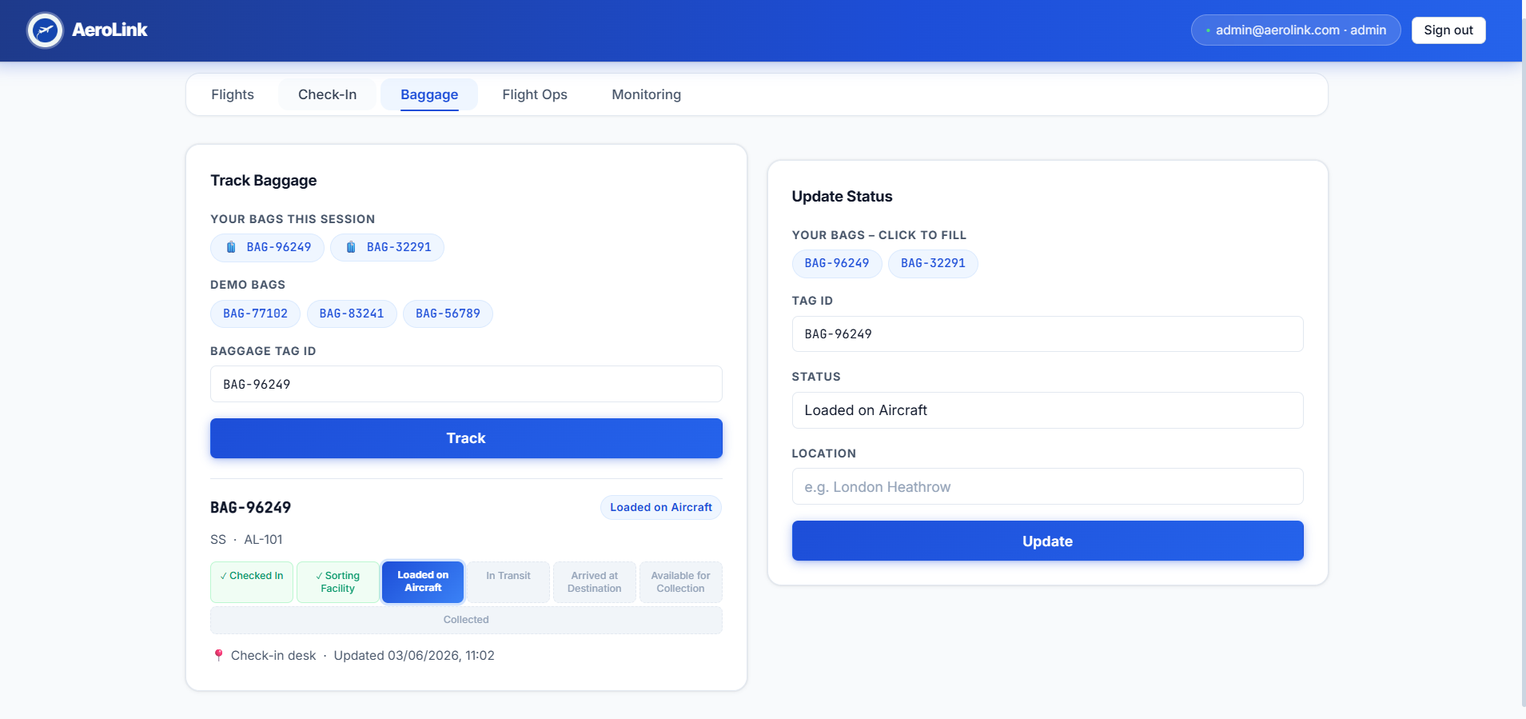
Figure 41 - Baggage dashboard successfully reading and writing real-time status updates to DynamoDB Part 2

The front end system can simulate third party checkouts with vendors such as Stripe by giving real time feedback using a model overlay.

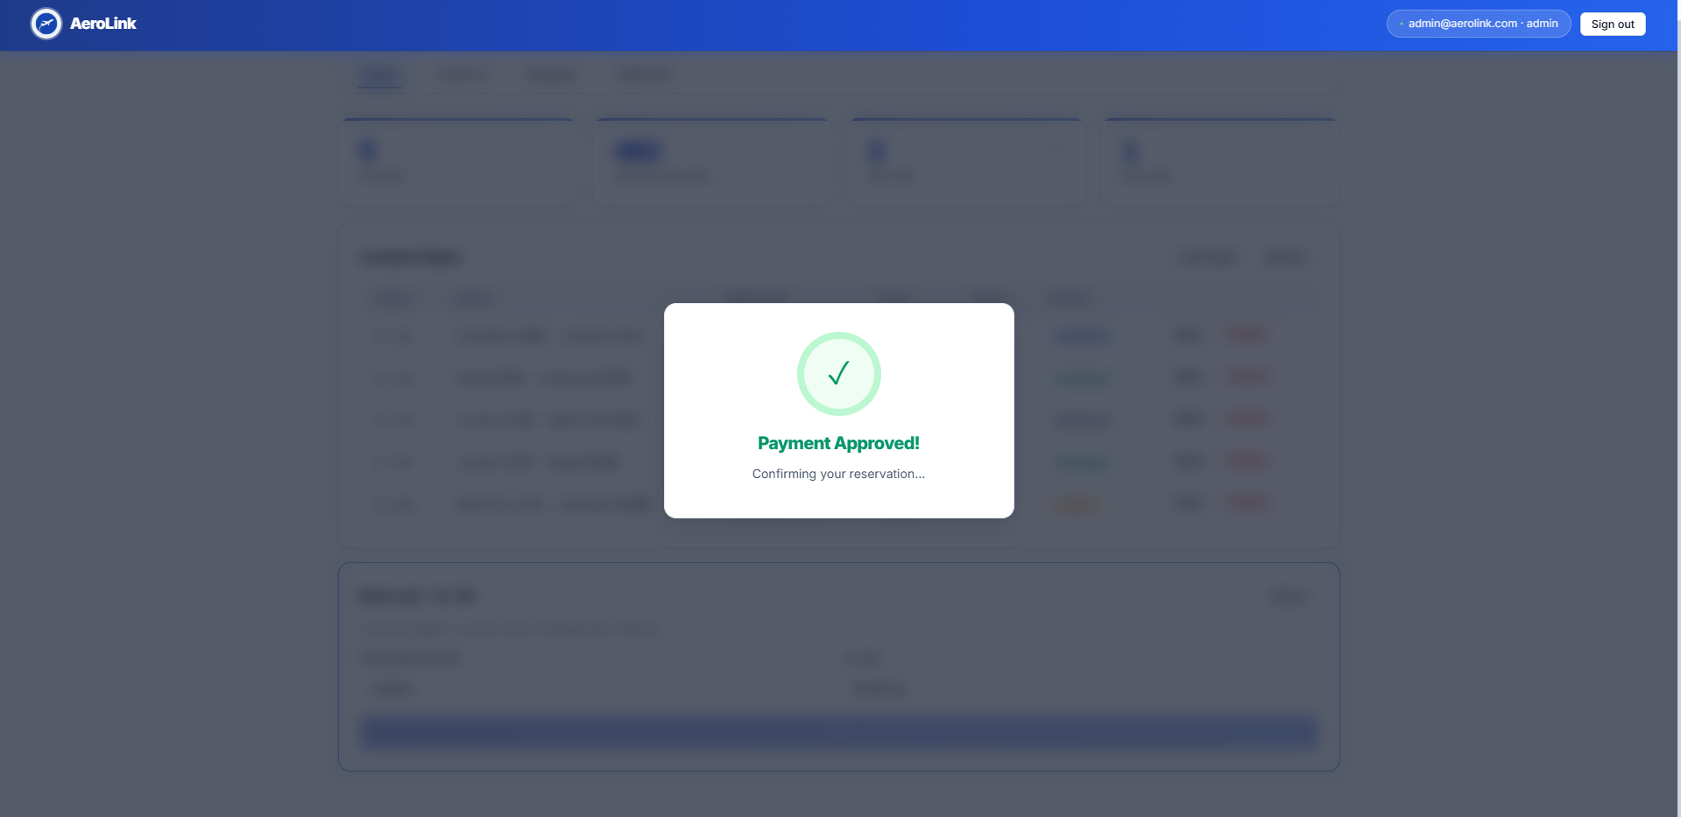
Figure 42 - Payment frontend

This Payment microservice also utilizes Amazon DynamoDB table since it gives single millisecond latency. Here the Transaction ID, Amount and Booking ID are all recorded appropriately.

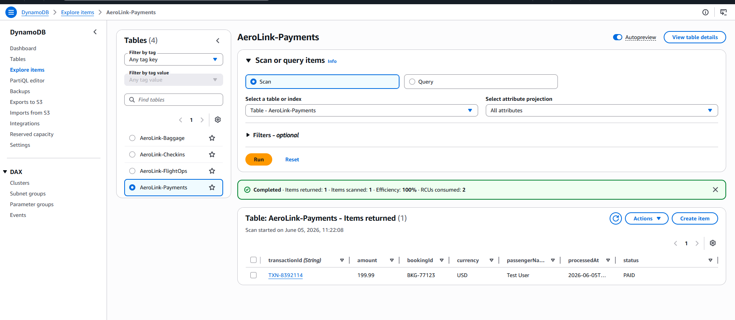
Figure 43 - Payment DynamoDB

Testing and Performance

Aerolink’s architecture may be sound on paper, but it has to be properly tested in order for it to be ready for use in the real world. The testing must be comprehensive and cover areas from the API layer validation, resilience, autoscaling and more as detailed in this report.

5.1 API Documentation and Functional Test

Well documented APIs are a must when it comes to having a microservice based architecture on the cloud for Aerolink. Swagger UI is used in this system to generate any Open API documentation needed automatically. Swagger UI can help to visually map and test backend endpoints using a web interface and gauge the correct contract that the front end and back end of the system has.

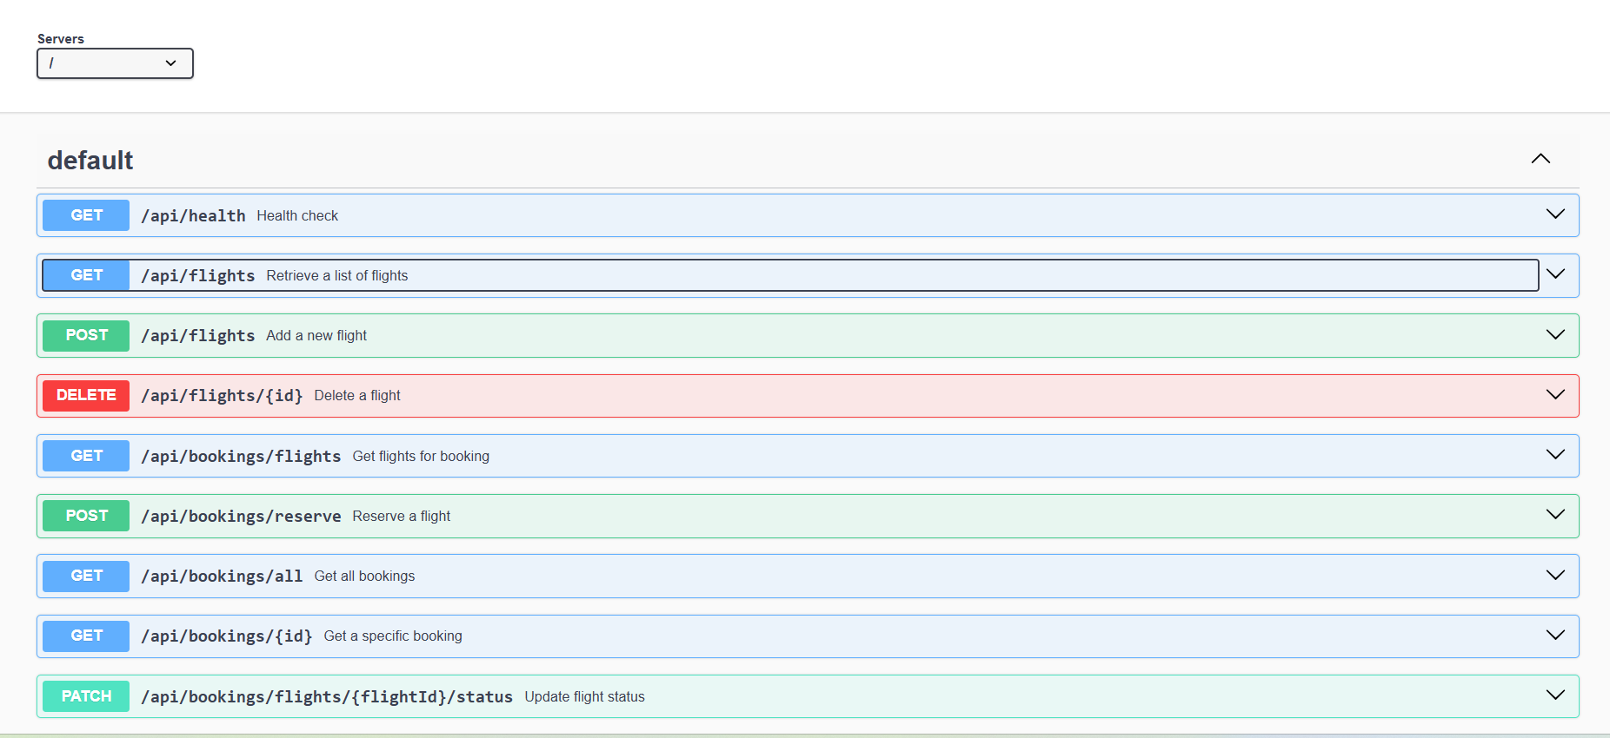
Figure 44 - Swagger API documentation

This functional routing and RESTful API must be further validated and tested by using Postman. In postman, a GET request can be put in the user facing Application Load Balancer to target an endpoint like /api/bookings/all. In the screenshot below it is clear how the ALB can correctly help route a request to the private ECS containers and still return a 200 OK status and JSON file. This means that the RESTful API is functioning as intended in this system in a proper and secure way.

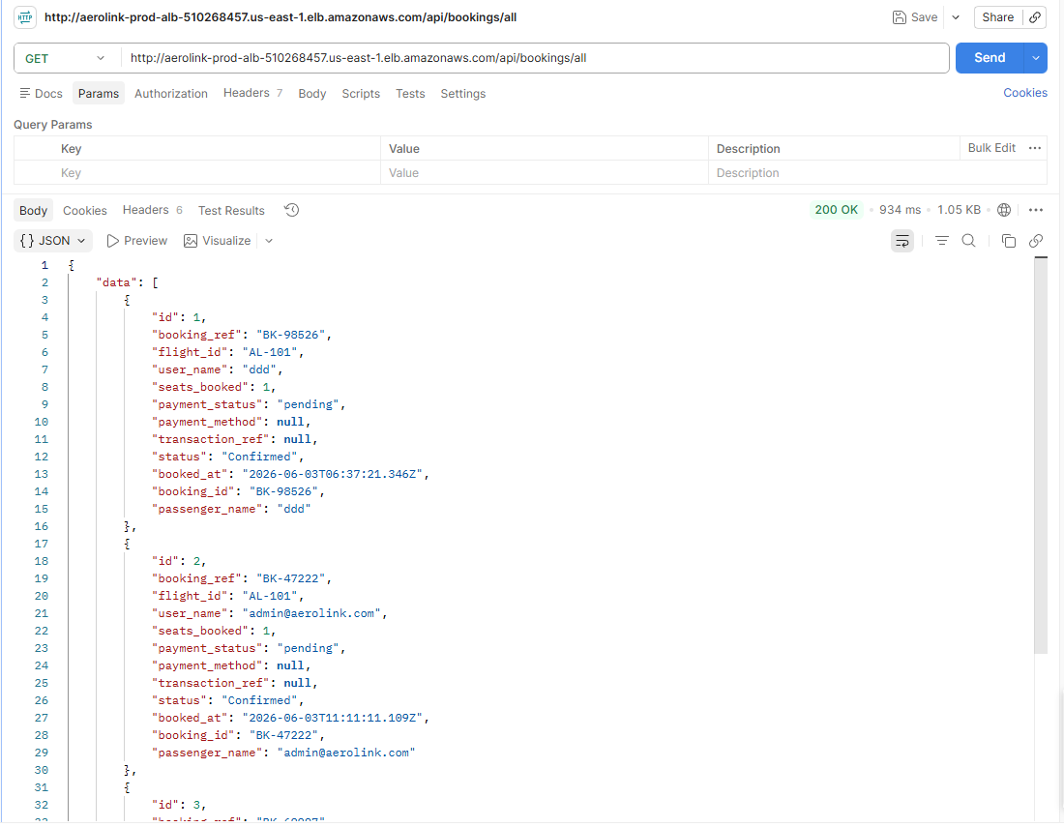
Figure 45 - Postman Testing

5.2 Unit Testing

Automated unit tests have to be done before the application is even deployed into the cloud to make sure that all the unique microservices can work as intended. Seat booking, baggage tracking and unique functions are tested to guarantee that the code is behaving as expected even in isolation so it can then be pushed into the AWS cloud.

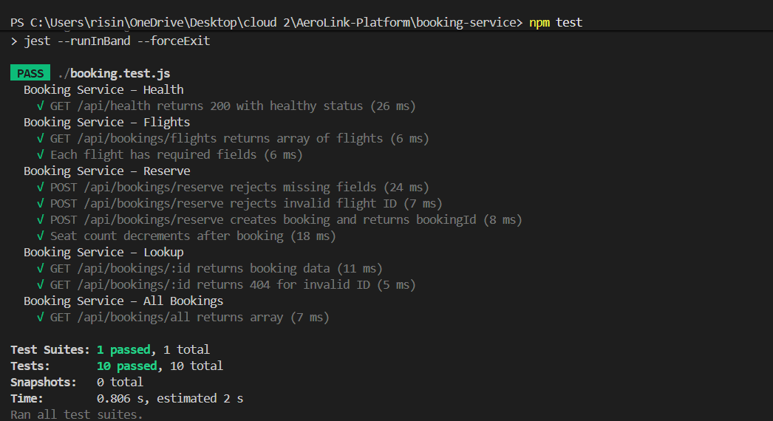
Figure 46 - Unit Testing For Microservices

5.3 Resilience and fault tolerance testing

If there is a network failure or any database failure the system will be very vulnerable and can lead to potential data loss. These issues are tackled in the code itself by the use of a circuit breaker pattern that can look at cross service communication and make a downstream service, such as booking service, and ensure if there is a failure that the circuit is opened so that the system does not overload with requests and allow for recovery time (Nygard, 2018).

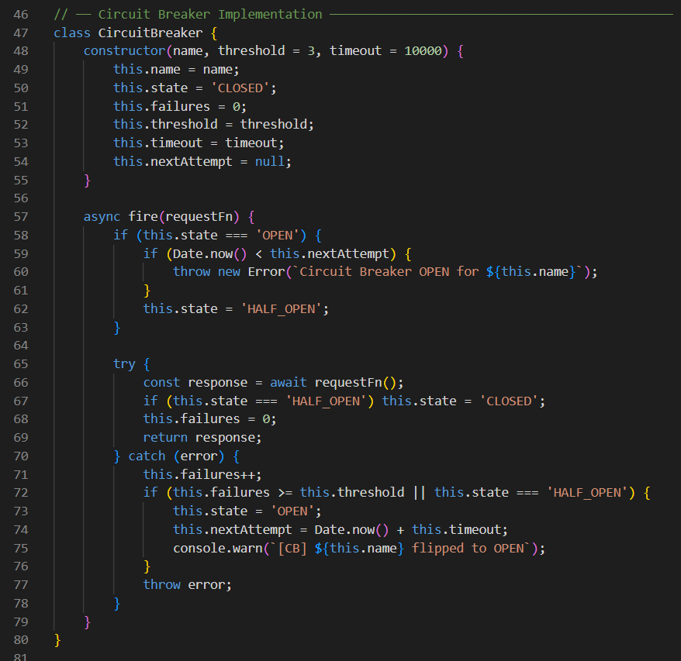
Figure 47 - Circuit Breaker Code

Alongside systems like the circuit breaker pattern, retry patterns that can also be used to intercept any network errors and retry the request till the point of exponential backoff before ultimately failing. This is to make sure that the network issues do not disrupt passengers’ experience.

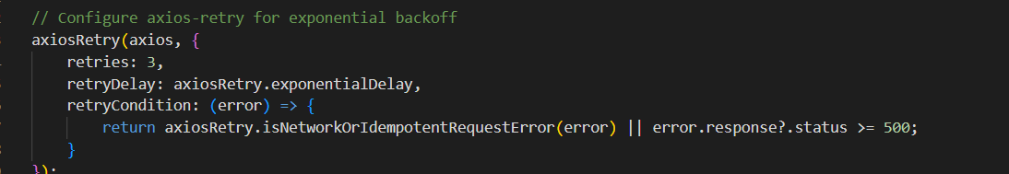
Figure 48 - Retry Code

Asynchronous events also require proper fault tolerance. For this Amazon SQS Dead-Letter Queue (DLQ) of ‘aerolink-prod-worker-dlq’ is used in the system. In this if any message fails to be processed after a maximum of 3 delivery attempts, the payload will be automatically routed to the DLQ and ensuring that the primary event bus is never blocked.

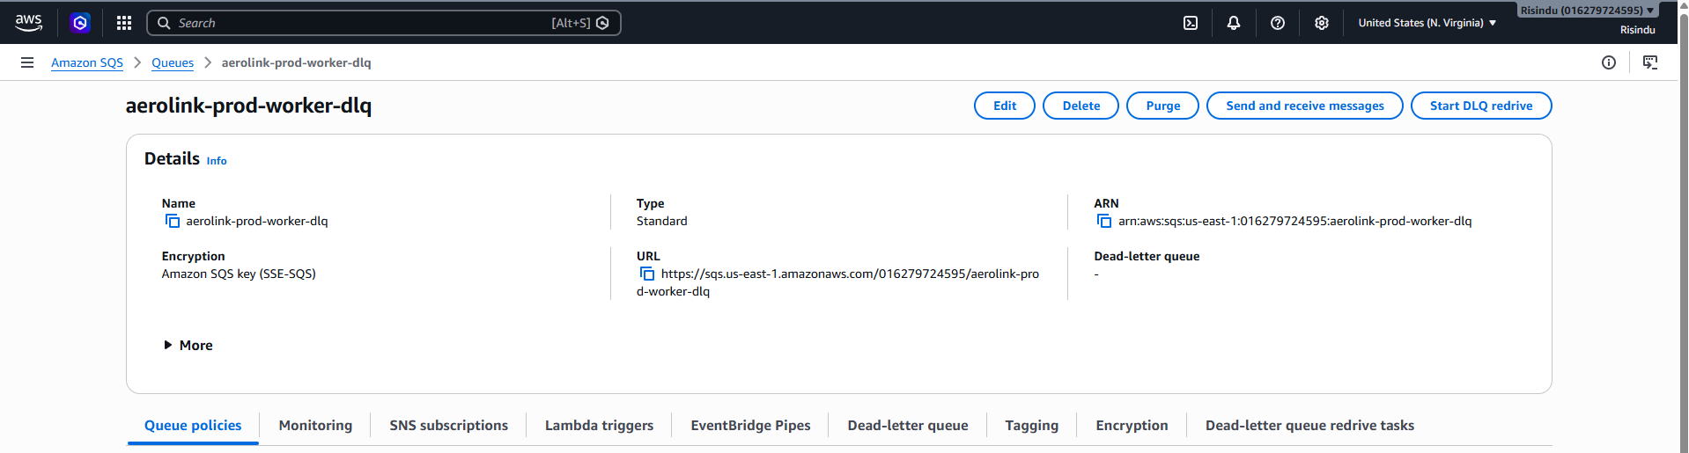
Figure 49 - aerolink-prod-worker-dlq in the AWS SQS Console

5.4 Performance, Stress Testing and Autoscaling

An airline has to always be ready for spikes in users during certain time periods such as international holidays. To test if the system can handle this, a stress test is carried out against the system to see if it can perform under stress and maintain performance as well as low latency during these times

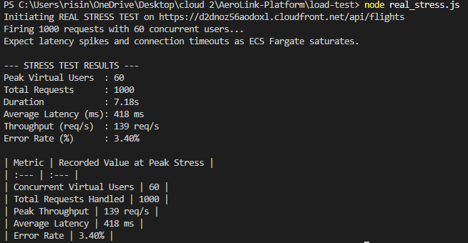
Figure 50 - Performance and Scalability Stress test

The table below shows a t that is est simulating 60 concurrent virtual users fired 1,000 rapid requests. The system was able to have 139 requests per second and an average latency of 418ms. This means that only a 3.40% connection timeout error rate happens just before ECS Auto-Scaling is triggered.

Table 1 - Stress Test Table
Metric | Recorded Value at Peak Stress
Concurrent Virtual Users | 60
Total Requests Handled | 1000
Peak Throughput | 139 req/s
Average Latency | 418 ms
Error Rate | 3.40%

The system also needs to be able to dynamically respond to these demands and spikes in traffic without manual intervention. In ECS Fargate tasks, Amazon ECS service autoscaling can be configured. This configuration has a target tracking scaling policy that can automatically scale out, add more container instances whenever the CPU utilization of the Booking service exceeds 70% in average (Abbott and Fisher, 2015). When the traffic dies down this will scale back in so that the expenses are not unnecessarily high.

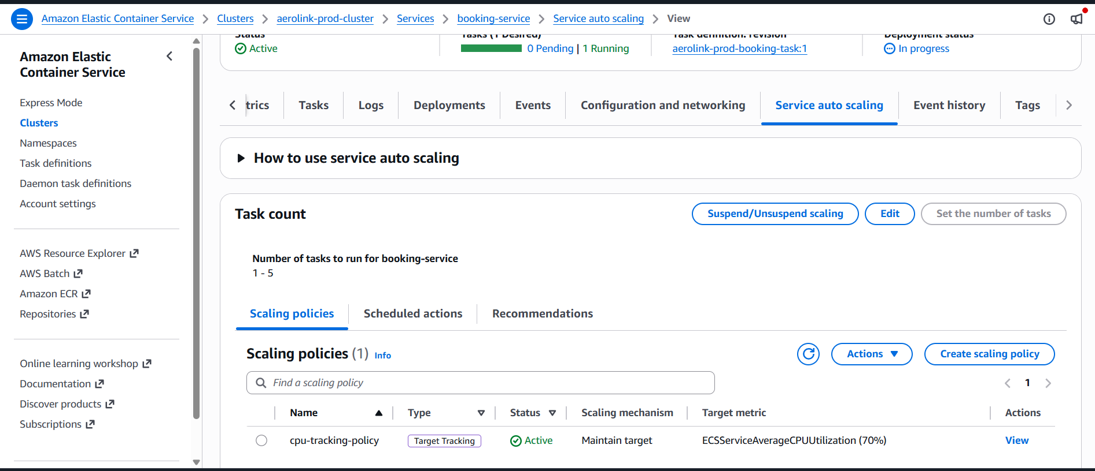
Figure 51 - CPU Target Tracking Policy (>70%)

5.5 Load testing Quantitative Results

Table 2 - Load Test
Endpoint Tested | Number of Requests | Average Latency (ms) | Throughput (req/s) | Error Rate (%)
GET/api/flights | 200 | 448 ms | 40 req/s | 6.50%

The baseline API performence has to be tested with a custom Node.js load test against a GET /api/flights endpoint simulating 20 concurrent virtual users. The above table shows how system successfully sustained 40 requests in a second with an average latency of only 448ms. This shows acceptable baseline performance before dynamic ECS Auto-Scaling was required to handle any extra traffic bursts.
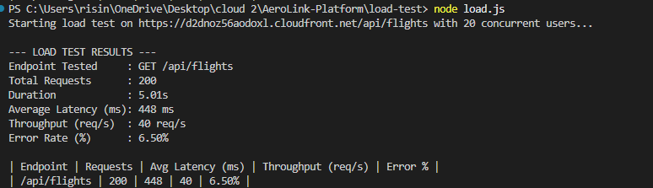
Figure 52 - Load Test Console Log

5.6 Integration Testing

Integration testing has to be carried out here to verify that the microservices, cloud databases, and AWS infrastructure components all work together as one. In here the testing is looking at whether service-to-service communication, database connectivity and end-to-end business workflows across the deployed AWS environment of Aerolink. If these results are passed this means that requests were routed correctly through the Application Load Balancer, data persisted in the appropriate cloud databases, and dependent services can communicate without any sort of failure happening.

Table 3 - Integration Testing
Test Scenario | Expected Outcome | Result
Booking Service → Aurora PostgreSQL | Reservation stored and seat inventory updated | Passed
Check-In Service → Booking Service | Reservation validation successful | Passed
FlightOps Service → Booking Service | Flight status updates propagated between services | Passed
Baggage Service → DynamoDB | Real-time baggage updates persisted and retrieved successfully | Passed

For more evidence on the testing, the figures 37-41 in section 4.6 of this report can be looked at. Moreover, the screenshot below shows a successful end-to-end integration test executed using the Swagger UI against the live AWS environment. In the procces of submitting a flight reservation request to the POST /api/bookings/reserve endpoint, the system can successfully route traffic in AWS CloudFront content delivery network and the Application Load Balancer so that it will reach the booking microservice hosted on ECS Fargate.

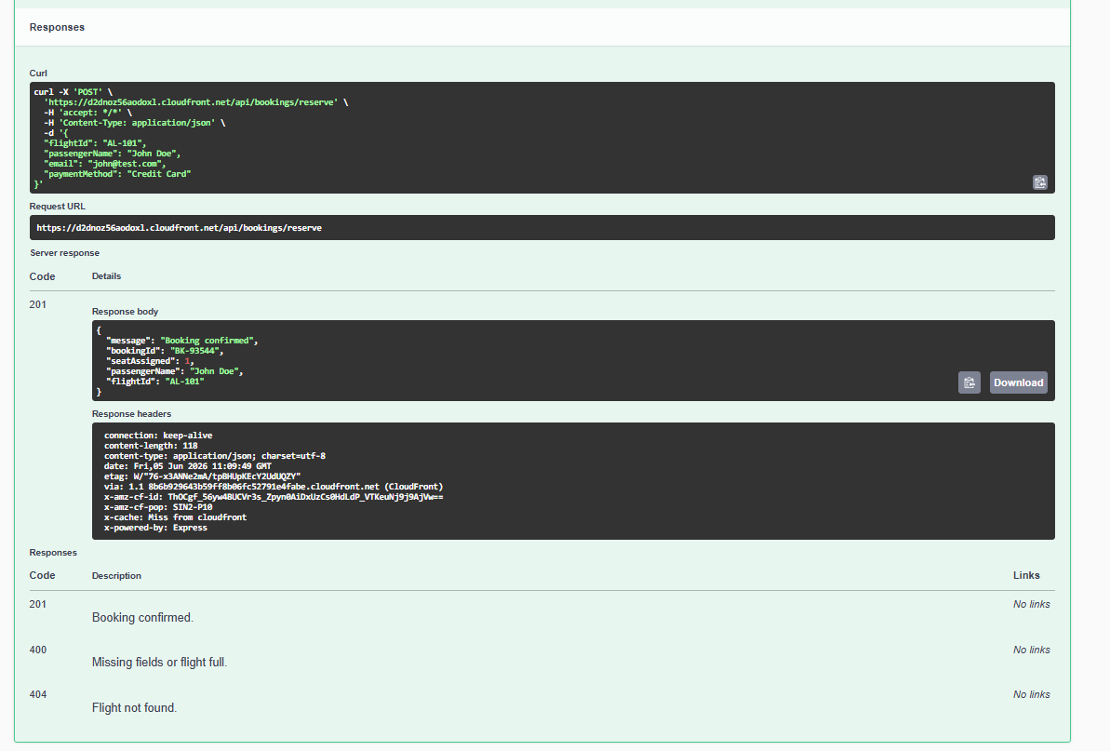
Figure 53 - Swagger Integration Testing

5.7 Security Testing

Security testing is also carried out here to authenticate that the security layer of the application is working properly. The screenshots below are proof that the layer is sound and functioning as intended.
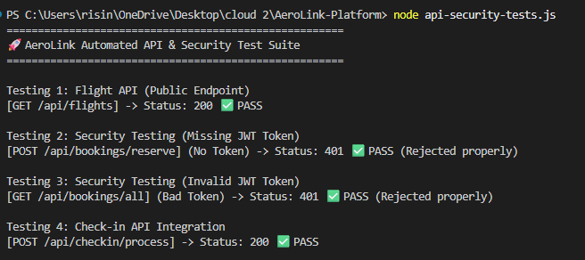
Figure 54 - Security testing

5.8 Observability

Centralized logging is vital if the system is to monitor and have operational visibility over all the decoupled microservices. Amazon CloudWatch Log Groups can be used for this purpose in Aerolink’s architecture by allocating groups to aggregate the containers normal output of stdout login in real time.
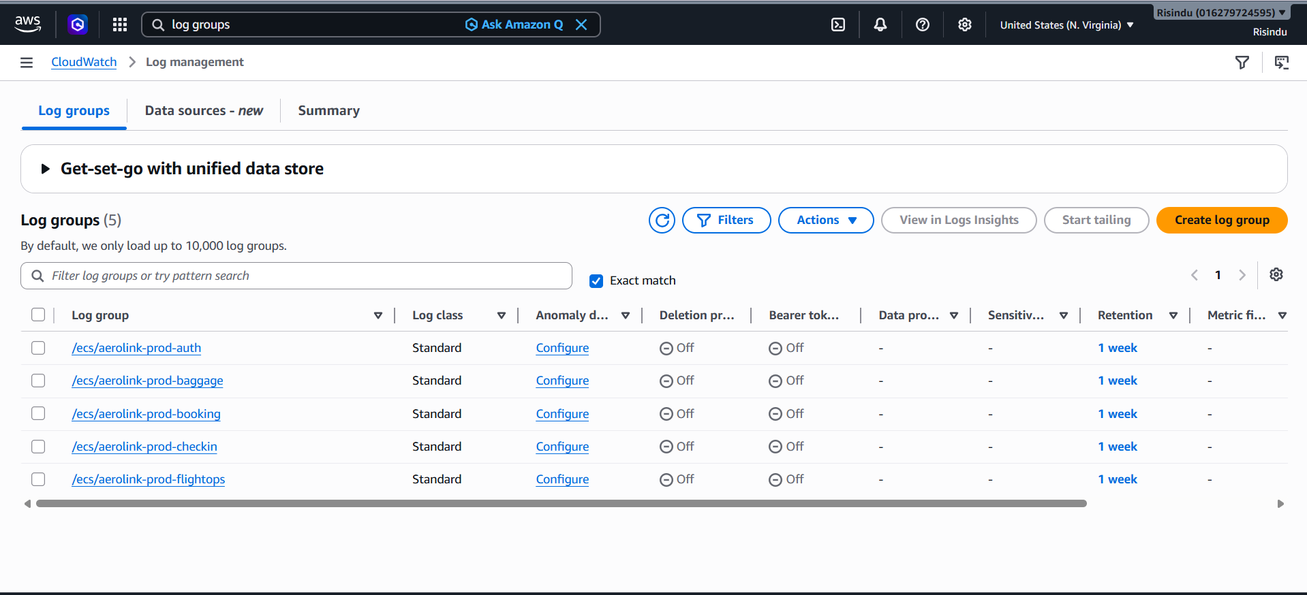
Figure 55 - Monitoring and Observability Log Groups

For the authentication service and booking service, dedicated log streams are created automatically allowing the admins of Aerolink’s system to be able to trace user journeys, find and debug API errors as well to overall be able to monitor the container health.

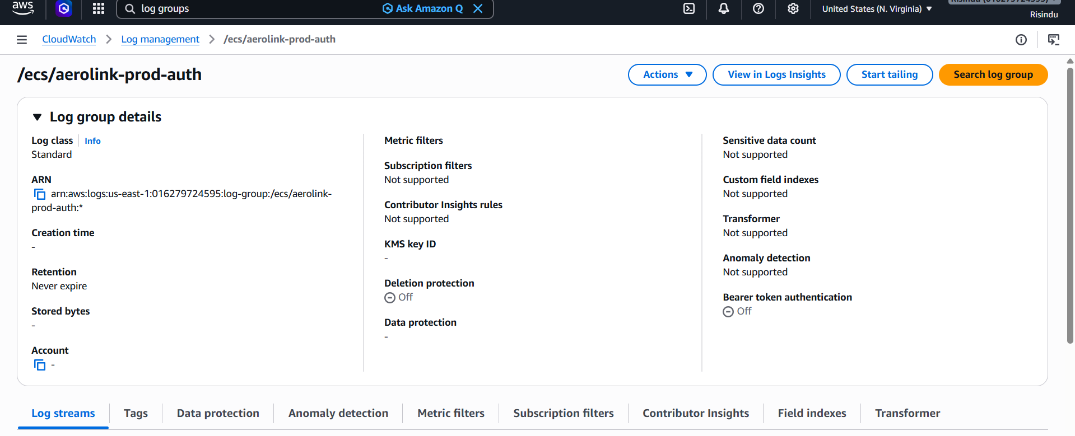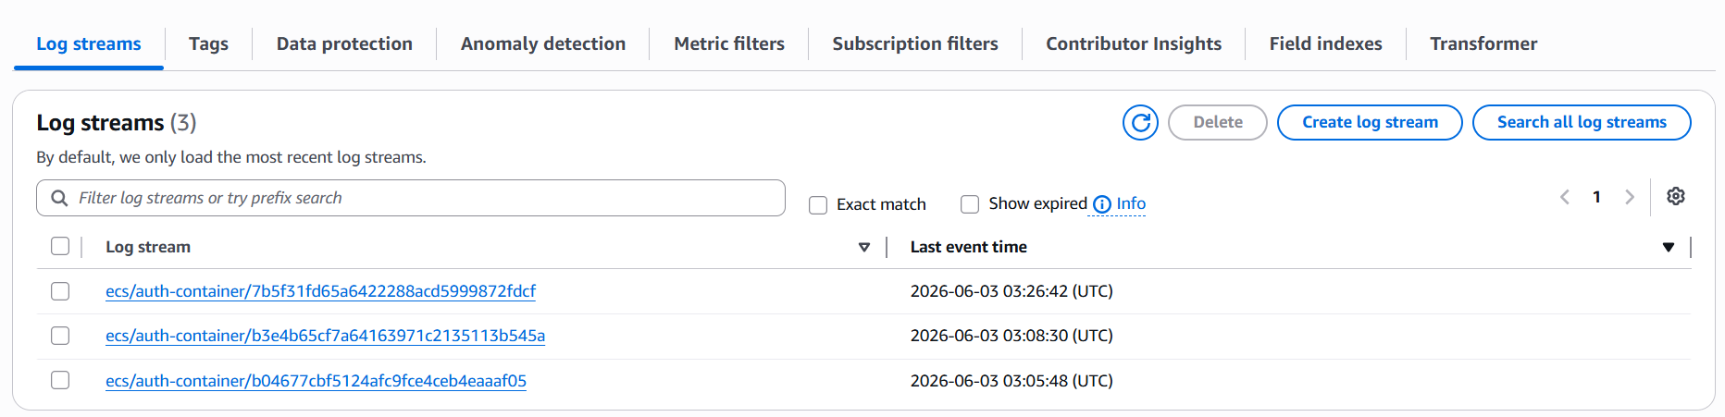
Figure 56 - Prod-Auth Log Group

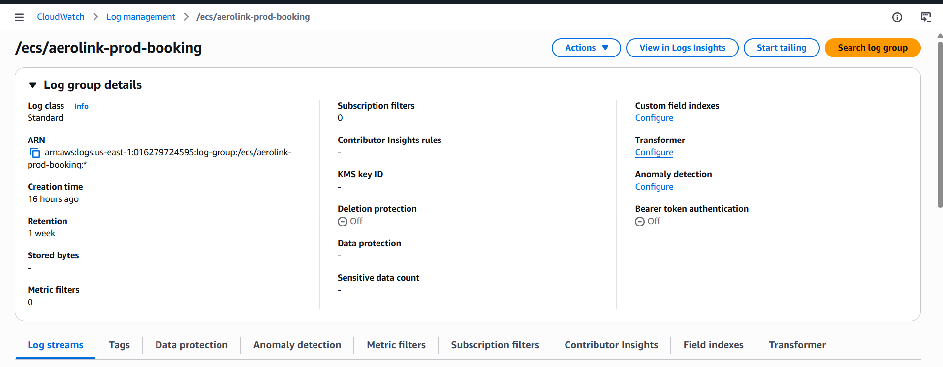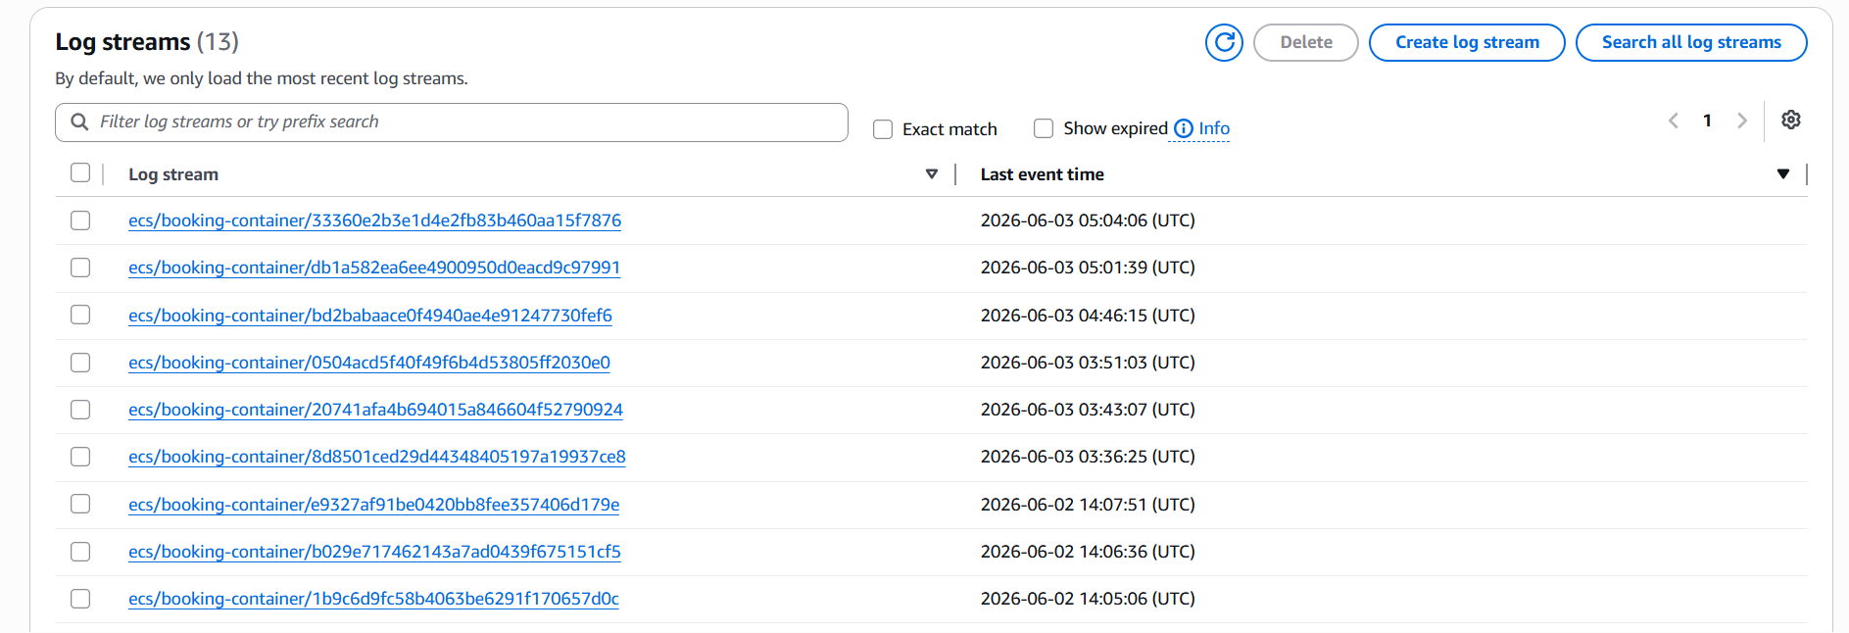
Figure 57 - Prod-Booking Log Group

Moreover, the "The AWS X-Ray Trace Map is dynamically visualizing the architecture topology and then showing traffic flow from the client to the aerolink-prod-alb load balancer while the captured distributed trace record can confirm that a correct (OK) end-to-end transaction with a total latency of exactly 1 second is present here.

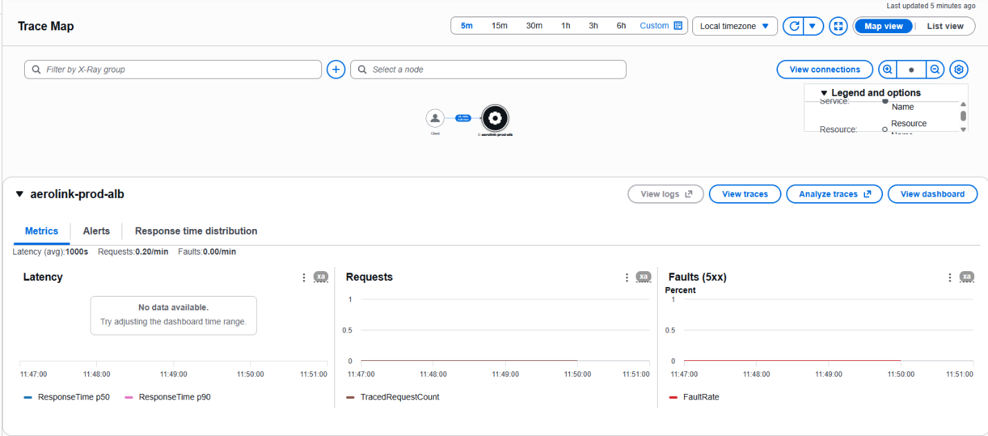
Figure 58 - Trace Map
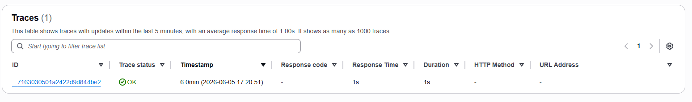
Figure 59 - Trace List

6.Challenges and Future Work for Aerolink

Moving an old monolith architecture to the cloud for a system with highly sensitive data such as Aerolink is inherently a difficult task that will run into certain challenges. The foundation is set and Aerolink can investigate improving the system beyond what is already implemented because of this successful architecture.

6.1 Technical Challenges

When discussing challenge faced in the cloud migration the most important one is that of the database migration. Moving from a monolithic database to isolated data storing for each service is a technical challenge for Aerolink. On top of this, to make sure data consistency takes place without synchronous bottlenecks, EventBridge and SQS make an event driven architecture that looks into and properly handles any asynchronous state changes.

Application Load Balancer (ALB) routing rules and proper tuning of AWS IAM roles are all required in Aerolink to prevent any unwanted exposure from the public internet and to securely manage communication in between services. Finally and importantly utlizing CloudFormation code for an error free deployment is a technological challenge to Aerolink as they were not run previously on a cloud architecture.

6.2 Future Work and Improvements

The current AWS architecture implemented is one that is secure, efficient, scalable and highly available. However, there are always more improvements that can be made in the AWS cloud for the benefit of streamlining Aerolink’s infrastructure even more. A few such mechanisms are highlighted below in this section.

Firstly, in the ever growing world of AI, Aerolink can utilize the AI functionalities of AWS with SageMaker in order to predict passenger demand and have smoother seat allocation. Moreover, SageMaker can even assit in looking at historical flight and baggage data to forecast flight scheduling and baggage handling. Secondly this system can be improved by implementing proper CI/CD automation. Using systems such as AWS code pipelines Continuous Integration and Continuous Deployment (CI/CD) pipelines can be implemented. This can help to more easily push code repositories while simultaneously integrating automatic testing and docker image builds as well as striving for zero downtime in the rollout process.

When the amount of microservices in Aerolink inevitably grow managing the network traffic and maintaining observability will become increasingly more complex. A service mesh such as AWS App mesh can be beneficial in this area since it can abstract the network logic away from the application code. Mutual TLS (mTLS) encryption can be used here with a service mesh for the internal container to container traffic which can help more with securing Aerolink. Finally, another improvement, Aerolink, can implement backend routes more efficiently with Amazon route 53 latency-based routing. In this deploying ECS clusters and Aurora Read Replicas in the secondary AWS regions like Asia or Europe, Route 53 can look into making dynamic international routing for users, so they are connected to the closest region to themselves.

References

1. Newman, S. (2019). Building Microservices. [online] O’Reilly Media. Available at: https://www.oreilly.com/library/view/building-microservices-2nd/9781492034018/
[Accessed 2 June 2026].
‌
2. aws (2024). AWS WAF - Web Application Firewall - Amazon Web Services (AWS). [online] Amazon Web Services, Inc. Available at: https://aws.amazon.com/waf/.

3. Hardt, D. (2026). RFC 6749: The OAuth 2.0 Authorization Framework. [online] IETF Datatracker. Available at: https://datatracker.ietf.org/doc/html/rfc6749 [Accessed 2 June 2026].

4. Turnbull, J. (2019). The Docker Book. [online] Dockerbook.com. Available at: https://dockerbook.com/ [Accessed 2 June 2026].
‌
5. Dataintensive.net. (2019). Designing Data-Intensive Applications (DDIA) — an O’Reilly book by Martin Kleppmann (The Wild Boar Book). [online] Available at: https://dataintensive.net/ [Accessed 2 June 2026].
‌
6. Rose, S., Borchert, O., Mitchell, S. and Connelly, S. (2020). Zero Trust Architecture. [online] doi:10.6028/nist.sp.800-207.

7. Morris, K. (2021). Infrastructure as Code. [online] Available at: https://www.oreilly.com/library/view/infrastructure-as-code/9781098114664/ [Accessed 2 June 2026].

‌8. Wiggins, A. (2017). The Twelve-Factor App. [online] 12factor.net. Available at: https://12factor.net/ [Accessed 2 June 2026].

9. Amazon Web Services, Inc. (2026). Global tables. [online] Available at: https://aws.amazon.com/dynamodb/global-tables/ [Accessed 2 June 2026].
10. Ford, N. and Richards, M. (2020). Fundamentals of Software Architecture. [online] O’Reilly Media. Available at: https://www.oreilly.com/library/view/fundamentals-of-software/9781492043447/ [Accessed 2 June 2026].
‌
11. Pragprog.com. (2018). Release It! Second Edition. [online] Available at: https://pragprog.com/titles/mnee2/release-it-second-edition/ [Accessed 2 June 2026].
‌
12. Praise for The Art of Scalability, Second Edition. (n.d.). [online] Available at: https://ptgmedia.pearsoncmg.com/images/9780134032801/samplepages/9780134032801.pdf.
‌

‌

‌

‌

Appendix

Front End Link – https://d2dnoz56aodoxl.cloudfront.net/

Github code link –

Swagger - https://d2dnoz56aodoxl.cloudfront.net/docs/index.html#/

Front End Screenshots
‌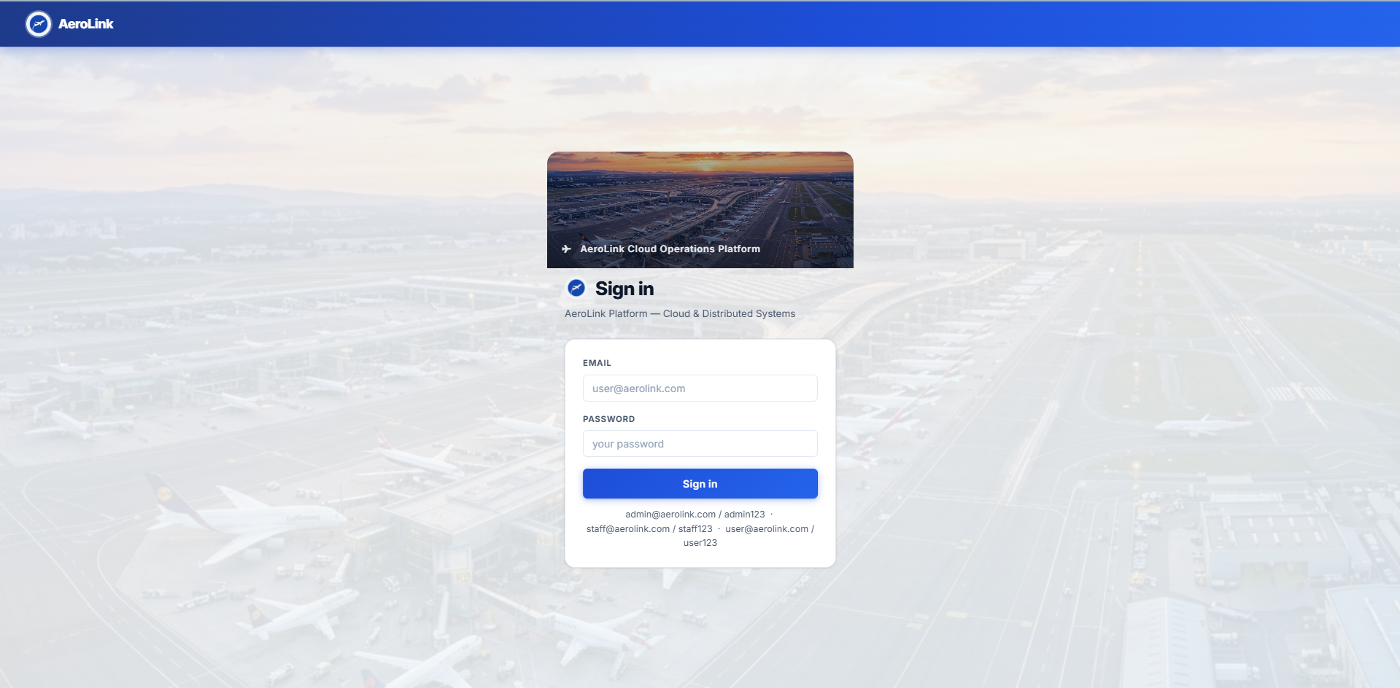
Figure 60 - Login Page

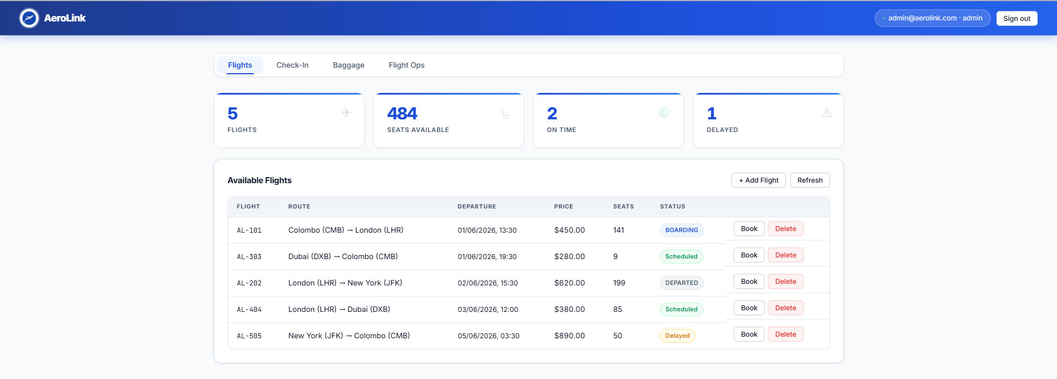
Figure 61 - Flight Booking Pag
‌
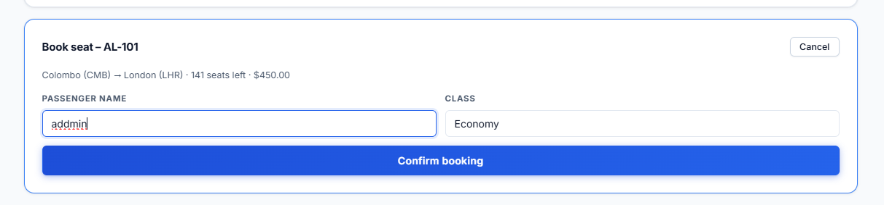
Figure 62 - booking information


Figure 63 - Payment Approved Pop up

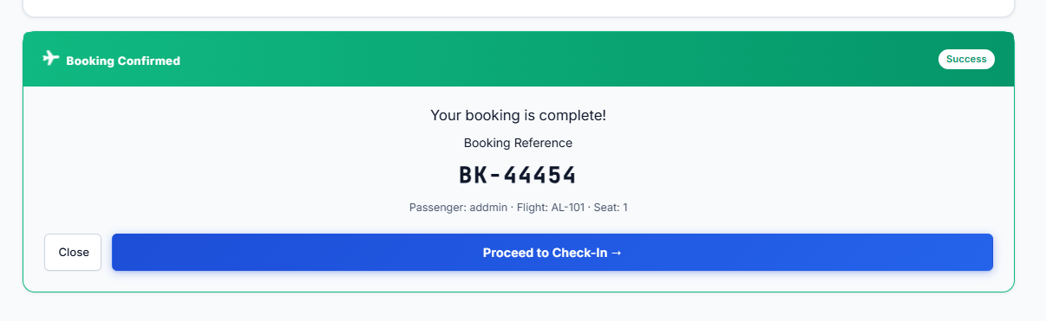
Figure 64 - Booking Complete

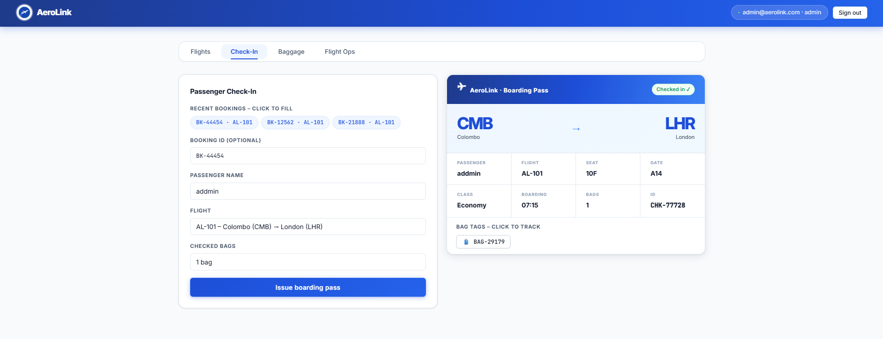
Figure 65 - Check-in Page

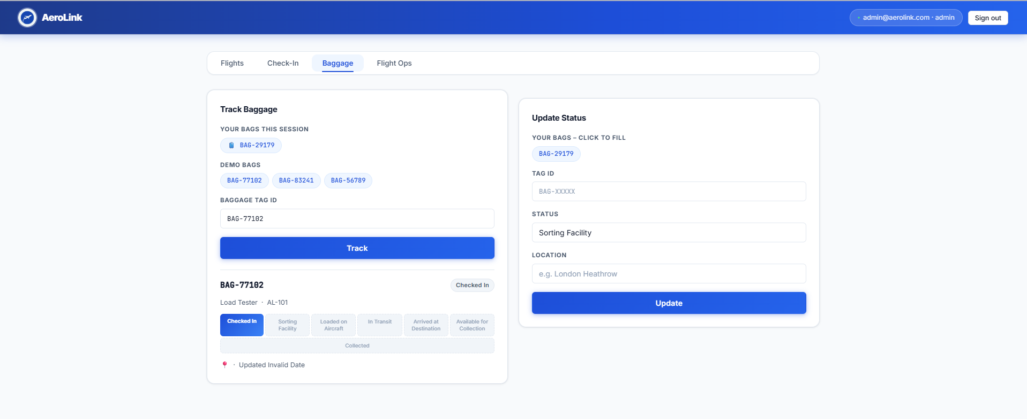
Figure 66 - Baggage Tracking Page

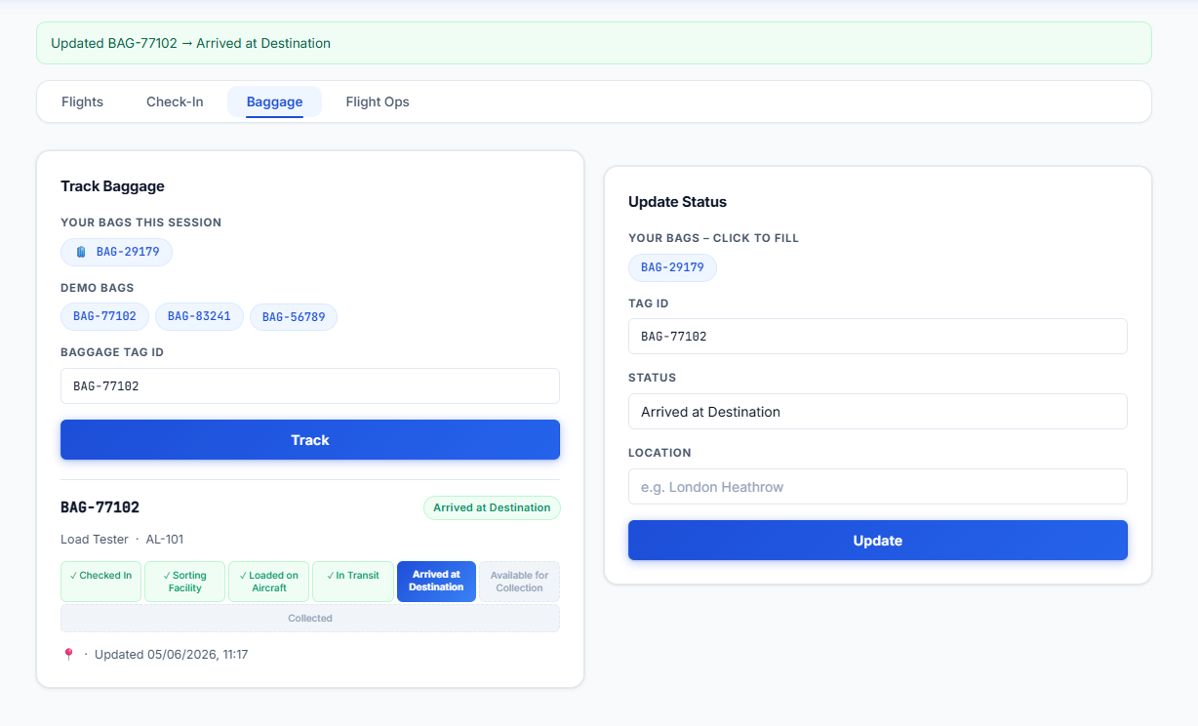
Figure 67 - Update Bag

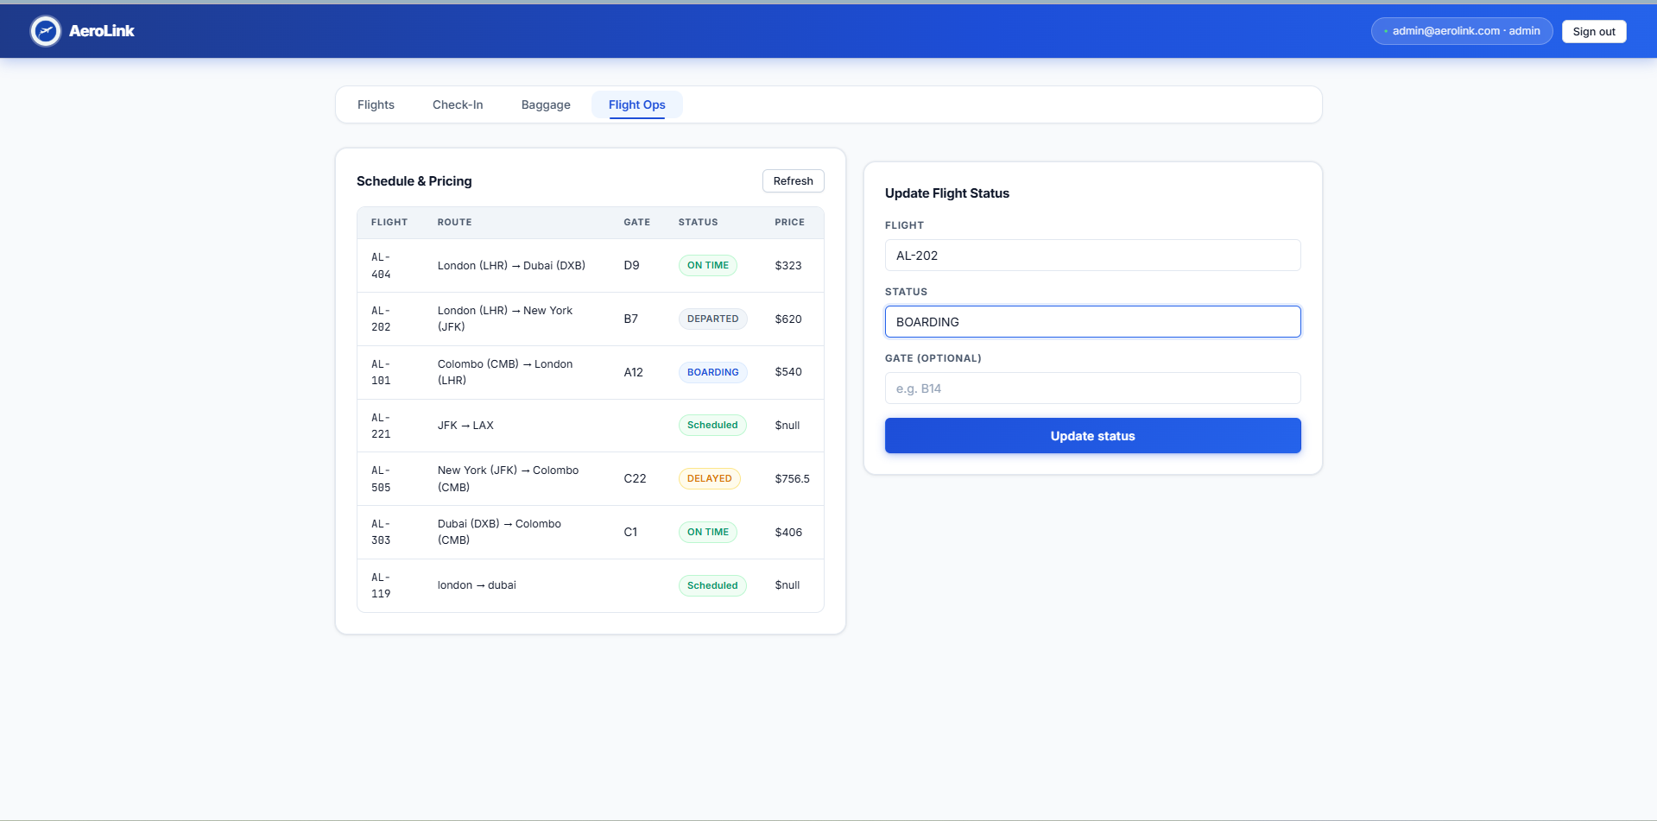
Figure 68 - Flight Ops Page

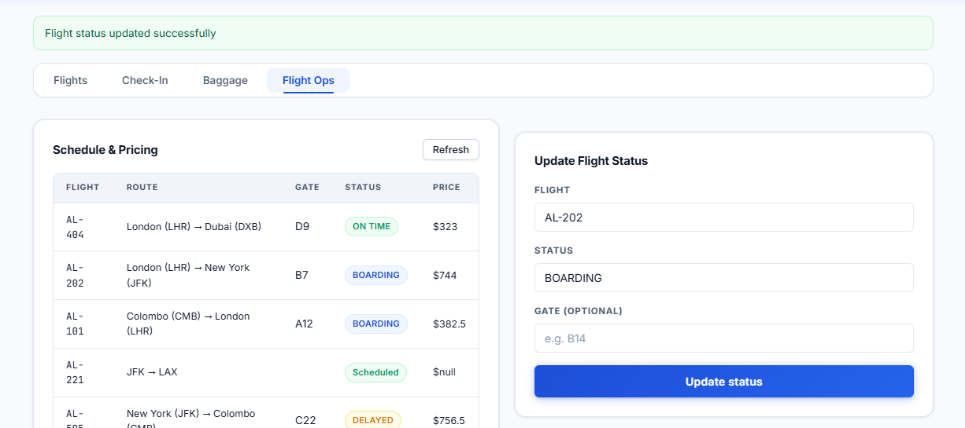
Figure 69 - Flight Ops updated

