Rising Data Component Guide:

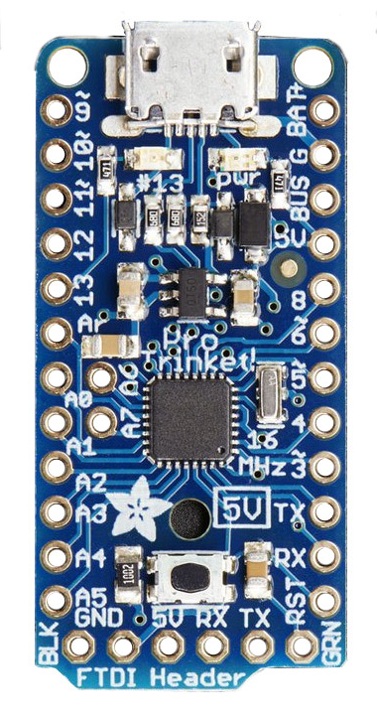
Arduino Pro Trinket 3V
This device replaces the App Board and provides the processing power for our payload. It uses an ATMega328 Processor that runs regular Arduino C/Processing Code written with the Arduinio IDE. While this device has a USB Port capable of powering the device and loading code, it does NOT have an on-board FTDI chip like many other Arduinos come equipped with. This means to have serial communication with the device, we must use an FTDI cable instead of a regular USB cable.

There are two versions of the Pro Trinket using 3.3V and 5V for logic levels respectively, we are using the 3.3V so be careful if ordering additional boards. The 5V has (almost) identical pins, and all the documentation provided by the manufacturer is for the 5V version. Don’t let this confuse you.

MicroSD Transflash Breakout

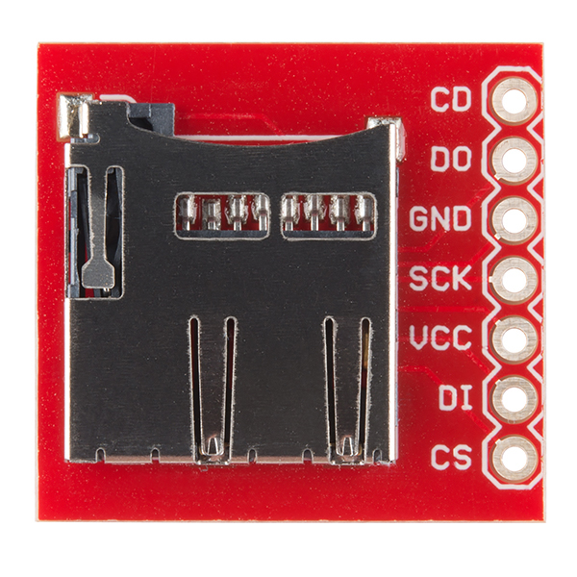
This device provides a mechanical and electrical connection to the pins on a micro SD card. Unlike other SD breakout boards, this does not provide any kind of integrated processor or logic level conversion, so it is as simple as you could imagine. It only provides a mechanical socket for the SD card, and brings the SD card pins out into a DIP mountable format.

This device connects to the Arduino over an SPI bus. It allows us to quickly log data as we collect it. The software we provide will allow us to write to an SD card formatted FAT16/32, so it can be removed and read as a text file from a regular computer.

9DOF Stick
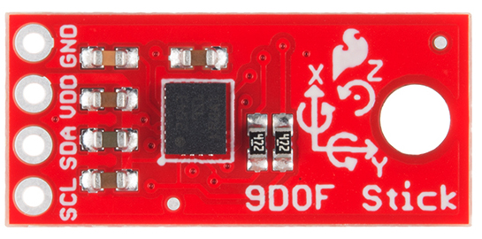
This device incorporates three sub-sensors: a 3-axis accelerometer, a 3-axis gyro, and a 3-axis magnetometer. This provides us with a good amount of telemetry for students to analyze after their flights. It communicates with the Arudino over an I2C interface.

