CAVA ANALYTICS TRAINING – MAC OS/LINUX
The current official CAVAanalytics repository is un-fao/CAVAanalytics, and its documentation recommends installing the spatial/system dependencies through Conda and then installing CAVAanalytics with pak.
CAVA training — complete setup
1. Create the Conda environment
In Terminal:
conda create -n CAVA_training -c conda-forge python=3.12 pip r-base r-rjava r-terra r-sf r-irkernel jupyterlab ipykernel
When prompted:
Proceed ([y]/n)? y
This installs the main Python, R, Jupyter and spatial components. The CAVAanalytics documentation specifically recommends installing r-java, r-terra and r-sf through Conda on macOS so that system dependencies are handled as binaries rather than compiled locally.

2. Activate the environment
conda activate CAVA
Your terminal should now start with:
(CAVA)

3. Check Python, R and Jupyter
python --version
R --version
jupyter lab --version
You should get something similar to:
Python 3.12.x
R version 4.x.x
4.x.x

4. Check the R spatial packages
Run:
R -q -e "library(terra); library(sf)"
If there are no errors, the spatial components are working.

5. Check Java / rJava
This is important because CAVAanalytics depends on rJava.
Run:
R -q -e "library(rJava); cat('rJava OK\n')"
You want:
rJava OK

6. Install pak
R -q -e "install.packages('pak', repos='https://cloud.r-project.org')"
Then verify:
R -q -e "library(pak); packageVersion('pak')"

7. Install CAVAanalytics
This is the key CAVA step:
R -q -e "pak::pkg_install('un-fao/CAVAanalytics')"
The official repository currently uses exactly this GitHub installation approach – 15 min more or less.
Note: use CAVAanalytics with a lowercase a, as in the current official repository/package name. The old Risk-Team/CAVAanalytics repository is no longer the canonical source.

8. Verify CAVAanalytics
Run:
R -q -e "library(CAVAanalytics); packageVersion('CAVAanalytics')"
You should get something like:
[1] "4.0.7"

9. Final complete verification
Final verification block:
python --version
R --version
jupyter lab --version
R -q -e "library(terra); library(sf); library(rJava); library(pak); library(CAVAanalytics); cat('All CAVA packages loaded successfully!'); packageVersion('CAVAanalytics')"
If everything is correct, you should see:
Python 3.12.x
R version 4.x.x
4.x.x
...
All CAVA packages loaded successfully!
[1] "4.0.x"

Copy-paste version for your training document
installation instructions like this:
# 1. Create the CAVA environment
conda create -n CAVA -c conda-forge python=3.12 pip r-base r-java r-terra r-sf r-irkernel jupyterlab ipykernel

# 2. Activate the environment
conda activate CAVA

# 3. Install pak
R -q -e "install.packages('pak', repos='https://cloud.r-project.org')"

# 4. Install CAVAanalytics
R -q -e "pak::pkg_install('un-fao/CAVAanalytics')"

# 5. Verify the installation
python --version
R --version
jupyter lab --version
R -q -e "library(terra); library(sf); library(rJava); library(pak); library(CAVAanalytics); cat('All CAVA packages loaded successfully!\n'); packageVersion('CAVAanalytics')"

Running CAVA analytics
Step 1 -Download VS Code: https://code.visualstudio.com/
Step 2 -Download the VS Code Python and R extensions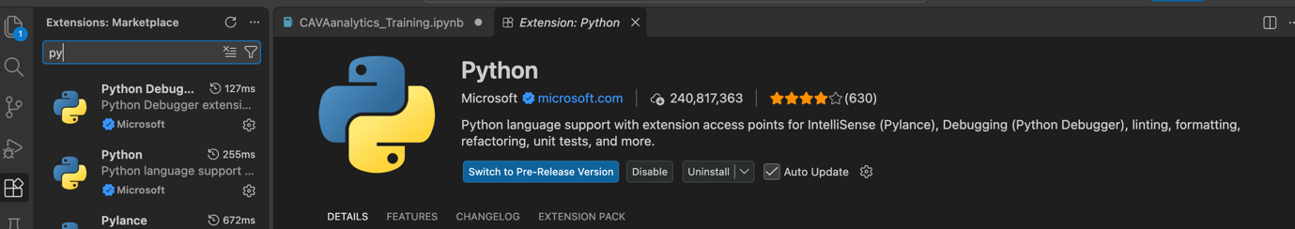
Step 3 – Download GitHub folder at: ()
Step 4 - Open the “CAVAanalytics_Training.ipynb” file in VS Code and select the CAVA (R) kernel:
- Click “Change Kernel” in top right
- Click Jupyter Kernel
- Click CAVA (R) kernel
Step 5 – Run .ipynb file!

