DPN2 — DPN2 Task 1: Cloud Data Solution Planning

Name: Taylor Wilkerson
Student ID: 011041148
Date: 3/30/2026

A. Requirements of a Cloud Data Solution
1. Discuss the functional requirements that must be considered when deciding on a cloud data storage solution for the provided scenario and why these requirements are important.
2. Discuss the non-functional requirements that must be considered when deciding on a cloud data storage solution for the provided scenario and why these requirements are important.
A. Requirements of a Cloud Data Solution
1. Functional requirements that must be considered
Functional requirements describe the specific capabilities the cloud data storage solution must provide in order to support Alliah Company’s daily operations. These requirements are important because they ensure the cloud solution can actually meet the company’s business and technical needs.
One major functional requirement is the ability to store and manage very large volumes of structured and semi-structured data. The scenario states that Alliah Company generates approximately 10 TB of transaction data per day, which means the cloud solution must support high-capacity storage for transaction records, customer interactions, vendor data, and internal operational data. This is important because the company’s current on-premises environment is already struggling under increased demand.
Another key functional requirement is real-time or near real-time data ingestion and processing. Because transactions and customer activity occur continuously, the company needs a system that can receive, update, and push data without major delay. This is especially important for use cases such as inventory updates, order tracking, fraud monitoring, and customer service responsiveness. If the storage system cannot support real-time movement of data, the business could lose agility and decision-making speed.
The solution must also support integration with multiple data sources and destinations. The scenario identifies sources such as the e-commerce platform, customer service systems, third-party vendors, and internal operations, while destinations include business intelligence tools, marketing systems, customer support tools, and financial reporting systems. This requirement is important because a cloud data solution must act as a centralized and accessible data platform rather than an isolated storage repository.
A further functional requirement is support for analytics and reporting workloads. Alliah Company relies on its data to drive sales and marketing strategy, inventory management, and customer relationship management, so the cloud solution must allow efficient querying, transformation, and downstream analysis. “Transactions and customer interactions [occur] around the clock, necessitating a solution that can handle real-time data processing and analytics” (Western Governors University, n.d.). This is important because the company’s data is not only stored for recordkeeping—it is also a core driver of business intelligence and operational decisions.
Finally, the cloud solution must include backup, recovery, and failover functionality as part of normal system operations. These are functional requirements because the system must be capable of automatically replicating, preserving, and restoring data when needed. This is important to ensure business continuity and prevent major disruptions to e-commerce operations if a system failure or outage occurs.

2. Non-functional requirements that must be considered
Non-functional requirements describe the quality attributes and performance expectations of the cloud data storage solution. These requirements are important because even if a system performs the required functions, it still must do so in a way that is reliable, secure, efficient, and sustainable for business growth.
One of the most important non-functional requirements is scalability. Alliah Company is a growing online retailer with an expanding customer base, so the cloud solution must be able to scale storage and compute resources up or down based on demand. This is critical because seasonal sales spikes, promotional campaigns, and long-term growth will likely increase data volume and system traffic over time. A cloud solution that cannot scale effectively would quickly become another bottleneck.
Another essential non-functional requirement is high availability. Because Alliah Company operates in e-commerce, customer transactions and interactions occur around the clock. The cloud data platform must therefore remain accessible with minimal downtime. High availability is important because outages could disrupt sales, delay customer service, interrupt reporting, and damage the customer experience.
Security is also a critical non-functional requirement. The scenario notes that the company handles sensitive data, including personally identifiable information (PII) and transaction records. The cloud storage solution must therefore provide strong access controls, encryption, monitoring, and auditing. This is important because a data breach could expose customer information, create legal liability, and severely damage the company’s trust and reputation.
Another major non-functional requirement is performance. The storage environment must support fast data ingestion, retrieval, and processing to meet the company’s need for real-time data pipelines and analytics. Performance is important because delays in processing transaction or operational data could negatively impact inventory accuracy, marketing responsiveness, and executive decision-making.
The solution must also meet compliance and legal requirements, including regulations such as GDPR and other privacy obligations mentioned in the scenario. This is important because the company likely handles customer data across multiple jurisdictions, and noncompliance could result in fines, legal action, and reputational harm. The chosen cloud storage environment must therefore support data governance, retention controls, and privacy safeguards.
Lastly, reliability and disaster recovery readiness are important non-functional requirements. The solution must consistently operate without data corruption or frequent interruption and must support recovery in the event of outages, cyberattacks, or infrastructure failures. This is important because an e-commerce company depends heavily on uninterrupted access to accurate and current data to maintain operations and customer trust.

B. Cloud Data Solution
1. Propose a cloud data storage solution that addresses the provided scenario.
1. Proposed cloud data storage solution
To address Alliah Company’s needs, I propose a cloud-based data storage architecture on Amazon Web Services (AWS). This solution would combine Amazon S3 for scalable raw and historical data storage, Amazon RDS (PostgreSQL or Aurora PostgreSQL) for structured transactional data, and Amazon Redshift for analytics and reporting workloads. Together, these services would provide a flexible, scalable, and secure environment capable of handling Alliah Company’s large and continuously growing data demands.
In this design, Amazon S3 would serve as the primary data lake for storing large volumes of raw transaction logs, customer interactions, vendor feeds, and operational records. Amazon RDS or Amazon Aurora PostgreSQL would support structured, high-performance transactional workloads that require relational integrity and reliable updates. Amazon Redshift would function as the company’s analytical data warehouse, allowing business intelligence, marketing, customer support, and financial teams to query large datasets efficiently for reporting and decision-making. This layered architecture aligns well with the scenario’s need for real-time ingestion, high-volume storage, and downstream analytics.
a. Identify the preferred cloud vendor and explain why this vendor is preferred.
1a. Preferred cloud vendor and why this vendor is preferred
The preferred cloud vendor for Alliah Company is Amazon Web Services (AWS) because it offers a mature, highly scalable, and widely adopted ecosystem of cloud storage, database, analytics, security, and disaster recovery services that align closely with the company’s needs as a fast-growing online retailer. AWS is especially well suited for e-commerce organizations because it supports both high-throughput transactional systems and large-scale analytics environments within the same platform.
AWS is preferred over other vendors because it provides a strong balance of storage flexibility, performance, cost control, and integration. For example, Amazon S3 can scale nearly without limit for raw and archived data, while Amazon Aurora and Amazon RDS support reliable relational database operations for day-to-day transaction processing. In addition, Amazon Redshift allows the company to run large-scale analytical queries without placing unnecessary strain on transactional systems. This separation of workloads is especially valuable for Alliah Company, since its data must support both operational systems and business intelligence functions.
Another reason AWS is preferred is its robust support for security and compliance, including encryption, identity and access management, logging, auditing, backup, and multi-region disaster recovery capabilities. Since Alliah Company handles customer transaction data and personally identifiable information (PII), these built-in capabilities are critical. AWS also supports strong automation and service integration, which makes it easier to build data pipelines that operate continuously and in near real time.
b. Describe the major features (e.g., class, size) of your proposed solution.
1b. Major features of the proposed solution
The proposed AWS cloud data storage solution includes several major features that support Alliah Company’s operational and analytical needs.
Amazon S3 (Simple Storage Service)

Amazon S3 would be used as the company’s primary cloud object storage layer. It is ideal for storing massive amounts of raw and semi-structured data, such as transaction logs, clickstream activity, vendor files, and archived records. A recommended configuration would include:

S3 Standard for frequently accessed current data
S3 Standard-Infrequent Access (IA) for less frequently used historical data
S3 Glacier / Glacier Deep Archive for long-term archival and compliance retention

This tiered structure helps control storage costs while maintaining data durability and availability.
Amazon Aurora PostgreSQL or Amazon RDS PostgreSQL
For structured relational data, I recommend Amazon Aurora PostgreSQL (preferred) or Amazon RDS PostgreSQL. This database layer would support:
- customer orders
- payment transaction metadata
- product inventory records
- customer account data
- operational application data
Aurora is especially attractive because it offers higher performance and better scalability than standard managed relational deployments while still maintaining PostgreSQL compatibility. Major features would include:
- Multi-AZ deployment for high availability
- Read replicas for performance scaling
- Automated backups
- Point-in-time recovery
- Encryption at rest and in transit
This makes it a strong fit for Alliah Company’s continuously active transaction environment.
Amazon Redshift
Amazon Redshift would serve as the company’s analytical data warehouse. This would allow Alliah Company to separate high-volume analytical workloads from day-to-day transaction processing. Redshift would be used for:
- sales trend analysis
- marketing campaign evaluation
- customer behavior analysis
- inventory forecasting
- executive reporting
A recommended setup would include:
- columnar storage
- massively parallel processing (MPP)
- separate compute and storage scaling (if using Redshift Serverless or RA3 nodes)
These features make Redshift well suited for processing and querying very large retail datasets efficiently.
Additional supporting features
To strengthen the architecture, the solution would also include:
- AWS Identity and Access Management (IAM) for role-based access control
- AWS Key Management Service (KMS) for encryption key management
- AWS Backup for centralized backup policies
- CloudWatch and CloudTrail for monitoring and auditing
- Multi-AZ deployment and replication for fault tolerance and disaster recovery
These supporting services help ensure the storage platform is secure, observable, and resilient.

2. Justify your proposed solution based on the functional and non-functional requirements you described in A1 and A2.
2. Justification of the proposed solution
The proposed AWS solution is justified because it directly addresses the functional requirements identified in section A1 and the non-functional requirements identified in section A2.
From a functional perspective, the proposed solution supports Alliah Company’s need to handle large-scale data storage, since Amazon S3 can store extremely high volumes of raw and historical data without the capacity limitations of traditional on-premises systems. This is especially important given the company’s generation of approximately 10 TB of transaction data per day. The use of Amazon Aurora or Amazon RDS also supports structured transaction management, while Amazon Redshift provides a dedicated platform for analytics and reporting. Together, these services ensure that the company can ingest, store, manage, and analyze data across multiple business functions.
The proposed solution also satisfies the need for real-time and continuous data flow. Because Alliah Company’s transactions and customer interactions occur around the clock, the system must support continuous ingestion and downstream availability. AWS services are well suited for scheduled and near real-time data pipelines, making them appropriate for operational workloads such as order management, customer support, inventory tracking, and business intelligence reporting.
From a non-functional perspective, the AWS architecture strongly supports scalability, which is essential for a rapidly growing e-commerce company. Amazon S3 can scale virtually without limit, Aurora can scale database performance through replicas and managed infrastructure, and Redshift can scale analytical workloads independently. This allows Alliah Company to expand its data environment as customer demand grows without requiring major redesigns.
The solution also supports high availability and reliability through Multi-AZ deployments, replication, automated failover, and managed backup capabilities. These features reduce downtime risk and help ensure that the company’s systems remain operational even during infrastructure failures or maintenance events. This is especially important in e-commerce, where outages can immediately affect revenue and customer satisfaction.
Additionally, the proposed AWS architecture addresses security and compliance needs through encryption, access controls, monitoring, and audit logging. Since the scenario specifically highlights the importance of protecting PII and transaction records while maintaining compliance with regulations such as GDPR, AWS provides a strong framework for implementing those controls. This makes the platform not only technically capable, but also appropriate from a governance and risk perspective.
Overall, AWS is the most appropriate cloud data storage solution for Alliah Company because it provides the flexibility, resilience, security, and performance necessary to support a high-growth online retailer that depends on real-time data, large-scale analytics, and secure customer operations.

C. Strategies and Requirements
1. Describe all security and legal requirements that must be considered in migrating the data to the cloud.
C. Strategies and Requirements
1. Security and legal requirements that must be considered in migrating the data to the cloud
When migrating Alliah Company’s data to the cloud, several important security and legal requirements must be considered to ensure the protection, confidentiality, integrity, and lawful handling of business and customer data. “The solution must be highly available, scalable, and secure, with the ability to process and analyze data in real time” (Western Governors University, n.d.). Because Alliah Company processes large volumes of transaction data, customer information, and operational data, cloud migration must be designed with both cybersecurity and compliance obligations in mind.
One of the most important security requirements is data encryption. Sensitive data, including customer personally identifiable information (PII), transaction records, and account details, should be encrypted both at rest and in transit. In the proposed AWS solution, this can be accomplished through AWS Key Management Service (KMS) for storage encryption and TLS/SSL for secure network communication. This is important because encryption reduces the risk of unauthorized disclosure if data is intercepted or accessed improperly.
Another critical requirement is identity and access management. “The solution must adhere to stringent security protocols to protect sensitive data, including PII and transaction records” (Western Governors University, n.d.). Access to data should be restricted based on the principle of least privilege, meaning employees and systems should only have access to the data necessary to perform their roles. AWS Identity and Access Management (IAM) policies, roles, and permissions can be used to enforce this. This is essential for reducing insider risk, preventing accidental misuse, and limiting the blast radius of compromised credentials.
A third key security requirement is network and infrastructure protection. The proposed cloud environment should isolate critical services within private subnets, use security groups and network access control lists (NACLs), and limit public exposure wherever possible. For example, relational databases such as Amazon Aurora or Amazon RDS should not be directly exposed to the public internet. This is important because it reduces the attack surface and protects core systems from unauthorized external access.
Monitoring, logging, and auditing are also required. Cloud environments must provide visibility into who accessed data, when it was accessed, and whether suspicious activity occurred. AWS services such as CloudTrail, CloudWatch, and database auditing tools can help track events, monitor anomalies, and support incident investigations. These capabilities are important because they support both operational security and compliance reporting.
From a legal and regulatory standpoint, the company must ensure compliance with data privacy and data protection laws, including GDPR as noted in the scenario. If Alliah Company serves customers in multiple regions, the organization must ensure lawful handling of personal data, proper retention practices, and secure deletion where required. In addition, the company should evaluate whether it must comply with other laws or standards such as consumer privacy laws, financial record retention requirements, and payment-related data security expectations. These legal requirements are important because noncompliance could result in fines, litigation, reputational harm, and loss of customer trust.
Finally, Alliah Company must establish data governance and retention policies. Not all data should be retained forever, and different classes of data may require different storage, archival, and deletion rules. For example, transaction records may need to be retained longer than marketing clickstream data. This is important because governance helps ensure the company remains compliant while controlling storage growth and reducing legal exposure.

2. Discuss the proposed backup strategies in the cloud. The following points must be explicitly addressed:
• Which types of backups are appropriate?
• Which types of backups are most cost-effective?
• How often is data backed up?
• How does the frequency with which the data is backed up impact the proposed architecture?
• How does the frequency with which the data is backed up impact cost?

2. Proposed backup strategies in the cloud
A strong backup strategy is essential for protecting Alliah Company’s data from accidental deletion, corruption, cyberattacks, infrastructure failures, and other disruptions. Because the company produces large volumes of data continuously, the backup design must balance availability, recovery speed, and cost efficiency.
Which types of backups are appropriate?
The most appropriate backup strategy for Alliah Company is a hybrid backup model that combines:
- Full backups
- Incremental backups
- Automated snapshots
- Cross-region replication for critical data
Full backups
Full backups capture an entire copy of a dataset or database. These are appropriate for scheduled baseline recovery points and are especially useful for relational systems such as Amazon Aurora / RDS and warehouse environments such as Amazon Redshift. Full backups are important because they provide a complete restore point in the event of major failure or corruption.
Incremental backups
Incremental backups only capture the data that has changed since the previous backup. These are highly appropriate for Alliah Company because the organization generates large volumes of new and changing data every day. Incremental backups are especially valuable for reducing backup time and storage consumption.
Automated snapshots
Snapshots are point-in-time images of storage or database states. These are appropriate for databases and data warehouses because they allow fast restoration and can be scheduled regularly. In AWS, automated snapshots can be used for Aurora/RDS and Redshift to provide operational recovery points.
Cross-region replication
For the most critical data, replication across AWS regions is appropriate. This is not a traditional “backup” alone, but it strengthens resilience by ensuring data is still recoverable if an entire region becomes unavailable. This is particularly important for disaster recovery planning.
Which types of backups are most cost-effective?
The most cost-effective approach for Alliah Company is a combination of incremental backups, automated snapshots, and lifecycle-based archival storage.
Incremental backups are generally the most cost-effective for high-volume, frequently changing data because they avoid repeatedly storing unchanged information. This is especially valuable for a company producing approximately 10 TB of data per day, where full backups of all data every time would become expensive very quickly.
Automated snapshots are also cost-effective because they provide fast recovery for structured systems without requiring manual backup administration. In addition, using Amazon S3 lifecycle policies to move older backup data into S3 Glacier or Glacier Deep Archive would significantly reduce long-term retention costs. This allows the company to retain older recovery points for compliance or business continuity without paying premium storage rates for infrequently accessed data.
Full backups are necessary, but they are the least cost-efficient when performed too frequently at scale. Therefore, they should be used strategically rather than excessively.

How often is data backed up?
Because Alliah Company generates transaction and customer interaction data continuously, the backup schedule should be tiered based on data criticality.
A reasonable backup schedule would include:
- Transactional relational databases (Aurora / RDS):
  - Continuous automated backups with point-in-time recovery
  - Daily snapshots
- Amazon Redshift data warehouse:
  - Daily snapshots
  - Additional snapshots before major updates or schema changes
- Amazon S3 raw and historical storage:
  - Versioning enabled continuously
  - Replication and lifecycle archival policies
- Critical configuration and metadata backups:
  - Daily or more frequently if changes occur
This frequency is appropriate because Alliah Company operates continuously and relies on timely data for inventory, customer experience, reporting, and financial operations. Frequent backups reduce the amount of data that could be lost in the event of failure.

How does backup frequency impact the proposed architecture?
The frequency of backups directly affects the architecture by requiring the system to support automation, storage tiering, and recovery orchestration.
Because backups must occur frequently, the architecture should include:
- automated backup policies
- database snapshot scheduling
- cross-region replication for critical workloads
- versioning for object storage
- separation of hot, warm, and archival storage layers
For example, enabling continuous backup and point-in-time recovery for Aurora requires the architecture to maintain transaction logs and recovery records in the background. Likewise, S3 versioning and replication require additional storage planning and bucket configuration. Redshift snapshot retention also affects how analytical data is preserved and restored. In other words, more frequent backups make the architecture more resilient, but they also require more deliberate design and governance.

How does backup frequency impact cost?
Backup frequency has a direct impact on cost because more frequent backups create more stored copies, metadata, snapshots, and replication activity.
If Alliah Company were to back up all data too frequently using full copies, costs would rise significantly due to:
- higher storage consumption
- increased snapshot retention
- replication transfer costs
- longer backup processing overhead
However, using a tiered backup strategy helps control these costs. For example:
- critical operational databases can be backed up continuously
- analytics and warehouse systems can be backed up daily
- older backups can be moved to lower-cost storage classes like Glacier
- incremental backups can reduce duplicate storage
This means the company can achieve strong recoverability without overpaying for unnecessary redundancy. In short, higher backup frequency improves resilience but increases cost, so the architecture should prioritize the most critical systems for the most frequent protection

3. Discuss how failover and disaster recovery planning are accommodated in the proposed design.
3. Failover and disaster recovery planning in the proposed design
Failover and disaster recovery planning are critical parts of the proposed AWS cloud design because Alliah Company’s business depends on continuous availability of customer, transaction, and operational data. Since the company operates in a real-time e-commerce environment, even short outages can affect revenue, customer trust, and internal business processes.
The proposed architecture accommodates failover by using Multi-AZ deployments for relational database services such as Amazon Aurora or Amazon RDS. In a Multi-AZ deployment, the primary database instance is replicated to a standby instance in a separate availability zone. If the primary instance fails due to hardware issues, service disruption, or zone-level failure, AWS can automatically fail over to the standby instance with minimal interruption. This improves high availability and reduces operational downtime.
For object storage, Amazon S3 already provides extremely high durability across multiple availability zones within a region. To strengthen resilience further, cross-region replication can be used for critical datasets so that copies of important business data exist in a second AWS region. This ensures that data remains available even in the event of a major regional outage or disaster.
For analytical workloads, Amazon Redshift snapshots and regional recovery planning allow restoration of the analytical environment if needed. Although analytics systems may not always require the same recovery speed as transactional systems, they remain essential for business reporting and operational insight, so they should still be included in disaster recovery planning.
The disaster recovery strategy should also define clear Recovery Time Objectives (RTOs) and Recovery Point Objectives (RPOs):
- RTO refers to how quickly systems must be restored after disruption.
- RPO refers to how much data loss is acceptable between the last backup and the failure.
For Alliah Company, a low RTO and low RPO are appropriate for transactional systems because order and customer data are mission-critical. Analytical and archival systems may tolerate slightly longer recovery times. Designing the architecture around these priorities ensures that the most important systems receive the highest level of resilience.
Overall, the proposed design supports failover and disaster recovery through redundancy, automated replication, scheduled backups, cross-region resilience, and managed cloud recovery capabilities. This ensures that Alliah Company can continue operating with minimal downtime and data loss even in the event of infrastructure failure, cyber incidents, or natural disasters.

D. Architecture Diagram
1. Create an architecture diagram for your proposed cloud data storage solution that includes the following:
• labels for data, including volume and type
• labels for target databases, including type and schema
• labeled processes, including cloud components used and frequency of operations
• labels for security groups
• labels for locations and availability zones
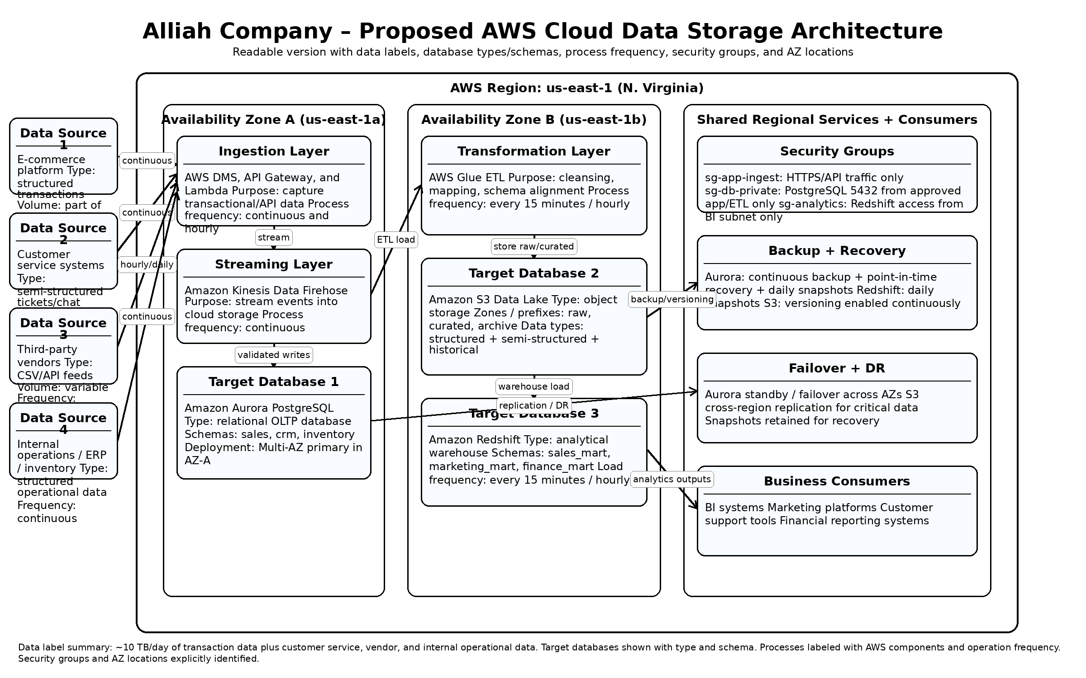
D1. Architecture Diagram Explanation
The architecture diagram illustrates a proposed AWS cloud data storage solution for Alliah Company designed to support the company’s rapidly growing e-commerce operations. Data enters the environment from several sources, including the e-commerce platform, customer service systems, third-party vendors, and internal operational systems. These sources generate both structured and semi-structured data continuously, contributing to the approximately 10 TB of transaction data produced daily in the scenario. Data is ingested using AWS services such as Database Migration Service (DMS), API Gateway, Lambda, Kinesis Data Firehose, and AWS Glue, which support continuous streaming and scheduled ETL processing. This design ensures that data can be collected, transformed, and routed efficiently for operational and analytical use.
The diagram also identifies the major target databases, security boundaries, and resilience features within the architecture. Amazon Aurora PostgreSQL serves as the primary relational database for transactional workloads and includes schemas such as sales, crm, and inventory, while Amazon S3 functions as the scalable data lake for raw, curated, and archived data. Amazon Redshift acts as the analytical warehouse and includes schemas such as sales_mart, marketing_mart, and finance_mart to support reporting and business intelligence. Security groups are included to restrict access to ingestion, database, and analytics components, while Multi-AZ deployment, backups, snapshots, and cross-region replication support failover and disaster recovery. Overall, the architecture is designed to provide scalability, security, availability, and real-time data support for Alliah Company’s cloud migration.

2. Identify which database objects need to be included.
a. Create a logical data diagram to store the data in the proposed solution, including the objects identified in D2.
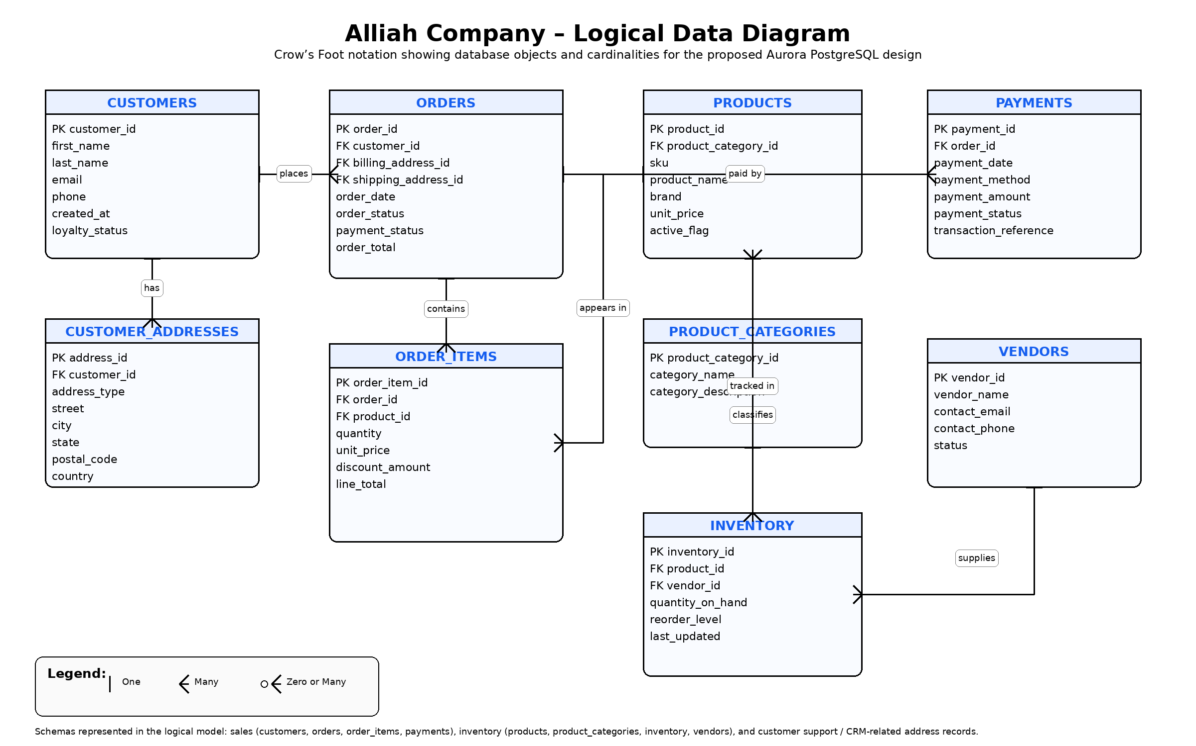
D2a. Logical Data Diagram Explanation

The logical data diagram represents the proposed relational database design for Alliah Company’s operational cloud database environment. The model is designed using Crow’s Foot notation, which visually identifies the relationships and cardinalities between the major database objects. The key entities included in the design are Customers, Customer_Addresses, Orders, Order_Items, Products, Product_Categories, Payments, Vendors, and Inventory. These entities support the structured storage of customer, sales, product, payment, and inventory data needed to operate a large-scale e-commerce platform.

The relationships shown in the model reflect how Alliah Company’s business data interacts in practice. For example, one customer may have many orders and multiple addresses, one order may contain many order items, and one product category may include many products. Likewise, one order may be associated with multiple payments, and one vendor may supply many inventory records. These one-to-many relationships help normalize the database design, reduce redundancy, and improve data integrity. Overall, the logical data diagram provides a structured foundation for supporting transactional processing in the proposed AWS cloud solution while also enabling reliable reporting, inventory visibility, and future analytical use.

3. Explain why each of the database objects identified in part D2 needs to be included.
D3. Explanation of Why Each Database Object Needs to Be Included
Each database object identified in the logical data diagram is necessary to support Alliah Company’s cloud-based e-commerce operations. Together, these objects create a structured relational design that supports customer management, order processing, product tracking, payment activity, vendor relationships, and inventory visibility. These objects are essential because they allow the company to manage high-volume transactional data in a way that is organized, scalable, and suitable for downstream reporting and analytics.
Customers
The Customers table is needed to store core customer account information such as customer ID, name, contact details, and account creation date. This object is necessary because customer identity must be linked to orders, addresses, and service interactions.
Customer_Addresses
The Customer_Addresses table is needed to store billing and shipping addresses separately from the main customer record. This improves normalization and allows one customer to maintain multiple addresses without duplicating customer data.
Orders
The Orders table is needed to capture each customer purchase at the transaction level. It stores order-specific details such as order date, status, payment status, and total value, making it central to sales processing and order tracking.
Order_Items
The Order_Items table is needed because one order can contain multiple products. This object records each line item within an order, including product, quantity, price, and line total, allowing the database to accurately represent multi-product purchases.
Products
The Products table is needed to store product-level information such as SKU, name, brand, and price. This object supports online catalog management, order processing, and inventory tracking.
Product_Categories
The Product_Categories table is needed to organize products into logical retail groupings. This improves product classification, reporting, and category-based analysis across the e-commerce platform.
Payments
The Payments table is needed to store payment transaction details associated with customer orders. This includes payment amount, method, status, and transaction reference, which are important for reconciliation, reporting, and financial accuracy.
Vendors
The Vendors table is needed because Alliah Company receives product and supply-related data from third-party vendors. This object stores vendor identification and contact details needed to support procurement and supply relationships.
Inventory
The Inventory table is needed to track stock availability, reorder thresholds, and inventory updates for products. This object supports real-time inventory visibility and helps ensure that product availability remains accurate across the business.
Conclusion
Overall, these database objects are necessary because they create the logical relational structure required to support Alliah Company’s operational workflows, maintain data integrity, and provide a reliable foundation for cloud-based storage, processing, and analytics.

References
DPN2 — DPN2 Task 1: Cloud Data Solution Planning. (n.d.). WGU Coursework.
https://tasks.wgu.edu/student/011041148/course/41540019/task/5487/overview
Western Governors University. (n.d.). Alliah Company scenario. Western Governors University.

