HBN1 — HBN1 Task 2: Data Analysis Report

Name: Taylor Wilkerson
Student ID: 011041148
Date: 5/7/26

Research Question
A. Summarize the real-data research question you identified in Task 1. Your summary should include justification for the research question you identified in Task 1, a description of the context in which the research question exists, and a discussion of your hypothesis.

The research question for this project is: How do socioeconomic and behavioral health factors influence adult obesity rates across counties in Georgia, and which counties are at highest risk for elevated obesity rates? This question was selected because obesity is a significant public health concern that is associated with increased risk of chronic diseases and long-term health complications. Although many health outcomes are influenced by individual behaviors, broader socioeconomic conditions and access to resources also play a critical role in shaping population-level health outcomes.

The context of this research lies within population health and preventive medicine, where factors such as income, employment, and lifestyle behaviors contribute to disparities in health outcomes across geographic regions. By analyzing county-level data, this project aims to identify patterns and relationships that contribute to higher obesity rates and to support targeted public health interventions.

The hypothesis guiding this analysis is that counties with lower median household income, higher unemployment rates, and higher prevalence of unhealthy behaviors such as smoking and physical inactivity will exhibit higher adult obesity rates.

- Null Hypothesis (H₀): There is no statistically significant relationship between socioeconomic and behavioral health factors and adult obesity rates across counties in Georgia.

- Alternative Hypothesis (H₁): There is a statistically significant relationship between these factors and adult obesity rates across counties in Georgia.

Data Collection
B. Report on your data-collection process by describing the relevant data you collected, discussing one advantage and one disadvantage of the data-gathering methodology you used, and discussing how you overcame any challenges you encountered during the process of collecting your data.

Data for this project was collected from publicly available sources, including the Centers for Disease Control and Prevention PLACES dataset and county-level socioeconomic data obtained from federal sources. The first dataset includes key socioeconomic indicators, as “poverty rates, population change, unemployment rates, and education levels vary across U.S. states and counties” (U.S. Department of Agriculture Economic Research Service, 2025). The second from the PLACES program, which “provides model-based, population-level analysis and community estimates of health measures to all counties… across the United States” (Centers for Disease Control and Prevention, 2024). Moreover, they both provided county-level information on demographic characteristics, socioeconomic indicators such as median household income and unemployment rates, and health-related measures including adult obesity rates, smoking prevalence, and physical inactivity.

An advantage of this data-gathering methodology is that the datasets are reliable, standardized, and widely used in public health and policy research, which enhances the credibility and validity of the analysis. A disadvantage is that the data originates from multiple sources with differing formats and structures, requiring additional data cleaning and transformation before analysis.

Several challenges were encountered during the data collection process. Initially, a dataset containing place-level observations was identified, which was not compatible with the county-level socioeconomic dataset. This issue was resolved by selecting a county-level dataset to ensure geographic consistency. Additionally, inconsistencies in county naming conventions across datasets created challenges during merging. These issues were addressed by standardizing county names through text processing techniques, allowing for accurate alignment and integration of the datasets into a unified analysis dataset.

Data Extraction and Preparation
C. Describe your data-extraction and -preparation process and provide screenshots to illustrate each step. Explain the tools and techniques you used for data extraction and data preparation, including how these tools and techniques were used on the data. Justify why you used these particular tools and techniques, including one advantage and one disadvantage of using them with your data-extraction and -preparation methods.

The first dataset was imported into Jupyter Notebook using Python and cleaned using the pandas library. Initial preparation steps included standardizing column names, converting values to numeric format, and removing non-county rows such as statewide totals. This was completed for “census_georgia_counties_1” for further clarification. Moreover, the dataset was originally structured in a long format, where each row represented a single attribute-value pair, it was transformed into a wide format using a pivot table operation. This allowed each county to be represented as a single row with multiple feature columns. The cleaned dataset was then exported as a CSV file for further analysis. This approach improved efficiency, reduced the risk of manual errors, and made the dataset suitable for statistical modeling.

Screenshot 1: Import Libraries

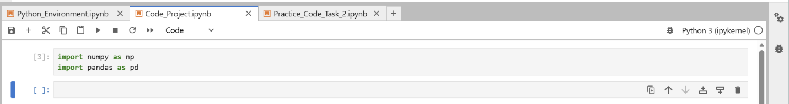
Screenshot 2: Original CSV snippet of “census_georgia_counties_1”
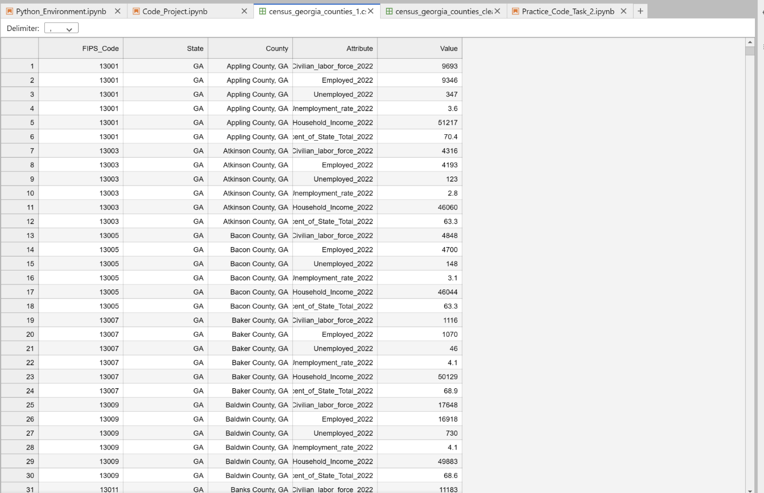

Screenshot 3: Python Code snippet showcasing data cleaning pt 1
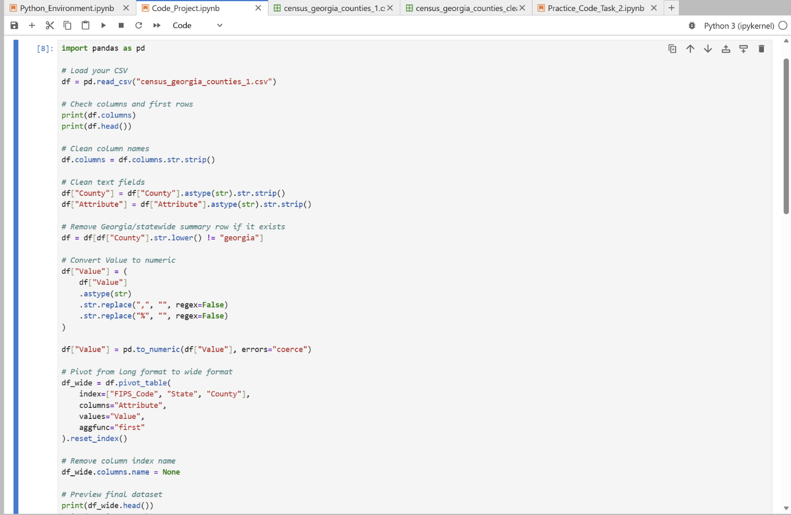
Screenshot 4: Python Code snippet showcasing data cleaning pt 2
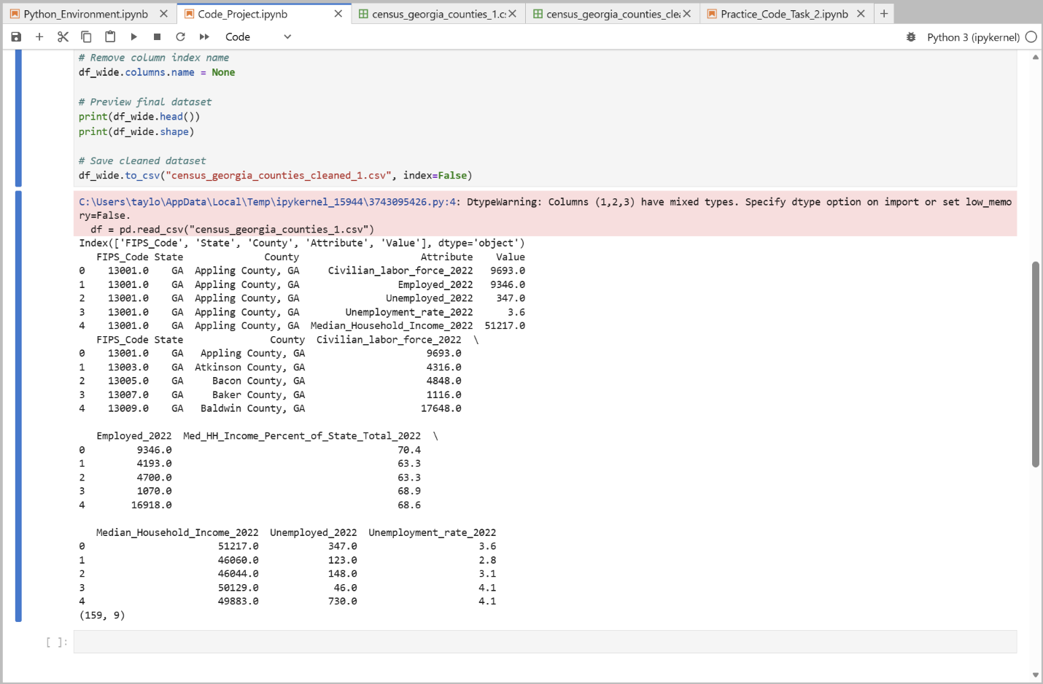

Screenshot 5: Snippet of CSV “census _georgia_counties_cleaned”
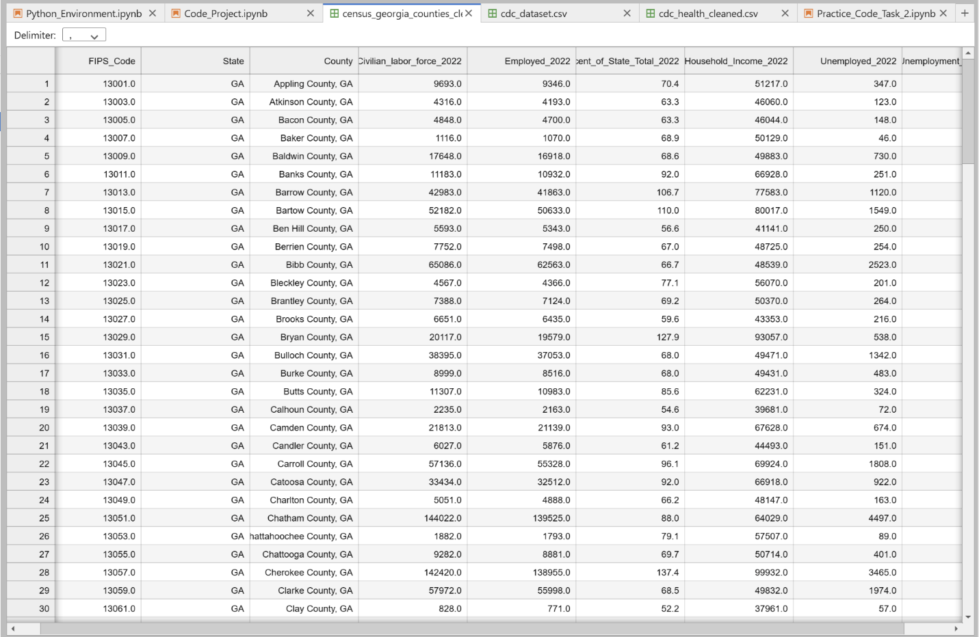

A second dataset obtained from the Centers for Disease Control and Prevention (CDC) was also prepared for analysis using Python in a Jupyter Notebook environment. The dataset was initially structured in a long format, with health measures recorded as separate rows for each county. To prepare the data, it was first filtered to include only counties within Georgia and a single year of observation to ensure consistency. Irrelevant columns were removed, and the remaining variables were cleaned by standardizing county names and converting values into numeric format.

The dataset was then transformed into a wide format using a pivot table operation, where each county was represented as a single row and each health measure became a separate column. A subset of relevant health indicators, including obesity, physical inactivity, smoking, and self-reported health status, was selected to reduce complexity and improve interpretability. The cleaned dataset was exported as a CSV file and merged with the primary dataset using county as the key.

These tools and techniques were selected because they allow efficient transformation of structured data and reduce the risk of manual errors. An advantage of this approach is that it enables reproducible data processing, while a disadvantage is that it requires careful validation to ensure accurate merging and alignment across datasets.

Screenshot 6: Original CSV snippet of “cdc_dataset”

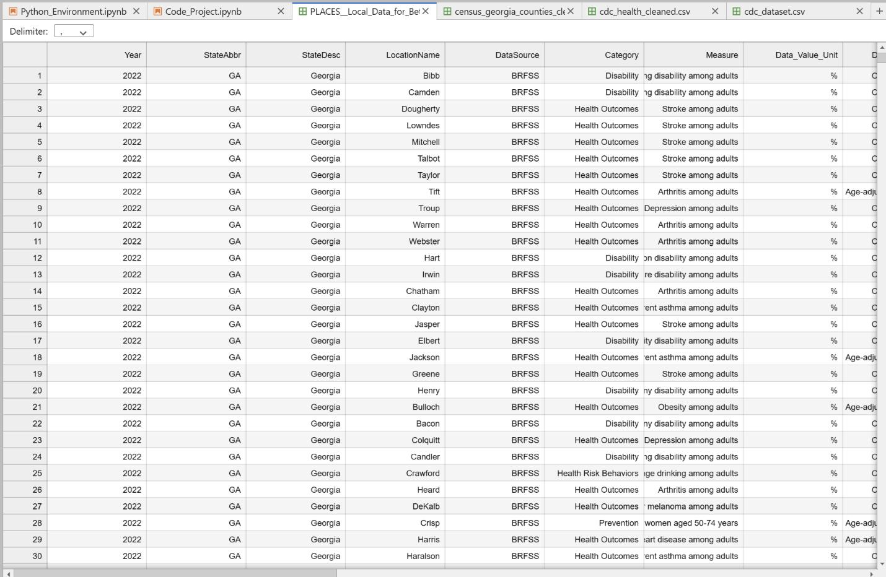

Screenshot 7: Python code of cleaning for “cdc_dataset”

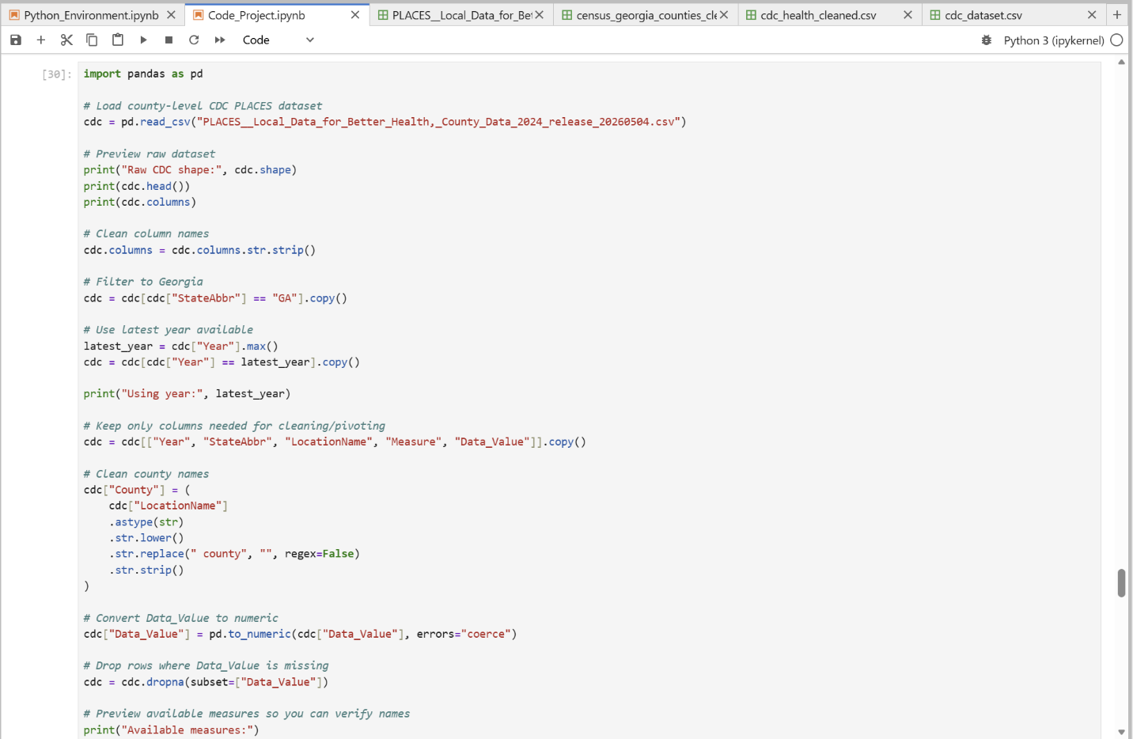

Screenshot 8: Python code of cleaning for “cdc_dataset” pt 2
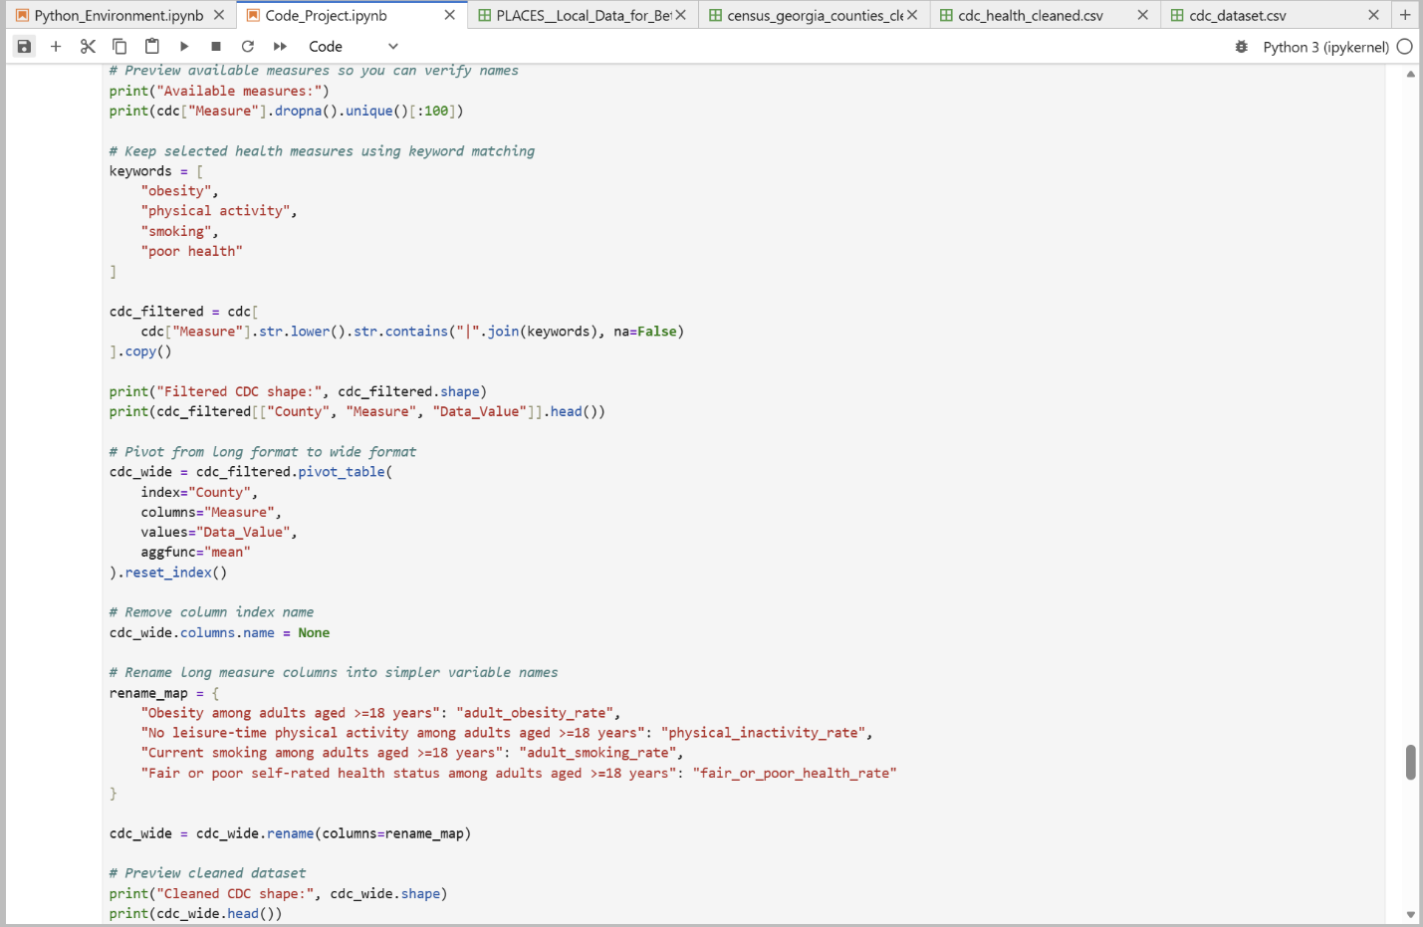

Screenshot 9: Python code of cleaning for “cdc_dataset” pt 3
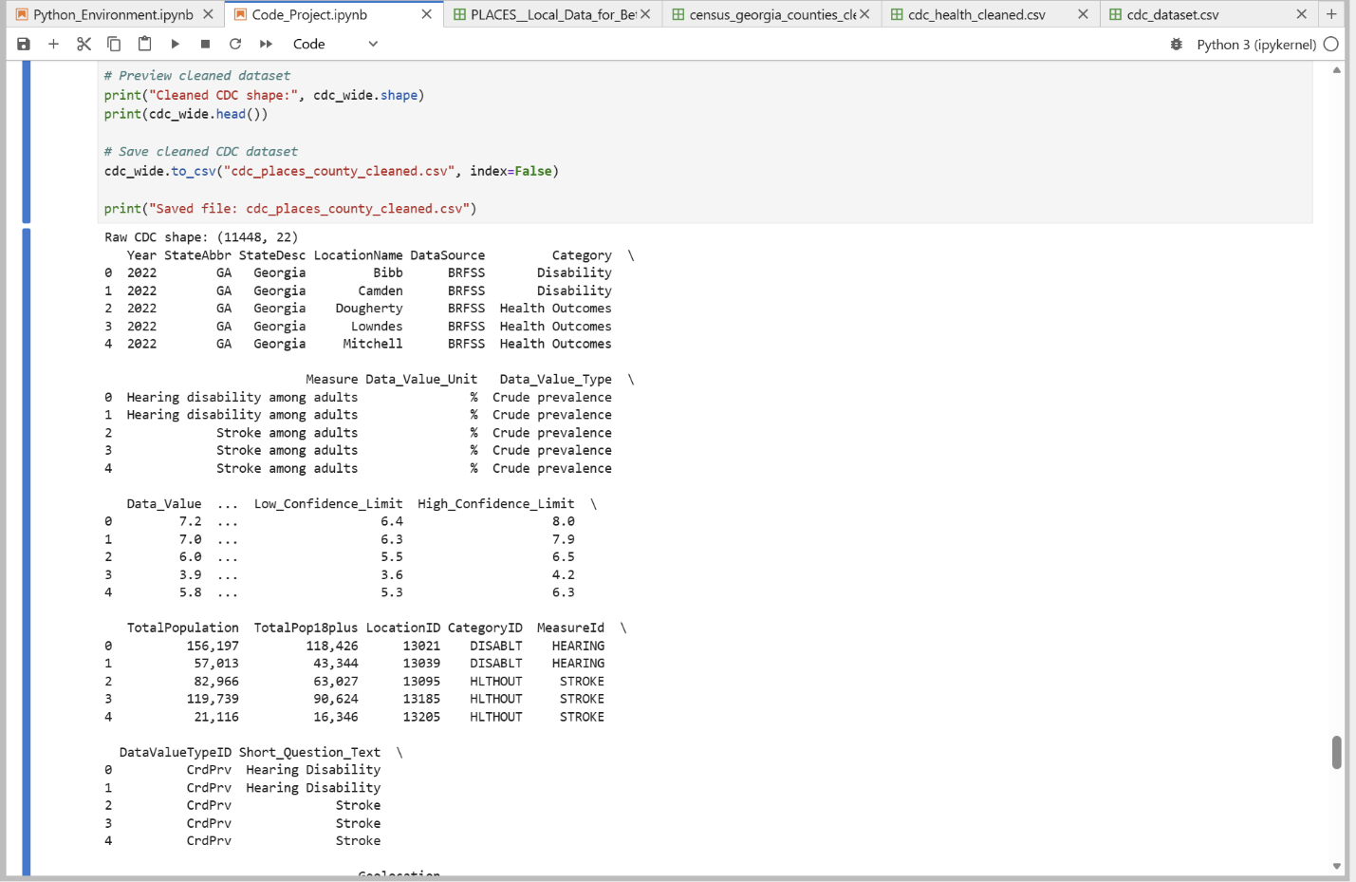

Screenshot 10: Snippet of CSV “cdc_places_county_cleaned”

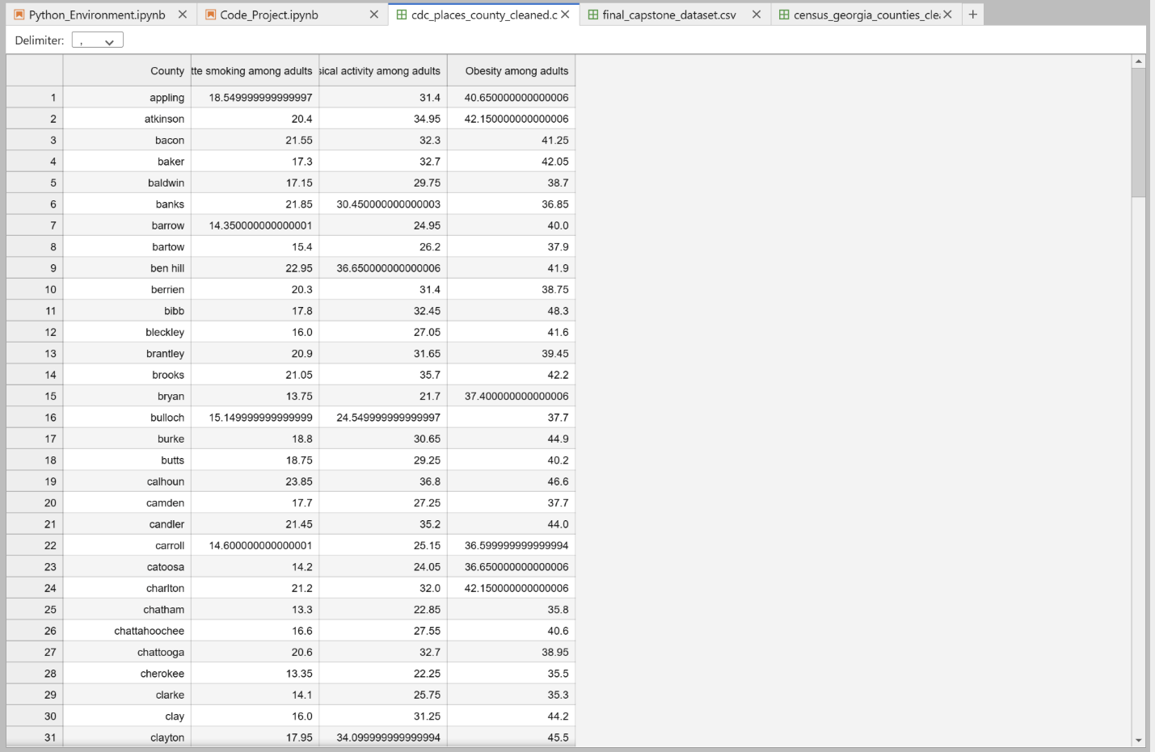

Screenshot 11: Python Code snippet of merger of datasets pt 1

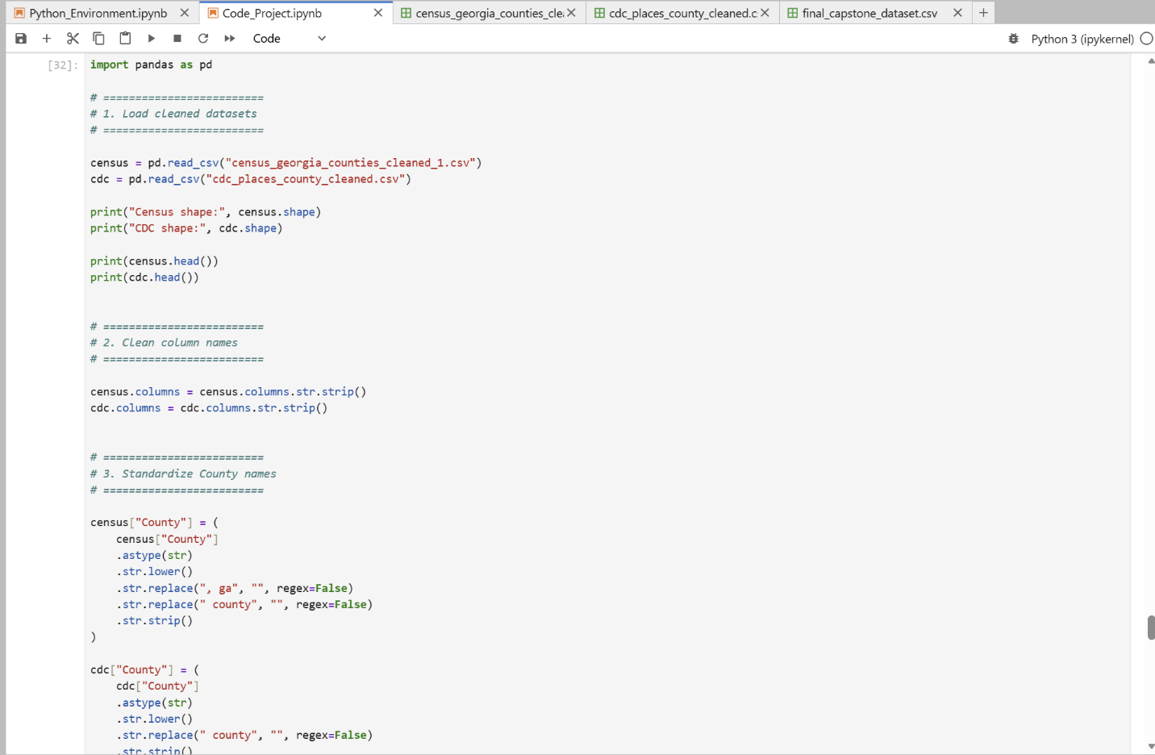

Screenshot 12: Python Code snippet of merger of datasets pt 2
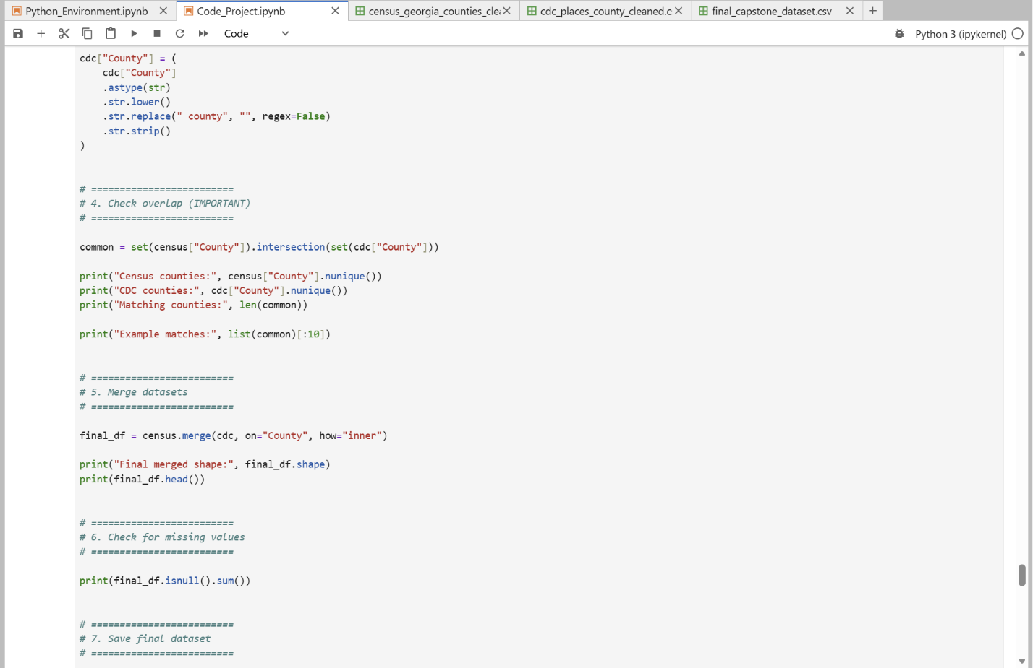
Screenshot 13: Python Code snippet of merger of datasets pt 3
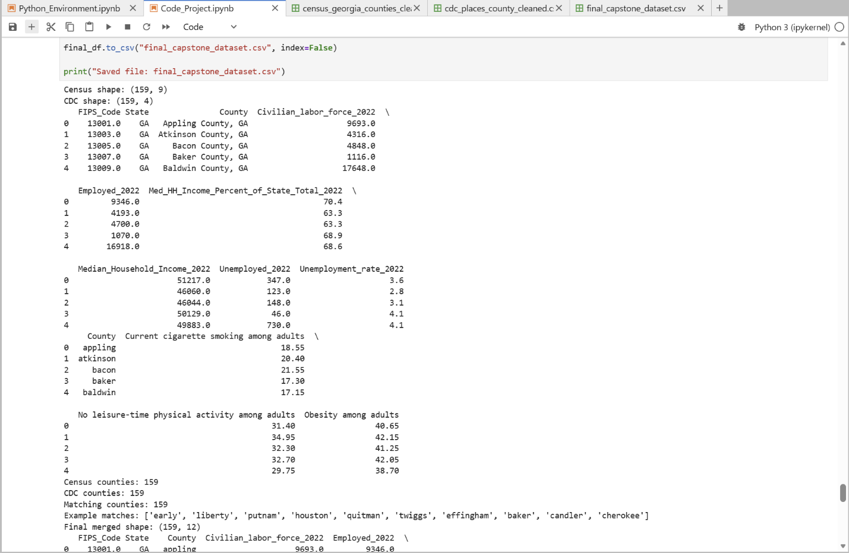

Screenshot 14: Snippet of CVC Final Dataset for capstone project
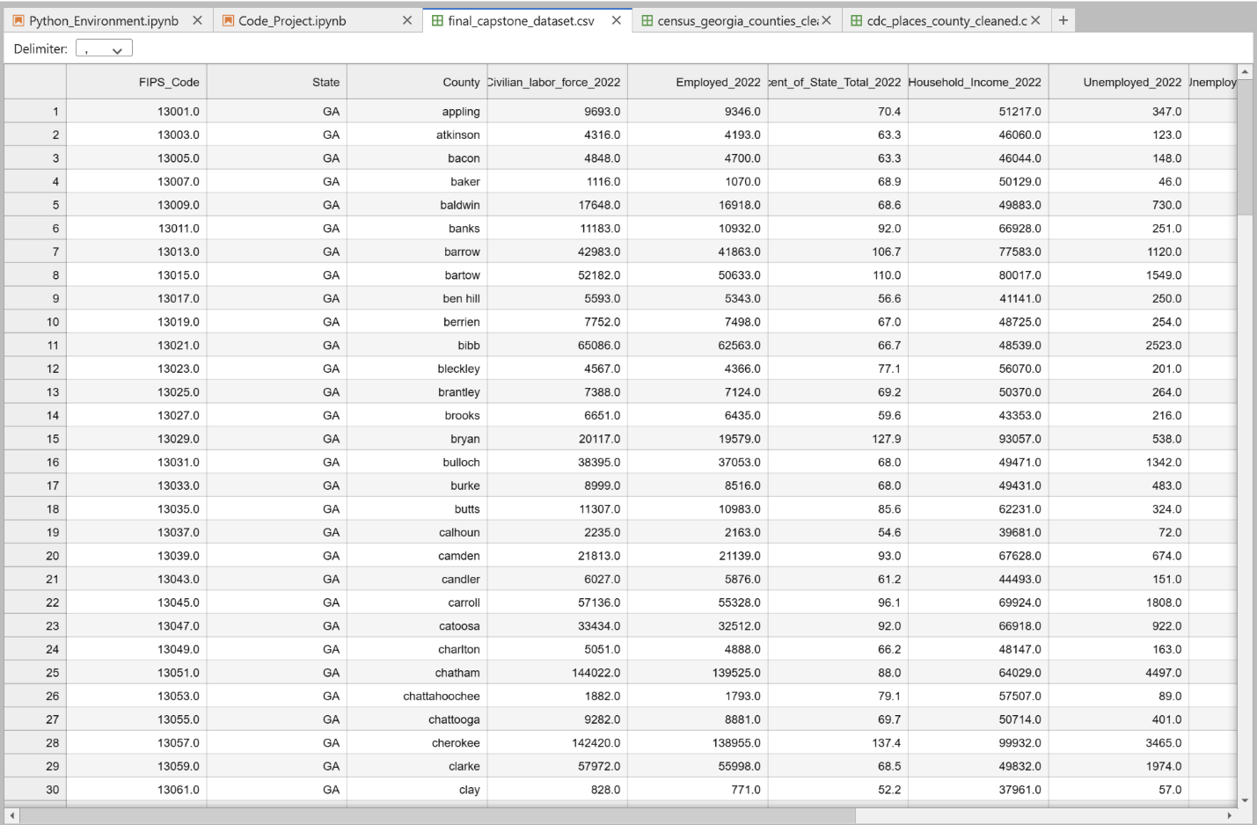

Analysis
D. Report on your data-analysis process by describing the analysis techniques you used to appropriately analyze the data. Include the calculations you performed and their outputs.
Justify how you selected the analysis techniques you used, including one advantage and one disadvantage of these techniques.

The data analysis process involved the use of statistical and machine learning techniques to evaluate the relationships between socioeconomic and behavioral health factors and adult obesity rates across counties in Georgia. The final dataset included variables such as median household income, unemployment rate, smoking prevalence, and physical inactivity, with adult obesity rate selected as the target variable.

Correlation analysis was first conducted to identify relationships between the independent variables and the target variable. The correlation results indicated that variables such as physical inactivity and smoking exhibited positive relationships with adult obesity rates, while median household income showed a negative relationship. These findings suggest that counties with higher rates of unhealthy behaviors tend to experience higher obesity rates.

Multiple linear regression was then applied to evaluate the linear relationships between predictors and the target variable. The model produced an R² value .79, indicating that approximately 79% of the variation in obesity rates could be explained by the selected predictors. The model also produced a root mean squared error (RMSE) of 1.61, reflecting the average prediction error. These results suggest that the model provides a reasonable level of explanatory power for understanding obesity trends across counties.

In addition, a random forest regression model was implemented to capture nonlinear relationships and interactions between variables. The random forest model achieved an R² value of .76, demonstrating a similar predictive performance compared to the linear regression model. The RMSE for the random forest model was 1.74 indicating the model’s prediction accuracy.

Feature importance analysis from the random forest model shows both a lack of physical activity and cigarette smoking among adults as the most influential predictors of adult obesity rates. This suggests that behavioral health factors play a significant role in explaining variations in obesity across counties.

These techniques were selected because they provide both interpretability and predictive capability. Linear regression offers a clear understanding of relationships between variables, while random forest models are capable of capturing more complex, nonlinear interactions.

An advantage of these methods is their ability to uncover meaningful patterns in both linear and nonlinear relationships within the data. However, a disadvantage is that more complex models, such as random forests, are less interpretable and make it more difficult to explain the exact influence of individual variables compared to linear regression.

Figure 1: Correlation between variables and adult obesity rate
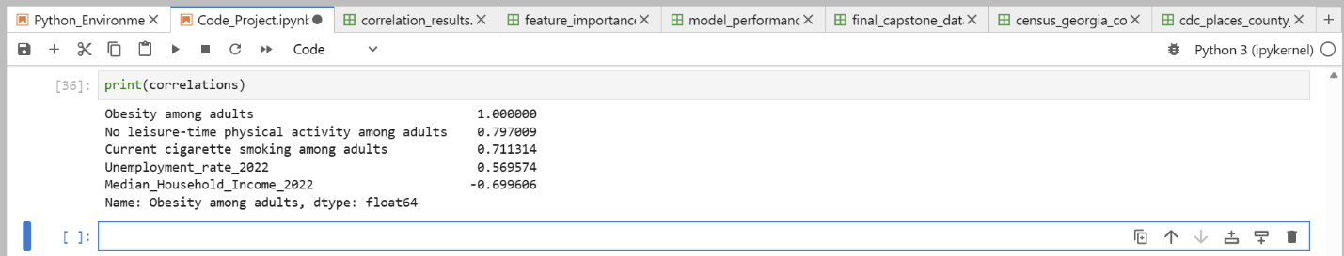

Figure 2: Visual representation of correlation with adult obesity rate
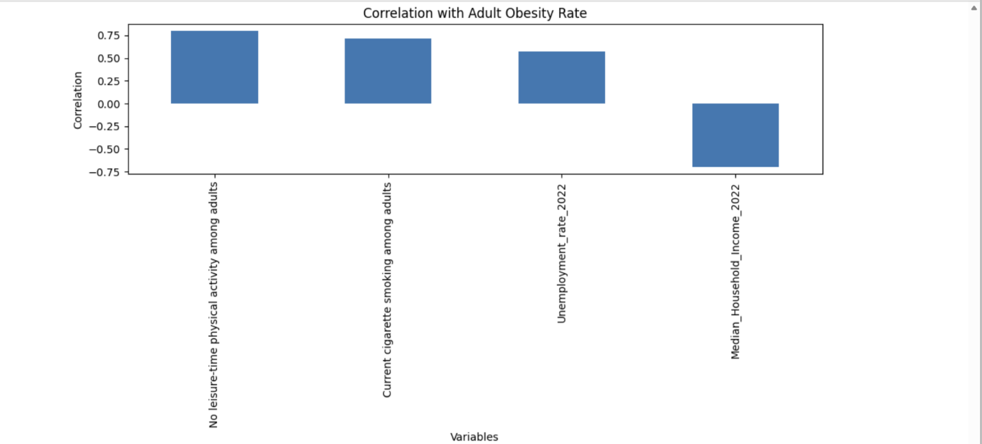

Figure 3: Linear regression model performance
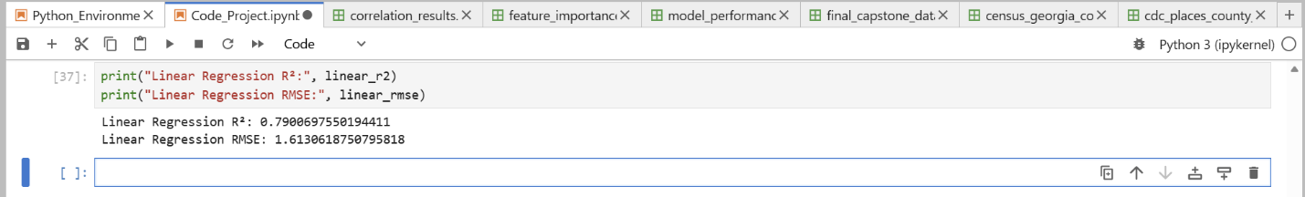

Figure 4: Random forest model performance
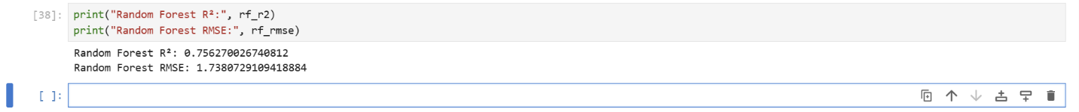

Figure 5: Feature importance from random forest model


Outcomes and Implications
E. Summarize the implications of your data analysis by discussing the results in the context of the research question, including one limitation of your analysis. Within the context of your research question, recommend a course of action based on your results. Then propose two directions or approaches for future study of the dataset.

The results of the data analysis provide insight into how socioeconomic and behavioral health factors influence adult obesity rates across counties in Georgia. The analysis demonstrated that behavioral factors, particularly physical inactivity and smoking, were among the strongest predictors of higher obesity rates. Additionally, socioeconomic variables such as median household income and unemployment rate showed meaningful relationships with obesity, suggesting that both economic conditions and lifestyle behaviors contribute to health disparities across counties.

The regression and random forest models further supported these findings by showing that a combination of socioeconomic and behavioral variables can explain a substantial portion of the variation in obesity rates. The random forest model, in particular, highlighted the relative importance of behavioral health factors, reinforcing the idea that lifestyle-related variables play a critical role in shaping population health outcomes.

One limitation of this analysis is that it relies on aggregated county-level data, which does not capture individual-level variation. As a result, the findings cannot establish causation and may be influenced by underlying factors not included in the dataset. Additionally, the use of a single year of data limits the ability to observe trends over time.

Based on these results, a recommended course of action is to implement targeted public health interventions in counties with higher rates of physical inactivity and smoking. These interventions may include community-based fitness programs, public health campaigns promoting physical activity, and smoking cessation initiatives. Improving access to recreational facilities and preventive healthcare services may also help address the underlying behavioral and socioeconomic factors associated with higher obesity rates.

Future research could expand this analysis in several ways. First, incorporating longitudinal data across multiple years would allow for the examination of trends and changes in obesity rates over time. Second, integrating additional variables such as healthcare access, education levels, and environmental factors could provide a more comprehensive understanding of the drivers of obesity and improve predictive modeling.

References

Centers for Disease Control and Prevention. (2024). PLACES: Local data for better health, county data (2024 release). https://data.cdc.gov/500-Cities-Places/PLACES-Local-Data-for-Better-Health-County-Data-20/fu4u-a9bh/data_preview

HBN1 — HBN1 Task 2: Data Analysis Report. (n.d.). WGU
Coursework. https://tasks.wgu.edu/student/011041148/course/33900019/task/4712/overview

U.S. Department of Agriculture Economic Research Service. (2025). County-level data sets: Download data. https://www.ers.usda.gov/data-products/county-level-data-sets/county-level-data-sets-download-data

