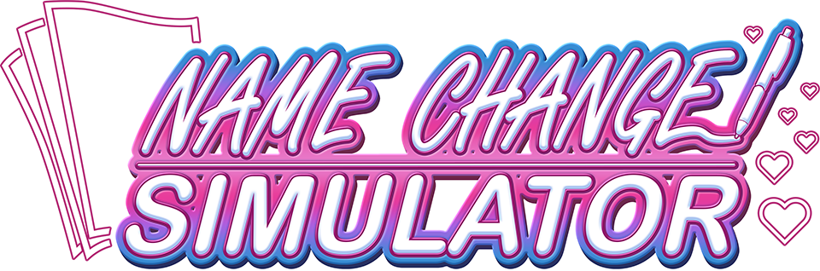What Happens Now?

Lauren here! Congrats on getting your name change forms all buttoned-up and ready to go. But we can’t celebrate quite yet: just having your forms in hand is but one part of the process. You’ll need to take care of the rest of this stuff outside of my office…

But, don’t sweat: I’ve prepped this handy checklist for you to take with you, free of charge! So feel free to save a copy, print it out, write all over it – whatever helps you the most!

# Your To-Do List:

**State: [TEMPLATE]**

* Step 1
* Step 2
* Step 3