## horizontal line



AI Movie Recommender System Design Document

15.04.2022

**─**

Chris Mutua

JKUAT

P.O. BOX 1764

Juja

# Table Of Contents

**Table Of Contents** **1**

**Functional Description** **1**

**User Interface** **1**

User Interface Design 2

Landing Webpage 2

Results Webpage 2

**Goals and Milestones** **2**

**Timeline** **4**

**Conclusion** **6**

# Functional Description

The system will be able to do the following once fully built, implemented, and deployed successively:

* Allow user requests and display the requests being made. This will enable simple tracking and follow-ups in case of errors and any complaints.
* Support input search autocomplete feature. This feature will minimize typing errors and also increase the searching speed since one won’t have to input the whole title if it already exists in the system.
* Fetch the connection between the title entered in the search bar and the ones in the datasets provided to it. Carry this out using the genre, title, directors, casts (actors), rating e.g. IMDB rating, and year among many other factors.
* Display the fetched results so that the user can easily choose their preference.
* In case of any errors, handle them with ease but also inform the end-user on how to proceed from them.
* Display additional information on the movie searched for such as reviewer comments which will help the user determine if the movie is appropriate for them.

# 

# User Interface

The following will have to be considered when building the site’s user interface:

* Consistency in design and color selections
* Simplicity in design
* Minimizing of errors
* Error handling and user-friendliness
* The minimalism of the site's content reduces three excessive use of long-term memories especially for old users since it can be stressful for them.

## User Interface Design

The application will contain two main webpages, these are:

1. Landing webpage
2. Results webpage

The contents of these web pages are as discussed below:

### Landing Webpage

This is also known as the main webpage since by default the application will use it as the landing page.

It shall contain the search bar which allows one to key in searches for the system to take in as input. It shall display autocompleted titles if they exist and are related to the search. One can click on them for a quick autocomplete feature.

It also displays errors such as if the system lacks the searched movie title.

It shall appear as shown below:

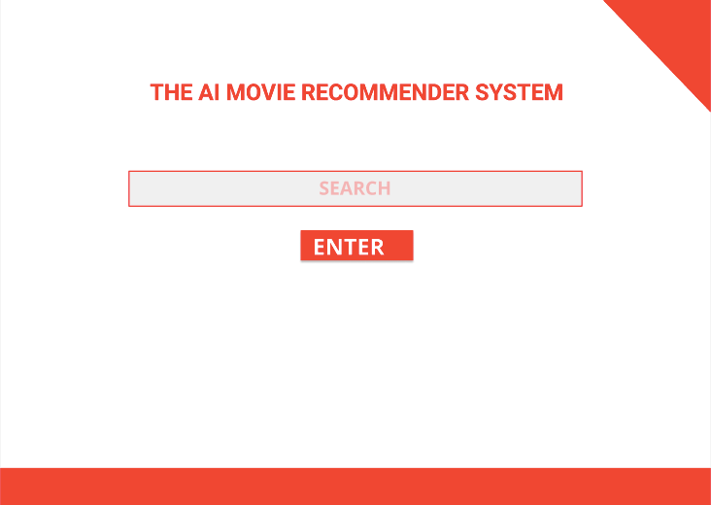

The site will display the following in case of any errors such as non-existent searches:

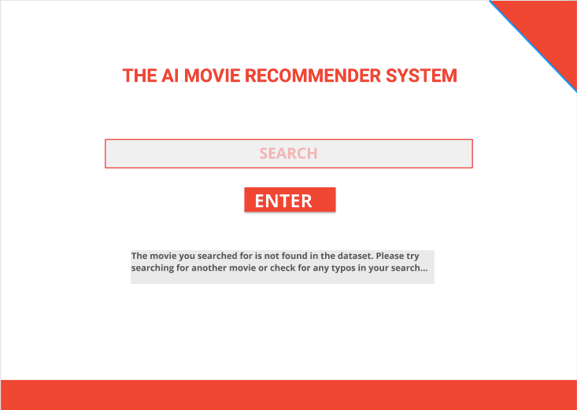

### Results Webpage

Whenever the user runs a successful search, the application will display the searched-for movie, its descriptions, reviews, and recommendations among other things. The design of this is shown in the image below:

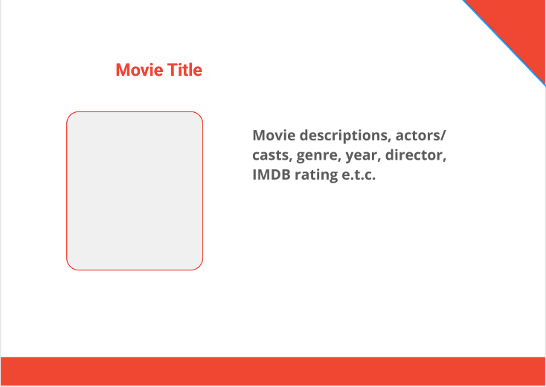

# Goals and Milestones

The following achievements will be able to show the progression of the application development process:

1. Creation of the Landing page and Results page web templates which will be used to generate static webpages that will have the fetched data in them
2. Create the Search Autocomplete feature
3. Create a connection between the application with the online dataset provided using the API and the API_KEY for recent and updated results
4. Create the AI engine to evaluate the datasets and display the results to best fit.
5. Document the system
6. Do tests using various data
7. Correct any minor errors and rerun tests
8. Do installations and deployments

# Timeline

The project will take approximately three months (3 months) to be completed.

The time will be split as follows:

|  |  |  |  |  |  |  |  |  |  |
| --- | --- | --- | --- | --- | --- | --- | --- | --- | --- |
| Dates | Days | Tasks | | | | | | | |
| 01/10/2021 to 06/10/2021 | 6 days | Creation of the web page templates |  |  |  |  |  |  |  |
| 07/10/2021 to 13/10/2021 | 7 days |  | Implementing Autocomplete feature |  |  |  |  |  |  |
| 14/10/2021 to 15/10/2021 | 1 day |  |  | Creating API connection with IMDB |  |  |  |  |  |
| 16/10/2021 to 05/11/2021 | 21 days |  |  |  | Create the AI engine |  |  |  |  |
| 06/11/2021 to 19/11/2021 | 14 days |  |  |  |  | Document the system |  |  |  |
| 20/11/2021 to 4/12/2021 | 14 days |  |  |  |  |  | Do system tests |  |  |
| 5/12/2021 to 12/12/2021 | 7 days |  |  |  |  |  |  | Correct errors and rerun tests |  |
| 13/12/2021 to 17/12/2021 | 4 days |  |  |  |  |  |  |  | Install and deploy the project |

# Conclusion

If the project is well developed within the speculated time, then the system will be very advantageous to the end-users who would like to get suggestions based on the ones which they have ever seen or that which they are interested in. It will have a well understandable structure that will facilitate developer contributions from other users.