# Letter of Transmittal

**Emily Becker**

5657 Blanchard Place

Sugar Hill, GA 30518

(770) 668-8599

[ebecker2@students.kennesaw.edu](mailto:ebecker2@students.kennesaw.edu)

June 14th, 2019

**Lee White**

Director of Parking and Transportation

House 3205 - 205

1000 Chastain Road

Kennesaw, GA 30144

Dear Mrs. White,

I am writing this to explain my plan for aiding the school bus system. As someone who rides the bus every day, I believe that I have a proposal that would greatly benefit your department. You recently sent out an RFP that wanted to address the decline of bus riders, and I immediately took the opportunity to write this letter.

My proposal has a few parts to it. Firstly, I want to have more efficient tracking of buses by building a new app that not only tracks them but also shows how long they will stay at a certain stop. I also want to add more routes to the BOB routes, focusing on locations closer to the Marietta Campus, such as Marietta Square. Finally, I want to make it so the bus runs longer, perhaps creating two different groups of bus drivers to work a day shift and a night shift.

One of the key benefits of this plan is money-both saving it and making it. The students won’t have to waste money on taxi services such as Uber, since the busses go to more places. The school will be able to create more jobs with new bus riders, giving the already employed ones a break and decreasing their stress. Increasing the number of routes could also increase the amount of events, both at the school and outside of it, that students go to.

I am qualified to do this because I have personal experience with the problem. I do not have a car, so I have to ride the bus every day from Marietta to Kennesaw and back. I want to go to events, but usually they either have no routes or the buses do not run long enough for me to come back on them. I want to be a part of the community, but the buses make that difficult.

Thank you for reading this letter of proposal. I am excited to hear your response. I will be available next week on Tuesday, starting at noon, to answer any questions you may have. My email is [ebecker4@students.kennesaw.edu](mailto:ebecker4@students.kennesaw.edu), and my phone number is 770-668-6599.

Many thanks,

Emily Becker

# Table of Contents

**Introduction** **4**

**Current Situation** **6**

**Project Plan** **8**

**Qualifications** **9**

**Costs And Benefits** **11**

**Conclusion** **13**

**Sources** **14**

# 

# Introduction

Like most colleges, Kennesaw State University has multiple campuses and a lot of people living on them, a good number of whom do not have a car or other means of transportation. There are many learning drivers on campus as well, who may not be fully capable of driving safely just yet. That is why the bus system is so important- it provides unlimited transport for those who cannot afford it.

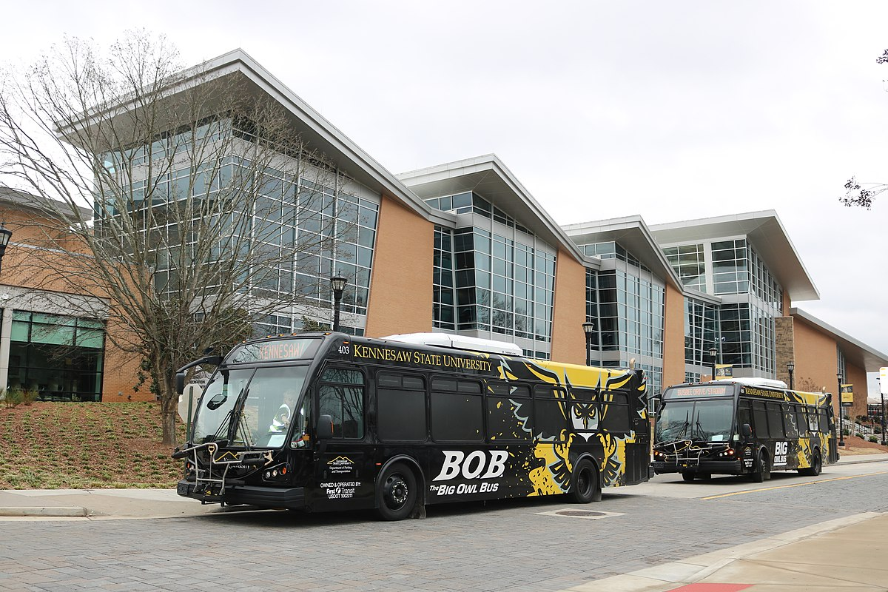

Kennesaw State Universities transportation system, specifically the Big Owl Bus (BOB), is an amazing tool for commuters from either campus. KSU Students without automobiles use the BOB every day to get between classes and save hundreds from not having to use paid transportation services like Uber, or worry about fees with Cobblinc. Most students do use the bus, regardless of their ability to drive or the amount of income they make. In fact, even in the smallest of sample sizes, you are likely to find someone who rides the bus.

Despite this, the bus system is somewhat clunky and could use some renovations in order to reach its full potential. A volatile mix of minor inconveniences and genuine problems has caused public opinion of the transportation system to become mixed. Many students depend on their University to provide them with reliable transportation to their classes, and to places where they wouldn’t be able to go otherwise. Therefore it is vital that the school renovates their transportation system to meet growing demands. With this in mind, let us view the ways our company’s proposal to upgrade the KSU transportation system can benefit KSU.

# Current Situation

The current Kennesaw Bus system is, admittedly, a bit shoddy. The arrival times, while fairly consistent, do not always track on the currently-used Rider app, sometimes vanishing altogether when the bus does not go on the designated path. Also, the app can lag and may not always be accurate, jumping from prediction time to prediction time when it senses a bus. This is not only a sign of poor app maintenance, but can be stress-inducing for both new students, or old ones who simply overslept. According to a survey that we conducted, almost 3/4ths of students would switch to another app if one existed.

There are currently 9 bus routes on the Big Owl Bus roster, plus 8 that connect to the campus on Cobblinc. The Cobblinc busses go to the Kennesaw Campus, but also to the Arts Center station- which is in the vicinity of the High Museum of Art. Out of the official Big Owl Bus routes, only two of them actually go to the Marietta Campus. Even then, only one of them goes to somewhere that does not have any relation to the KSU campus- one that goes to a Walmart. Simply put, the Kennesaw State University bus system focuses more on convenience than it does on community, relying on Cobblinc for that aspect of life. Cobblinc and Uber charge fees of varying amounts to students before they can board, which is inconvenient for a college student- especially if their school has a transportation option that they have already paid for.

Speaking of community, the smaller number of buses on campus means that when a special event happens that requires transportation, all transportation on the Marietta campus comes to a halt in order to accommodate said event. Take, for example, Owl-O-Ween, an event that happens annually on the Kennesaw campus. The majority of Big Owl Bus vehicles change their routes to accommodate the event, leaving the majority of the bus routes either understaffed or non-functional. This is incredibly inconvenient for Marietta campus students who either want to go to the event or want to go to the other campus for any other reason.

Some students have expressed a desire to increase the amount of transportation on campus, although for different reasons than wanting a more leisure-oriented series of bus routes. In an editorial for the Kennesaw State University newspaper, The Sentinel, Alya McGuinness suggested that expanding Atlanta’s major bus system to KSU would help reduce the carbon footprint of the school, and shorten the commute time from the campus to the city. We agree with the views that McGuiness expressed, and also believe that there is an aspect of potential expansion that cannot be measured by simple ecology.

# Project Plan

Our plan is a multifaceted one, with several interconnected initiatives.

* First, we want to increase the number of busses/vans on the Kennesaw State University transportation routes. We believe that this will help with the second phase of our plan, and allow for longer stretches of time for bus operation. W
* Second, we want to heighten the frequency that the busses run from stop to stop, and campus to campus. This needs to be improved because not everyone has a car and is reliant on the busses to get them to where they want to go, which can lead to problems with attendance in both school and events. Tying into this, we want to make it so that the last bus does not come in at 10:35 as it currently does, but instead at 11:35. This will only really work once the busses are in operation.
* Third, we want to increase the amount of bus stops, focusing more on the Marietta area. We believe that this is important because the current bus system is, admittedly, a bit shoddy. The arrival times are inconsistent, the busses vary in size and quality (for example, a small van heading all the way to the Kennesaw campus), and occasionally smaller bus vans are not monitored on the Rider app that is used currently to track vehicles.
* Finally, we want to construct a new app that will track the busses and vans more accurately and in spite of whatever path they may take to get to their destination. Rider does not work as effectively as it should, especially as a transport app for an up and coming university. On top of this, both of our major competitors, Cobblinc and Uber, both have apps of their own. This can likely be done over the course of the summer semester.

We also want to streamline the busses that are used so one type is used exclusively for intercampus travel and the other for intra-campus travel. The system used to track the busses should also be updated to make it more efficient and accurate, potentially leading to an entirely new app. Tangible benefits include improved trust in the school’s transportation system, increased attendance of intercampus events, and a larger sense of comradery in the school. In the chart below, we listed a general timeline for accomplishing our goals over the summer semester starting the weak after the end of the spring semester to avoid interference with the current B.O.B. system.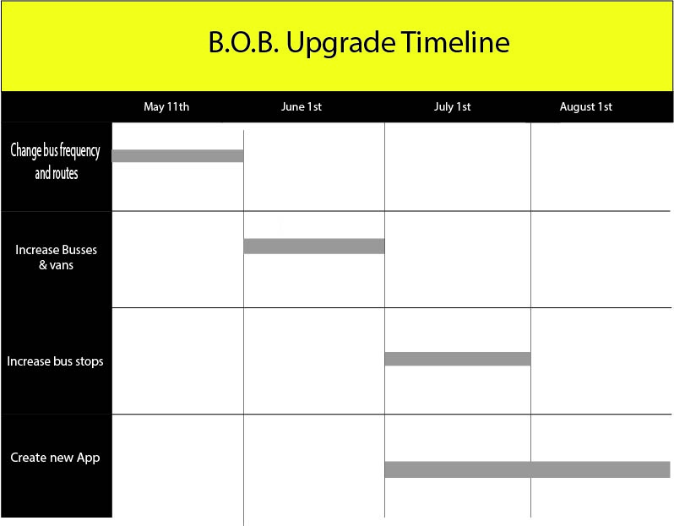

Starting with planning to bus routes and stop frequencies, we will then move to acquiring the appropriate amount of busses and vans. We will then go into constructing new bus stops in July then have our new app developed over July to finalize the app before the fall winter semester begins in August.

# Qualifications

With previous experience in supplementing commuter travel systems, our team has the expertise needed to champion this project. We have made several unofficial tracking apps for several other schools with bus systems, such as Georgia Tech and the University of Florida. However, while they are unofficial, they are highly recommended by students and have been mentioned in several articles.

Our company has several years of experience in transportation, route organization, and app development. Market research and consumer reports have exposed us to the main issues with student transportation and associated technologies. Over the years, we have developed a special identity as a group who values the college experience and knows that these are still formative years for students.

On top of this, we have several technical communicators on staff. These technical communicators can write grants and proposals to convince companies to sell their busses to us, sometimes for reduced prices. As of 2020, we have written over 100 proposals for various companies, and we have an approval rate of 90% For that reason, we have the utmost confidence that we can gather any number of and type busses that you may choose to use.

We have also done proper research into the frequency students expect from their university’s transportation. Our organization surveys members of the student body to also account their specific needs from their university and the unique campus and transportation situation they may be in. Here are a few examples tailored to our proposal:

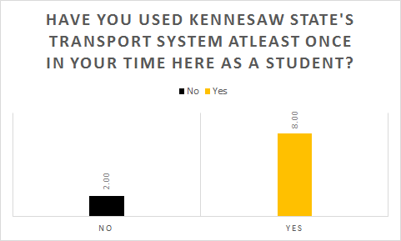

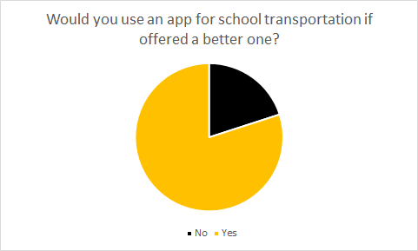

# 

# Costs And Benefits

The exact cost of a bus varies depending on what kind of fuel said bus uses. The approximate prices are as follows:

* $550,000 for a diesel-powered bus
* $714,000 for a hybrid bus
* $918,000 for an electric bus

In contrast, a van would cost around anywhere from $24,000 to $38,000. As you can see, vans would be much more cost effective. On top of this, fueling a van can cost $2,100 annually, as compared to a bus, which would cost around $2,600. Also, a bus driver has a salary of up to $50,000 a year. If we, for example, buy two diesel-powered busses, we would have to add a total of $100,000 to our salaries, on top of the almost 15 million dollars needed for the busses themselves.

Another option could be leasing busses. It costs around $1,300 per week to rent an average bus, which would add up to $19,500 for a semester, assuming a semester is 15 weeks. Busses could also be rented for special events, thus allowing the already-existing busses to function as normal for the duration of the event. It would be cheaper to rent a bus for a whole semester than simply buying one, although we will leave that to the discretion of the committee.

As for the app, average app development tends to range from $5,000 to $10,000. We are asking for $7,000 as a starting point to develop ours, since that would be a fair amount of middle ground.

All things considered, we are asking for a starting price of 9.5 million dollars.

* 9 million dollars for buying/leasing busses and paying bus drivers
* 7000 dollars for app development and testing
* 400,000 for advertisement of the new system and destinations

The social benefits of this expansion are simple, but impactful. The increase in stops throughout the city would help create a symbiotic relationship between it and the school. Local events and businesses would gain more publicity, and Kennesaw’s Marietta campus could gain traction for its own events, for example OwlCon. Having more busses would improve the frequency and consistency of busses arriving, and likewise increase student ability to have classes on both campuses. Later bus times would also benefit students who either have later classes or work while living off or away from campus. All these factors will help improve quality of life on campus, and thus improve reception of Kennesaw State as a whole.

We are students at Kennesaw State University, so we know what the school wants and needs. As members of the faculty, you must share this understanding. We have pride in our school and our identity as a campus. We have not abandoned our former identity as Southern Polytechnic and adding more local bus locations will help us retain that identity. This is our chance to give back to the city that we see as a hometown, and the school we see as a home.

# Conclusion

Kennesaw State University has a lot of untapped potential in its transportation system. We are in the middle of a historical change not only in our school, but in the world in general. With increasing safety measures and a need to keep people as separate as possible, busses could help in that goal.

While it is true that bus stations would help decrease our carbon footprint, there is a much larger meaning to increasing school transportation. College is meant to be a time of blooming independence, with students being able to carve out their own personalities and interests away from their parents. If we focus all of our time and energy on the necessities, we miss out on the simple pleasures of life. At the end of the day, both work and play matter, and they exist in a delicate balance. As the old saying goes: “All work and no play makes Jack a dull boy.”

There is a large number of new students coming in and an unprecedented opportunity to improve the internal structure of our organization. The coronavirus has demonstrated Thus, we believe that now is the best time to rework the bus system into something that benefits everyone.

We greatly appreciate your time in reading this proposal. If you are interested in this proposal, please contact us. Our email is [acantwell@students.kennesaw.edu](mailto:acantwell@students.kennesaw.edu), and our phone number is 770-668-6599.

# Sources

#### *Overview of Transit Vehicles* (2020). *Codot.gov*. Retrieved 23 April 2020, from <https://www.codot.gov/programs/commuterchoices/documents/trandir_transit.pdf>

#### 

#### *How Much Does It Cost to Purchase and Operate a Bus?*. (2020). *LiveAbout*. Retrieved 23 April 2020, from <https://www.liveabout.com/bus-cost-to-purchase-and-operate-2798845>

*How Much Do Bus Driver Jobs Pay per Hour?*. Zip Recuiter. (2020). Retrieved 23 April 2020, from <https://www.ziprecruiter.com/Salaries/How-Much-Does-a-Bus-Driver-Make-an-Hour>.

#### 

#### *OPINION: Expanding public transportation can aid students' commute, reduce carbon footprint – The Sentinel*. *The Sentinel*. Retrieved 23 April 2020, from <http://ksusentinel.com/2019/09/30/opinion-expanding-public-transportation-can-aid-students-commute-reduce-carbon-footprint/>