Project 3 report : Angry Bird

F74046234
吳貞頤
資訊一甲 108

# UML Diagram

MainWindow
-ui:MainWindow *
-scene:QGraphicsScene *
-world:b2World *
-itemList:QList<GameItem *>
-timer:QTimer
-land:Land *
-ybird:yellowbird *
-bbird :bluebird *
-a:bluebird *
-b:bluebird *
-wbird:whitebird *
-rbird:Bird *
-eggy:egg *
-once:int
-y_once:int
-b_once:int
-w_once:int
-redgenerated:int
-whichbird:int
-timer_detect:QTimer *
-timer_collide:QTimer *
-piggy:enemy *
-piggy2:enemy *
-*ob1:obstacle
-*ob2:obstacle
-*ob3:obstacle
-*ob4:obstacle
-*ob5:obstacle
-*ob6:obstacle
-scoretext:QString
-displayscore: int
-launcher:invwall *
-int defeat1: int
-int defeat2: int
<<constructor>>MainWindow(QWidget *parent = 0)
<<destructor>>~MainWindow()
+showEvent(QShowEvent *): void
+eventFilter(QObject *,QEvent *event): bool
+closeEvent(QCloseEvent *): void
+mousePressEvent(QMouseEvent *event): void
+generate_nextbird(): void
+showScore(): void
+restartfunc(): void
<<slots>>+ifcolliding(): void
<<slots>>+on_pushButton_exit_clicked(): void
<<slots>>+on_pushButton_restart_clicked(): void
<<signals>>quitGame():void
<<slots>>-tick(): void
<<slots>>-QUITSLOT(): void
<<slots>>-detect(): void

Land
<<constructor>>Land(float x, float y, float w, float h, QPixmap pixmap, b2World *world, QGraphicsScene *scene)

GameItem
+g_body:b2Body *
+g_pixmap: QGraphicsPixmapItem
#g_size:QSizeF
#g_world:b2World *
#g_worldsize:static QsizeF
#g_windowsize:static QSizeF
<<constructor>>GameItem(b2World *world)
<<destructor>>~GameItem()
+setGlobalSize(QSizeF worldsize, QSizeF windowsize):static void
<<slot>>+paint():void

bird
<<constructor>>+Bird(float x, float y, float radius, QTimer *timer, QPixmap pixmap, b2World *world, QGraphicsScene *scene)
+setLinearVelocity(b2Vec2 velocity):void

bluebird
+alreadyclicked:int
<<constructor>>bluebird(float x, float y, float radius, QTimer *timer, QPixmap pixmap, b2World *world, QGraphicsScene *scene)
+setLinearVelocity(b2Vec2 velocity):void
+morebird(b2World *world, QGraphicsScene *scene, int *once):void

yellowbird
<<constructor>>yellowbird(float x, float y, float radius, QTimer *timer, QPixmap pixmap, b2World *world, QGraphicsScene *scene)
+setLinearVelocity(b2Vec2 velocity): void

whitebird
+alreadyclicked:int
<<constructor>>whitebird(float x, float y, float radius, QTimer *timer, QPixmap pixmap, b2World *world, QGraphicsScene *scene)
+setLinearVelocity(b2Vec2 velocity):void

egg
<<constructor>>egg(float x, float y, float radius, QTimer *timer, QPixmap pixmap, b2World *world, QGraphicsScene *scene)
+setLinearVelocity(b2Vec2 velocity):void

enemy
<<constructor>>enemy(float x, float y, float radius, QTimer *timer, QPixmap pixmap, b2World *world, QGraphicsScene *scene)
+setLinearVelocity(b2Vec2 velocity): void

invwall
<<constructor>>invwall(float x, float y, float w, float h, b2World *world)

obstacle
<<constructor>>obstacle(float x, float y, float w, float h, QTimer *timer, QPixmap pixmap, b2World *world, QGraphicsScene *scene)
+setLinearVelocity(b2Vec2 velocity): void

# Screenshot

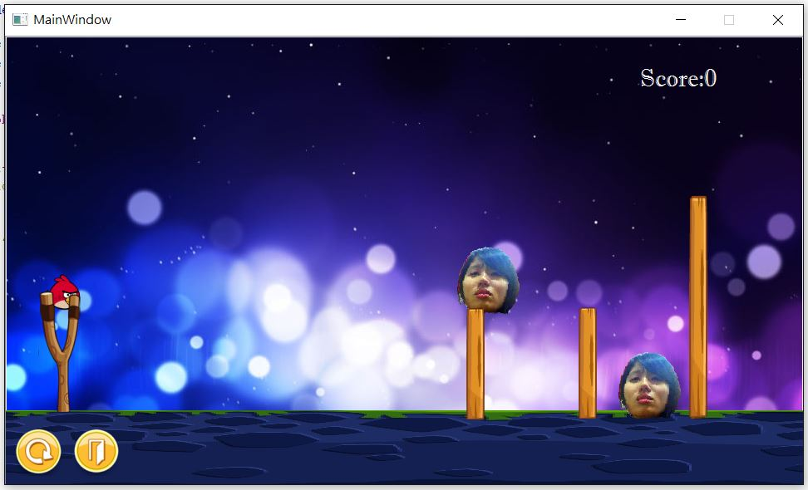

(the initial screen of the game)

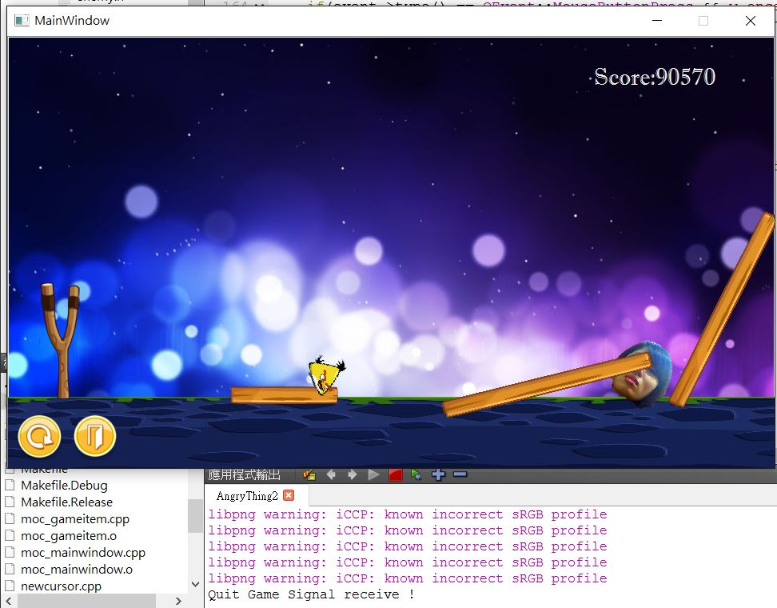

(if score>70000 or the two pigs are both defeated, then emit quitGame signal)

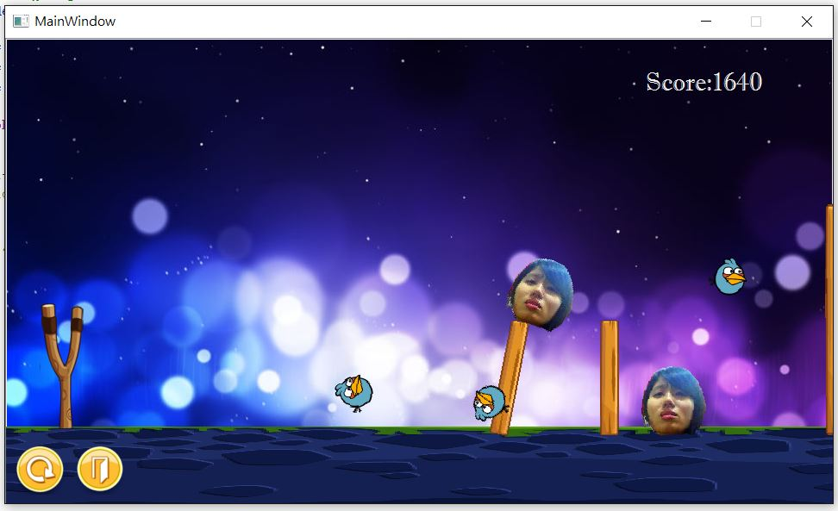
(the blue bird will come as three birds after clicking on the screen)

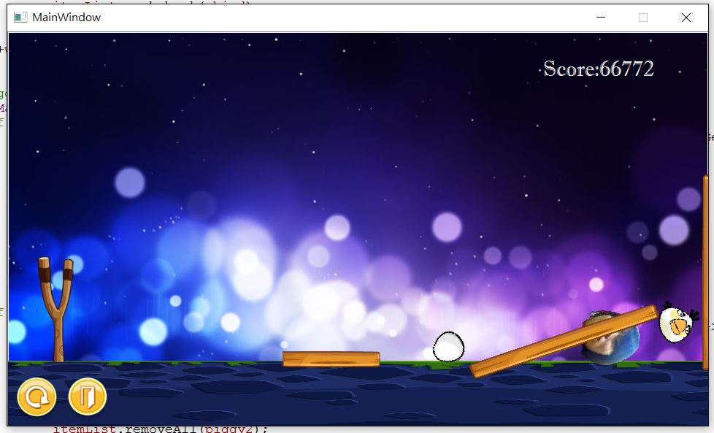
(the white bird will lay an egg after clicking on the screen)

# How to play

The game started with a red bird appeared after 1.5 seconds. Always click on the screen to launch the birds.

You can click on the screen after launching the birds to activate the special functions:
blue bird → it will come as three birds after clicking
yellow bird → it will accelerate based on the flying direction when clicking
white bird → it will lay an egg which falls vertically after clicking

Defeat a pig successfully → score + 35000
Push a pig successfully → add score

If the score reaches 70000 or the two pigs are defeated, then you win.

There are two buttons on the lower left corner, the left one is to restart no matter when, and the right one is to exit from this game level.

# Program Architecture

main.cpp will let the mainwindow show, then the showevent function in the mainwindow and the constructor will do the initialization. All the necessary objects are the data member in the mainwindow class.

Inherits from GameItem:
bird
bluebird
yellowbird
whitebird
egg
enemy
obstacle

Inherits from Land:
invwall (the invisible boundaries on the right side and the left side)

A QList called ItemList records all the items required refreshing on the screen. If the restart button is clicked, it will delete all the items listed in the ItemList, then clear the ItemList and do the variable initialization.
No matter the player win or lose, as the game finished, it will emit a quitGame signal.

