Requirement spesification :

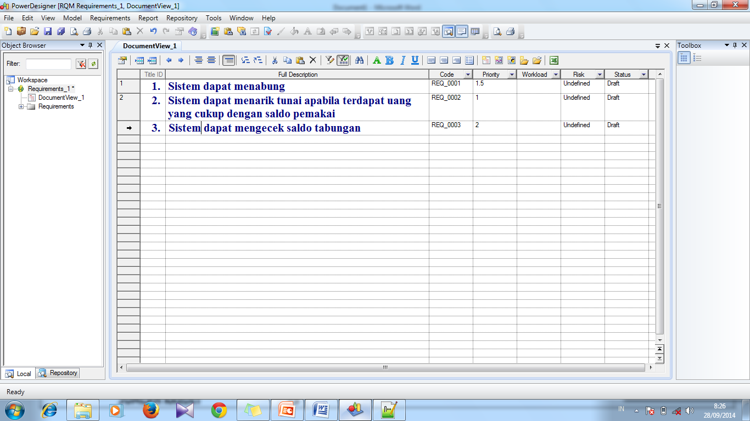

Source Code program :

import java.util.Scanner;

public class Bank {

public static void main(String[] args) {

int menu = 0;

int saldo = 40000;

boolean hitung = true;

Scanner t = new Scanner(System.in);

while (hitung) {

System.out.println(" Bank Chaiya-Chaiya ");

System.out.println("============================");

System.out.println("1.Cek Saldo = ");

System.out.println("2.Menabung = ");

System.out.println("3.Tarik Tunai = ");

System.out.println("4.Keluar");

System.out.println("===========================");

menu = t.nextInt();

switch (menu) {

case 1:

System.out.println("Saldo anda adalah " + saldo);

System.out.println("Apakah anda ingin kembali ke menu ? 1.ya 2.Tidak");

int a = t.nextInt();

if (a == 1) {

hitung = true;

} else if (a == 2) {

hitung = false;

}

break;

case 2:

System.out.println("Masukkan jumlah yg anda simpan =");

int b = t.nextInt();

saldo = saldo + b;

System.out.println("Apakah anda yakin ingin keluar ? 1.Ya 2.Tidak");

int v = t.nextInt();

if (v == 1) {

hitung = true;

} else if (v == 2) {

hitung = false;

}

break;

case 3:

System.out.println("Masukkan Jumlah uang yg anda ambil");

int n = t.nextInt();

saldo = saldo - n;

if (n <= 40000) {

System.out.println("Gagal");

saldo = saldo + n;

} else {

System.out.println("Saldo Anda Adalah" + saldo);

}

System.out.println("Apakah Anda ingin keluar ? 1.ya 2. Tidak");

int d = t.nextInt();

if (d == 1) {

hitung = true;

} else if (d == 2) {

hitung = false;

}

break;

case 4:

hitung = false;

System.exit(0);

}

}

}

}