基于GaussDB的SQL查询练习实验

姓名： 汤清云 学号： 2013536

实验步骤：

* 登录华为云IAM用户
* 访问对应数据库
* 进行相关数据查询

实验报告

实验步骤：

1.给出职工中所有男性的所有信息（empid,empname,age,sex,edpid）

Select \* from employee where sex= ‘男’;

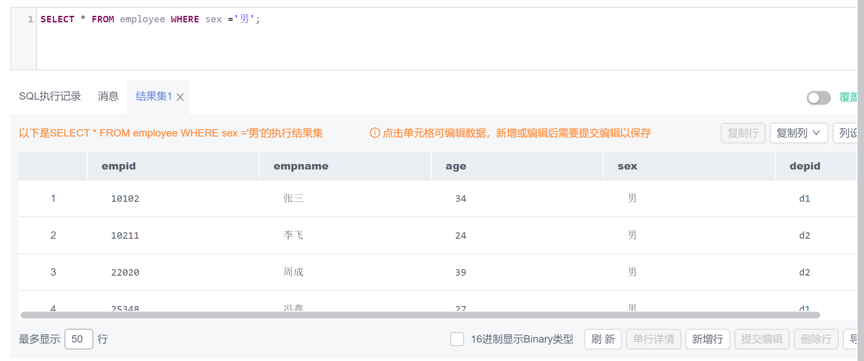

2.统计“李”性职工信息，按年龄降序排序。（empid,empname,age,location）

SELECT empid ,empname ,age,location from employee,department WHERE employee.depid =department.depid and employee.empname LIKE '李%' ORDER BY employee.age DESC

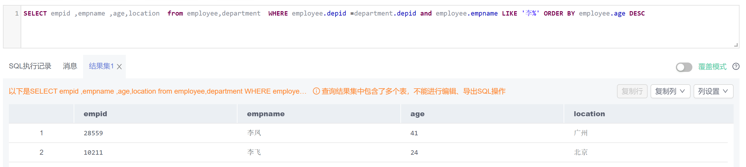

3. 给出每位职员参与项目的最高预算和最低预算（empname，highestbudget，lowestbudget）

SELECT empname,MAX(budget) AS 'highestbudget',min(budget) AS 'lowestbudget' FROM employee,project,workson

WHERE employee.empid = workson.empid and workson.proid =project.proid

GROUP BY employee.empname

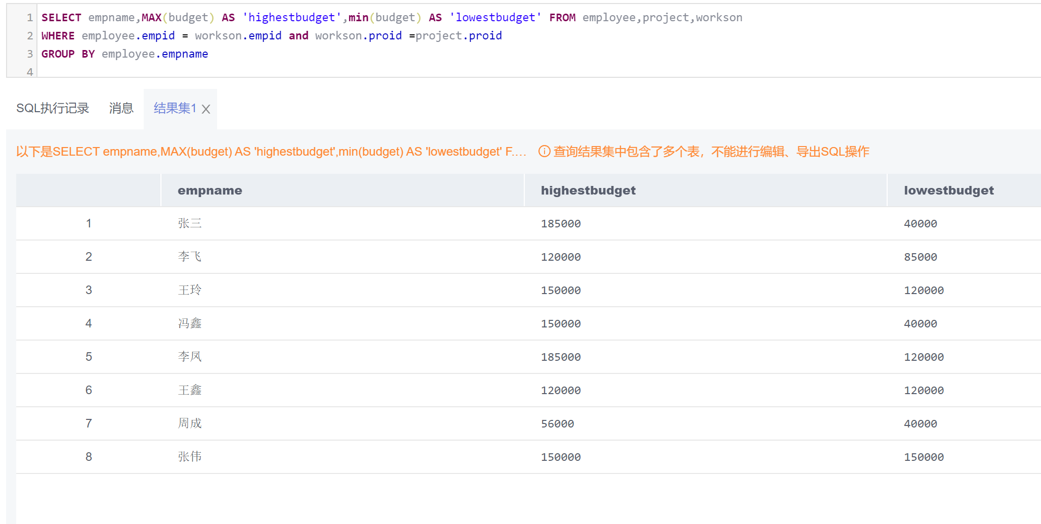

4.给出所有项目超过一个的员工的id和参加的项目个数（empid, num）

SELECT employee.empid,COUNT (workson.proid) AS 'num' FROM employee,workson

WHERE workson.empid =employee.empid

GROUP BY employee.empid

HAVING COUNT(\*) >1

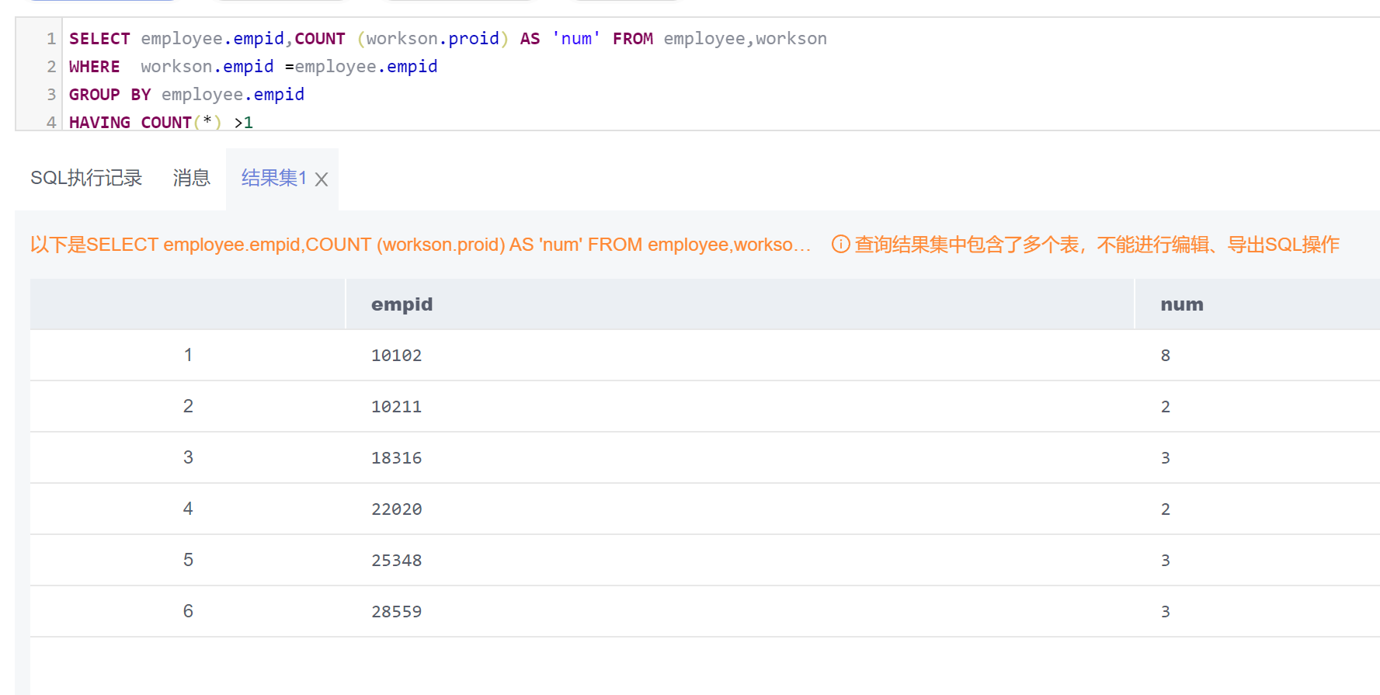

5.给出项目种类号为“c2”且预算最多的项目。（proid，projectname，budget）

SELECT proid,projectname,budget FROM project

WHERE catid ='c2' AND budget >=ALL (SELECT budget FROM project WHERE catid ='c2');

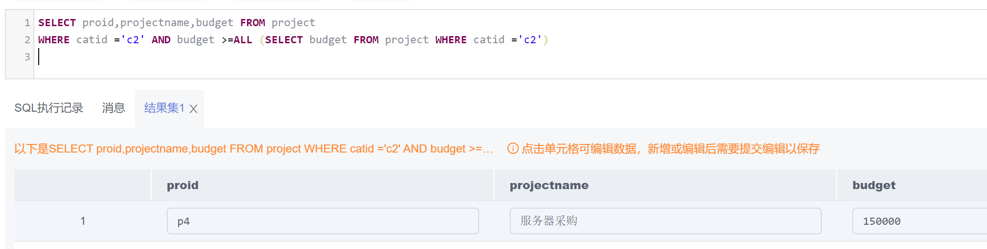

6. 给出参加“产品推广”项目，但不担任职位的员工的员工信息，（empid,empname，age,sex.depid）

SELECT employee.empid ,employee.empname,employee.age,employee.sex ,employee.depid FROM employee,workson,project

WHERE employee.empid =workson.empid AND workson.job IS NULL AND workson.proid =project.proid AND project.projectname ='产品推广'

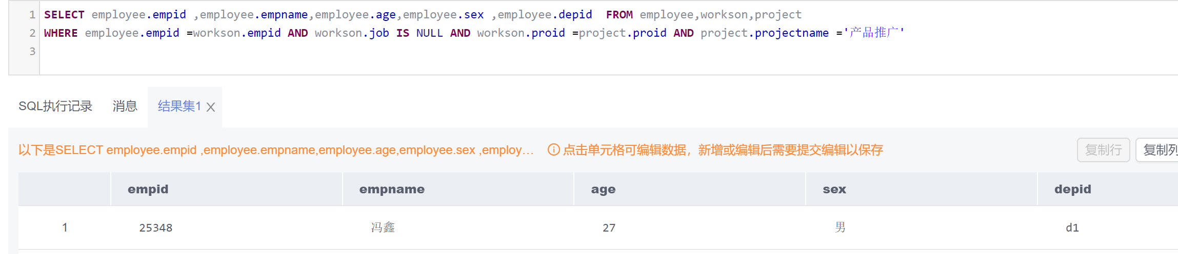

7. 给出工号为“10102”的员工每类项目的参加总数，若没有参加过某类项目，则参加项目总数显示为0（catid，proNum）

SELECT project.catid ,COUNT (DISTINCT project.proid ) AS 'proNum' FROM workson,project

WHERE workson.empid ='10102'

GROUP BY project.catid ;

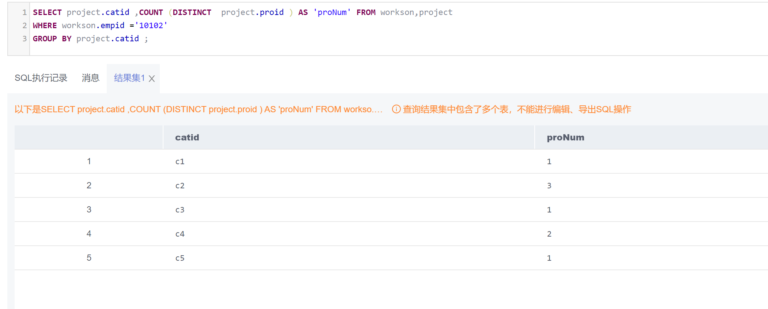

8. 给出没有参与“软件类”项目女性职工的信息（empid,empname, age,sex,depid）

SELECT \* FROM employee

WHERE sex ='女' AND empid NOT IN

(SELECT empid FROM workson WHERE workson.proid IN

(SELECT proid FROM project WHERE project.catid ='c4')

)

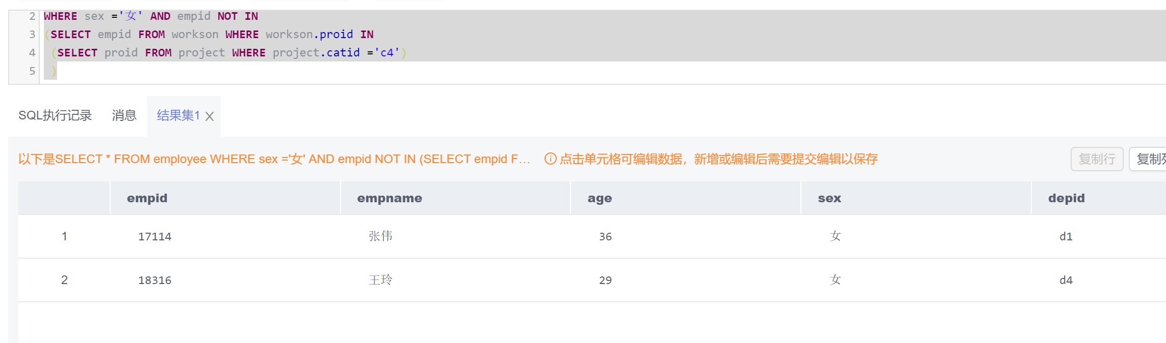

9. 给出有30岁以上男性员工的省份名称和该省男员工最大年龄，结果按最大年龄升序排序.

SELECT department.location,MAX( employee.age ) AS ‘maxAge' FROM department,employee

WHERE employee.sex ='男' AND employee.depid =department.depid AND department.depid IN

(SELECT depid FROM employee WHERE age >30)

GROUP BY department.depid

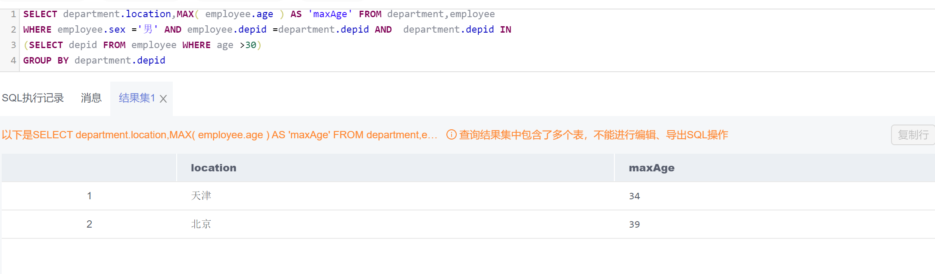

10. 给出在广州工作的、参加“'产品推广'”项目的职员id、姓名及他们参加的项目个数（empid, empname, procnt）

SELECT employee.empid ,employee.empname ,COUNT (\*) FROM employee,workson WHERE employee.empid IN

(SELECT employee.empid FROM employee,workson,project

WHERE employee.depid IN (SELECT depid FROM department WHERE location ='广州' )

AND workson.proid IN (SELECT project.proid FROM project WHERE projectname ='产品推广')

AND employee.empid =workson.empid

AND workson.proid =project.proid

)

AND employee.empid =workson.empid

