**IMPLEMENTAION OF ONLINE PARKING SYSTEM WITH DYNAMIC PRICING FOR SHOPPING MALLS**

Riswan Basha S

U.G. Student, Department of Electronics and Communication Engineering, Kumaraguru College of Technology, Coimbatore, TamilNadu, India.

**ABSTRACT:**

Pollution behind traffic congestion caused by people is getting worse than the pollution caused by the industries. One of the main sources of traffic congestion is searching for a parking slot. Now a day, people are advanced and they need to be their needy in a smart way. According to the statistics, 1% of world oil is getting wasted day by day due to the traffic congestion. In order to prevent the traffic due to the searching of parking slots, the best way of preventing is to make it as an online application or a web application. The goal is to make the parking slot to be booked online with the basement number and slot number. This decreases the time spent in searching the parking slots manually. Online parking will make the user and customer more benefits and pressure. According to the statistics, smart parking technology could save two lakhs of petroleum saving till 2035, if implemented successfully.

keywords: Traffic congestion, Smart parking, Web application, Parking slots.

**1.INTRODUCTION:**

In this technology, our main target user is shopping mall owners. In shopping malls, there are approximately four to five basements. In each basement, there may be fifteen to twenty workers are allotted just to allocate the parking slots for the customer. This system is a big process in which it takes a lot of officers to supervise them. So, there may be around twenty-five employees in each basement. If we consider this for all the basement, it will go around 100 members based on the shopping malls. Our proposed technology is to make the shopping mall owners to be benefitted. If smart parking is implemented, the customer need not to search for a parking slot and basement, as the web application will show the available parking slots. The customer just needs to open the web/mobile portal and the web page will show the entire details about the parking slots available and its basement with the map we provided. If the customer booked any of the slots from their respective location to the shopping mall destination, the estimated time provided by the application is calculated for entering. If the customer doesn’t enter the location which he has provided, he/she will be given a grace time of 30minutes to park in the respective slot. This entry can be either manually checked or with the QR we generate after the booking. The process of this technology is similar to the book my show application. The customer can book the seat wherever needed and when entering the confirmation is checked with the QR provided. Likewise, parking slots are also can be booked wherever the customer needed. In this system, just half the employees are enough to supervise the customers as they already know the exact location and the parking slot. This system also includes dynamic pricing in which this method will make the target user more beneficiary in the peak days like weekend. This dynamic pricing is just to increase or decrease the price of the slots according to the customers in the shopping malls, cars in the parking area or in the holidays.

**2.OBJECTIVE:**

* **Optimized parking facility** – Customer finds the best parking spot available, time saving, frustration. The parking slot fills up efficiently.
* **Reduced traffic** – Traffic flow increases as some of the cars are need to drive around in search of parking slot or the location.
* **Reduced pollution** – Searching for parking area burns around one million barrels of petroleum every day. An optimal parking technology will minimize the driving effort and emission.
* **Enhanced User Experience** – A smart parking system will make the entire customer experience into a unique action. Customers payment, identification of slots, searching a location and time notifications will become the part of destination arrival process.
* **New Revenue Streams** – Dynamic pricing can be enabled as the customer can know the peak hours.
* **Integrated Payments** – Customer can pay either in online or in spot where the booking is being checked. This could also enable customer loyalty and valuable user feedback.
* **Increased Safety** – slot-searching on traffic on the streets can reduce accidents caused by the distraction of searching for parking can be decreased and time is saved.
* **Real-time Data** –Smart parking solution can be used to prove to be invaluable to lot owners as to how to make adjustments and improvements to drivers.
* **Decreased Management Costs** – Smart Technology and less manual activities will make the target user benefitted.

**3.PROPOSED METHODOLOGY:**

A. WORKING DESCRIPTION:

This system is based on the INTERNET OF THINGS in which all the data of the parking slots will be gathered and display the nearest parking slot which is available. In this system, we have included the location map where the customer can find the exact route of the destination and parking slot available there. For our prototype, IR Sensor will detect the entry and exit of the car’s where the data will be stored in the cloud in which booking process will be allocated according to that. If someone books the slot, the slot colour will turn on to green colour and once if the car reaches the destination the colour would become red, so that the other persons can check the availability of the remaining free slots. And the confirmation message will be appeared on the home page after booking is confirmed.

B. TARGERUSER/USE CASE:

Shopping Mall’s Owners /

* -To reduce the number of labor's in parking slot.
* -customer can book their parking slot and knows where exactly the slot is.

C. PHYSICAL SIGNIFICANCE:

* Searching for a parking space is getting worsefor many people in cities around the world.
* Online booking for parking slots will make the customer not to search for parking slot and to make traffic and getting frustration.

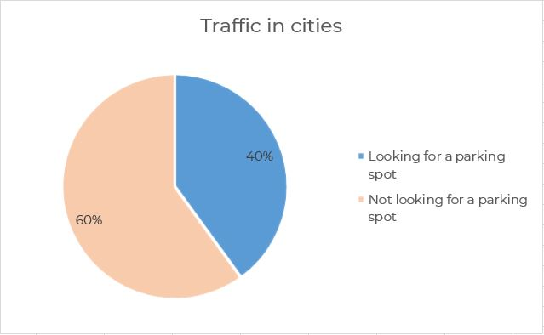

D. VALUE PROPOSITION:

* To reduce the cost of manpower in parking areas.
* Dynamic way of pricing

E. ADOPTION BARRIERS:

It requires maintenance contracts with the supervisors

It may be a bit confusing for unfamiliar users.

F. PROCESS:

1. Timing starts when customer enters the mall.

2.The booking will automatically cancel after half an hour if customer doesn’t come.

3.dynamic pricing by data analysis.

G. FLOWCHART:

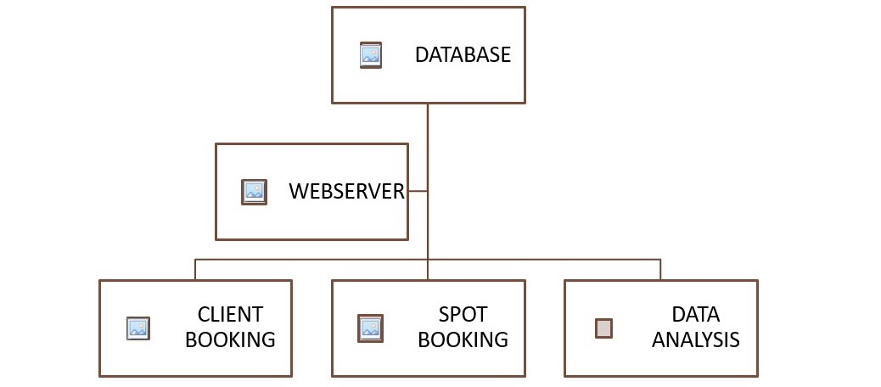

H. TECHNOLOGIES USED:

In Web application tools, we have used

* HTML
* CSS
* JS
* PHP

**5.RESULT:**

The result of the paper is to make the parking area connected with the world as well as reducing time and can be cost effective for the customer. The result of this paper is to reduce the time for searching for a parking slot. This paper reduces overall fuel energy of the vehicle which is consumed in the search of the car parking. This paper gives the clearest explanation about the accessing of the online booking system of a parking slot and explained about the various issues and benefits of the target user. The following results are shown below from Fig.1 to Fig.8 with clear explanation obtained.

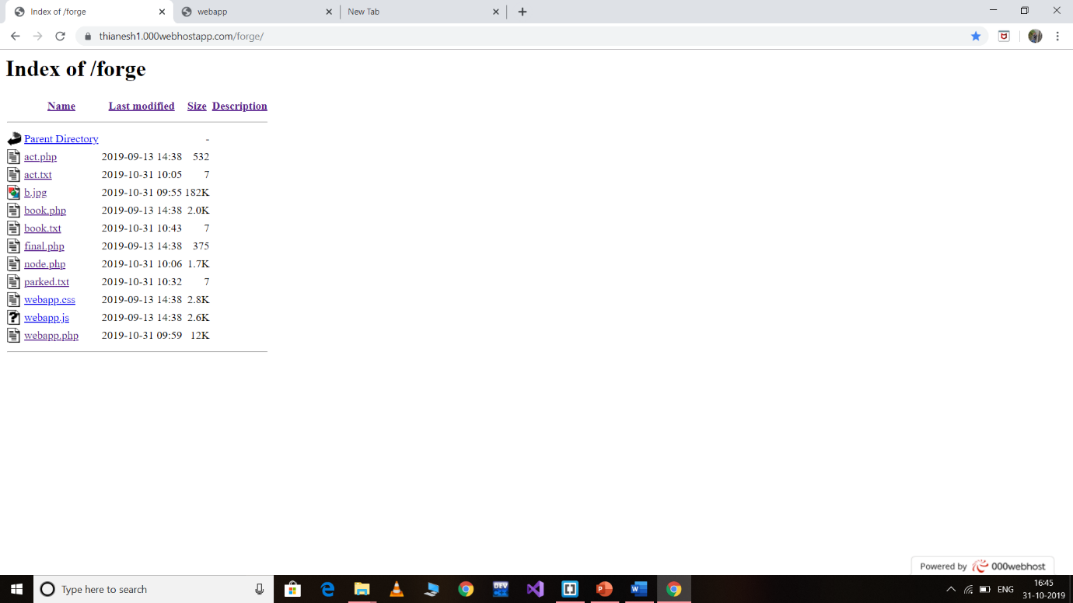

Fig. 1. This method used 000webhost as a server to interface webpage and the corresponding inputs

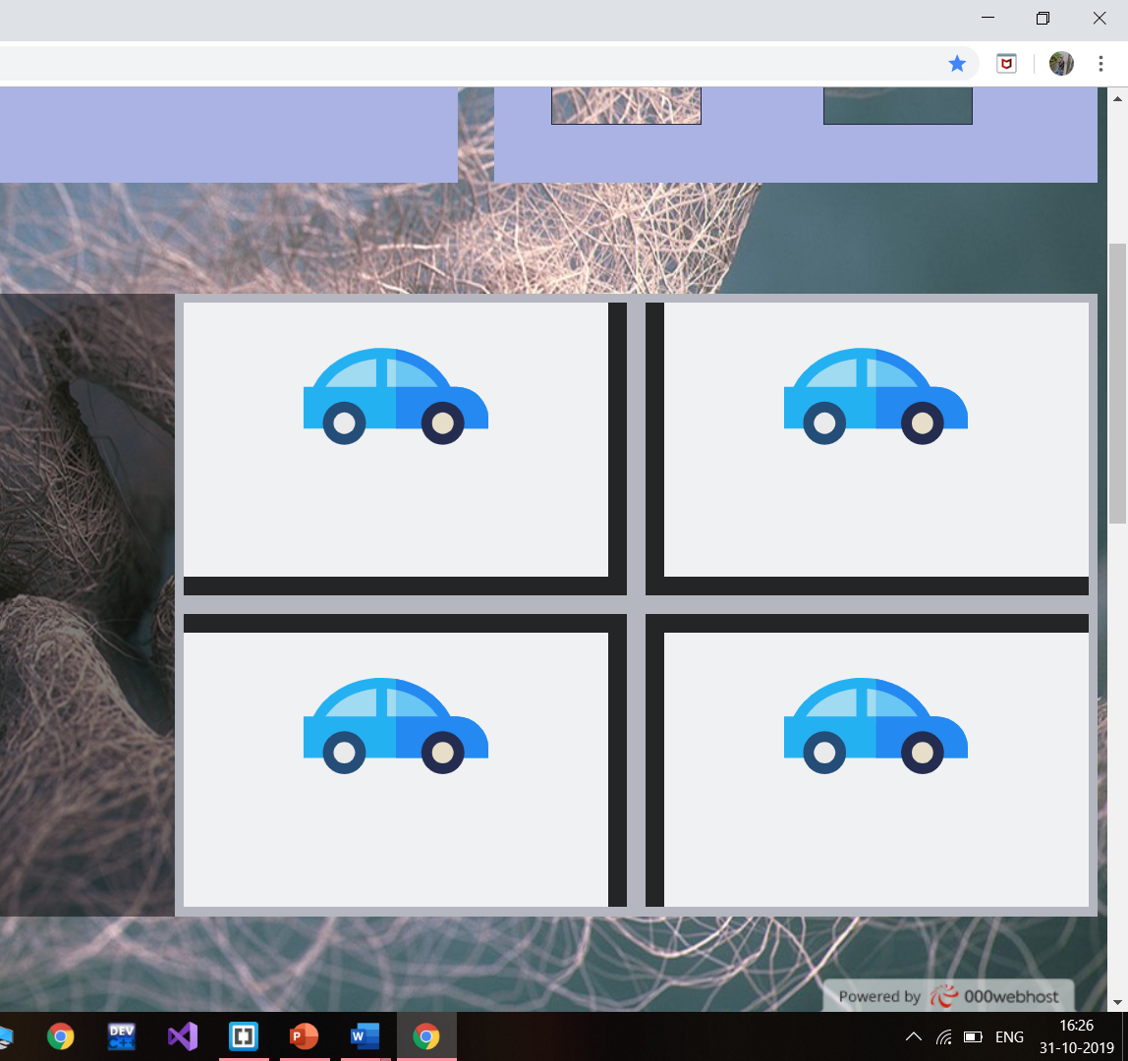

Fig. 2. We can see the webpage with four parking slots available

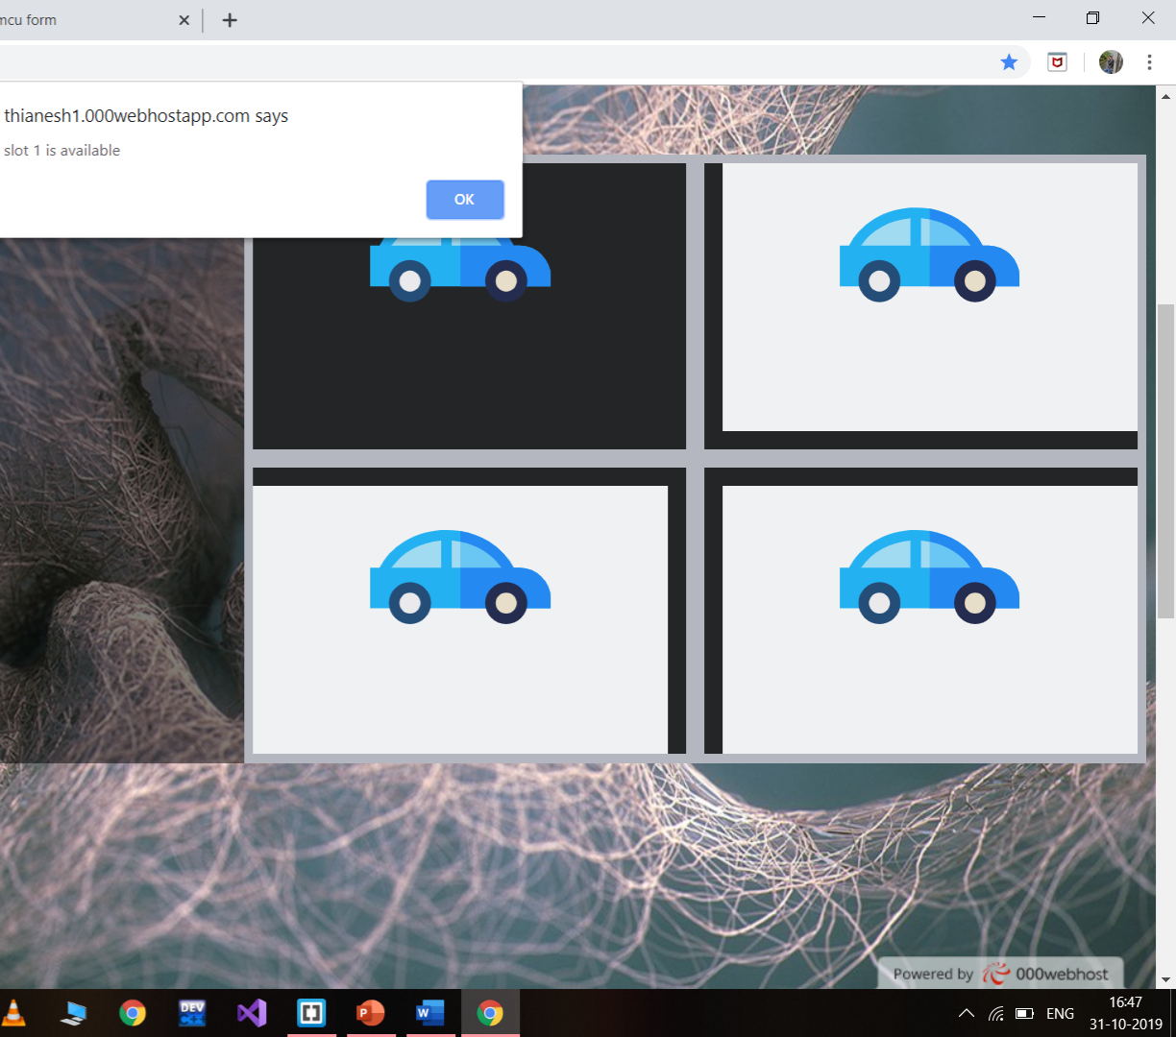

Fig. 3. After knowing the availability of slots, we can able to book the slots



Fig. 4. Confirmation page is displayed

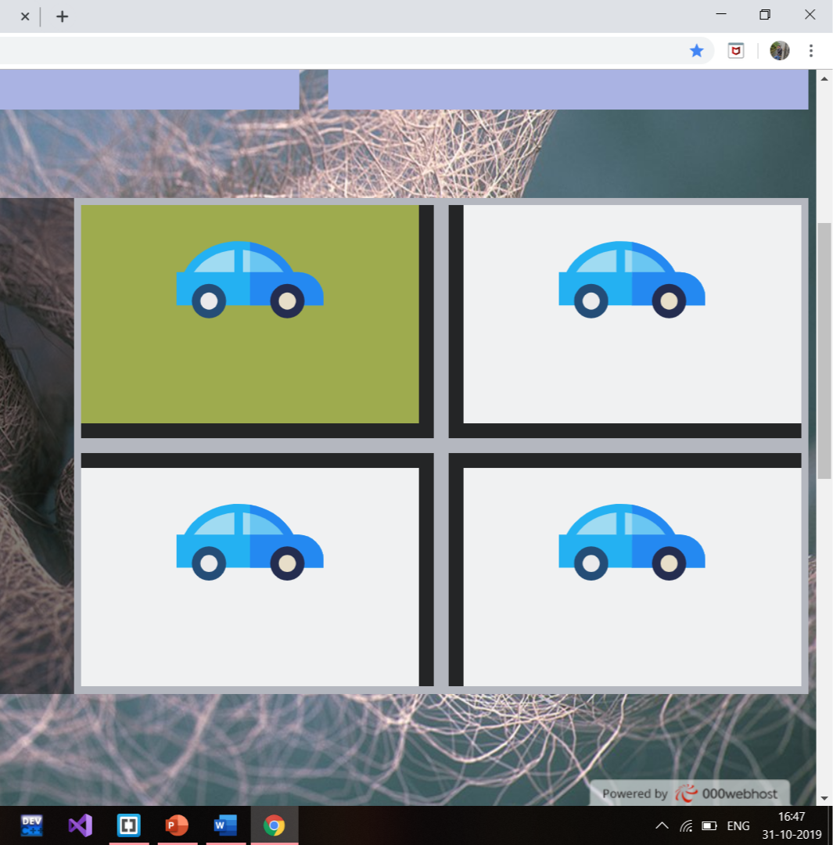

Fig. 5. After Confirmation, the booked slot will be turned into GREEN colour as a booking clearance

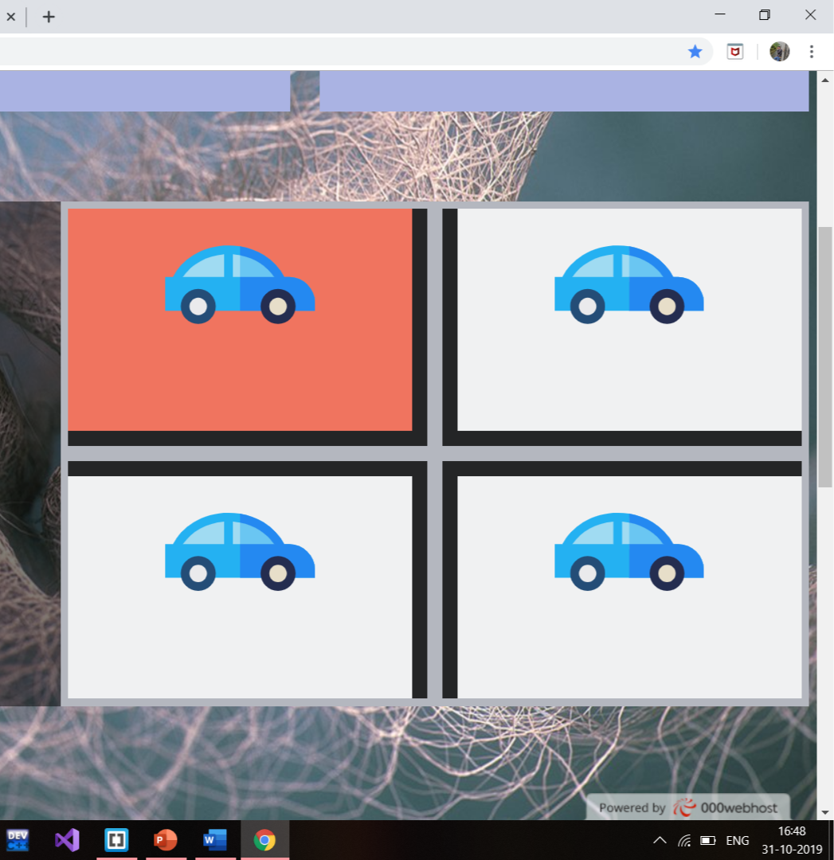

Fig. 6. After the input has given, Slot has been changed to RED colour as a parked clearance

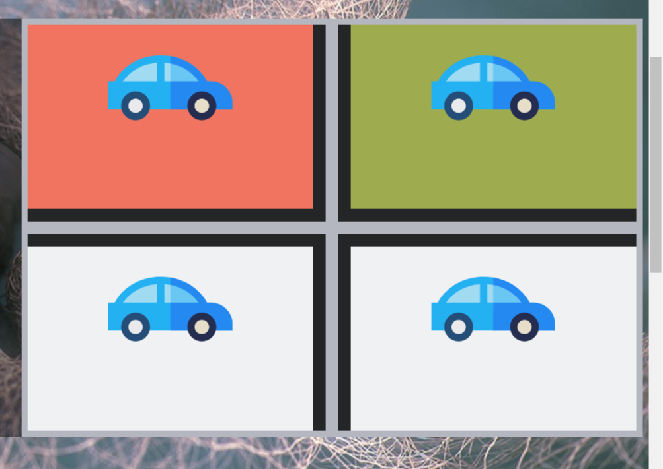

Fig. 7. Likewise, we can book multiple slots and park according to the booked slot

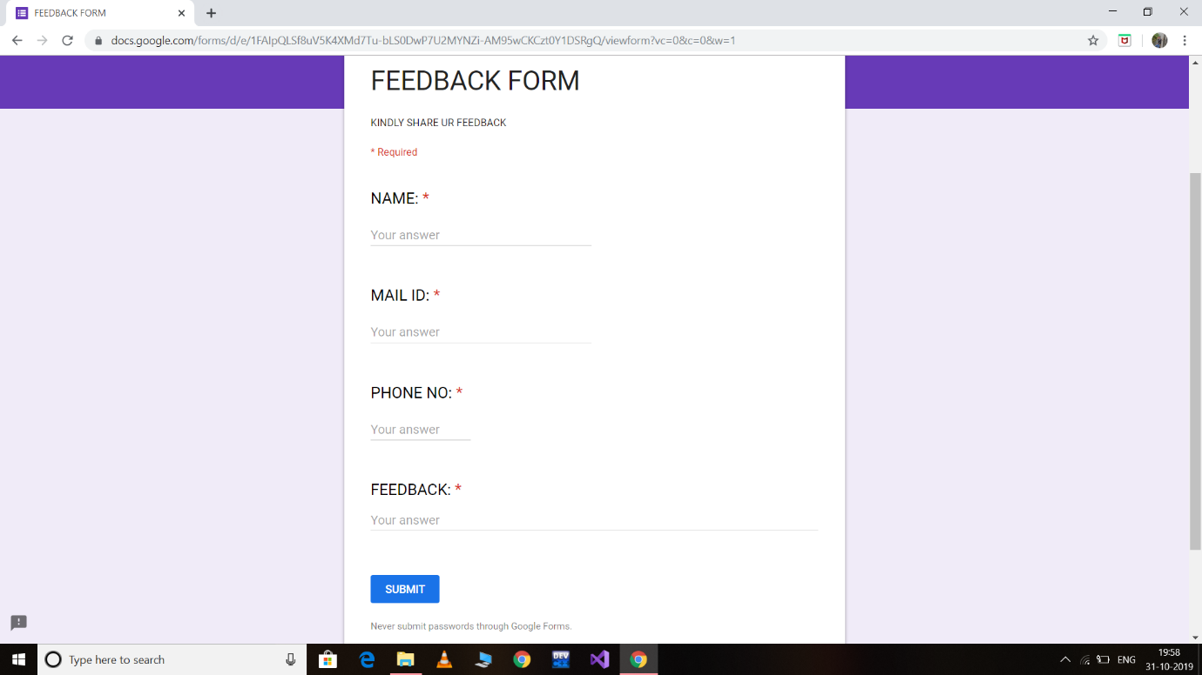

Fig. 8. Feedback Form is also provided in this webpage

**6.CONCLUSION:**

From the above study following conclusions are made.

* By increasing the number of slots, basement employees decrease.
* Dynamic pricing with moderate fair will have the highest rate of customer’s loyalty.
* By introducing Image processing, this technique can be integrated into a next level of approach.
* This kind of smart approach will enhance our cities into smart cities.
* This Technology is also applicable for private and open parking system.

**7.REFERENCES:**

* <https://www.happiestminds.com/whitepapers/smart-parking.pdf>
* <https://www.hackster.io/taifur/smart-parking-system-b3f5a0>
* <https://www.instructables.com/id/SMART-CAR-Having-Parking-Capabilities-of-Its-Own/>
* <https://www.researchgate.net/publication/313667380_Smart_Parking_System_Student_Activity_Project>
* <https://www.academia.edu/34838312/Automated_Car_Parking_System>
* <https://www.scribd.com/document/217240025/automated-parking-system-Project-Report>