**Aspect Category Detection**

Nikita Rechal1 and Sooriyan Aliyoglu2

1Department of Computer Engineering, Castle University, New City, Cyprus

[a.orther@xx.yy.zz](mailto:a.orther@xx.yy.zz)

2MediDeniz Software, Old Street, New York, USA

[a.etherwen@zzz.com](mailto:a.etherwen@zzz.com)

# ***Abstract***

*The major subtask of Sentiment analysis based on aspects (ABSA)is the category of aspect detection (ACD). Due to the subjectivity inherent in categorizing, as well as the occurrence of overlapping classes, it is a difficult challenge to solve. Rule-based techniques, as well as other machine learning approaches, have been used to tackle ACD, and a majority of them are statistical behavior. We employed an association rule-based method in this article. We developed a mixed principle strategy that incorporates both association rule mining and semantics associations to address the statistical limitations of association rules. We employed the concept of word-embed for semantic linkages. The experiments were carried out using the SemEval dataset, which is a standardized set of data for categorizing features industry. We discovered how semantic connections could help to enhance classification accuracy by complementing statistical associations. The proposed method outperforms several statistical methods.*

# ***Keywords***

*Association Rule, Semantic Association, Review Analysis, Word-embedding, Aspect Category Detection.*

**1. Introduction**

Consumers are increasingly using online sources of opinionated data, such as blogs and reviews, to calculate organizations, facilities, and products. Further by the rapid surge of community-based platforms, for instance, blogs, Instagram, and review sites individuals no need to depend solely on near once to take advice. Online product reviews are quickly becoming a valuable resource for making purchasing decisions. Despite their widespread availability, it might be difficult to extract relevant data from these not structured reviews. No one can read all of them. As a result, information from these reviews needs to be extracted automatically. In most circumstances, the attitude represented in the review is more important than the content of the review. As a result, we have a well-known sentiment analysis difficulty.

Analysis of sentiment is commonly expressed as a categorization that is either true or false, in which the whole document could be classified as negative or positive. However, this is a generic preparation. A document can discuss a variety of features (aspects) of a product/entity, and that it can be negative for some and positive for remaining. As a result, aspect-based sentiment analysis becomes a more difficult problem.

ABSA itself is the method of dogging, moreover, aggregating user feedback for every part or feature of a corporation or an item that is elaborate in evaluations.[1] Despite ABSA could be thought of as a more than one class classification task, the task's implementation is difficult. Identifying aspect-phrases and assessing the perception related to terms that are given, are two of ABSA's subtasks. A study by Schouten et al.[2] provides more information about ABSA. A single term of aspect

might present a general feature, and many terms of aspect may correspond to the same aspect. Pizza and pasta, for example, may match the restaurant domain's feature FOOD. Aspect categorization is the process of classifying terms in a generic aspect. A fine-grained entity is a term of aspect, whereas a coarse entity is a category of aspect. We will be able to recognize some feature categories linked with a product/domain in an ideal world. The known aspect categories in the restaurant domain, for example, maybe SERVICE, AMBIENCE, FOOD, and PRICE. However, the category of aspect is fraught with subjectivity; for instance, categories of aspects may be ill-defined, moreover, classes may overlap. The majority of the moment, categories of features are identified in passing in the document.

The laid paper aims to solve the difficult problem of categorizing aspects, which is a major ABSA subtask. Despite considerable achievement has been accomplished in this domain, it pales in comparison to what has been achieved in the area of sentiment analysis. To build the relationship between the categories and the terms associated with them in the document, most previous publications used either a semantic or a statistical approach. Both systems have advantages and disadvantages. To exploit more associations, we combined these two methodologies in our approach. We employed association rules in conjunction with word-embedding to capture semantic and statistical associations.

Such a method has never been done before in the domain of aspect categorization, as far as our knowledge. Given the paucity of research in this field, our approach offers a fresh perspective on the difficult challenge of aspect categorization. Even though our technique is domain-independent, we tested it using standard data from the restaurant domain given by SemEval2014. The following is how the rest of the article is prepared. The background and motivation are discussed in section 2. In section 3, we discuss similar work on detecting aspect categories (ACD). The details of our proposed method are presented in section 4. section 5 details the experimental setup and outcomes. At last, Section 6 contains the conclusion and recommendations for further work.

**2. History And Motivation**

Our research focuses on the categorization of aspects, which is a broad and theoretical phrase. As a result, in this section, we concentrate on more objectively characterizing the aspect classification problem. Table 1 shows review phrases with associated- categories and aspect-terms to help clarify the problem statement. The idea of aspect- terms, and category of aspect have been clearly distinguished in the instances provided. As demonstrated in Table 1, a statement of review is not limited to a single category.

Three other possibilities are also depicted in this table. First, when the category of aspect and the aspect word are the same and expressly stated (3rd and 4th). This is a straightforward example, and finding an aspect category for a particular review statement is much easier. After that, when an aspect-term appears in a statement and denotes a category of aspect (first and sixth). At last, there exist instances where

neither the category of aspect nor the feature term is given (2nd and 5th). It's difficult to determine aspect categories when the aspect term isn't directly specified but is implied in the statement. In that situation, additional information such as contextual data or domain knowledge is required to derive the category of aspect.

On the topic of sentiment analysis on reviews, a lot of work has been done. However, due to several problems and subjectivity, relatively little work in the field of aspect categorization has been done. The job has been explained for the restaurant industry solely in SemEval (National Semantic Evaluation Workshop). Because of the nature of the topic, it has been approached in a variety of methods.

To extract the category of aspect, researchers explored a variety of statistical classification and rule-based approaches and were able to obtain reasonable accuracy. Based on term repetition and statistical indicators, these strategies attempt to create a link between the category of aspect and its document term. Most approaches are incapable of detecting the category of aspect in a statement containing less common but category representative phrases. Finding the category of aspect presentative phrases is critical in the process of determining aspect categories. For instance, in the sixth instance of the first table, the word Mojito refers to the category of FOOD, yet it may be canceled out by most stats-based approaches due to its low frequency in corpora.

Table 1. Heading and text fonts.

| **Review statement** | **Terms of aspects** | **Categories of aspect** |
| --- | --- | --- |
| 1. “pizza was delicious.” | pizza | FOOD |
| 2. “delicious but expensive.” | — | FOOD, PRICE |
| 3. “the food was very cheap.” | food | FOOD, PRICE |
| 4. “The food was great.” | food | FOOD |
| 5. “It is very overpriced and not very tasty.” | — | FOOD, PRICE |
| 6. “Mojito was one of the best items they served” | mojito | FOOD |

We adopt an association rule-based technique with a combination of the semantic-similarity notion employing word-embedding for the category of aspect detection to address the aforementioned issue. Despite its low frequency, the word Mojito can be used to assign the statement to the category for FOOD because of its high semantic resemblance. Our goal is to create a detector for aspect categories based on semantic and statistical connections between the category of aspect and document terms. If used correctly, semantic techniques can overcome some of the constraints of statistical approaches, potentially improving the standard of the outcome.

**3. Associated Work**

We've included the studies that are particularly about ACD in the linked work. Because of the multi-class characteristic of the problem, the researchers used a variety of

machine-learning classifiers to determine the category of aspect. Kiritchenko et al,[3] created three 5 support vector machines utilizing various characteristics, one for each of the categories. To train SVM classifiers, they used lexicon features, non-contiguous n-gram, word cluster n-gram, character n-grams, stemmed n-gram, and n-gram. On the flip side, Alghunaim[4] trained the SVM but present words in the form of a vector with the help of the Word2Vec Skip-gram model, which is trained on a dataset of Google news. Following that, utilizing vector representation of words, certain features such as category similarity (CS), normalized average vector (NAV), and token number (TN) were derived. The bag-of-words model can be used by linear classification models like SVM to create predictions. Even if they use word-embedding, these models failed to use the sequential information of terms in the phrase.

Zhou et al[5] employed a semi-supervised word-embedding approach to generate continuous word representations, for reviews that contain noisy labels. Then, with the help of a neural network top on the word vectors, deeper and hybrid features are generated automatically. Finally, hybrid features are utilized to train a logistic regression classifier to determine the category of aspect. Word2Vec was used to represent six words in Blinov,[6] work (Skip-gram with 300 dimensions). By averaging the word vectors in each statement, a vector was created. Each category was turned into a vector in the same way. Each category's distance is determined for each new statement. Finally, a category was selected that produces the shortest distance. The majority of these algorithms rely on basic Google pre-trained word embedding. It fails to account for feelings; for instance, the vectors of the words "good" and "bad" had a major similarity value since they were used for the same context in the corpus of news by which they were trained.

Most of the studies have used rule-based approaches to address the problem of ACD. A normalized number of co-relation matrix of categories and words was employed by Schouten et al[7]. A score was derived for each statement by adding every words’ weights in the statement and normalizing it by the total quota of terms in the statement. After that, for every category, a score is assigned to each statement. A different threshold (that yields the optimal training data’s f1-score) was optimized for all categories using training data. If a statement’s score in data of testing exceeds the threshold for any category, the statement is assigned to that category. Schouten et al[8] employed a word category co-occurrence matrix, which was similar to the approaches described above. They took the highest word weight in place of an average of every words’ weight in the statement for computing statement score, and the rest of the method was the same as before, save for category MISC/ANC, which was allocated to statement which is not associated with any category.

Bornebusch et al[9] assumed that aspect-terms were established and utilized them to discover categories. If the term of aspect is a term of category, they are allocated to the category that is related; on the other hand, if it, recognize the term of aspect as bread for a FOOD category, they are assigned the FOOD category. An equality between the category and term of aspect of it was generated with the help of RiTa for all other unassigned terms of aspects (WordNet similarity calculation). The term of aspect is given to the associated category if the length of the path is less than 0.4. ANC/MISC is allocated if no category of aspect is found.

Schouten et al[10] used an ontology-driven method for ABSA. They only require training data up to 20%, to produce an outcome, which can be compared with the bag-of-words method. For each aspect category, the not dependent binary SVM classifiers are trained by them. To create properties for those classifiers, different pre-processing processes (lemmatization, part-of-speech tagging, correcting spelling, disambiguation of the word- sense, tokenization, syntactic analysis, and more.) were done on the statement. Also, they developed an ontology-specific domain to extract ontology concepts (expression of sentiment, and target of sentiment), which aided in finding the appropriate category label of aspect and label of sentiment, despite multi-aspect phrases. Using domain-specific ontologies always improves accuracy, but techniques which are based on ontology are not scalable. Moreover, it requires a lot of manual labor to create and maintain the ontology.

Patra et al[11] take the help of a mixture of a conditional random field (CRF) and rule-based approaches to determine aspect categories. As features, they used sentiment lexicons, aspect-term, WordNet data dependency relations, and POS. Garcia-Pablos et al[12] take help of a maximum entropy classifier, continuous word embedding, and atopic modeling (LDA) method to generate sentiment which is negative terms with minimum seeds, positive-sentiment words, and a weighted list of aspect-terms (all feature terms and few negative and positive terms) in input. Moreover, they demonstrate their product as a multilingual ABSA and multi-domain system that was not supervised.

In the past, many researchers in ABSA used association rule mining. To get both implicit and explicit characteristics to ABSA, Liu et al[13] created all strong association rules. However, when the segment of the statement (brief incomplete statements or phrases) have only one word, such as "large" and "heavy," this method fails. Because the phrase must contain at least two words to produce association rules. Hai et al[14] employed rules of association to find implicit features, and it distinguishes between feature words and opinion terms by keeping opinion terms solely in the feature words and rule predecessor in the consequents of rules.

**3. Suggested Method**

**3.1. Task Definition**

For a laid already defined class of category if aspect set C = {c1, c2, c3, …, ck}, where C represents the label of category area, with possible k number of categories; moreover, a set of review R = {R1, R2, R3, …, Rn} with n number of review statements, the problem of ACD could be written to absorb a function h ∶ R → 2C with the help of training set of more than one categories D = (ri, Yi)|1 ≤ i ≤ n, Yi ⊆ C is a label of the category’s set related with ri. For every not seen review r ∈ R, the category of aspect prophecy function h(⋅) forecast h(r) ⊆ C as the set of the absolute label or category to r.

**3.2. The suggested approach**

To produce the rules, a rule-based technique utilizes semantic and statistical correlations between the terms of reviews (words) and their related categories, offered by us. The procedure can be broken down into the following steps:

* + 1. Using class-based association rules, determine the statistical association between the category of aspect and review terms to find representative words for each category of aspect (CARs).
    2. On the domain-specific dataset, train word embedding.
    3. Using word embedding, we were able to discover a semantic link between review terms and aspect categories.
    4. Formulation of Aspect Rules
       1. Produce CARs.
       2. Use word embedding to update rules to include semantic aspects.
    5. Analyze and evaluate the test data outcomes.

**3.3 Workflow**

Now, we are prepared to develop association rules after preparing data and understanding the word-embedding model. Figure 1 depicts our model's abstract workflow, and Figure 2 depicts the method which is created by us, works on an ordinary dataset. The following steps are included in the rule generation process:

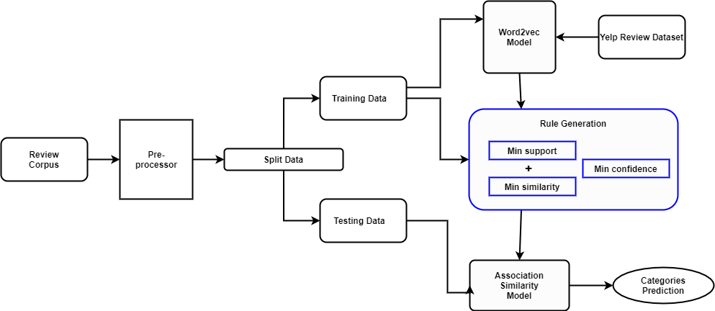

Figure 1. Suggested model’s flow chart

**3.4 Metrics generation**

In C, set of categories, every laid categories aspect is recognized and saved. To create a document-term-matrix DTM, we used the collection of review R and V set of vocabularies, which include the number of terms in every document. As a result, each row represents a review Ri and each column represents a word wj (term). The count of wj within Ri will be represented by cell-value DTMi,j. A CTM is now generated, displaying the term frequency in every ck category. Reviews associating to the identical category are recognized, with the help of information that is labeled and merged into k set for this purpose (each category has its group). In CTM, every review row associated with the identical group are added and stored from DTM.

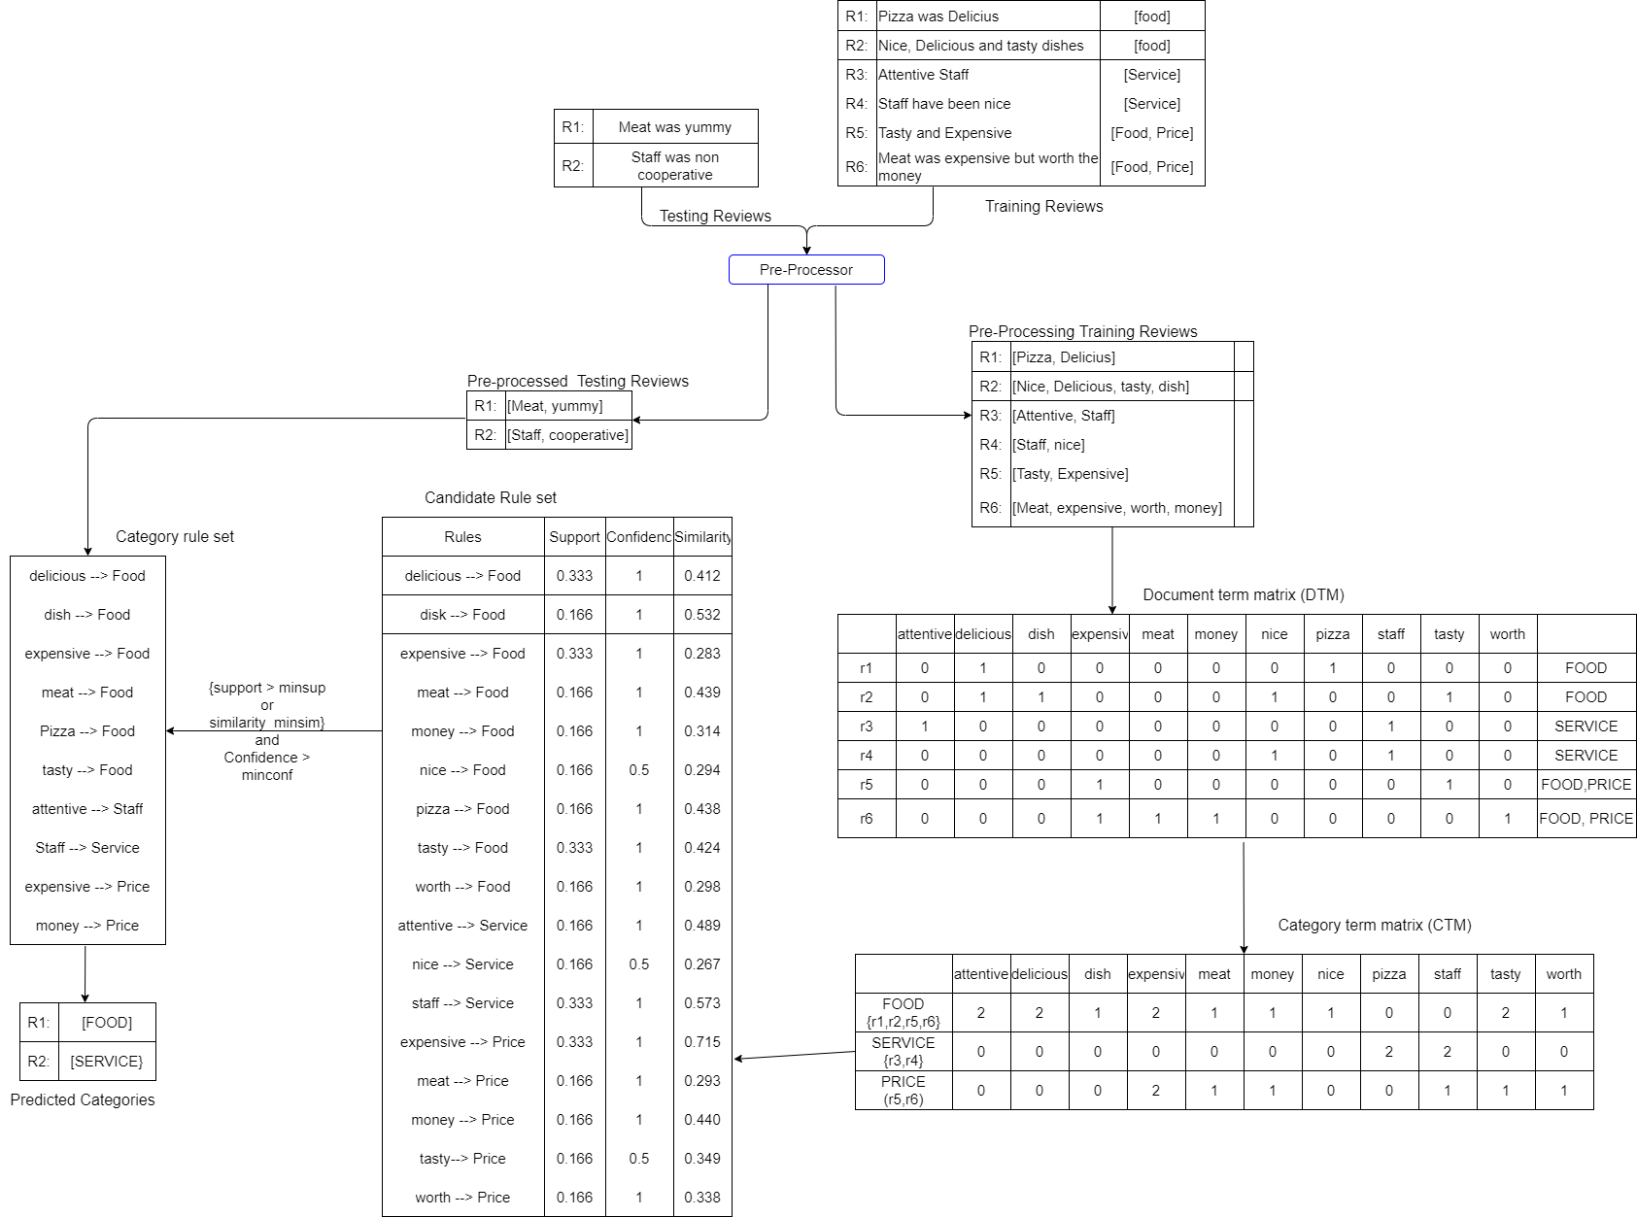

Figure 2.An example of the proposed model in operation

## **3.5 Creating rules with the help of confidence and support**

In this case, there is an entry, which is another than zero, in CTMj,i for every category cj and word wi, the laid candidate rules can be generated wi → cj. Equations (1) and (2) are used to compute the support supi,j, and confidence confi,j scores for each association rule.

𝑠upi,j = (𝑤i 𝖠 𝑐j). count⁄n (1)

confi,j = (𝑤i 𝖠 𝑐j). count⁄𝑤i . 𝑐o𝑢𝑛𝑡 (2)

In which,

1. (wi 𝖠 cj).count is the entire quota of the frequency the wi term appears in cj category and serves as a value in each cell of CTMj,i.
2. wi.count is the entire number of occurrences of wi term in R, which is a collection of reviews and serves the DTM’s ith column addition.
3. The total number of evaluations, represented by n in R.

The term's weight in the all-over review corpus is represented by support, and the importance of a term in a category is represented by confidence. A higher support value indicates that a term occurs more frequently in the corpus as a whole. The higher the value of confidence, the greater the importance of that word in the associated category. The DTM and CTM can be used to easily calculate both support and confidence values. We only counted one instance of a word in the collection of reviews.

## **3.6 Semantic similarity is being incorporated into association rules**

To evaluate the equality of a category and a word, firstly, we prepared word embedding on the Yelp restaurants dataset using the Word2Vec model. We require a collection of words to present every category after we got word-embedding for vocabulary. A straightforward method to present a category is to utilize one word, in this instance, the name of the category. For instance, the word-embedding of SERVICE can be used to represent the category of aspect SERVICE. This representation, however, has some drawbacks; such as service and staff, contains excessive similarity, but a less similarity for some terms, for instance, manager, waiter, and many more. One word could not adequately describe every categories’ aspect. In place of, using one word to represent one category, we have used a group of words. If the word staff is chosen to represent the SERVICE category in addition to the “service”, further words which are semantically alike to service, for instance, waiter and chef, can then be preserved.

Because of this reason, we gathered the topmost K alike terms from the collection of vocab, which have the greatest cosine similarity with the category of aspect’s name, where the category name itself is represented using word-embedding. These topmost K terms now functioned as categories of aspects. To compute the similarity of a category cj and word wi, cosine similarity is evaluated of every K term in category cj and word wi. The highest value of similarity of them is kept as the wi and cj’s similarity value.

simi,j = max(k ∈ {1, K})(cosine(𝑤i, 𝑐j𝑘 )) (3)

Finally, for category cj, rules satisfying (minsup or minsim) and minconf are saved in CRS (j), which is known as category-rule-set.

**4. Experimental Configuration**

## **4.1 Information regarding dataset**

SemEval-2014 challenge’s subtask is the research task for this article. So the unchanged SemEval2014 task4 dataset from the domain of restaurant was utilized. It includes 800 testing and 3041 training examples. The challenge is to categorize customer review statements into different categories of aspects based on their total meaning. These categories are frequently preconceived.

There are five categories in the dataset: ANECDOTES/MISCELLANEOUS SERVICE, PRICE, AMBIENCE, and FOOD. Every evaluation is associated with a minimum of one category. Because few reviews may be associated not only with a single category, it creates this challenge of multi-label categorization. The distribution of the categories’ counts for each review statement in testing and training data is depicted in Figure 3. Moreover, there is no similar categories’ bifurcation in the review corpus, as can be seen in diagram 4, where a couple of categories, FOOD and ANECDOTES/MISCELLANEOUS, excessive over testing as well as in training data, on the other hand, the other three have nearly equal bifurcation. The ANECDOTES/MISCELLANEOUS is associated with statements that do not fit any classes, from remaining. We made the model to predict 4 categories. The bifurcation of the fifth category is done in pre-processing part.

## **4.2 Evaluation metric**

We take the help of three metrics to evaluate performance: f1-score, recall, and precision. They are calculated in the following manner.

Figure 3.The quota of categories for each review statement

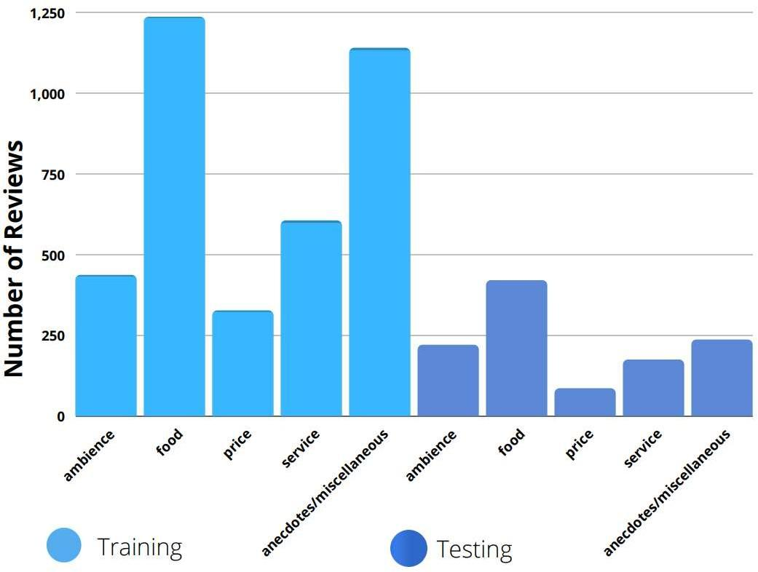

Figure 4.The quota of reviews per category in both testing and training data

where TP, TN, FP, and FN represent the total number of True Positives, True Negatives, False Positives, and False Negatives.

|  | **True label** | **False label** |
| --- | --- | --- |
| True Prediction | TP | FP |
| False Prediction | FN | TN |

## **4.2 Analyses and outcome of an experiments**

Rather than, learning more than one threshold support level, we observed every measurement separately for each category. For the SERVICE, PRICE, FOOD, and AMBIENCE categories, the threshold confidence values are [0.59, 0.64, 0.59, 0.54]

and the threshold support values are [0.003, 0.002, 0.004, 0.003]. While the threshold similarity value for each category is set to 0.50. Table 2 shows the results with these settings.

Table 2. Outcomes of the model for a variety of minimal confidence values and minimal support values in various categories.

|  | **Service** | **Price** | **Food** | **Ambience** | **Average** |
| --- | --- | --- | --- | --- | --- |
| F1-score | 70.05% | 56.36% | 78.72% | 57.39% | 65.63% |
| Precision | 70.15% | 59.05% | 62.95% | 62.86% | 63.75% |
| Recall | 70.85% | 53.91% | 89.66% | 52.08% | 66.63% |

The more than one optimal values model, despite the somewhat better outcome, over- fits the set of data. To explain the threshold, some classes utilize less, for example, 321 instances. Because of the compact dimension of the dataset, the optimal calculated for the compact group is over-fitted rather generalized. With the help of the domain of restaurant word-embedding (yelp), the concluding outcome for all categories is shown in Table 2.

Table 3. On test data, our approach’s (yelp.skipgram.100d) evaluation metrics

| **Category** | **True Positive** | **False Positive** | **True Negative** | **False Negative** | **F1-score** | **Precision** | **Recall** |
| --- | --- | --- | --- | --- | --- | --- | --- |
| Service | 141 | 60 | 534 | 58 | 70.05% | 70.15% | 70.85% |
| Price | 62 | 43 | 649 | 53 | 56.36% | 59.05% | 53.91% |
| Food | 260 | 153 | 353 | 30 | 78.72% | 62.95% | 89.66% |
| Ambience | 66 | 39 | 641 | 59 | 57.39% | 62.86% | 52.08% |
| Average | 529 | 295 | 2177 | 200 | 65.63% | 63.75% | 66.63% |

Table 4. Extracted category representative

| **Ambience** | **Food** | **Price** | **Service** |
| --- | --- | --- | --- |
| airport | across | afford | add |
| amid | american | afternoon | ask |
| background | avail | alcohol | bad |
| bathroom | basil | ambient | caviar |
| bistro | bbq | attest | fast |
| blah | bean | bang | five |
| boot | beef | bargain | gave |
| breath | bite | barney | help |
| broadway | bland | beat | hostess |
| busier | blue | bill | hour |
| calm | bun | bore | owner |
| chic | burger | bought | problem |
| chill | calamari | break | profession |
| cigar | cart | brule | prompt |

**5. Conclusion**

A principle-based solution to ACD, which is a fundamental task of sentiment analysis based on aspect, was proposed, in this article. Each category of aspect received its own set of rules. The rules for categorization were developed with the help of the concept of the semantic and statistical association between terms and categories of aspect. The principles were created by combining word embedding and a class-based association technique. Our method is context agnostic, which means it may be used in any domain without modifying the algorithm. Simultaneously, incorporating domain knowledge can improve accuracy even further.

In the future, without taking the help of unigrams to forecast the category of aspect, we will aim to use n-grams as a class signifier. To disambiguate the context, we also can study how to embed text for a combination of terms. "I don't like the hot dog they served," for example. FOOD type could not be determined solely by the words "hot" and "dog" in the given review sentence, however, "hot" and "dog" can be achieved by working jointly. Simultaneously, both the FOOD category and "hot dog" word-embedding will have a close relationship. This method works best with data that are modest to moderate in size. Till now, we can achieve a 66% F1-score on the SemEval-2014 dataset with as few as 1000 training instances. We are unable to put our model to the SemEval-2016 dataset with our current approach settings due to the hierarchical category structure. However, we are working to improve the result in our upcoming research.

**References**

1. Wang Bo, Liu Min. Deep learning for aspect-based sentiment analysis. Stanford University Report. 2015.
2. Schouten K, Frasincar F. Survey on aspect-level sentiment analysis, IEEE Trans Knowl Data Eng. 2016;28(3):813-830.
3. Kiritchenko S, Zhu X, Cherry C, Mohammad S. NRC-Canada-2014: detecting aspects and sentiment in customer reviews. Paper presented at: Proceedings of the 8th International Workshop on Semantic Evaluation (SemEval 2014); 2014:437-442; The Association for Computer Linguistics.
4. Alghunaim A, Mohtarami M, Cyphers S, Glass J. A vector space approach for aspect based sentiment analysis. Paper presented at: Proceedings of the VS@HLT-NAACL: The Association for Computational Linguistics; 2015:116- 122.
5. Zhou X, Wan X, Xiao J. Representation learning for aspect category detection in online reviews. Paper presented at: Proceedings of the 29th AAAI Conference on Artificial Intelligence; 2015:417-424; AAAI Press.
6. Blinov P, Kotelnikov EV.. Blinov: Distributed representations of words for aspect-based sentiment analysis at SemEval 2014. Paper presented at: Proceedings of the 8th International Workshop on Semantic Evaluation (SemEval 2014); 2014:140-144; The Association for Computer Linguistics.
7. Schouten K, Frasincar F, Jong F. COMMIT-P1WP3: a co-occurrence based approach to aspect-level sentiment analysis. Paper presented at: Proceedings of the 8th international workshop on semantic evaluation (SemEval 2014); 2014:203-207; The Association for Computer Linguistics.
8. Schouten K, Weijde O, Frasincar F, Dekker R. Supervised and unsupervised aspect category detection for sentiment analysis with co-occurrence data. IEEE Trans Cybern. 2018;48(4):1263-1275.
9. Bornebusch F, Cancino G, Diepenbeck M, et al. iTac: aspect based sentiment analysis using sentiment trees and dictionaries. Paper presented at: Proceedings of the 8th International Workshop on Semantic Evaluation (SemEval2014); 2014:351-355; The Association for Computer Linguistics.
10. Schouten K, Frasincar F, Jong F. Ontology-enhanced aspect-based sentiment analysis. Paper presented at: Proceedings of the International Conference on Web Engineering; vol. 10360; 2017:302-320; Springer.
11. Patra BG, Mandal S, Das D, Bandyopadhyay S. JU_CSE: A conditional random field (crf) based approach to aspect based sentiment analysis. Paper presented at: Proceedings of the 8th International Workshop on Semantic Evaluation (SemEval 2014); 2014:370-374; The Association for Computer Linguistics.
12. García-Pablos A, Cuadros M, Rigau G. W2VLDA: almost unsupervised system for aspect based sentiment analysis. Expert Syst Appl. 2018;91:127-137.
13. Liu B, Hu M, Cheng J. Opinion observer: analyzing and comparing opinions on the web. Paper presented at: Proceedings of the 14th International Conference on World Wide Web; 2005:342-351; ACM.
14. Hai Z, Chang K, Kim J-J. Implicit feature identification via co-occurrence association rule mining. Paper presented at: Proceedings of the International Conference on Intelligent Text Processing and Computational Linguistics; vol. 6608, 2011:393-404; Springer.

**Authors** 

Short Biography