SHARDA UNIVERSITY
INVENTION DISCLOSURE FORM
CONFIDENTIAL

Please fill in the details with complete information.
IMPORTANT

Please note that patent is always about a solution to an existing technical/industrial problem. As such, this draft patent document (IDF) is crafted in a manner so as to distinctly highlight the existing technical problem, the technical advancement proposed by the inventor(s), and the manner in which the proposed advancement solves the existing technical problem.

➢ Particulars of Inventors

S  No | Name (Full) | Department/School | Designation | Mobile No. | Email | Official Address
1 | Anant Kesarwani | Department of  Computer Science  and Engineering | Student | 8887968769 | anantkesarwani01@gmail.com | Student, Greater  Noida, Sharda University
2 | Harshta Sood | Department of  Computer Science  and Engineering | Student | 9990497955 | harshtasood@gmail.com | Student, Greater  Noida, Sharda University
3 | Ritwik Dhull | Department of  Computer Science  and Engineering | Student | 9555750099 | ritwik.dhull@gmail.com | Student, Greater  Noida, Sharda University
4 | Ashish Kumar | Department of  Computer Science  and Engineering | Assistant  Professor | 8410707739 | ashish.kumar@sharda.ac.in | Assistant  Professor, Greater Noida,  Sharda University

A Real-Time Adaptive Machine Learning Pipeline for Streaming
Financial Fraud Detection with Dynamic Class-Imbalance Handling

Abstract :

In the current invention, the presented concept is a real-time, streaming machine learning pipeline for the detection of fraudulent financial transactions (including credit card and mobile-money/digital-wallet transactions) as they occur, rather than through periodic offline batch analysis. Incoming transactions are continuously ingested through a streaming layer and passed through an online feature-engineering module that computes both transaction-level attributes and derived behavioural features, such as balance-inconsistency scores and transaction-velocity measures, at the moment of arrival.

An adaptive class-imbalance handler continuously re-balances the learning process using an incremental sampling strategy, instead of a one-time static undersampling or oversampling of a fixed historical dataset. A hybrid ensemble classifier, combining distance-based, margin-based and tree-based learners, produces a real-time fraud probability score for every transaction. A concept-drift monitoring module continuously tracks the statistical behaviour of incoming transactions and triggers incremental model updates whenever the fraud pattern is found to be drifting from the pattern on which the model was last tuned.

The proposed invention offers a scalable, low-latency and self-adapting mechanism for financial fraud detection that overcomes the limitations of existing static, offline-trained fraud detection systems by continuously learning from live transaction streams while preserving detection accuracy under high and evolving class imbalance.

Field of Invention :

The given invention is related to the domain of financial cybersecurity, real-time data-stream processing and machine learning, and more particularly to a streaming, self-adapting ensemble-based system and method for the real-time detection of fraudulent financial transactions, including credit card and digital/mobile payment transactions.

Description Of Prior Art :

1) Offline / Batch Machine Learning Based Fraud Detection

• Existing research applies supervised machine learning techniques such as K-Nearest Neighbors (KNN), Support Vector Machine (SVM), Logistic Regression and Naïve Bayes to historical, fixed-size datasets of credit card transactions to distinguish fraudulent transactions from genuine ones.

• In such prior work, a static dataset (for example, a fixed set of European credit card transactions recorded over a two-day period) is split once into a training set and a testing set, typically in a 70:30 ratio, and the models are trained and evaluated only on this fixed historical split.
• The best performing model in such studies (Support Vector Machine) has been reported to achieve an accuracy of approximately 99.94% on the held-out test data, with Logistic Regression, KNN and Naïve Bayes achieving comparatively lower accuracies.

• Such systems are inherently offline in nature: the model is trained once on historical data and subsequently used to score new transactions without any mechanism to continuously ingest live transaction streams or to adapt to new/evolving fraud patterns.

2) Feature-Engineered Batch Models for Financial/Mobile-Payment Fraud

• Other prior research applies Logistic Regression and Random Forest models to large, simulated mobile-money/digital-payment datasets, deriving engineered features such as an originator balance-inaccuracy feature and a destination balance-inaccuracy feature to better separate fraudulent from genuine transactions.

• Such work demonstrates that tree-based ensemble models (Random Forest) substantially outperform simple linear models (Logistic Regression) on this task, achieving recall and precision figures close to 100% on held-out test data, as against a considerably lower recall for Logistic Regression.

• To address the very high class imbalance typically observed in fraud data (fraudulent transactions forming well under 1% of all transactions), such prior work relies on a one-time static undersampling of the majority (non-fraud) class within the training dataset alone, after which the resulting fixed, rebalanced dataset is used to train the model once.

• This approach does not provide any mechanism to rebalance the class distribution as new transactions continuously arrive, nor does it monitor whether the proportion or nature of fraud is changing over time.

3) Limitations Common to Existing Approaches

• Both categories of prior art evaluate their models only in an offline, one-time train-test setting on a historical dataset; neither discloses a mechanism for ingesting a live, continuous transaction stream and scoring each transaction in real time as it occurs.

• Neither prior work discloses any mechanism for detecting concept drift, that is, a change in the statistical pattern of fraud over time, nor a mechanism for incrementally updating the trained model in response to such drift without a full offline retraining cycle.

• The class-imbalance handling techniques disclosed (static undersampling on a fixed training set) are not adaptive; they cannot respond to a stream in which the proportion of fraudulent transactions may itself vary over time.

• Neither prior work combines multiple heterogeneous classifiers (distance-based, margin-based and tree-based) into a single ensemble scoring engine capable of producing a unified, real-time fraud probability score.

4) Gap and Motivation Identified

• There exists a clear need for a fraud detection mechanism that operates on live, continuously arriving financial transaction streams rather than on a static, historical dataset evaluated once.

• There exists a further need for a mechanism that adaptively rebalances the learning process as the stream evolves, and that detects and responds to concept drift in fraud patterns through incremental model updates, without requiring the system to be taken offline for full retraining.

• The identified gap has motivated the development of the present invention, which combines real-time streaming ingestion, on-the-fly feature engineering, adaptive class-imbalance handling, hybrid ensemble scoring, and concept-drift-triggered incremental learning into a single, unified fraud detection pipeline.

Disclose working of invention along with drawing, schematics and flow diagrams with
explanation:
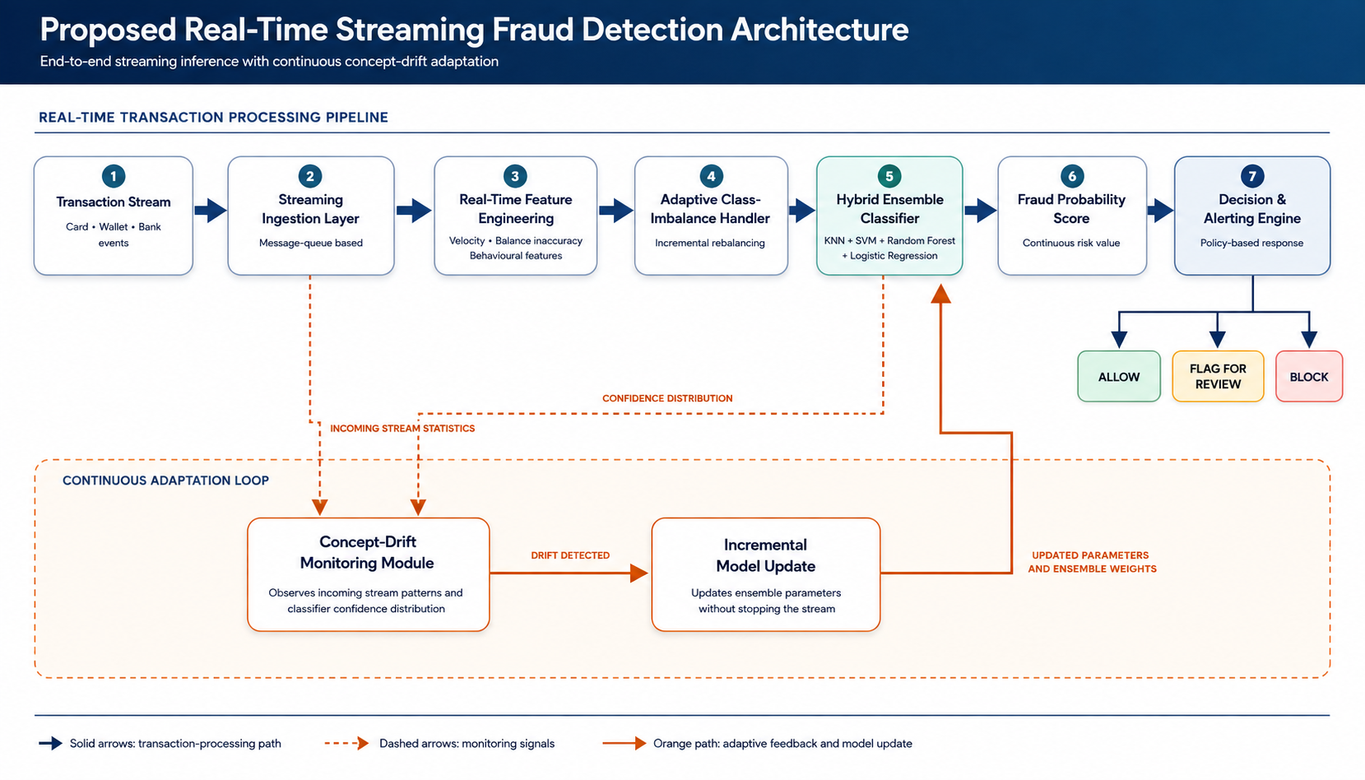

1) Streaming Ingestion Layer

• The system begins with a streaming ingestion layer that continuously receives individual transaction events (credit card authorizations, mobile-wallet transfers, cash-outs, and similar events) as they occur, rather than as a static uploaded dataset.

• Each incoming transaction is queued and forwarded to the feature engineering module with minimal delay so as to enable near real-time scoring.

2) Real-Time Feature Engineering Module

• For every incoming transaction, the module computes engineered features on the fly, including balance-inaccuracy scores (the deviation between the expected post-transaction balance and the recorded balance for both the originator and the recipient) and transaction-velocity features (such as the frequency and recency of transactions for the same account).

• These features are computed using only the data available up to that point in the stream, without requiring access to the full historical dataset at scoring time.

3) Adaptive Class-Imbalance Handler

• Because genuine transactions vastly outnumber fraudulent ones, the module maintains a continuously updated, bounded reference sample of both classes and incrementally rebalances the training signal supplied to the classifier as new transactions and their (eventual) fraud/non-fraud labels arrive.

• Unlike a one-time static undersampling of a fixed historical dataset, this rebalancing is performed continuously so that the model remains sensitive to the fraud class even as the incoming transaction mix changes over time.

4) Hybrid Ensemble Classifier

• A hybrid ensemble, combining a distance-based learner (KNN), a margin-based learner (SVM), a probabilistic linear learner (Logistic Regression) and a tree-based ensemble learner (Random Forest), independently scores each transaction, and the individual scores are fused into a single, unified fraud probability score.

• The fused score benefits from the complementary strengths of each base learner, rather than relying on the output of a single model as in prior batch-trained systems.

5) Concept-Drift Monitoring and Incremental Update

• A dedicated monitoring module continuously tracks statistical properties of the incoming feature distribution and of the ensemble's prediction confidence.

• When a statistically significant drift is detected, an incremental model update is triggered, in which the affected base learner(s) are updated using the most recent transaction window, avoiding the need for a full offline retraining cycle on the complete historical dataset.

6) Decision and Alerting Engine

• Based on the fused fraud probability score, the decision engine classifies the transaction as Allow, Flag for Manual Review, or Block, according to configurable thresholds.

• The decision, together with the contributing feature values, is made available to downstream systems (payment gateways, core banking systems, or wallet applications) in real time.

GENERAL UTILITY / APPLICATIONS / ADVANTAGES OF THE INVENTION :

Utility of the Invention:

• The invention provides a real-time, self-adapting mechanism for detecting fraudulent financial transactions as they occur, rather than after the fact through periodic offline batch analysis.

• It offers continued detection accuracy under evolving fraud patterns and class imbalance by incrementally updating the model in response to detected concept drift.

• The system is designed to operate efficiently on high-velocity transaction streams typical of banking, card-payment and mobile-money networks.

Application of Invention:

• Real-time authorization-time fraud screening for credit and debit card transactions.

• Fraud monitoring for mobile-money and digital-wallet cash-out/transfer transactions.

• Payment gateway and fintech transaction risk-scoring engines.

• Core-banking transaction monitoring systems requiring continuous, low-latency fraud alerts.

• Insurance and e-commerce platforms requiring streaming anomaly detection on transactional data.

Advantages of the Invention:

• Enables real-time, per-transaction fraud scoring instead of periodic offline batch evaluation.

• Adapts continuously to evolving fraud patterns through concept-drift detection and incremental model updates, without requiring full retraining.

• Handles class imbalance adaptively as the transaction stream evolves, rather than through a one-time static rebalancing of a fixed historical dataset.

• Combines the complementary strengths of multiple heterogeneous classifiers into a single fused fraud score, improving robustness over any single-model approach.
• Reduces detection latency and operational overhead compared to systems that require full periodic retraining on the entire historical dataset.

Implementation Status :

The proposed invention is currently in the early stages of design and implementation. The overall system architecture, workflow, and implementation strategy have been planned, and the individual modules of the proposed pipeline have been identified and designed. Development
of the system is ongoing, with the implementation of the streaming framework, feature engineering pipeline, ensemble machine learning models, and adaptive learning components planned as subsequent phases.

The proposed design is based on established open-source technologies and widely adopted machine learning and stream-processing frameworks, indicating that the invention is technically feasible and can be implemented using currently available tools and technologies. Upon completion of
development and testing, the system is intended to operate in real-world financial transaction processing environments for real-time fraud detection.

Disclaimer:

The undersigned inventor(s) hereby declare that all statements, descriptions, and representations made in this Invention Disclosure Form are true, complete, and made to the best of their knowledge and belief. The inventor(s) shall bear sole responsibility and liability for the accuracy, validity, and authenticity of the information and data provided herein. The Research and Development Cell (RDC), the Institution, and any associated patent attorney, agent, or representative shall not be held liable or accountable for any inaccuracies, omissions, misrepresentations, or consequences arising from the information furnished by the inventor(s).
Signature: Ritwik
Name: Ritwik Dhull
Date : 04/08/2026

