4.2 Normalisation

4.2.1 Database Design

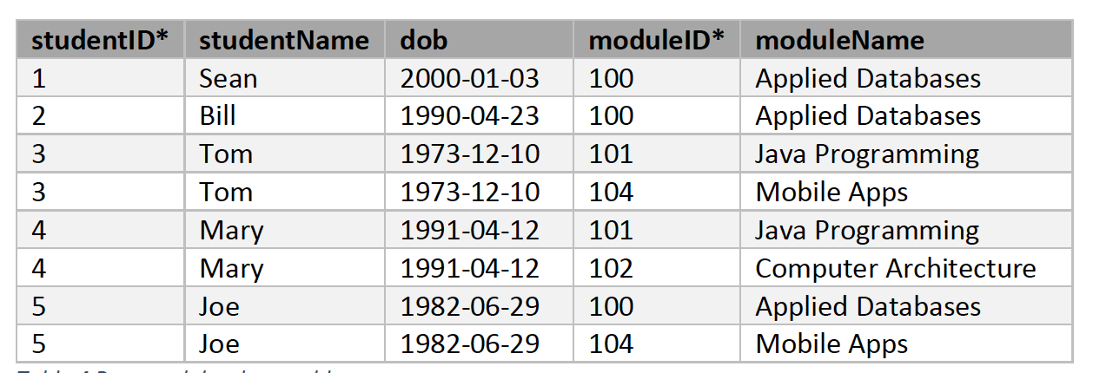

Looking at the table above, it would be better to split tables into student and module and have a reference table to minimise data redundancy and data duplication.

**Student Table**

*studentID is primary key

|  |  |  |
| --- | --- | --- |
| studentID* | studentName | dob |
| 1 | Sean | 2000-01-03 |
| 2 | Bill | 1990-04-23 |
| 3 | Tom | 1973-12-10 |
| 4 | Mary | 1991-04-12 |
| 5 | Joe | 1982-06-29 |

**Module Information**

*moduleID is primary key

|  |  |
| --- | --- |
| moduleID* | moduleName |
| 100 | Applied Databases |
| 101 | Java Programming |
| 102 | Computer Architecture |
| 104 | Mobile Apps |

**Reference Table**

|  |  |
| --- | --- |
| studentID* | moduleID* |
| 1 | 100 |
| 2 | 100 |
| 3 | 101 |
| 3 | 104 |
| 4 | 101 |
| 4 | 102 |
| 5 | 100 |
| 5 | 104 |