**Comparative Analysis**

Using the ycsb library, a benchmark test was performed on MySQL and MongoDB, results were gathered for both databases based on operation count of 1000, 10000, 10000, 100000, 1000000, 10000000.

**Runtime**

MongoDB performed the best when looking at runtime performance. It is more than 2 times faster than MySQL

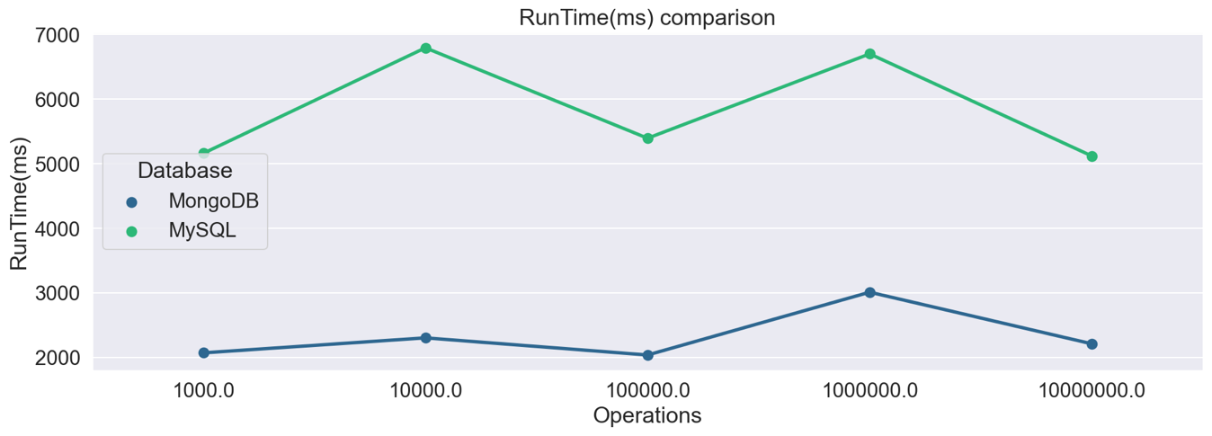

**Throughput**

Throughput is a measure of how many units of information a system can process in a given amount of time

When analysing both databases throughput (ops/sec), MongoDB was able to process more than double the information that MySQL could.

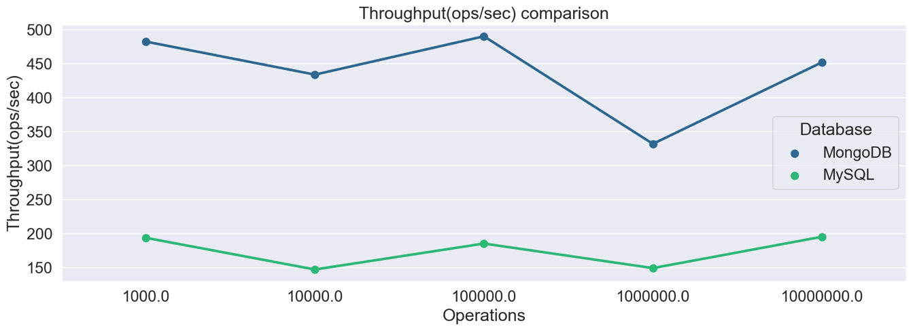

**Insert**

MongoDB is a document-oriented NoSQL database used for handling big data. MongoDB uses collections and documents.

Partition-tolerant, consistency

Integrates with Mapreduce

Schema-less database, highly scalable deep query-ability, faster access to data