Evolutionary Conservation of Recurrent Human TP53 Cancer Mutation Hotspots Across Mammalian Species

Ritika Rajendra Rawatˡ, Department of Bioinformatics, Guru Nanak Khalsa College of Arts, Science and Commerce, University of Mumbai
Sermarani Nadar², Department of Bioinformatics, Guru Nanak Khalsa College of Arts, Science and Commerce, University of Mumbai
Gursimran Kaur³, Department of Bioinformatics, Guru Nanak Khalsa College of Arts, Science and Commerce, University of Mumbai
Corresponding Author: ritikarvl2627@gmail.com

Abstract
TP53 is the most frequently mutated tumor suppressor gene in human cancer, yet the evolutionary constraints underlying recurrent TP53 mutation hotspots remain incompletely characterized. We investigated whether recurrent human TP53 cancer hotspot residues are preferentially located at evolutionarily constrained positions across mammals by integrating comparative genomics, phylogenetic analysis, and cancer mutation data. A curated alignment of 56 mammalian TP53 protein sequences was generated and mapped to the 393-residue human TP53 reference sequence. Residue-level conservation was quantified using majority-residue conservation, Shannon entropy, and domain-matched statistical analyses. Cancer mutation frequencies were obtained from TCGA PanCancer studies through cBioPortal and integrated with evolutionary conservation metrics. The six canonical TP53 hotspot residues (R175, G245, R248, R249, R273, and R282) were completely conserved across all mammalian sequences and exhibited significantly greater conservation than non-hotspot residues within the DNA-binding domain (Mann–Whitney U, p = 0.0156). This pattern remained robust after phylogenetic sensitivity analyses excluding overrepresented mammalian lineages. Across all TP53 residues, mutation recurrence showed a significant positive association with evolutionary conservation (Spearman ρ = 0.430, p = 4.49 × 10⁻¹⁹). Five of the six canonical hotspots ranked among the most frequently mutated TP53 codons in TCGA PanCancer datasets, whereas R249 displayed complete evolutionary conservation but comparatively lower mutation recurrence, suggesting context-dependent selective pressures. These findings demonstrate that recurrent TP53 cancer mutations preferentially occur at evolutionarily constrained and functionally important residues, providing an evolutionary framework for interpreting recurrent TP53 mutation hotspots in human cancer.

Keywords
TP53; mutation hotspots; comparative genomics; mammalian evolution; cancer genomics; evolutionary oncology; cBioPortal; TCGA PanCancer

1. Introduction
TP53 is a central tumor suppressor gene that regulates cellular responses to DNA damage, oncogenic stress, genomic instability, and other forms of cellular injury [8,9]. Through its role as a transcription factor, p53 influences cell-cycle arrest, apoptosis, senescence, DNA repair, and metabolic adaptation. Loss or alteration of TP53 function is therefore a major route through which cancer cells evade normal growth control and acquire selective advantage.
A distinctive feature of TP53 in human cancer is the recurrence of specific missense mutation hotspots [8,10,11]. Unlike tumor suppressor genes that are frequently inactivated by broadly distributed truncating alterations, TP53 often accumulates recurrent missense mutations within its DNA-binding domain. Several codons, including R175, G245, R248, R249, R273, and R282, are repeatedly observed across cancer datasets and are widely treated as canonical TP53 hotspots [8,10,11]. These mutations can impair DNA binding, destabilize the DNA-binding domain, alter transcriptional activity, and in some contexts contribute to dominant-negative or gain-of-function effects [8,9]. However, the evolutionary constraint of these recurrent hotspot residues across mammals remains an important dimension of their functional interpretation.
Comparative sequence analysis provides a way to evaluate whether cancer-associated residues occupy evolutionarily constrained positions. Residues that are conserved across divergent mammalian species are more likely to be functionally important, structurally constrained, or intolerant to amino-acid substitution. For TP53, this is particularly relevant because the DNA-binding domain is both functionally central and enriched for recurrent cancer mutations. However, this creates an analytical challenge: hotspot residues should not be compared only against the entire protein background, because the DNA-binding domain is more conserved than several other TP53 regions. A stricter test requires comparison against non-hotspot residues within the same domain.
A second challenge is phylogenetic sampling. Mammalian comparative datasets often contain uneven representation of closely related species, which can inflate apparent conservation signals if not evaluated carefully. Sensitivity analyses that remove overrepresented lineages or reduce datasets to broader taxonomic representatives can help determine whether observed conservation patterns are robust or driven by particular clades.
A third challenge is integrating evolutionary conservation with large-scale cancer mutation data. Although recurrent TP53 hotspot mutations have been extensively characterized in cancer genomics studies, comparatively fewer analyses have systematically evaluated whether these recurrent mutation positions correspond to evolutionarily constrained residues across diverse mammalian species. A residue may be highly conserved but infrequently mutated in cancer, whereas another may recur because of tumor-type-specific mutational processes or selective pressures rather than evolutionary constraint alone. Consequently, evolutionary conservation is most informative when interpreted alongside large-scale cancer mutation-frequency data. Pan-cancer datasets provide an opportunity to test whether recurrent TP53 mutation positions are preferentially enriched at evolutionarily constrained residues and whether canonical hotspot codons represent a distinct subset of highly constrained functional sites.
Despite extensive investigation of TP53 mutation hotspots in cancer, the relationship between evolutionary constraint, domain-specific conservation, phylogenetic sampling, and large-scale cancer mutation recurrence has not been evaluated within a unified analytical framework. In this study, we integrate comparative mammalian sequence analysis, domain-matched conservation testing, phylogenetic sensitivity analyses, maximum-likelihood phylogenetic reconstruction, and TCGA PanCancer/cBioPortal mutation-frequency data to systematically investigate whether recurrent human TP53 cancer hotspot residues occupy evolutionarily constrained positions across mammals. By combining residue-level evolutionary conservation with pan-cancer mutation recurrence, this work provides an evolutionary framework for interpreting recurrent TP53 mutation hotspots while distinguishing functional constraint from direct mechanisms of cancer mutation recurrence.
This integrative computational framework enables systematic evaluation of evolutionary constraint at residue resolution while accounting for domain-specific conservation, phylogenetic sampling effects, and large-scale cancer mutation recurrence.

2. Materials and Methods

2.1 Study design
This study integrated comparative mammalian protein-sequence analysis, residue-level conservation scoring, domain-matched statistical testing, phylogenetic sensitivity analysis, cancer mutation-frequency integration, structural-class annotation, and maximum-likelihood phylogenetic reconstruction to evaluate whether recurrent human TP53 cancer mutation hotspots occupy evolutionarily constrained mammalian residues.
The primary analysis focused on six canonical human TP53 cancer hotspot residues: R175, G245, R248, R249, R273, and R282. These residues were analyzed using human TP53 residue numbering and compared with non-hotspot residues within the TP53 DNA-binding domain and whole-protein background residues.

2.2 Mammalian TP53 sequence retrieval and dataset construction
A seed list of mammalian species was assembled to represent major mammalian orders, including Primates, Rodentia, Carnivora, Artiodactyla, Perissodactyla, Proboscidea, Cetacea, Chiroptera, Lagomorpha, Eulipotyphla, Cingulata, Sirenia, and marsupial lineages. TP53 protein sequences were retrieved from NCBI using automated accession search and candidate selection. Candidate sequences were prioritized using TP53/p53 annotation terms, sequence length compatibility with canonical TP53 protein size, and exclusion of partial, pseudogene-like, hypothetical, unnamed, or low-quality records where detected.
After retrieval and quality control, 56 mammalian TP53 protein sequences were retained for analysis. All retained sequences passed accession, sequence-length, and annotation-flag screening in the final accession audit. Quality-control checks included sequence length screening, detection of ambiguous amino acids, internal stop codons, partial annotations, pseudogene annotations, and noncanonical description flags. The curated sequence set was stored as TP53_curated_v0.fasta.

2.3 Multiple sequence alignment and human residue mapping
Curated TP53 protein sequences were aligned using MAFFT [3]. The resulting multiple sequence alignment was mapped to the human TP53 reference sequence by tracking ungapped human residue positions across alignment columns. This enabled each alignment column to be assigned to a corresponding human TP53 residue position from 1 to 393.
The six canonical hotspot positions R175, G245, R248, R249, R273, and R282 were checked explicitly in the human reference sequence to confirm correct residue mapping. For each hotspot position, the corresponding alignment column was extracted across all mammalian sequences, and hotspot conservation was calculated.

2.4 TP53 domain annotation
Human TP53 residues were assigned to domain categories using residue-coordinate boundaries applied consistently across all analyses. The following working domain annotations were used: transactivation domain, proline-rich region, DNA-binding domain, oligomerization domain, C-terminal regulatory region, and interdomain or unannotated residues. The DNA-binding domain was used as the primary domain-matched control region because all six canonical hotspots are located within this domain.

2.5 Residue-level conservation analysis
For each human TP53 residue position, conservation was calculated from the corresponding multiple-alignment column. Gap characters were excluded from amino-acid frequency calculations but retained for gap-fraction reporting. The following residue-level metrics were calculated:
- majority-residue conservation, defined as the frequency of the most common non-gap amino acid at a position;
- human-residue conservation, defined as the frequency of the human reference amino acid among non-gap residues;
- Shannon entropy, calculated from non-gap amino-acid frequencies;
- normalized entropy, calculated by dividing Shannon entropy by log2(20);
- unique residue count;
- gap count and gap fraction.
Residues with high gap fractions were excluded from selected statistical comparisons where specified. Canonical hotspot residues were compared with non-hotspot residues from the DNA-binding domain and with broader whole-protein background residues.

2.6 Hotspot versus control statistical testing
Canonical hotspot conservation was compared with control residue groups using one-sided Mann–Whitney U tests. The primary comparison tested whether canonical hotspot residues had greater conservation than non-hotspot residues within the DNA-binding domain. Additional comparisons were performed against whole-protein non-hotspot residues and terminal-domain residues.
Effect size was estimated using Cliff’s delta. Bootstrap confidence intervals for mean conservation differences were calculated by resampling hotspot and control groups with replacement. Entropy-based comparisons used the reciprocal hypothesis that canonical hotspots had lower entropy than control residues.
DBD-matched permutation testing was additionally performed to provide a randomized domain-matched validation of the hotspot and recurrent-codon conservation signals. For each query set, DNA-binding-domain residue sets of equal size were randomly sampled from the DBD background, and the observed mean conservation of the query set was compared against the resulting null distribution. Permutation analyses were conducted for the six canonical hotspots and for the top 10, top 20, and top 30 recurrently mutated TP53 codon sets.

2.7 Phylogenetic sensitivity analysis
To test whether hotspot conservation patterns were driven by overrepresentation of closely related mammalian lineages, sensitivity analyses were performed using multiple reduced datasets:
- full dataset;
- dataset excluding primates;
- dataset excluding rodents;
- dataset excluding both primates and rodents;
- dataset reduced to one representative species per mammalian order.
For each sensitivity dataset, residue-level conservation was recalculated and canonical hotspot conservation was compared with DNA-binding-domain non-hotspot controls. An extended recurrent hotspot panel was also analyzed as a provisional secondary analysis.

2.8 cBioPortal / TCGA PanCancer TP53 mutation-frequency integration
Human TP53 mutation data were retrieved from TCGA PanCancer Atlas studies through the cBioPortal REST API [1,2,12]. TP53 mutations were queried using Entrez Gene ID 7157 across available PanCancer Atlas studies. Retrieved mutation records were filtered and processed to extract protein-change annotations and corresponding TP53 codon positions.
Mutation counts were aggregated by human TP53 codon. For each codon, the number of mutations, number of contributing cancer studies, number of unique samples, observed protein changes, mutation types, mutation-frequency fraction, mutation-frequency percentage, and mutation-frequency rank were calculated. The codon-level mutation-frequency table was then merged with the residue-level mammalian conservation table using human TP53 residue position.

2.9 Mutation recurrence and conservation association analysis
To evaluate whether cancer mutation recurrence was associated with mammalian evolutionary constraint, Spearman rank correlations were calculated between TP53 mutation count and conservation metrics. Correlations were performed across all 393 human TP53 residues, within the DNA-binding domain, among mutated codons only, and among mutated codons within the DNA-binding domain.
Top recurrent mutated codon groups were also compared with DNA-binding-domain background residues. The top 10, top 20, and top 30 mutated codons were tested for elevated conservation relative to DNA-binding-domain non-top-mutated background residues using one-sided Mann–Whitney U tests.

2.10 Structural-class annotation of recurrent TP53 codons
Canonical TP53 hotspots were manually annotated into structural classes based on their functional role within the DNA-binding domain. R248 and R273 were classified as DNA-contact hotspots. R175, G245, R249, and R282 were classified as structural-core hotspots. Additional recurrent noncanonical codons among the top mutated positions were annotated as recurrent DNA-binding-domain codons or recurrent oligomerization-domain codons.
Structural-class summaries were generated by calculating mutation counts, mean mutation count, mean conservation, median conservation, and mean entropy for each structural category.

2.11 Maximum-likelihood phylogenetic reconstruction
Maximum-likelihood phylogenetic reconstruction was performed using IQ-TREE v2.2.6. The best-fitting amino acid substitution model was selected automatically using ModelFinder based on the Bayesian Information Criterion (BIC). ModelFinder identified the Q.bird+I+G4 substitution model as the optimal model for the aligned TP53 protein sequences. Maximum-likelihood tree inference was performed under this model with 1,000 ultrafast bootstrap replicates to assess branch support. The resulting phylogeny was visualized and interpreted to evaluate the evolutionary relationships among the mammalian TP53 sequences.

2.12 Figure generation and data outputs
All statistical summaries, conservation tables, mutation-frequency tables, merged annotation tables, and figures were generated using Python, with Biopython used for sequence and phylogenetic file handling [7]. Figures included conservation profiles, hotspot-versus-control plots, phylogenetic sensitivity plots, mutation-count versus conservation plots, TP53 domain/lollipop mutation maps, mutation-distribution plots, top-mutated-codon conservation plots, and maximum-likelihood phylogeny visualizations.

2.13 Reproducibility
All scripts, intermediate outputs, final result tables, log files, and figures were organized within the project directory. Key outputs included curated FASTA files, MAFFT alignments, residue-level conservation tables, cBioPortal mutation-frequency tables, merged conservation-mutation tables, statistical summaries, IQ-TREE phylogenetic outputs, and publication-style figures. The analysis snapshot was frozen as release version v0 before manuscript drafting.

3. Results

3.1 Construction of a curated mammalian TP53 protein alignment
To evaluate the evolutionary constraint of recurrent human TP53 cancer mutation hotspots, a curated mammalian TP53 protein dataset was assembled and aligned. After sequence retrieval and quality control, 56 mammalian TP53 protein sequences were retained for comparative analysis. The alignment was mapped to the human TP53 reference sequence, enabling residue-level analysis across 393 human TP53 positions. Domain annotations were assigned using human TP53 residue coordinates, including the transactivation domain, proline-rich region, DNA-binding domain, oligomerization domain, and C-terminal regulatory region.
Residue-level conservation varied across TP53 domains. The DNA-binding domain showed high overall conservation, with mean majority-residue conservation of 0.936 and median conservation of 1.000. In contrast, the transactivation domain and proline-rich region showed lower average conservation, consistent with greater sequence variability outside the structured DNA-binding core. These results established a residue-level conservation landscape across mammalian TP53 and provided the basis for domain-matched hotspot comparisons.
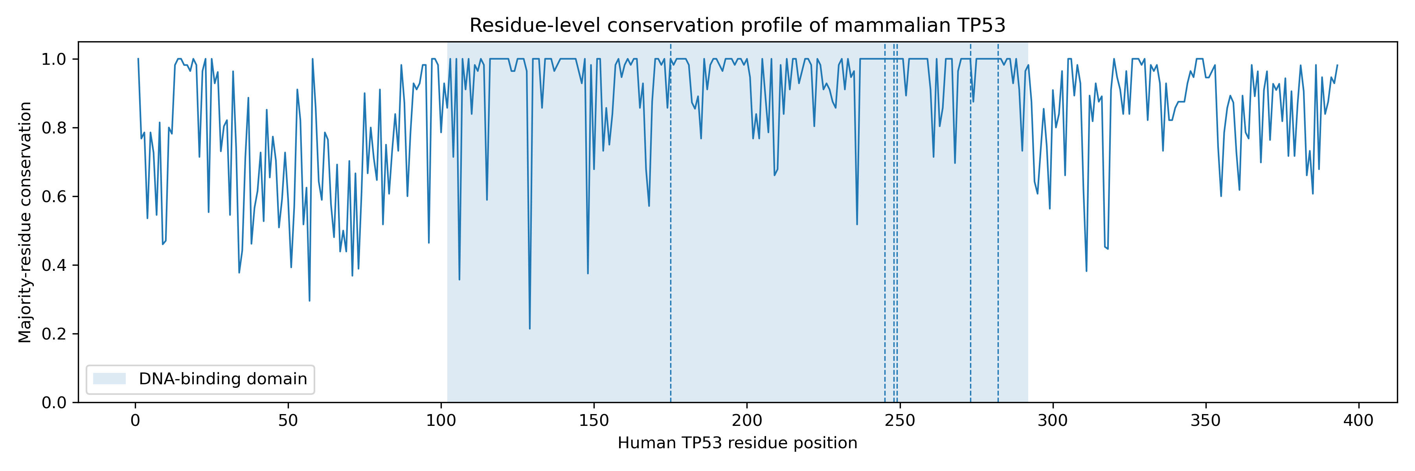
Figure 1. Residue-level conservation profile of mammalian TP53
Residue-level majority conservation across 393 human TP53 positions was calculated from a curated alignment of 56 mammalian TP53 protein sequences. The DNA-binding domain is shaded, and the six canonical cancer hotspot residues R175, G245, R248, R249, R273, and R282 are marked with vertical dashed lines.

3.2 Canonical TP53 cancer hotspot residues are invariant across mammals
The six canonical TP53 cancer mutation hotspot residues R175, G245, R248, R249, R273, and R282 were mapped onto the mammalian alignment using human TP53 residue numbering. All six hotspot residues were invariant across the 56-species mammalian dataset. Each hotspot showed majority-residue conservation of 1.000, human-residue conservation of 1.000, Shannon entropy of 0.000, and no alignment gaps at the corresponding hotspot position.
This invariant pattern was observed for both DNA-contact hotspots and structural-core hotspots. R248 and R273, which were annotated as DNA-contact hotspots, showed complete conservation across mammals. R175, G245, R249, and R282, annotated as structural-core hotspots within the DNA-binding domain, were also completely conserved. These findings indicate that canonical human TP53 cancer hotspots occupy highly constrained mammalian residues.

3.3 Canonical hotspots are more conserved than DNA-binding-domain background residues
Because the TP53 DNA-binding domain is itself highly conserved, hotspot conservation was compared against domain-matched non-hotspot residues rather than only against the whole protein. Canonical hotspots showed higher majority-residue conservation than DNA-binding-domain non-hotspot residues, with mean conservation of 1.000 for hotspots compared with 0.934 for DNA-binding-domain controls. This difference was statistically significant using a one-sided Mann–Whitney U test (U = 819.0, p = 0.0156), with a moderate effect size by Cliff’s delta (δ = 0.476).
The same pattern was observed when conservation was measured using human-residue conservation. Canonical hotspots had mean human-residue conservation of 1.000 compared with 0.910 for DNA-binding-domain non-hotspot residues (U = 819.0, p = 0.0156; Cliff’s δ = 0.476). Entropy-based analysis gave the reciprocal result: canonical hotspots had lower Shannon entropy than DNA-binding-domain non-hotspot residues (0.000 versus 0.304; one-sided p = 0.0156). These results support that canonical hotspots are unusually constrained even relative to the already conserved TP53 DNA-binding domain.
DBD-matched permutation testing provided an additional randomized validation of the hotspot-conservation signal. Randomly sampled DNA-binding-domain residue sets of equal size to the canonical hotspot set produced a null mean conservation of 0.936, whereas the observed canonical hotspot mean was 1.000, yielding an empirical one-sided p-value of 0.0236. This result supports the conclusion that the canonical hotspot residues are more conserved than expected from random sampling within the same functional domain.
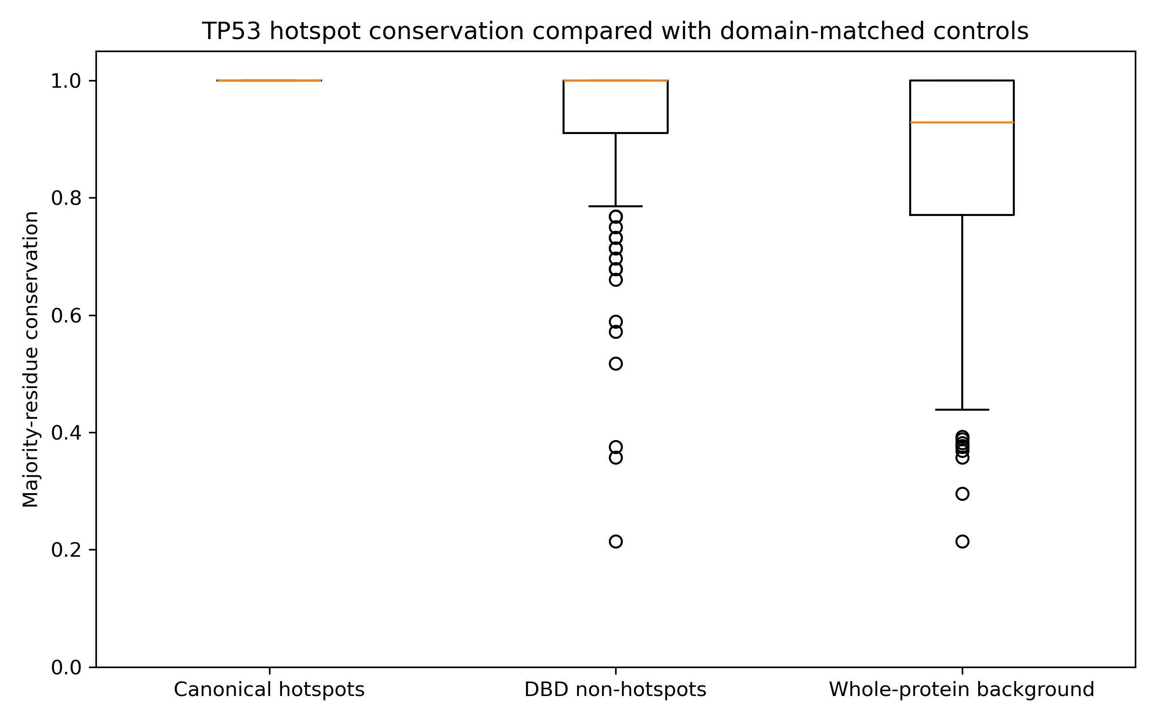
Figure 2. Canonical TP53 hotspots show elevated conservation relative to domain-matched controls
Boxplot comparison of majority-residue conservation between canonical TP53 hotspot residues, DNA-binding-domain non-hotspot residues, and whole-protein non-hotspot background residues. Canonical hotspots showed complete conservation and were significantly more conserved than DNA-binding-domain controls.

3.4 Phylogenetic sensitivity analysis supports robustness of the hotspot-conservation signal
To test whether the hotspot-conservation signal was driven by overrepresentation of closely related mammalian lineages, sensitivity analyses were performed by removing major taxonomic groups and by reducing the dataset to one representative species per mammalian order. The hotspot conservation signal remained positive in all sensitivity datasets.
Canonical hotspots remained more conserved than DNA-binding-domain background residues in the full dataset, after excluding primates, after excluding rodents, after excluding both primates and rodents, and after reducing the dataset to one species per mammalian order. In the full dataset, the mean conservation difference between hotspots and DNA-binding-domain controls was 0.066 (p = 0.0156). After excluding primates, the difference remained 0.067 (p = 0.0196). After excluding rodents, the difference was 0.063 (p = 0.0245). After excluding both primates and rodents, the difference was 0.064 (p = 0.0316). In the one-species-per-order dataset, the difference was 0.082 (p = 0.0355).
An extended recurrent hotspot panel showed the same direction of effect. Across sensitivity datasets, extended recurrent codons were more conserved than DNA-binding-domain non-hotspot controls, with positive mean conservation differences and statistically significant one-sided tests. These findings indicate that the canonical hotspot signal is not solely explained by primate or rodent sampling and remains detectable under phylogenetic downsampling.
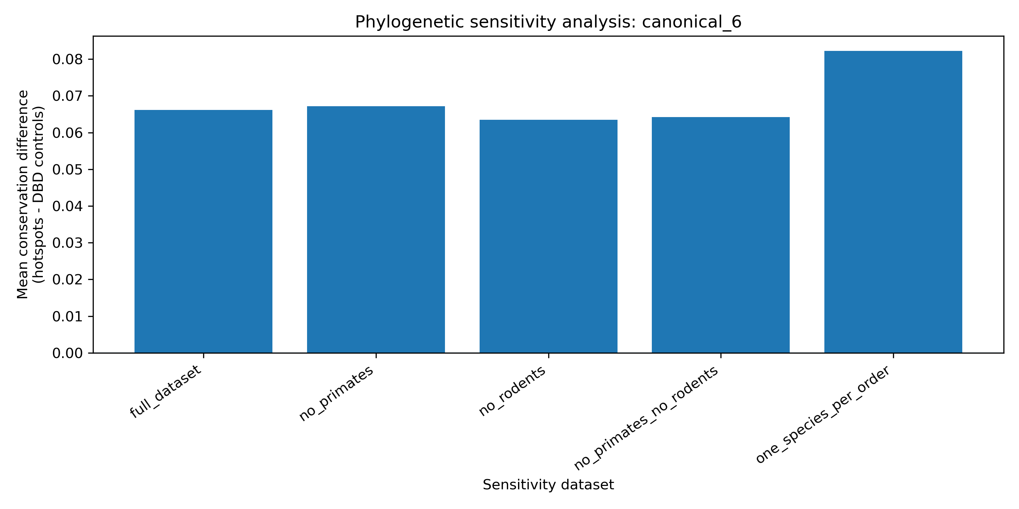
Figure 3. Phylogenetic sensitivity analysis of canonical hotspot conservation
Sensitivity analysis comparing canonical hotspot conservation with DNA-binding-domain non-hotspot conservation across reduced mammalian datasets. The signal remained positive after removing major taxonomic groups and after order-level downsampling.

3.5 Human TP53 cancer mutation recurrence is associated with mammalian residue conservation
To connect mammalian evolutionary constraint with human cancer mutation recurrence, TP53 mutation-frequency data were retrieved from TCGA PanCancer/cBioPortal studies. Across the analyzed studies, 4,225 TP53 mutations were collected, mapping to 300 TP53 codons. The most frequently mutated codons included R273, R248, R175, R213, R282, G245, Y220, H179, T125, and H193.
Mutation recurrence was positively associated with mammalian conservation. Across all 393 human TP53 residues, mutation count correlated with majority-residue conservation (Spearman ρ = 0.430, p = 4.49 × 10^-19) and with human-residue conservation (ρ = 0.430, p = 4.19 × 10^-19). Within the DNA-binding domain alone, mutation count remained positively correlated with majority-residue conservation (ρ = 0.368, p = 1.68 × 10^-7) and human-residue conservation (ρ = 0.374, p = 9.57 × 10^-8). Among mutated codons only, the correlation remained positive across all mutated residues and within the DNA-binding domain.
Top recurrent codons also showed elevated conservation compared with DNA-binding-domain background residues. The top 10 mutated codons had mean majority-residue conservation of 1.000 compared with 0.932 for DNA-binding-domain background residues (p = 0.00244). The top 20 and top 30 mutated codons also showed higher conservation than DNA-binding-domain controls. These results support an association between TP53 cancer mutation recurrence and mammalian evolutionary constraint.
Permutation analysis further supported conservation enrichment among recurrently mutated TP53 codons. The top 10, top 20, and top 30 recurrent codon sets showed higher conservation than expected under DBD-matched random sampling, with empirical one-sided p-values of 0.00182, 0.00139, and 0.00003, respectively.
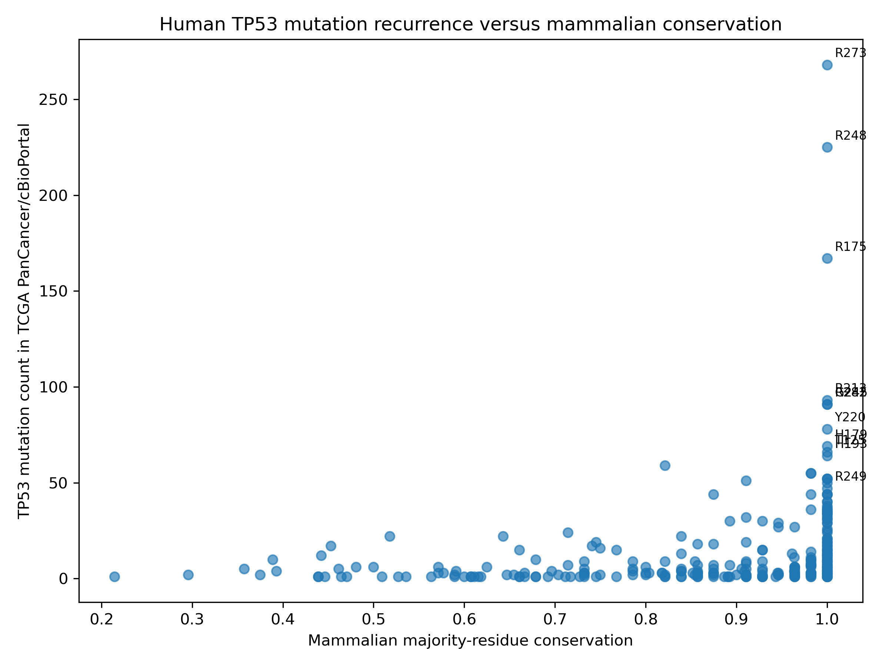
Figure 4. Human TP53 mutation recurrence is positively associated with mammalian conservation
Scatter plot showing the relationship between TP53 mutation count from TCGA PanCancer/cBioPortal data and mammalian majority-residue conservation. Mutation recurrence was positively associated with mammalian conservation across all TP53 residues and within the DNA-binding domain.

3.6 Canonical hotspots dominate recurrent TP53 mutation positions but R249 shows context-dependent recurrence
Five of the six canonical TP53 hotspot residues ranked among the six most frequently mutated TP53 codons in the TCGA PanCancer/cBioPortal dataset. R273 ranked first with 268 mutations, R248 ranked second with 225 mutations, R175 ranked third with 167 mutations, R282 ranked fifth with 91 mutations, and G245 ranked sixth with 91 mutations. R249 was also fully conserved across mammals but ranked nineteenth in this PanCancer-derived dataset, with 47 mutations.
Structural-class annotation separated canonical hotspots into DNA-contact and structural-core classes. The DNA-contact hotspots R273 and R248 together accounted for 493 mutations and showed complete mammalian conservation. The structural-core canonical hotspots R175, G245, R249, and R282 together accounted for 396 mutations and also showed complete conservation. Recurrent non-canonical DNA-binding-domain codons, including R213, Y220, H179, T125, H193, C176, R158, and R280, showed high conservation as a group, with mean conservation of 0.998 and median conservation of 1.000.
These findings indicate that recurrent TP53 mutation targets are concentrated within highly conserved functional regions of the protein. However, the lower PanCancer rank of R249 compared with R273, R248, R175, R282, and G245 suggests that recurrence is not determined by conservation alone and may depend on tumor type, mutational exposure, or context-specific selective pressures.
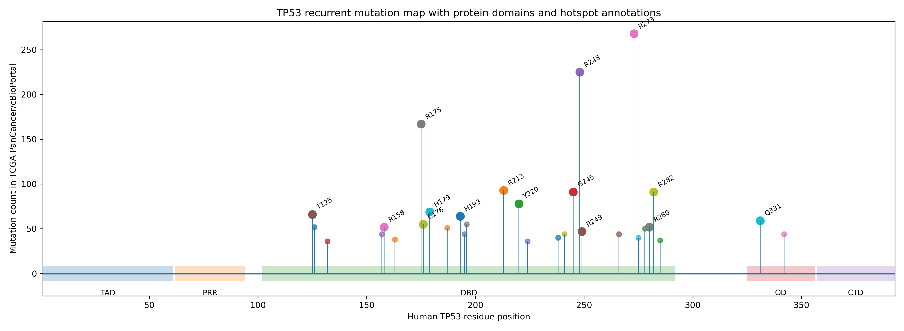
Figure 5. TP53 domain-level mutation map with canonical and recurrent hotspot annotations
Lollipop-style map of recurrent TP53 mutation counts across the human TP53 protein sequence. The figure highlights the concentration of recurrent TP53 mutations within the DNA-binding domain, including DNA-contact hotspots and structural-core hotspots.

3.7 Maximum-likelihood phylogeny supports taxonomic coherence of the mammalian TP53 dataset
A maximum-likelihood phylogeny was reconstructed from the curated mammalian TP53 protein alignment using IQ-TREE with ModelFinder-based model selection. The best-fit model was Q.bird+I+G4. The inferred tree broadly recovered expected mammalian taxonomic groupings, including primate, rodent, carnivore, artiodactyl/cetacean, chiropteran, proboscidean, and marsupial relationships. This supported the overall taxonomic coherence of the curated TP53 dataset and provided an evolutionary framework for interpreting residue conservation patterns.

Figure 6. Maximum-likelihood phylogeny of mammalian TP53 protein sequences
Maximum-likelihood phylogeny reconstructed from the curated 56-sequence mammalian TP53 protein alignment using IQ-TREE. ModelFinder selected Q.bird+I+G4 as the best-fit amino-acid substitution model. Branch support was estimated using 1000 ultrafast bootstrap replicates and 1000 SH-aLRT replicates [4,5,6].

4. Discussion
This study integrated mammalian comparative sequence analysis, domain-matched conservation testing, phylogenetic sensitivity analysis, cancer mutation-frequency data, structural-class annotation, and maximum-likelihood phylogeny to evaluate whether recurrent human TP53 cancer mutation hotspots occupy evolutionarily constrained residues. The central finding is that canonical TP53 cancer hotspots are invariant across a curated mammalian TP53 alignment and are more conserved than non-hotspot residues within the already highly conserved DNA-binding domain. Integration with TCGA PanCancer/cBioPortal mutation-frequency data further showed that human TP53 mutation recurrence is positively associated with mammalian residue conservation. Together, these results support the interpretation that recurrent TP53 cancer mutations concentrate at evolutionarily constrained and functionally sensitive positions.
The complete conservation of R175, G245, R248, R249, R273, and R282 across 56 mammalian TP53 sequences is consistent with the essential functional role of these residues within the TP53 DNA-binding domain. Importantly, the analysis did not rely only on whole-protein background comparisons, which would risk inflating the apparent significance of hotspot conservation because the DNA-binding domain is more conserved than several other regions of TP53. Instead, canonical hotspots were compared directly with DNA-binding-domain non-hotspot residues. Even under this stricter domain-matched comparison, hotspots showed significantly higher conservation and lower entropy than background residues, indicating that their constraint exceeds the average constraint of the domain in which they occur.
Phylogenetic sampling can distort comparative conservation analyses when closely related taxa are overrepresented. The sensitivity analysis addressed this issue by excluding primates, excluding rodents, excluding both primates and rodents, and reducing the dataset to one representative species per mammalian order. The hotspot-conservation signal remained positive in all sensitivity datasets. This does not eliminate all phylogenetic non-independence, but it strengthens the conclusion that the observed pattern is not simply an artifact of primate or rodent sampling.
The integration of cancer mutation-frequency data provides an additional layer of interpretation. Across 4,225 TP53 mutations from TCGA PanCancer/cBioPortal data, mutation count was positively associated with mammalian conservation across all TP53 residues and within the DNA-binding domain. This finding suggests that recurrent TP53 mutation positions are enriched among constrained residues rather than being distributed randomly across the protein. Five of the six canonical hotspots ranked among the six most frequently mutated TP53 codons, while R249 remained fully conserved but ranked lower in the PanCancer dataset. This distinction is biologically important because it indicates that conservation alone does not determine mutation recurrence. Mutation exposure, tumor type, nucleotide context, tissue-specific selection, and cancer-specific fitness effects likely influence which constrained residues become recurrent cancer hotspots.
Structural-class annotation further refined the interpretation. R248 and R273 were classified as DNA-contact hotspots and together showed the highest mutation burden among canonical hotspots. R175, G245, R249, and R282 were classified as structural-core hotspots and were also completely conserved. This separation is useful because DNA-contact and structural-core mutations may disrupt TP53 function through different mechanisms: DNA-contact mutations can directly impair DNA binding, whereas structural-core mutations may destabilize the DNA-binding domain or alter its conformation. The high conservation and high recurrence of both classes support the broader conclusion that recurrent TP53 cancer mutations are concentrated at residues with strong functional constraint.
The recurrent noncanonical codons also showed high conservation, especially within the DNA-binding domain. Codons such as R213, Y220, H179, T125, H193, C176, R158, and R280 were frequently mutated and highly conserved. This suggests that the canonical six-hotspot model captures only part of the recurrent TP53 mutation landscape. A broader recurrent-codon framework may better represent the relationship between evolutionary constraint and cancer mutation recurrence, especially when integrating pan-cancer data.
This work has limitations. First, the study used protein-sequence conservation rather than codon-level evolutionary models. Protein conservation is appropriate for identifying constrained amino-acid positions but does not directly estimate nucleotide substitution rates or dN/dS. Future work could integrate codon-aware alignments and phylogenetic models to estimate site-specific selection. Second, the mammalian dataset, while taxonomically broad, still contains uneven representation across orders. Sensitivity analysis partially addresses this, but larger curated datasets with one or more balanced representatives per order would improve robustness. Third, cBioPortal/TCGA PanCancer mutation counts reflect the composition of available tumor datasets and are not equivalent to universal mutation probabilities. Tumor-type-specific analyses may reveal stronger or weaker recurrence patterns for particular codons, especially R249. Fourth, structural annotation was performed at a functional-class level and should be expanded using experimentally resolved TP53 structures, DNA-contact maps, zinc-binding annotations, and domain-stability data.
The results should therefore be interpreted as evidence of association, not causation. Evolutionary conservation does not cause cancer mutation recurrence by itself. Rather, conservation marks residues that are likely functionally constrained, and cancer recurrence may emerge when mutation at such residues disrupts TP53 function in ways that provide selective advantage to tumor cells. This distinction is important for avoiding overinterpretation. The present analysis supports a model in which recurrent TP53 cancer hotspots are enriched at evolutionarily constrained and functionally sensitive residues, but additional structural, biochemical, and tumor-type-specific analyses are required to determine the mechanisms underlying individual hotspot recurrence.
In summary, this study provides a reproducible computational framework linking mammalian evolutionary constraint with human TP53 cancer mutation recurrence. By combining domain-matched conservation analysis, phylogenetic sensitivity testing, pan-cancer mutation-frequency integration, and structural-class annotation, the work strengthens the evolutionary interpretation of recurrent TP53 mutation hotspots while preserving appropriate caution about causality and cancer-context dependence.

5. Conclusions
This study provides a reproducible computational framework linking mammalian TP53 evolutionary constraint with recurrent human cancer mutation patterns. The results show that canonical TP53 cancer hotspots are invariant across the curated mammalian alignment, significantly more conserved than DNA-binding-domain background residues, and supported by domain-matched permutation testing. Integration with TCGA PanCancer/cBioPortal mutation-frequency data further indicates that recurrent TP53 mutation positions are enriched among evolutionarily constrained residues. These findings support the interpretation that recurrent TP53 cancer hotspots concentrate at functionally sensitive residues, while preserving the important distinction that conservation is an indicator of functional constraint rather than a direct cause of mutation recurrence.

6. Data and Code Availability

6.1 Data Availability
Mammalian TP53 protein sequences were obtained from the NCBI Protein database, and TP53 mutation data were retrieved from the TCGA PanCancer Atlas through the cBioPortal platform. The processed datasets generated during this study, including residue-level conservation tables, mutation-frequency summaries, merged annotation tables, statistical outputs, phylogenetic outputs, and supplementary materials, are available from the corresponding author upon reasonable request.

6.2 Code Availability
The custom Python scripts developed for sequence processing, conservation analysis, statistical testing, mutation-frequency integration, phylogenetic analyses, and figure generation are available from the corresponding author upon reasonable request.

7. Declarations

7.1 Author Contributions
Ritika Rajendra Rawat conceived and designed the study, developed the computational workflow, curated the mammalian TP53 dataset, performed the bioinformatics analyses, statistical analyses, phylogenetic reconstruction, integrated TCGA/cBioPortal mutation data, generated the figures and tables, interpreted the results, and drafted the manuscript. Sermarani Nadar and Gursimran Kaur contributed to scientific discussions, interpretation of the results, critical review of the manuscript, and approved the final version for submission. All authors read and approved the final manuscript.

7.2 Funding
This research received no specific grant from any funding agency in the public, commercial, or not-for-profit sectors.

7.3 Competing Interests
The author declares no competing interests.

7.4 Ethics Approval
This study used publicly available protein sequence data and publicly accessible de-identified cancer mutation data. No human participants, clinical intervention, animal experimentation, or identifiable private data were involved.

7.5 Acknowledgements
The authors acknowledge the open availability of NCBI Protein, cBioPortal, TCGA PanCancer Atlas data, MAFFT, IQ-TREE, Biopython, SciPy, pandas, and related open-source computational tools that enabled this study. The authors also acknowledge the Department of Bioinformatics, University of Mumbai, Guru Nanak Khalsa College for academic support during the development of this research work.

Supplementary Material

Supplementary Figures
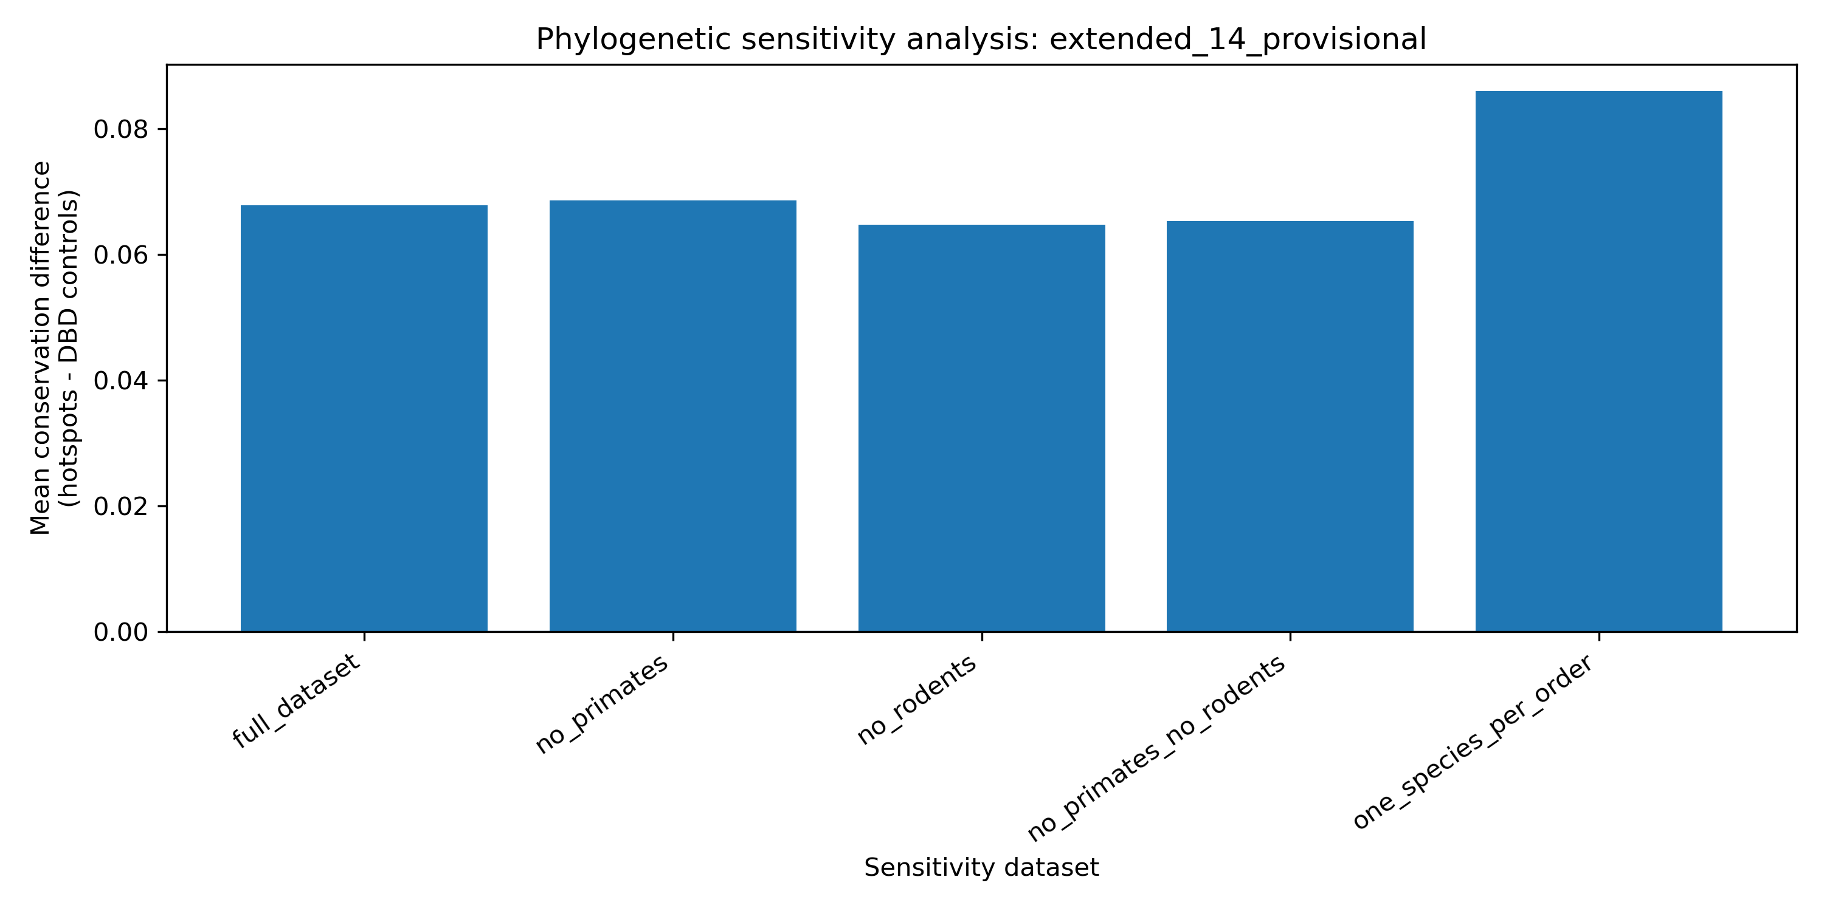
Supplementary Figure S1. Extended recurrent TP53 codon sensitivity analysis
Supplementary Figure S2. Conservation of the top 30 recurrent TP53 mutated codons.
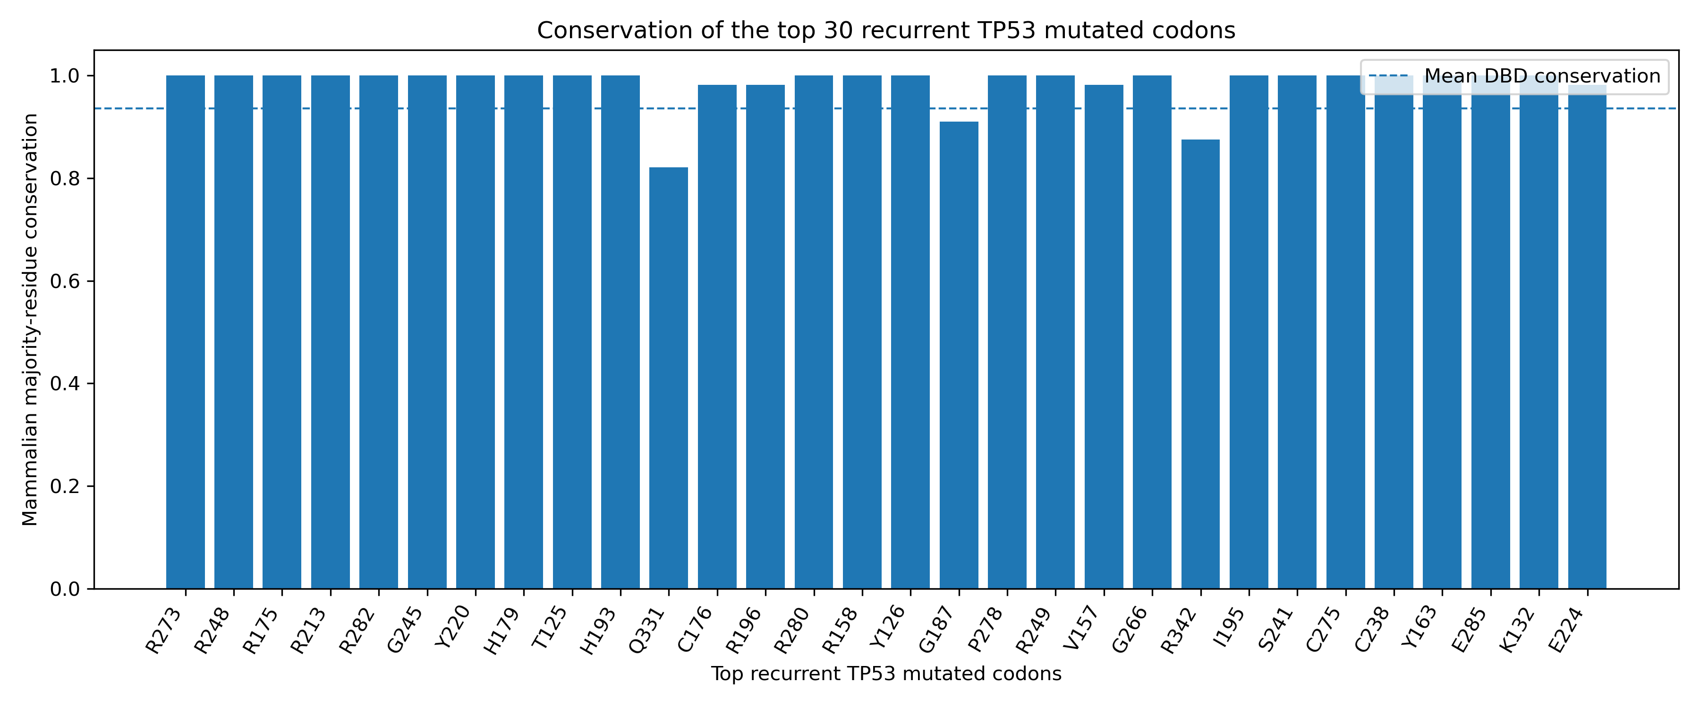
Supplementary Figure S2. Conservation of top 30 recurrent TP53 mutated codons
Supplementary Figure S3. Distribution of TP53 mutation counts across the human protein sequence.
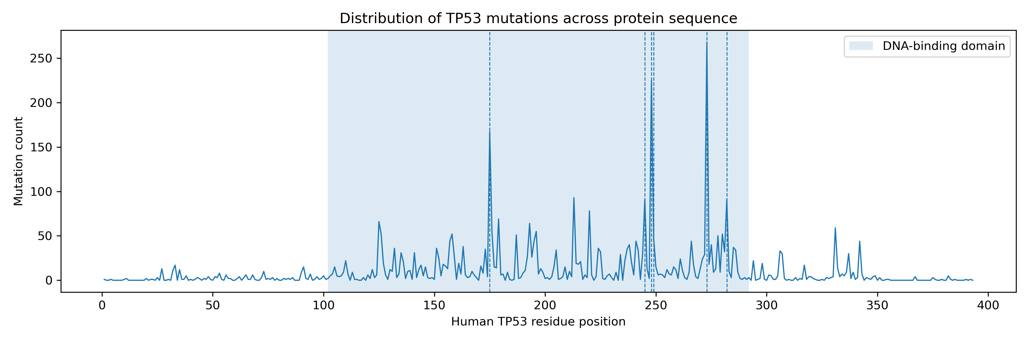
Supplementary Figure S3. Distribution of TP53 mutation counts across human TP53

Supplementary Tables
Supplementary Table S1. TP53 sequence accession and audit table for the 56 mammalian protein sequences retained after quality control.
Supplementary Table S2. DBD-matched permutation statistics for canonical TP53 hotspots and top recurrent TP53 codon sets.
Supplementary Table S3. Residue-level mammalian TP53 conservation table mapped to human TP53 residue numbering.
Supplementary Table S4. cBioPortal/TCGA PanCancer TP53 mutation-frequency table aggregated by codon.
Supplementary Table S5. Structural-class summary of canonical and recurrent TP53 codons.

References
- Cerami, E., Gao, J., Dogrusoz, U., Gross, B. E., Sumer, S. O., Aksoy, B. A., Jacobsen, A., Byrne, C. J., Heuer, M. L., Larsson, E., Antipin, Y., Reva, B., Goldberg, A. P., Sander, C., & Schultz, N. (2012). The cBio cancer genomics portal: an open platform for exploring multidimensional cancer genomics data. Cancer discovery, 2(5), 401–404. https://doi.org/10.1158/2159-8290.CD-12-0095
- Gao, J., Aksoy, B. A., Dogrusoz, U., Dresdner, G., Gross, B., Sumer, S. O., Sun, Y., Jacobsen, A., Sinha, R., Larsson, E., Cerami, E., Sander, C., & Schultz, N. (2013). Integrative analysis of complex cancer genomics and clinical profiles using the cBioPortal. Science signaling, 6(269), pl1. https://doi.org/10.1126/scisignal.2004088
- Katoh, K. & Standley, D. M. MAFFT Multiple Sequence Alignment Software Version 7: Improvements in Performance and Usability. Molecular Biology and Evolution 30, 772–780 (2013). doi:10.1093/molbev/mst010.
- Minh, B. Q., Schmidt, H. A., Chernomor, O., Schrempf, D., Woodhams, M. D., von Haeseler, A., & Lanfear, R. (2020). IQ-TREE 2: New Models and Efficient Methods for Phylogenetic Inference in the Genomic Era. Molecular biology and evolution, 37(5), 1530–1534. https://doi.org/10.1093/molbev/msaa015
- Kalyaanamoorthy, S., Minh, B. Q., Wong, T. K. F., von Haeseler, A., & Jermiin, L. S. (2017). ModelFinder: fast model selection for accurate phylogenetic estimates. Nature methods, 14(6), 587–589. https://doi.org/10.1038/nmeth.4285
- Hoang, D. T., Chernomor, O., von Haeseler, A., Minh, B. Q., & Vinh, L. S. (2018). UFBoot2: Improving the Ultrafast Bootstrap Approximation. Molecular biology and evolution, 35(2), 518–522. https://doi.org/10.1093/molbev/msx281
- Cock, P. J., Antao, T., Chang, J. T., Chapman, B. A., Cox, C. J., Dalke, A., Friedberg, I., Hamelryck, T., Kauff, F., Wilczynski, B., & de Hoon, M. J. (2009). Biopython: freely available Python tools for computational molecular biology and bioinformatics. Bioinformatics (Oxford, England), 25(11), 1422–1423. https://doi.org/10.1093/bioinformatics/btp163
- Olivier, M., Hollstein, M., & Hainaut, P. (2010). TP53 mutations in human cancers: origins, consequences, and clinical use. Cold Spring Harbor perspectives in biology, 2(1), a001008. https://doi.org/10.1101/cshperspect.a001008
- Joerger, A. C., & Fersht, A. R. (2008). Structural biology of the tumor suppressor p53. Annual review of biochemistry, 77, 557–582. https://doi.org/10.1146/annurev.biochem.77.060806.091238
- Petitjean, A., Mathe, E., Kato, S., Ishioka, C., Tavtigian, S. V., Hainaut, P., & Olivier, M. (2007). Impact of mutant p53 functional properties on TP53 mutation patterns and tumor phenotype: lessons from recent developments in the IARC TP53 database. Human mutation, 28(6), 622–629. https://doi.org/10.1002/humu.20495
- Olivier, M., Eeles, R., Hollstein, M., Khan, M. A., Harris, C. C., & Hainaut, P. (2002). The IARC TP53 database: new online mutation analysis and recommendations to users. Human mutation, 19(6), 607–614. https://doi.org/10.1002/humu.10081
- Liu, J., Lichtenberg, T., Hoadley, K. A., Poisson, L. M., Lazar, A. J., Cherniack, A. D., Kovatich, A. J., Benz, C. C., Levine, D. A., Lee, A. V., Omberg, L., Wolf, D. M., Shriver, C. D., Thorsson, V., Cancer Genome Atlas Research Network, & Hu, H. (2018). An Integrated TCGA Pan-Cancer Clinical Data Resource to Drive High-Quality Survival Outcome Analytics. Cell, 173(2), 400–416.e11. https://doi.org/10.1016/j.cell.2018.02.052

