Contents
Java Spring Boot MySQL Assessment Project 2
Scenario 2
Add Lab Details 3
Request Body 3
Response Success 3
Response if Lab exists 3
Get Lab Details by Lab Id 4
Request Response 4
Response if Lab doesn’t exist 4
Get Lab Details by Customer Name 4
Request Response 5
Response if Lab doesn’t exist 5
Get Lab details by Lab Name 5
Request Response 5
Response if Lab doesn’t exist 6
Get all Lab Details 6
Request Response 6
Get Total Lab Count 7
Request Response 7
Update Lab Details for the Lab ID 7
Request Body 7
Request Response 7
Error response on updating invalid id 8
Delete the Lab by Lab ID 8
Request Response 8
Error response on deleting invalid lab id 8
Angular React Web Application 9

Java Spring Boot MySQL Assessment Project

This assessment is to measure the programming skills on Java, MySQL and Spring Boot framework involving JPA and other tools. The candidate will have to build different set of REST APIs using Java Spring Boot framework according to the API contract given in this document against each REST API service.

There will be multiple assessment as shown in the below screenshot.

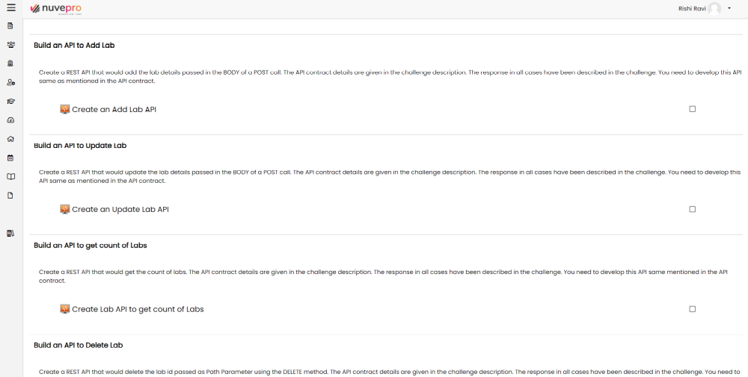

On submitting each of these assessments, the validation code is going to check if the REST API is behaving based on the contract.

Finally, you need to develop a Web Application based on Angular React that consumes these APIs.

Scenario

Your organization wants to develop a set of REST APIs that will perform the following actions. There shall be MySQL database – ‘nuveprodb’ created with table ‘lab_details’ having following columns lab_id int 10, lab_name varchar 200, lab_customer varchar 200, lab_type varchar 30, lab_category varchar 30 and primary key is lab_id. The CRUD operations shall happen on ‘nuveprodb’.
- Add the lab details received.
- Get the lab details by Lab ID and give the details in the response.
- Get the lab details by Client Name and give the details in the response.
- Get the lab details by Lab Name and give the details in the response.
- Get all lab details.
- Update the lab details.
- Delete the lab.
- Get the total lab count.

Once the APIs have been developed, create a Web Application using Angular React that would consume these APIs to perform different tasks.

Add Lab Details

Create a REST API that would add the lab details passed in the BODY of a POST call. The API contract details are given in the challenge description. The response in all cases have been described in the challenge. You need to develop this API same as mentioned in the API contract.

The base URI is 'http://localhost:8080' and the resource name is 'addLab' to form a POST request 'http://localhost:8080/addLab '.

base_uri: http://localhost:8080/addLab

Request Body
{
"id": 14,
"name": "AWS Cloud Practitioner",
"customer": "Customer T",
"type": "Account",
"category": "Project"
}

Response Success

When the response is success, you need to give a response json as given below and the HTTP Status response shall be 201, Created. It has to return a header 'Status' as 'Success'.

{
"id": 14,
"responseMessage": "Lab added successfully.",
"status": "Success"
}

HTTP Status 201, Created.
This call returns a Header as well in the Response. Check for Header – key Status, value Success

Response if Lab exists

If the lab id passed already exists, the Response shall be as given below and the HTTP Status shall be 202, Accepted.

{
"id": 14,
"responseMessage": "Lab already exists!!",
"status": "Request Accepted"
}

HTTP Status 202, Accepted.

Get Lab Details by Lab Id

Create a REST API to get the lab details by passing the lab id. The API contract details are given in the challenge description. The response in all cases have been described in the challenge. You need to develop this API same mentioned in the API contract.

base_uri: http://localhost:8080/labs/{{labId}}

Sample request: http://localhost:8080/labs/14

Request Response

When the response is success, you need to give a response json as given below and the HTTP Status 202, Accepted.

{
"id": 14,
"name": "AWS Cloud Practitioner",
"customer": "Customer T",
"type": "Account",
"category": "Project"
}

HTTP Status 202, Accepted.

Response if Lab doesn’t exist

{
"id": 18,
"response_message": "Lab doesn't exist!! Check the Lab Id."
}

HTTP Status 404, Not Found

Get Lab Details by Customer Name

Create a REST API to get the lab details by passing the customer’s name. The API contract details are given in the challenge description. The response in all cases have been described in the challenge. You need to develop this API same mentioned in the API contract.

base_uri: http://localhost:8080/labs/client?clientName={{ clientName }}

Sample Request: http://localhost:8080/labs/client?clientName=Customer T

Request Response

When the response is success, you need to give a response json as given below and the HTTP Status 200, Ok.

[
{
"id": 14,
"name": "AWS Cloud Practitioner",
"customer": "Customer T",
"type": "Account",
"category": "Project"
}
]

HTTP Status 200, OK.

Response if Lab doesn’t exist

{
"id": 18,
"response_message": "Lab doesn't exist!! Check the Customer Id."
}

HTTP Status 404, Not Found

Get Lab details by Lab Name

Create a REST API to get the lab details by passing the lab name. The API contract details are given in the challenge description. The response in all cases have been described in the challenge. You need to develop this API same mentioned in the API contract.

base_uri: http://localhost:8080/labs/lab?labName={{labName}}

Sample Request: http://localhost:8080/labs/lab?labName=Customer T

Request Response

When the response is success, you need to give a response json as given below and the HTTP Status 200, Ok.

[
{
"id": 14,
"name": "AWS Cloud Practitioner",
"customer": "Customer T",
"type": "Account",
"category": "Project"
},
{
"id": 764,
"name": "Azure Fundamentals",
"customer": "Customer T",
"type": "Current",
"category": "Assessment"
}
]

HTTP Status 200, OK.

Response if Lab doesn’t exist

{
"id": 18,
"response_message": "Lab doesn't exist!! Check the Customer Name."
}

HTTP Status 404, Not Found

Get all Lab Details

Create a REST API to get the all the lab details. The API contract details are given in the challenge description. The response in all cases have been described in the challenge. You need to develop this API same mentioned in the API contract.

base_uri: http://localhost:8080/labs/allLabs

Request Response
[
{
"id": 14,
"name": "AWS Cloud Practitioner",
"customer": "Customer T",
"type": "Account",
"category": "Project"
},
{
"id": 764,
"name": "AWS Cloud Practitioner",
"customer": "Customer T",
"type": "Account",
"category": "Assessment"
}
]

HTTP Status 200, OK.

If no labs exist return the String ‘Total count of labs: 7’ and HTTP status code 200, Ok.

Get Total Lab Count

Create a REST API that would get the count of labs. The API contract details are given in the challenge description. The response in all cases have been described in the challenge. You need to develop this API same mentioned in the API contract.

base_uri: http://localhost:8080/labs/labCount

Request Response

For this Get call, the Request Response shall be a String and an HTTP Status 200, Ok.

Total count of labs: 7

HTTP Status 200, Ok.

Update Lab Details for the Lab ID

Create a REST API that would update the lab details passed in the BODY of a POST call. The API contract details are given in the challenge description. The response in all cases have been described in the challenge. You need to develop this API same as mentioned in the API contract.

base_uri: http://localhost:8080/labs/updateLab/{{labIdToUpdate}}

Request Body
{
"name": "AWS Cloud Practitioner",
"customer": "Customer T",
"type": "Account",
"category": "Assessment"
}

Request Response

When the response is success, you need to give a response json as given below and the HTTP Status response shall be 200, Ok. It has to return a header 'Status' as 'Success'.

{
"labId": 764,
"response_message": "Lab details updated successfully."
}

HTTP Status 200, Ok.

Error response on updating invalid id

Error response on passing an invalid lab id to update.

{
"timestamp": "2022-07-21T16:10:32.432+00:00",
"status": 404,
"error": "Not Found",
"path": "/labs/updateLab /120"
}

HTTP Status 404, Not Found.

Delete the Lab by Lab ID

Create a REST API that would delete the lab id passed as Path Parameter using the DELETE method. The API contract details are given in the challenge description. The response in all cases have been described in the challenge. You need to develop this API same mentioned in the API contract.

base_uri: http://localhost:8080/labs/deleteLab/{{labIdToDelete}}

Request Response

When the response is success, you need to give a response json as given below and the HTTP Status response shall be 200, Ok.

{
"labId": 5,
"response_message": "Lab deleted successfully."
}

HTTP Status 200, Ok.

Error response on deleting invalid lab id
You need to give a response json given below and the HTTP status code shall be 404, Not Found

{
"timestamp": "2022-07-21T16:12:02.730+00:00",
"status": 404,
"error": "Not Found",
"path": "/labs/deleteLab/5"
}

HTTP Status 404, Not Found.

Angular React Web Application

Create a web application implementing all these APIs to perform respective actions.
- There shall be a login screen.

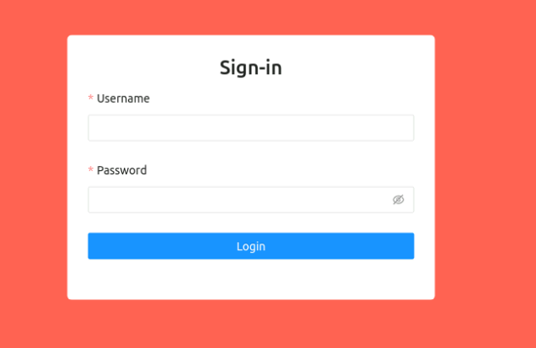

- Once admin login, he shall see all lab details.

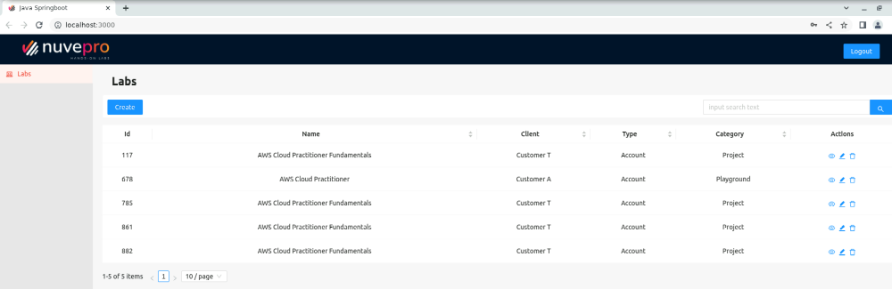

- He shall be able to add new labs.

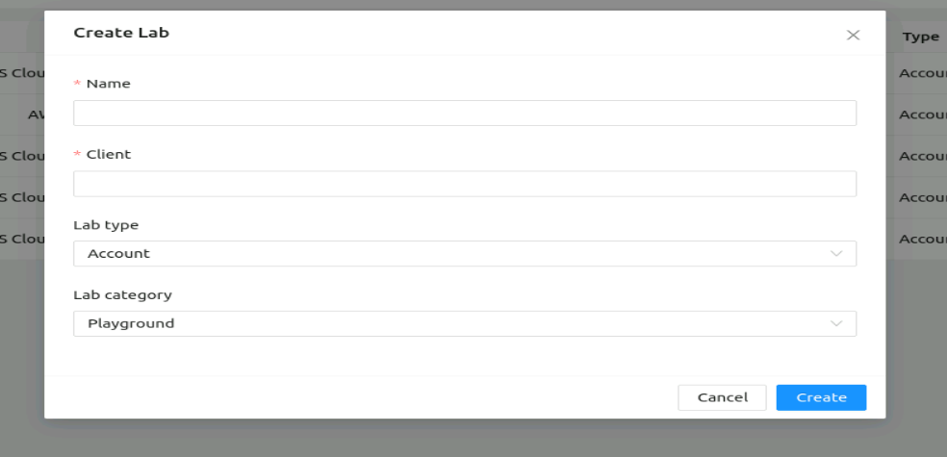
- He shall be able to edit existing lab.

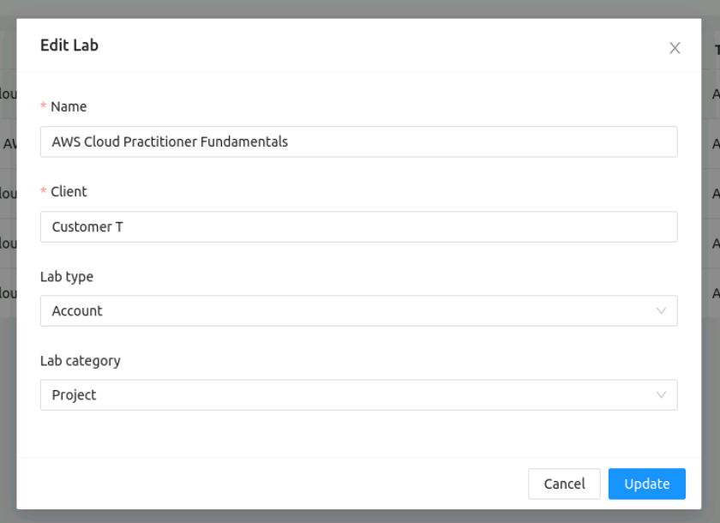

- He shall be able to delete lab.

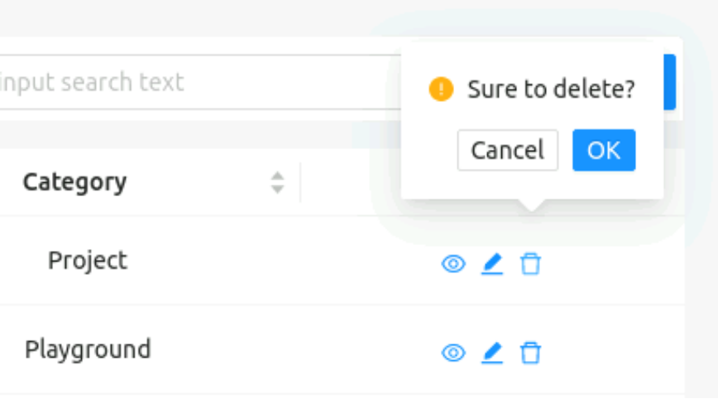

- He shall be able to search for lab, by Lab Name and by Customer Name.
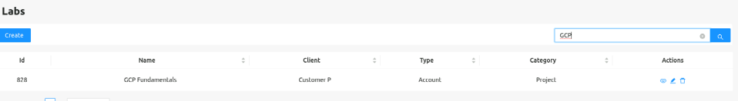

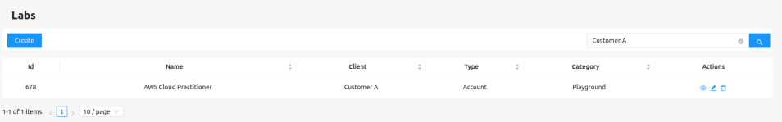

- He shall be able to view lab details.

