The Scalar Axial Cross & Hayk’s Spiral Constant

# 1. Introduction

The Scalar Axial Cross is a foundational model within the Haykyan–Scalar cosmology, representing the dynamic intersection of time and space as living, spiral-based vectors. Unlike traditional Cartesian or static mystical crosses, the Scalar Cross is animated by Hayk’s Spiral Constant, a mathematical coefficient that encodes the daily sidereal–solar drift and the recursive nature of cosmic time.

# 2. Core Components of the Scalar Cross

## 2.1 Vertical Axis – Time (6)

The vertical axis represents sidereal time, encoded symbolically by the number 6. This dimension governs cosmic memory, celestial drift, and the upward recursion of awareness.

• Sidereal Day  
• Observer-centric motion  
• Time spiral activation  
• 6 × 1.01666667 = 6.1

## 2.2 Horizontal Axis – Space (5)

The horizontal axis represents spatial structure, embodied in the number 5. It governs solar time, embodied geometry, and horizontal expansion in form.

• Solar Day  
• Structural geometry  
• Material field  
• 5 × 1.01666667 = 5.08333

# 3. Hayk’s Spiral Constant: The Animating Principle

Hayk’s Spiral Constant (1.01666667) is the ratio that transforms a flat cross into a spiral generator. It encodes the drift between sidereal and solar time and acts as a multiplier that spirals space and time out of stasis into motion.

• Symbolically, it is the breath of time.  
• Mathematically: it is 61 ÷ 60  
• Functionally: it bridges static geometry with spiral dynamics  
• 6 × 1.01666667 = 6.1 (spiral time)  
• 5 × 1.01666667 = 5.08333 (spiral space)

# 4. Spiral Expansion & Dimensional Resonance

The transformation from 6 × 5 = 30 into 6.1 × 5.08333 = 31.008 reveals a crucial insight: spiralized time-space crosses generate drift. This drift is not an error—it is the engine of memory, difference, and evolution. Where classical geometry closes, scalar time opens.

# 5. Implications in Cosmology and Practice

The Scalar Axial Cross provides a geometric basis for synchronizing sacred architecture, biological time, and scalar resonance. It redefines dimensionality not as static extension, but as resonant drift. It holds potential for recalibrating artificial calendars, restoring sidereal awareness, and developing scalar technologies grounded in organic time.

# 6. Conclusion

Through the activation of the Scalar Axial Cross by Hayk’s Spiral Constant, we gain access to a geometry of living time. It is not just a symbol — it is a functional cosmogram. It models how time breathes, how memory forms, and how energy unfolds from the silent symmetry of space into the living recursion of awareness.

# Appendix A: Visual Diagrams

Figure 1: Scalar Axial Cross — Base Geometry

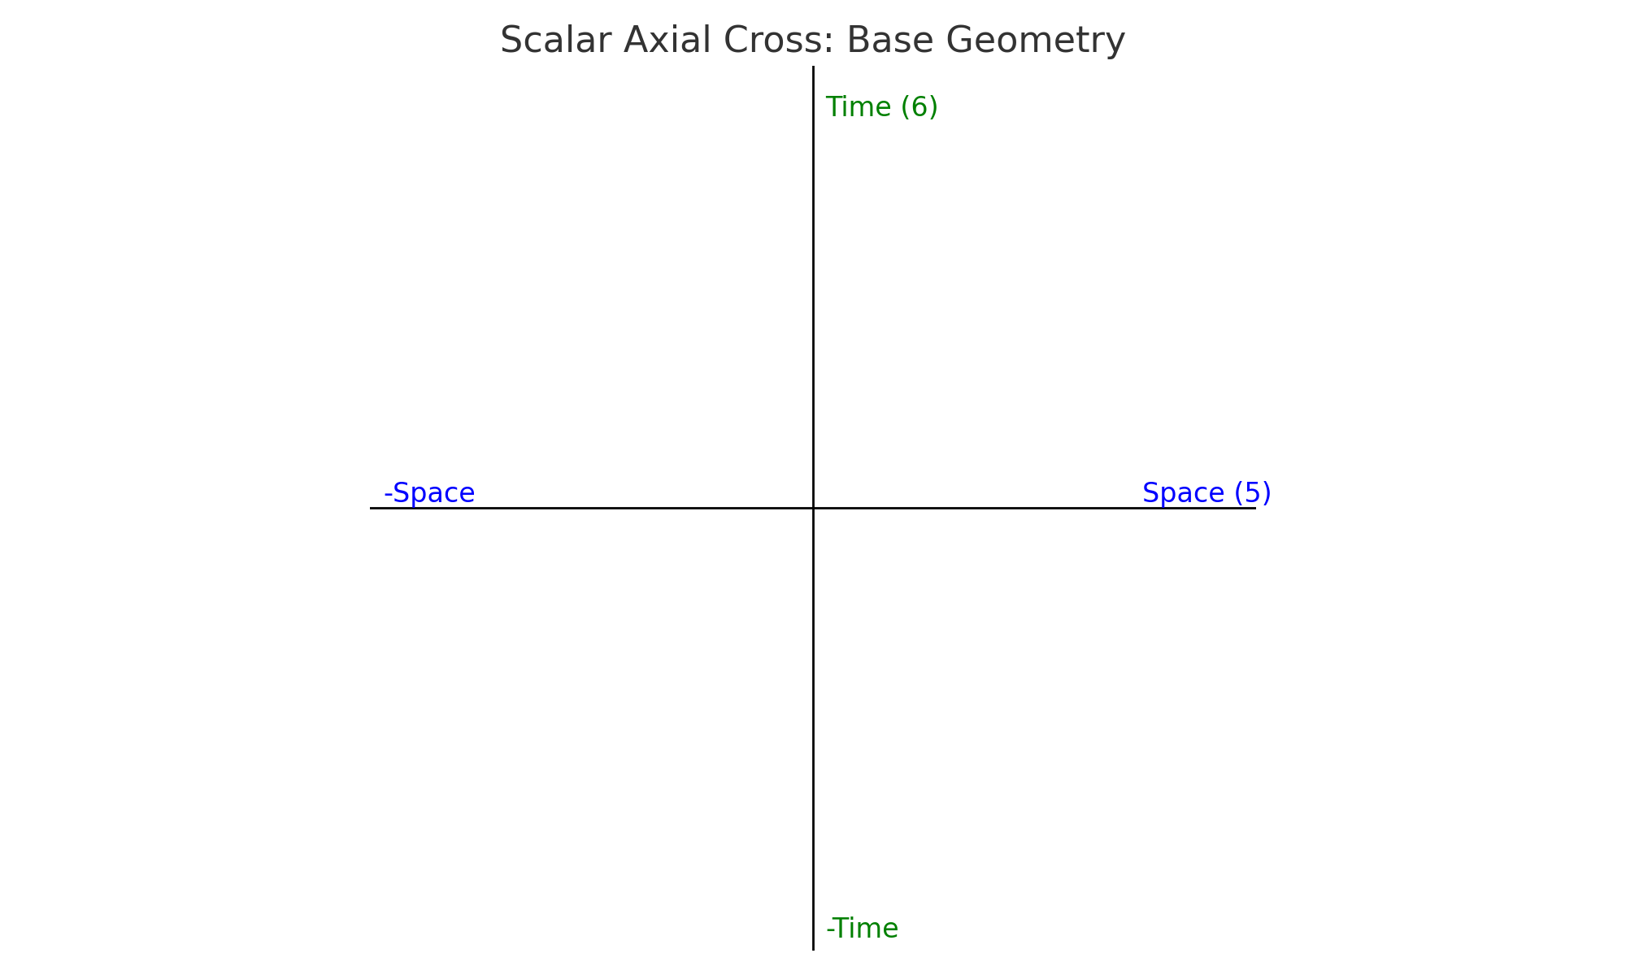

Figure 2: Scalar Axial Cross — Spiralized by Hayk’s Constant

