MOST. RITA MONI  Mohammadpur, Dhaka-1207  Contact: +8801531885751  E-mail: ritamoni515@gmail.com | 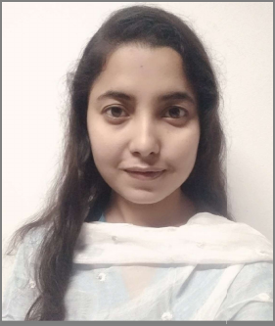

CAREER OBJECTIVE
To utilize my technical skills for achieving the target and developing the best performance in the organization with honesty. I would like to implement my innovative ideas, skills and creativity for accomplishing the projects. I want to build my career as a hard working and ambitious person.
SKILLS
Operating System : Windows (Windows 10, 11)
Office Program : Microsoft Office package (Word, Excel, Outlook, PowerPoint)
Google Drive (Docs, Sheets, Slides, Forms) & Spreadsheets.
Others : Web design and development (MERN)
EDUCATIONAL QUALIFICATION
Diploma in Computer Science Technology
Rangpur Polytechnic Institute, Rangpur
Duration: 2018-2022
CGPA: 3.81
PROFESSIONAL TRAININGS
MERN Stack Web Development
Programming Hero
Duration: Six Months
Awal Centre, Banani, Dhaka
Spoken English
Saifur's
Duration: Three Months
Rangpur Branch
LANGUAGES
Bangla : Native
English : Advanced
ACHIEVEMENTS
- Black belt certificate from Programming Hero.
- Leadership skills from ICT Olympiad Bangladesh.
PERSONAL DETAILS
Name : Most. Rita Moni
Father's Name : Md. Dalim Chowdhury
Mother's Name : Most. Anjuara Begum
Date of Birth : 31 July 2000
Religion : Islam
Marital Status : Unmarried
Nationality : Bangladeshi
Present Address : Mohammadpur, Dhaka-1207
Permanent Address : Radhakrishnopur, Hajirhat, Rangpur
PERSONAL EVALUATION
- Honest, ethical, energetic, sincere and reliable.
- Astonishing capability of adhering to any given responsibility to do perfectly.
- Strong leadership and organizing ability.
- Capable to work under any pressure with accuracy.
DECLARATION
I do hereby declare that the information given above is true and correct to the best of my knowledge and belief.
RITA
…………………………………………
Most. Rita Moni

