# **Cause of Death Project-**

Project Assigned Date:27/01/2023

Project Submission Date:9/02/2023

DALYs are measuring lost health and are a standardized metric that allow for direct comparisons of disease burdens of different diseases across countries, between different populations, and over time. One DALY represents one lost year of healthy life. The first ‘Global Burden of Disease’ (GBD) was GBD 1990 and the DALY metric was prominently featured in the World Bank’s 1993 World Development Report. Today it is published by both the researchers at the Institute of Health Metrics and Evaluation (IHME) and the ‘Disease Burden Unit’ at the World Health Organization (WHO), which was created in 1998. The IHME continues the work that was started in the early 1990s and publishes the Global Burden of Disease study.

In this Dataset, contains disease related mortality numbers from 1990 to 2019 which spans close to 30 years. Lifestyle related illnesses are diseases which have sprung up as a by-product of advancement and this has impacted every aspect of our life. The world just witnessed how a pandemic can change our lives forever. But beyond the pandemic there are a host of other illness which plague our everyday world and which influence the minds of our decision makers.

We have Historical Data of different cause of deaths for all ages around the World.

In this dataset there are 6120 rows and 34 columns

The key features of this Dataset are: Meningitis, Alzheimer's Disease and Other Dementias, Parkinson's Disease, Nutritional Deficiencies, Malaria, Drowning, Interpersonal Violence, Maternal Disorders, HIV/AIDS, Drug Use Disorders, Tuberculosis, Cardiovascular Diseases, Lower Respiratory Infections, Neonatal Disorders, Alcohol Use Disorders, Self-harm, Exposure to Forces of Nature, Diarrheal Diseases, Environmental Heat and Cold Exposure, Neoplasms, Conflict and Terrorism, Diabetes Mellitus, Chronic Kidney Disease, Poisonings, Protein-Energy Malnutrition, Road Injuries, Chronic Respiratory Diseases, Cirrhosis and Other Chronic Liver Diseases, Digestive Diseases, Fire, Heat, and Hot Substances, Acute Hepatitis.

In this Dataset, contains disease related mortality numbers from 1990 to 2019 which spans close to 30 years.

# **DISEASE SPECIFIC COUNTRY MORTALITY FOR 30 YEARS**

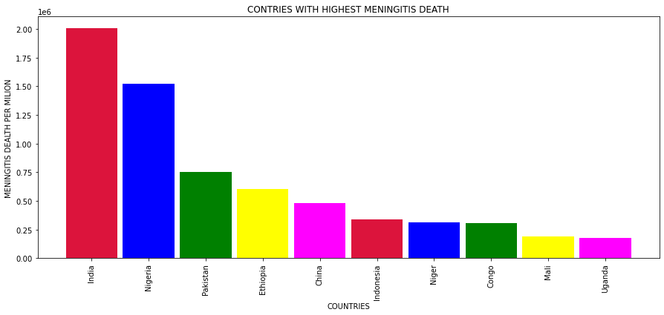

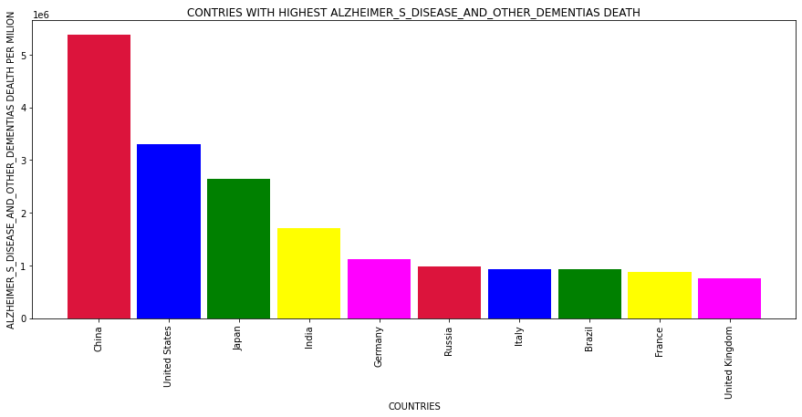

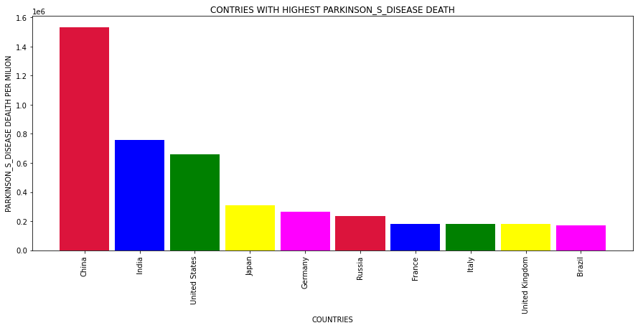

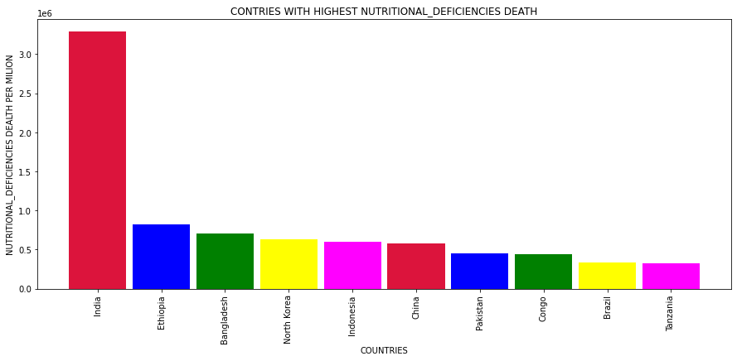

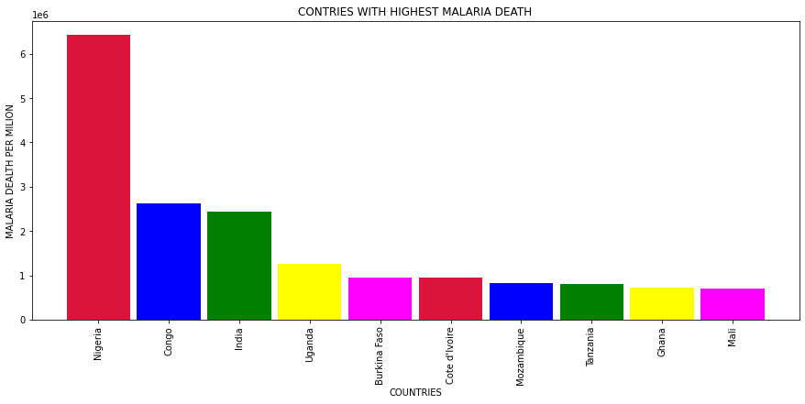

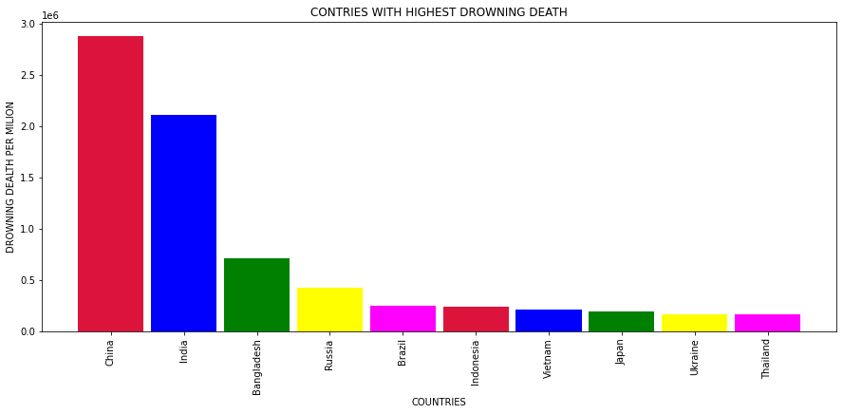

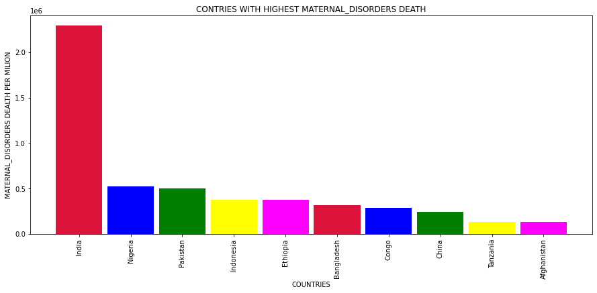

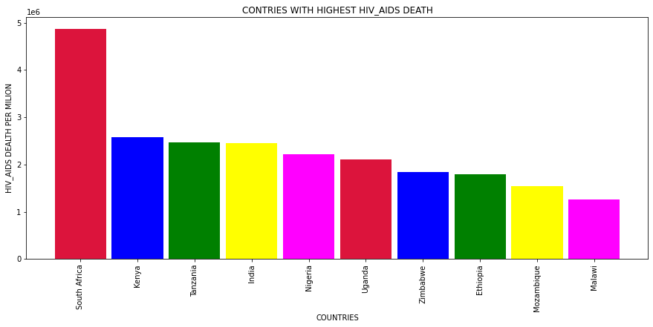

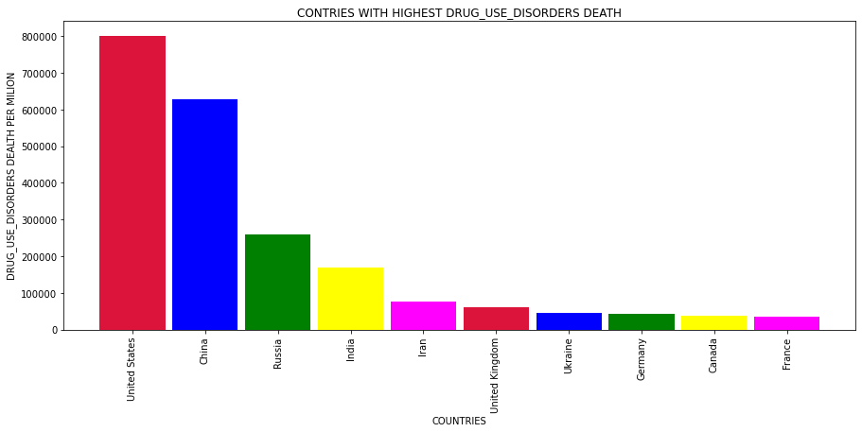

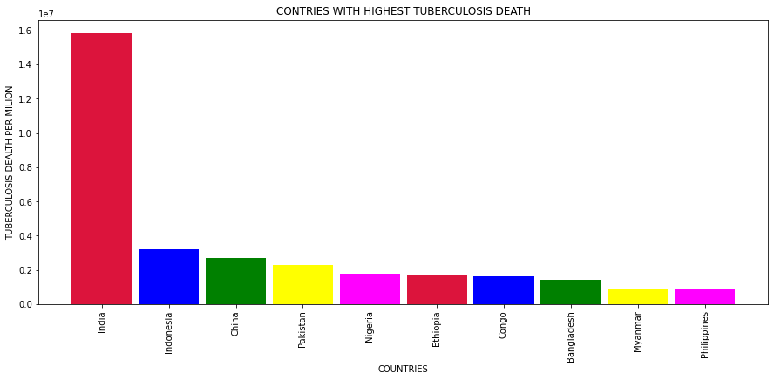

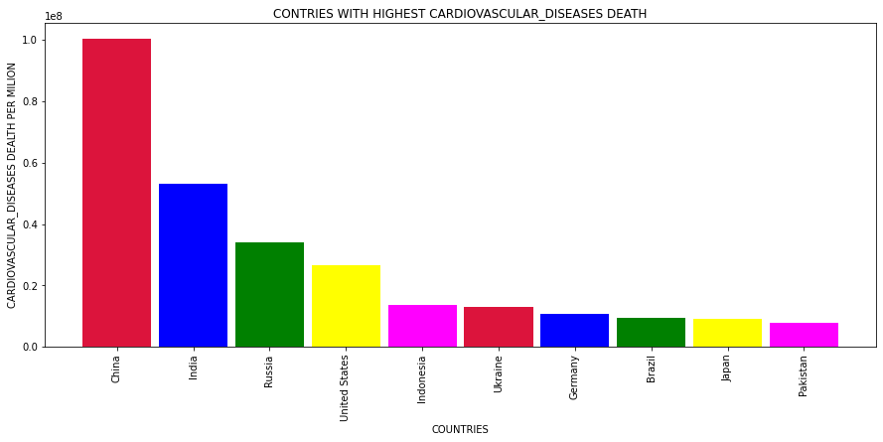

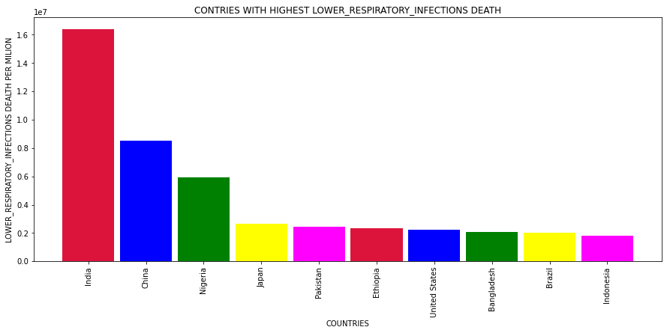



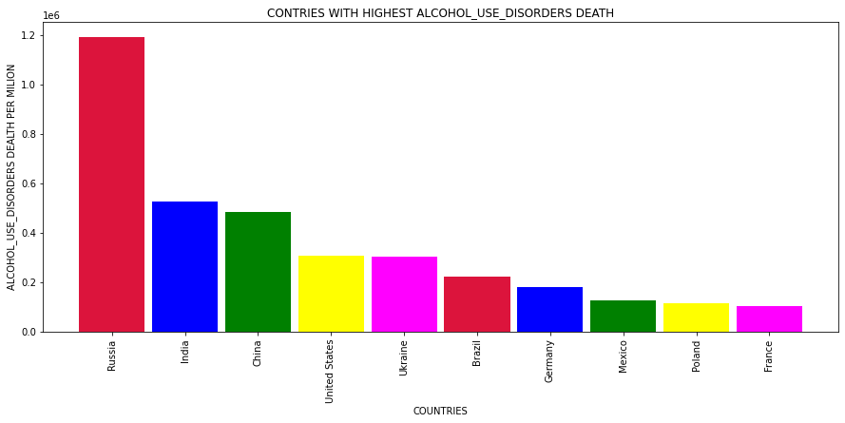

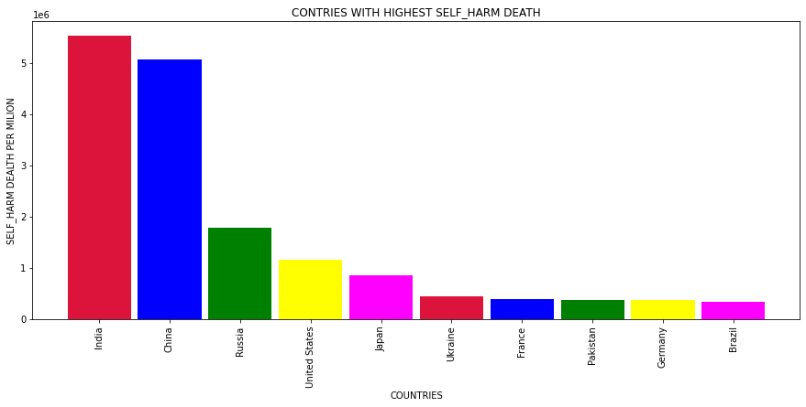

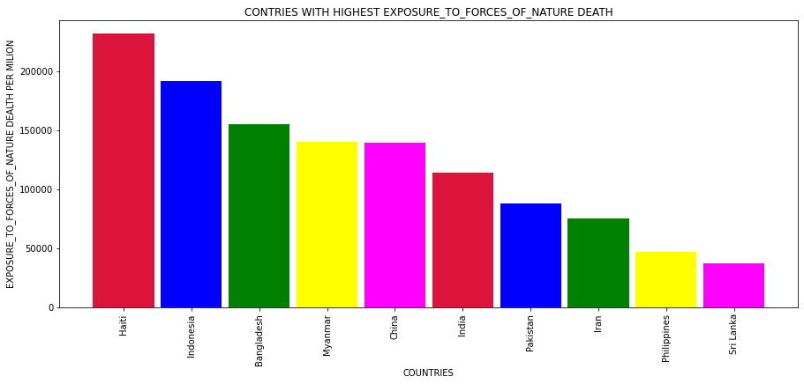

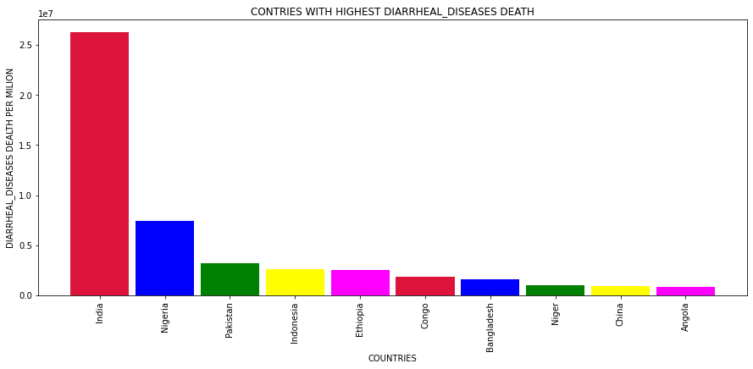

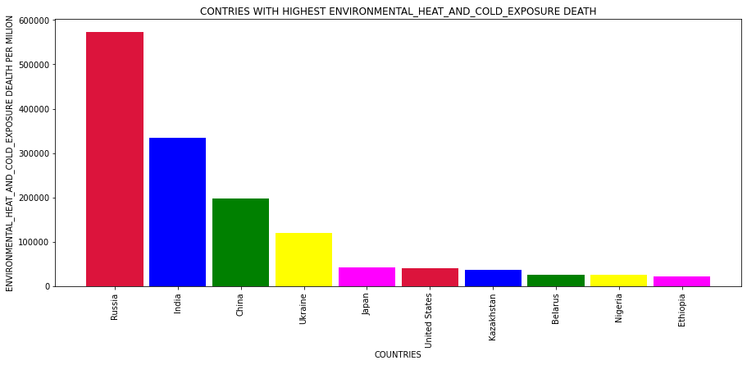

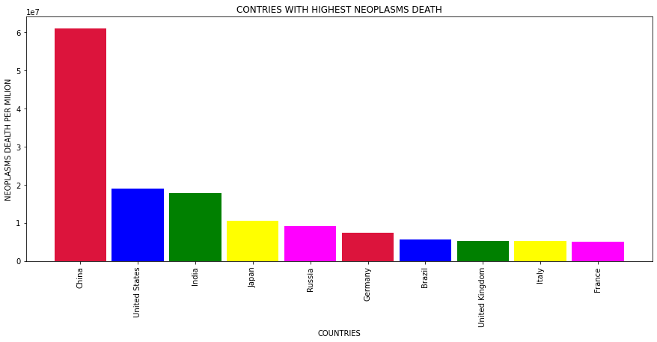

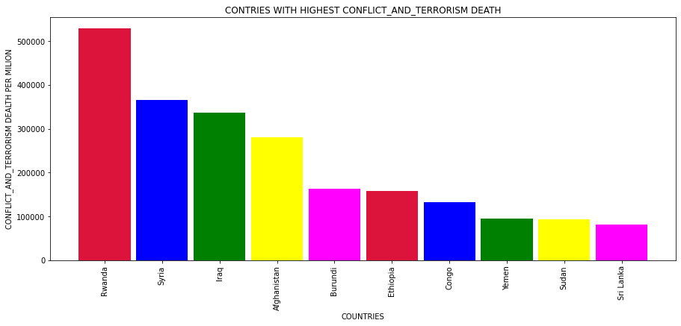

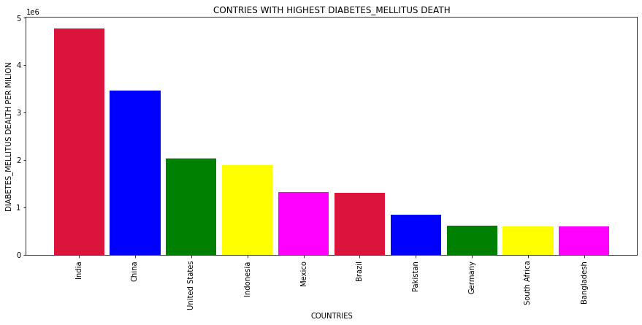

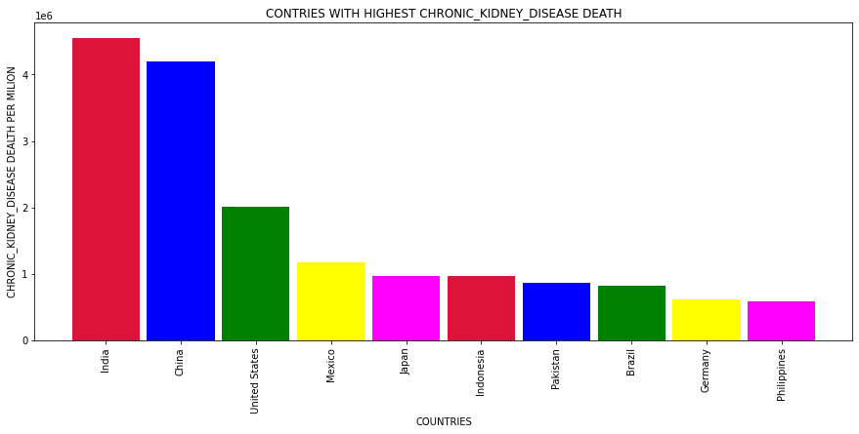

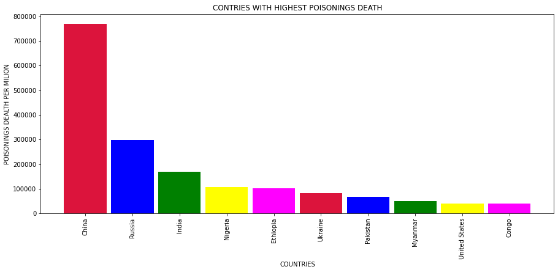

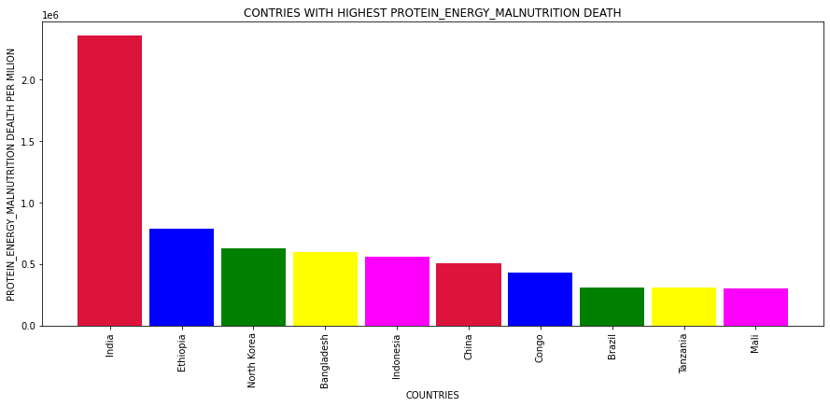

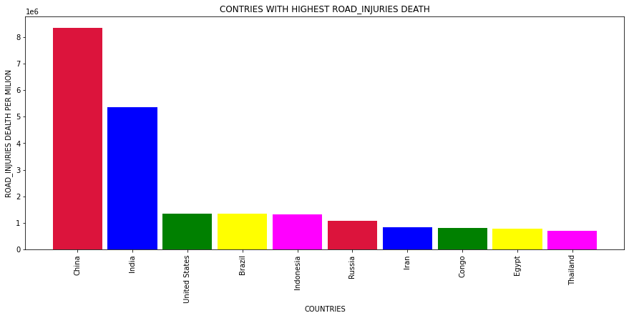

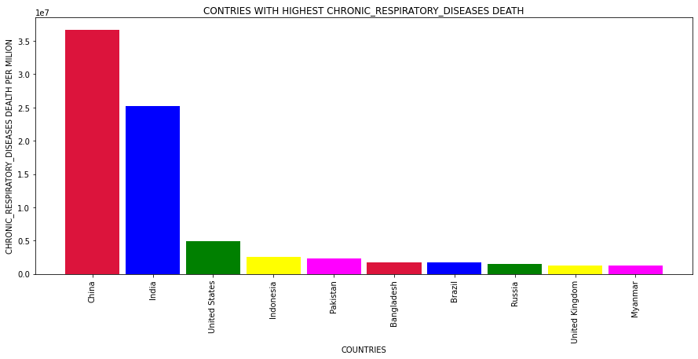

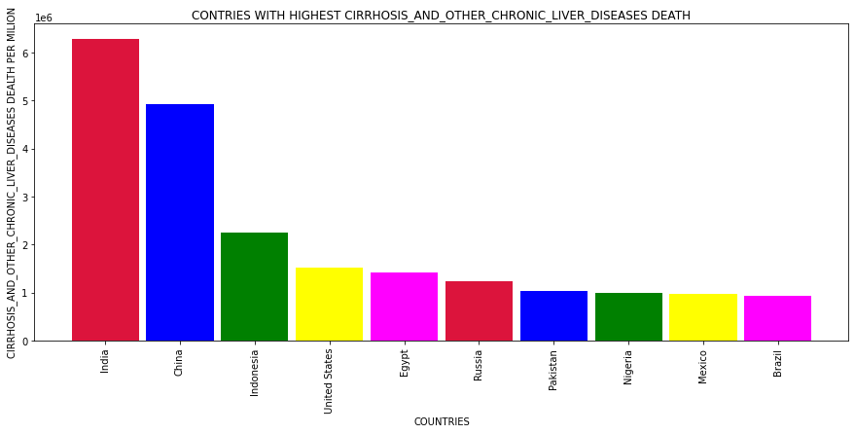

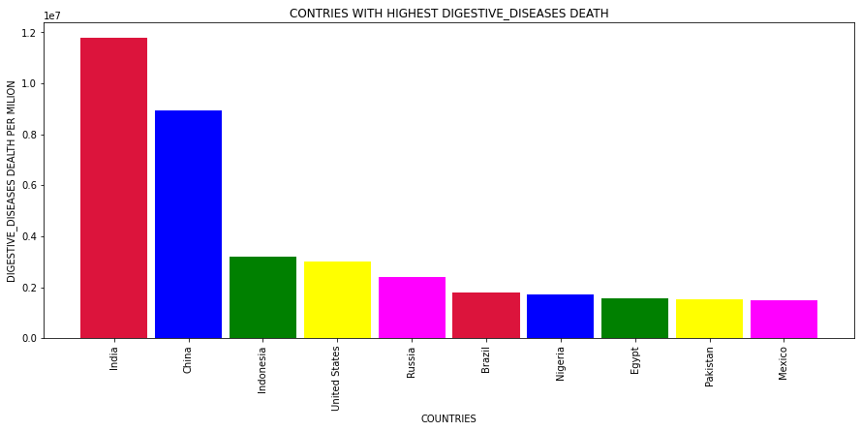

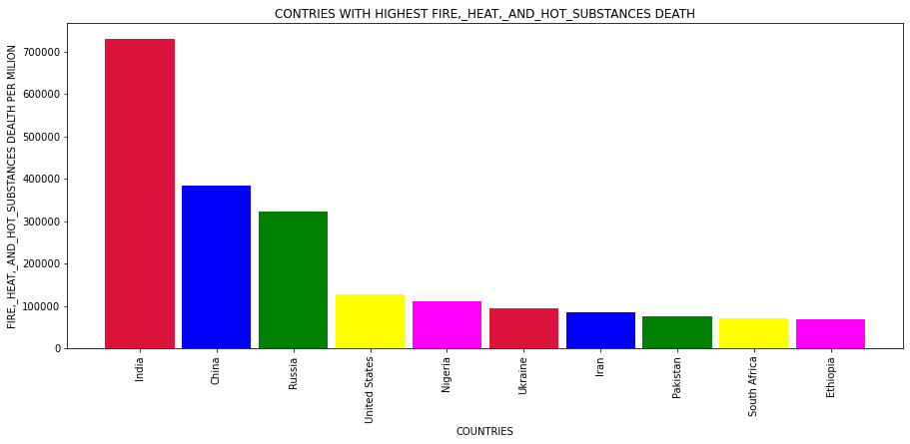

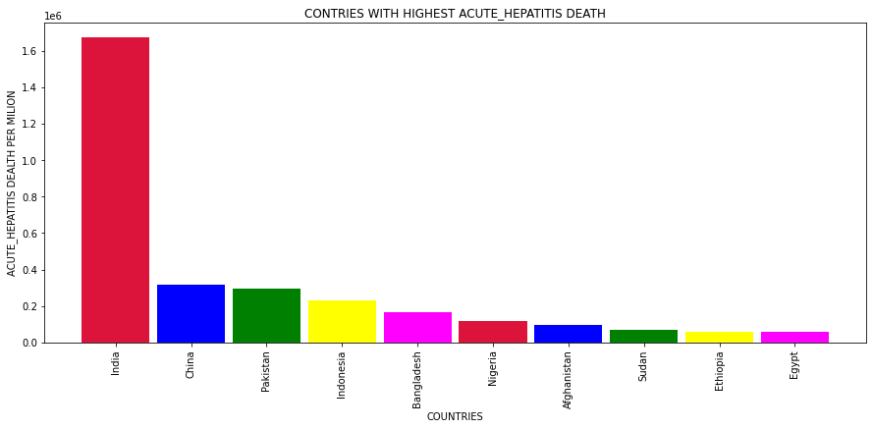

# **COUNTRY SPECIFIC DISEASE FATALITY FOR SPAN OF 30 YEARS¶**

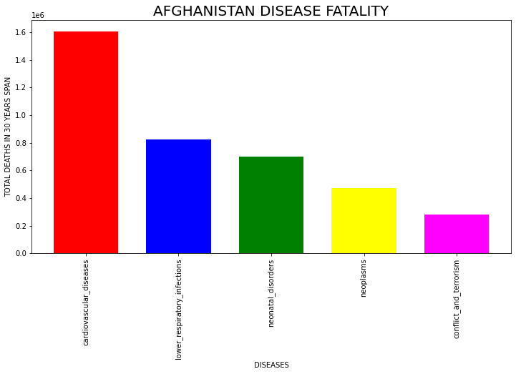

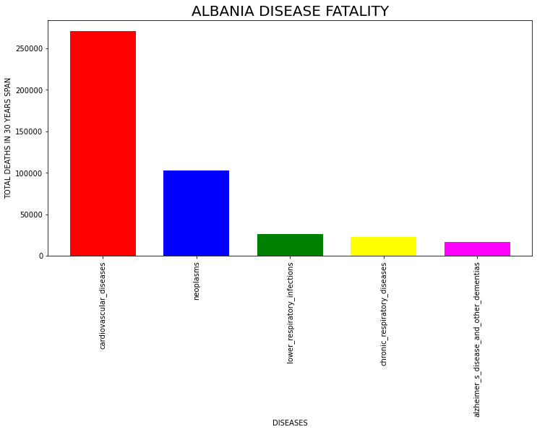

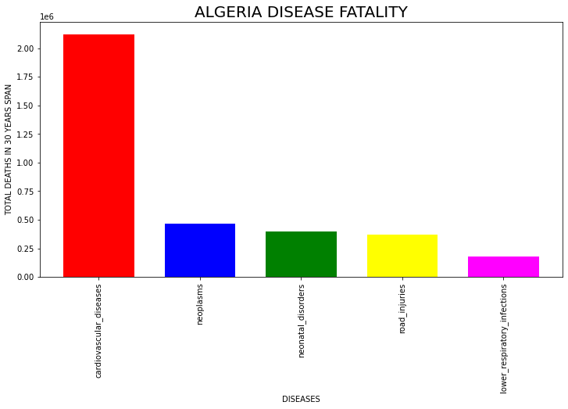

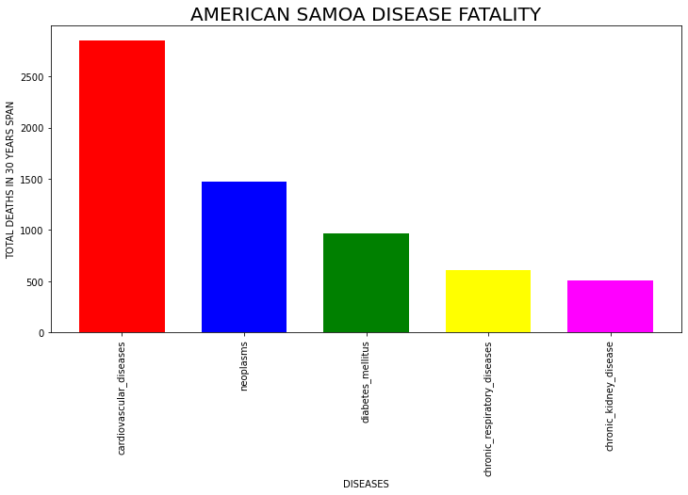

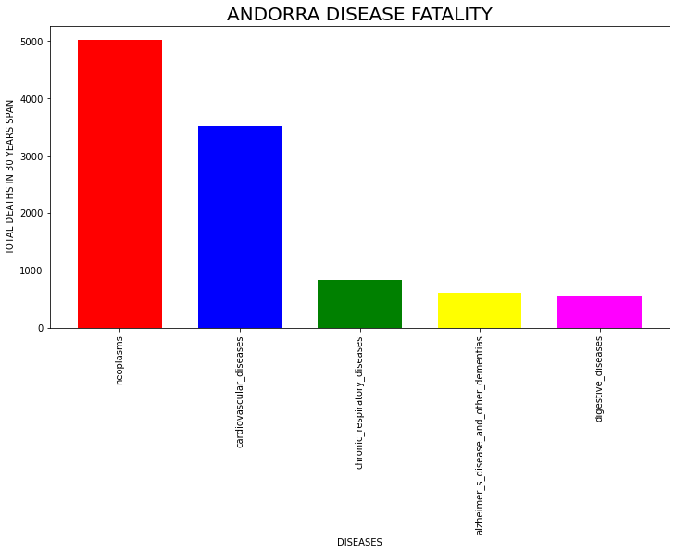

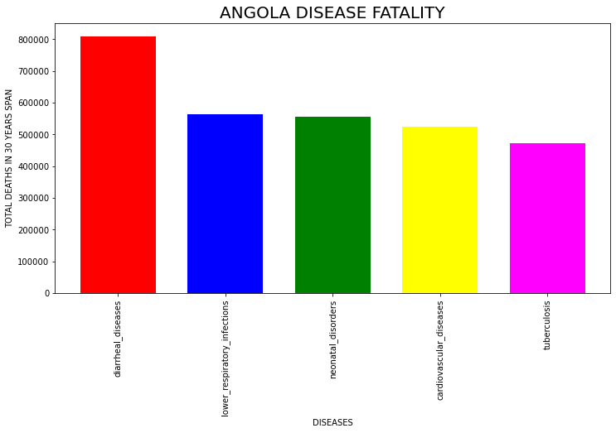

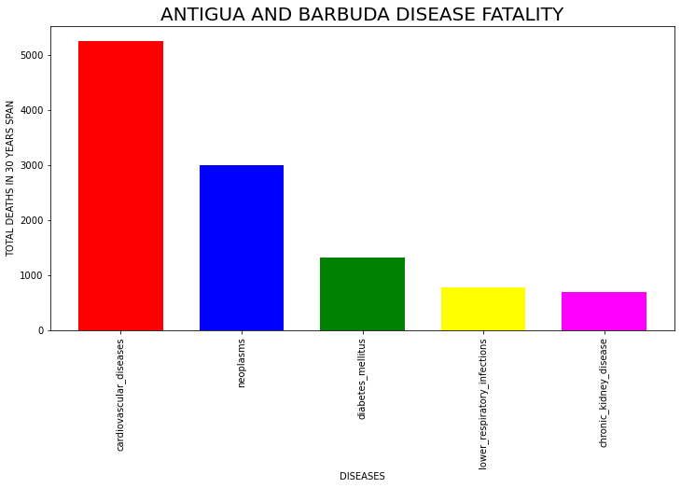

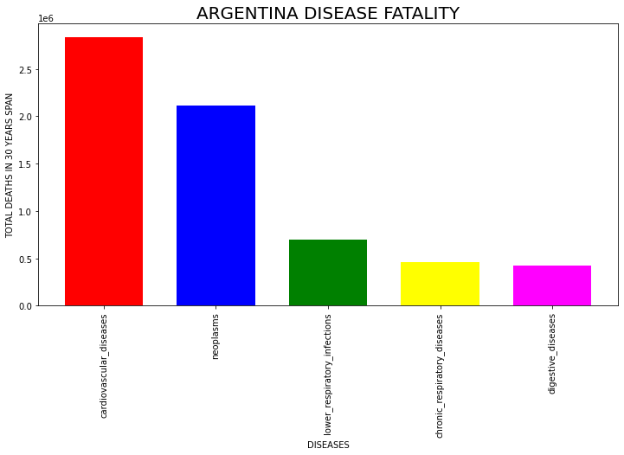

For all country we plotted bar plots graphs.

# **WHICH ARE THE COUNTRIES FACING OVERALL HIGHEST DEATHS DUE TO DISEASES**

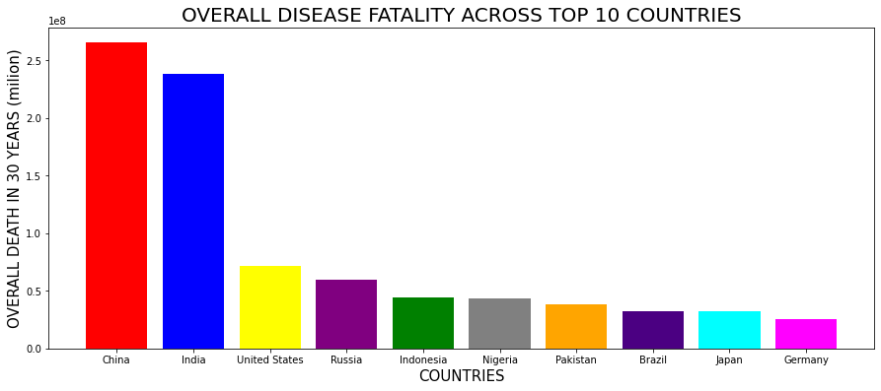

# **WHICH ARE THE TOP KILLER DISEASES IN THE WORLD**

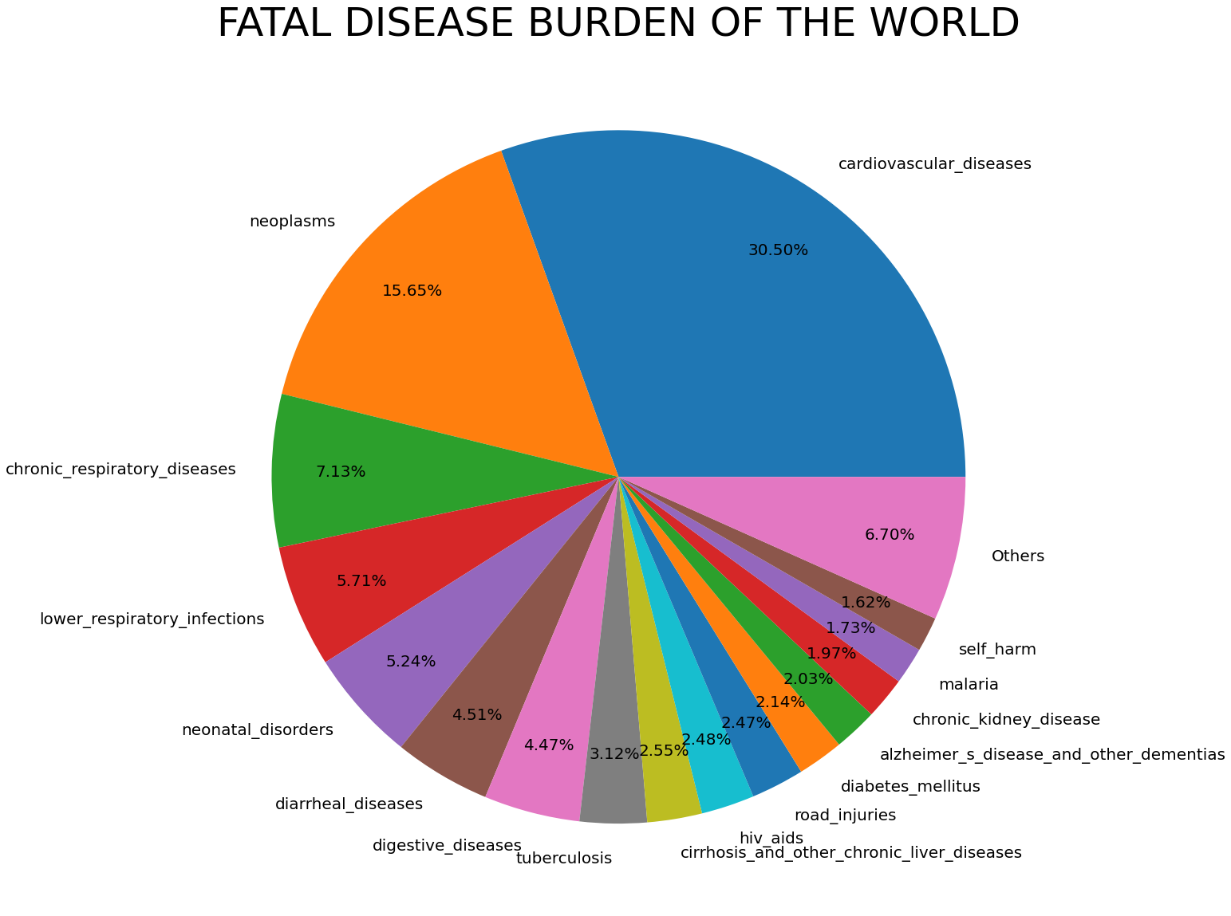

# **FATAL DISEASE BURDEN OF THE WORLD**

OBSERVATIONS - CHINA, INDIA AND USA face the largest brunt of deaths due to diseases in the world Cardiovascular diseases, Neoplasms (Malignancy/Cancer) and Lower Respiratory Tract Infections (for example: Pneumonia) are the top 3 killer diseases in the world.

# **Cardiovascular disease remains the leading burden of disease**

The number of deaths related to cardiovascular problems increases year by year, accounting for the highest proportion of all causes. Especially in countries with large populations and developed economies.

According to WHO data, heart disease is the largest cause of death in the world. In which, ischemic heart disease accounted for 16% and stroke accounted for 11% of global deaths. Since 2000, the number of deaths from the disease has increased the most, increasing by more than 2 million to 8.9 million deaths in 2019.

Especially in the current situation of COVID-19 epidemic, the risk of death often focuses mainly on the elderly population, with underlying medical conditions such as hypertension, cardiovascular disease and other chronic diseases. Data from Wuhan (China) show that the mortality rate accounts for 10.5% in people with COVID-19 with heart disease, 7.3% in people with diabetes, 6.3% in people with diabetes. people with respiratory disease and 6% in those with hypertension. On the other hand, worries about the epidemic situation and people's travel restrictions have led to cardiovascular patients delaying their follow-up visits. This is really dangerous for general chronic illness, which often has no obvious symptoms or signs.

|  |  |  |  |  |  |  |  |  |  |  |  |  |  |  |  |  |  |  |  |  |  |  |  |  |  |
| --- | --- | --- | --- | --- | --- | --- | --- | --- | --- | --- | --- | --- | --- | --- | --- | --- | --- | --- | --- | --- | --- | --- | --- | --- | --- |
|  |  |  |  |  |  |  |  |  |  |  |  |  |  |  |  |  |  |  |  |  |  |  |  |  |  |
|  |  |  |  |  |  |  |  |  |  |  |  |  |  |  |  |  |  |  |  |  |  |  |  |  |  |
|  |  |  |  |  |  |  |  |  |  |  |  |  |  |  |  |  |  |  |  |  |  |  |  |  |  |
|  |  |  |  |  |  |  |  |  |  |  |  |  |  |  |  |  |  |  |  |  |  |  |  |  |  |
|  |  |  |  |  |  |  |  |  |  |  |  |  |  |  |  |  |  |  |  |  |  |  |  |  |  |
|  |  |  |  |  |  |  |  |  |  |  |  |  |  |  |  |  |  |  |  |  |  |  |  |  |  |