List Examples:  
  
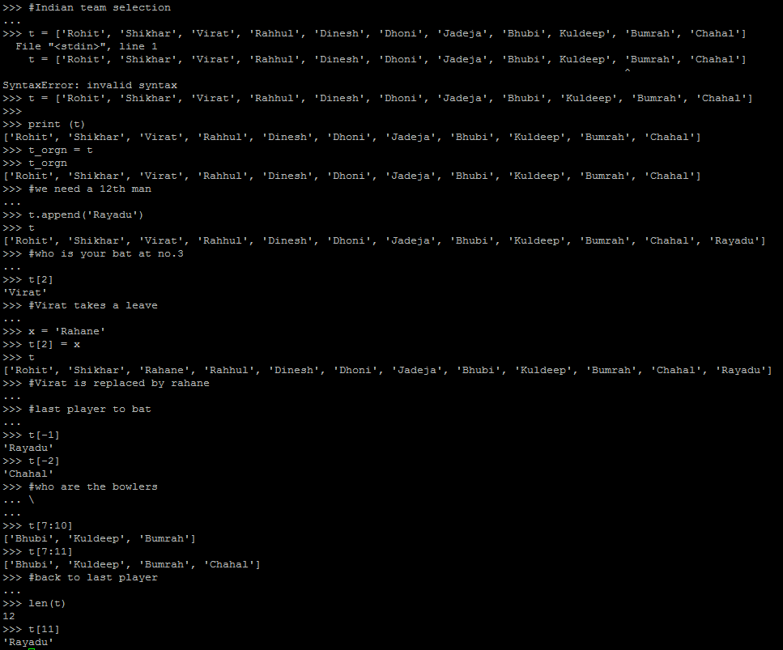

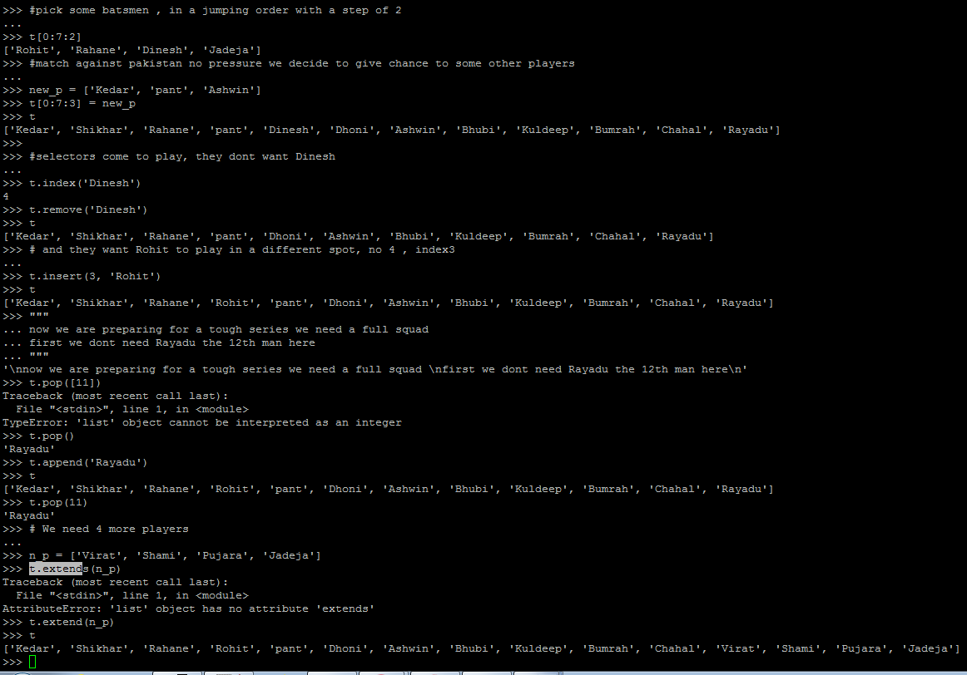

Taking user Input and Remembering Tuple:

**#!/usr/bin/python3**

**name = input("What is your name? ")**

**birthdate = input("What is your birthdate? ")**

**age = input("How old are you? ")**

**tup = (name, birthdate, age)# its immutable**

**print("Hey %s , See, you were born on %s, so can say you are %d years old" % tup)**

**age = int(age)**

**print(" Half of "+name+"\'s age is "+(age/2))**

***#Python3.6 utilities***

***#print(f"{name} was born on {birthdate}")***

***#print(f"Half of his age is {age / 2}")***

Discussing Function and remembering Dict:

