**Q.1 ---> FIND THE STADIUM WHERE THE MOST MATCH PLAYED (2008-2024)**

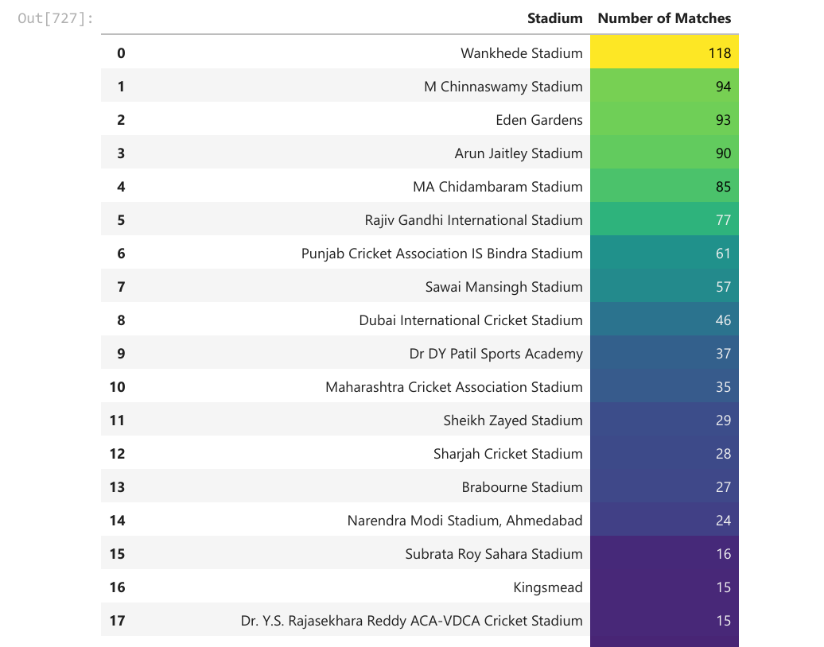

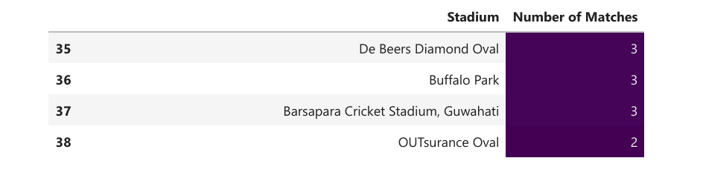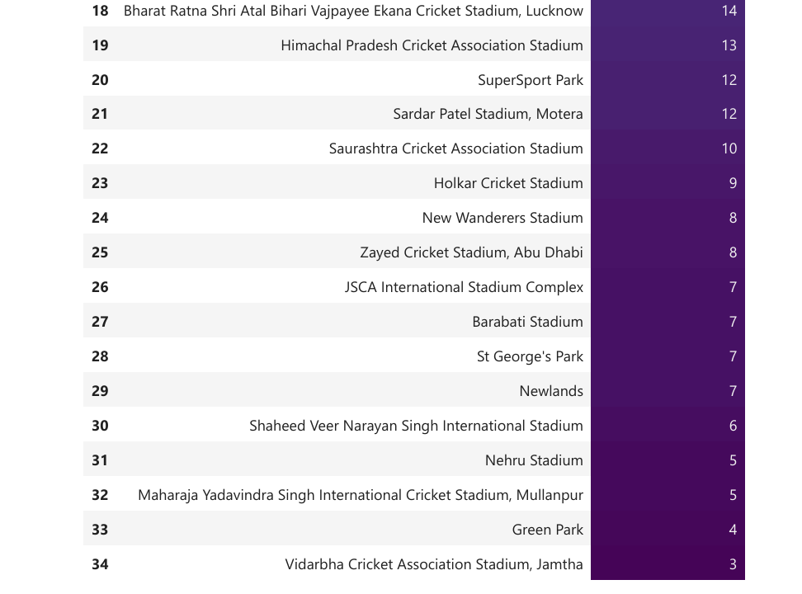

**CONCLUSION - - ->>*TILL NOW Wankhede Stadium HOLDS THE HIGHEST NUMBER OF MATCH PLAYED.***

***---------------------------------------------------------------------------------------------------------------***

**Q.2 ---> TOTAL RUNS ACCROSS SEASON**

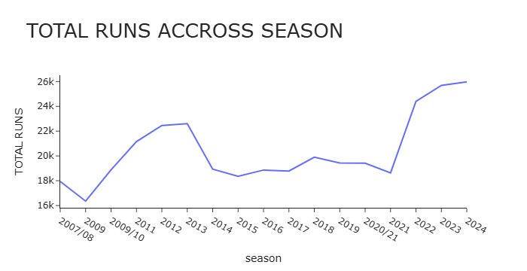

***CONCLUSION --> DAY BY DAY THE RUNS BUBBLE IN IPL INCREASING.***

**Q.3 ---> UMPIRE WITH MOST NUMBER OF UMPIRING.**

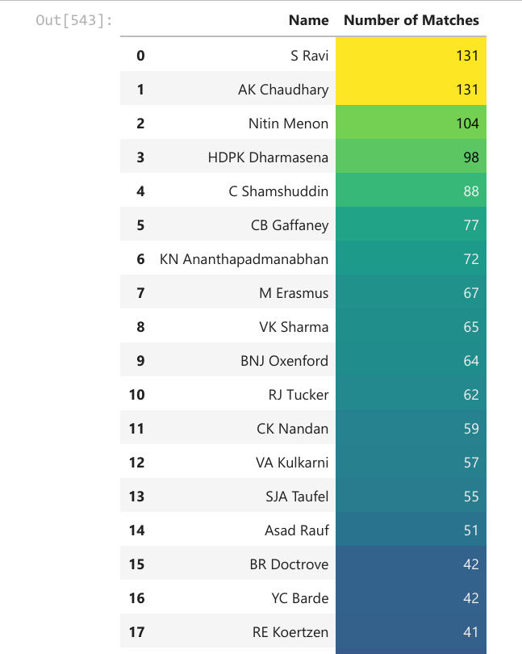

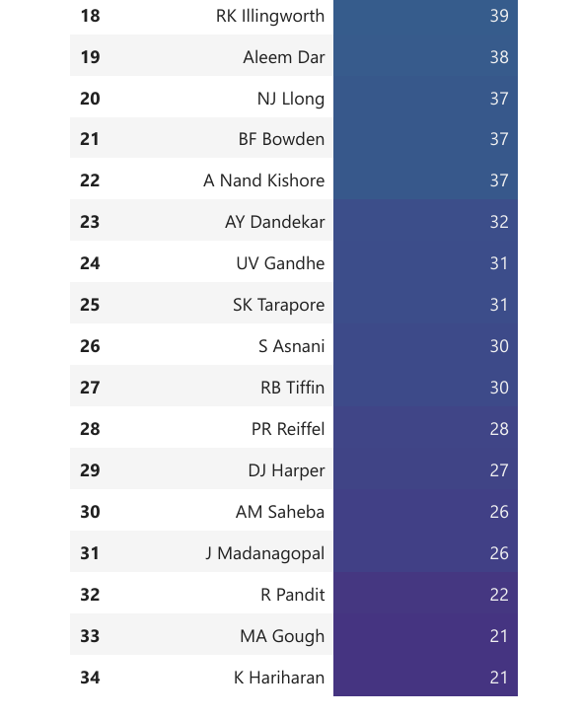

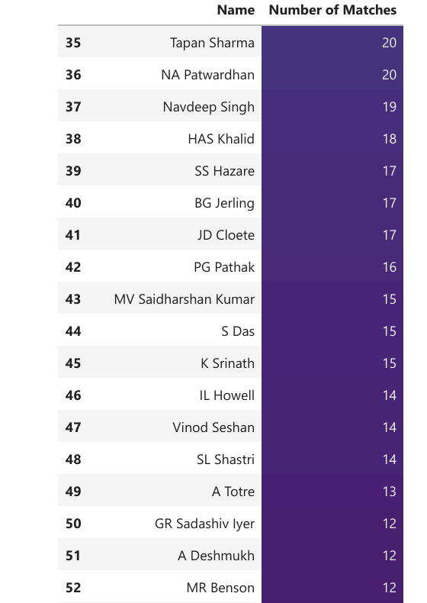

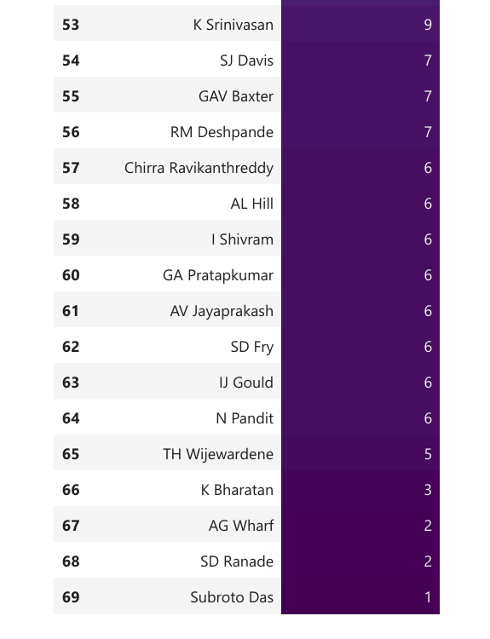

**CONCLUSION -- *S RAVI AND AK CHAUDHARY HAS UMPAIRED IN 131 MATCHES, FOLLOWED BY NIT IN MENON WHO HAS UMPAIRED 104 MATCHES.***

***---------------------------------------------------------------------------------------------------------------***

**Q.3 ---> MOST NUMBER OF TOSS WINNER IN THE IPL SEASON.**

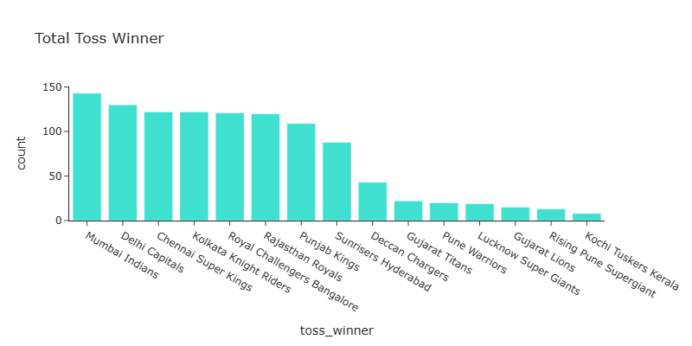

**CONCLUSION --- Mumbai Indians HAS WON THE HIGHEST NUMBER OF TOSS (143) , FOLLOWED BY DELHI CAPITALS (130).**

**---------------------------------------------------------------------------------------------------------------**

**Q.4 --> Which decision was made after winning the toss.**

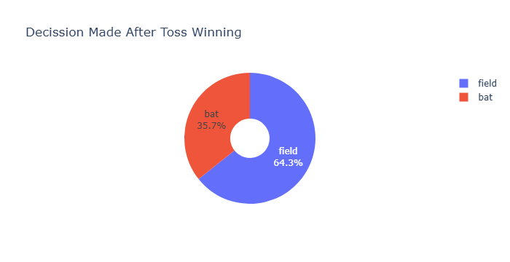

***CONCLUSION --- ITS A TENDS TO CHOOSE FIELD FIRST AFTER WINNING THE TOSS.***

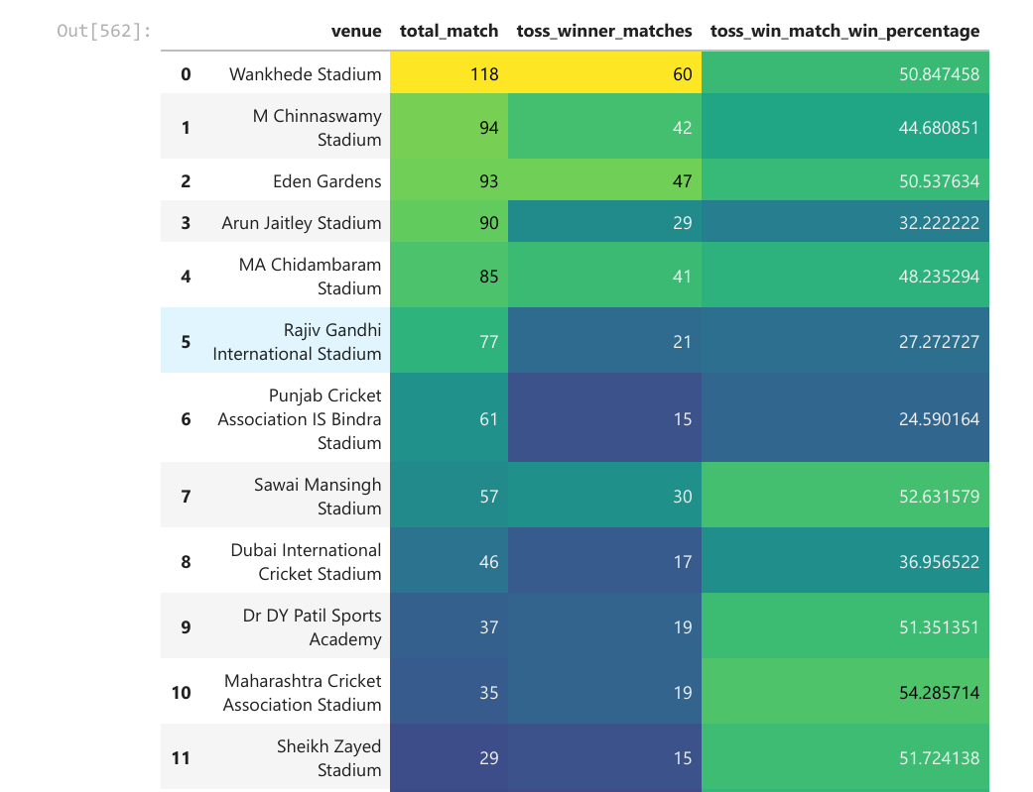**Q.5 ---> VENUE WISE TOSS WIN MATCH WIN PERCENTAGE.**

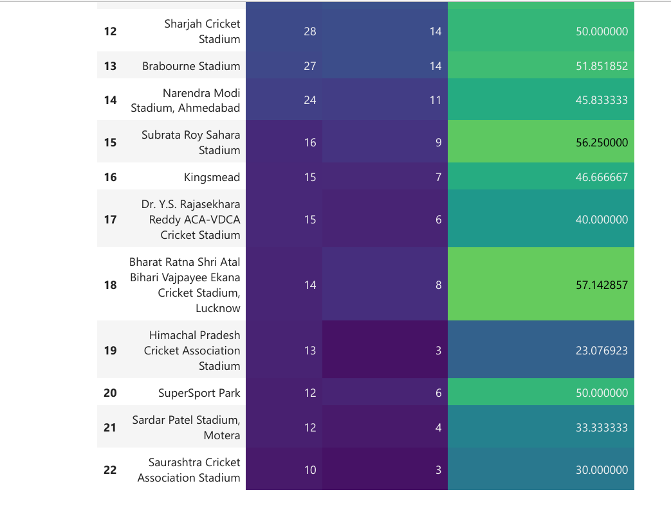

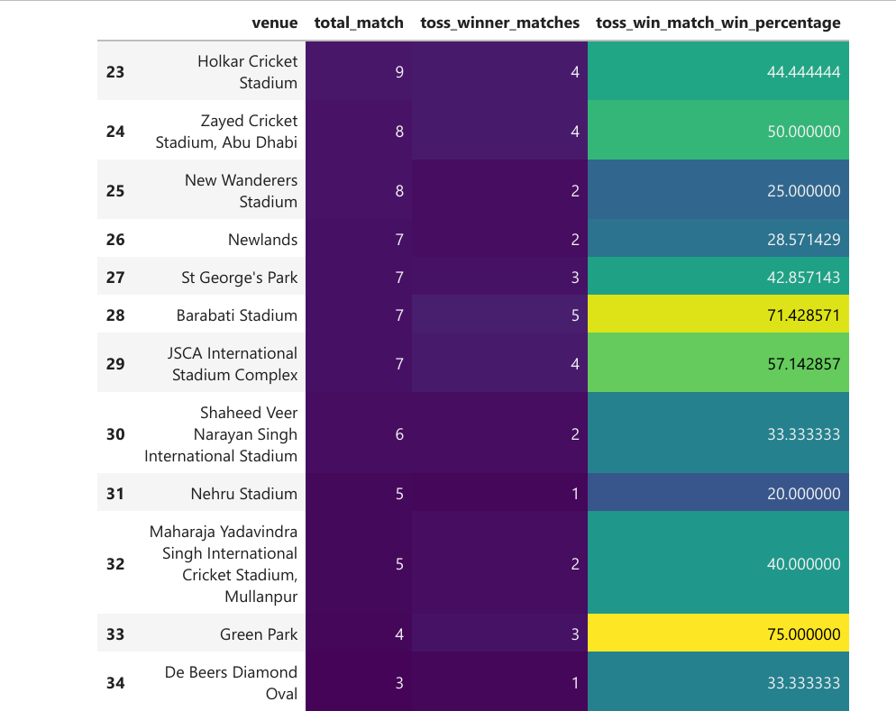

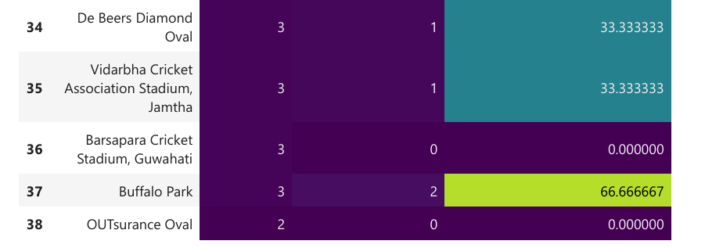

**Conclusion: From the data, we can clearly see that at Wankhede Stadium, a total of 118 matches were played, out of which 60 were won by teams that won the toss. This gives a toss-win match-win percentage of 50.84%, which is the highest. The second highest is at M. Chinnaswamy Stadium, with a toss-win match-win percentage of 44.68%.**

**---------------------------------------------------------------------------------------------------------------**

**Q.6 --> TEAM'S WON THE TOURNAMENT.**

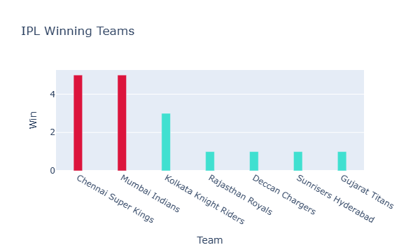

***CONCLUSION --- Chennai Super Kings WON THE MOST TOURAMENT TITLE 5 TIMES ALONG WITH THE Mumbai Indians, FOLLOWED BY Kolkata Knight Riders WITH 3 TROPHY.***

**Q.7 ---> FIND THE TOTAL MATCHS AND WIN MATCHES BY EACH TEAM.**

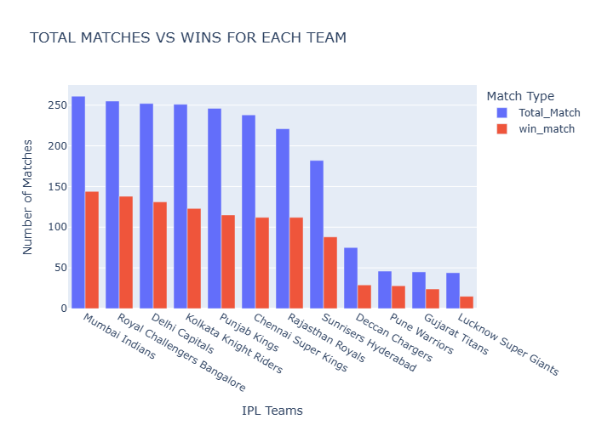

***CONCLUSION --- Mumbai Indians PLAYED 261 MATCHES AND WON 144 MATCHES, Royal Challengers Bangalore PLAYED 255 MATCHES AND WON 138 MATCHES...Delhi Capitals(252) and Kolkata Knight Riders(251) both played 250+ matches.***

**Q.8 ---> LUCKY VENUE FOR A TEAM.**

**Lucky venue for RCB-**

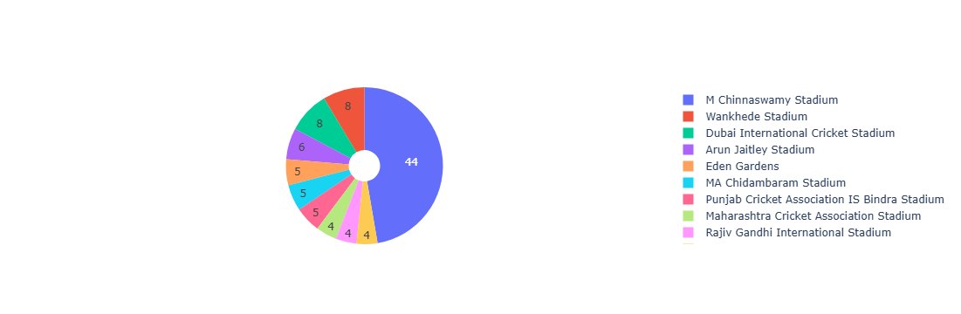

**Lucky venue for Mumbai Indians-**

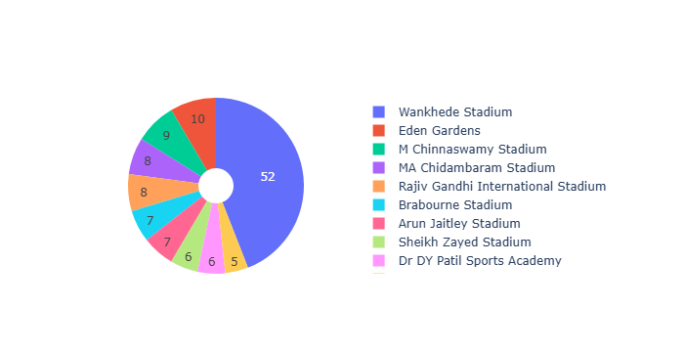

**Lucky venue for Chennai Super Kings –**

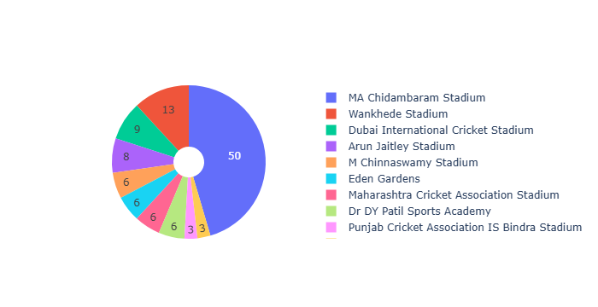

**CONCLUSION --- FROM HERE WE CAN COLCLUDE THAT EACH TEAMS FAVOURITE VENUE IS THEIR HOME GROUND.**

**Q.9 ---> FIND OUT EACH TEAM FIGHT HEAD TO HEAD**

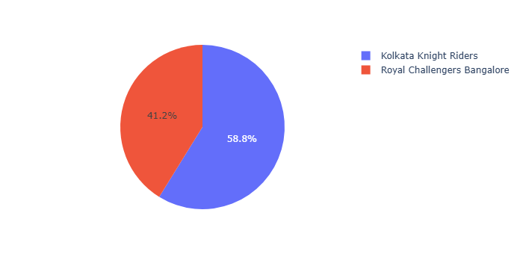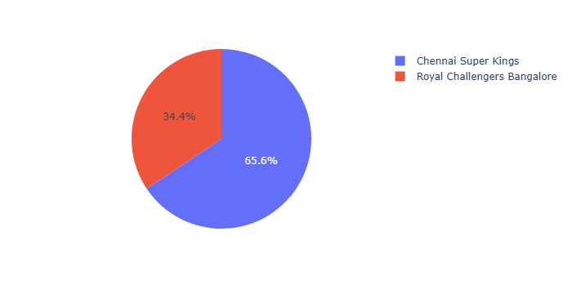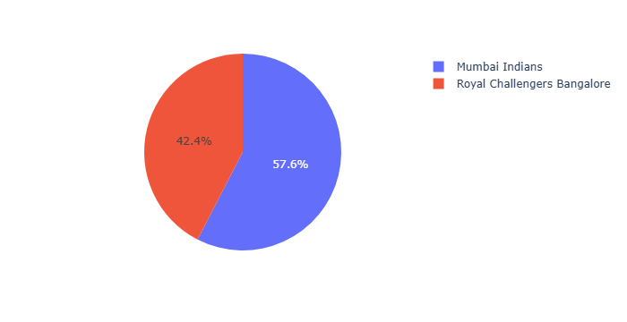

**Q.10 ---> TOP 5 PLAYERS WITH HIGHEST RUNS.**

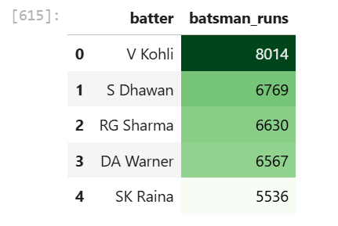

***KING KHOLI COMES WITH THE HIGHEST RUN SCORERS.***

**Q.11 ---> Individual player performance analysis: Here, I analyze Virat's performance.**

**Q.11A --> KOHLI'S RUN ANALYSIS**

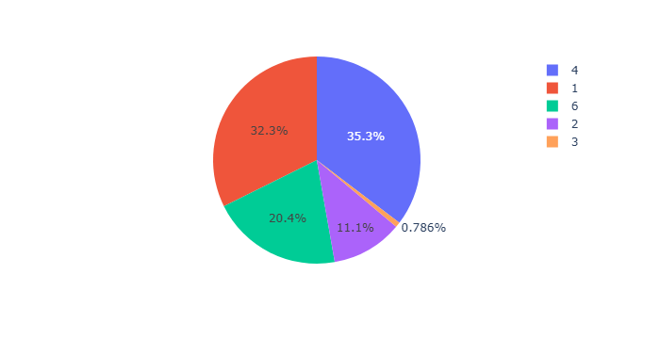

***VIRAT KOHLI RUN ANALYSIS HE SCORED scored 2591 by taking 1's (32.3%) , virat scored 890 by taking 2's(11.1%) ,HE scored 63 by taking 3's ,virat scored 2832 by hiting 4's (35.3%) AND scored 1638 by hiting 6's (20.4%),KING LOVES TO TAKE SINGLE ALSO HE LOVE TO HIT 4'S***

**Q.11B --> KHOLI'S DISMISSAL ANALYSIS**

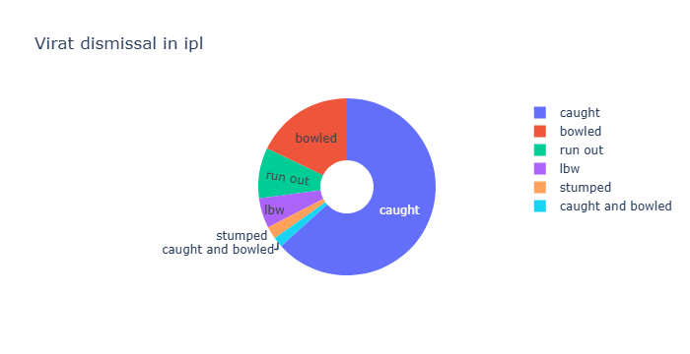

***MOST OF THE TIME HE CAUGHT OUT (63.3%) FOLLOWED BY BOWLED OUT(17.9%).***

**Q.11C --> WHO TAKES KOHLI'S WICKET MOST OF THE TIME.**

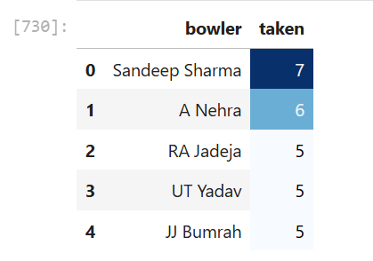

***7 TIMES Sandeep Sharma SEND HIM TO THE PAVILION ,FOLLOWED BY ASHISH NEHRA 6 TIMES.***

**Q.11D --> KOHLI'S FIRST AND SEOCEND INNINGS COMPARISION.**

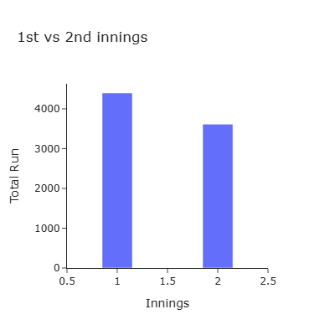

***IN INNINGS 2 HE SCORED 3614 RUNS ALMOST HALF OF HIS ENTIRE RUN ,A ABSOLUTE CHASE MASTER.***

**Q.11E --> KOHLI'S RUNS AGAINST EACH TEAM**

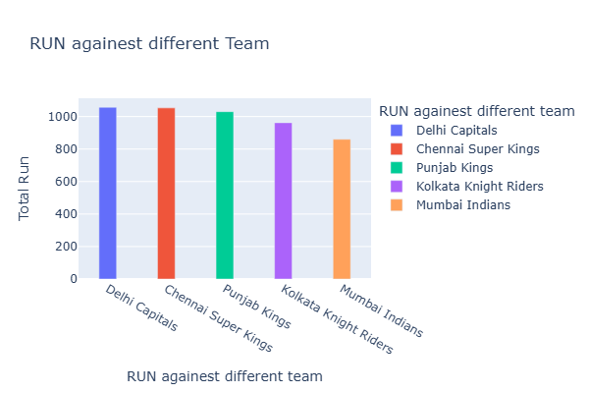

***FROM THIS WE CAN SAY THAT HIS FAVOURITE OPPONENTS ARE Delhi Capitals (1057 RUNS) , Chennai Super Kings (1053 RUNS), Punjab Kings (1030 RUNS).***

**Q.11F --> HIS FAVOURITE VENUE.**

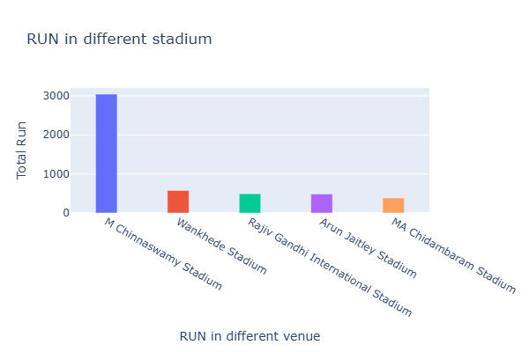

***OF COURSE M Chinnaswamy Stadium WITH 3040 RUNS.***

**Q.11G --> KING'S RUNS BY EACH SEASON**

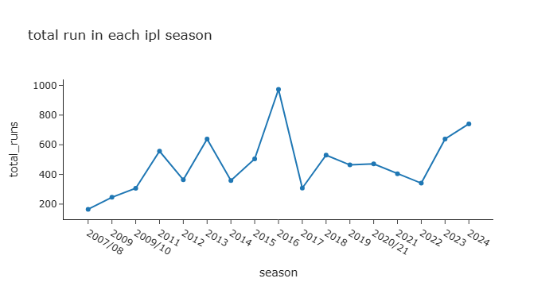

***CONCLUSION --- KING'S PICK YEAR WAS 2016 WITH 973 RECORD BRACKING RUN , AFTER THAT THERE WAS A DOWNFALL, BUT THEN THE LAST TWO YEARS HE CAME BACK SUPREMLY 2023 WITH 639 RUNS ,2024 WITH 741 RUNS, ORANGE CUP WINNER.***

***Q.12 ---> HIGHEST WICKET TAKER.***

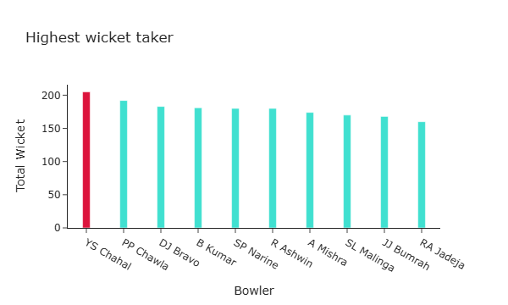

***CONCLUSION --- YS Chahal HOLDS THE HIGHEST WICKET TAKER WITH 205 WICKET, FOLLOWED PP Chawla WITH 192 WICKET.***

***Q.13 ---> INDIVIDUAL BOWLER PERFROMANCE ANALYSIS . I CHOOSE YS Chahal.***

***DISMISSAL TYPE—***

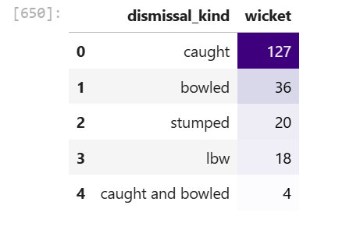

***CONCLUSION --- MOST NUMBER OF TIME ,127 TIMES HE TOOK WICKET BY CAUGHT.***

***FAVOURITE VENUE—***

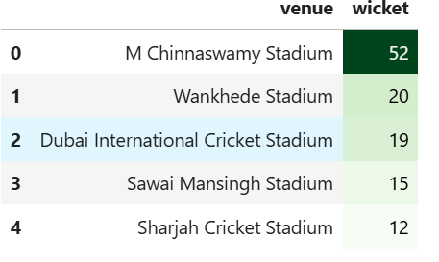

***chahla FAVOURITE VENUE IS M Chinnaswamy Stadium WHERE HE TOOK 52 WICKET ,FOLLOWED BY Wankhede Stadium 20 WICKET.***

***WHEN HE IS EFFECTIVE—***

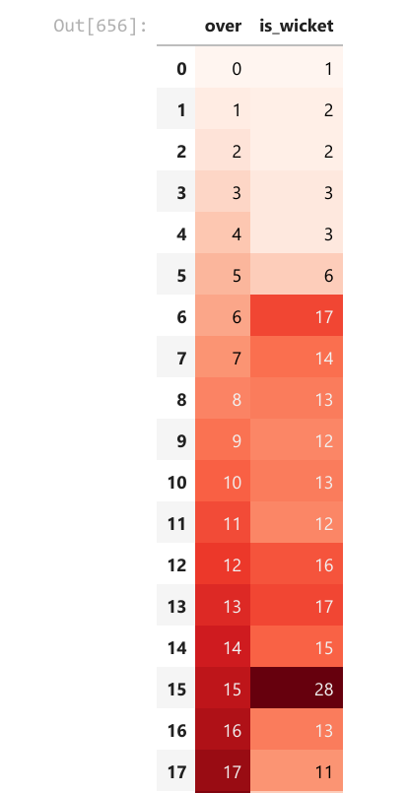

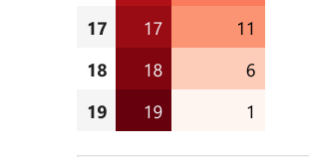

***CONCLUSION --- chahal TOOK 28 WICKETS AT 15'TH OVER ,BETWEEN 6 TO 17 OVERS HE TOOKES MOST OF HIS WICKETS SO HE IS EFFECTIVE IN MIDDLE OVERS.***

**Chahal’s WICKET PER SEASON—**

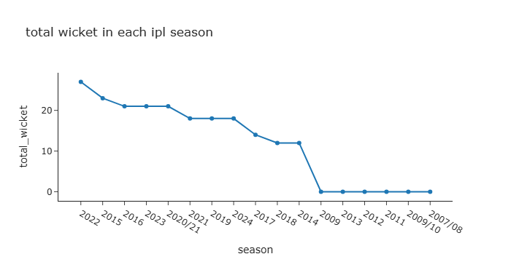

***HE TOOK 27 WICKET IN 2022***

**TOTAL RUNS VS TOTAL WICKET PER SEASON—**

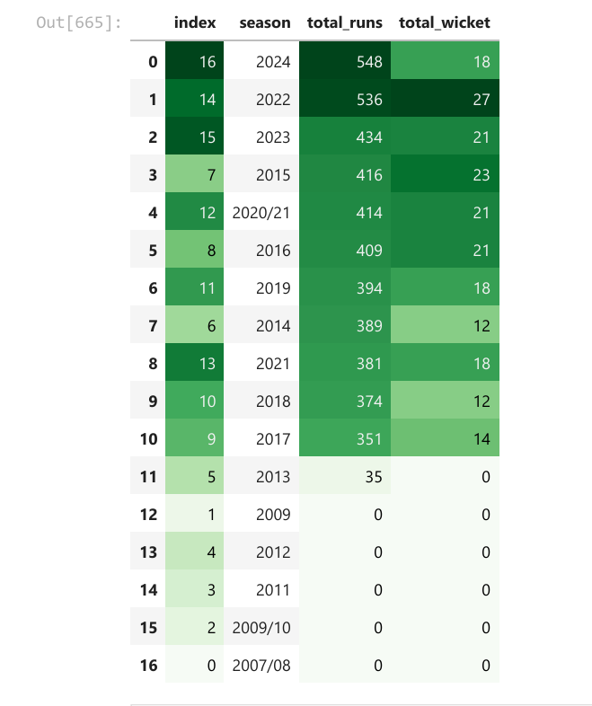

**HIS FAVOURITE BATSMAN—**

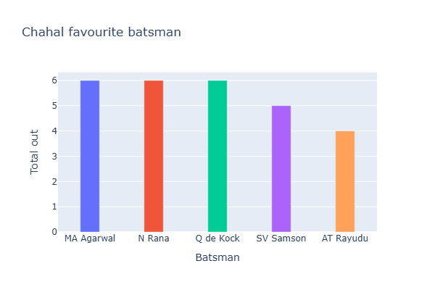

***MA Agarwal GOT OUT 6 TIMES ,FOLLOWED BY N Rana 6 TIMES BY CHAHAL***

**Q.14 INNINGS WISE RUN ANALYSIS BY TEAM.**

**FIRST INNINGS**

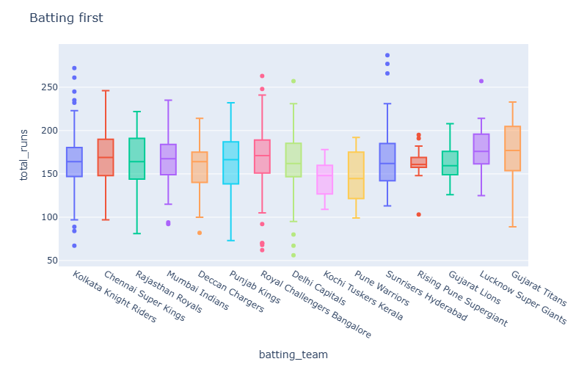

***CONCLUSION --- WHILE BATTING FIRST RCB , KKR , DC , SRH , LSG HAD 250+ SCORED ALSO WHILE BATTING FIRST KKR , RCB , DC HAD SCORED LESS THAN 70 RUNS***

**SECOND INNINGS**

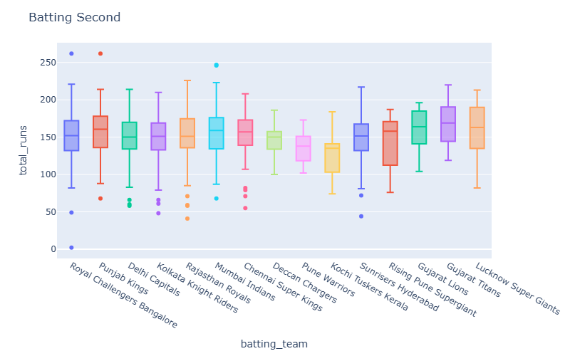

**CONCLUSION --- WHILE BOWLING RCB , PBKS THEY BOTH GOT 250 + RUNS.**

**Q.16 MOST 200+ RUNS BY A BATTNG TEAM AND BOWLING TEAM.**

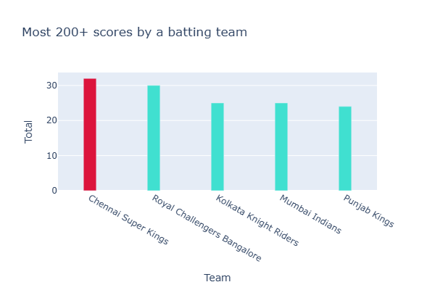

***CONCLUSION -- CSK ACHIEVED MOST 200+ RUNS WHILE BATTING 32 TIMES FOLLOWED BY RCB 30 TIMS.***

**BOWLING TEAM**

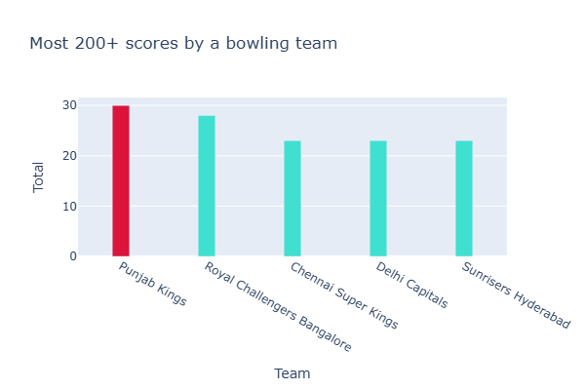

***CONCLUSION --- WHILE BOWLING PBKS HAD ACHIEVED 30 TIMES 200 + RUNS FOLLOWED BY RCB 28 TIMES***

**Q.17 WIN A MATCH WITH MAXIMUN RESULT MARGIN**

***CONCLUSION ---IN 2017 MI VS DC ,MI WON BY A HUGE MARGIN BY 146 RUNS***

***Q.18 TEAMS WITH MORE THAN 100+ RESULT MARGIN.***

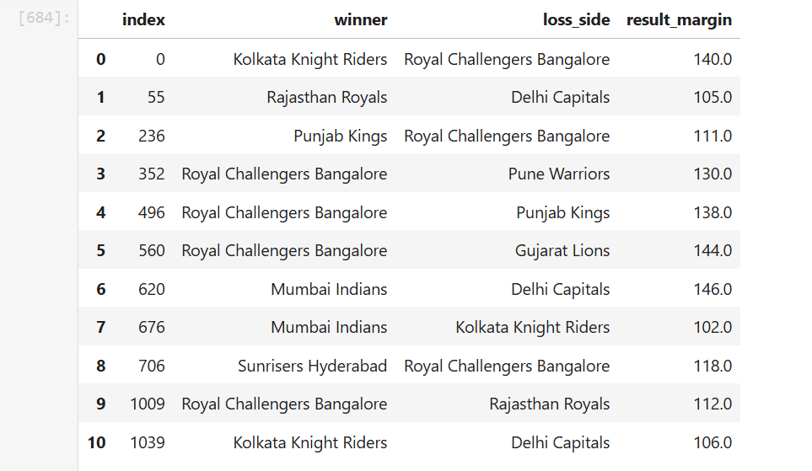

**CONCLUSION -- RCB WIN 4 TIMES WITH 100+ RUNS ALSO LOSS 3 TIME WITH 100+**

**Q.19 BATSMAN WITH MOST NUMBER OF BALL PLAYED**

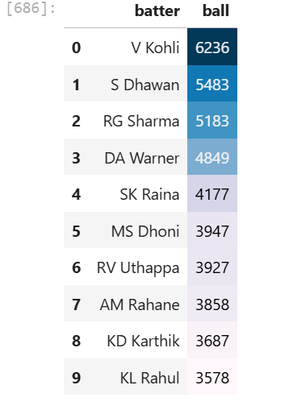

**CONCLUSION --- CLEARLY KING KOHLI PLAYED MOST BALLS 6326 BALLS, FOLLOWED BY S Dhawan 5483 BALLS,RG Sharma 5183 BALLS**

**Q.20 MOST NUMBER OF 6'S**

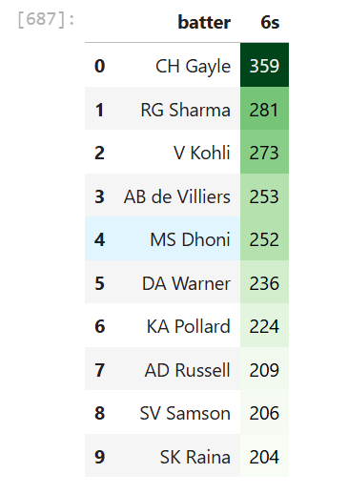

**CONCLUSION -- UNIVERSE BOSS CONQUER WITH 359 SIXS, RG Sharma 281 SIXS, FOLLOWED BY KOHLI 273 SIXS**

**Q.21 MOST NUMBER OF 4'S.**

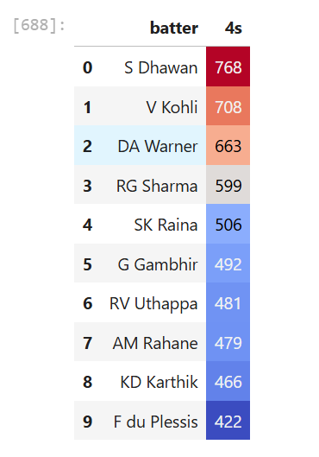

**CONCLUSION S Dhawan HITS 768,V Kohli 708 AND FOLLOWED BY DA Warner 663 FOURS**

**Q.22 WICKET KEEPER WITH MOST NUMBER OF STUMPED**

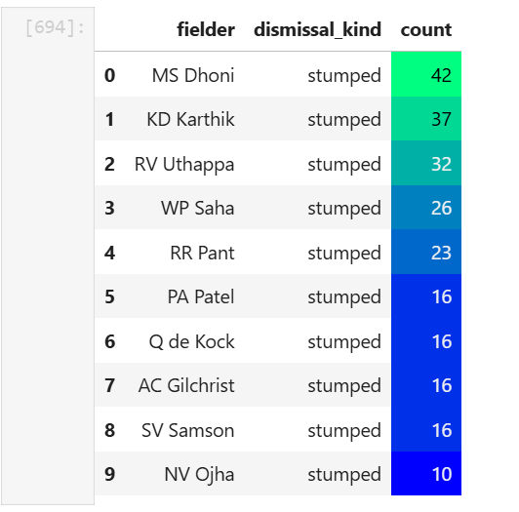

**CONCLUSION -- MS Dhoni stumped 42 ,FOLLOWED BY KD Karthik stumped 37,AND RV Uthappa stumped 32 ALL THREE INDIAN.**

**Q.23 HIGHEST STRIKE RATE DURING DEATH OVER**

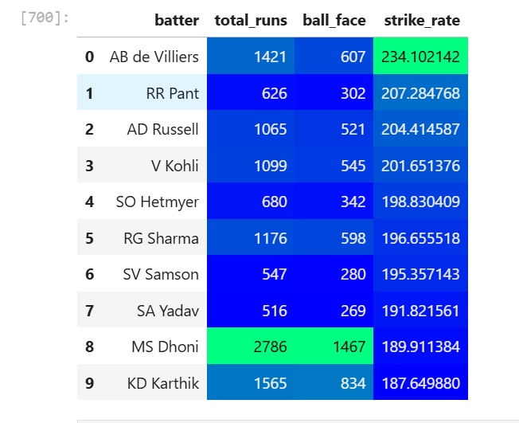

**conclusion --- AB de Villiers with 1421 runs 607 ball played and 234.10 STRIKE RATE HOLD THE RECORD ,WHILE DHONI DURING DEATH OVER SCORED 2786 RUNS.**

**Q.24 MOST MOM PLAYER**

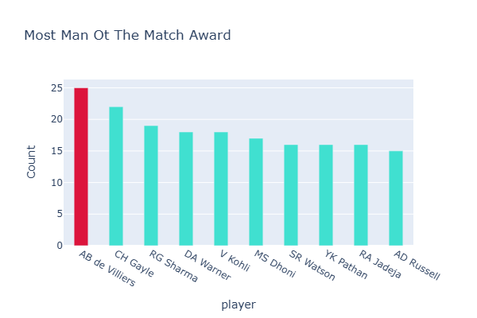

**CONCLUSION --- AB de Villiers WITH 25,CH Gayle WITH 22,FOLLOWED BY RG Sharma WITH 19 MOM AWARD ARE THE TOP THREE**

**Q.25 BEST RUN RATE DURING POWER PLAY AND DEATH OVER (2024)**

**DURING POWER PLAY**

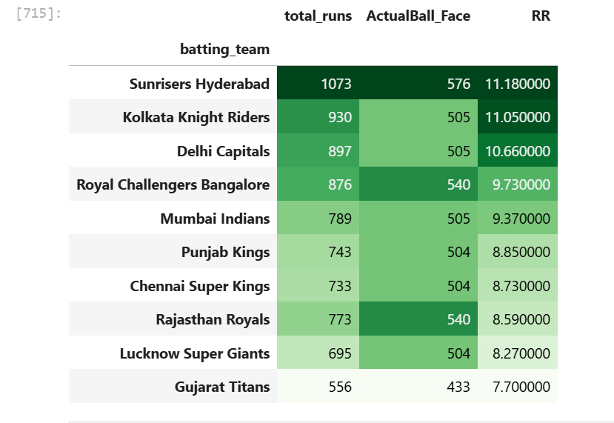

**CONCLUSION --- SRH , KKR , DC BOTH THE TEAM HAVE 10+ RUN RATE DURING POWER PLAY**

**DURING DEATH OVER**

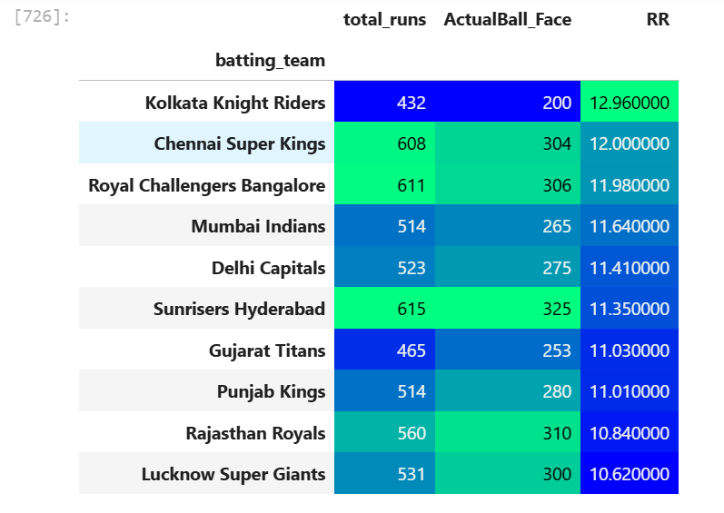

**KKR HAVE A RUN RATE ABOUT 13 DURING DEATH OVER WHERE SRH SCORED 615 RUN WITH A 11.13 RUN RATE DURING DEATH OVER**