 | Airline Ticket Reservation System  Technical Design Document
 | Prepared By / Last Updated By | Reviewed By | Approved By
Name
Role
Signature
Date

Table of Contents

1.0 Introduction 3
1.1 Purpose of this document 3
1.2 Project overview 3
2.0 Solution Summary 3
2.1 Scope 3
2.2 Assumptions 3
2.3 Dependencies 3
2.4 Risks 3
3.0 Schematic Diagram 3
4.0 System Design 4
4.1 Proposed design 4
4.2 Component inventory 4
5.0 Database Design 4
5.1 Data Model 4
5.2 Tables Structure 4
6.0 Appendices 4
6.1 Glossary 4
6.2 Other 5
7.0 Terms & Conditions 5
8.0 Change Log 5

Introduction

Purpose of this document
The purpose of this document is to document the technical design, component details and Database design. This will also capture the scope, assumptions, risk, dependencies of this project.

Project overview
Airline Ticket Reservation System is an online flight ticket booking web application. Through it users will be able to book ticket for flight from some source to a destination. They will be responsible for paying for the ticket. And will be able to see all the past booking history. New users can also sign up. Admin will be responsilbe for adding new flight and scheduling them. And they will be able to view all user information and all bookings.

Solution Summary

Scope
- Create and maintenance of admin login formation
- Maintenance of user registration information
- Maintenance of news feed information created by user
- Maintenance of flight information created by admin
- Maintenance of flight schedule information created by user
- Maintenance of flight booking information crated by user
- Creation and maintenance of database
- Creation and maintenance of views

Assumptions
When the project will be completed,
Users will be able to login or sign up. They will have option to reset password. They can be able to change they details and change password. Users will be able to book ticket for a flight from some source to a destination, pay for the ticket, and view all the passed history and passenger information
Admin can be able to add new flight and schedule them for some day(s) of the week, create new news which will be displayed in user home page. And to view all the user information and flight booking information.

Dependencies
- Admin information has to be there in the database.
- User has to sign up first before any kind of interation.
- Account and bank information have to present in the database.

Risks
Many users registration will be tedeous to keep track on.

Schematic Diagram
A schematic, or schematic diagram, is a representation of the elements of a system using abstract, graphic symbols rather than realistic pictures. It gives an overview of overall system
Use Case Diagram
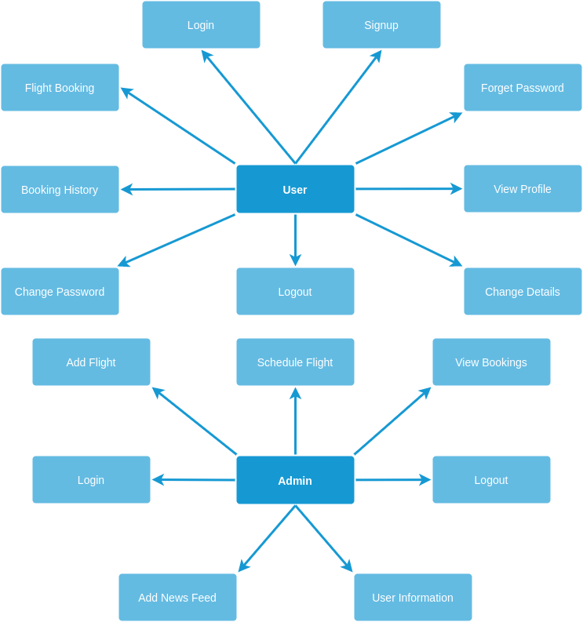

Admin Flow
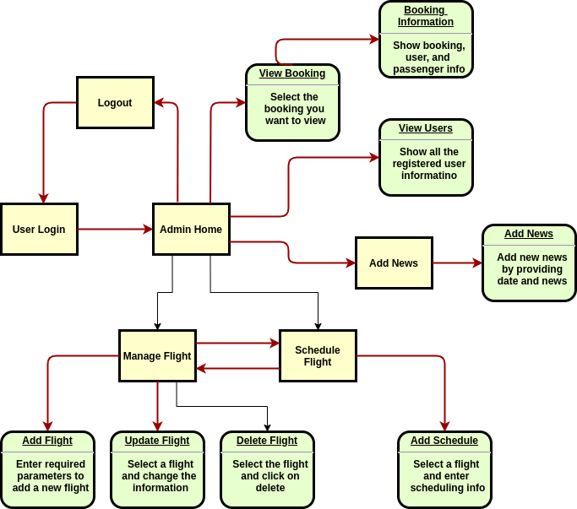

User Flow
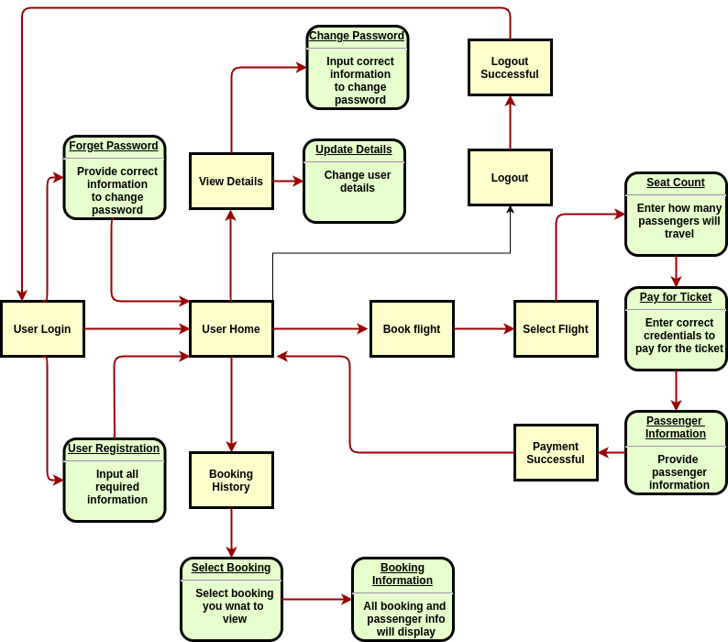

Models
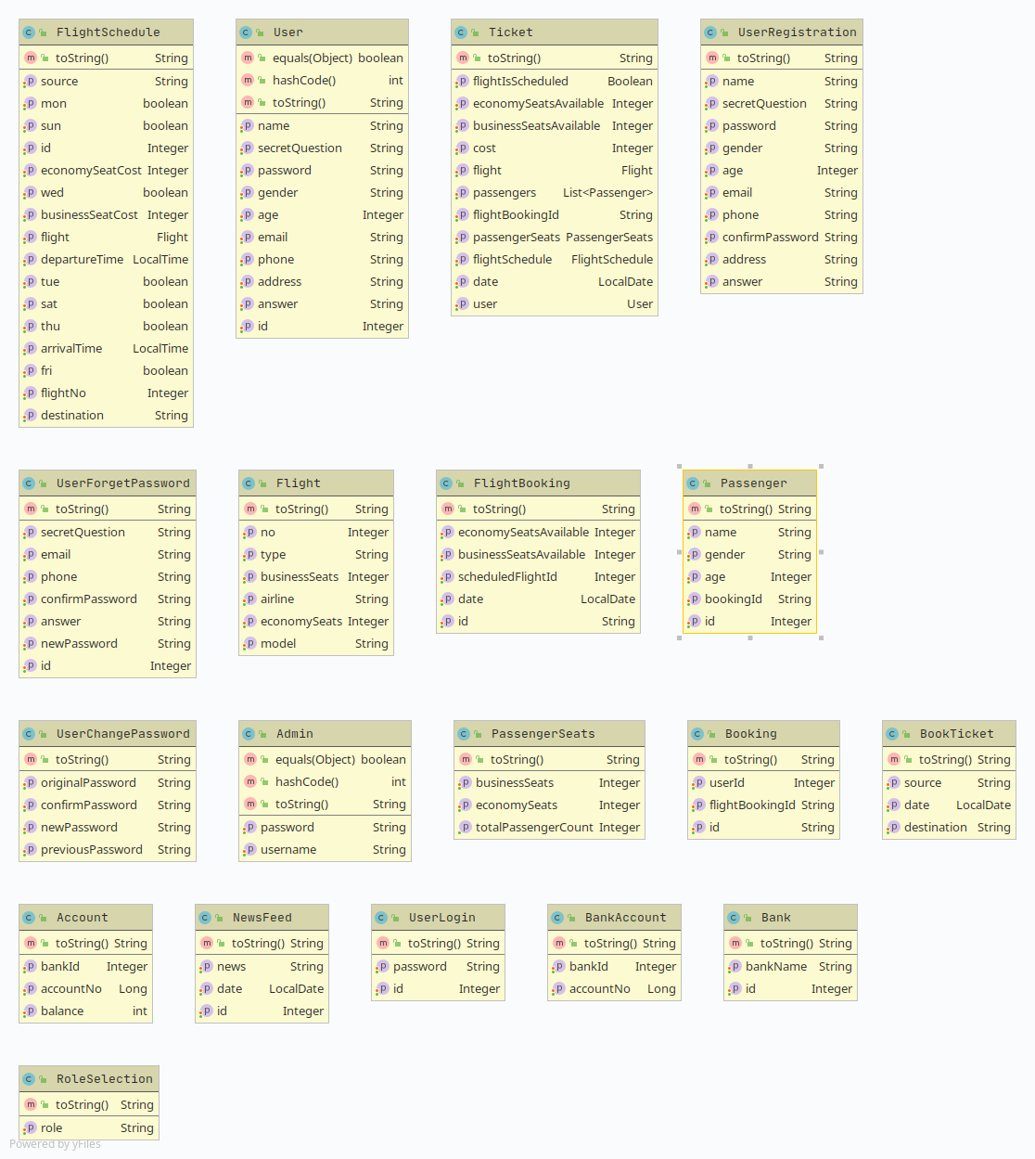

Controllers
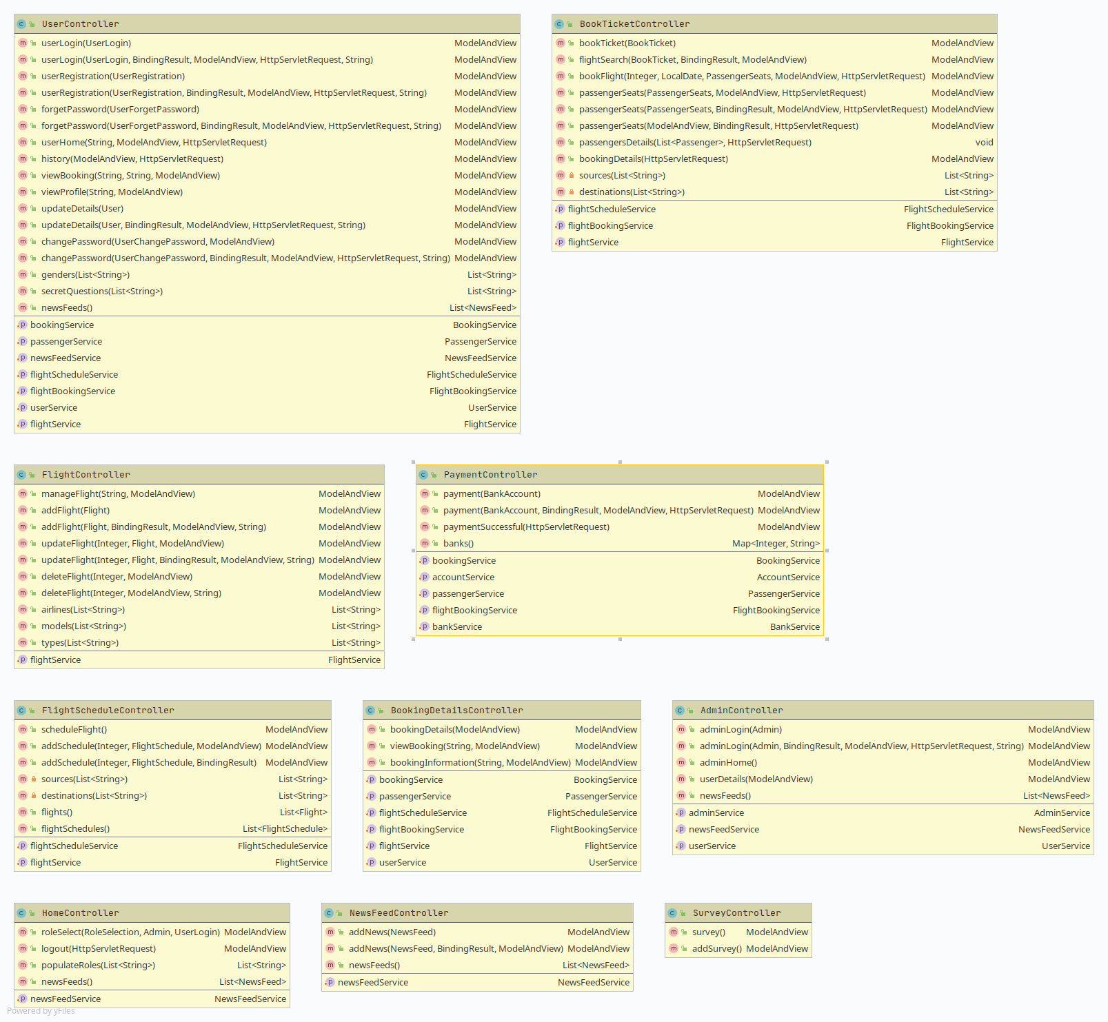
Services
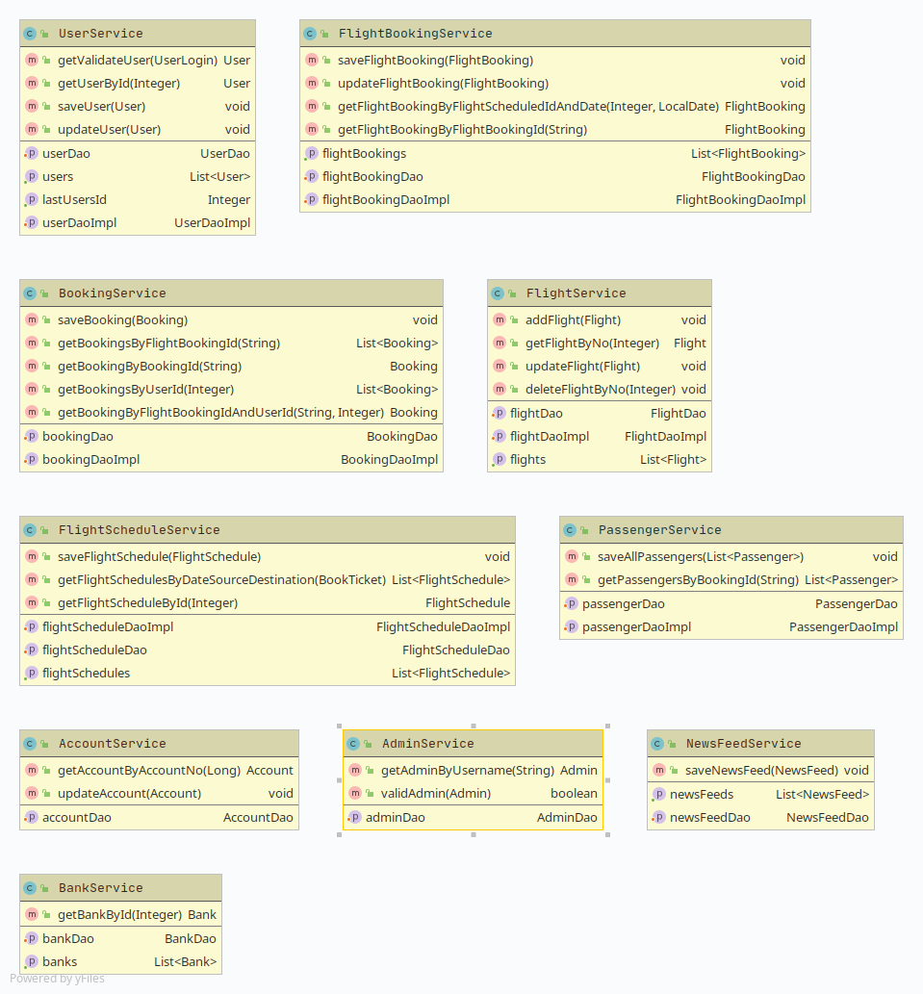

Data Acess Objects
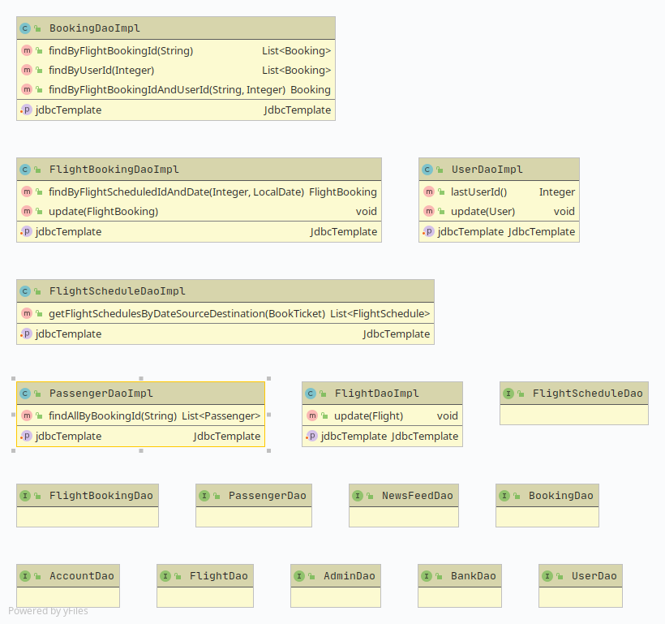

System Design

Proposed design
The functionality of the project is shared between two kinds of roles, admin and user.
Admin will be responsible for adding new flight and scheduling flights. View all the booking information and user details. Admin can also be able to add new news feed information.
User will be responsible for booking new flight, putting passenger information and paying for the flight. He/she will be able to see all the booking information and will be able to view and change profile information

Component inventory
The project in consist of many layer of connented compoent which make sure a smooth flow of data. The project follows all the spcification of MVC pattern.
- View: All the web pages which be visible to the end user, and that is the way for the user to interact with the application
- Controller: Controllers are responsible for redering the web pages in the browser, and also takes care of any request made by the user. It also interact to the database by the service layer.
- Service: Service layer is a middle ware between the database and controller to introduce an abstraction and it is also responsible for execute any kind of business logic required by the application.
- Data Access Object(DAO): Dao classes interact with the database and execute quries
- Model: Models contains information which is needed by all the above mentioned layers. All the layers interact with each other by models.

Database Design

Data Model
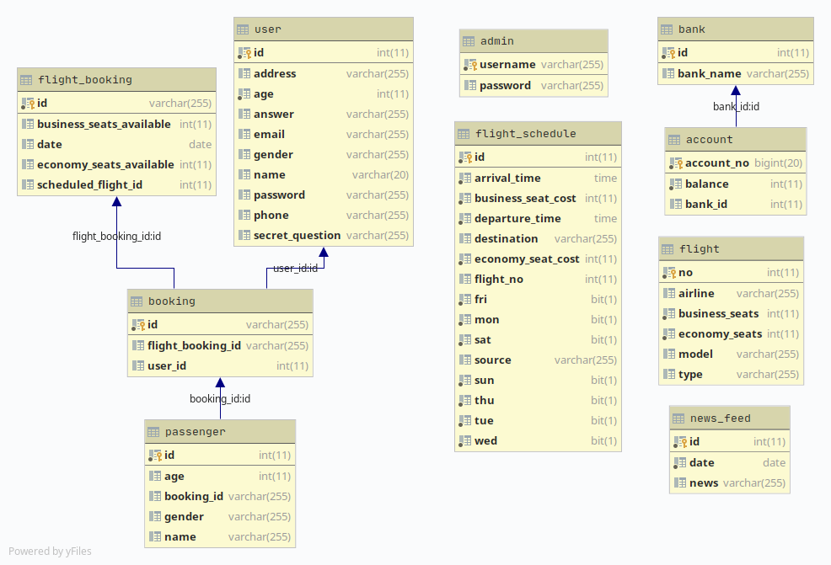

Tables Structure
Admin
Column Name | Data Type | Length | Nulls
Username | Varchar | 255 | Not null
Password | Varchar | 255 | Not null

User
Column Name | Data Type | Length | Nulls
Id | Int | 11 | Not null
Password | Varchar | 255 | Not null
Name | Varchar | 255 | Not null
Age | Int | 11 | Not null
Gender | Varchar | 255 | Not null
Email | Varchar | 255 | Not null
Address | Varchar | 255 | Not null
Phone | Varchar | 255 | Not null
Secret_question | Varchar | 255 | Not null
Answer | Varchar | 255 | Not null

Flight
Column Name | Data Type | Length | Nulls
No | Int | 11 | Not null
Airline | Varchar | 255 | Not null
Model | Varchar | 255 | Not null
Type | Varchar | 255 | Not null
Business_seats | Varchar | 255 | Not null
Economy_seats | Varchar | 255 | Not null

Flight_Schedule
Column Name | Data Type | Length | Nulls
Id | Int | 11 | Not null
Flight_no | Int | 11 | Not null
Source | Varchar | 255 | Not null
Destination | Varchar | 255 | Not null
Arrival_time | Time | - | Not null
Departure_time | Time | - | Not null
Business_seat_cost | Int | 11 | Not null
Economy_seat_cost | Int | 11 | Not null
Sun | Bit | 1 | Not null
Mon | Bit | 1 | Not null
Tue | Bit | 1 | Not null
Wed | Bit | 1 | Not null
Thu | Bit | 1 | Not null
Fri | Bit | 1 | Not null
Sat | Bit | 1 | Not null

Flight_Booking
Column Name | Data Type | Length | Nulls
Id | Int | 11 | Not null
Scheduled_flight_id | Int | 11 | Not null
Date | Date | - | Not null
Business_seats_available | Int | 11 | Not null
Economy_seats_available | Int | 11 | Not null

Booking
Column Name | Data Type | Length | Nulls
Id | Int | 11 | Not null
Flight_booking_id | Int | 11 | Not null
User_id | Int | 11 | Not null

Passenger
Column Name | Data Type | Length | Nulls
Id | Int | 11 | Not null
Booking_id | Int | 11 | Not null
Name | Varchar | 255 | Not null
Age | Int | 11 | Not null
Gender | Varchar | 255 | Not null

News_Feed
Column Name | Data Type | Length | Nulls
Id | Int | 11 | Not null
News | Varchar | 255 | Not null
Date | Date | - | Not null

Appendices

Glossary
Acronyms | Definitions

Other

Terms & Conditions
Disclaimer: Please do not circulate or distribute this document outside of Cognizant Network, We have a Zero Tolerance Policy. Kindly adhere to 100% Compliance at all times.

Change Log
Please note that this table needs to be maintained even if a Configuration Management tool is used.
Version Number | Changes made
V<n.n> | <If the change details are not explicitly documented in the table below, reference should be provided here>
V<n.n> | Page no | Changed by | Effective date | Changes effected

