**PROBLEM STATEMENT**

Build a number guessing game using python, where the user gives a range and then the computer selects a random number and calculates the minimum number of guesses required to correctly guess the number.

**PROCEDURE**

Step 1: Start

Step 2: Take two numbers from the user

Step 3: Using python in-built functions, make the computer select a number between them

Step 4: The user can then make a minimum number of guesses. The repetitive guessing while be done using a while loop

Step 5: If he/she can correctly guess it within that, a “Congratulations” message will appear on the screen

Step 6: If they cannot guess the number, a message will appear saying they tried well and the correct number

Step 7: Stop

**CODE**

import random

import math

# Taking Inputs

lower = int(input("Enter Lower bound:- "))

# Taking Inputs

upper = int(input("Enter Upper bound:- "))

# generating random number between

# the lower and upper

x = random.randint(lower, upper)

print("\n\tYou've only ",

round(math.log(upper - lower + 1, 2)),

" chances to guess the integer!\n")

# Initializing the number of guesses.

count = 0

# for calculation of minimum number of

# guesses depends upon range

while count < math.log(upper - lower + 1, 2):

count += 1

# taking guessing number as input

guess = int(input("Guess a number:- "))

# Condition testing

if x == guess:

print("Congratulations you did it in ",

count, " try")

# Once guessed, loop will break

break

elif x > guess:

print("You guessed too small!")

elif x < guess:

print("You Guessed too high!")

# If Guessing is more than required guesses,

# shows this output.

if count >= math.log(upper - lower + 1, 2):

print("\nThe number is %d" % x)

print("\tBetter Luck Next time!")

**RESULTS**

The input/output came as below :-

Enter Lower bound:- 8

Enter Upper bound:- 90

You've only 6 chances to guess the integer!

Guess a number:- 87

You Guessed too high!

Guess a number:- 50

You guessed too small!

Guess a number:- 60

You guessed too small!

Guess a number:- 70

You guessed too small!

Guess a number:- 80

You Guessed too high!

Guess a number:- 77

You Guessed too high!

Guess a number:- 74

You guessed too small!

The number is 76

Better Luck Next time!

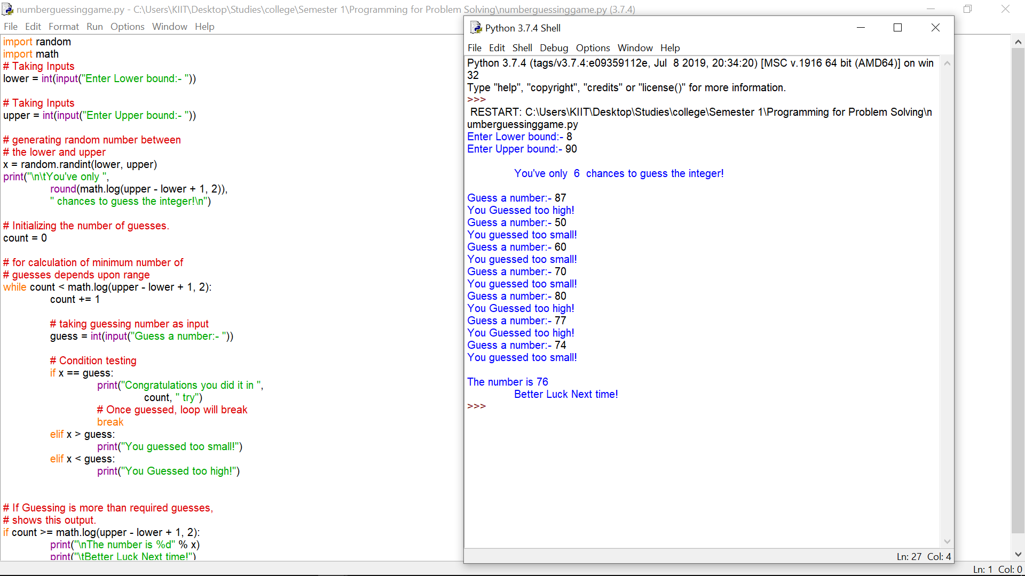

**CONCLUSION**

The given problem was solved using python programming language. The program was tested and the desired result was computed.