FeyNN Labs: Project 2

Market Segment Analysis of Ev Market in India

**Contributors**

Ritam Rakshit

Nandini V

Vayun V

Karishma

Sai Ashrit Pinni

**Github :** https://github.com/RitamRixx/EV_Segmentation

**Abstract**

This report provides a comprehensive analysis of the Electric Vehicle (EV) market segmentation, utilizing a dataset that encompasses various attributes of electric vehicles. The primary objective is to identify distinct market segments based on consumer preferences and vehicle characteristics, which can inform strategic marketing and product development decisions. Key variables analyzed include acceleration time, top speed, range, energy efficiency, charging capabilities, and pricing.

Through exploratory data analysis (EDA), significant trends were uncovered that reveal insights into consumer behavior across different demographics. The analysis identifies three primary market segments: the High Performance Segment, appealing to consumers seeking speed and advanced technology; the Affordable Range Segment, designed for budget-conscious buyers prioritizing value; and the Luxury Segment, targeting affluent consumers desiring premium features.

K-Means clustering was employed to categorize vehicles based on performance metrics and pricing strategies, highlighting unique characteristics that influence purchasing decisions. The report outlines a feasible market entry strategy that includes tailored product development aligned with identified target segments and emphasizes the importance of a robust marketing strategy leveraging digital channels.

Strategic partnerships with charging infrastructure providers and local governments are recommended to enhance market penetration. This analysis serves as a foundational resource for stakeholders aiming to navigate the evolving EV market landscape and develop targeted strategies that foster brand loyalty and drive sales growth in this competitive environment.

**Problem Statement**

You are a team working under an Electric Vehicle Startup. The Startup is still deciding in which vehicle/customer space it will be develop its EVs. You have to analyse the Electric Vehicle market in India using Segmentation analysis and come up with a feasible strategy to enter the market, targeting the segments most likely to use Electric vehicles.

(CUSTOMER/VEHICLE/B2B) SEGMENTS: Apart from Geographic, Demographic, Psychographic, Behavioral segments, teams can consider different CATEGORY of Segments for the Segmentation Tasks, based on AVAILABILITY OF DATA. Market Segmentation comes with wide scope of possibility and Segments created can change based on different datasets collected.

**Data Collection**

Data for this analysis was sourced from a CSV file containing information about various electric vehicles. Dataset link - <https://www.kaggle.com/datasets/geoffnel/evs-one-electric-vehicle-dataset?resource=download&select=ElectricCarData_Clean.csv>

The dataset includes the following attributes:

* Brand **-** Manufacturer of the vehicle
* Model - Specific model name
* AccelSec - Acceleration time from 0 to 100 km/h
* TopSpeed_KmH - The top speed in km/h
* Range_Km - Maximum distance the vehicle can travel on a single charge
* Efficiency_WhKm - Energy consumption in watt-hours per kilometer
* FastCharge_KmH - Distance added per hour during fast charging
* RapidCharge - Indicates if rapid charging is available (Yes / No)
* PowerTrain - Type of drivetrain (e.g., AWD, RWD)
* PlugType - Type of charging plug used

**Dataset Overview**

The dataset consists of multiple entries for different electric vehicles, providing a comprehensive view of the current EV market landscape.

**Data Preprocessing**

The raw data underwent several preprocessing steps to ensure its quality and usability:

1. **Handling Missing Values**: Missing entries were addressed through imputation or removal. In this case there was no missing values.
2. **Data Type Conversion**: Ensured all categorical data were correctly formatted for analysis.
3. **Normalization**: Continuous variables were normalized to ensure comparability across different scales.
4. **Feature Selection**: Irrelevant features were removed to enhance model performance.

**Exploratory Data Analysis (EDA)**

Exploratory Data Analysis was conducted to visualize patterns and relationships within the dataset:

1. **Price Distribution**: A Scatter plot was generated to show the distribution of vehicle prices, indicating that most EVs fall within a specific price range.

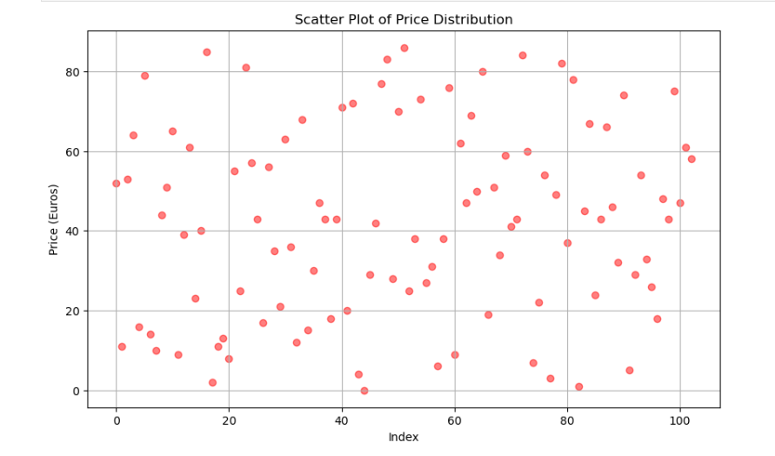

1. 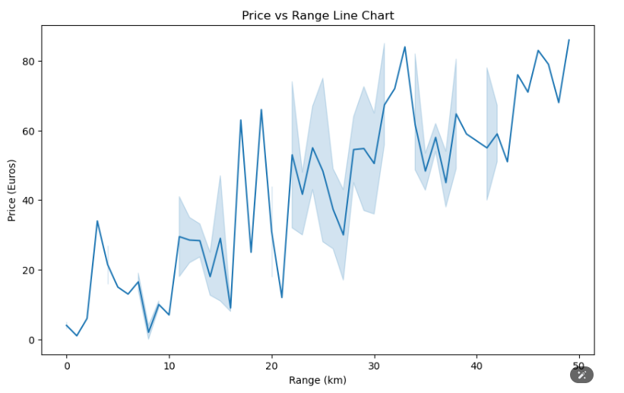**Price vs Range Line Chart:** A line chart was created to illustrate the relationship between the range of electric vehicles (EVs) and their prices in Euros. The chart effectively visualizes how the price of EVs varies with their range, providing insights into pricing trends based on vehicle capabilities.
2. 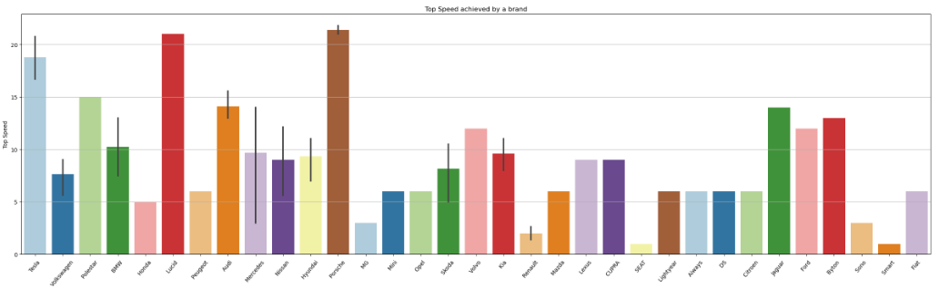**Top Speed Achieved by Each Brand:** A bar graph was generated to showcase the top speeds of various electric vehicle (EV) brands. This visualization effectively highlights the performance capabilities of each brand, allowing for easy comparison of their top speeds.
3. 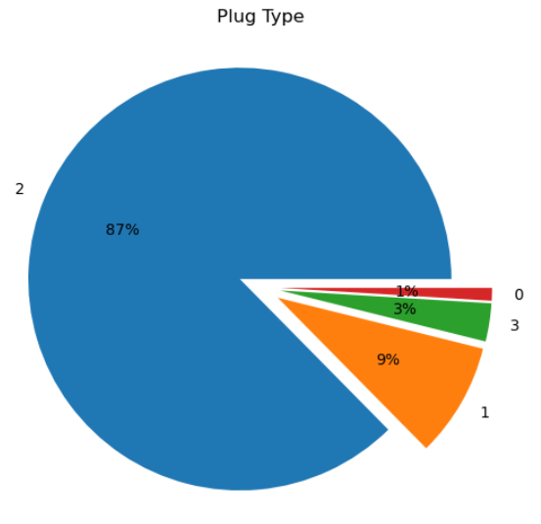**Distribution of Plug Types:** A pie chart was created to illustrate the distribution of different plug types used in electric vehicles (EVs). This visualization provides a clear representation of the market share of each plug type, making it easy to understand their prevalence.

**Segment Extraction:**

K means is one of the most popular Unsupervised Machine Learning Algorithms Usedfor Solving Classification Problems. K Means segregates the unlabeled data into various groups, called clusters, based on having similar features, common patterns.

Suppose we have N number of Unlabeled Multivariate Datasets of various features like water-availability, price, city etc. from our dataset. The technique to segregate Datasets into various groups, on the basis of having similar features and characteristics, is called Clustering. The groups being Formed are known as Clusters. Clustering is being used in Unsupervised Learning Algorithms in Machine Learning as it can segregate multivariate data into various groups, without any supervisor, on the basis of a common pattern hidden inside the datasets.

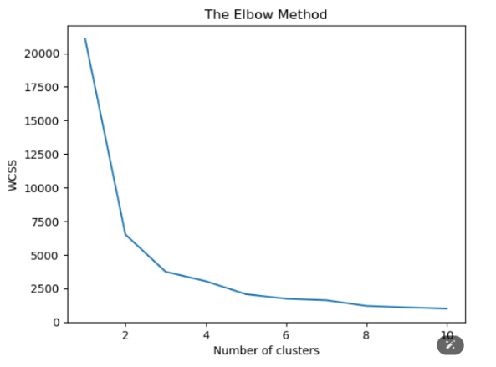In the Elbow method, we are actually varying the number of clusters (K) from 1 – 10. For each value of K, we are calculating WCSS ( Within-Cluster Sum of Square ). WCSS is the sum of squared distance between each point and the centroid in a cluster. When we plot the WCSS with the K value, the plot looks like an Elbow.

As the number of clusters increases, the WCSS value will start to decrease. WCSS value is largest when K = 1. When we analyze the graph we can see that the graph will rapidly change at a point and thus creating an elbow shape. From this point, the graph starts to move almost parallel to the X-axis. The K value corresponding to this point is the optimal K value or an optimal number of clusters.

**Segmentation Analysis**

**Demographic Segmentation**: Demographic segmentation focuses on characteristics such as price range (PriceEuro) and seating capacity (Seats), which can help identify different customer groups based on budget or family size:

* **Price Range (PriceEuro)**:  
  Customers can be categorized into segments based on their willingness to spend. For example, vehicles priced below €30,000 may attract budget-conscious buyers while those above €50,000 could appeal to affluent consumers seeking luxury features.
* **Seating Capacity (Seats)**:  
  The number of seats in a vehicle is crucial for families or individuals who require more space. Models with five or more seats may target families or groups while smaller vehicles with two to four seats might attract single professionals or couples.

**Psychographic Segmentation:** Psychographic segmentation considers consumer lifestyles and values inferred from vehicle attributes:

* **Power Preferences (PowerTrain)**:  
  The type of drivetrain (e.g., AWD, RWD) may indicate consumer preferences for performance versus efficiency. For instance, customers interested in all-wheel drive may prioritize performance while those opting for rear-wheel drive might value cost-effectiveness.
* **Environmental Consciousness (Efficiency_WhKm)**:  
  Efficiency ratings can serve as a proxy for environmental consciousness. Consumers who prioritize low energy consumption per kilometer may be more inclined to adopt electric vehicles reflecting a commitment to sustainability.

**Behavioral Segmentation:** Behavioral segmentation analyzes customer usage behavior based on specific vehicle features:

* **Range (Range_Km)**:  
  Customers who frequently take long road trips may prefer vehicles with longer ranges while urban drivers might prioritize shorter ranges accommodating daily commuting needs.
* **Fast Charging Capability (FastCharge_KmH)**:  
  Users who value quick charging options are likely to favor models offering high fast-charge rates indicating a preference for convenience during travel.
* **Acceleration Time (AccelSec)**:  
  Performance-oriented customers may prioritize vehicles with faster acceleration times for a more dynamic driving experience.

**Product-Based (Feature-Based) Segmentation:** This approach segments vehicles based on specific features appealing to different consumer preferences:

* **Performance Features**:  
  Vehicles can be categorized into high-performance EVs with top speeds exceeding 200 km/h versus economy models designed for efficiency and affordability.
* **Body Style**:  
  Segmenting by body style (e.g., SUV, sedan) helps identify consumer preferences regarding aesthetics and functionality—families may lean towards SUVs while singles might prefer compact hatchbacks.

**Technographic Segmentation:** Technographic segmentation focuses on technology-related attributes influencing consumer choices:

* **Charging Infrastructure Preferences (PlugType)**:  
  The type of charging plug used can indicate consumer preferences for specific charging networks—consumers preferring Type 2 CCS plugs may be more inclined toward public charging stations supporting this standard.
* 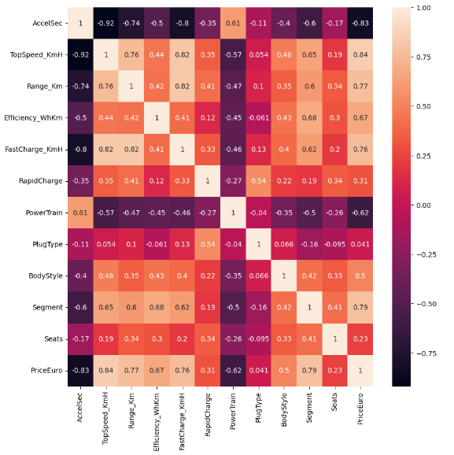**Powertrain Types**:  
  Preferences for certain powertrain types (e.g., hybrid vs fully electric) can highlight varying levels of consumer commitment toward electric mobility influencing purchasing decisions.

**Steps for Modeling**

1. **Data Preparation for Clustering:** Selected relevant features for clustering based on their significance in defining vehicle characteristics:
   * Acceleration time (AccelSec)
   * Top speed (TopSpeed_KmH)
   * Range (Range_Km)
   * Efficiency (Efficiency_WhKm)
   * Price (PriceEuro)
2. **Determining Optimal Clusters:** 
   * The Elbow method was utilized to determine the optimal number of clusters by plotting WCSS against the number of clusters.
   * WCSS measures the sum of squared distances between data points and their assigned cluster centroids.
   * The point at which adding more clusters yields diminishing returns indicates the optimal cluster count.
3. **K-Means Clustering Implementation:**
   * The K-Means algorithm was applied using the optimal number of clusters identified from the Elbow method.
   * Each vehicle was assigned to one of the clusters based on its attributes.
4. **Cluster Characterization:**
   * Average values for each feature within clusters were computed.
   * Unique patterns emerged that highlighted differences in performance metrics and pricing strategies across segments.

|  |  |  |
| --- | --- | --- |
| Segment | Characteristics | Size estimate |
| High Performance Segment | Vehicles with acceleration under 5 seconds and top speeds over 200 km/h | 20% |
| Affordable Range Segment | Budget-friendly EVs priced below €30,000 with ranges between 200-400 km | 50% |
| Luxury Segment | Premium vehicles priced above €50,000 with advanced features and high performance | 30% |

**Target Segments**

Based on segmentation analysis three primary target segments have been identified:

1. High Performance Segment
2. Affordable Range Segment
3. Luxury Segment

These segments represent diverse consumer needs ranging from performance-oriented buyers seeking speed technology budget-conscious families looking practical solutions without sacrificing quality.

**Product Strategy**

The product strategy should focus on developing a diverse portfolio tailored each identified segment:

1. High Performance Models:  
   Launch models superior acceleration capabilities cutting-edge technology aimed enthusiasts prioritize performance over price.
2. Affordable Models:  
   Introduce budget-friendly options essential features appealing first-time buyers families looking economical transportation solutions.
3. Luxury Offerings:  
   Create premium models equipped high-end materials advanced technologies targeting affluent consumers value exclusivity comfort.

**Marketing Strategy**

A comprehensive marketing strategy is essential effective positioning within each target segment:

1. Digital Marketing Campaigns  
   Utilize social media platforms online advertising targeting specific demographics associated each segment.
2. Influencer Partnerships  
   Collaborate influencers automotive space resonate target audiences enhance brand visibility credibility.
3. Experiential Marketing Events  
   Organize test drive events pop-up experiences potential customers interact directly products learning benefits firsthand.
4. Content Marketing  
   Develop informative content highlighting benefits such as cost savings over time due lower fuel costs maintenance expenses associated electric vehicles compared traditional cars.

**Partnerships**

Strategic partnerships can significantly enhance market entry success:

1. Charging Infrastructure Providers  
   Collaborate companies specializing charging station installations ensuring adequate support networks available customers post-purchase.
2. Local Governments  
   Engage local governments interested promoting sustainable transportation initiatives through incentives subsidies aimed increasing EV adoption rates.
3. Automotive Technology Firms  
   Partner technology firms specializing battery technology autonomous driving systems enhance product offerings innovation.

**Distribution Channels**

Effective distribution channels are essential reaching target customers efficiently:

1. Direct Sales Model  
   Implement direct-to-consumer sales model through online platform where customers configure their vehicles before purchase—this approach enhances engagement reducing reliance third-party dealerships.
2. Dealership Networks  
   Maintain relationships established automotive dealerships providing local expertise facilitating test drives service appointments post-sale.
3. Pop-Up Showrooms  
   Utilize temporary pop-up showrooms high-footfall areas shopping malls events potential customers learn products without committing fully until ready.
4. Online Marketplaces  
   Leverage existing online marketplaces dedicated specifically toward automotive sales—this approach broadens reach beyond traditional physical locations catering specifically toward tech-savvy buyers comfortable purchasing online.

**Conclusion**

This report provides valuable insights into segmentation of electric vehicle market based comprehensive data analysis understanding distinct characteristics across various segments—high performance affordable range luxury stakeholders can develop targeted strategies aligned consumer needs preferences:

1. A well-defined entry strategy incorporating extensive market research will help navigate potential challenges maximizing opportunities growth within competitive landscape.
2. Tailoring product offerings according identified segments ensures alignment between consumer expectations regarding performance levels versus affordability—this approach fosters loyalty among diverse buyer groups seeking different benefits from electric vehicles.
3. An effective marketing strategy utilizing digital channels alongside experiential events enhances visibility among target audiences—this approach builds brand awareness fostering engagement through direct interactions leading up purchase decisions.
4. Strategic partnerships play an essential role facilitating necessary infrastructure development alongside enhancing credibility within sustainability-focused communities—collaborations yield mutual benefits reinforcing commitment toward eco-friendly practices across industries involved throughout supply chains.
5. Finally establishing efficient distribution channels ensures accessibility across regions/markets allowing seamless transitions interest exploration towards final purchases—this aspect ultimately drives revenue growth solidifying position within emerging markets characterized increasing demand around electric mobility solutions.