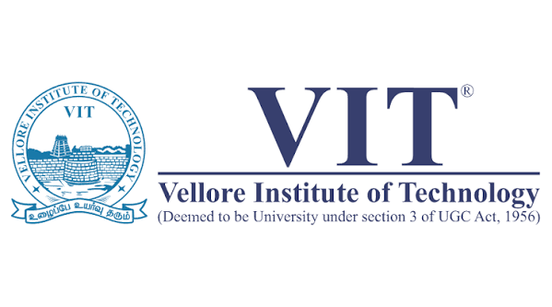
SCHOOL OF COMPUTER SCIENCE AND ENGINEERING
Fall Semester 2026-2027

Project – Report

Multi-Temporal Water Body Analysis of Hyderabad’s Urban Lakes Using Deep Learning

By-
K Ritanshu Kumar - 22MID0328

Under the Guidance of –
DR. Rohini S
Abstract
Urban lakes play an important role in flood control, groundwater recharge, biodiversity conservation, and maintaining ecological balance. However, rapid urbanization, encroachment, and pollution have contributed to the gradual degradation of many urban lakes in Hyderabad. Monitoring these changes accurately is essential for effective environmental management and sustainable urban planning.
This project proposes a deep learning-based framework to monitor the surface area changes of Hyderabad's major urban lakes—Hussain Sagar, Osman Sagar, and Himayat Sagar—using multi-temporal Sentinel-2 satellite imagery from 2018 to 2025. The proposed methodology involves semantic segmentation of satellite images to identify water bodies and estimate their surface area over different years. The project aims to develop a systematic pipeline for analyzing temporal changes in lake extent using remote sensing and artificial intelligence techniques.

Problem Domain
This project belongs to the interdisciplinary domain of:
- Remote Sensing and Geospatial Analysis
- Artificial Intelligence and Deep Learning
- Computer Vision
- Environmental Monitoring
- Urban Water Resource Management
The project combines satellite imagery with deep learning techniques to study long-term changes in urban lake boundaries.

Background of the Problem
Urban lakes provide several environmental and social benefits, including flood mitigation, groundwater recharge, climate regulation, and ecological balance. In rapidly expanding cities such as Hyderabad, these lakes are increasingly affected by urban development, pollution, and land-use changes.
Hussain Sagar, Osman Sagar, and Himayat Sagar are among Hyderabad's most significant water bodies. Over time, these lakes have experienced noticeable changes in their water spread area due to various environmental and human-induced factors. Although satellite imagery has been widely used for environmental monitoring, there remains a need for a systematic approach to analyze long-term lake surface area changes using modern deep learning techniques.
This project proposes the use of Sentinel-2 satellite imagery and semantic segmentation to create a reliable framework for monitoring yearly changes in lake surface area. The study aims to provide quantitative information that can support future environmental monitoring and conservation efforts.

Relevant Sustainable Development Goal(s) (SDGs)
SDG 6 – Clean Water and Sanitation
- Supports sustainable management of freshwater resources.
- Encourages monitoring and conservation of urban water bodies.
SDG 11 – Sustainable Cities and Communities
- Promotes sustainable urban planning.
- Supports monitoring of natural resources within urban environments.
SDG 13 – Climate Action
- Encourages long-term environmental monitoring using satellite data.
- Supports climate resilience through improved understanding of water resource changes.
SDG 15 – Life on Land
- Contributes to the conservation of freshwater ecosystems and surrounding biodiversity.

Technology Readiness Level (TRL)
TRL 3 — Experimental Proof of Concept
The core individual techniques this project relies on — U-Net segmentation, NDWI/MNDWI water indices, Sentinel-2 satellite data pipelines — are all well-established and proven in prior literature and other geographic contexts. This project is at the stage of applying and validating these techniques in a new, specific, previously-unstudied context (Hyderabad's three urban lakes). Initial data acquisition has already been completed — Sentinel-2 satellite imagery for all three lakes (Hussain Sagar, Osman Sagar, Himayat Sagar) has been successfully sourced via Google Earth Engine across the target study period (2018–2025), confirming data availability and feasibility of the proposed pipeline.

