**How to run GUI**

1. open the GUI interface by command line: **python gui.py**

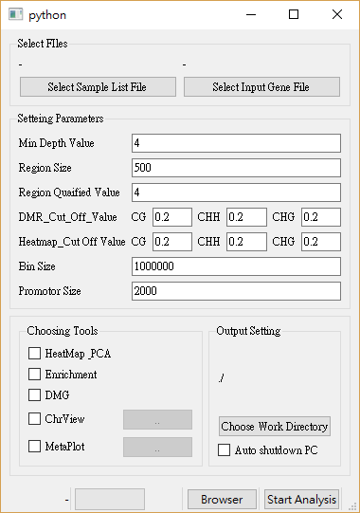

2. Choose the location of input Files (sample list & Gene annotation gtf file)



This section let users to select input files, containing sample list (.txt) and gene annotation gtf file (.gtf)

1. Sample list format should be a txt file and must contains 3 column, **sample name, CGmap location** and **sample’s group**

e.g.

|  |  |  |
| --- | --- | --- |
| WT_1 | C:/Users/usrname/project/CGmap/WT_1.CGmap.gz | WT |
| WT_2 | C:/Users/usrname/project/CGmap/WT_2.CGmap.gz | WT |
| Mut_1 | C:/Users/usrname/project/CGmap/Mut_1.CGmap.gz | Mutant |
| Mut_2 | C:/Users/usrname/project/CGmap/Mut_2.CGmap.gz | Mutant |

1. Click Select … File button. Then program will show file dialogue, choosing input files which you want to analysis.

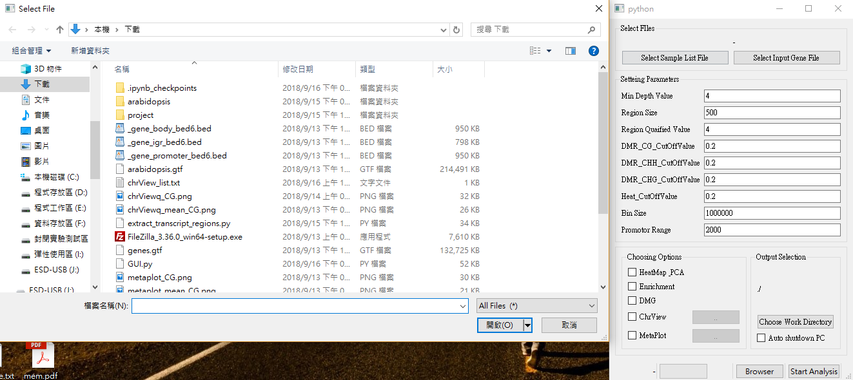

1. After choosing file. Label will show the its path

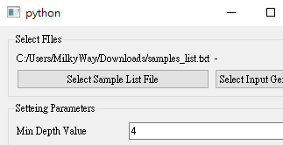

1. Selecting gene annotation file’s path (*gene annotation must be a gtf format)

[Setting Parameters]



This section let users to set analysis parameters

1. Default value of each parameter is already set. You can click the textbox to modify it
2. If you don’t know how to set some parameters, you can let your mouse on the parameter’s name a period of time (may 2 seconds). Then it will display the description to help you setting it. You also can read the parameters description file to help you setting it.
3. There are fool-proof design there. If the parameter is integer only, the program can’t let you input float number or other illegal values. It can help you set parameters more security.

[Tools Selection]



This section let users to choose which tools users want to use.

1. Check the tool’s box which you want to use. If you choose ChrView or Metaplot, it also has advanced options. Click the right button to set it.
2. Advanced option of ChrView is letting users to decide which group of samples minus which group of samples in ChrView-mean tool which is plotting the methylation level difference between two group of samples. The group name is load from sample list (means you may select sample list before setting this option), so you just have to choose it.

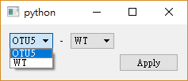

1. Similar with ChrView advanced option. The Metaplot advanced option also need users to set which group of samples minus which group. The difference is Metaplot advanced option also need to assign a specific genome feature which is going to plot in Metaplot.

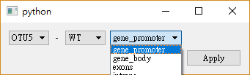

[Other settings]



This section provide two functions. One is let users assign a folder that output files will save in it. Another One is let computer auto shutdown when analysis in complete.

1. Similar with select input file. Click Choose Work Directory button, you can choose which folder you want the output file save in.

(This Function is disabled currently, the output folder is same as this program’s folder)

1. If you want to enable the auto shutdown pc function, you just have to do is check it. But you may confirm that you have enough permission to execute shutdown command and **It is not recommended and cautioned that using this function on public computers or servers**.

[State Monitor Area]



This section provide the real-time analysis state and progress. Starting analysis and previewing the report are also in this section.

1. After set parameters and settings, Click the start Analysis can start analysis, or program will show message box to remind you to complete setting parameters.
2. When analysis started, the label and progress bar which on the left side will show the current analysis state and progress. You can check it in any time.
3. After analysis Completed. Click the Browser button can open a simple analysis report viewer which showing the analysis report (Only contain figures). The Browser

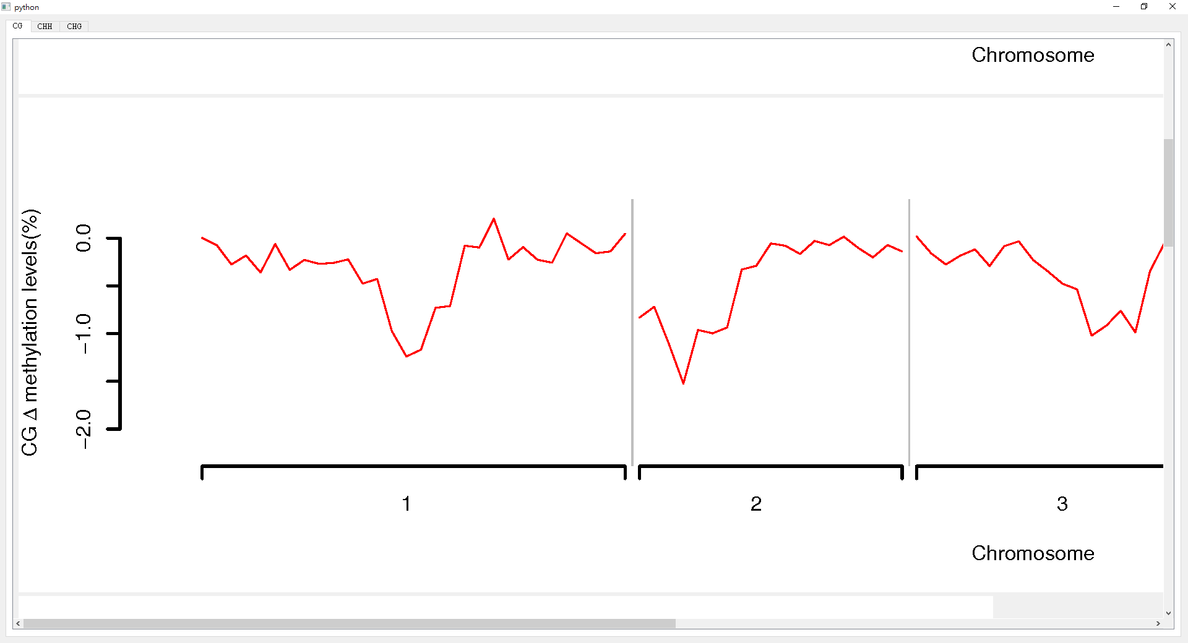

1. The output chart is sorted according to three types of methylation, and the user can switch using the pagination bar at the top.

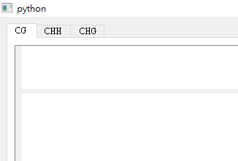

1. Opening this Browser before analysis complete then Browser will show some description texts. Its mean is reminding you wait the analysis complete and use this browser again.

