PENETRATION TESTING REPORT
FOOTPRINTING & NETWORK SCANNING PHASES
W2-PM-FINAL | CYBERSECURITY | NETWORKWALKS

Pentester Name  (Cybersecurity Intern) | Prince Manu Gyebi
Program/Batch | NETWORKWALKS Cybersecurity Internship - B082
Date | 18 August 2026
Modules completed | W2-PM4 (theHarvester Footprinting)  W2-PM5 (Zenmap Network Scanning)
Target / Scope | 1. networkwalks.com (internship-scoped target)  2. My own local LAN
Authorisation basis | Internship-assigned target / tester-owned local network
Phases covered | Phase 1: Reconnaissance & Footprinting  Phase 2: Scanning & Network Discovery  Phase 3-5: Not covered in this report

1. Liability Disclaimer
Testing was limited to networkwalks.com as the internship-assigned target and to my own local LAN. Activities consisted of passive OSINT reconnaissance and host discovery only. No exploitation, unauthorised access, credential attacks or destructive testing was performed.

2. Introduction
This report documents the Week 2 activities completed for W2-PM4 and W2-PM5. W2-PM4 covered passive footprinting of networkwalks.com with theHarvester, while W2-PM5 covered local network discovery with Zenmap/Nmap on my own LAN.
The report records the methods used, results obtained, source and tooling limitations, troubleshooting performed, security observations and evidence handling. Public copies of infrastructure and device-specific findings were sanitised where appropriate.

3. Tools Used
The following platforms and utilities were used during the two activities.
Tool | Purpose
Kali Linux 2026.2 | Operating system used for theHarvester reconnaissance.
theHarvester 4.10.1 | Passive OSINT enumeration against the internship-scoped domain.
Linux shell / tee | Command execution, piping and preservation of terminal output as evidence.
Oracle VirtualBox | Virtualisation platform hosting the Kali Linux environment.
Windows 11 | Host operating system used for local network identification and scanning.
Zenmap / Nmap 7.991 | Ping scanning, live-host discovery and network topology visualisation.
Windows Command Prompt | Local IP, subnet, gateway and MAC address verification using ipconfig.

4. Activities Performed

4.1 Footprinting & Reconnaissance

Passive reconnaissance was performed against networkwalks.com using theHarvester on Kali Linux. Two query modes were compared: Baidu-only and multi-source.
Task 1 queried Baidu with a result limit of 1000: theHarvester -d networkwalks.com -l 1000 -b baidu. The command completed successfully and returned no IP addresses, email addresses, people or hosts.
The Task 1 output was captured with tee. The pipe passed theHarvester output to tee, which displayed the stream in the terminal while writing the same output to task1-baidu.txt.
Task 2 queried all supported sources with a result limit of 50: theHarvester -d networkwalks.com -l 50 -b all.
Several source modules required API credentials that were not configured locally. Those modules returned credential-related errors, while theHarvester continued querying accessible sources and available fallback methods.
The multi-source run returned 3 ASNs, 2 interesting URLs, 4 IP addresses and 32 hosts. No email addresses, people or LinkedIn users were returned.
Before publication, the discovered IP addresses and hostnames were redacted. Summary counts and non-sensitive tool output were retained.

4.2 Network Scanning with Zenmap
Zenmap/Nmap was used to perform host discovery on my own local Wi-Fi network. The activity covered subnet identification, live-host discovery, IP and MAC address verification, topology visualisation and PDF export.
Windows IP configuration output was used to identify the active Wireless LAN adapter and derive the local network values:
- Local IPv4 address: 192.168.2.27
- Subnet mask: 255.255.255.0
- Default gateway: 192.168.2.1
- LAN subnet: 192.168.2.0/24

The 192.168.2.0/24 subnet was scanned with Zenmap's Ping scan profile (nmap -sn 192.168.2.0/24). The scan checked 256 addresses and identified 2 live hosts: the gateway at 192.168.2.1 and the Windows host at 192.168.2.27.
Zenmap returned the gateway MAC address, while the Windows host MAC address was verified using ipconfig /all. The Topology view displayed the Windows host and local gateway around Zenmap's localhost reference node; localhost was not a third discovered live host.
The first topology export failed with "error while writing to output stream" while the save dialog was set to C:\Program Files (x86)\Nmap. The failure was consistent with a permissions issue because Program Files is a protected Windows directory and standard application processes may not have write access there. After changing the destination to the user Desktop, the PDF exported successfully. MAC addresses were redacted from public screenshots.

5. Risk Analysis / Impact
The activities produced reconnaissance and discovery observations rather than validated vulnerabilities. The table below records the observed exposure and its potential security relevance.
# | Risk / Finding | Evidence / Observation | Potential Impact | Risk Level
1 | Public infrastructure footprint discoverable | Multi-source OSINT returned 3 ASNs, 2 URLs, 4 IP addresses and 32 hosts | Can support external infrastructure mapping and selection of systems for further reconnaissance | ● Low
2 | Local hosts respond to discovery | Zenmap identified 2 live hosts on the local /24 subnet | Systems already present on the LAN can enumerate active devices | ● Low
3 | Device identifiers visible locally | Gateway and local-host MAC addresses were obtainable during local verification | Supports local asset identification and device fingerprinting | ● Low
4 | Basic local topology observable | Zenmap mapped the Windows host and gateway on the local segment | Exposes basic network structure to authorised users or other systems on the same LAN | ● Low

Risk level key: ● Critical ● Medium ● Low
The ratings reflect limited information exposure observed during reconnaissance and host discovery; they do not represent confirmed vulnerabilities.
No exploitation, service testing or vulnerability validation was performed in W2-PM4 or W2-PM5.
A hostname, IP address, ASN, MAC address or responsive host is not, by itself, evidence of a security weakness. Validation of exploitability or business impact would require additional authorised testing and system context.

6. Recommendations
The following controls are appropriate for the exposure observed:
- Maintain an external asset and DNS inventory
Track public domains, subdomains, hosts and related infrastructure, and retire stale records when they are no longer required.
- Review and minimise public exposure
Periodically review externally visible hostnames and services so only necessary systems remain exposed.
- Monitor the external footprint
Use authorised reconnaissance at defined intervals to identify unexpected changes in publicly discoverable infrastructure.
- Reconcile internal host discovery with asset records
Compare discovered LAN hosts with the expected device inventory and investigate any unrecognised system.
- Maintain current network documentation
Keep address ranges, topology and known-device information current to support administration and incident response.
- Protect evidence and authorisation boundaries
Store raw reconnaissance output securely, sanitise public copies, and restrict testing to systems for which ownership or permission is established.

7. Conclusion
Week 2 covered two complementary information-gathering activities: passive external reconnaissance and local network discovery.
In W2-PM4, the Baidu-only query returned no findings, while multi-source enumeration returned 3 ASNs, 2 interesting URLs, 4 IP addresses and 32 hosts despite several unavailable API-backed sources. The output was preserved as evidence and public copies were sanitised before publication.
In W2-PM5, the 192.168.2.0/24 LAN was scanned across 256 addresses and 2 live hosts were identified. IP and MAC address information was verified and the resulting topology was visualised in Zenmap.
The topology export issue was resolved by moving the output from the protected Nmap installation directory to the user Desktop, where the PDF saved successfully.
No exploitation or vulnerability validation was performed. All activity remained within the internship-assigned target or my own LAN.

8. Evidence Collected
Selected evidence is reproduced below. Full technical records are available in the associated GitHub repositories; public copies have been sanitised where necessary.

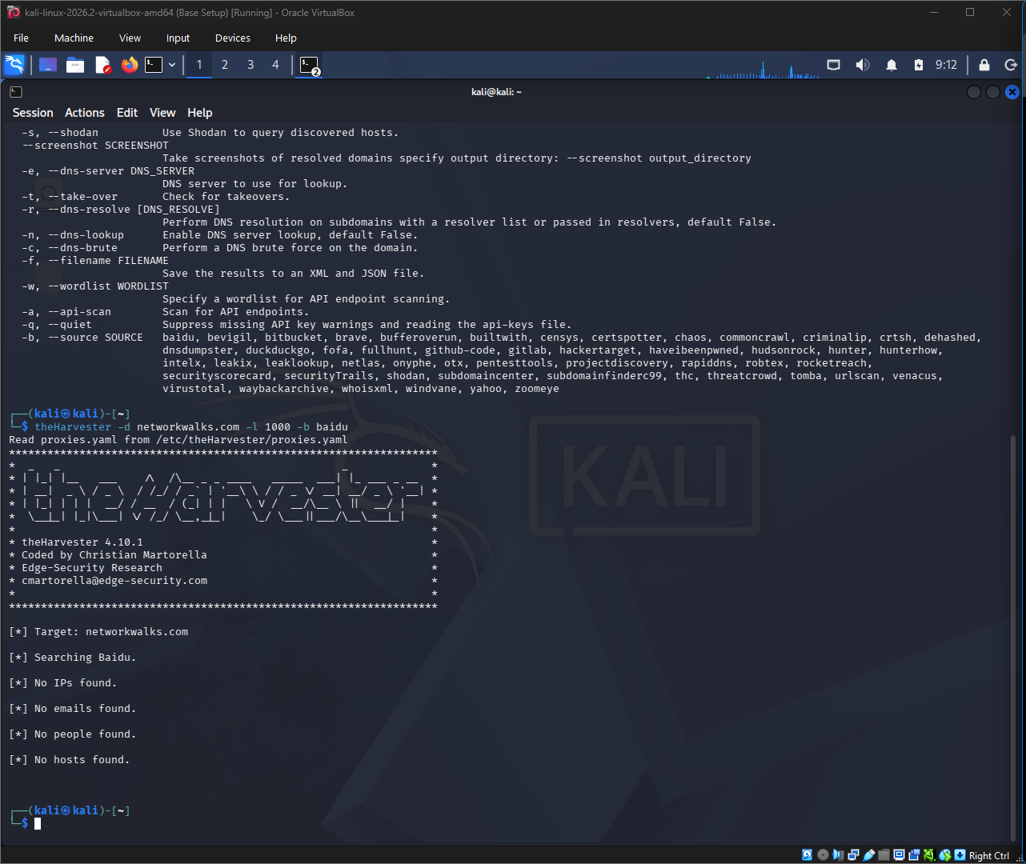
Figure 1. W2-PM4 Task 1: Baidu query completed with no findings.
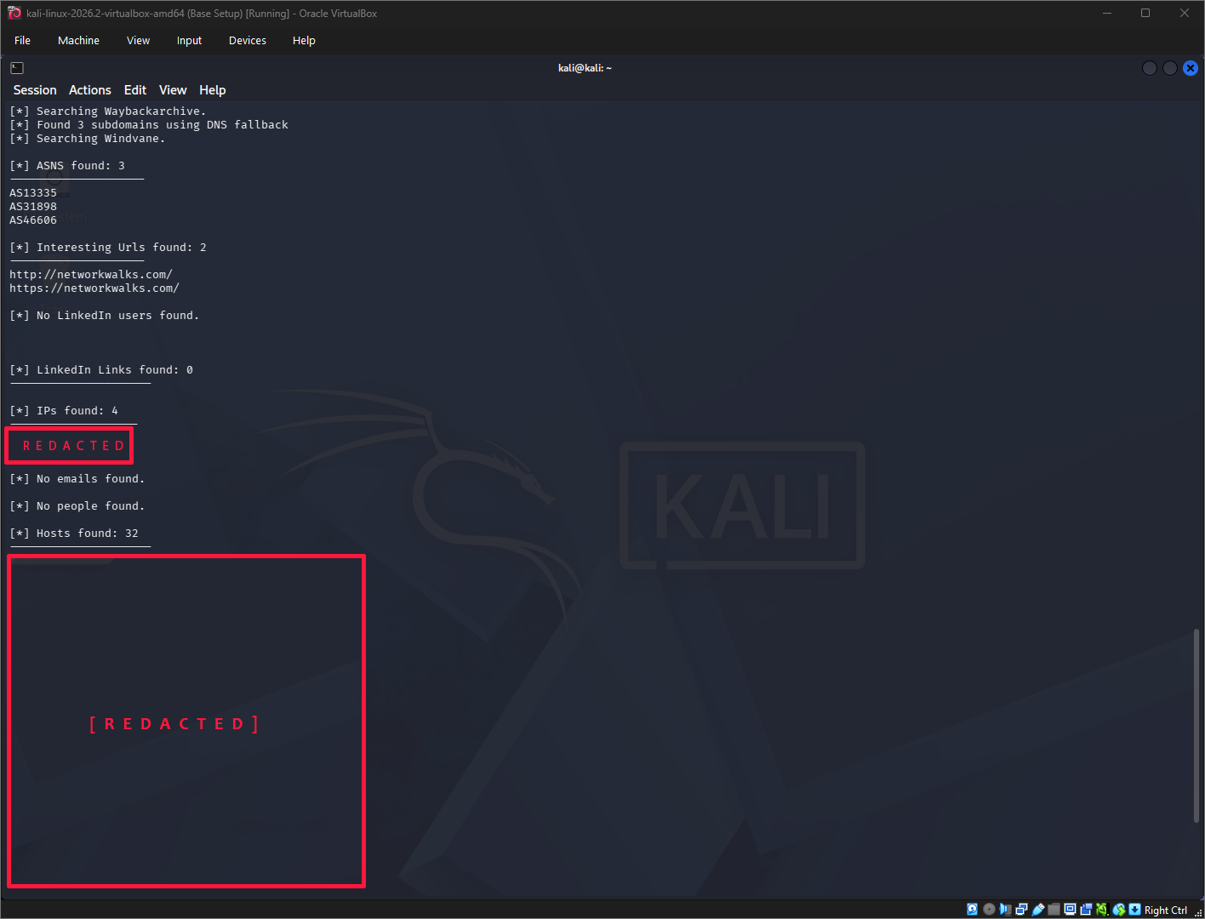
Figure 2. W2-PM4 Task 2: multi-source results with IP addresses and hosts redacted.
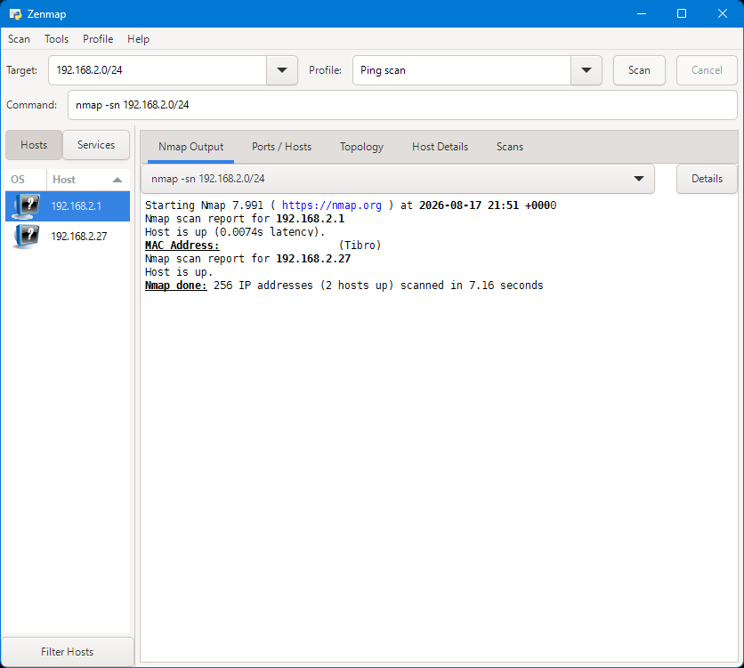
Figure 3. W2-PM5 Ping scan: 256 IP addresses scanned and 2 hosts up; MAC address redacted.
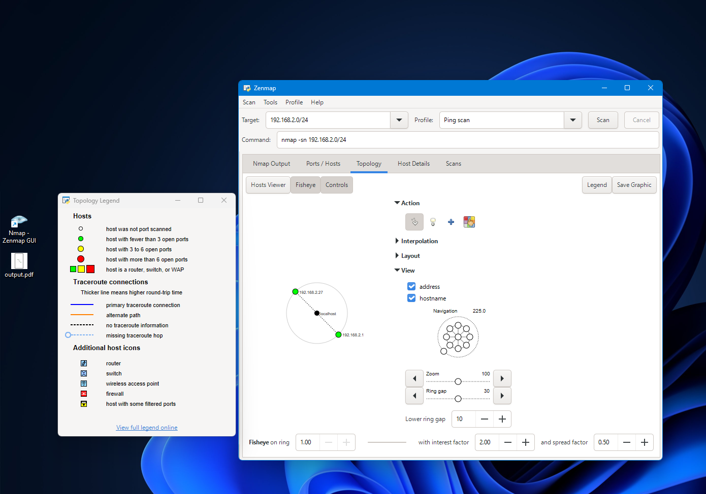
Figure 4. W2-PM5 Zenmap topology and successfully saved topology PDF.

Project Repositories
W2-PM4 - theHarvester: https://github.com/Ritchalison/networkwalks-B082-week2-PM4-theHarvester
W2-PM5 - Zenmap: https://github.com/Ritchalison/networkwalks-B082-week2-PM5-Zenmap

[END]

Author
Prince Manu Gyebi
Cybersecurity Intern - Batch B082, NETWORKWALKS
LinkedIn: https://www.linkedin.com/in/princemanugyebi

Project Information
Program: NETWORKWALKS Cybersecurity Internship | Week: 02 | Report Scope: PM4 + PM5

