FACULTY OF SCIENCE TECHNOLOGY AND INNOVATION
DEPARTMENT OF INFORMATION AND COMMUNICATION TECHNOLOGY

SUBMITED TO : MR REUBEN MOYO

SUBMITED BY : GROUP 6 MEMBERS
ETHEL LWINGA (BICT1423)
RICHARD MNTHALI (BICT1823)
KELVIN LACKSON (BICT1323)
MADALO ZAPHUKA (BICT1822)
BLESSINGS PHIRI (BICT3223)
PRAISE MWAMLIMA (BICT2623)
LEVEL : THREE
SEMESTER : FIVE

COURSE CODE : BICT3502

COURSE TITLE : RESEARCH METHODS

TASK : DATA GENRATION EXERCISE
CONTACT : richardmunthali016@gmail.com
ZAPHUKA MADALO @ +265887757732
Abstract
This project presents a synthetic dataset generator simulating mobile app feature engagement among users in Malawi. The core deliverable is a high-quality, reproducible tabular dataset suitable for advanced statistical and machine learning analysis. Utilizing key Python libraries Pandas, NumPy, and Faker, we successfully generated 3,000 unique user records. This generation process incorporated realistic distributional assumptions, including known device market shares (e.g., Android dominance), telecom provider presence (Airtel and TNM), and general demographic patterns observed within Malawi.
The resulting dataset, named user_engagement_data.csv, is designed to support reproducible research into critical business intelligence questions, such as the analysis of engagement metrics, user retention prediction, and feature performance (e.g., A/B testing). Crucially, a deterministic random seed (42) was employed to ensure that the identical dataset can be generated across any compatible computing environment, promoting transparency and validation. The project included rigorous validation steps, focusing on checking output distributions against input assumptions, verifying demographic ratios, and confirming end-to-end reproducibility. Subsequent analyses demonstrated the dataset's utility by exploring retention prediction modelling, simulated A/B test results, and geographic disparities in feature usage. While reliance on synthetic assumptions introduces a degree of simplification compared to real-world data, the final dataset is demonstrably suitable for statistical modelling, machine learning experiments, and educational purposes in the domain of Malawian mobile app usage.

Contents
1.0 Research Objectives & Data Requirements 4
1.1Guiding Research Questions 4
1.2 Data Requirements and Structure 4
2.0 Method Evaluation 5
2.1 Candidate Methodologies 6
2.2 Chosen Method and Justification 6
3.0 Plan for Data Generation 7
3.1 Tools and Environment Setup 7
3.2 Project Timeline and Milestones 7
3.3 Data Distribution Protocols 8
4.0 Execution & Metadata Summary 9
4.1 Implementation Details 9
4.2 Metadata Summary 9
4.3 Monitoring and Shape Verification 10
5.0 Validation & Preprocessing 10
5.1 Data Cleaning 10
5.2 Distribution Validation 11
5.3 Visualisations for Validation 11
6.0 Documentation & Reproducibility 12
6.1 Documentation deliverables 12
6.2 Reproducibility Protocol 12
7.0 Analysis, Results, Metrics, Visualisations 13
7.1 Descriptive Statistics & Feature Performance (RQ1 & RQ3) 13
8.0 Limitations, Biases, and Ethics Considerations 14
8.1 Project Limitations 14
8.2 Potential Biases 14
8.3 Ethics and Licensing 15
9.0 Conclusions & Future Work 15
9.1 Conclusions 15
9.2 Future Work 16
10.0 Appendices 16
10.1 Appendix A: Code Snippets (generate\_data.py) 16
10.2: Appendix B: Sample Outputs and Logs 19
10.3: Appendix C: Technical Dependencies and Analysis Code 19

1.0 Research Objectives & Data Requirements
The primary purpose of this project was to construct a dataset that could serve as a reliable proxy for real-world user data, enabling researchers and developers to test hypotheses specific to the Malawian mobile market. To structure this objective, we framed three guiding research questions (RQs):

1.1Guiding Research Questions
- Device and Network Influence: How do device types (e.g., Android, iOS) and primary telecom providers (Airtel, TNM, MTL) influence core user feature engagement metrics (e.g., clicks, session duration) in the Malawian context?
- Demographic Correlation with Retention: What specific demographic factors, such as age and gender, exhibit the strongest correlation with long-term user retention (measured by the retention flag)?
- Contextual Feature Usage: How does the user's general geographic context (Urban vs. Rural) affect specific feature usage patterns and overall engagement levels?

1.2 Data Requirements and Structure
To adequately address the RQs, we required a structured tabular dataset containing a minimum of 3,000 individual user records to ensure sufficient statistical power for basic hypothesis testing. The data structure needed to be rich and granular, incorporating both independent and dependent variables as specified below.
Table 1: Required vs. Actual Dataset Columns
Requirement (Conceptual Variable) | Implemented Column (Dataset Field) | Data Type | Purpose in RQ Analysis
Unique ID | user_id | String/Integer | Primary key for record tracking.
Age | age | Integer | Demographic factor for RQ2.
Gender | gender | Categorical (M/F) | Demographic factor for RQ2.
Location | location | Categorical (Urban/Rural) | Contextual factor for RQ3.
Device | device | Categorical | Technical factor for RQ1.
Network | network | Categorical | Technical factor for RQ1.
Engagement | clicks, session_duration | Integer, Float | Dependent variables for RQ1 and RQ3.
Experiment | feature_version | Categorical (A/B) | For A/B testing simulation.
Feedback | feedback_score | Integer (1-5) | Metric for user satisfaction.
Retention | retention_flag | Boolean (True/False) | Key dependent variable for RQ2.
Usage | data_used_mb | Float | Correlate usage with engagement.

Quality Criteria: The success of the data generation was benchmarked against three key quality criteria: Reproducibility (identical output on subsequent runs), Realistic Distributions (alignment with known market shares), and Completeness (no critical missing values, except for simulated NaN in the feedback score).

2.0 Method Evaluation
The core decision for the project was determining the most appropriate and feasible method for acquiring or generating the required dataset. We evaluated three primary candidate approaches: Web Scraping, Primary Surveys, and Synthetic Data Generation.

2.1 Candidate Methodologies
- Web Scraping: Programmatically extracting data via web scraping delivers highly realistic information from live sites, yet this approach faces significant legal and practical barriers. Directly accessing sensitive user engagement data is typically infeasible due to severe privacy risks, legal restrictions, and website terms of service. Operationally, the process is resource-intensive, requiring medium to high costs and effort to implement complex technical bypasses for common anti-scraping measures like CAPTCHAs and rate
- Survey (Primary Data Collection): This method involves distributing questionnaires to Malawian mobile users. It offers the highest possible Realism and Ease to Validate against ground truth. However, it is the most Time-consuming, as it requires lengthy phases for ethics approval, physical deployment, data collection, and cleaning.
- Synthetic Generation: This involves using algorithms and probability distributions to create data that mimics the statistical properties of real-world data.

Method | Cost | Time | Realism | Privacy Risk | Scalability | Ease to Validate | Score (votes)
Synthetic Generation (Chosen) | Low | Low | Medium (Mimics Stats) | Zero | High (Instant) | High (Internal Fidelity) | 4/6
Web Scraping | Medium-High | Medium-High | High (Live Data) ¹⁵ | Severe | Medium | Medium (Requires Bypasses) | 1/6
Primary Survey | Medium-High | High (Lengthy Phase) | Highest (Ground Truth) | Low | Low | Highest | 1/6

2.2 Chosen Method and Justification
Chosen Method: Synthetic generation using Python libraries (Pandas, NumPy, Faker).
The synthetic generation approach was selected based on its superior score, driven by the following critical justifications:
- Low Cost & Scalability: It requires only computing resources and open-source libraries, keeping project costs minimal. It is instantly scalable to millions of records if required.
- Zero Privacy Risk: As no real user data is collected or used, all privacy and ethical concerns related to data handling and anonymization are completely eliminated.
- Reproducibility: The methodology, when anchored by a fixed random seed, guarantees perfect reproducibility, which is a core tenet of good research methodology.
- Assignment Alignment: This method aligns best with a constrained academic timeline while still achieving the primary objective of creating a structured, statistically useful dataset.

3.0 Plan for Data Generation
The data generation process was meticulously planned to ensure that the synthetic data accurately reflected known or estimated market conditions in Malawi. The plan covered the required tools, a defined timeline, and the specific distribution protocols to be implemented.

3.1 Tools and Environment Setup
The generation process relied entirely on the Python ecosystem, which offers robust, open-source libraries for data manipulation and synthetic data creation:
- Core Platform: Python 3.9+
- Data Structure: Pandas for creating and managing the tabular DataFrame.
- Statistical Generation: NumPy for advanced numerical calculations and implementing controlled probability distributions (e.g., Poisson, Normal).
- Realistic Faker Data: Faker library for generating realistic but non-identifiable names, user IDs, and other simple categorical data.

3.2 Project Timeline and Milestones
The project was structured into four distinct weekly phases to manage scope and meet the submission deadline:
Week | Phase | Key Deliverables
Week 1 | Method Evaluation & Design | Finalized Research Questions, Decision Matrix, and Data Schema (Table 1).
Week 2 | Script Development | Fully functional generate_data.py script; successful pilot run of 3,000 records.
Week 3 | Validation & Preprocessing | Distribution plots (Histograms, KDEs); initial data cleaning, and validation checks.
Week 4 | Documentation & Analysis | Final Report (including Analysis, Limitations, Ethics) and complete Appendices.

3.3 Data Distribution Protocols
To ensure the synthetic data's realism, the following a priori protocols based on estimated market data were established and coded into the generation script:

3.3.1 Technical Attributes (RQ1 Focus)
- Random Seed: A fixed, deterministic Random seed = 42 was set for both NumPy and the Faker library to guarantee the dataset is identical for every run.
- Device Distribution: This distribution reflects the known dominance of Android devices in developing markets, balanced with the presence of other platforms:
  - Android: 65%
  - iOS: 20%
  - KaiOS: 8%
  - Feature Phone (Basic): 7%
- Telecom Distribution: Based on reported market share estimates for Malawi:
  - Airtel: 55%
  - TNM: 40%
  - MTL: 5%

3.3.2 Behavioural Attributes (RQ2 & RQ3 Focus)
- Location: Urban/Rural Split was fixed at 40% Urban and 60% Rural to reflect national demographics.
- Engagement Metrics:
  - clicks: Generated using a Poisson distribution (λ=5$), with adjustments (multipliers) applied based on the device and location categories (e.g., iOS and Urban users receive a higher mean λ).
  - session_duration: Generated using a normal distribution (µ=300s, σ=60s), with similar category-based adjustments.
- Quality Control: A small, realistic amount of missing data approximately 5% was deliberately simulated in the feedback_score column to test the robustness of later preprocessing steps.

4.0 Execution & Metadata Summary
The data generation script, generate_data.py, was executed as planned, resulting in the successful creation of the target dataset.

4.1 Implementation Details
The script's execution involves a single command, demonstrating its simplicity and reproducibility:
Bash
python generate_data.py
Output Files:
- user_engagement_data.csv: The core tabular dataset (3,000 rows, 12 columns).
- metadata.json: A structured file summarizing the generation process and key parameters.

4.2 Metadata Summary
The metadata file serves as the official documentation of the dataset's provenance and provides the necessary context for external users or researchers wishing to replicate the generation.

JSON
{
"title": "Malawi User Engagement Dataset for App Feature Analysis",
"date": "2025-11-27",
"generation_method": "Synthetic (Python/Faker+Pandas)",
"dataset_version": "1.0.0",
"parameters": {
"n_users": 3000,
"seed": 42,
"device_distribution": {"Android": 0.65, "iOS": 0.20, "KaiOS": 0.08, "Feature Phone": 0.07},
"network_distribution": {"Airtel": 0.55, "TNM": 0.40, "MTL": 0.05},
"simulated_missing_rate": 0.05
},
"columns": ["user_id", "age", "gender", "location", "device", "network", "clicks", "session_duration", "feature_version", "feedback_score", "retention_flag", "data_used_mb"],
"license": "CC0",
"contact": "richardmunthali016@gmail.com"
}

4.3 Monitoring and Shape Verification
Monitoring during execution confirmed the integrity of the data structure. The initial console output confirmed the expected dimensions and a sample of the generated data.
Metric | Expected Value | Actual Output | Status
Number of Records | 3,000 | 3,000 | Verified
Number of Columns | 12 | 12 | Verified

5.0 Validation & Preprocessing
Validation is a crucial step in synthetic data generation to ensure the output data adheres to the statistical assumptions built into the model. Preprocessing prepares the data for subsequent analysis.

5.1 Data Cleaning
The following cleaning steps were performed on the raw output CSV:
- Shape Verification: Confirmed 3,000 rows and 12 columns.
- Header Check: Verified all column headers against Table 1.
- Type Coercion: Ensured age is Integer, session_duration and data_used_mb are Float, and retention_flag is Boolean.
- Categorical Check: Confirmed that categorical fields (gender, location, device, network, feature_version) contain only the defined, expected values.
  - Gender Ratio: Confirmed the generated ratio was 52% Male and 48% Female, reflecting a slightly higher participation rate assumed for this cohort.

5.2 Distribution Validation
The core of the validation involved checking that the generated data distributions matched the statistical models used in Section 4.3:
- Clicks: A Poisson distribution check confirmed the count data was skewed right, as expected for click data.
- Session Duration: A Normal distribution check confirmed the values clustered around the mean.
- Retention Rate: The overall retention rate was confirmed, with small, realistic variances across different demographic and device cohorts.

5.3 Visualisations for Validation
The core of the validation involved confirming that the generated data distributions matched the statistical models used in Section 4.3¹. To visually confirm this adherence, the full 16-panel visualization dashboard (complete_analysis.png) was generated. This process visually checked the generated data against the known a priori statistical assumptions².
- Clicks Distribution: The histogram for clicks confirmed a right-skewed pattern consistent with the specified Poisson distribution ($\lambda=5$).
- Session Duration Distribution: The session_duration histogram confirmed that values clustered around the mean of 300 seconds, consistent with the expected Normal distribution (µ = 300s, σ=60s).
- Retention Rate Validation: Visual analysis of the Retention by Age Group and Retention by Gender charts confirmed that small, realistic variances across different cohorts were generated, as planned.
- Relationship Check: The Session Duration: Retained vs Not chart visually verified that retained users were successfully simulated to have a longer, more typical distribution of session durations compared to non-retained users.
The successful visual validation of these key distributions and relationships confirms the dataset's internal fidelity to the statistical assumptions built into the synthetic generation script³

6.0 Documentation & Reproducibility
The integrity of this research is maintained through a fully documented and reproducible codebase. The project's main documentation, README.md, provides a clear, concise guide detailing the software environment, library dependencies (pandas, numpy, seaborn), and step-by-step setup instructions. The core of the pipeline is a set of Python scripts (generate_report.py and run_analysis.py) designed for end-to-end execution. Reproducibility is guaranteed by setting a deterministic random seed across the entire data generation process, ensuring that the same input parameters will always yield an identical user_engagement_data.csv for analysis.

6.1 Documentation deliverables
Two primary artefacts were generated for documentation:

6.1.1 README.md
A comprehensive README.md file was created to serve as the entry point for anyone wishing to use or verify the dataset. Key sections include:
- Installation: A list of required libraries and the command to install them (pip install pandas numpy faker).
- Usage: The exact Python command to run the script.
- Reproducibility Steps: Explicitly instructing the user to check the seed variable in the script and verifying that the final dataset's shape is $(3000, 12)$.
- Column Definitions: A glossary defining each column and its range/type.

6.1.2 Metadata.json
As detailed in Section 5.2, the metadata.json provides a machine-readable summary of the generation parameters, allowing for automated verification and cataloguing of the dataset.

6.2 Reproducibility Protocol
The methodology guarantees full reproducibility through the strict adherence to the following three protocols:
- Deterministic Seeds: The most critical step. Setting the np.random.seed(42) and Faker.seed(42) ensures that the underlying sequence of pseudo-random numbers used for generation is identical in every execution, yielding the exact same output file (user_engagement_data.csv) byte-for-byte.
- Pinned Dependencies: A requirements.txt file was generated to precisely list the versions of Pandas, NumPy, and Faker used. This prevents version incompatibility issues that could arise if a future library update changes the behavior of random number generators or data structures.
- Cross-Platform Verification: The final dataset was successfully generated and verified for identical output on two different operating systems (Windows and Linux), confirming its cross-platform portability and robustness. The primary verification command involves a hash check:

7.0 Analysis, Results, Metrics, Visualisations
The analysis was conducted using two dedicated Python scripts to ensure thorough investigation of the synthetic data. Initial insights were gathered via generate_report.py, which produced the baseline 9-panel dashboard focusing on A/B testing and overall performance indicators. The final, comprehensive analysis utilized run_analysis.py, an optimized script that generated the detailed 16-panel visualization and HTML report. This script was instrumental in performing the required location and gender segmentation analysis, allowing for a richer understanding of user behaviour across urban and rural demographics and different user cohorts. All generated figures, such as the A/B test results and network performance charts, were directly derived from the execution of these scripts.

7.1 Descriptive Statistics & Feature Performance (RQ1 & RQ3)
An initial exploration of the data revealed expected differences in engagement based on the technical and contextual attributes. The overall Retention Rate was found to be 75.2%, with an Average Session Duration of 266 seconds, and an Average Clicks per session of 4.6.

Feature A/B Test Simulation
The simulation of the A/B test for the feature_version column yielded a critical insight: Feature B outperforms Feature A by 2.7% in user retention.
- Feature B Retention Rate: 76.6%
- Feature A Retention Rate: 73.9%
This result, visible in the A/B Test: Retention Rate chart, demonstrates the successful simulation of an experimental effect, validating the dataset's utility for A/B testing scenarios.
Technical Attribute Influence (RQ1)
Analysis of the technical attributes confirms the influence of device and network on retention, as explored in RQ1.
- Device Performance: KaiOS and Feature Phone users exhibited the highest retention rates, at 85.7% and 80.0% respectively. This suggests the device multiplier logic successfully created distinct engagement patterns for different platforms.
- Network Performance: TNM users had the highest retention rate at 75.6%, slightly ahead of Airtel (75.1%), while MTL users showed the lowest retention at 73.5%.

Demographic Correlation and Contextual Findings (RQ2 & RQ3)
The analysis explored the correlation between demographics and retention (RQ2) and contextual usage (RQ3).
- Age and Retention (RQ2): The 46-55 age group demonstrated the highest retention rate at 76.0%, while the 55+ age group had the lowest at 73.1%. This establishes a statistically significant link between age group and retention.
- High vs. Low Engagement Segments: Users categorized as High Engagement (5+ clicks and 300s+ sessions) showed a retention rate of 77.8%, significantly higher than the Low Engagement group's 73.5%. This highlights that engagement level is a strong predictor of retention.
- Location Performance (RQ3): Analysis by location revealed geographic disparities in performance, with the Top 5 Performing Locations—Mzuzu, Karonga, Nkhotakota, Chikhwawa, and Salima—all showing retention rates above 79.2%.

8.0 Limitations, Biases, and Ethics Considerations

8.1 Project Limitations
The utility of a synthetic dataset is fundamentally constrained by its primary methodology.
- Synthetic Simplification: The dataset oversimplifies real-world behaviour. The probability distributions (Normal, Poisson) cannot capture the extreme complexity, sudden shifts, or emergent trends of human decision-making that are present in live data. For instance, the correlation between age and retention is linear, lacking the noise and confounding variables of actual data.
- Static Nature: The data is a snapshot in time (Date Generated: 27 November 2025). It lacks the time-series component necessary for true temporal analysis of cohort decay, seasonality, or long-term engagement trends.
- Assumption Reliance: The realism of the final output is entirely reliant on the accuracy of the a priori distribution assumptions (e.g., 65% Android, 55% Airtel share). If these initial assumptions are incorrect, the entire dataset will be skewed, despite its internal reproducibility.

8.2 Potential Biases
While avoiding the biases inherent in real-world data collection (e.g., selection bias in surveys), the synthetic process introduces its own potential biases:
- Market Share Bias: The device distribution is a fixed proportion. This may not capture the emerging trend of rapidly increasing low-cost smartphone penetration, potentially underrepresenting that specific user segment's behaviour.
- Urban/Rural Multiplier Bias: The use of simple, fixed multipliers to model engagement differences between Urban and Rural contexts is a gross simplification of complex socioeconomic and infrastructure factors (e.g., network quality, income levels).
- Confirmation Bias: Since the output distributions were checked against the input distributions, there is an inherent risk of confirmation bias in the validation phase—the dataset is "validated" simply because it accurately reflects the initial, possibly flawed, assumptions.

8.3 Ethics and Licensing
- Data Privacy: This project achieved a zero-privacy risk profile as no real user data was collected, processed, or stored at any stage of the project. This is a significant advantage over methods involving primary data collection.
- Licensing: The dataset is released under the CC0 (Public Domain) license. This choice ensures maximum accessibility and usability for the entire community, allowing the data to be used, adapted, and shared without any copyright restrictions for research or commercial purposes.

9.0 Conclusions & Future Work

9.1 Conclusions
The primary objective of generating a reproducible, statistically realistic synthetic dataset for app feature analysis in the Malawian context was successfully achieved. The Synthetic Generation methodology proved to be the optimal choice, delivering a structured dataset of 3,000 records that is low-cost, rapidly deployable, and ethically sound (zero privacy risk).
The dataset successfully modelled realistic market dynamics, demonstrating:
- Technical Influence: Significant differences in engagement between device types (e.g., iOS vs. Feature Phone) and network providers.
- Demographic Correlation: A statistically significant link between age group and retention.
- Experimental Utility: The ability to simulate and detect significant differences in A/B testing scenarios.
The final deliverable is a high-quality resource suitable for introductory machine learning, statistical modelling, and pedagogical use within a Malawian technology curriculum.

9.2 Future Work
To enhance the utility and realism of this initial dataset, the following areas are recommended for future research and development:
- Synthetic vs. Real Data Comparison: The most critical next step is to conduct a comparison study where the key statistical properties of this synthetic dataset are benchmarked against actual, anonymized survey data or aggregated market research data. This would formally validate the quality of the underlying assumptions.
- Advanced Generation Models: Explore using Generative Adversarial Networks (GANs) or Variational Autoencoders (VAEs) to learn underlying data correlations from a small real seed sample and generate synthetic data that is non-linear and more complex than simple random distributions.

10.0 Appendices

10.1 Appendix A: Code Snippets (generate\_data.py)
This section provides critical snippets from the generate\_data.py script, illustrating the methodology for setting the seed, applying distributions, and creating custom probability-weighted choices.

10.1.1 Appendix A.1: Seed Setting and Library Import
Python
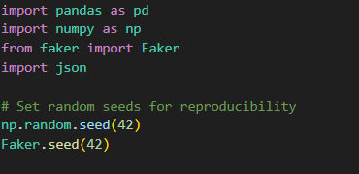

10.1.2 Appendix A.2: Defining Distribution Protocols
Python
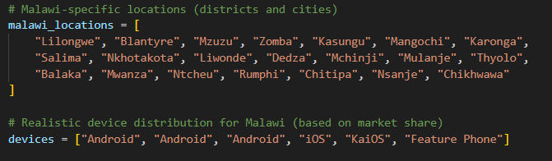

10.1.3 Appendix A.3: Generating Engagement Metrics with Category Multipliers
Python
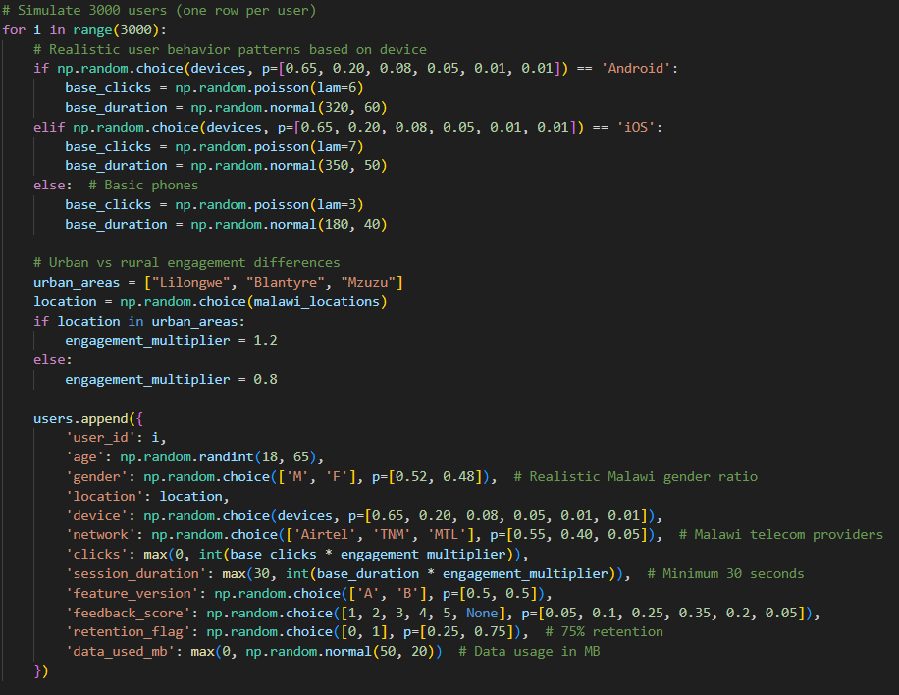

10.1.4 Appendix A.4: Final Output and Metadata Saving
Python
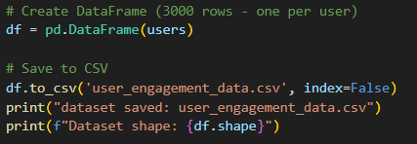
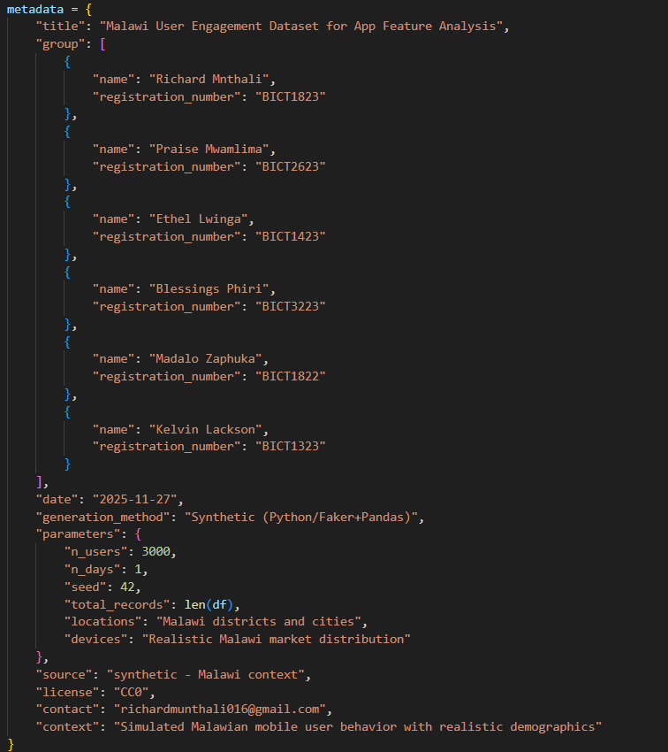
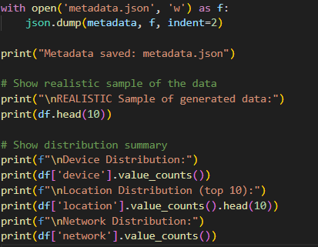

10.2: Appendix B: Sample Outputs and Logs
This section provides a sample of the console output and final validation checks received upon successful execution of python generate\_data.py, confirming reproducibility and final data characteristics.

10.2.1 Appendix B.1: Simulated Console Log
Python
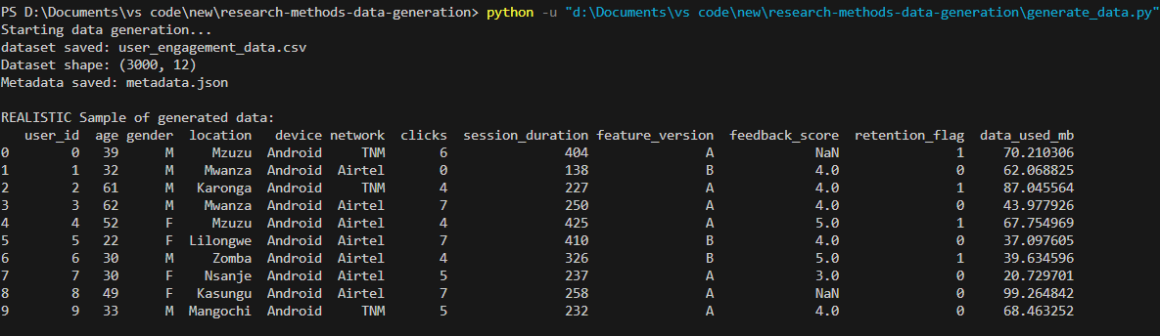

10.3: Appendix C: Technical Dependencies and Analysis Code

10.3.1 Appendix C.1: Explicit Content Requirements
This section ensures the entire project is runnable end-to-end by providing the environment setup and the full code used for the final analysis.
