LOKI Testing Dataset
This document outlines all of the features of the LOKI testing dataset for use by Biofilter and BioBin. This is a very limited dataset designed to allow the easy production of models in order to check validity of the methods.

SNPS
There are 2 chromosomes, 1 and 2, that contain all of the genetic information. Chromosome 1 is 80 base pairs long, and chromosome 2 is 30 base pairs long. On each chromosome, SNPS occur every seven base pairs, and are numbered sequentially starting with “rs1” on chromosome 1 and “rs21” on chromosome 2. Odd SNPs (rs1, rs3, ...) have a role of “Exon”, and even SNPs have a role of “Intron.” See the diagram below:
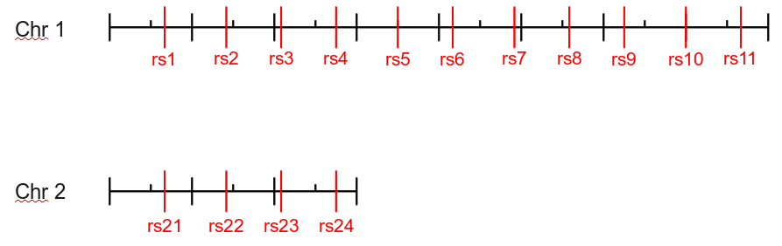

Genes
There are 6 genes available in the test dataset, with names “G#”, where “#” is the gene number (from 1-6). The boundaries of the genes are defined for two populations, “NO-LD” and “PLUS5”. The “PLUS5” boundaries are shifted by 5 base pairs over the NO-LD population. The boundaries are given in the table below, and illustrated in the diagram below:
Gene | Chromosome | Population
Gene | Chromosome | NO-LD |  | PLUS5
Gene | Chromosome | Start | End | Start | End
G1 | 1 | 5 | 15 | 10 | 20
G2 | 1 | 25 | 35 | 30 | 40
G3 | 1 | 45 | 55 | 50 | 60
G4 | 1 | 65 | 75 | 70 | 80
G5 | 1 | 30 | 50 | 35 | 55
G6 | 2 | 10 | 20 | 15 | 25

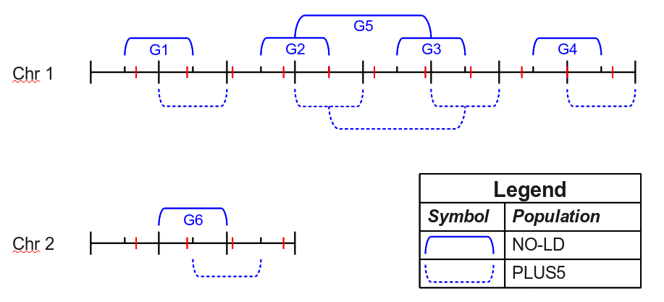

Gene Aliases
Each gene in the dataset also has the unique alias of “R#”, which is equivalent to “G#”. Additionally, there is a single ambiguous alias of “G23”, which refers to both “G2” and “G3”. Th table below lists all of the available aliases:
Alias | Gene(s)
R1 | G1
R2 | G2
R3 | G3
R4 | G4
R5 | G5
R6 | G6
G23 | G2,G3

Pathways
The test dataset has 3 pathways from two sources. The source names are “S1” and “S2.” The three pathways are “P1”, “P2”, and “P3.” P! and P2 are both from S1, and P1 is the parent pathway of P2. P3 comes from S2 and has no relationships to other pathways. P1 contains the genes G1 and G2; P2 contains the gene G4, and P3 contains the genes G2 and G3. See the diagram below for clarification:
